Nenana river ice from VIIRS 375 m: Run 19: four river / land states on the river + 1 px buffer (RF, UNet++, 2D CNN)
Part of the VIIRS series (runs 17-20); labels from the run 16 Landsat 30 m maps, VIIRS 375 m inputs only.

Contents

1. Summary
rule | model | accuracy | balanced acc | Cohen κ | macro prec | macro rec | macro F1 | weighted F1
rule50 | RF | 0.794 | 0.676 | 0.696 | 0.638 | 0.676 | 0.644 | 0.805
rule50 | UNet++ | 0.714 | 0.535 | 0.569 | 0.558 | 0.535 | 0.535 | 0.710
rule50 | 2D CNN | 0.812 | 0.661 | 0.719 | 0.652 | 0.661 | 0.655 | 0.815
rule90 | RF | 0.818 | 0.710 | 0.714 | 0.689 | 0.710 | 0.662 | 0.838
rule90 | UNet++ | 0.742 | 0.481 | 0.565 | 0.495 | 0.481 | 0.477 | 0.715
rule90 | 2D CNN | 0.854 | 0.665 | 0.766 | 0.672 | 0.665 | 0.664 | 0.853

- Best rule50 model: 2D CNN, accuracy 0.812, macro F1 0.655; 9,645 scored VIIRS pixels.
- Leave-one-date-out over the 6 run 16 dates: each date is predicted by models trained on the other 5.
- rule50 accuracy per date (RF): 2023-05-05 0.76, 2023-07-24 0.97, 2023-10-04 0.68, 2024-04-21 0.55, 2024-06-22 1.00, 2026-03-26 0.80.
- State 2 (open river, snow land) is rare, so its F1 is low for every model.

2. Data and design

2.1 Why VIIRS
Run 16 maps six classes from Landsat 30 m, but Landsat passes every 8-16 days and is often cloudy. VIIRS passes daily at 375 m. Runs 17-20 move from 30 m to 375 m: the run 16 maps are summarised per VIIRS pixel and used as labels, and VIIRS bands are the only image inputs.

2.2 Grids
layer | grid
Run 16 Landsat map | EPSG:4326, 995 x 1635 px, 0.00027027° (~30 m); classes 1 river, 2 ice, 3 snow, 4 forest, 5 shrub_grass_wetland, 6 bare_developed
VIIRS (Patches/nenana_<date>/<date>_viirs_375m.tif) | EPSG:4326, 80 x 132 px, 0.00337838° (12.5 Landsat px); 9 bands I1, I2, I3 (TOA reflectance), I4, I5 (brightness temperature K), SZA, SAA, VZA, VAA
Water mask alaska_occ_375m.tif | EPSG:4326, same 0.00337838° grid, aligned exactly (offset col 6412, row 2209); JRC water occurrence 0-1

2.3 Dates
date | season | use | VIIRS-Landsat shift m (S, E) | VZA °
2023-04-19 | spring, snow | VIIRS only (prediction) | 30, 0 | 9
2023-05-05 | spring break-up | labelled (run 16 map) | 60, -26 | 9
2023-07-24 | summer | labelled (run 16 map) | 0, 26 | 12
2023-10-04 | autumn freeze-up | labelled (run 16 map) | 30, -52 | 10
2024-04-21 | spring break-up | labelled (run 16 map) | 0, -26 | 13
2024-06-22 | summer | labelled (run 16 map) | 30, 0 | 1
2024-09-02 | late summer | VIIRS only (prediction) | -90, -78 | 2
2025-07-04 | summer | VIIRS only (prediction) | 30, -26 | 7
2026-03-26 | late winter | labelled (run 16 map) | 0, 0 | 28
2026-08-01 | summer | VIIRS only (prediction) | 0, 26 | 28

Run 16 dates without a VIIRS file (2024-03-12, 2024-04-20, 2024-04-29) are left out. The 4 VIIRS-only dates have no run 16 map and are only predicted (no score).

2.4 From 30 m classes to VIIRS pixels
- Each Landsat pixel is assigned to the VIIRS pixel it falls in, after moving the Landsat map by the run 17 shift (at most ~60 m). Shares of each class per VIIRS pixel = 'box' fractions.
- A VIIRS pixel is used when >= 98 % of it is mapped. A VIIRS pixel holds 12 or 13 Landsat pixels per side (12.5 on average); an early version divided by 12.5² and dropped every 12 x 12 pixel (a dashed grid of holes, ~25 % of pixels). Fixed: the share is now divided by the real count (floor 12 x 12, so edge pixels still count as partial). Runs 17-20 use the fix.
- Four parts per pixel: open_river = river, ice = ice, snow = snow, snow_free_land = forest + shrub + bare.

2.5 The four states and the two rules
state | river | land
1 ice_free_river_snow_free_land | open | no snow
2 ice_free_river_snow_covered_land | open | snow
3 ice_covered_river_snow_free_land | ice | no snow
4 ice_covered_river_snow_covered_land | ice | snow

- rule50 (majority): river open if open / (open + ice) > 0.5; land snow-covered if snow / (snow + no-snow land) > 0.5.
- rule90: river open only if open share > 0.9; land snow-free only if snow share < 0.1 (mixed pixels count as snow-covered).
- A pixel with < 1 % river (or < 1 % land) takes the ratio of the whole date, so every pixel gets a state.

2.6 Inputs
Per VIIRS pixel: I1, I2, I3, I4, I5, NDVI_I = (I2-I1)/(I2+I1), NDSI_I = (I1-I3)/(I1+I3), I4-I5, solar zenith, view zenith, JRC mean occurrence and JRC water-zone share (occurrence >= 5 %). RF also gets 3 x 3 mean / std of I1, I2, I3, I5. Runs 19 and 20 add the water-mask occurrence (21 RF inputs). No Landsat band is ever an input.

3. Run 19: four states on the river + 1 px buffer
Water mask alaska_occ_375m.tif cropped to the image: river = occurrence >= 0.05 (the run 16 5 % rule), 988 pixels; buffer = 1 VIIRS pixel (375 m) around it, 678 pixels. Predicted area 1,666 pixels; ~1,530-1,640 per date are used (>= 98 % mapped by the Landsat map).
Models predict the four states at once (one 4-class model per rule), trained and scored only on these pixels: RF classifier with the run 16 settings (depth 16, min leaf 20, sqrt, 300 trees, balanced_subsample; 21 inputs, so no top-25 selection); UNet++ (resnet18, 4-class cross-entropy on mask pixels, 1500 steps, flips, flip TTA); 2D CNN (4 conv 3 x 3 layers 32-64-64-64 with batch norm and ReLU, dropout 0.1, 1 x 1 output, no down-sampling, so each pixel sees 9 x 9 VIIRS pixels = 3.4 km; 97k parameters; same training as UNet++).
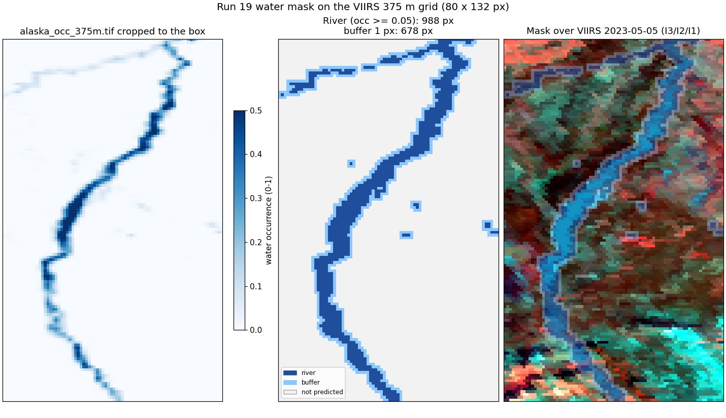
Run 19: the water mask cropped to the image and the predicted area.

rule50
model | accuracy | macro F1
RF | 0.794 | 0.644
UNet++ | 0.714 | 0.535
2D CNN | 0.812 | 0.655

state | true px | RF F1 | RF prec | RF rec | UNet++ F1 | UNet++ prec | UNet++ rec | 2D CNN F1 | 2D CNN prec | 2D CNN rec
1 open river, no-snow land | 3,745 | 0.90 | 0.94 | 0.87 | 0.81 | 0.89 | 0.74 | 0.90 | 0.93 | 0.86
2 open river, snow land | 145 | 0.19 | 0.13 | 0.34 | 0.03 | 0.11 | 0.02 | 0.19 | 0.18 | 0.21
3 ice river, no-snow land | 2,403 | 0.67 | 0.64 | 0.71 | 0.55 | 0.56 | 0.54 | 0.69 | 0.66 | 0.73
4 ice river, snow land | 3,352 | 0.82 | 0.84 | 0.79 | 0.75 | 0.67 | 0.84 | 0.84 | 0.84 | 0.84

RF confusion, rule50 (rows true, columns predicted)
true \ predicted | 1 | 2 | 3 | 4
1 open river, no-snow land | 3,244 | 34 | 425 | 42
2 open river, snow land | 21 | 49 | 47 | 28
3 ice river, no-snow land | 158 | 117 | 1,702 | 426
4 ice river, snow land | 28 | 184 | 481 | 2,659

UNet++ confusion, rule50 (rows true, columns predicted)
true \ predicted | 1 | 2 | 3 | 4
1 open river, no-snow land | 2,765 | 15 | 609 | 356
2 open river, snow land | 47 | 3 | 32 | 63
3 ice river, no-snow land | 150 | 4 | 1,296 | 953
4 ice river, snow land | 156 | 5 | 370 | 2,821

2D CNN confusion, rule50 (rows true, columns predicted)
true \ predicted | 1 | 2 | 3 | 4
1 open river, no-snow land | 3,238 | 8 | 455 | 44
2 open river, snow land | 48 | 31 | 33 | 33
3 ice river, no-snow land | 130 | 55 | 1,749 | 469
4 ice river, snow land | 55 | 83 | 404 | 2,810

rule90
model | accuracy | macro F1
RF | 0.818 | 0.662
UNet++ | 0.742 | 0.477
2D CNN | 0.854 | 0.664

state | true px | RF F1 | RF prec | RF rec | UNet++ F1 | UNet++ prec | UNet++ rec | 2D CNN F1 | 2D CNN prec | 2D CNN rec
1 open river, no-snow land | 3,298 | 0.88 | 0.94 | 0.83 | 0.82 | 0.78 | 0.86 | 0.92 | 0.93 | 0.90
2 open river, snow land | 244 | 0.22 | 0.14 | 0.56 | 0.01 | 0.04 | 0.01 | 0.17 | 0.24 | 0.13
3 ice river, no-snow land | 1,377 | 0.65 | 0.79 | 0.55 | 0.27 | 0.39 | 0.20 | 0.68 | 0.63 | 0.73
4 ice river, snow land | 4,726 | 0.90 | 0.89 | 0.90 | 0.81 | 0.77 | 0.85 | 0.90 | 0.90 | 0.89

RF confusion, rule90 (rows true, columns predicted)
true \ predicted | 1 | 2 | 3 | 4
1 open river, no-snow land | 2,736 | 445 | 43 | 74
2 open river, snow land | 74 | 136 | 2 | 32
3 ice river, no-snow land | 69 | 129 | 759 | 420
4 ice river, snow land | 37 | 267 | 161 | 4,261

UNet++ confusion, rule90 (rows true, columns predicted)
true \ predicted | 1 | 2 | 3 | 4
1 open river, no-snow land | 2,830 | 17 | 193 | 258
2 open river, snow land | 169 | 2 | 11 | 62
3 ice river, no-snow land | 194 | 22 | 282 | 879
4 ice river, snow land | 440 | 11 | 236 | 4,039

2D CNN confusion, rule90 (rows true, columns predicted)
true \ predicted | 1 | 2 | 3 | 4
1 open river, no-snow land | 2,974 | 37 | 197 | 90
2 open river, snow land | 133 | 32 | 28 | 51
3 ice river, no-snow land | 24 | 6 | 1,009 | 338
4 ice river, snow land | 68 | 61 | 376 | 4,221

Confusion matrices and other metrics
Rows = true state, columns = predicted state; each cell shows the pixel count and the % of that true state (recall). Balanced accuracy = mean recall over the states present; Cohen κ = agreement beyond chance; weighted F1 = F1 weighted by the number of true pixels per state.
rule | model | accuracy | balanced acc | Cohen κ | macro prec | macro rec | macro F1 | weighted F1
rule50 | RF | 0.794 | 0.676 | 0.696 | 0.638 | 0.676 | 0.644 | 0.805
rule50 | UNet++ | 0.714 | 0.535 | 0.569 | 0.558 | 0.535 | 0.535 | 0.710
rule50 | 2D CNN | 0.812 | 0.661 | 0.719 | 0.652 | 0.661 | 0.655 | 0.815
rule90 | RF | 0.818 | 0.710 | 0.714 | 0.689 | 0.710 | 0.662 | 0.838
rule90 | UNet++ | 0.742 | 0.481 | 0.565 | 0.495 | 0.481 | 0.477 | 0.715
rule90 | 2D CNN | 0.854 | 0.665 | 0.766 | 0.672 | 0.665 | 0.664 | 0.853

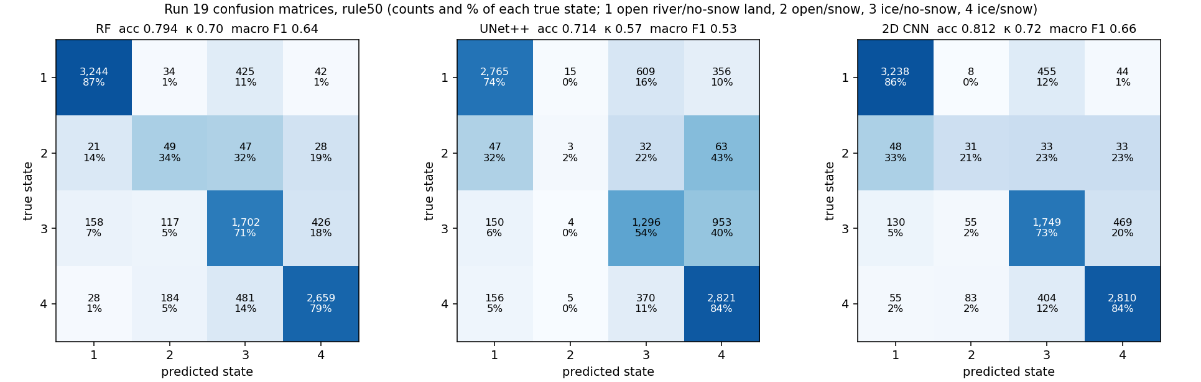
Run 19: confusion matrices, rule50, every model (leave-one-date-out).
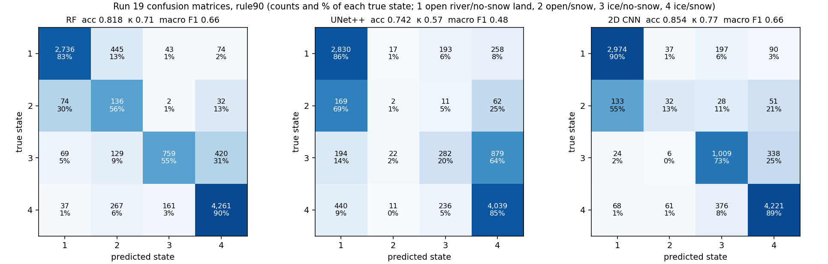
Run 19: confusion matrices, rule90, every model (leave-one-date-out).
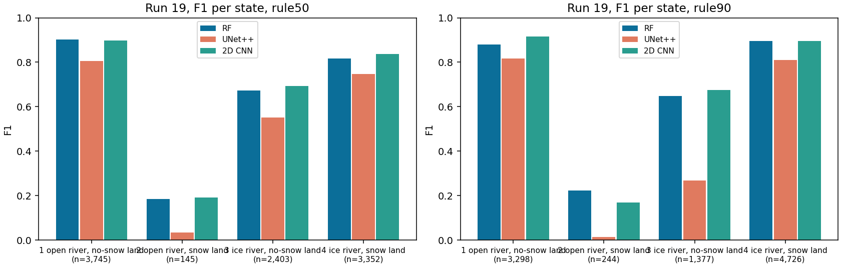
Run 19: F1 per state and model (n = true pixels).

Accuracy per date
date | px | RF 50 | RF 90 | UNet++ 50 | UNet++ 90 | 2D CNN 50 | 2D CNN 90
2023-05-05 | 1,599 | 0.76 | 0.92 | 0.76 | 0.90 | 0.75 | 0.93
2023-07-24 | 1,638 | 0.97 | 0.78 | 0.80 | 0.84 | 0.96 | 0.91
2023-10-04 | 1,599 | 0.68 | 0.59 | 0.46 | 0.31 | 0.72 | 0.64
2024-04-21 | 1,639 | 0.55 | 0.71 | 0.59 | 0.57 | 0.67 | 0.78
2024-06-22 | 1,641 | 1.00 | 0.94 | 0.86 | 0.88 | 0.99 | 0.92
2026-03-26 | 1,529 | 0.80 | 0.96 | 0.82 | 0.96 | 0.77 | 0.94

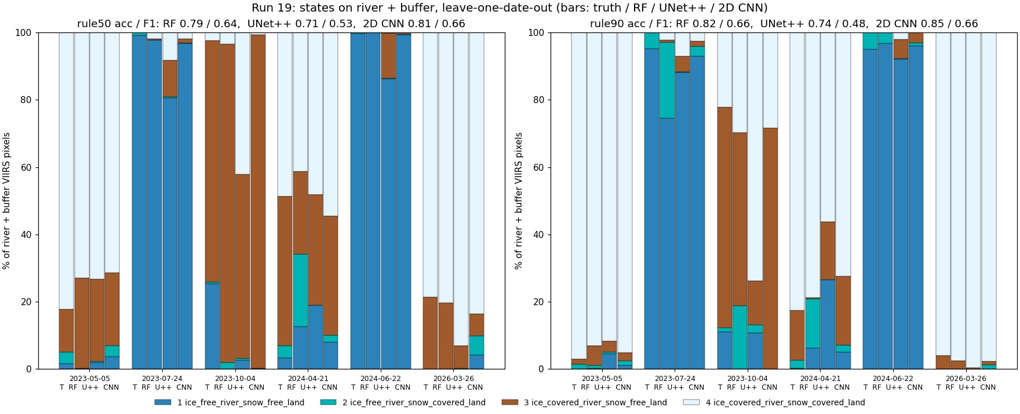
Run 19: states per date, truth and every model.

Prediction images with the water / land split
Each image starts with VIIRS (I3/I2/I1) and Landsat 30 m of the same day side by side, for visual checking. Landsat is shown in bands B6/B5/B4 (SWIR1 / NIR / red), the same bands as VIIRS I3/I2/I1, so colours compare directly: ice and snow are cyan, open water dark blue, vegetation green / red. Landsat exists for all 10 dates (the README of each Patches folder gives its time; VIIRS passed 21-69 min later). Our masks are drawn on both: yellow line = river (occurrence >= 0.05), orange dashed line = outer edge of the 1-pixel buffer (run 19 only). On days without a run 16 map, Landsat is only shown, never used as truth or input. Third panel: the run 16 Landsat 30 m map (six classes) - the label source on the 6 labelled days; on the 4 other days the run 16 model applied to that Landsat scene in run 17, shown for comparison only.
Then one map per model with all four predicted states. Yellow box: water (river) % vs land %, water split into open water / ice, land split into snow / no snow, for the predicted area and for the whole VIIRS image (the % comes from the run 18 % models; for the 2D CNN a % model of the same design). The six labelled days are left-out test days; the four VIIRS-only days are predicted by final models trained on all six labelled days.
date | source | area | water % | open / ice % of water | land % | snow / no snow % of land
2023-05-05 | Landsat truth | river + buffer | 24.5 | 5 / 95 | 75.5 | 77 / 23
2023-05-05 | Landsat truth | whole VIIRS image | 4.0 | 5 / 95 | 96.0 | 73 / 27
2023-05-05 | RF | river + buffer | 23.9 | 12 / 88 | 76.1 | 64 / 36
2023-05-05 | RF | whole VIIRS image | 6.7 | 20 / 80 | 93.3 | 64 / 36
2023-05-05 | UNet++ | river + buffer | 17.2 | 3 / 97 | 82.8 | 66 / 34
2023-05-05 | UNet++ | whole VIIRS image | 3.0 | 6 / 94 | 97.0 | 66 / 34
2023-05-05 | 2D CNN | river + buffer | 22.8 | 4 / 96 | 77.2 | 87 / 13
2023-05-05 | 2D CNN | whole VIIRS image | 3.8 | 5 / 95 | 96.2 | 84 / 16
2023-07-24 | Landsat truth | river + buffer | 24.2 | 100 / 0 | 75.8 | 1 / 99
2023-07-24 | Landsat truth | whole VIIRS image | 3.9 | 100 / 0 | 96.1 | 0 / 100
2023-07-24 | RF | river + buffer | 20.6 | 92 / 8 | 79.4 | 7 / 93
2023-07-24 | RF | whole VIIRS image | 4.4 | 92 / 8 | 95.6 | 6 / 94
2023-07-24 | UNet++ | river + buffer | 20.8 | 89 / 11 | 79.2 | 11 / 89
2023-07-24 | UNet++ | whole VIIRS image | 4.7 | 78 / 22 | 95.3 | 11 / 89
2023-07-24 | 2D CNN | river + buffer | 23.2 | 97 / 3 | 76.8 | 4 / 96
2023-07-24 | 2D CNN | whole VIIRS image | 3.9 | 96 / 4 | 96.1 | 4 / 96
2023-10-04 | Landsat truth | river + buffer | 23.1 | 49 / 51 | 76.9 | 5 / 95
2023-10-04 | Landsat truth | whole VIIRS image | 3.7 | 49 / 51 | 96.3 | 6 / 94
2023-10-04 | RF | river + buffer | 10.6 | 47 / 53 | 89.4 | 18 / 82
2023-10-04 | RF | whole VIIRS image | 1.9 | 48 / 52 | 98.1 | 13 / 87
2023-10-04 | UNet++ | river + buffer | 8.7 | 53 / 47 | 91.3 | 16 / 84
2023-10-04 | UNet++ | whole VIIRS image | 1.5 | 51 / 49 | 98.5 | 11 / 89
2023-10-04 | 2D CNN | river + buffer | 22.6 | 41 / 59 | 77.4 | 7 / 93
2023-10-04 | 2D CNN | whole VIIRS image | 4.0 | 39 / 61 | 96.0 | 10 / 90
2024-04-21 | Landsat truth | river + buffer | 24.1 | 10 / 90 | 75.9 | 49 / 51
2024-04-21 | Landsat truth | whole VIIRS image | 3.9 | 11 / 89 | 96.1 | 36 / 64
2024-04-21 | RF | river + buffer | 21.7 | 20 / 80 | 78.3 | 48 / 52
2024-04-21 | RF | whole VIIRS image | 6.6 | 50 / 50 | 93.4 | 29 / 71
2024-04-21 | UNet++ | river + buffer | 16.6 | 16 / 84 | 83.4 | 49 / 51
2024-04-21 | UNet++ | whole VIIRS image | 3.1 | 20 / 80 | 96.9 | 32 / 68
2024-04-21 | 2D CNN | river + buffer | 26.1 | 19 / 81 | 73.9 | 51 / 49
2024-04-21 | 2D CNN | whole VIIRS image | 8.2 | 37 / 63 | 91.8 | 38 / 62
2024-06-22 | Landsat truth | river + buffer | 24.2 | 100 / 0 | 75.8 | 1 / 99
2024-06-22 | Landsat truth | whole VIIRS image | 3.9 | 100 / 0 | 96.1 | 0 / 100
2024-06-22 | RF | river + buffer | 21.4 | 97 / 3 | 78.6 | 2 / 98
2024-06-22 | RF | whole VIIRS image | 3.7 | 97 / 3 | 96.3 | 1 / 99
2024-06-22 | UNet++ | river + buffer | 18.4 | 97 / 3 | 81.6 | 1 / 99
2024-06-22 | UNet++ | whole VIIRS image | 3.0 | 95 / 5 | 97.0 | 0 / 100
2024-06-22 | 2D CNN | river + buffer | 23.8 | 100 / 0 | 76.2 | 0 / 100
2024-06-22 | 2D CNN | whole VIIRS image | 4.5 | 99 / 1 | 95.5 | 0 / 100
2026-03-26 | Landsat truth | river + buffer | 25.6 | 0 / 100 | 74.4 | 71 / 29
2026-03-26 | Landsat truth | whole VIIRS image | 4.2 | 0 / 100 | 95.8 | 68 / 32
2026-03-26 | RF | river + buffer | 23.1 | 7 / 93 | 76.9 | 74 / 26
2026-03-26 | RF | whole VIIRS image | 5.1 | 8 / 92 | 94.9 | 66 / 34
2026-03-26 | UNet++ | river + buffer | 28.3 | 1 / 99 | 71.7 | 81 / 19
2026-03-26 | UNet++ | whole VIIRS image | 5.0 | 2 / 98 | 95.0 | 78 / 22
2026-03-26 | 2D CNN | river + buffer | 19.7 | 1 / 99 | 80.3 | 80 / 20
2026-03-26 | 2D CNN | whole VIIRS image | 3.3 | 1 / 99 | 96.7 | 76 / 24
2023-04-19 | RF | river + buffer | 23.6 | 1 / 99 | 76.4 | 83 / 17
2023-04-19 | RF | whole VIIRS image | 4.4 | 2 / 98 | 95.6 | 78 / 22
2023-04-19 | UNet++ | river + buffer | 23.8 | 2 / 98 | 76.2 | 79 / 21
2023-04-19 | UNet++ | whole VIIRS image | 4.0 | 3 / 97 | 96.0 | 76 / 24
2023-04-19 | 2D CNN | river + buffer | 24.9 | 1 / 99 | 75.1 | 86 / 14
2023-04-19 | 2D CNN | whole VIIRS image | 4.2 | 4 / 96 | 95.8 | 76 / 24
2024-09-02 | RF | river + buffer | 20.1 | 89 / 11 | 79.9 | 4 / 96
2024-09-02 | RF | whole VIIRS image | 3.5 | 89 / 11 | 96.5 | 3 / 97
2024-09-02 | UNet++ | river + buffer | 20.9 | 96 / 4 | 79.1 | 2 / 98
2024-09-02 | UNet++ | whole VIIRS image | 3.8 | 90 / 10 | 96.2 | 1 / 99
2024-09-02 | 2D CNN | river + buffer | 24.7 | 95 / 5 | 75.3 | 2 / 98
2024-09-02 | 2D CNN | whole VIIRS image | 4.4 | 91 / 9 | 95.6 | 2 / 98
2025-07-04 | RF | river + buffer | 23.6 | 97 / 3 | 76.4 | 7 / 93
2025-07-04 | RF | whole VIIRS image | 6.4 | 98 / 2 | 93.6 | 5 / 95
2025-07-04 | UNet++ | river + buffer | 24.3 | 99 / 1 | 75.7 | 3 / 97
2025-07-04 | UNet++ | whole VIIRS image | 4.6 | 90 / 10 | 95.4 | 3 / 97
2025-07-04 | 2D CNN | river + buffer | 29.6 | 91 / 9 | 70.4 | 16 / 84
2025-07-04 | 2D CNN | whole VIIRS image | 6.5 | 81 / 19 | 93.5 | 22 / 78
2026-08-01 | RF | river + buffer | 21.0 | 96 / 4 | 79.0 | 3 / 97
2026-08-01 | RF | whole VIIRS image | 3.6 | 96 / 4 | 96.4 | 2 / 98
2026-08-01 | UNet++ | river + buffer | 24.0 | 98 / 2 | 76.0 | 2 / 98
2026-08-01 | UNet++ | whole VIIRS image | 4.4 | 92 / 8 | 95.6 | 1 / 99
2026-08-01 | 2D CNN | river + buffer | 22.0 | 100 / 0 | 78.0 | 0 / 100
2026-08-01 | 2D CNN | whole VIIRS image | 3.5 | 100 / 0 | 96.5 | 0 / 100

States, % of predicted pixels (1 / 2 / 3 / 4), rule50
date | source | 1 | 2 | 3 | 4
2023-05-05 | Landsat truth | 1.6 | 3.5 | 12.7 | 82.2
2023-05-05 | RF | 0.3 | 0.0 | 26.9 | 72.9
2023-05-05 | UNet++ | 2.0 | 0.3 | 24.5 | 73.2
2023-05-05 | 2D CNN | 3.7 | 3.2 | 21.8 | 71.4
2023-07-24 | Landsat truth | 99.1 | 0.9 | 0.0 | 0.0
2023-07-24 | RF | 97.7 | 0.0 | 0.4 | 2.0
2023-07-24 | UNet++ | 80.5 | 0.3 | 10.9 | 8.2
2023-07-24 | 2D CNN | 96.6 | 0.2 | 1.3 | 1.9
2023-10-04 | Landsat truth | 25.3 | 0.6 | 71.6 | 2.5
2023-10-04 | RF | 0.0 | 2.0 | 94.6 | 3.4
2023-10-04 | UNet++ | 2.6 | 0.6 | 54.7 | 42.1
2023-10-04 | 2D CNN | 0.3 | 0.0 | 99.1 | 0.7
2024-04-21 | Landsat truth | 3.3 | 3.7 | 44.4 | 48.6
2024-04-21 | RF | 12.6 | 21.4 | 24.6 | 41.3
2024-04-21 | UNet++ | 18.9 | 0.1 | 32.8 | 48.1
2024-04-21 | 2D CNN | 8.1 | 2.0 | 35.4 | 54.5
2024-06-22 | Landsat truth | 99.7 | 0.3 | 0.0 | 0.0
2024-06-22 | RF | 99.9 | 0.1 | 0.0 | 0.0
2024-06-22 | UNet++ | 86.2 | 0.2 | 13.4 | 0.2
2024-06-22 | 2D CNN | 99.3 | 0.1 | 0.6 | 0.0
2026-03-26 | Landsat truth | 0.0 | 0.0 | 21.5 | 78.5
2026-03-26 | RF | 0.0 | 0.0 | 19.8 | 80.2
2026-03-26 | UNet++ | 0.0 | 0.2 | 6.8 | 93.0
2026-03-26 | 2D CNN | 4.1 | 5.8 | 6.4 | 83.6
2023-04-19 | RF | 0.0 | 0.0 | 10.4 | 89.6
2023-04-19 | UNet++ | 0.1 | 0.1 | 14.6 | 85.2
2023-04-19 | 2D CNN | 1.3 | 1.4 | 12.2 | 85.1
2024-09-02 | RF | 47.9 | 0.0 | 52.1 | 0.0
2024-09-02 | UNet++ | 49.3 | 0.0 | 50.5 | 0.2
2024-09-02 | 2D CNN | 39.1 | 0.0 | 60.7 | 0.2
2025-07-04 | RF | 100.0 | 0.0 | 0.0 | 0.0
2025-07-04 | UNet++ | 100.0 | 0.0 | 0.0 | 0.0
2025-07-04 | 2D CNN | 99.8 | 0.2 | 0.1 | 0.0
2026-08-01 | RF | 99.9 | 0.0 | 0.1 | 0.0
2026-08-01 | UNet++ | 85.7 | 0.1 | 11.2 | 3.1
2026-08-01 | 2D CNN | 98.5 | 0.1 | 1.4 | 0.0

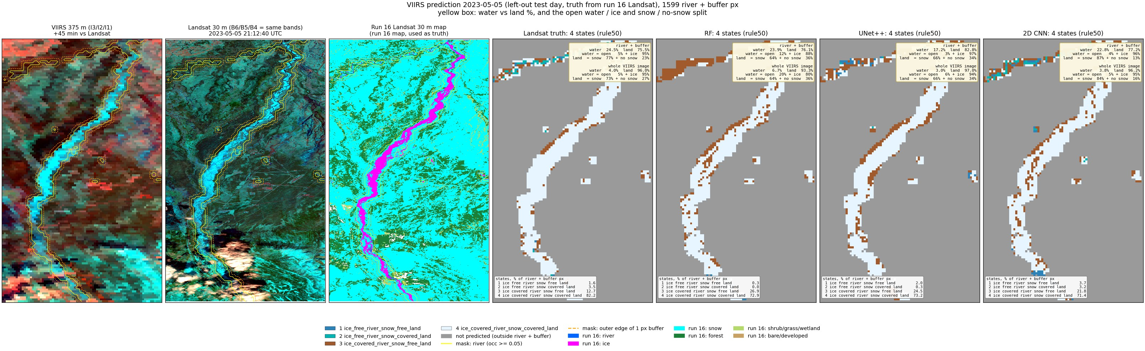
Run 19, 2023-05-05 (spring break-up, left-out test day): predicted states (rule50) and the water / land split.
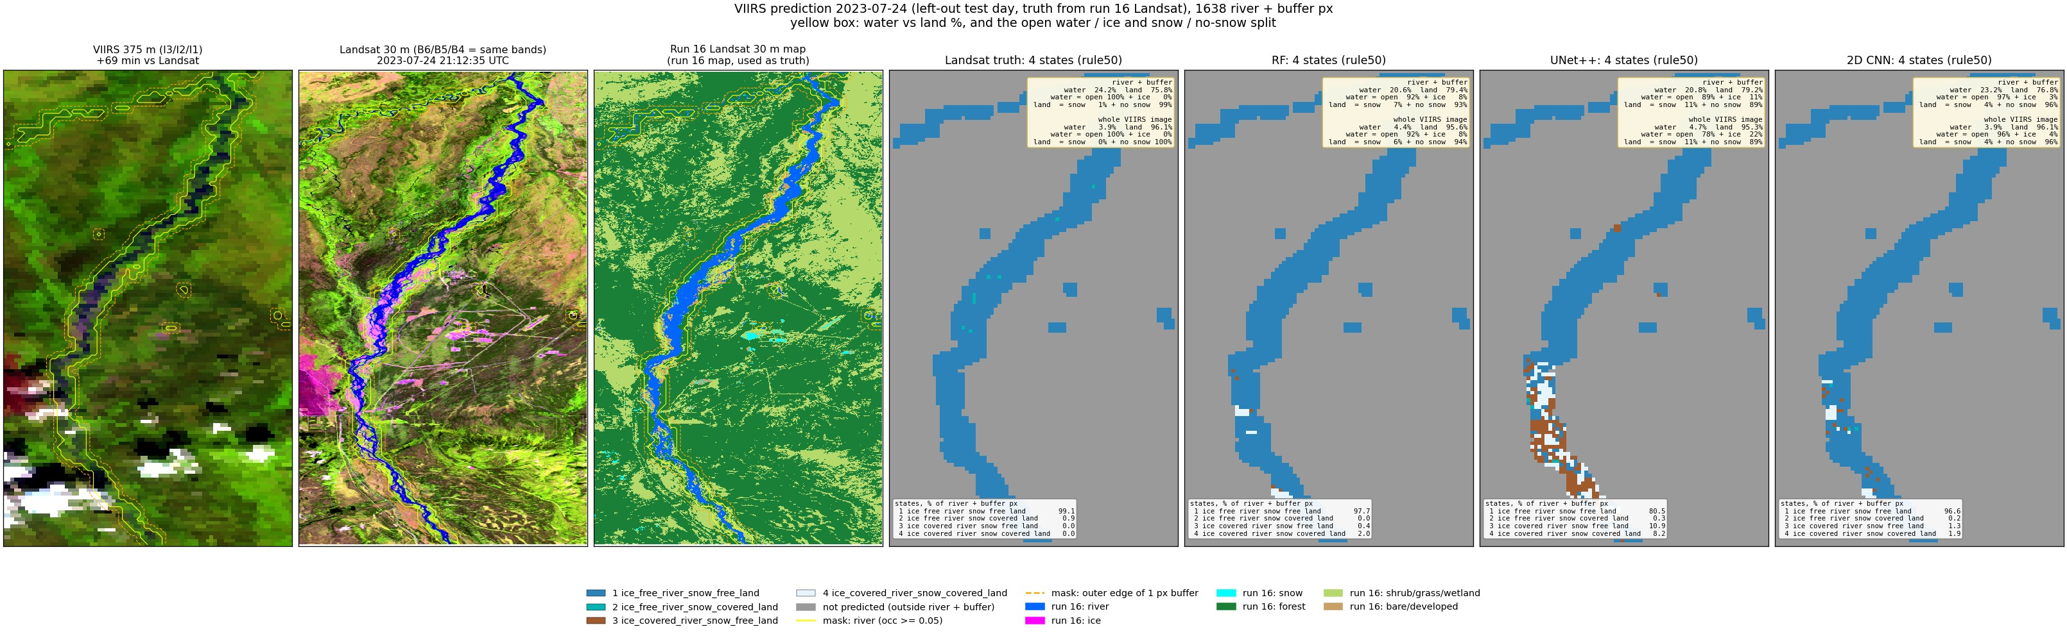
Run 19, 2023-07-24 (summer, left-out test day): predicted states (rule50) and the water / land split.
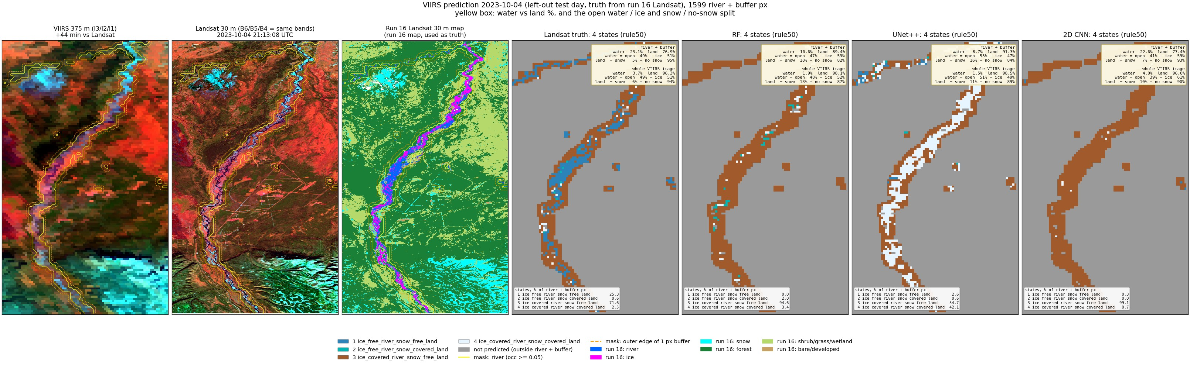
Run 19, 2023-10-04 (autumn freeze-up, left-out test day): predicted states (rule50) and the water / land split.
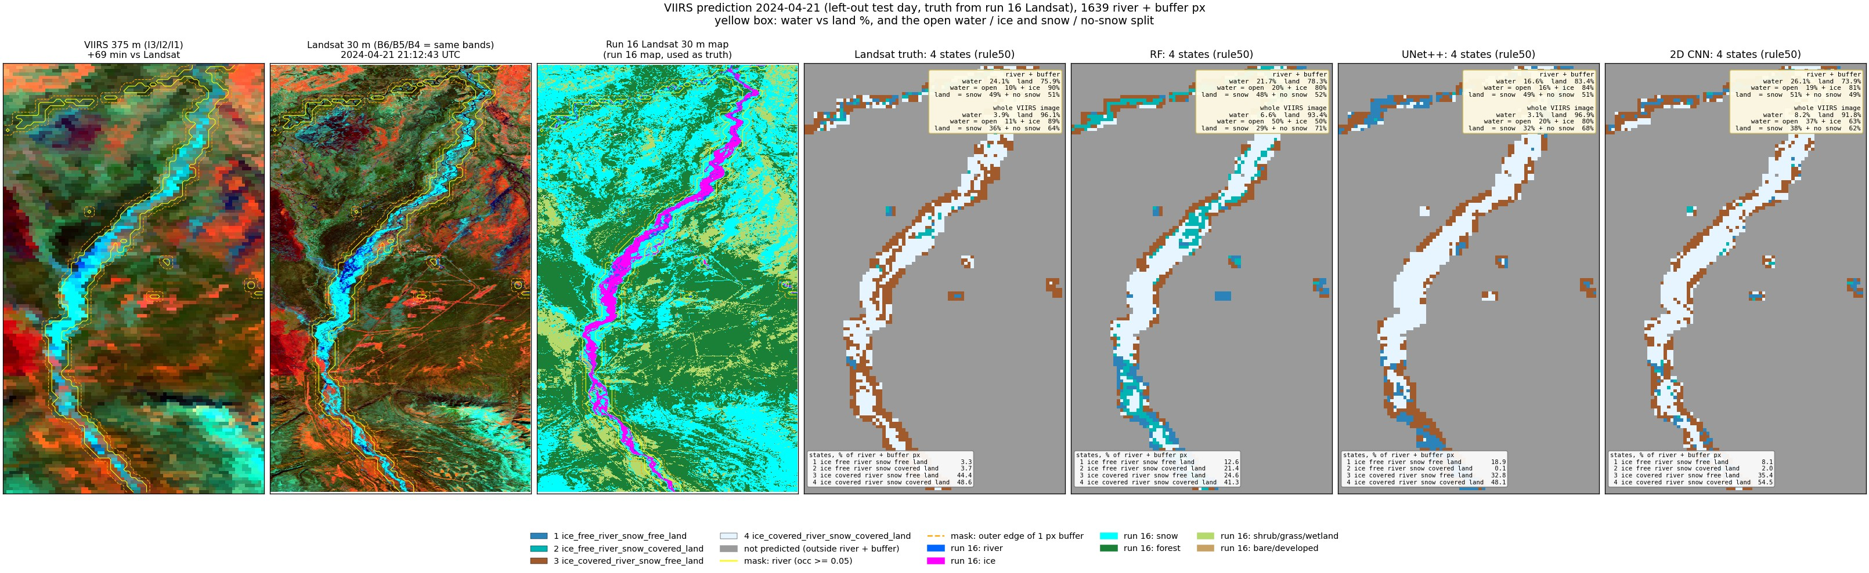
Run 19, 2024-04-21 (spring break-up, left-out test day): predicted states (rule50) and the water / land split.
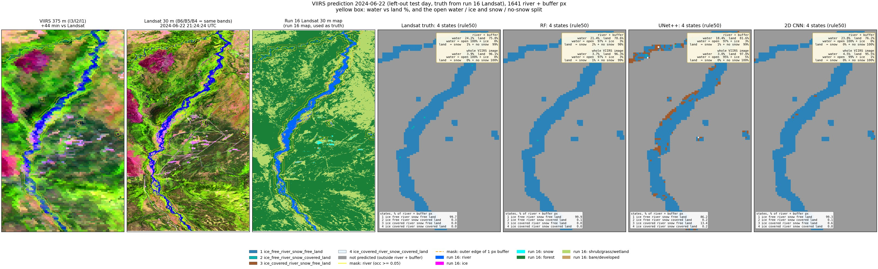
Run 19, 2024-06-22 (summer, left-out test day): predicted states (rule50) and the water / land split.
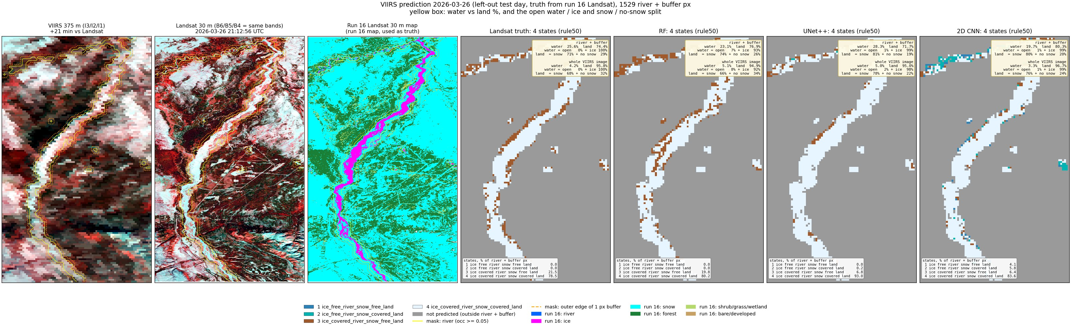
Run 19, 2026-03-26 (late winter, left-out test day): predicted states (rule50) and the water / land split.
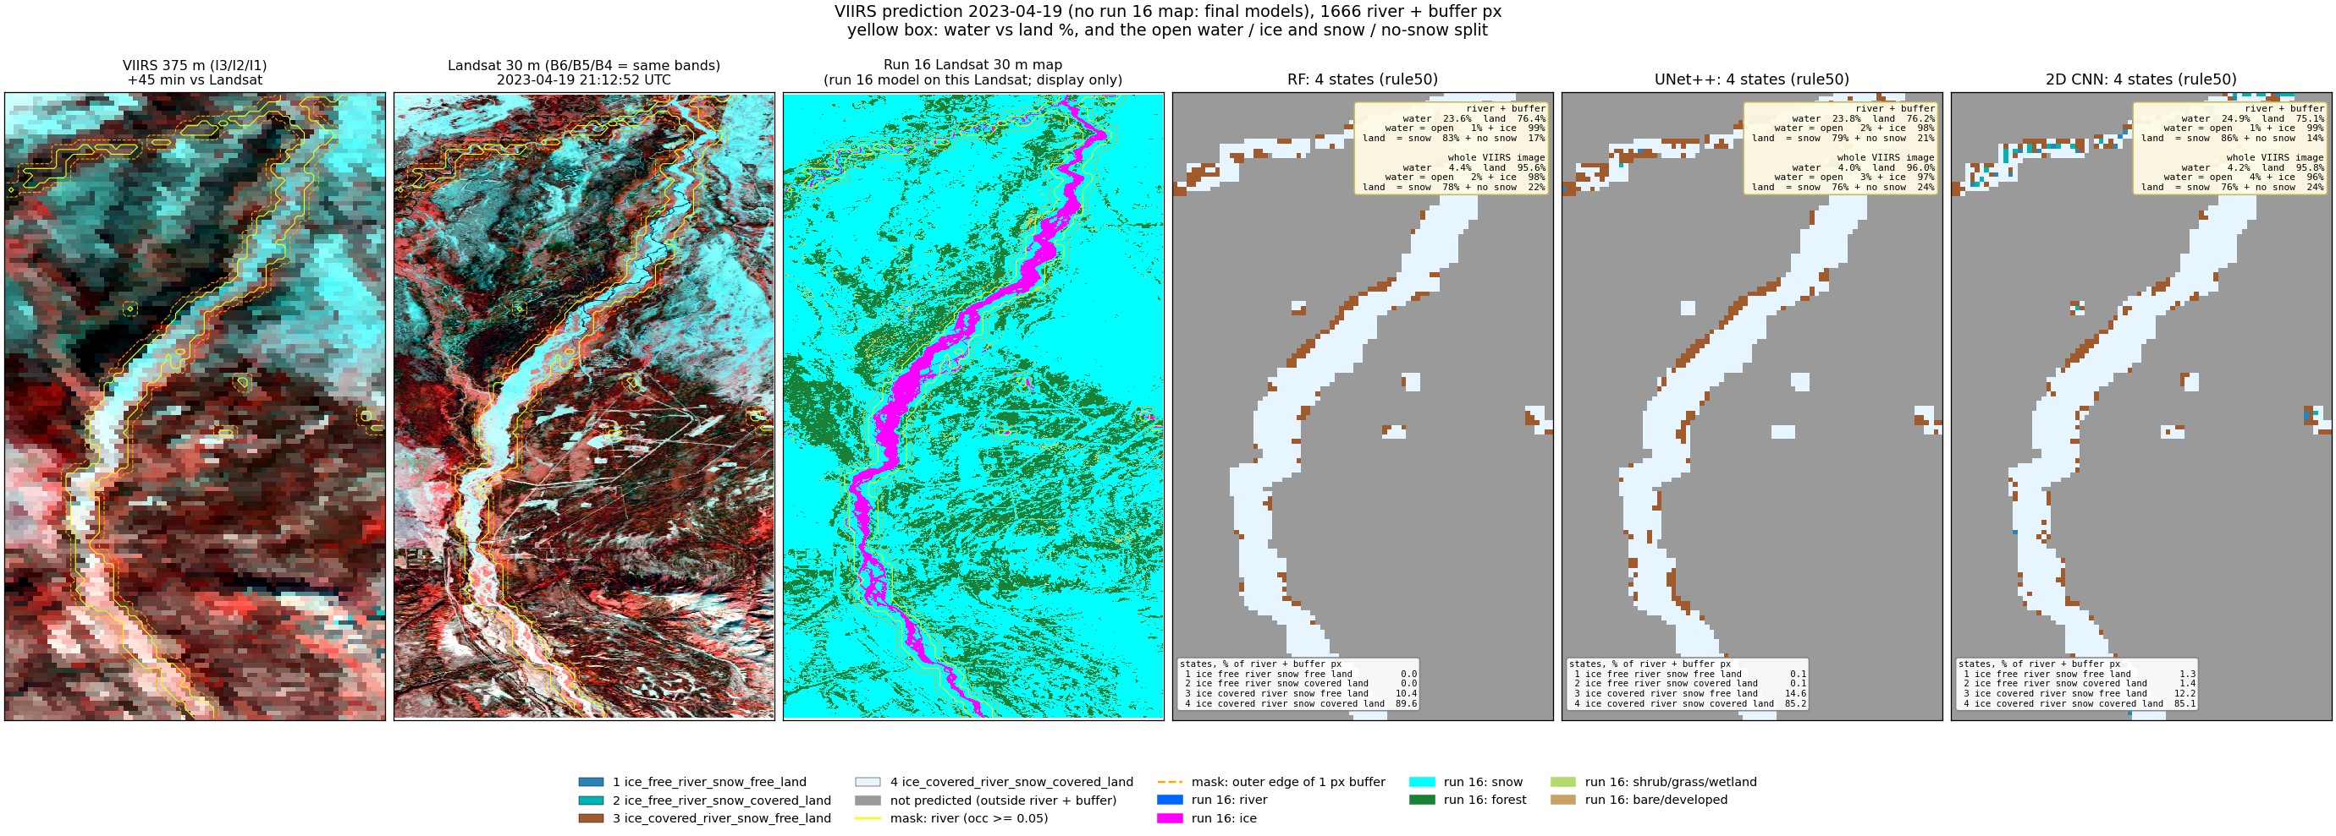
Run 19, 2023-04-19 (spring, snow, VIIRS only, final models): predicted states (rule50) and the water / land split.
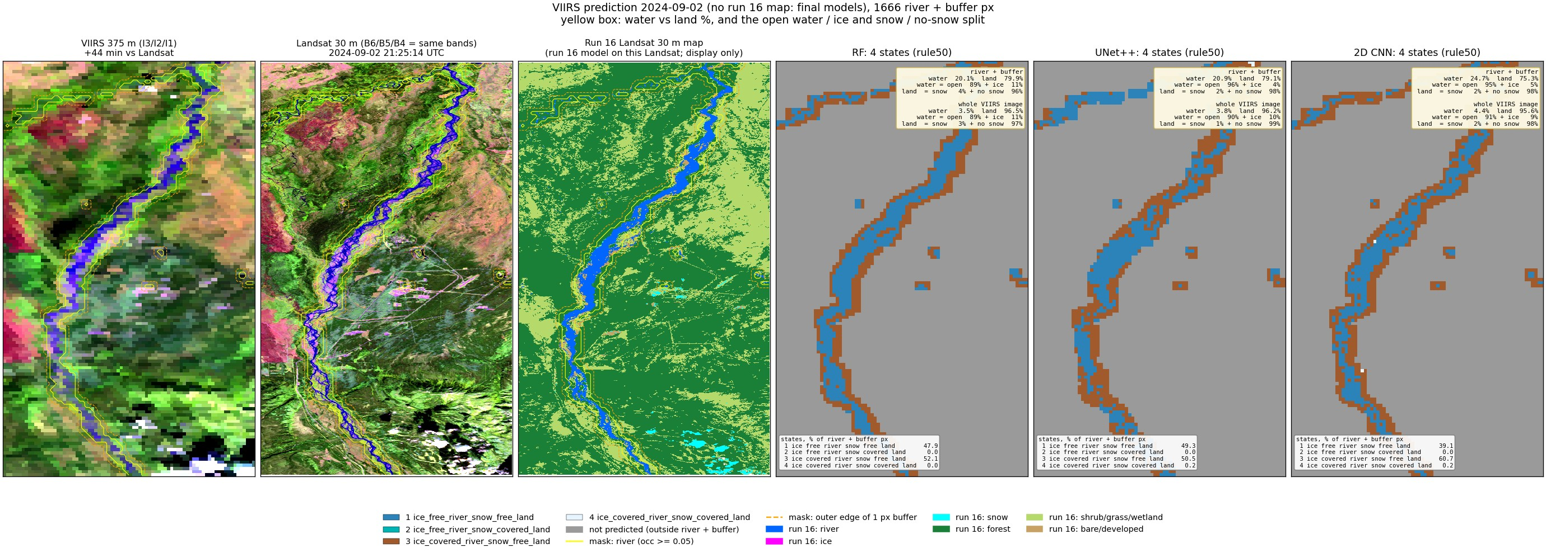
Run 19, 2024-09-02 (late summer, VIIRS only, final models): predicted states (rule50) and the water / land split.
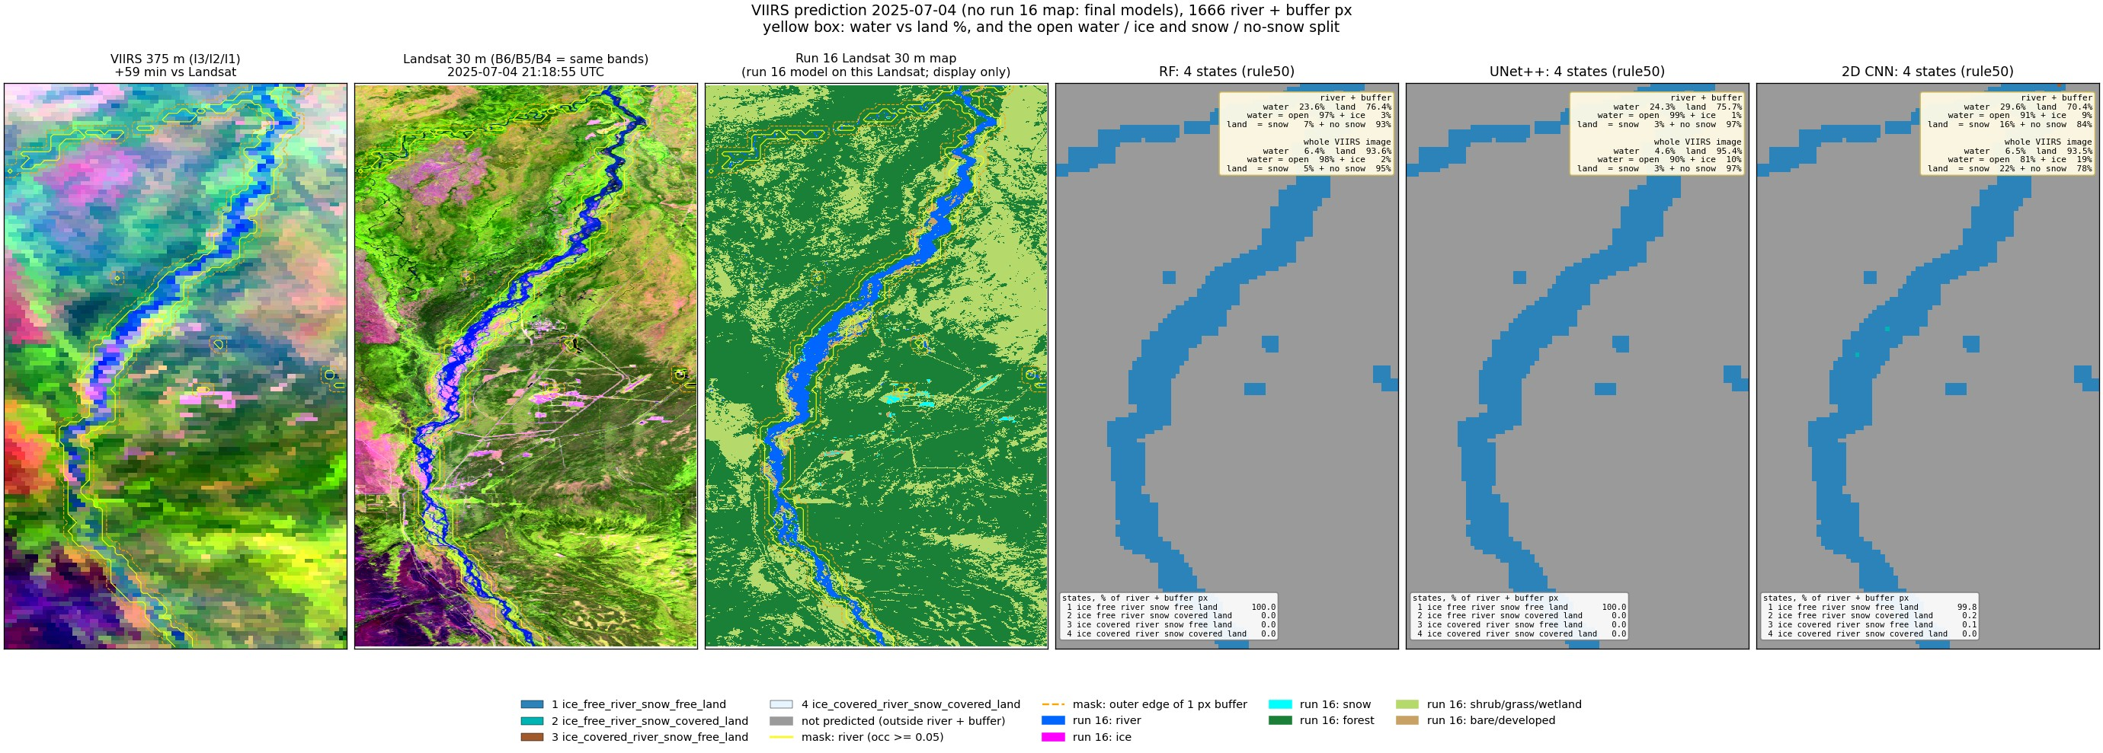
Run 19, 2025-07-04 (summer, VIIRS only, final models): predicted states (rule50) and the water / land split.
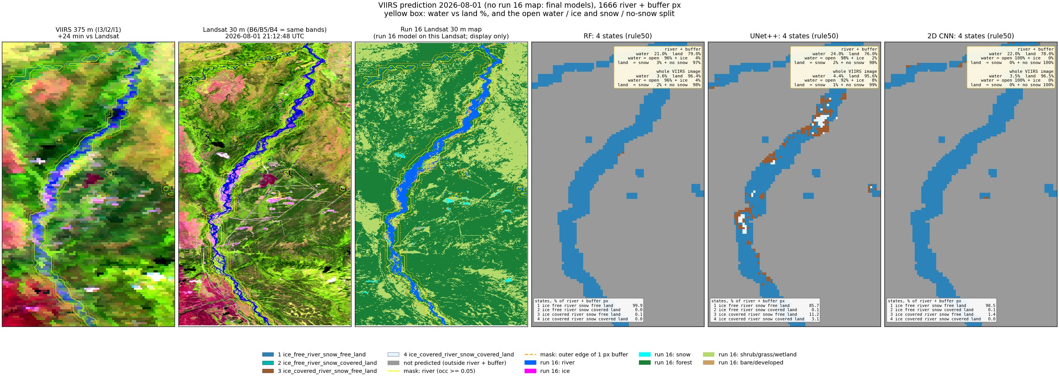
Run 19, 2026-08-01 (summer, VIIRS only, final models): predicted states (rule50) and the water / land split.

4. Things to know
- Labels are the run 16 Landsat maps, not hand labels: any run 16 error (gravel as river, cloud as snow/ice) becomes a VIIRS label.
- Only 6 labelled days; each model sees 5 per fold. Ice and break-up states come from 3 days.
- State 2 (open river, snow land) has a few hundred pixels in total; its F1 is not reliable.
- The JRC occurrence behind the water mask ends in 2021; moved channels fall outside the mask.
- VIIRS view angle and clouds vary daily; no cloud mask is applied, so cloudy days give wrong states.
- The 30 m to 375 m shift (run 17) is small (<= ~60 m) and applied before the shares are computed.

5. Files
what | where (~/Desktop/nenana_crops/daksh/)
run 17 unmixing | rf_viirs_unmix.py -> output/17_viirs_unmix/ (results.json, summary.txt, <date>/weights_psf.tif, viirs_fit.tif, viirs_residual.tif)
run 18 whole image | viirs_states.py -> output/18_viirs_states/ (truth|rf|unetpp/pct_<date>.tif, <rule>/class_<date>.tif, images/)
run 18 images | make_run18_images.py -> output/18_viirs_states/images/
run 19 river + buffer | RIVER_BUFFER=1 viirs_river_states.py -> output/19_viirs_river_states/ (mask/, truth|rf|unetpp|cnn2d/<rule>/class_<date>.tif, images/)
run 20 river only | RIVER_BUFFER=0 viirs_river_states.py -> output/20_viirs_river_only/
prediction images | RIVER_BUFFER=1|0 viirs_river_predict.py -> <run>/predict/ (images/pred_<date>.jpg, pred_<date>_rule90.jpg, totals.json, VIIRS-only maps)
water mask | ~/Desktop/nenana_crops/alaska_occ_375m.tif; cropped copies in <run>/mask/
this report | report/word_content_viirs.py + report/build_word.js; deck presentation/build_deck_viirs.js

Every .tif is on the VIIRS grid (EPSG:4326) and opens in QGIS; class maps carry a .qml style (1-4 colours, 0 = not predicted).

