Nenana river ice from VIIRS: run 21, run 16 on VIIRS upsampled to 30 m
Run 16 repeated with one change: the image is VIIRS 375 m upsampled to the Landsat 30 m grid instead of Landsat. Same six classes, same water-mask rule, same hand labels and rule labels, same Random Forest settings, same 5-fold spatial cross-validation.

Contents

1. Summary
model / labels | pixels | accuracy | balanced acc | Cohen κ | macro F1
RF (VIIRS), rule labels | 72,989 | 0.962 | 0.769 | 0.943 | 0.761
RF (VIIRS), original labels | 82,721 | 0.845 | 0.612 | 0.771 | 0.601
UNet++ (VIIRS), rule labels | 72,989 | 0.828 | 0.660 | 0.754 | 0.620
UNet++ (VIIRS), original labels | 82,721 | 0.728 | 0.502 | 0.613 | 0.503
Run 16 RF (Landsat), rule labels, same dates | 73,078 | 0.985 | 0.962 | 0.977 | 0.904
Run 16 RF (Landsat), original labels, same dates | 82,812 | 0.864 | 0.708 | 0.800 | 0.675

- RF on VIIRS at 30 m: 0.962 accuracy, macro F1 0.761 on the rule labels (run 16 on Landsat, same dates: 0.985 / 0.904).
- River (0.98), forest (0.98), shrub (0.97) and bare (0.94) stay high: river is fixed by the water mask, the land classes come mostly from NLCD (the land forest's top inputs are NLCD layers).
- Ice drops to F1 0.65 and snow fails (F1 0.04): snow patches and the ice / open water mix are smaller than a 375 m VIIRS pixel, so the upsampled signal cannot place them at 30 m.
- Summer days are near perfect; freeze-up (2023-10-04) and break-up (2024-04-21) drop to about 0.72-0.74.

2. What is the same as run 16 and what changed
 | run 16 | run 21
image | Landsat 30 m surface reflectance + thermal | VIIRS I1-I5, 375 m, bilinear-upsampled to 30 m, moved by the run 17 shift
classes | river, ice, snow, forest, shrub_grass_wetland, bare_developed | same
water mask rule | JRC occurrence >= 5 %: river / ice only; land: snow / forest / shrub / bare | same (same 30 m mask)
labels | hand labels moved onto the rule (rule labels) | same, on the dates that have VIIRS
model | ZoneModel: one RF per zone, top 25 inputs, depth 16, leaf 20, sqrt, 300 trees, balanced_subsample | same code
evaluation | 5-fold spatial CV (row blocks), rule and original labels | same code
dates | 7 labelled dates + 2 new | 4 labelled (2023-07-24, 2023-10-04, 2024-04-21, 2024-06-22); maps for all 10 VIIRS dates
inputs | 66 (bands, pairs, indices, textures, angles, NLCD) | 46 from the VIIRS bands (below)

2.1 Inputs
The run 16 pool rebuilt on the VIIRS bands: red = I1, nir = I2, swir1 = I3, plus I4 and thermal = I5; all nd_ / diff_ pairs of red, nir, swir1; SAVI, MSAVI, nir + swir1, I4 - I5; NDVI, NDSI (I1 - I3), nir and red texture means / standard deviations in 3 x 3 and 7 x 7 windows (30 m pixels); terrain illumination (slope, northness, eastness, cos incidence, shadow) with the VIIRS sun angle; NLCD 2016 as 10 groups. VIIRS has no blue or green I-band, so EVI, BSI, NDWI, AWEI and the tasselled cap of run 16 do not exist here. As in run 16 the per-date sun constants are left out.
water RF, top 25 inputs (final model): thermal, I4, red_mean7, cos_incidence, NDSI_mean7, red_mean3, red, NDVI_mean3, nd_red_swir1, NDSI_mean3, diff_red_swir1, NDVI_mean7, SAVI, nd_nir_swir1, nd_red_nir, I4_minus_I5, MSAVI, nir, NDVI_std7, NDVI_std3, swir1, nir_plus_swir1, nir_mean7, nir_mean3, diff_nir_swir1.
land RF, top 25 inputs (final model): nlcd_barren, nlcd_woody_wetland, nlcd_deciduous_forest, nlcd_evergreen_forest, red_mean7, red_mean3, thermal, I4, red, NDSI_mean7, nlcd_shrub, NDSI_mean3, nd_red_swir1, I4_minus_I5, MSAVI, swir1, SAVI, NDVI_mean3, slope_deg, nir_std7, diff_red_swir1, diff_red_nir, NDVI_std7, cos_incidence, NDVI_std3.

2.2 Dates and labels
date | season | labelled px | rule-label px
2023-07-24 | summer | 31,028 | 25,502
2023-10-04 | autumn freeze-up | 7,833 | 7,250
2024-04-21 | spring break-up | 3,048 | 2,297
2024-06-22 | summer | 40,812 | 37,940

Run 16 dates without VIIRS (2024-03-12, 2024-04-20, 2024-04-29) are left out, so run 16's external test (2024-03-12) has no run 21 counterpart. Maps are made for all 10 VIIRS dates with the final model.

3. Results (5-fold spatial cross-validation)

RF
RF, rule labels: class | true px | pred px | precision | recall | F1
river | 32,274 | 32,169 | 0.981 | 0.978 | 0.979
ice | 1,876 | 1,981 | 0.635 | 0.671 | 0.652
snow | 189 | 842 | 0.027 | 0.122 | 0.045
forest | 22,043 | 21,836 | 0.987 | 0.978 | 0.983
shrub_grass_wetland | 15,499 | 15,123 | 0.978 | 0.954 | 0.966
bare_developed | 1,108 | 1,038 | 0.971 | 0.910 | 0.939

RF, original labels: class | true px | pred px | precision | recall | F1
river | 40,012 | 33,913 | 0.930 | 0.789 | 0.854
ice | 1,728 | 2,005 | 0.471 | 0.547 | 0.506
snow | 563 | 1,283 | 0.018 | 0.041 | 0.025
forest | 22,113 | 25,899 | 0.833 | 0.975 | 0.898
shrub_grass_wetland | 15,582 | 17,662 | 0.838 | 0.949 | 0.890
bare_developed | 2,723 | 1,959 | 0.515 | 0.370 | 0.431

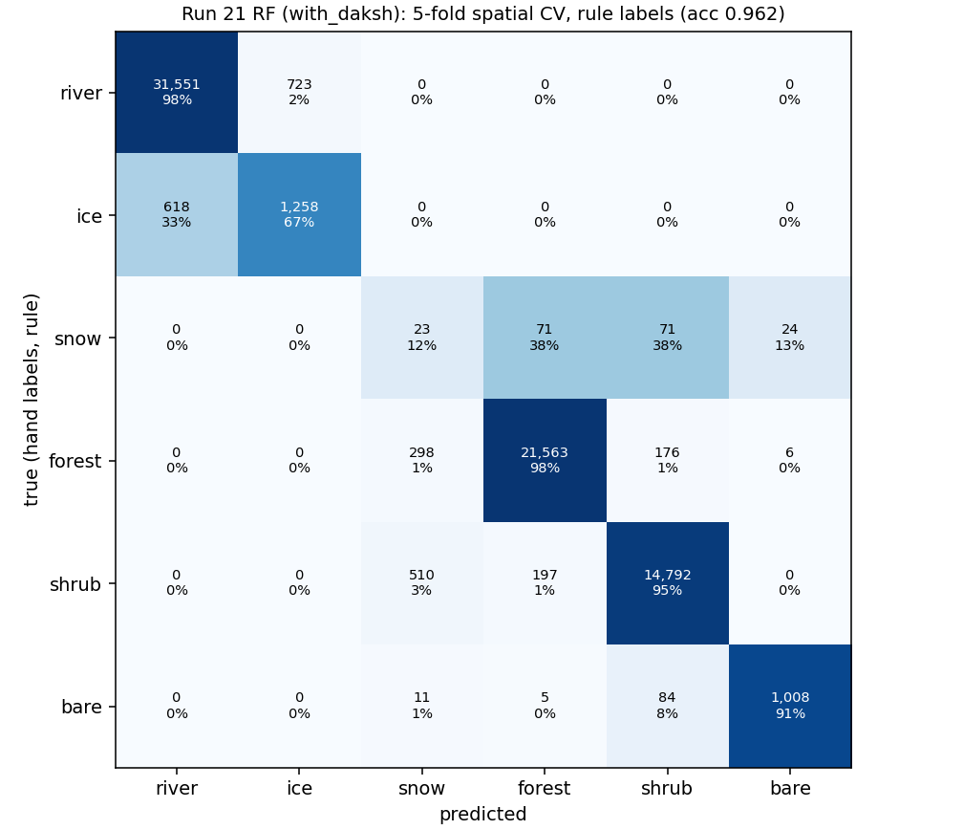
Run 21 RF: confusion matrix, rule labels (counts and % of each true class).

UNet++
UNet++, rule labels: class | true px | pred px | precision | recall | F1
river | 32,274 | 33,257 | 0.965 | 0.995 | 0.980
ice | 1,876 | 893 | 0.811 | 0.386 | 0.523
snow | 189 | 7,863 | 0.005 | 0.196 | 0.009
forest | 22,043 | 13,109 | 0.957 | 0.569 | 0.714
shrub_grass_wetland | 15,499 | 15,564 | 0.901 | 0.905 | 0.903
bare_developed | 1,108 | 2,303 | 0.438 | 0.910 | 0.591

UNet++, original labels: class | true px | pred px | precision | recall | F1
river | 40,012 | 35,004 | 0.917 | 0.802 | 0.856
ice | 1,728 | 914 | 0.577 | 0.305 | 0.399
snow | 563 | 8,188 | 0.005 | 0.066 | 0.008
forest | 22,113 | 15,063 | 0.833 | 0.568 | 0.675
shrub_grass_wetland | 15,582 | 18,000 | 0.779 | 0.900 | 0.835
bare_developed | 2,723 | 5,552 | 0.182 | 0.370 | 0.244

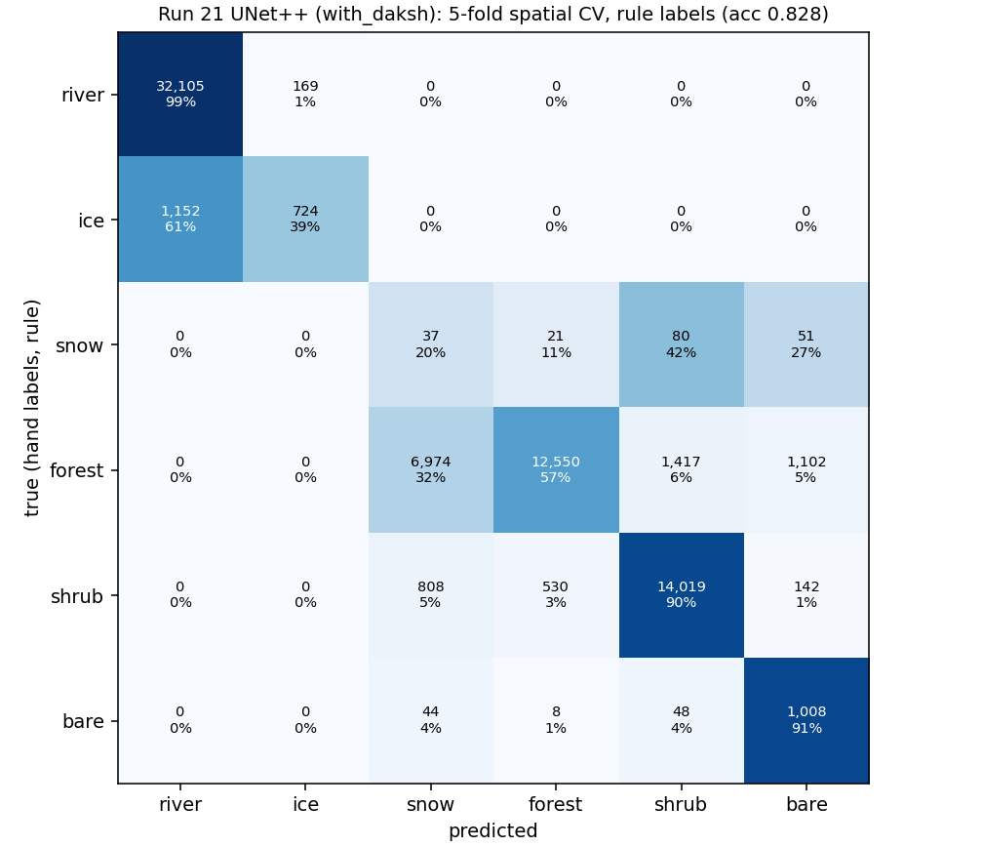
Run 21 UNet++: confusion matrix, rule labels (counts and % of each true class).

Run 16 (Landsat) on the same dates, for comparison
run 16 class (rule labels) | true px | precision | recall | F1
river | 32,251 | 0.995 | 0.993 | 0.994
ice | 1,881 | 0.891 | 0.919 | 0.905
snow | 189 | 0.416 | 0.915 | 0.572
forest | 22,103 | 0.988 | 0.983 | 0.986
shrub_grass_wetland | 15,544 | 0.984 | 0.977 | 0.981
bare_developed | 1,110 | 0.993 | 0.986 | 0.989

Per date (rule labels)
date | season | px | RF acc / F1 | UNet++ acc / F1
2023-07-24 | summer | 25,502 | 1.000 / 0.86 | 1.000 / 0.52
2023-10-04 | autumn freeze-up | 7,250 | 0.738 / 0.52 | 0.696 / 0.53
2024-04-21 | spring break-up | 2,297 | 0.715 / 0.47 | 0.623 / 0.34
2024-06-22 | summer | 37,940 | 0.994 / 1.00 | 0.750 / 0.82

4. Maps
Each image, left to right: VIIRS upsampled to 30 m; Landsat of the same day (B6/B5/B4, the bands of VIIRS I3/I2/I1); the ground truth = hand labels painted on the dimmed Landsat image; the run 16 (Landsat) map; the run 21 map from VIIRS. Yellow line = 30 m water mask (river / ice only inside). The per-date accuracy is the cross-validated accuracy on that day's hand labels; the maps themselves come from the final model trained on all labelled pixels.
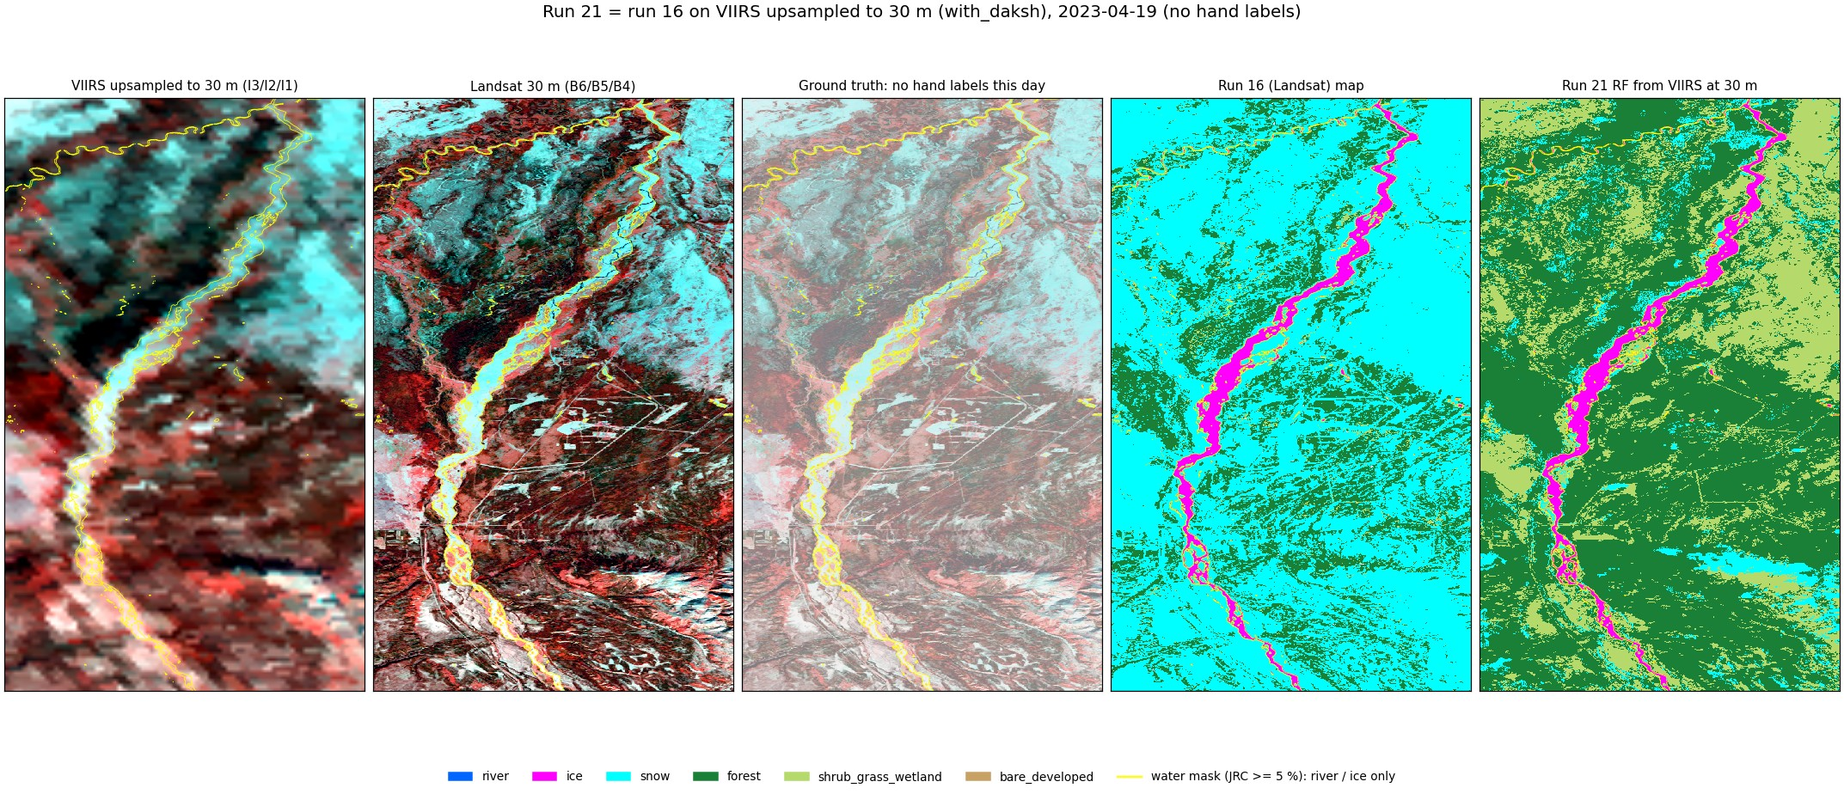
Run 21 RF, 2023-04-19 (spring, snow, no hand labels).
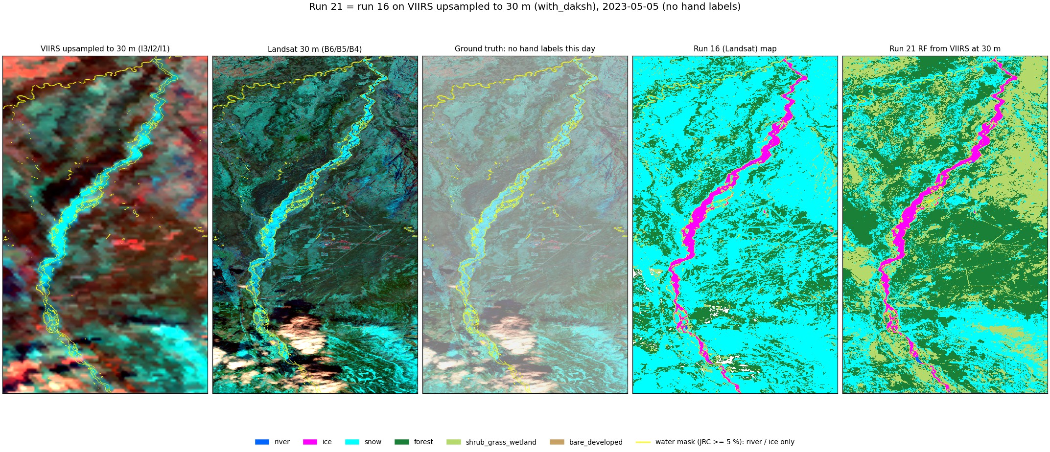
Run 21 RF, 2023-05-05 (spring break-up, no hand labels).
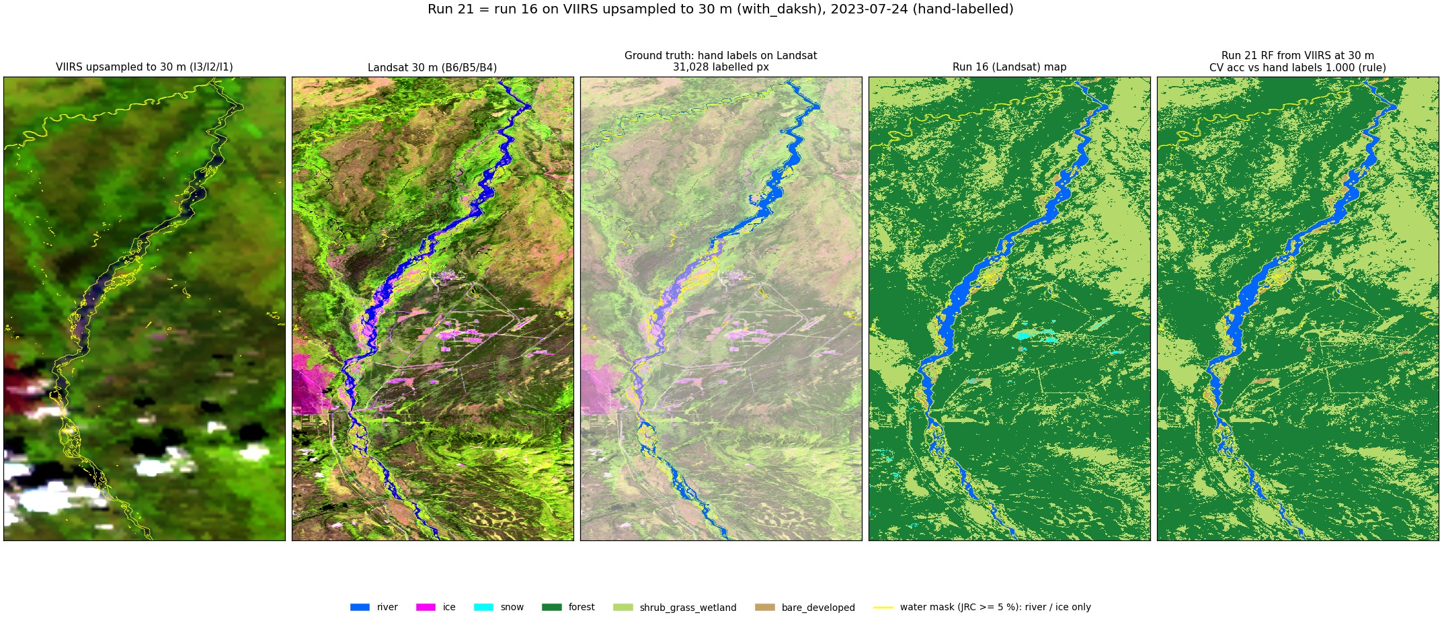
Run 21 RF, 2023-07-24 (summer, hand-labelled).
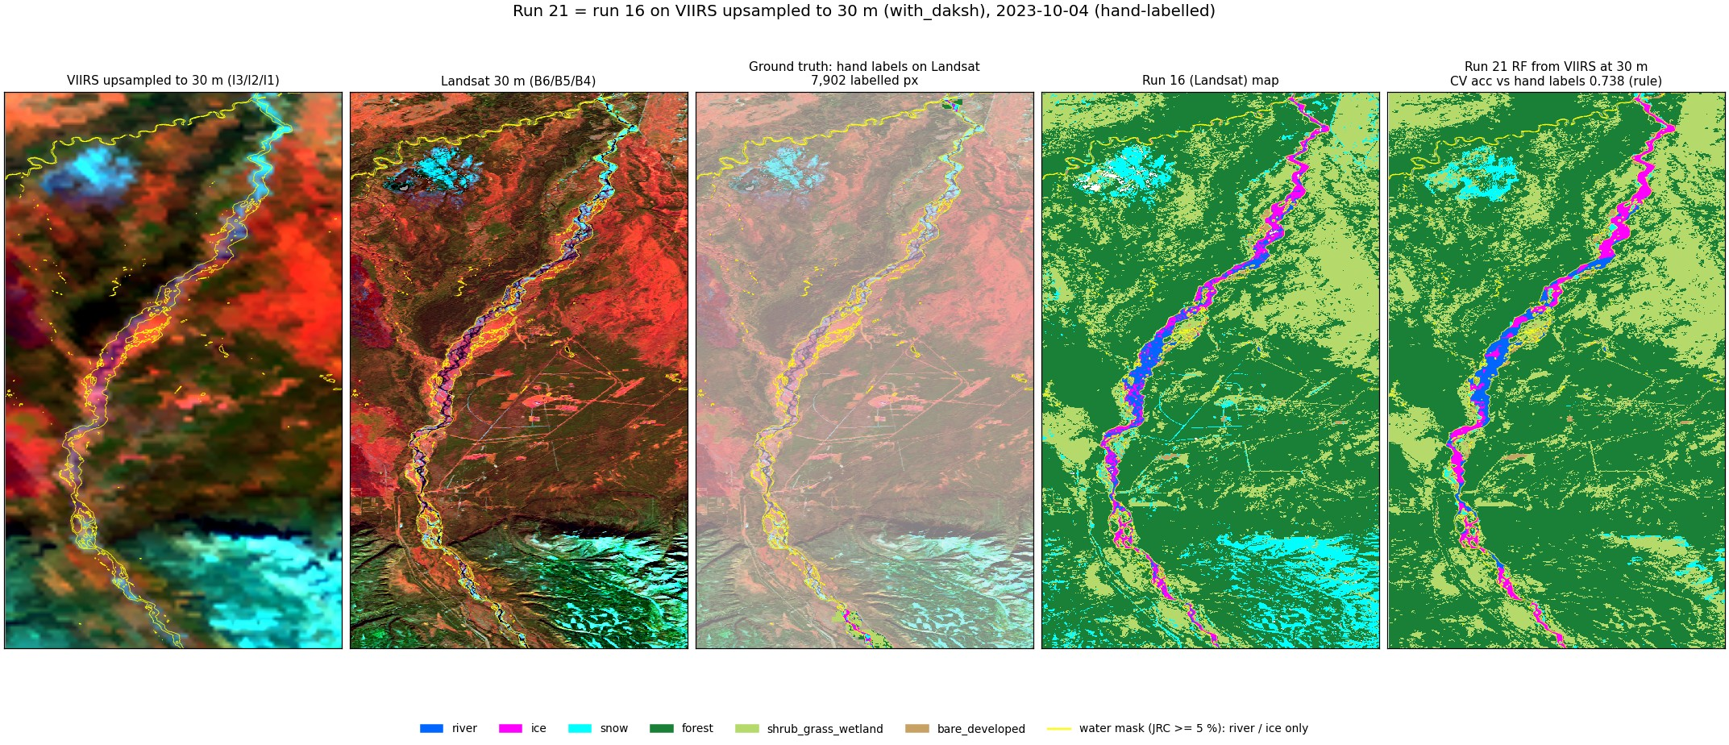
Run 21 RF, 2023-10-04 (autumn freeze-up, hand-labelled).
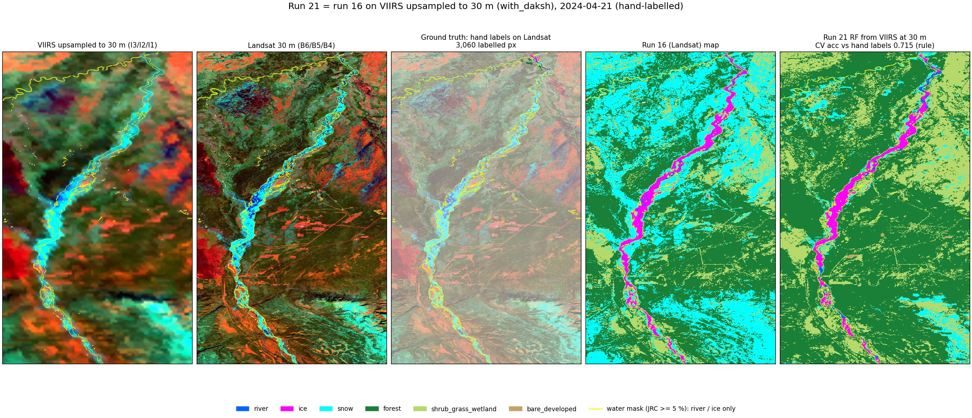
Run 21 RF, 2024-04-21 (spring break-up, hand-labelled).
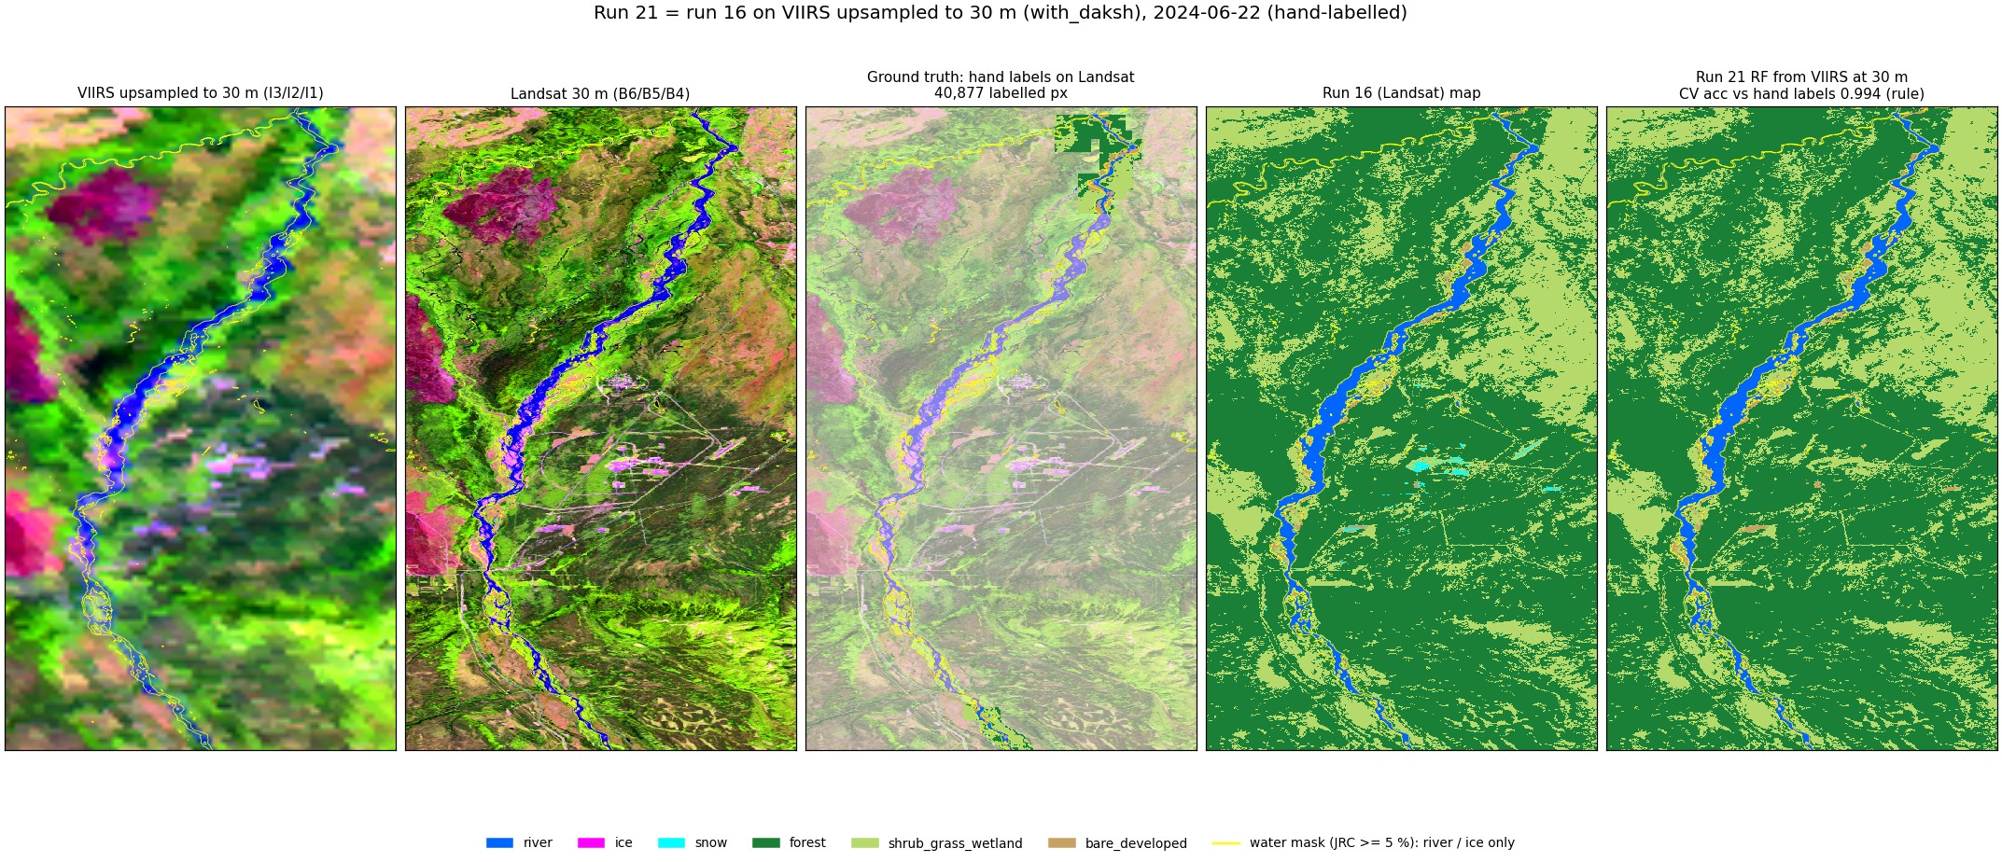
Run 21 RF, 2024-06-22 (summer, hand-labelled).
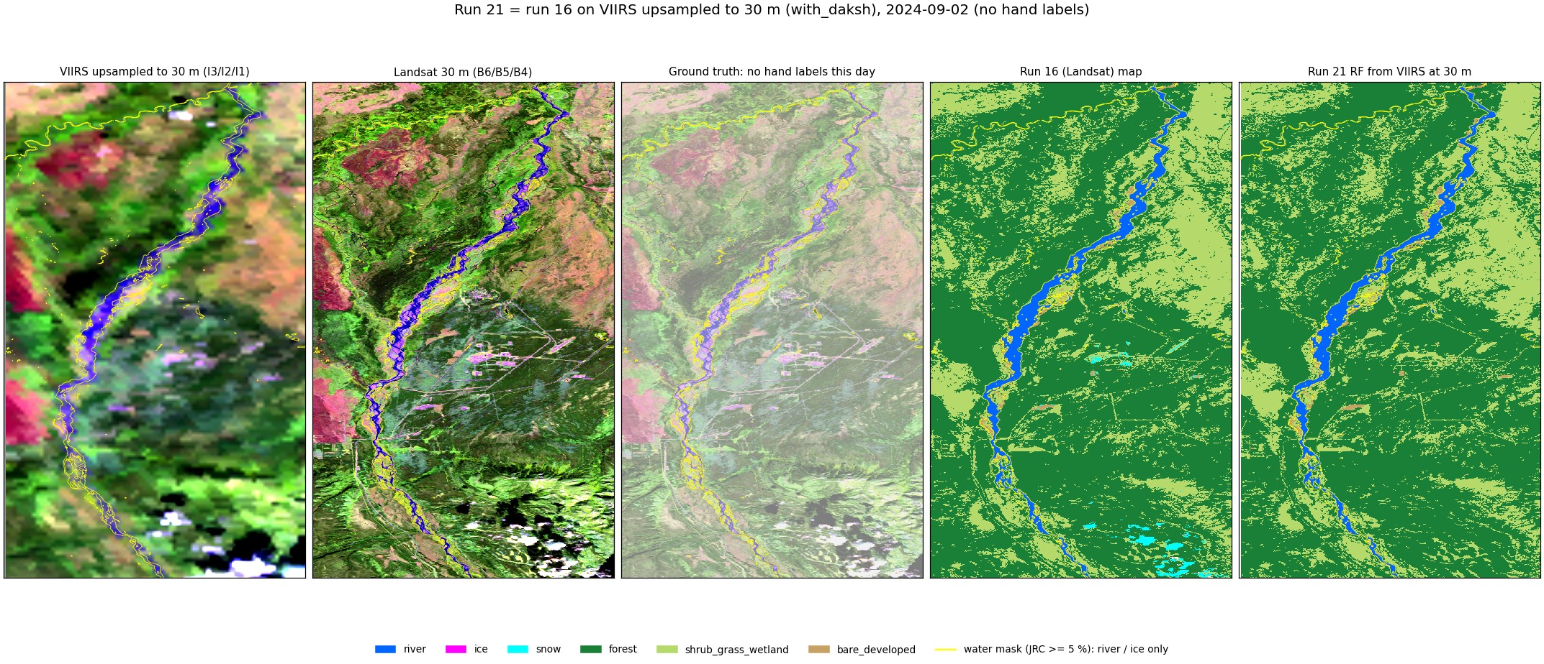
Run 21 RF, 2024-09-02 (late summer, no hand labels).
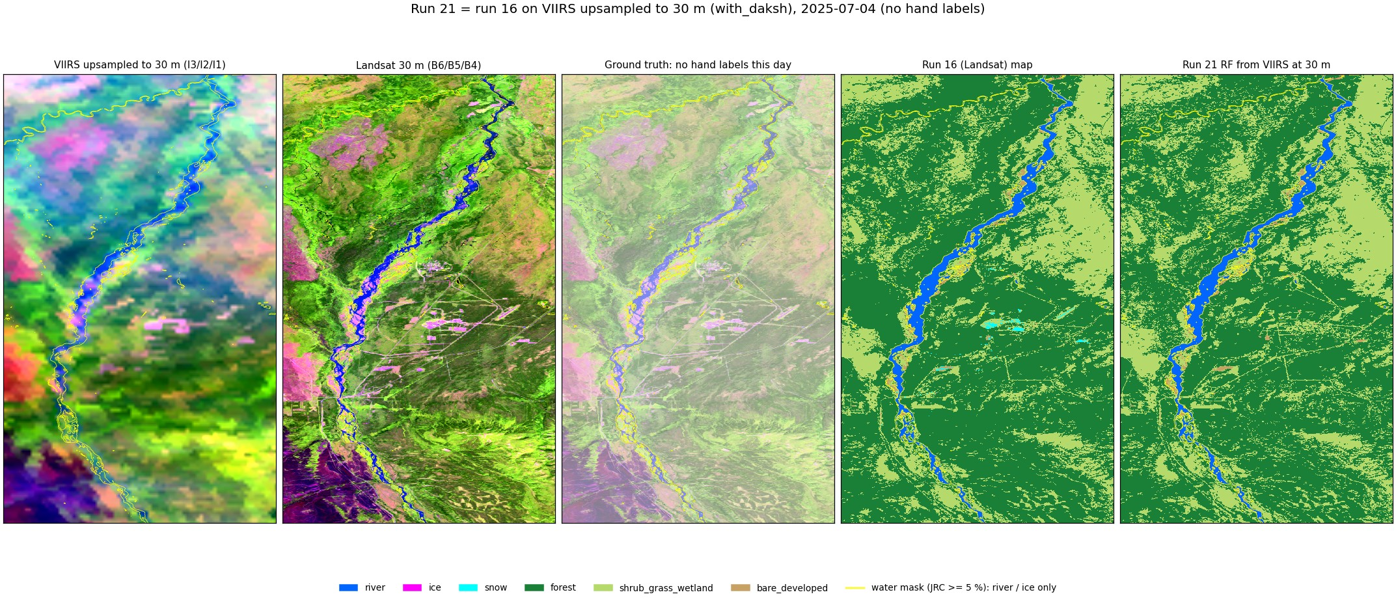
Run 21 RF, 2025-07-04 (summer, no hand labels).
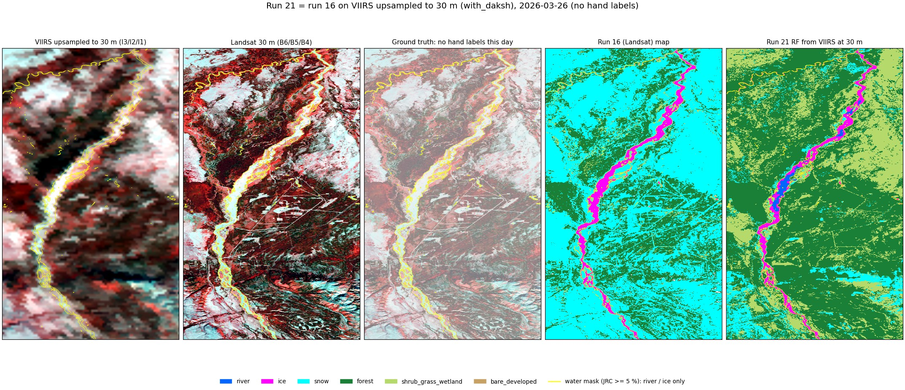
Run 21 RF, 2026-03-26 (late winter, no hand labels).
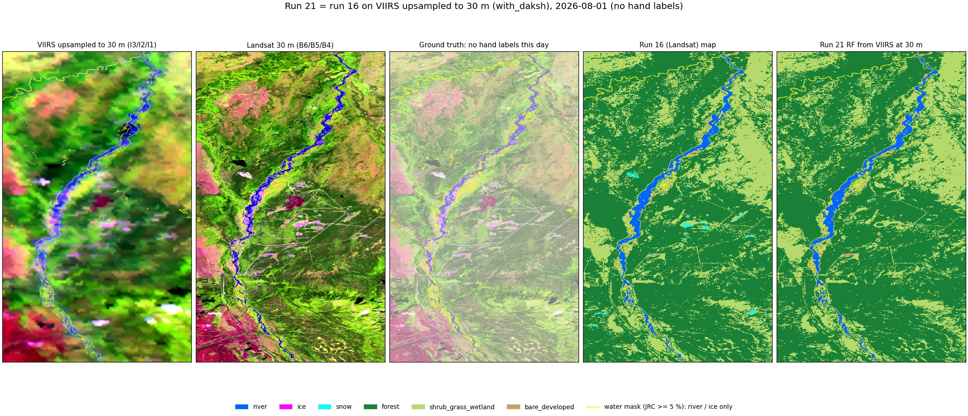
Run 21 RF, 2026-08-01 (summer, no hand labels).
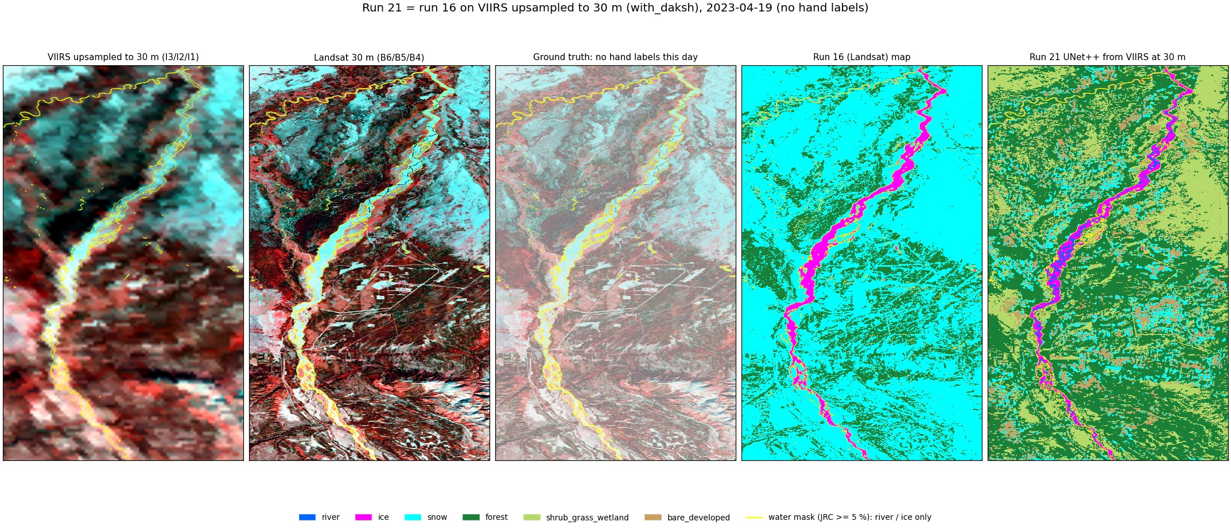
Run 21 UNet++, 2023-04-19 (spring, snow, no hand labels).
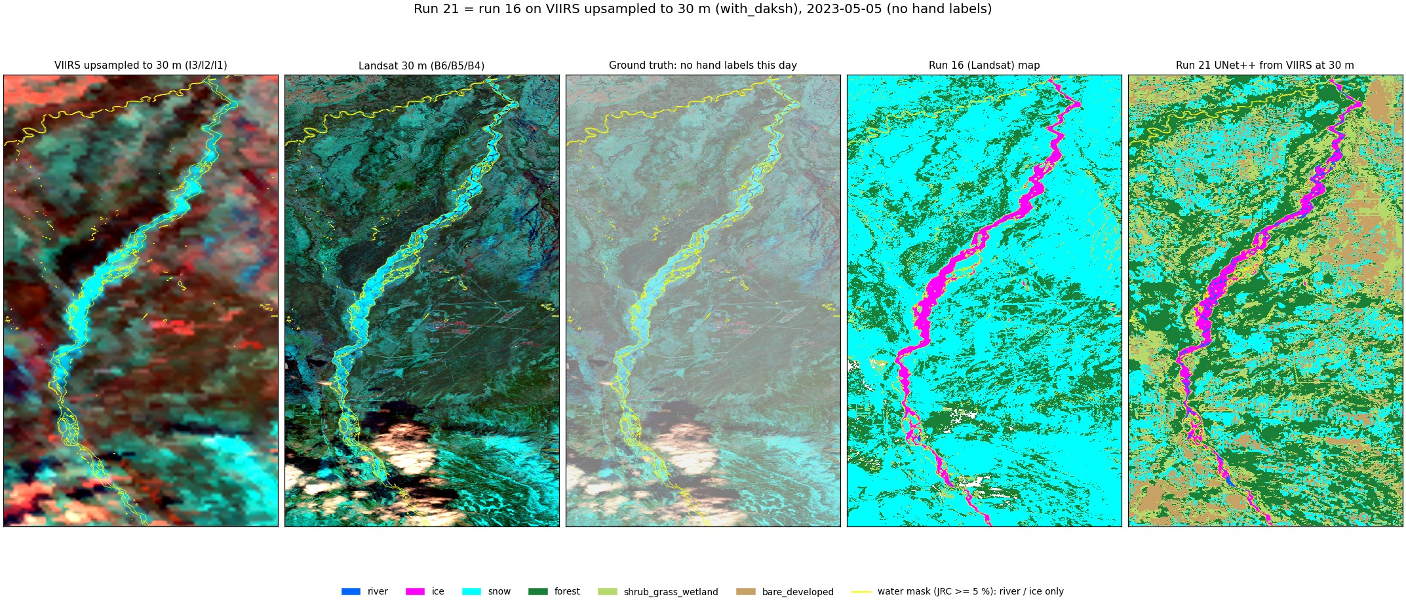
Run 21 UNet++, 2023-05-05 (spring break-up, no hand labels).
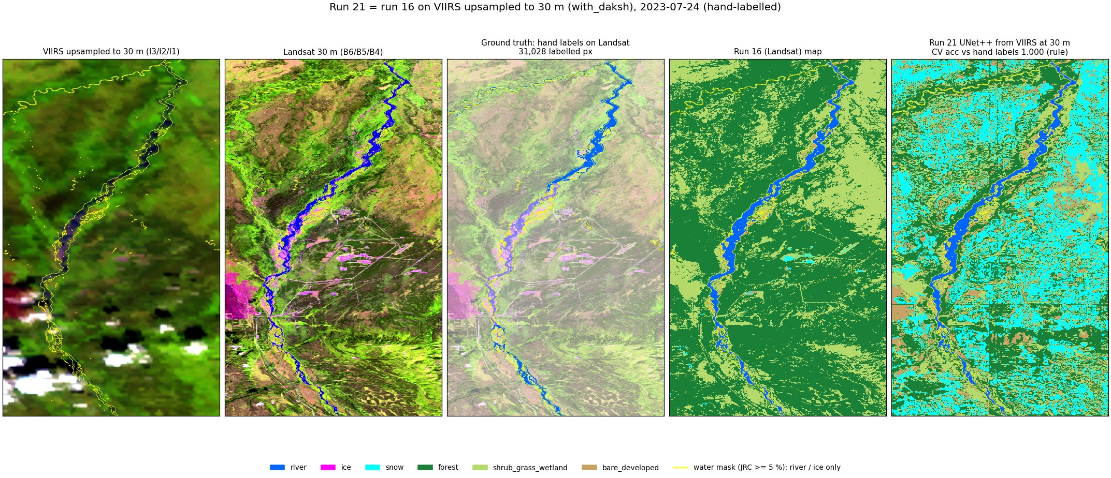
Run 21 UNet++, 2023-07-24 (summer, hand-labelled).
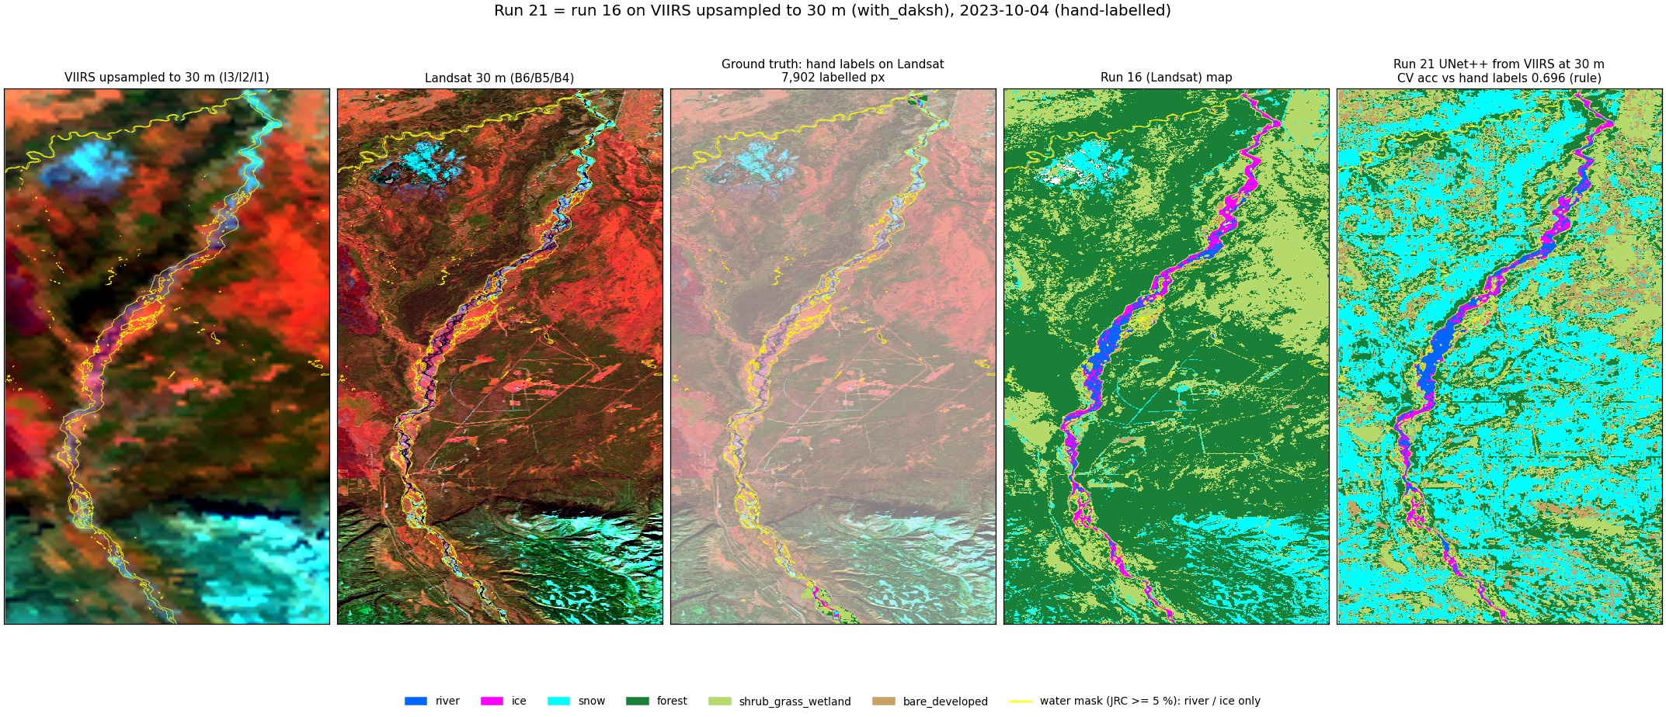
Run 21 UNet++, 2023-10-04 (autumn freeze-up, hand-labelled).
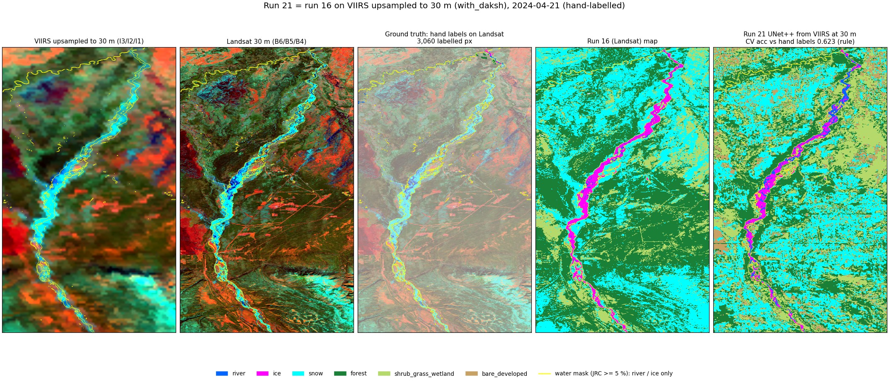
Run 21 UNet++, 2024-04-21 (spring break-up, hand-labelled).
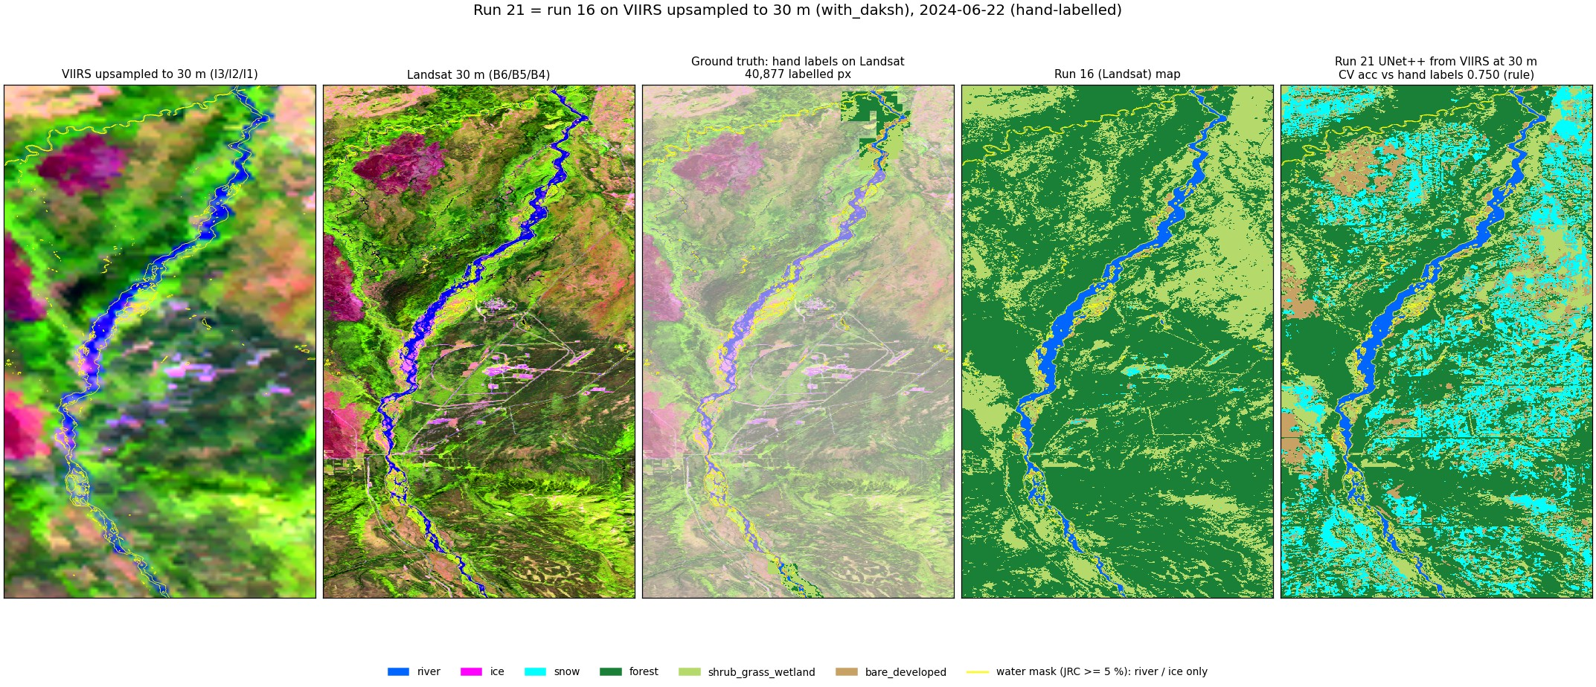
Run 21 UNet++, 2024-06-22 (summer, hand-labelled).
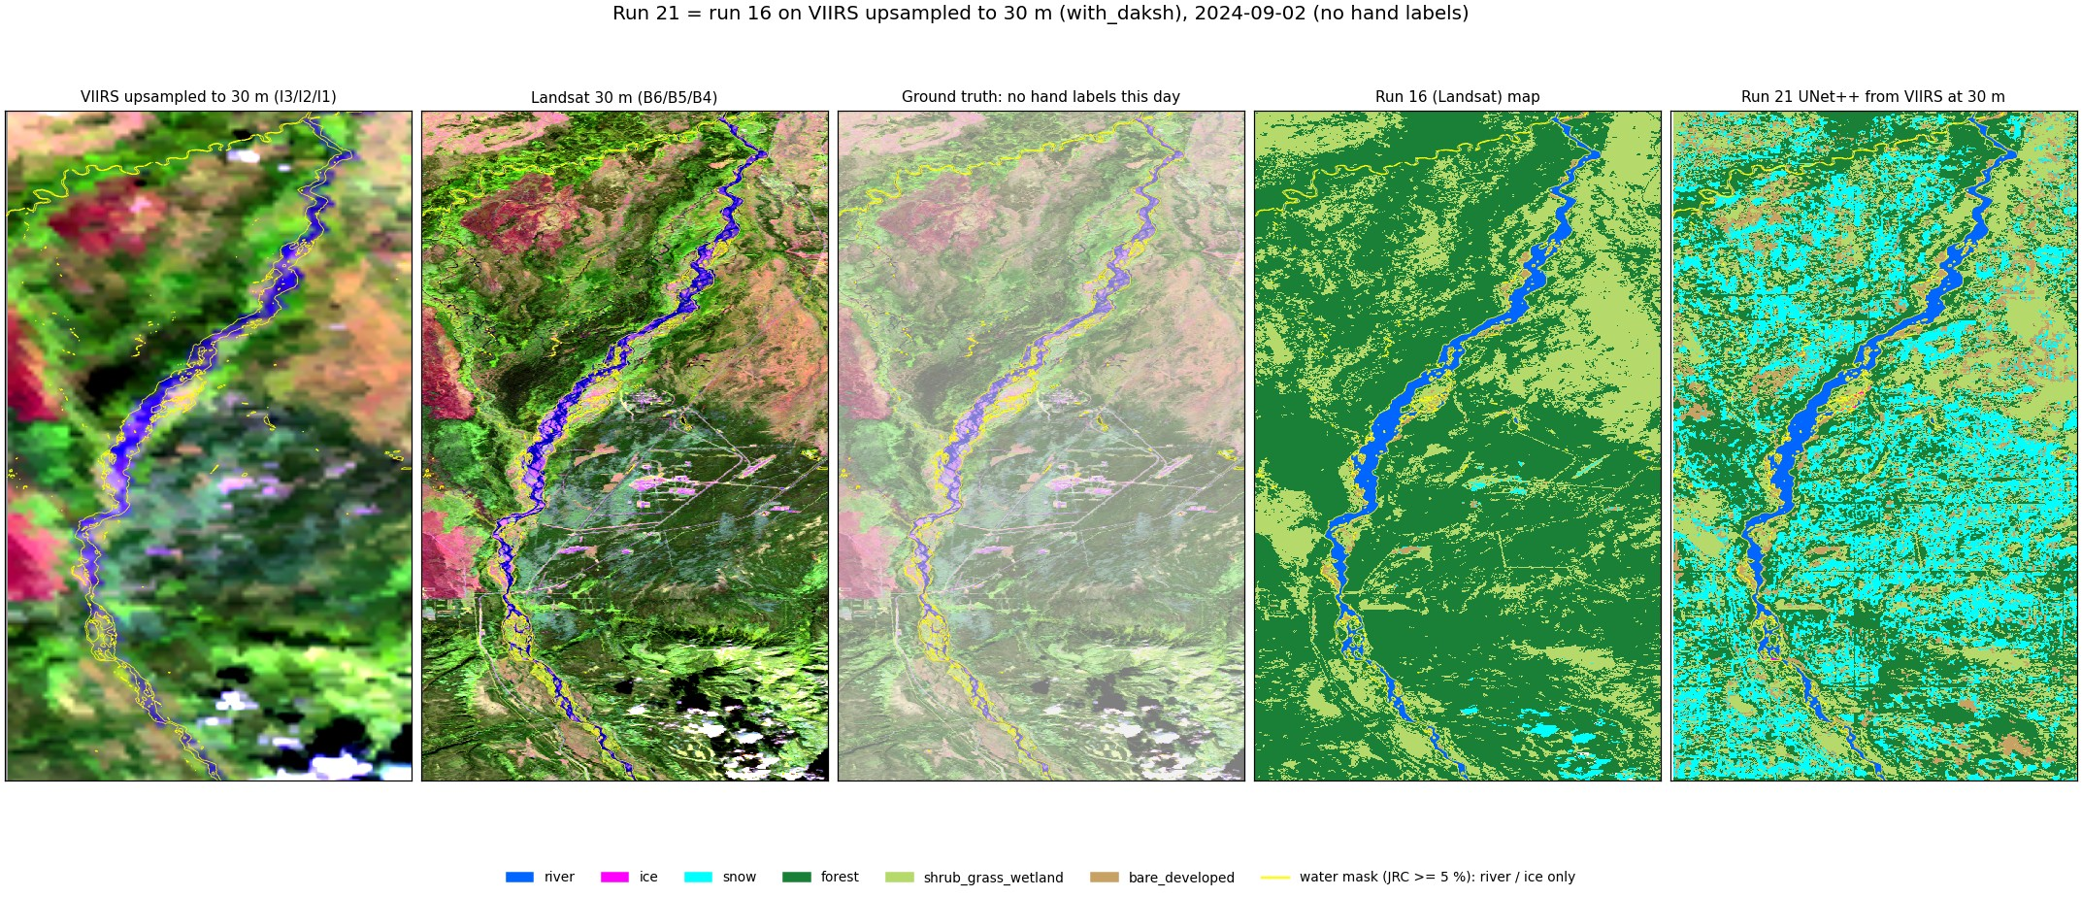
Run 21 UNet++, 2024-09-02 (late summer, no hand labels).
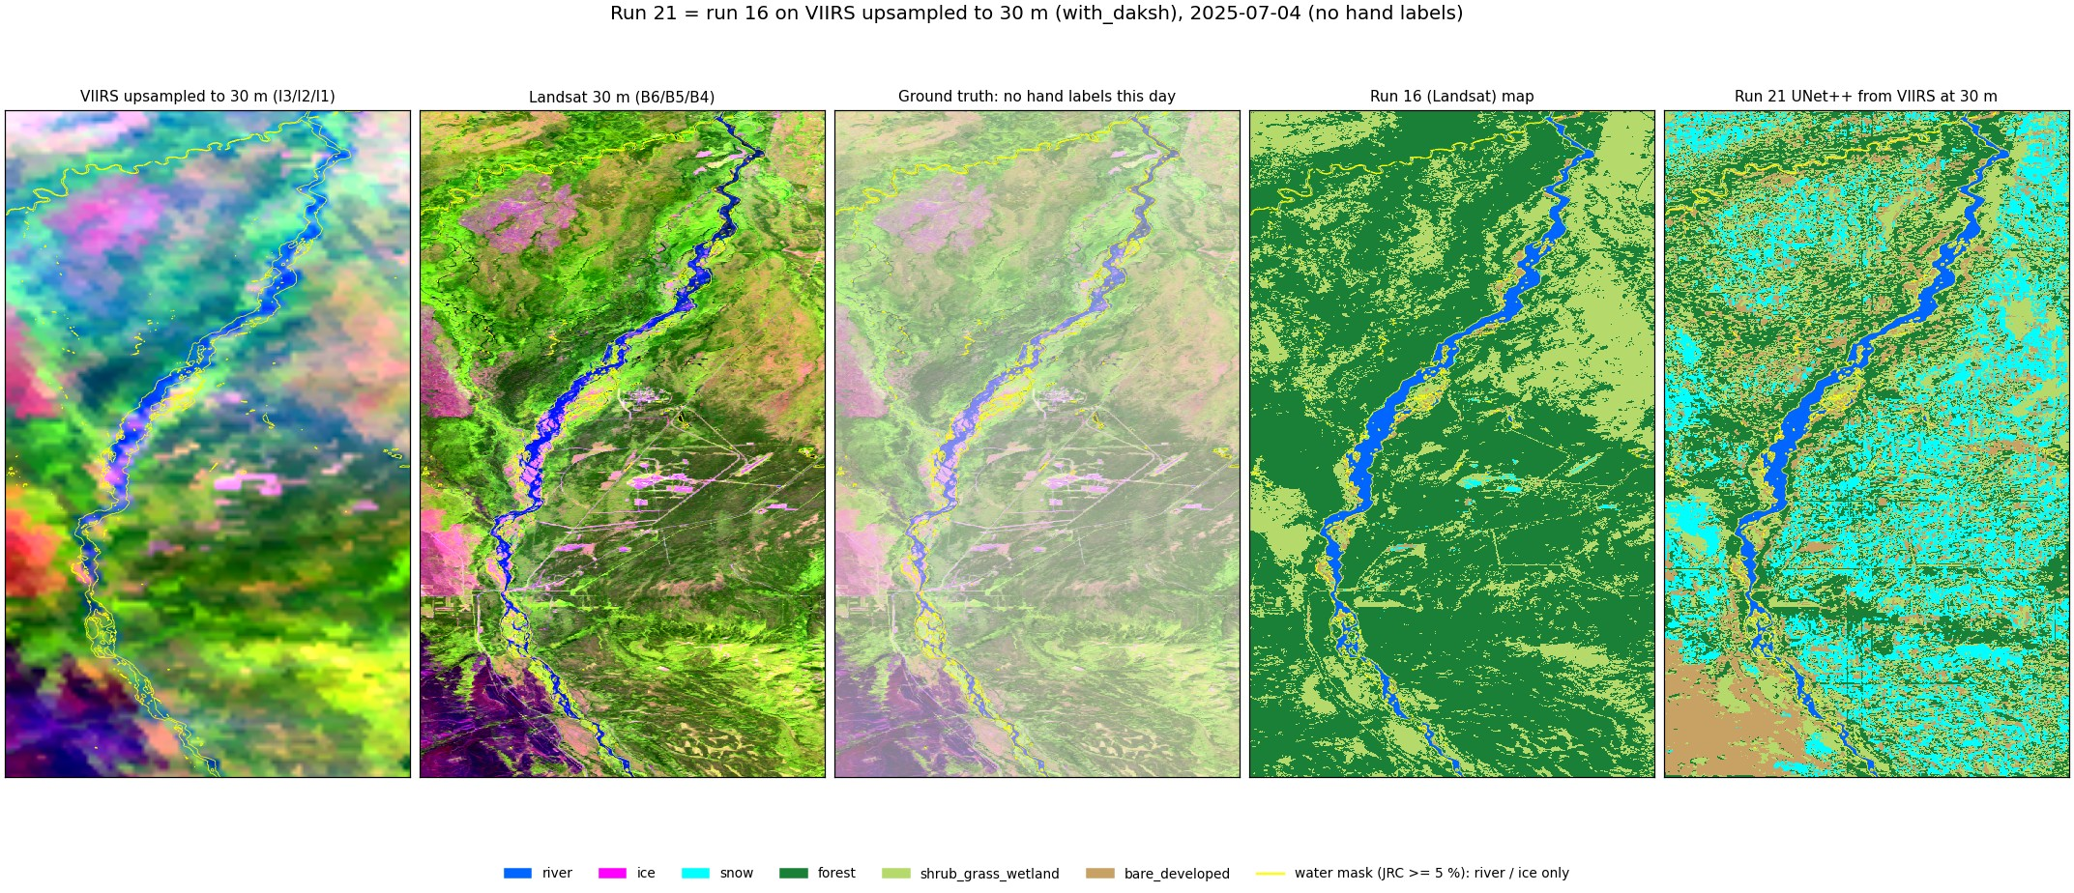
Run 21 UNet++, 2025-07-04 (summer, no hand labels).
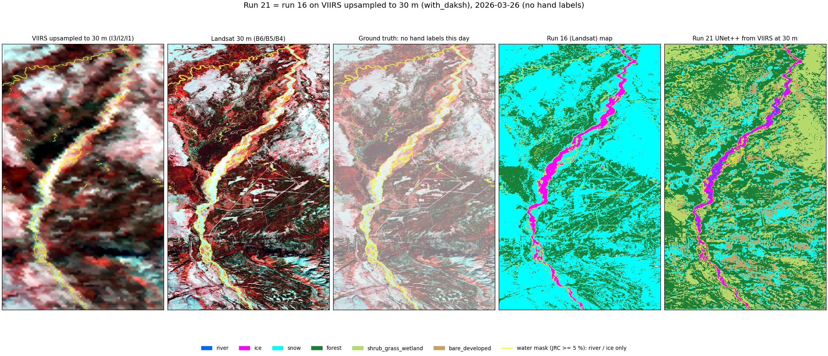
Run 21 UNet++, 2026-03-26 (late winter, no hand labels).
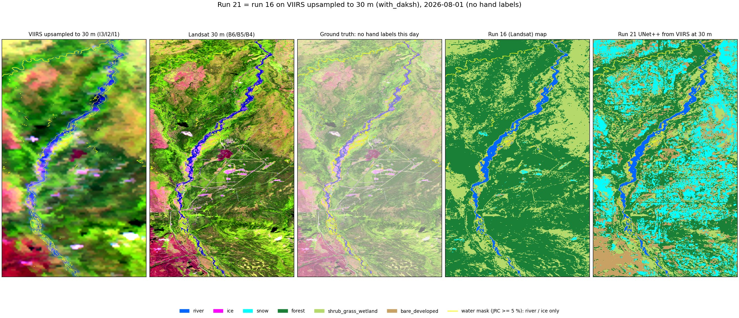
Run 21 UNet++, 2026-08-01 (summer, no hand labels).

5. Things to know
- Upsampling copies each 375 m VIIRS value to its 12.5 x 12.5 Landsat pixels: VIIRS adds no 30 m detail. 30 m edges come from NLCD, the terrain, the texture windows and the water mask.
- Land classes largely reproduce NLCD; the high forest / shrub / bare scores measure agreement with NLCD as much as with VIIRS.
- Snow on land is usually patchy at 30 m and averaged away at 375 m, hence the low snow score.
- Only 4 labelled dates (vs 7 in run 16) and few ice / snow pixels: ice and snow scores move a lot with each polygon.
- Spatial CV holds out row blocks, not dates: the same date is in training and test (as in run 16).
- No cloud mask on VIIRS.

6. Files
what | where (~/Desktop/nenana_crops/daksh/)
script | viirs_run16.py (uses viirs_30m.py for the upsampling and image helpers)
results | output/21_viirs_run16/2_with_daksh/random_forest/ (metrics.txt, oof.npz, pred_<date>.tif + .qml, images/)
all metrics | output/21_viirs_run16/metrics_all.json
report / deck | report/word_content_run21.py + report/build_word.js; ~/Desktop/nenana_river_models/presentation/build_deck_run21.js

