Nenana river ice from VIIRS 375 m: runs 17-20
Unmixing (run 17), four river / land states over the whole image (run 18), and the four states on the river only, with and without a buffer (runs 19 and 20). Models: Random Forest, UNet++ and a plain 2D CNN. Labels come from the run 16 Landsat 30 m maps.

Contents

1. Summary
run | model | rule50 acc | rule50 F1 | rule90 acc | rule90 F1 | VIIRS px
Run 18: whole image | RF | 0.759 | 0.574 | 0.846 | 0.637 | 60,068
Run 18: whole image | UNet++ | 0.704 | 0.532 | 0.744 | 0.570 | 60,068
Run 19: river + 1 px buffer | RF | 0.794 | 0.644 | 0.818 | 0.662 | 9,645
Run 19: river + 1 px buffer | UNet++ | 0.714 | 0.535 | 0.742 | 0.477 | 9,645
Run 19: river + 1 px buffer | 2D CNN | 0.812 | 0.655 | 0.854 | 0.664 | 9,645
Run 20: river only | RF | 0.731 | 0.580 | 0.799 | 0.600 | 5,717
Run 20: river only | UNet++ | 0.698 | 0.481 | 0.755 | 0.431 | 5,717
Run 20: river only | 2D CNN | 0.751 | 0.588 | 0.825 | 0.602 | 5,717

- Goal: Landsat (30 m) is rare; VIIRS (375 m) is daily. The run 16 Landsat maps give the labels, VIIRS alone gives the inputs, so the models can map the river state on any VIIRS day.
- Run 17 replicates Oleson et al. (1995): per-class VIIRS values recovered by least squares from the Landsat class shares. It works on snow / break-up days (I1 R² up to 0.77) and fails in summer (R² < 0.1), as in the paper's prairie case.
- Run 18 predicts the % of open water, ice, snow and snow-free land in every VIIRS pixel (RF R² 0.79-0.90 per part), then the four states by a 50 % or 90 % rule. Its river state mostly follows the day, so a wrong day flips the whole image.
- Run 19 predicts the four states directly on river + buffer pixels. Best rule50: 2D CNN 0.812 accuracy. It fixes run 18's 2024-04-21 collapse (RF 0.11 -> 0.55).
- Run 20 drops the buffer (river pixels only). Best rule50: 2D CNN 0.751.
- State 2 (open river, snow land) is very rare (a few hundred pixels), so its F1 stays low in every run.
- All scores are leave-one-date-out: each date is predicted by models trained on the other 5 dates only.

2. Data and design

2.1 Why VIIRS
Run 16 maps six classes from Landsat 30 m, but Landsat passes every 8-16 days and is often cloudy. VIIRS passes daily at 375 m. Runs 17-20 move from 30 m to 375 m: the run 16 maps are summarised per VIIRS pixel and used as labels, and VIIRS bands are the only image inputs.

2.2 Grids
layer | grid
Run 16 Landsat map | EPSG:4326, 995 x 1635 px, 0.00027027° (~30 m); classes 1 river, 2 ice, 3 snow, 4 forest, 5 shrub_grass_wetland, 6 bare_developed
VIIRS (Patches/nenana_<date>/<date>_viirs_375m.tif) | EPSG:4326, 80 x 132 px, 0.00337838° (12.5 Landsat px); 9 bands I1, I2, I3 (TOA reflectance), I4, I5 (brightness temperature K), SZA, SAA, VZA, VAA
Water mask alaska_occ_375m.tif | EPSG:4326, same 0.00337838° grid, aligned exactly (offset col 6412, row 2209); JRC water occurrence 0-1

2.3 Dates
date | season | use | VIIRS-Landsat shift m (S, E) | VZA °
2023-04-19 | spring, snow | VIIRS only (prediction) | 30, 0 | 9
2023-05-05 | spring break-up | labelled (run 16 map) | 60, -26 | 9
2023-07-24 | summer | labelled (run 16 map) | 0, 26 | 12
2023-10-04 | autumn freeze-up | labelled (run 16 map) | 30, -52 | 10
2024-04-21 | spring break-up | labelled (run 16 map) | 0, -26 | 13
2024-06-22 | summer | labelled (run 16 map) | 30, 0 | 1
2024-09-02 | late summer | VIIRS only (prediction) | -90, -78 | 2
2025-07-04 | summer | VIIRS only (prediction) | 30, -26 | 7
2026-03-26 | late winter | labelled (run 16 map) | 0, 0 | 28
2026-08-01 | summer | VIIRS only (prediction) | 0, 26 | 28

Run 16 dates without a VIIRS file (2024-03-12, 2024-04-20, 2024-04-29) are left out. The 4 VIIRS-only dates have no run 16 map and are only predicted (no score).

2.4 From 30 m classes to VIIRS pixels
- Each Landsat pixel is assigned to the VIIRS pixel it falls in, after moving the Landsat map by the run 17 shift (at most ~60 m). Shares of each class per VIIRS pixel = 'box' fractions.
- A VIIRS pixel is used when >= 98 % of it is mapped. A VIIRS pixel holds 12 or 13 Landsat pixels per side (12.5 on average); an early version divided by 12.5² and dropped every 12 x 12 pixel (a dashed grid of holes, ~25 % of pixels). Fixed: the share is now divided by the real count (floor 12 x 12, so edge pixels still count as partial). Runs 17-20 use the fix.
- Four parts per pixel: open_river = river, ice = ice, snow = snow, snow_free_land = forest + shrub + bare.

2.5 The four states and the two rules
state | river | land
1 ice_free_river_snow_free_land | open | no snow
2 ice_free_river_snow_covered_land | open | snow
3 ice_covered_river_snow_free_land | ice | no snow
4 ice_covered_river_snow_covered_land | ice | snow

- rule50 (majority): river open if open / (open + ice) > 0.5; land snow-covered if snow / (snow + no-snow land) > 0.5.
- rule90: river open only if open share > 0.9; land snow-free only if snow share < 0.1 (mixed pixels count as snow-covered).
- A pixel with < 1 % river (or < 1 % land) takes the ratio of the whole date, so every pixel gets a state.

2.6 Inputs
Per VIIRS pixel: I1, I2, I3, I4, I5, NDVI_I = (I2-I1)/(I2+I1), NDSI_I = (I1-I3)/(I1+I3), I4-I5, solar zenith, view zenith, JRC mean occurrence and JRC water-zone share (occurrence >= 5 %). RF also gets 3 x 3 mean / std of I1, I2, I3, I5. Runs 19 and 20 add the water-mask occurrence (21 RF inputs). No Landsat band is ever an input.

3. Run 17: unmixing (Oleson et al. 1995)
Oleson, Sarlin, Bajjouk, Steffen (1995, RSE 54: 98-112) recover the reflectance of each land-cover class from coarse pixels: coarse value = Σ class share x class value, solved by least squares over all pixels of the scene. Here the class shares come from the run 16 Landsat map, weighted by a Gaussian point-spread function (σ = 375 m / 2.8 = 134 m, cut at 2σ), and the best VIIRS-Landsat shift is searched within ±6 rows / ±14 columns of Landsat pixels.
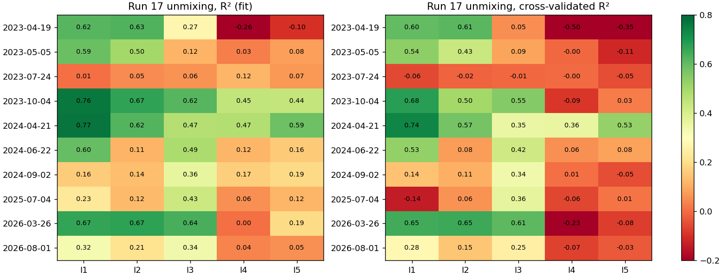
Run 17: R² and cross-validated R² of the unmixing per band and date (Gaussian weights, best shift).
date | pixels | I1 R² / cv | I2 R² / cv | I3 R² / cv | I5 R² / cv | I1 R² box
2023-04-19 | 9,967 | 0.62 / 0.60 | 0.63 / 0.61 | 0.27 / 0.05 | -0.10 / -0.35 | 0.54
2023-05-05 | 9,616 | 0.59 / 0.54 | 0.50 / 0.43 | 0.12 / 0.09 | 0.08 / -0.11 | 0.52
2023-07-24 | 9,880 | 0.01 / -0.06 | 0.05 / -0.02 | 0.06 / -0.01 | 0.07 / -0.05 | 0.01
2023-10-04 | 9,729 | 0.76 / 0.68 | 0.67 / 0.50 | 0.62 / 0.55 | 0.44 / 0.03 | 0.69
2024-04-21 | 9,988 | 0.77 / 0.74 | 0.62 / 0.57 | 0.47 / 0.35 | 0.59 / 0.53 | 0.71
2024-06-22 | 10,010 | 0.60 / 0.53 | 0.11 / 0.08 | 0.49 / 0.42 | 0.16 / 0.08 | 0.55
2024-09-02 | 9,905 | 0.16 / 0.14 | 0.14 / 0.11 | 0.36 / 0.34 | 0.19 / -0.05 | 0.12
2025-07-04 | 10,010 | 0.23 / -0.14 | 0.12 / 0.06 | 0.43 / 0.36 | 0.12 / 0.01 | 0.21
2026-03-26 | 9,237 | 0.67 / 0.65 | 0.67 / 0.65 | 0.64 / 0.61 | 0.19 / -0.08 | 0.59
2026-08-01 | 9,880 | 0.32 / 0.28 | 0.21 / 0.15 | 0.34 / 0.25 | 0.05 / -0.03 | 0.29

All fit metrics per band (Gaussian weights, best shift)
Run 17 is a regression (VIIRS value from class shares), so it has no confusion matrix. Its metrics: R² of the fit, cross-validated R² (5 folds of pixels), RMSE and cross-validated RMSE (reflectance for I1-I3, kelvin for I4-I5).
date | band | R² | cv R² | RMSE | cv RMSE | R² no shift | R² box
2023-04-19 | I1 | 0.618 | 0.603 | 0.097 | 0.099 | 0.619 | 0.542
2023-04-19 | I2 | 0.627 | 0.613 | 0.091 | 0.093 | 0.628 | 0.551
2023-04-19 | I3 | 0.271 | 0.054 | 0.010 | 0.012 | 0.269 | 0.241
2023-04-19 | I4 | -0.263 | -0.500 | 1.055 | 1.150 | -0.251 | -0.365
2023-04-19 | I5 | -0.101 | -0.354 | 1.020 | 1.131 | -0.093 | -0.210
2023-05-05 | I1 | 0.592 | 0.538 | 0.054 | 0.057 | 0.588 | 0.520
2023-05-05 | I2 | 0.502 | 0.431 | 0.046 | 0.049 | 0.499 | 0.439
2023-05-05 | I3 | 0.116 | 0.088 | 0.020 | 0.020 | 0.115 | 0.100
2023-05-05 | I4 | 0.029 | -0.005 | 2.433 | 2.475 | 0.037 | 0.030
2023-05-05 | I5 | 0.081 | -0.114 | 1.955 | 2.153 | 0.088 | 0.067
2023-07-24 | I1 | 0.006 | -0.058 | 0.063 | 0.065 | 0.006 | 0.005
2023-07-24 | I2 | 0.049 | -0.016 | 0.073 | 0.076 | 0.047 | 0.044
2023-07-24 | I3 | 0.060 | -0.007 | 0.063 | 0.066 | 0.057 | 0.052
2023-07-24 | I4 | 0.116 | -0.003 | 2.782 | 2.964 | 0.114 | 0.096
2023-07-24 | I5 | 0.066 | -0.051 | 3.083 | 3.270 | 0.065 | 0.058
2023-10-04 | I1 | 0.762 | 0.682 | 0.020 | 0.023 | 0.759 | 0.694
2023-10-04 | I2 | 0.668 | 0.500 | 0.028 | 0.035 | 0.660 | 0.600
2023-10-04 | I3 | 0.617 | 0.554 | 0.018 | 0.020 | 0.612 | 0.559
2023-10-04 | I4 | 0.445 | -0.087 | 1.324 | 1.853 | 0.439 | 0.388
2023-10-04 | I5 | 0.441 | 0.025 | 0.929 | 1.227 | 0.439 | 0.385
2024-04-21 | I1 | 0.771 | 0.736 | 0.031 | 0.034 | 0.768 | 0.709
2024-04-21 | I2 | 0.620 | 0.574 | 0.028 | 0.029 | 0.621 | 0.563
2024-04-21 | I3 | 0.470 | 0.352 | 0.023 | 0.025 | 0.468 | 0.413
2024-04-21 | I4 | 0.472 | 0.355 | 2.325 | 2.569 | 0.470 | 0.416
2024-04-21 | I5 | 0.586 | 0.526 | 1.943 | 2.079 | 0.585 | 0.524
2024-06-22 | I1 | 0.597 | 0.530 | 0.007 | 0.007 | 0.598 | 0.550
2024-06-22 | I2 | 0.115 | 0.075 | 0.041 | 0.042 | 0.116 | 0.107
2024-06-22 | I3 | 0.487 | 0.419 | 0.020 | 0.021 | 0.483 | 0.450
2024-06-22 | I4 | 0.119 | 0.057 | 3.601 | 3.725 | 0.116 | 0.101
2024-06-22 | I5 | 0.158 | 0.083 | 2.763 | 2.884 | 0.157 | 0.136
2024-09-02 | I1 | 0.163 | 0.143 | 0.018 | 0.018 | 0.144 | 0.120
2024-09-02 | I2 | 0.135 | 0.108 | 0.035 | 0.036 | 0.123 | 0.112
2024-09-02 | I3 | 0.362 | 0.336 | 0.028 | 0.029 | 0.338 | 0.301
2024-09-02 | I4 | 0.166 | 0.006 | 2.154 | 2.353 | 0.170 | 0.145
2024-09-02 | I5 | 0.188 | -0.049 | 1.574 | 1.788 | 0.194 | 0.163
2025-07-04 | I1 | 0.229 | -0.139 | 0.011 | 0.014 | 0.228 | 0.207
2025-07-04 | I2 | 0.124 | 0.061 | 0.041 | 0.042 | 0.124 | 0.116
2025-07-04 | I3 | 0.427 | 0.363 | 0.019 | 0.020 | 0.422 | 0.393
2025-07-04 | I4 | 0.055 | -0.060 | 3.814 | 4.040 | 0.054 | 0.044
2025-07-04 | I5 | 0.117 | 0.011 | 2.405 | 2.546 | 0.116 | 0.097
2026-03-26 | I1 | 0.667 | 0.647 | 0.101 | 0.104 | 0.667 | 0.593
2026-03-26 | I2 | 0.673 | 0.653 | 0.099 | 0.102 | 0.673 | 0.599
2026-03-26 | I3 | 0.636 | 0.612 | 0.010 | 0.010 | 0.636 | 0.564
2026-03-26 | I4 | 0.004 | -0.226 | 1.126 | 1.249 | 0.004 | -0.058
2026-03-26 | I5 | 0.192 | -0.076 | 1.190 | 1.373 | 0.192 | 0.116
2026-08-01 | I1 | 0.324 | 0.279 | 0.012 | 0.012 | 0.325 | 0.292
2026-08-01 | I2 | 0.213 | 0.151 | 0.040 | 0.042 | 0.216 | 0.196
2026-08-01 | I3 | 0.337 | 0.251 | 0.024 | 0.025 | 0.332 | 0.303
2026-08-01 | I4 | 0.037 | -0.068 | 3.493 | 3.679 | 0.035 | 0.030
2026-08-01 | I5 | 0.054 | -0.031 | 2.651 | 2.769 | 0.053 | 0.046

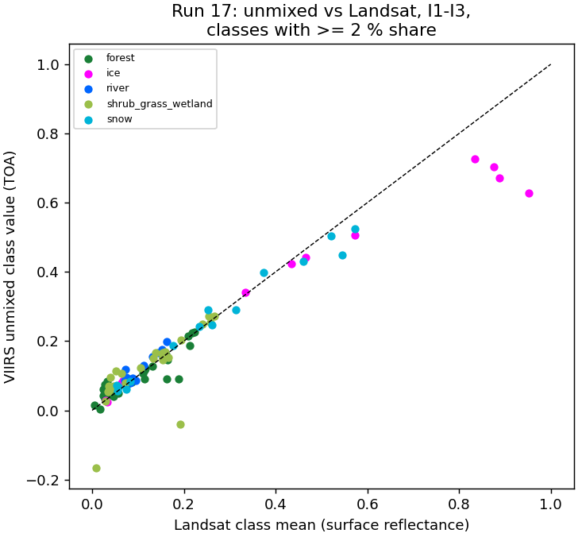
Run 17: unmixed VIIRS class values against the Landsat mean of the same class (red / NIR / SWIR1).
2024-04-21, I1 (red) unmixed: river -0.070, ice 0.422, snow 0.187, forest 0.069, shrub_grass_wetland 0.079, bare_developed 0.094. Ice and snow match Landsat within ~0.01; river (0.4 % of the image) comes out negative.
- Works when the classes differ strongly and each covers enough of the image: snow / ice dates, I1 and I2.
- Fails in summer (R² < 0.1): forest, shrub and river look alike at 375 m, as in the paper's prairie scene.
- Rare classes (river 0.4 %) get unstable or negative values: the paper's 'well represented' condition.
- Gaussian weights beat box weights (higher I1 R²); the shift adds little (<= ~60 m).
- Run 17 is a check of the physics; runs 18-20 learn the inverse (VIIRS -> shares / states) instead.

4. Run 18: % mix and states over the whole image
RF regressor (4 outputs, depth 12, min leaf 20, sqrt, 300 trees) and UNet++ (resnet18, softmax over the four parts, soft cross-entropy, 1500 steps, flips, flip test-time augmentation) predict the four part shares of every VIIRS pixel. The states come from the predicted shares by rule50 / rule90.
model | open water MAE pp / R² | ice | snow | snow-free land | rule50 acc | rule90 acc
RF | 1.6 / 0.84 | 1.4 / 0.90 | 11.3 / 0.79 | 11.4 / 0.82 | 0.759 | 0.846
UNet++ | 1.1 / 0.76 | 1.3 / 0.77 | 11.8 / 0.71 | 12.1 / 0.73 | 0.704 | 0.744

date | truth % water/ice/snow/land | RF % | RF acc50 | UNet++ % | U++ acc50
2023-05-05 | 0.2 / 3.8 / 70.1 / 26.0 | 1.3 / 5.4 / 59.9 / 33.4 | 0.71 | 0.2 / 2.8 / 63.9 / 33.1 | 0.76
2023-07-24 | 3.9 / 0.0 / 0.4 / 95.7 | 4.1 / 0.3 / 5.9 / 89.6 | 0.96 | 3.7 / 1.0 / 10.0 / 85.2 | 0.86
2023-10-04 | 1.8 / 1.9 / 6.2 / 90.0 | 0.9 / 1.0 / 13.0 / 85.1 | 0.93 | 0.8 / 0.7 / 10.4 / 88.1 | 0.06
2024-04-21 | 0.4 / 3.5 / 34.9 / 61.2 | 3.3 / 3.3 / 27.3 / 66.1 | 0.11 | 0.6 / 2.5 / 30.8 / 66.1 | 0.74
2024-06-22 | 3.9 / 0.0 / 0.3 / 95.8 | 3.6 / 0.1 / 0.9 / 95.3 | 1.00 | 2.9 / 0.1 / 0.2 / 96.7 | 0.99
2026-03-26 | 0.0 / 4.2 / 64.8 / 31.0 | 0.4 / 4.7 / 62.9 / 32.0 | 0.87 | 0.1 / 4.9 / 74.6 / 20.5 | 0.80

RF rule50 per state
state | true px | RF F1 | RF prec | RF rec
1 open river, no-snow land | 20,978 | 0.80 | 0.68 | 0.97
2 open river, snow land | 188 | 0.01 | 0.01 | 0.05
3 ice river, no-snow land | 20,630 | 0.67 | 0.93 | 0.52
4 ice river, snow land | 18,272 | 0.82 | 0.84 | 0.79

UNet++ rule50 per state
state | true px | UNet++ F1 | UNet++ prec | UNet++ rec
1 open river, no-snow land | 20,978 | 0.78 | 0.67 | 0.92
2 open river, snow land | 188 | 0.04 | 0.02 | 0.14
3 ice river, no-snow land | 20,630 | 0.51 | 0.70 | 0.40
4 ice river, snow land | 18,272 | 0.80 | 0.80 | 0.81

RF part % per date: MAE (percentage points) / R²
date | open_river | ice | snow | snow_free_land
2023-05-05 | 1.3 / -0.63 | 3.0 / 0.93 | 21.5 / 0.30 | 20.1 / 0.30
2023-07-24 | 2.2 / 0.90 | 0.3 / -2397913384223.22 | 5.8 / -22.79 | 7.3 / 0.12
2023-10-04 | 1.3 / 0.54 | 1.2 / 0.63 | 8.9 / 0.48 | 9.0 / 0.71
2024-04-21 | 3.3 / -1.18 | 1.4 / 0.93 | 15.9 / 0.58 | 15.6 / 0.68
2024-06-22 | 1.1 / 0.95 | 0.1 / -367573116821.66 | 1.1 / 0.11 | 1.9 / 0.94
2026-03-26 | 0.4 / -1286.60 | 2.2 / 0.94 | 15.4 / 0.70 | 14.8 / 0.70

UNet++ part % per date: MAE (percentage points) / R²
date | open_river | ice | snow | snow_free_land
2023-05-05 | 0.4 / -0.08 | 1.4 / 0.85 | 19.5 / 0.26 | 18.9 / 0.21
2023-07-24 | 2.4 / 0.76 | 1.0 / -17065437849465.22 | 9.8 / -49.81 | 12.0 / -1.03
2023-10-04 | 1.4 / 0.49 | 1.5 / 0.43 | 7.4 / 0.41 | 7.8 / 0.64
2024-04-21 | 0.8 / -0.13 | 1.8 / 0.78 | 17.8 / 0.46 | 17.3 / 0.54
2024-06-22 | 1.5 / 0.85 | 0.1 / -392672718401.64 | 0.4 / 0.25 | 1.7 / 0.85
2026-03-26 | 0.1 / -128.72 | 1.9 / 0.85 | 16.6 / 0.51 | 15.5 / 0.51

Confusion matrices and other metrics
Rows = true state, columns = predicted state; each cell shows the pixel count and the % of that true state (recall). Balanced accuracy = mean recall over the states present; Cohen κ = agreement beyond chance; weighted F1 = F1 weighted by the number of true pixels per state.
rule | model | accuracy | balanced acc | Cohen κ | macro prec | macro rec | macro F1 | weighted F1
rule50 | RF | 0.759 | 0.585 | 0.643 | 0.615 | 0.585 | 0.574 | 0.757
rule50 | UNet++ | 0.704 | 0.567 | 0.560 | 0.549 | 0.567 | 0.532 | 0.690
rule90 | RF | 0.846 | 0.660 | 0.760 | 0.686 | 0.660 | 0.637 | 0.850
rule90 | UNet++ | 0.744 | 0.584 | 0.604 | 0.609 | 0.584 | 0.570 | 0.739

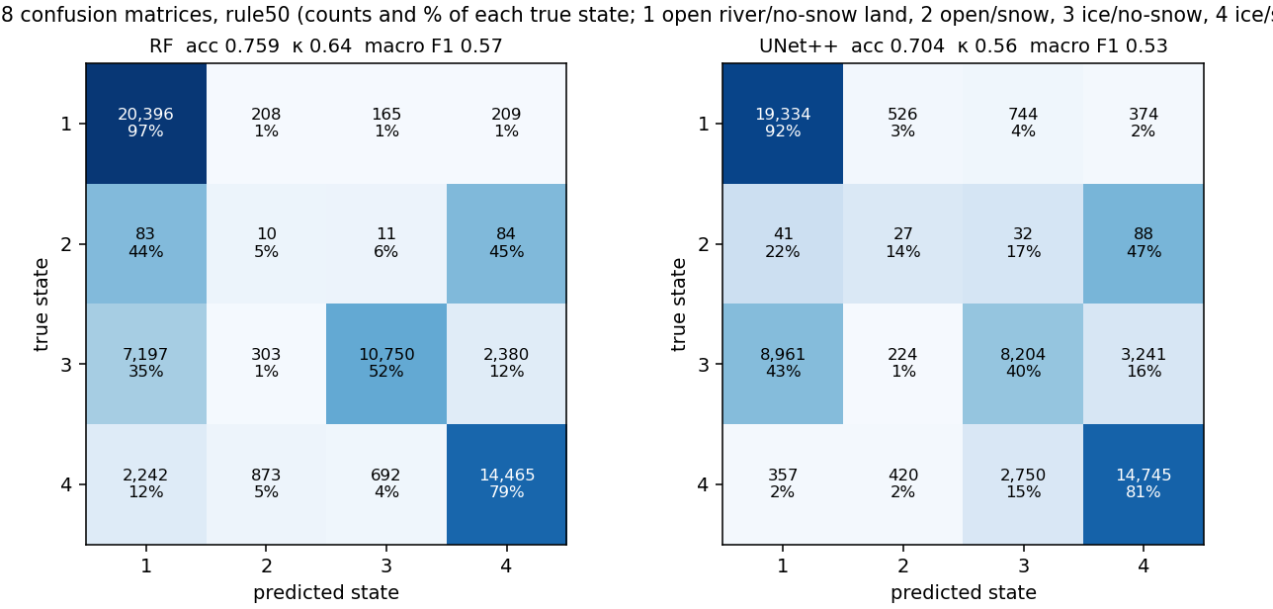
Run 18: confusion matrices, rule50, every model (leave-one-date-out).
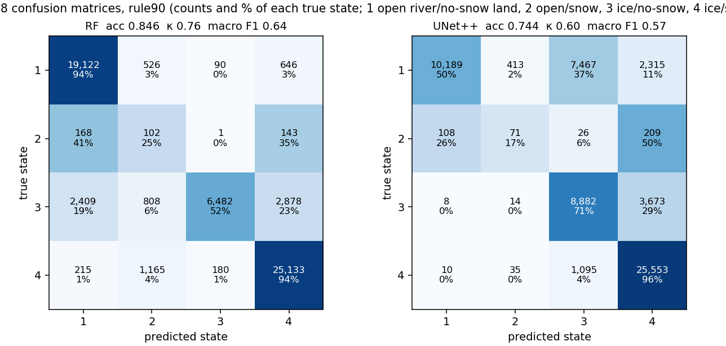
Run 18: confusion matrices, rule90, every model (leave-one-date-out).
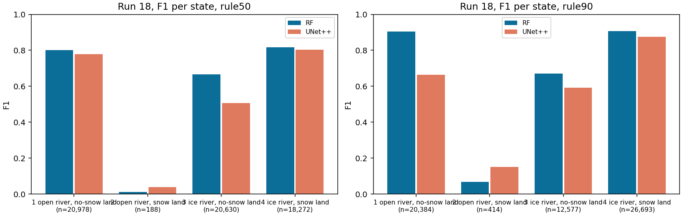
Run 18: F1 per state and model (n = true pixels).
- The snow / land split is learned well; the river state of most pixels comes from the whole-date ratio (< 1 % river), so one wrong day flips the whole image: RF calls 2024-04-21 open.
- UNet++ has only 5 images per fold and is less accurate than RF.
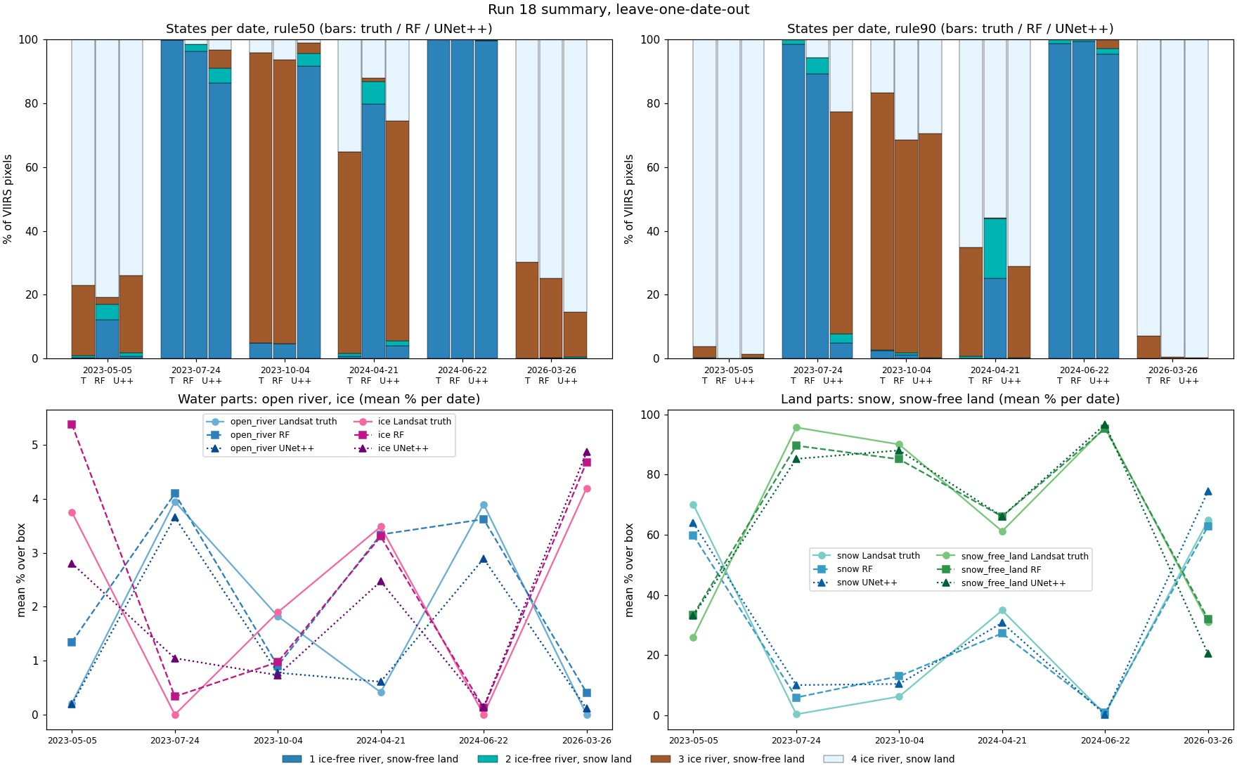
Run 18 summary: states per date (truth / RF / UNet++) and mean % per part.
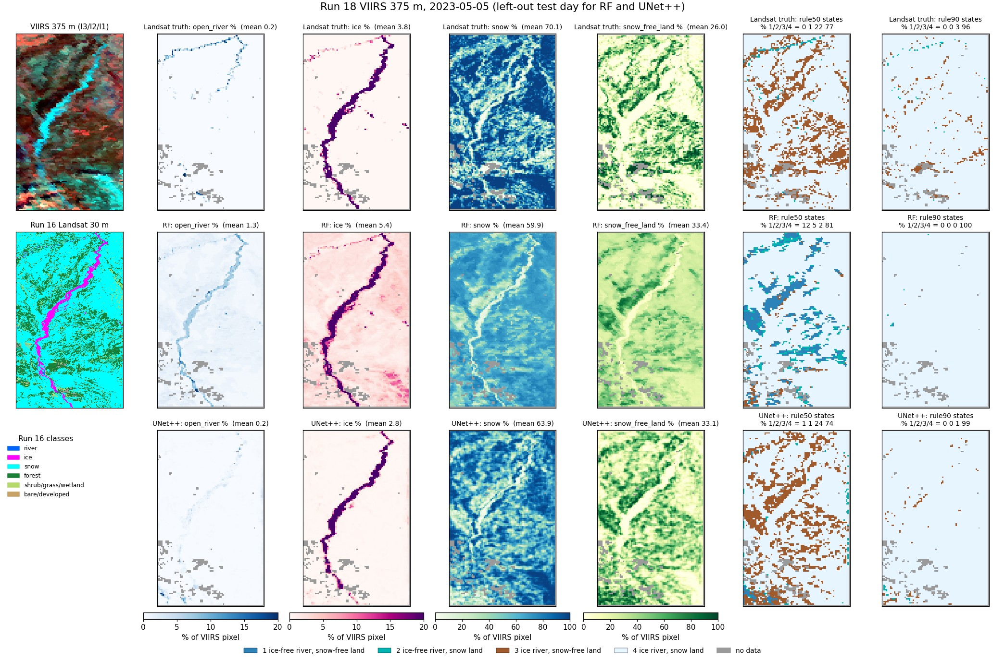
Run 18, 2023-05-05 (spring break-up): % maps and state maps, truth / RF / UNet++.
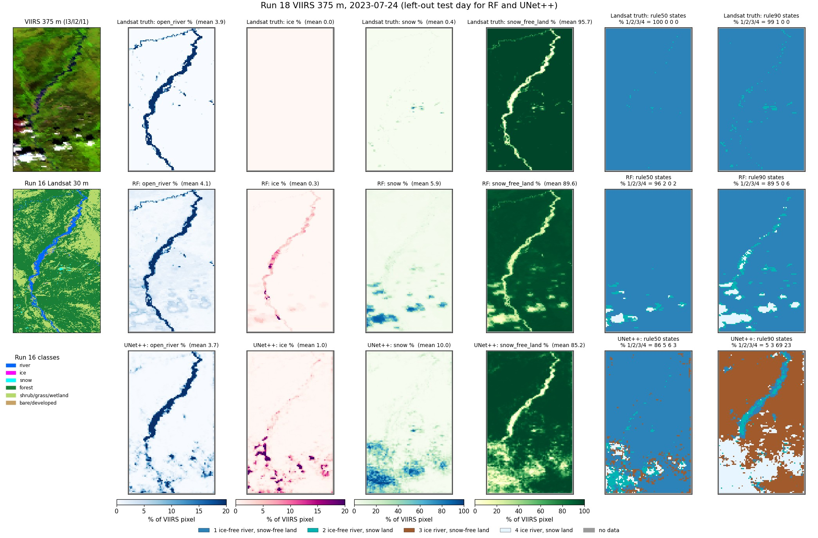
Run 18, 2023-07-24 (summer): % maps and state maps, truth / RF / UNet++.
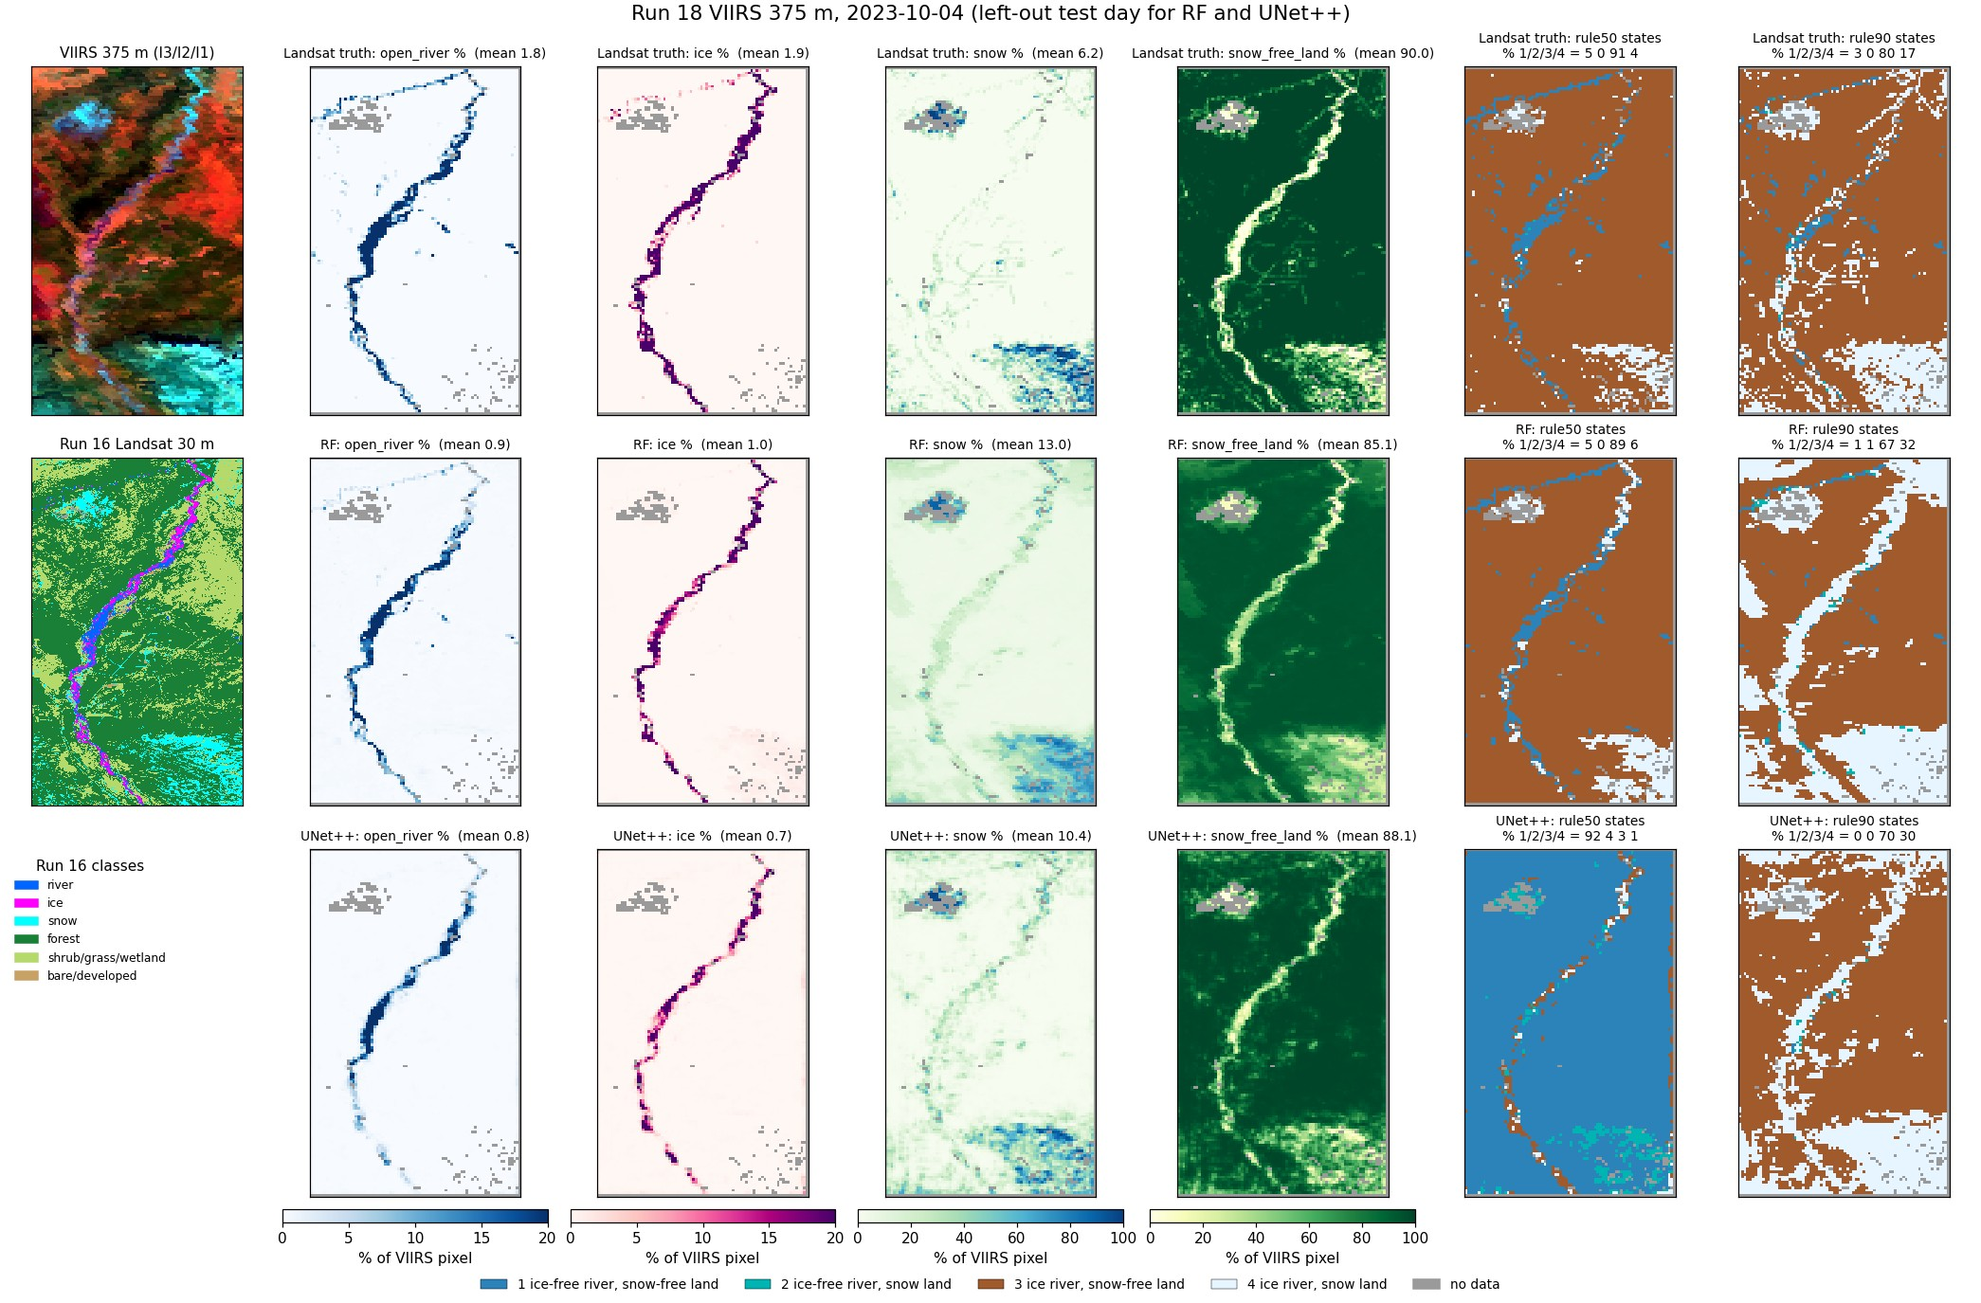
Run 18, 2023-10-04 (autumn freeze-up): % maps and state maps, truth / RF / UNet++.
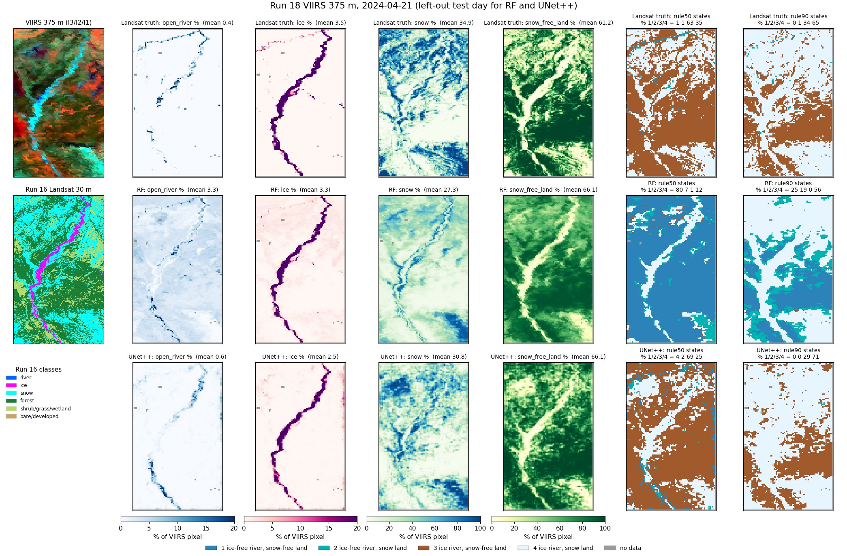
Run 18, 2024-04-21 (spring break-up): % maps and state maps, truth / RF / UNet++.
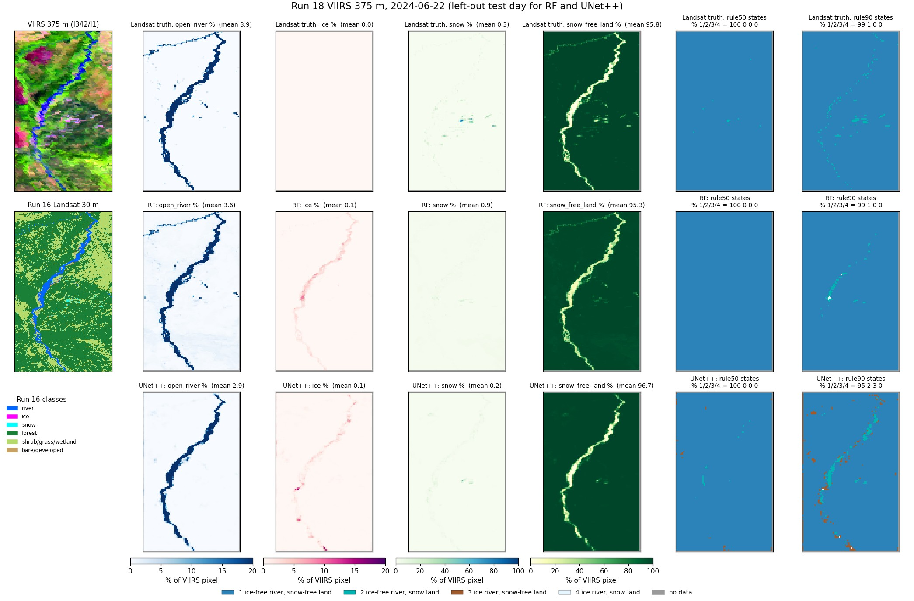
Run 18, 2024-06-22 (summer): % maps and state maps, truth / RF / UNet++.
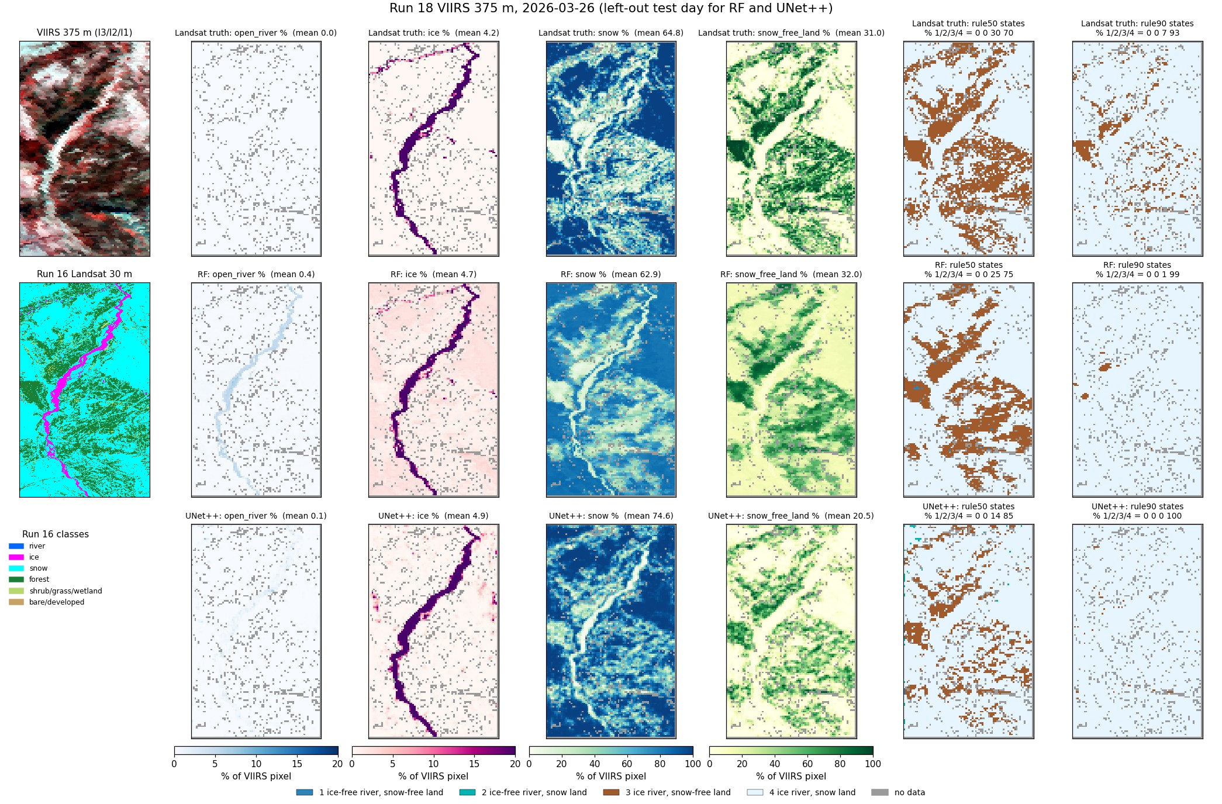
Run 18, 2026-03-26 (late winter): % maps and state maps, truth / RF / UNet++.

5. Run 19: four states on the river + 1 px buffer
Water mask alaska_occ_375m.tif cropped to the image: river = occurrence >= 0.05 (the run 16 5 % rule), 988 pixels; buffer = 1 VIIRS pixel (375 m) around it, 678 pixels. Predicted area 1,666 pixels; ~1,530-1,640 per date are used (>= 98 % mapped by the Landsat map).
Models predict the four states at once (one 4-class model per rule), trained and scored only on these pixels: RF classifier with the run 16 settings (depth 16, min leaf 20, sqrt, 300 trees, balanced_subsample; 21 inputs, so no top-25 selection); UNet++ (resnet18, 4-class cross-entropy on mask pixels, 1500 steps, flips, flip TTA); 2D CNN (4 conv 3 x 3 layers 32-64-64-64 with batch norm and ReLU, dropout 0.1, 1 x 1 output, no down-sampling, so each pixel sees 9 x 9 VIIRS pixels = 3.4 km; 97k parameters; same training as UNet++).
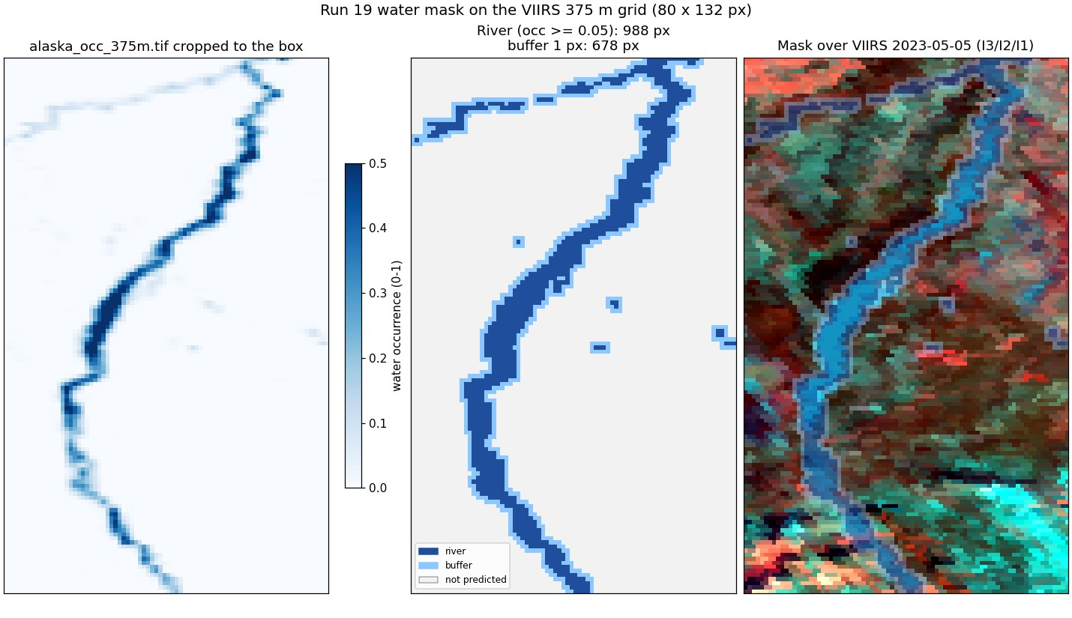
Run 19: the water mask cropped to the image and the predicted area.

rule50
model | accuracy | macro F1
RF | 0.794 | 0.644
UNet++ | 0.714 | 0.535
2D CNN | 0.812 | 0.655

state | true px | RF F1 | RF prec | RF rec | UNet++ F1 | UNet++ prec | UNet++ rec | 2D CNN F1 | 2D CNN prec | 2D CNN rec
1 open river, no-snow land | 3,745 | 0.90 | 0.94 | 0.87 | 0.81 | 0.89 | 0.74 | 0.90 | 0.93 | 0.86
2 open river, snow land | 145 | 0.19 | 0.13 | 0.34 | 0.03 | 0.11 | 0.02 | 0.19 | 0.18 | 0.21
3 ice river, no-snow land | 2,403 | 0.67 | 0.64 | 0.71 | 0.55 | 0.56 | 0.54 | 0.69 | 0.66 | 0.73
4 ice river, snow land | 3,352 | 0.82 | 0.84 | 0.79 | 0.75 | 0.67 | 0.84 | 0.84 | 0.84 | 0.84

RF confusion, rule50 (rows true, columns predicted)
true \ predicted | 1 | 2 | 3 | 4
1 open river, no-snow land | 3,244 | 34 | 425 | 42
2 open river, snow land | 21 | 49 | 47 | 28
3 ice river, no-snow land | 158 | 117 | 1,702 | 426
4 ice river, snow land | 28 | 184 | 481 | 2,659

UNet++ confusion, rule50 (rows true, columns predicted)
true \ predicted | 1 | 2 | 3 | 4
1 open river, no-snow land | 2,765 | 15 | 609 | 356
2 open river, snow land | 47 | 3 | 32 | 63
3 ice river, no-snow land | 150 | 4 | 1,296 | 953
4 ice river, snow land | 156 | 5 | 370 | 2,821

2D CNN confusion, rule50 (rows true, columns predicted)
true \ predicted | 1 | 2 | 3 | 4
1 open river, no-snow land | 3,238 | 8 | 455 | 44
2 open river, snow land | 48 | 31 | 33 | 33
3 ice river, no-snow land | 130 | 55 | 1,749 | 469
4 ice river, snow land | 55 | 83 | 404 | 2,810

rule90
model | accuracy | macro F1
RF | 0.818 | 0.662
UNet++ | 0.742 | 0.477
2D CNN | 0.854 | 0.664

state | true px | RF F1 | RF prec | RF rec | UNet++ F1 | UNet++ prec | UNet++ rec | 2D CNN F1 | 2D CNN prec | 2D CNN rec
1 open river, no-snow land | 3,298 | 0.88 | 0.94 | 0.83 | 0.82 | 0.78 | 0.86 | 0.92 | 0.93 | 0.90
2 open river, snow land | 244 | 0.22 | 0.14 | 0.56 | 0.01 | 0.04 | 0.01 | 0.17 | 0.24 | 0.13
3 ice river, no-snow land | 1,377 | 0.65 | 0.79 | 0.55 | 0.27 | 0.39 | 0.20 | 0.68 | 0.63 | 0.73
4 ice river, snow land | 4,726 | 0.90 | 0.89 | 0.90 | 0.81 | 0.77 | 0.85 | 0.90 | 0.90 | 0.89

RF confusion, rule90 (rows true, columns predicted)
true \ predicted | 1 | 2 | 3 | 4
1 open river, no-snow land | 2,736 | 445 | 43 | 74
2 open river, snow land | 74 | 136 | 2 | 32
3 ice river, no-snow land | 69 | 129 | 759 | 420
4 ice river, snow land | 37 | 267 | 161 | 4,261

UNet++ confusion, rule90 (rows true, columns predicted)
true \ predicted | 1 | 2 | 3 | 4
1 open river, no-snow land | 2,830 | 17 | 193 | 258
2 open river, snow land | 169 | 2 | 11 | 62
3 ice river, no-snow land | 194 | 22 | 282 | 879
4 ice river, snow land | 440 | 11 | 236 | 4,039

2D CNN confusion, rule90 (rows true, columns predicted)
true \ predicted | 1 | 2 | 3 | 4
1 open river, no-snow land | 2,974 | 37 | 197 | 90
2 open river, snow land | 133 | 32 | 28 | 51
3 ice river, no-snow land | 24 | 6 | 1,009 | 338
4 ice river, snow land | 68 | 61 | 376 | 4,221

Confusion matrices and other metrics
Rows = true state, columns = predicted state; each cell shows the pixel count and the % of that true state (recall). Balanced accuracy = mean recall over the states present; Cohen κ = agreement beyond chance; weighted F1 = F1 weighted by the number of true pixels per state.
rule | model | accuracy | balanced acc | Cohen κ | macro prec | macro rec | macro F1 | weighted F1
rule50 | RF | 0.794 | 0.676 | 0.696 | 0.638 | 0.676 | 0.644 | 0.805
rule50 | UNet++ | 0.714 | 0.535 | 0.569 | 0.558 | 0.535 | 0.535 | 0.710
rule50 | 2D CNN | 0.812 | 0.661 | 0.719 | 0.652 | 0.661 | 0.655 | 0.815
rule90 | RF | 0.818 | 0.710 | 0.714 | 0.689 | 0.710 | 0.662 | 0.838
rule90 | UNet++ | 0.742 | 0.481 | 0.565 | 0.495 | 0.481 | 0.477 | 0.715
rule90 | 2D CNN | 0.854 | 0.665 | 0.766 | 0.672 | 0.665 | 0.664 | 0.853

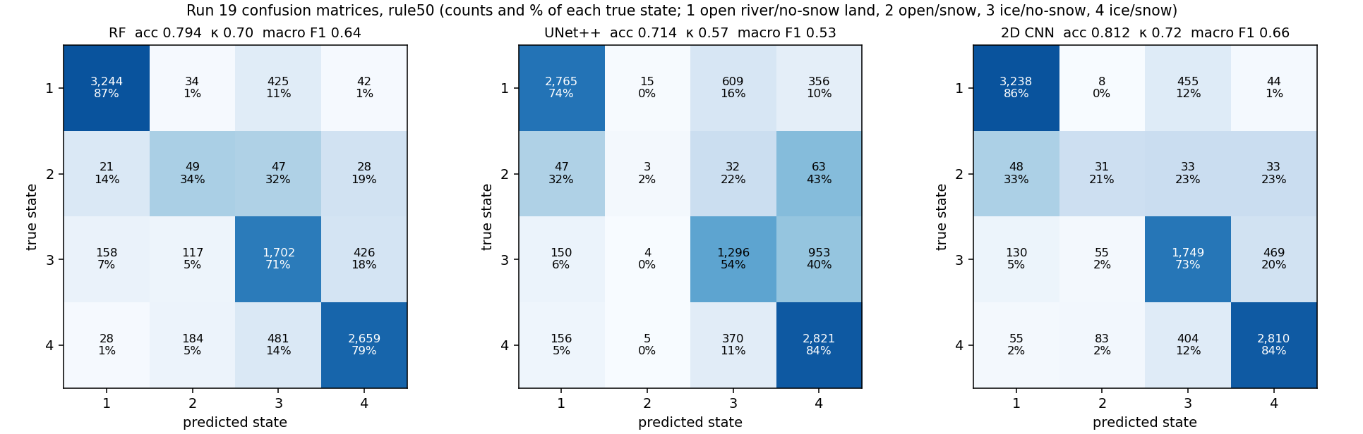
Run 19: confusion matrices, rule50, every model (leave-one-date-out).
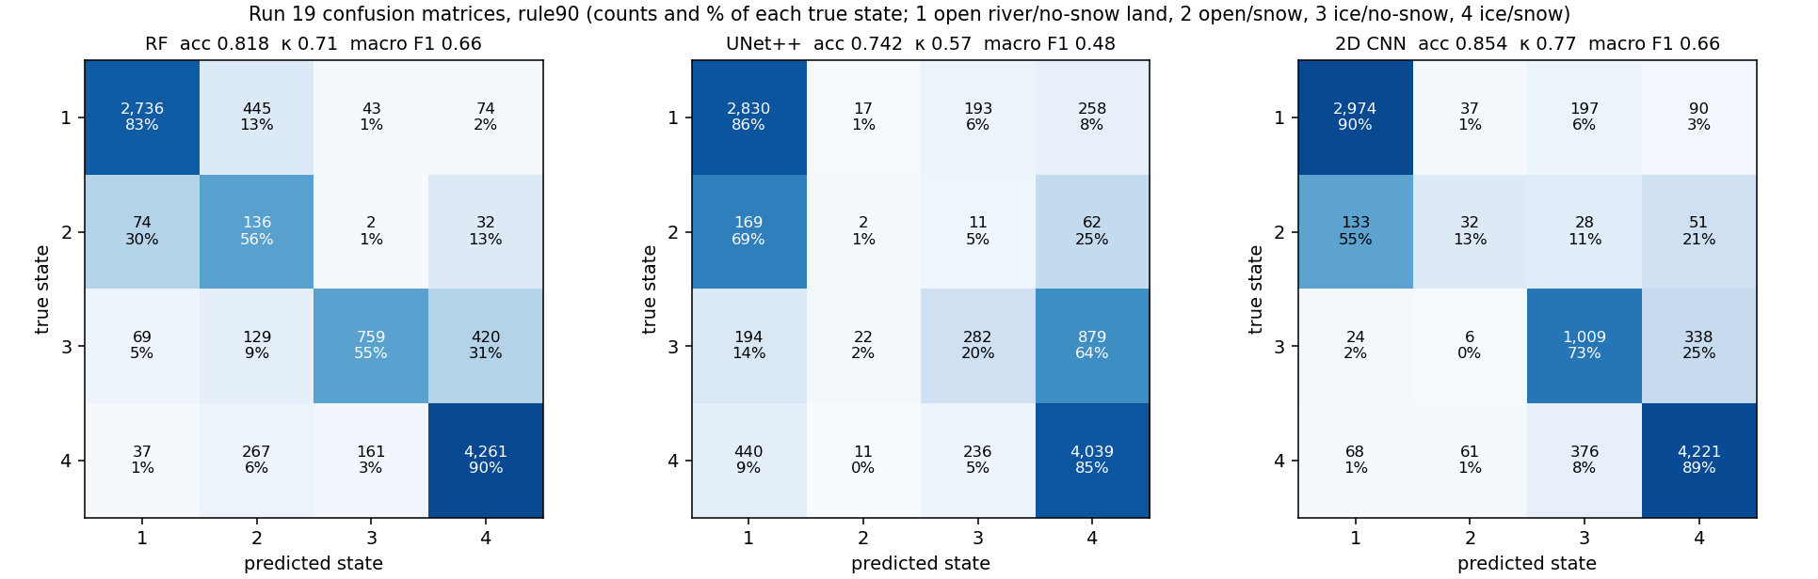
Run 19: confusion matrices, rule90, every model (leave-one-date-out).
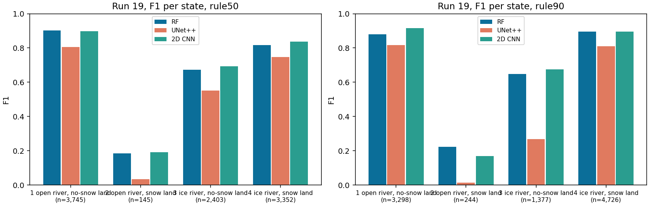
Run 19: F1 per state and model (n = true pixels).

Accuracy per date
date | px | RF 50 | RF 90 | UNet++ 50 | UNet++ 90 | 2D CNN 50 | 2D CNN 90
2023-05-05 | 1,599 | 0.76 | 0.92 | 0.76 | 0.90 | 0.75 | 0.93
2023-07-24 | 1,638 | 0.97 | 0.78 | 0.80 | 0.84 | 0.96 | 0.91
2023-10-04 | 1,599 | 0.68 | 0.59 | 0.46 | 0.31 | 0.72 | 0.64
2024-04-21 | 1,639 | 0.55 | 0.71 | 0.59 | 0.57 | 0.67 | 0.78
2024-06-22 | 1,641 | 1.00 | 0.94 | 0.86 | 0.88 | 0.99 | 0.92
2026-03-26 | 1,529 | 0.80 | 0.96 | 0.82 | 0.96 | 0.77 | 0.94

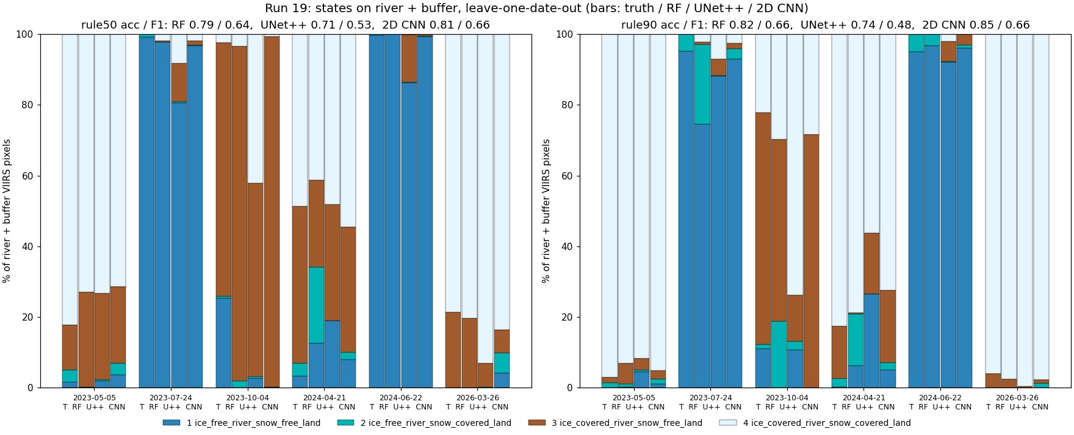
Run 19: states per date, truth and every model.

Prediction images with the water / land split
Each image starts with VIIRS (I3/I2/I1) and Landsat 30 m of the same day side by side, for visual checking. Landsat is shown in bands B6/B5/B4 (SWIR1 / NIR / red), the same bands as VIIRS I3/I2/I1, so colours compare directly: ice and snow are cyan, open water dark blue, vegetation green / red. Landsat exists for all 10 dates (the README of each Patches folder gives its time; VIIRS passed 21-69 min later). Our masks are drawn on both: yellow line = river (occurrence >= 0.05), orange dashed line = outer edge of the 1-pixel buffer (run 19 only). On days without a run 16 map, Landsat is only shown, never used as truth or input. Third panel: the run 16 Landsat 30 m map (six classes) - the label source on the 6 labelled days; on the 4 other days the run 16 model applied to that Landsat scene in run 17, shown for comparison only.
Then one map per model with all four predicted states. Yellow box: water (river) % vs land %, water split into open water / ice, land split into snow / no snow, for the predicted area and for the whole VIIRS image (the % comes from the run 18 % models; for the 2D CNN a % model of the same design). The six labelled days are left-out test days; the four VIIRS-only days are predicted by final models trained on all six labelled days.
date | source | area | water % | open / ice % of water | land % | snow / no snow % of land
2023-05-05 | Landsat truth | river + buffer | 24.5 | 5 / 95 | 75.5 | 77 / 23
2023-05-05 | Landsat truth | whole VIIRS image | 4.0 | 5 / 95 | 96.0 | 73 / 27
2023-05-05 | RF | river + buffer | 23.9 | 12 / 88 | 76.1 | 64 / 36
2023-05-05 | RF | whole VIIRS image | 6.7 | 20 / 80 | 93.3 | 64 / 36
2023-05-05 | UNet++ | river + buffer | 17.2 | 3 / 97 | 82.8 | 66 / 34
2023-05-05 | UNet++ | whole VIIRS image | 3.0 | 6 / 94 | 97.0 | 66 / 34
2023-05-05 | 2D CNN | river + buffer | 22.8 | 4 / 96 | 77.2 | 87 / 13
2023-05-05 | 2D CNN | whole VIIRS image | 3.8 | 5 / 95 | 96.2 | 84 / 16
2023-07-24 | Landsat truth | river + buffer | 24.2 | 100 / 0 | 75.8 | 1 / 99
2023-07-24 | Landsat truth | whole VIIRS image | 3.9 | 100 / 0 | 96.1 | 0 / 100
2023-07-24 | RF | river + buffer | 20.6 | 92 / 8 | 79.4 | 7 / 93
2023-07-24 | RF | whole VIIRS image | 4.4 | 92 / 8 | 95.6 | 6 / 94
2023-07-24 | UNet++ | river + buffer | 20.8 | 89 / 11 | 79.2 | 11 / 89
2023-07-24 | UNet++ | whole VIIRS image | 4.7 | 78 / 22 | 95.3 | 11 / 89
2023-07-24 | 2D CNN | river + buffer | 23.2 | 97 / 3 | 76.8 | 4 / 96
2023-07-24 | 2D CNN | whole VIIRS image | 3.9 | 96 / 4 | 96.1 | 4 / 96
2023-10-04 | Landsat truth | river + buffer | 23.1 | 49 / 51 | 76.9 | 5 / 95
2023-10-04 | Landsat truth | whole VIIRS image | 3.7 | 49 / 51 | 96.3 | 6 / 94
2023-10-04 | RF | river + buffer | 10.6 | 47 / 53 | 89.4 | 18 / 82
2023-10-04 | RF | whole VIIRS image | 1.9 | 48 / 52 | 98.1 | 13 / 87
2023-10-04 | UNet++ | river + buffer | 8.7 | 53 / 47 | 91.3 | 16 / 84
2023-10-04 | UNet++ | whole VIIRS image | 1.5 | 51 / 49 | 98.5 | 11 / 89
2023-10-04 | 2D CNN | river + buffer | 22.6 | 41 / 59 | 77.4 | 7 / 93
2023-10-04 | 2D CNN | whole VIIRS image | 4.0 | 39 / 61 | 96.0 | 10 / 90
2024-04-21 | Landsat truth | river + buffer | 24.1 | 10 / 90 | 75.9 | 49 / 51
2024-04-21 | Landsat truth | whole VIIRS image | 3.9 | 11 / 89 | 96.1 | 36 / 64
2024-04-21 | RF | river + buffer | 21.7 | 20 / 80 | 78.3 | 48 / 52
2024-04-21 | RF | whole VIIRS image | 6.6 | 50 / 50 | 93.4 | 29 / 71
2024-04-21 | UNet++ | river + buffer | 16.6 | 16 / 84 | 83.4 | 49 / 51
2024-04-21 | UNet++ | whole VIIRS image | 3.1 | 20 / 80 | 96.9 | 32 / 68
2024-04-21 | 2D CNN | river + buffer | 26.1 | 19 / 81 | 73.9 | 51 / 49
2024-04-21 | 2D CNN | whole VIIRS image | 8.2 | 37 / 63 | 91.8 | 38 / 62
2024-06-22 | Landsat truth | river + buffer | 24.2 | 100 / 0 | 75.8 | 1 / 99
2024-06-22 | Landsat truth | whole VIIRS image | 3.9 | 100 / 0 | 96.1 | 0 / 100
2024-06-22 | RF | river + buffer | 21.4 | 97 / 3 | 78.6 | 2 / 98
2024-06-22 | RF | whole VIIRS image | 3.7 | 97 / 3 | 96.3 | 1 / 99
2024-06-22 | UNet++ | river + buffer | 18.4 | 97 / 3 | 81.6 | 1 / 99
2024-06-22 | UNet++ | whole VIIRS image | 3.0 | 95 / 5 | 97.0 | 0 / 100
2024-06-22 | 2D CNN | river + buffer | 23.8 | 100 / 0 | 76.2 | 0 / 100
2024-06-22 | 2D CNN | whole VIIRS image | 4.5 | 99 / 1 | 95.5 | 0 / 100
2026-03-26 | Landsat truth | river + buffer | 25.6 | 0 / 100 | 74.4 | 71 / 29
2026-03-26 | Landsat truth | whole VIIRS image | 4.2 | 0 / 100 | 95.8 | 68 / 32
2026-03-26 | RF | river + buffer | 23.1 | 7 / 93 | 76.9 | 74 / 26
2026-03-26 | RF | whole VIIRS image | 5.1 | 8 / 92 | 94.9 | 66 / 34
2026-03-26 | UNet++ | river + buffer | 28.3 | 1 / 99 | 71.7 | 81 / 19
2026-03-26 | UNet++ | whole VIIRS image | 5.0 | 2 / 98 | 95.0 | 78 / 22
2026-03-26 | 2D CNN | river + buffer | 19.7 | 1 / 99 | 80.3 | 80 / 20
2026-03-26 | 2D CNN | whole VIIRS image | 3.3 | 1 / 99 | 96.7 | 76 / 24
2023-04-19 | RF | river + buffer | 23.6 | 1 / 99 | 76.4 | 83 / 17
2023-04-19 | RF | whole VIIRS image | 4.4 | 2 / 98 | 95.6 | 78 / 22
2023-04-19 | UNet++ | river + buffer | 23.8 | 2 / 98 | 76.2 | 79 / 21
2023-04-19 | UNet++ | whole VIIRS image | 4.0 | 3 / 97 | 96.0 | 76 / 24
2023-04-19 | 2D CNN | river + buffer | 24.9 | 1 / 99 | 75.1 | 86 / 14
2023-04-19 | 2D CNN | whole VIIRS image | 4.2 | 4 / 96 | 95.8 | 76 / 24
2024-09-02 | RF | river + buffer | 20.1 | 89 / 11 | 79.9 | 4 / 96
2024-09-02 | RF | whole VIIRS image | 3.5 | 89 / 11 | 96.5 | 3 / 97
2024-09-02 | UNet++ | river + buffer | 20.9 | 96 / 4 | 79.1 | 2 / 98
2024-09-02 | UNet++ | whole VIIRS image | 3.8 | 90 / 10 | 96.2 | 1 / 99
2024-09-02 | 2D CNN | river + buffer | 24.7 | 95 / 5 | 75.3 | 2 / 98
2024-09-02 | 2D CNN | whole VIIRS image | 4.4 | 91 / 9 | 95.6 | 2 / 98
2025-07-04 | RF | river + buffer | 23.6 | 97 / 3 | 76.4 | 7 / 93
2025-07-04 | RF | whole VIIRS image | 6.4 | 98 / 2 | 93.6 | 5 / 95
2025-07-04 | UNet++ | river + buffer | 24.3 | 99 / 1 | 75.7 | 3 / 97
2025-07-04 | UNet++ | whole VIIRS image | 4.6 | 90 / 10 | 95.4 | 3 / 97
2025-07-04 | 2D CNN | river + buffer | 29.6 | 91 / 9 | 70.4 | 16 / 84
2025-07-04 | 2D CNN | whole VIIRS image | 6.5 | 81 / 19 | 93.5 | 22 / 78
2026-08-01 | RF | river + buffer | 21.0 | 96 / 4 | 79.0 | 3 / 97
2026-08-01 | RF | whole VIIRS image | 3.6 | 96 / 4 | 96.4 | 2 / 98
2026-08-01 | UNet++ | river + buffer | 24.0 | 98 / 2 | 76.0 | 2 / 98
2026-08-01 | UNet++ | whole VIIRS image | 4.4 | 92 / 8 | 95.6 | 1 / 99
2026-08-01 | 2D CNN | river + buffer | 22.0 | 100 / 0 | 78.0 | 0 / 100
2026-08-01 | 2D CNN | whole VIIRS image | 3.5 | 100 / 0 | 96.5 | 0 / 100

States, % of predicted pixels (1 / 2 / 3 / 4), rule50
date | source | 1 | 2 | 3 | 4
2023-05-05 | Landsat truth | 1.6 | 3.5 | 12.7 | 82.2
2023-05-05 | RF | 0.3 | 0.0 | 26.9 | 72.9
2023-05-05 | UNet++ | 2.0 | 0.3 | 24.5 | 73.2
2023-05-05 | 2D CNN | 3.7 | 3.2 | 21.8 | 71.4
2023-07-24 | Landsat truth | 99.1 | 0.9 | 0.0 | 0.0
2023-07-24 | RF | 97.7 | 0.0 | 0.4 | 2.0
2023-07-24 | UNet++ | 80.5 | 0.3 | 10.9 | 8.2
2023-07-24 | 2D CNN | 96.6 | 0.2 | 1.3 | 1.9
2023-10-04 | Landsat truth | 25.3 | 0.6 | 71.6 | 2.5
2023-10-04 | RF | 0.0 | 2.0 | 94.6 | 3.4
2023-10-04 | UNet++ | 2.6 | 0.6 | 54.7 | 42.1
2023-10-04 | 2D CNN | 0.3 | 0.0 | 99.1 | 0.7
2024-04-21 | Landsat truth | 3.3 | 3.7 | 44.4 | 48.6
2024-04-21 | RF | 12.6 | 21.4 | 24.6 | 41.3
2024-04-21 | UNet++ | 18.9 | 0.1 | 32.8 | 48.1
2024-04-21 | 2D CNN | 8.1 | 2.0 | 35.4 | 54.5
2024-06-22 | Landsat truth | 99.7 | 0.3 | 0.0 | 0.0
2024-06-22 | RF | 99.9 | 0.1 | 0.0 | 0.0
2024-06-22 | UNet++ | 86.2 | 0.2 | 13.4 | 0.2
2024-06-22 | 2D CNN | 99.3 | 0.1 | 0.6 | 0.0
2026-03-26 | Landsat truth | 0.0 | 0.0 | 21.5 | 78.5
2026-03-26 | RF | 0.0 | 0.0 | 19.8 | 80.2
2026-03-26 | UNet++ | 0.0 | 0.2 | 6.8 | 93.0
2026-03-26 | 2D CNN | 4.1 | 5.8 | 6.4 | 83.6
2023-04-19 | RF | 0.0 | 0.0 | 10.4 | 89.6
2023-04-19 | UNet++ | 0.1 | 0.1 | 14.6 | 85.2
2023-04-19 | 2D CNN | 1.3 | 1.4 | 12.2 | 85.1
2024-09-02 | RF | 47.9 | 0.0 | 52.1 | 0.0
2024-09-02 | UNet++ | 49.3 | 0.0 | 50.5 | 0.2
2024-09-02 | 2D CNN | 39.1 | 0.0 | 60.7 | 0.2
2025-07-04 | RF | 100.0 | 0.0 | 0.0 | 0.0
2025-07-04 | UNet++ | 100.0 | 0.0 | 0.0 | 0.0
2025-07-04 | 2D CNN | 99.8 | 0.2 | 0.1 | 0.0
2026-08-01 | RF | 99.9 | 0.0 | 0.1 | 0.0
2026-08-01 | UNet++ | 85.7 | 0.1 | 11.2 | 3.1
2026-08-01 | 2D CNN | 98.5 | 0.1 | 1.4 | 0.0

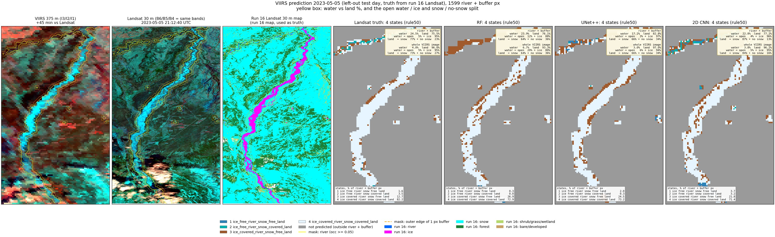
Run 19, 2023-05-05 (spring break-up, left-out test day): predicted states (rule50) and the water / land split.
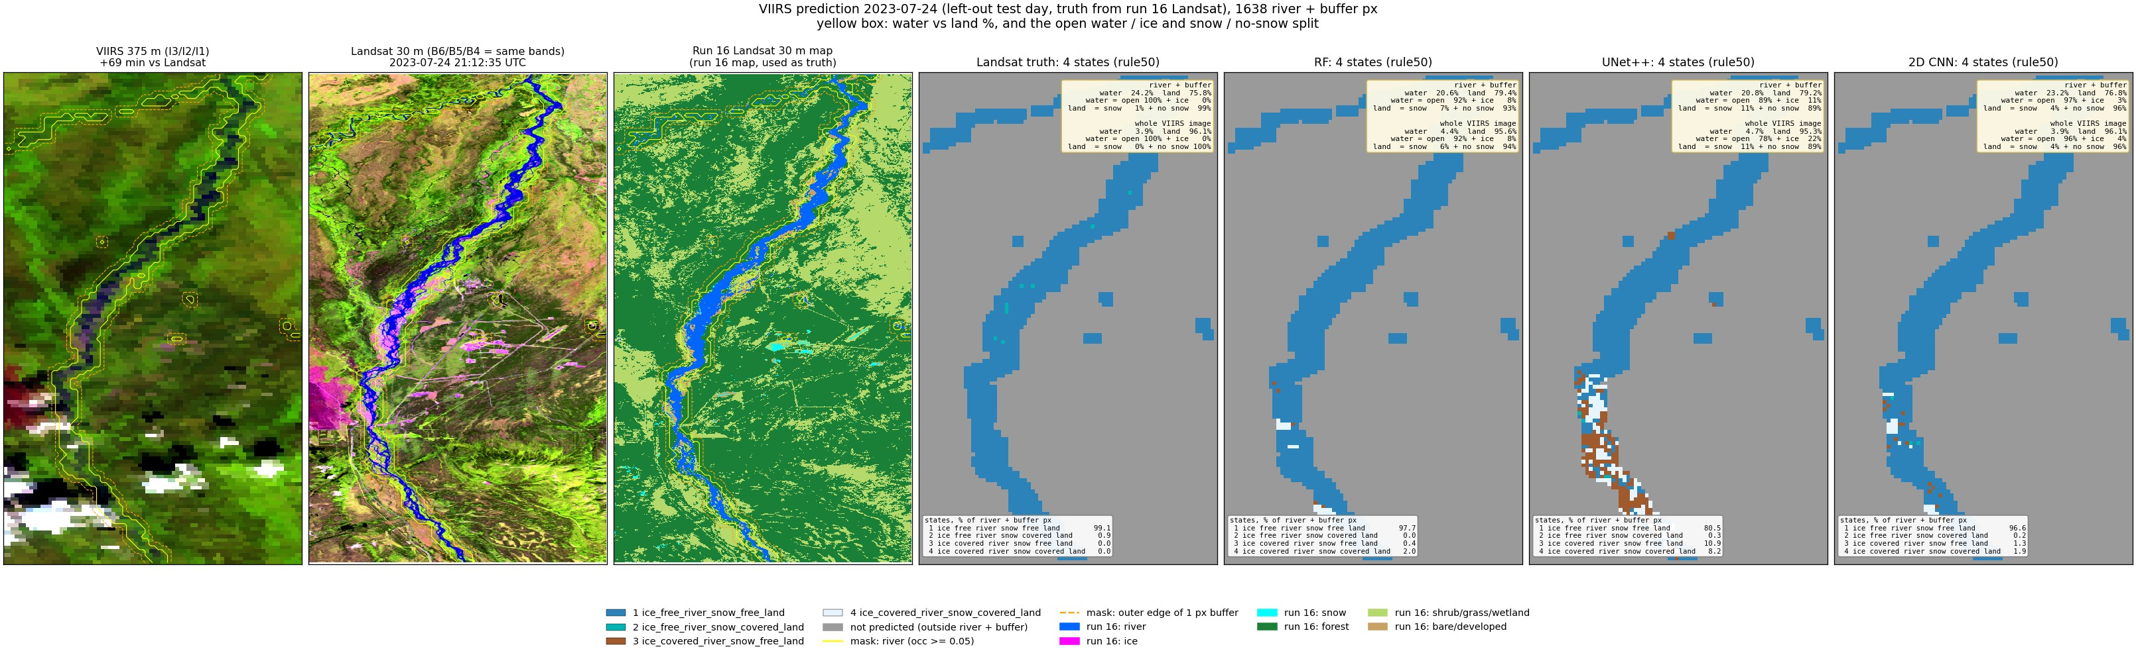
Run 19, 2023-07-24 (summer, left-out test day): predicted states (rule50) and the water / land split.
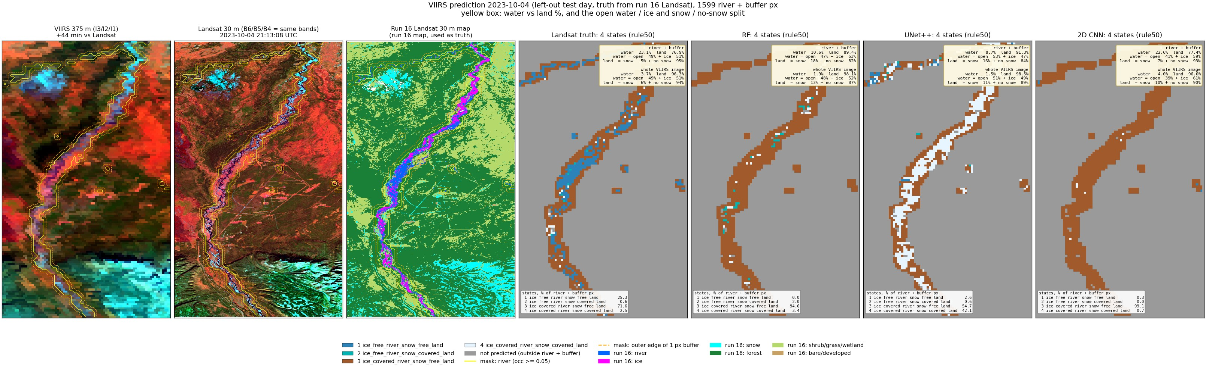
Run 19, 2023-10-04 (autumn freeze-up, left-out test day): predicted states (rule50) and the water / land split.
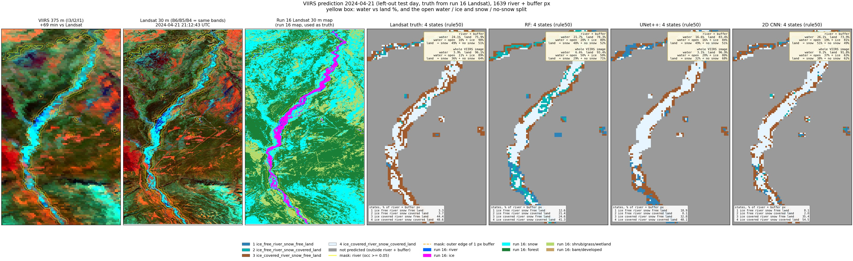
Run 19, 2024-04-21 (spring break-up, left-out test day): predicted states (rule50) and the water / land split.
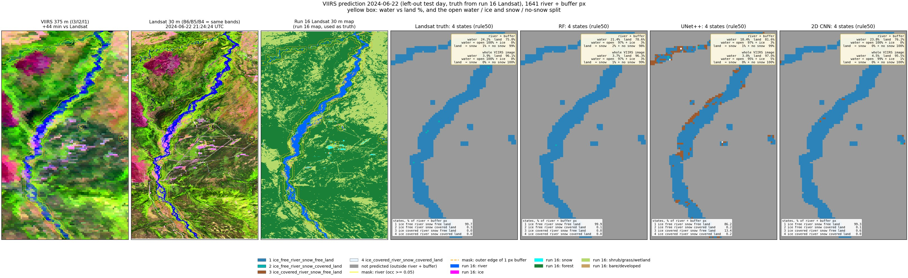
Run 19, 2024-06-22 (summer, left-out test day): predicted states (rule50) and the water / land split.
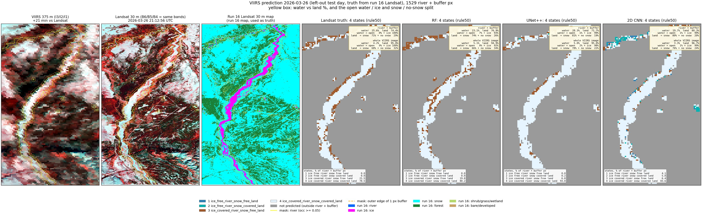
Run 19, 2026-03-26 (late winter, left-out test day): predicted states (rule50) and the water / land split.
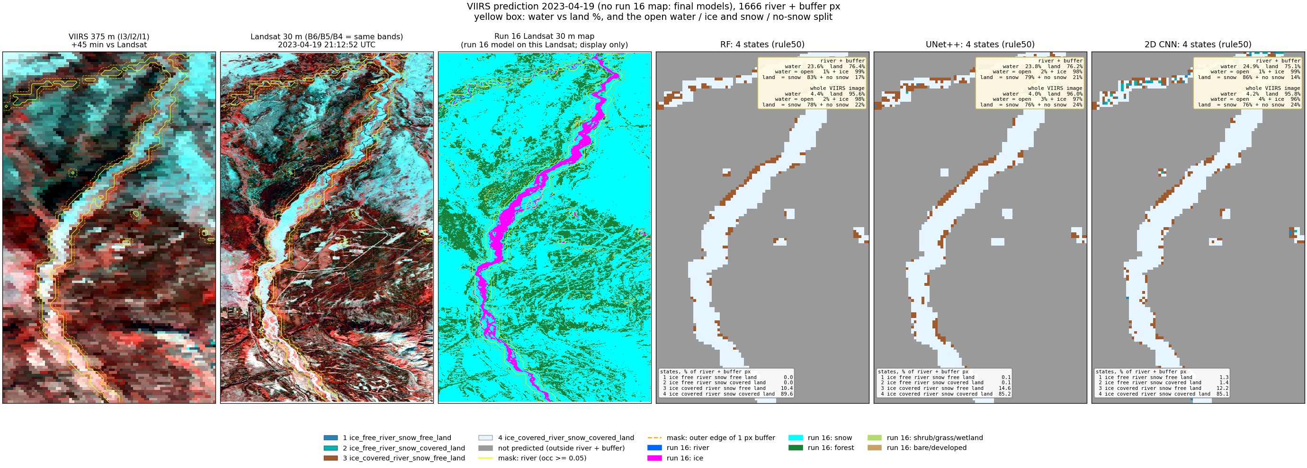
Run 19, 2023-04-19 (spring, snow, VIIRS only, final models): predicted states (rule50) and the water / land split.
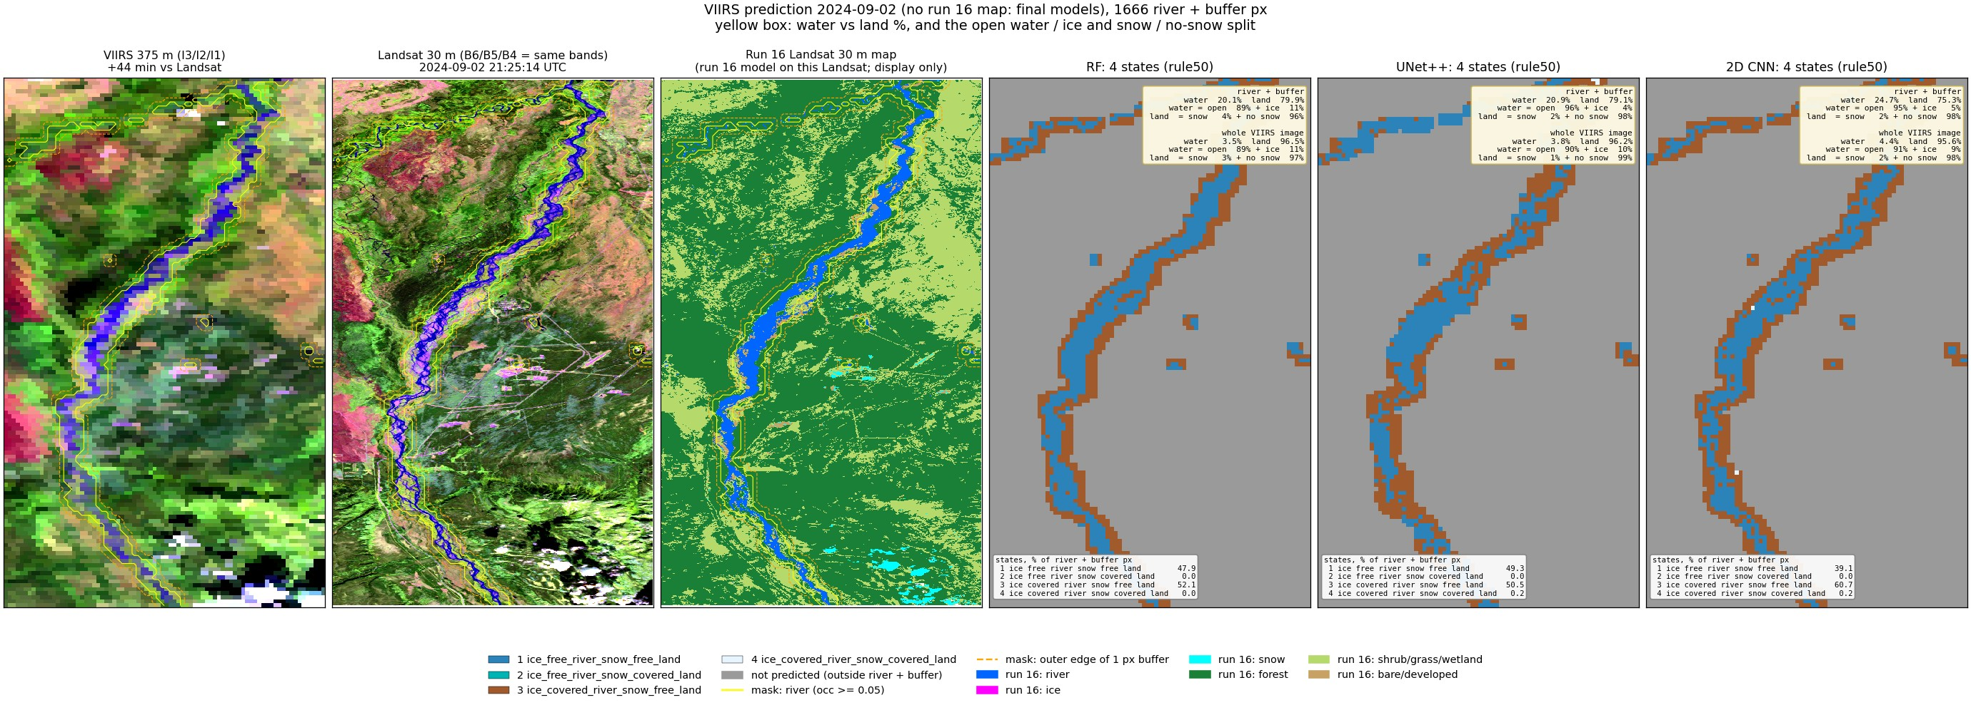
Run 19, 2024-09-02 (late summer, VIIRS only, final models): predicted states (rule50) and the water / land split.
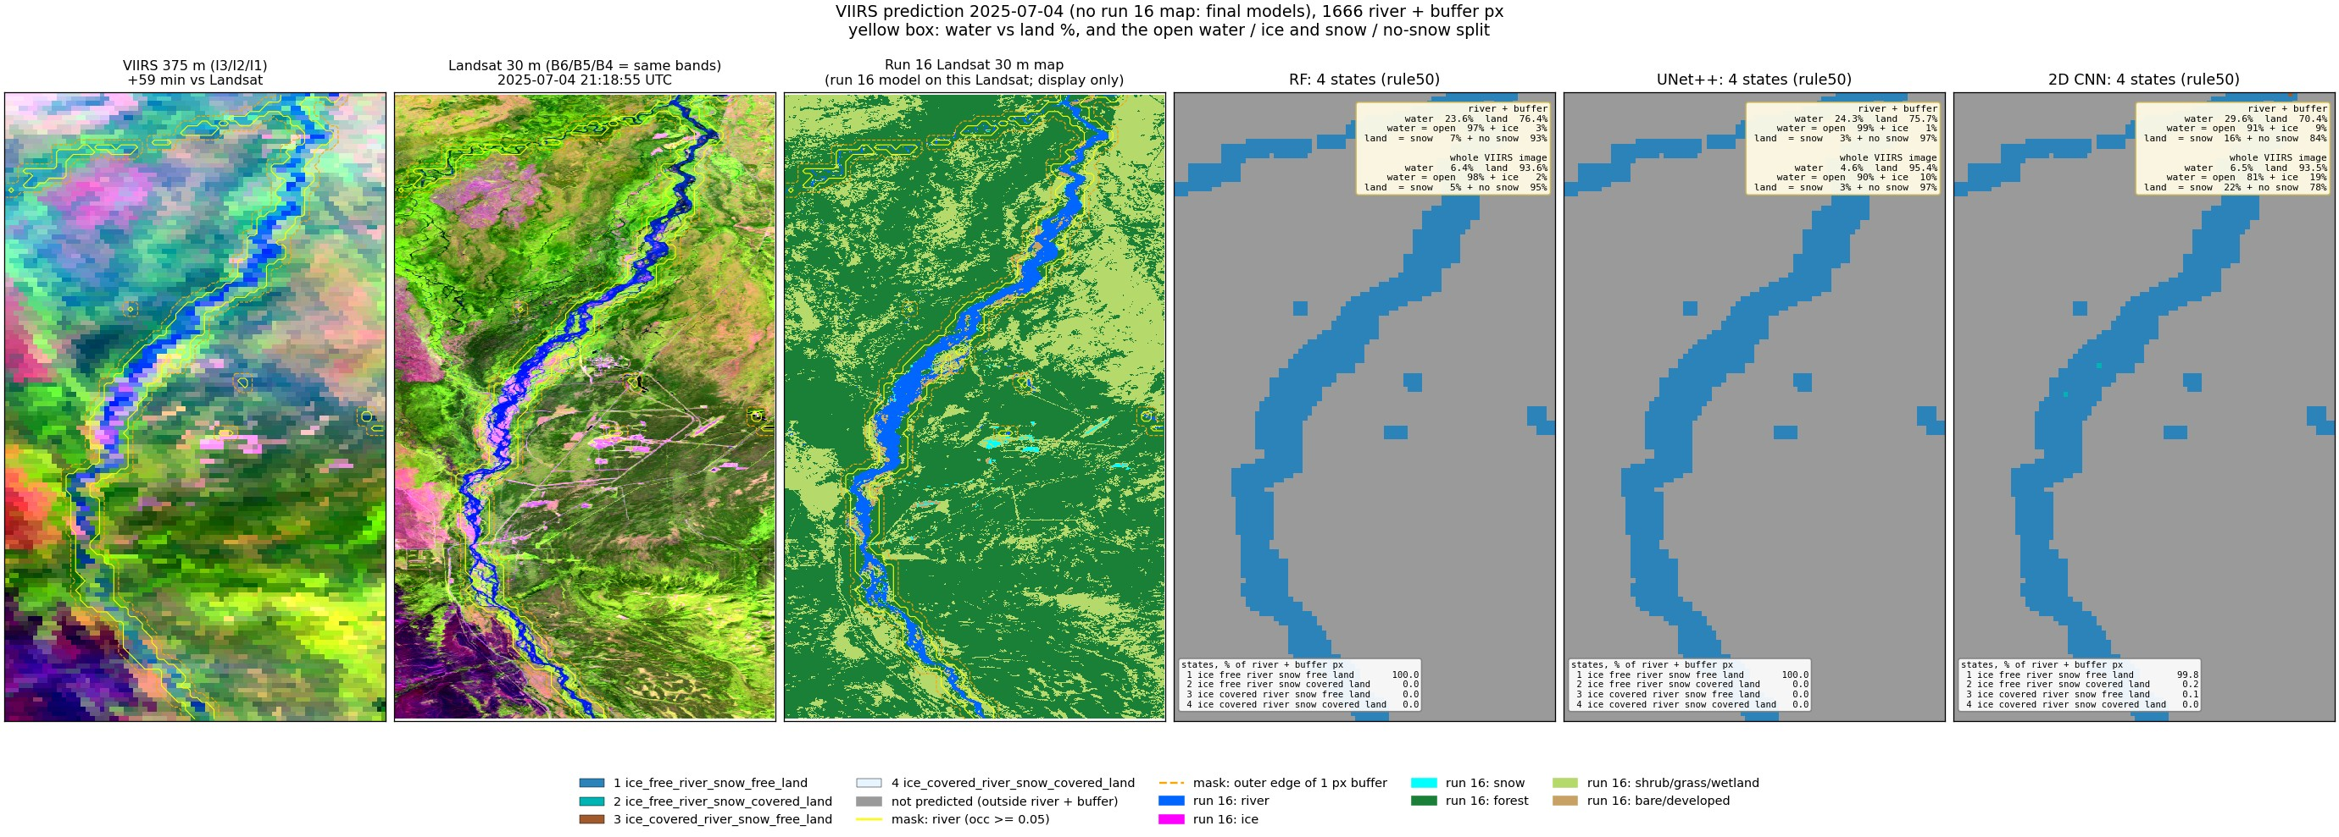
Run 19, 2025-07-04 (summer, VIIRS only, final models): predicted states (rule50) and the water / land split.
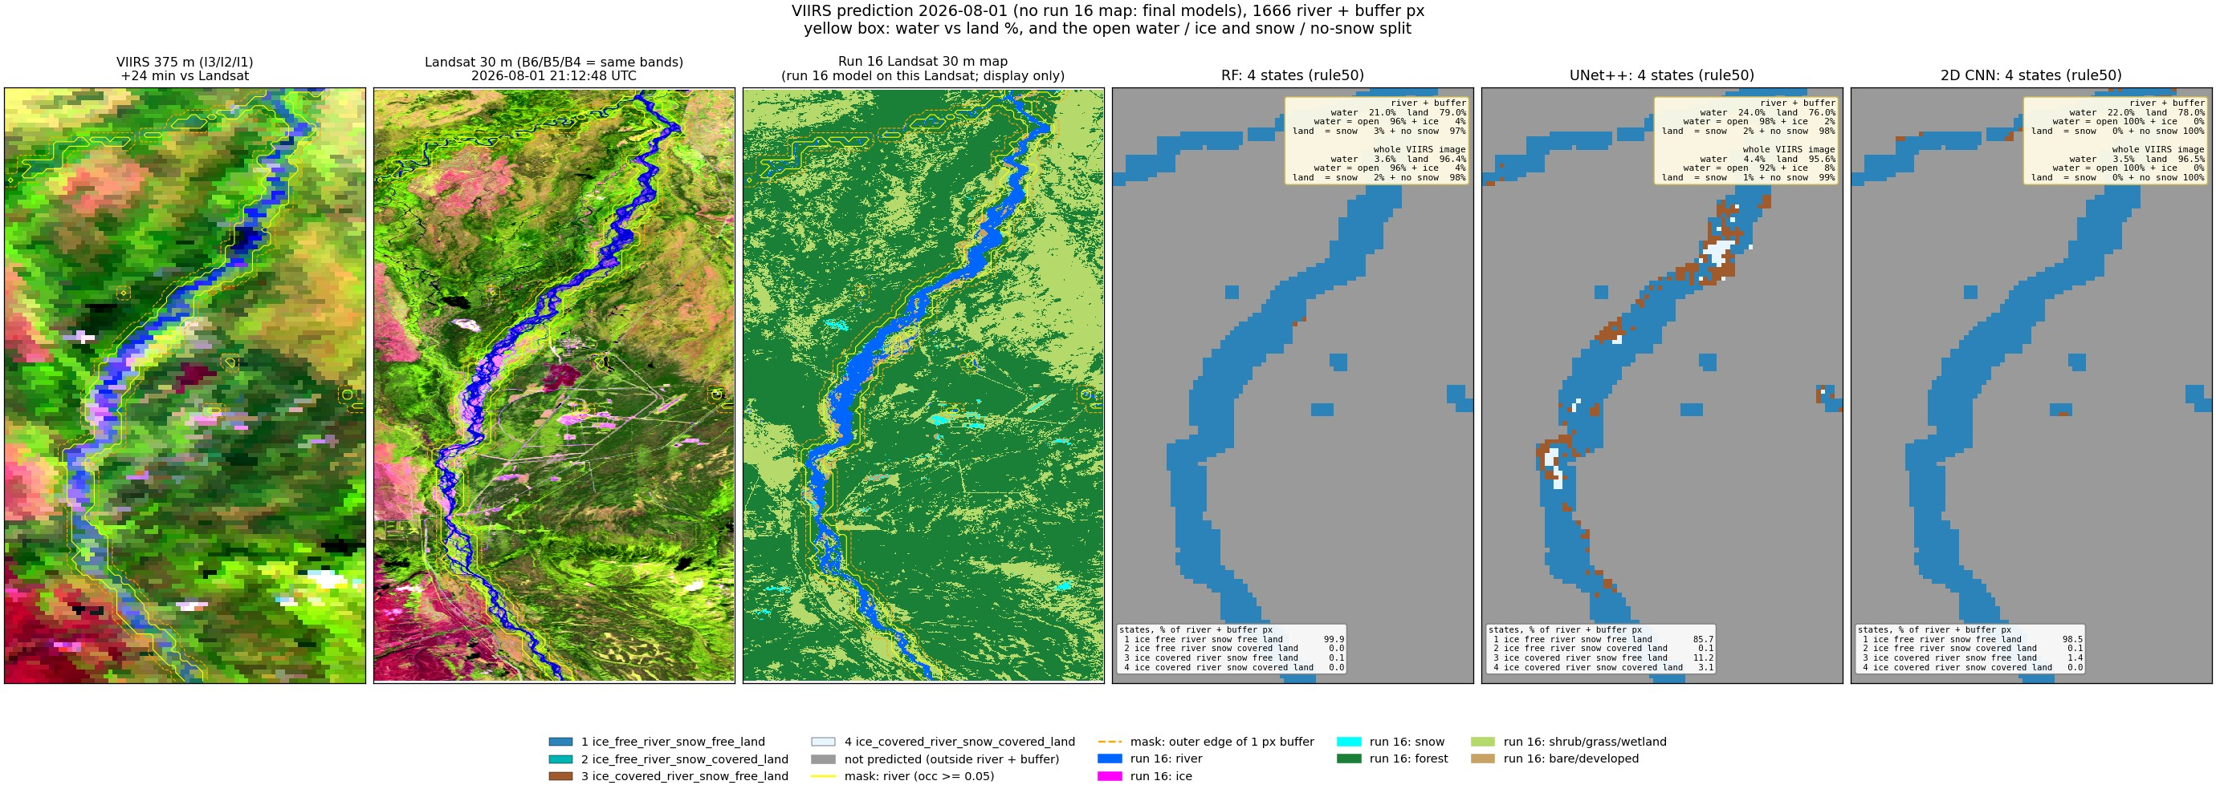
Run 19, 2026-08-01 (summer, VIIRS only, final models): predicted states (rule50) and the water / land split.

6. Run 20: four states on the river only (no buffer)
Same water mask and cut (occurrence >= 0.05), no buffer: 988 river pixels only. Buffer pixels are mostly land, so their river state came from the date; without them every scored pixel holds river.
Models predict the four states at once (one 4-class model per rule), trained and scored only on these pixels: RF classifier with the run 16 settings (depth 16, min leaf 20, sqrt, 300 trees, balanced_subsample; 21 inputs, so no top-25 selection); UNet++ (resnet18, 4-class cross-entropy on mask pixels, 1500 steps, flips, flip TTA); 2D CNN (4 conv 3 x 3 layers 32-64-64-64 with batch norm and ReLU, dropout 0.1, 1 x 1 output, no down-sampling, so each pixel sees 9 x 9 VIIRS pixels = 3.4 km; 97k parameters; same training as UNet++).
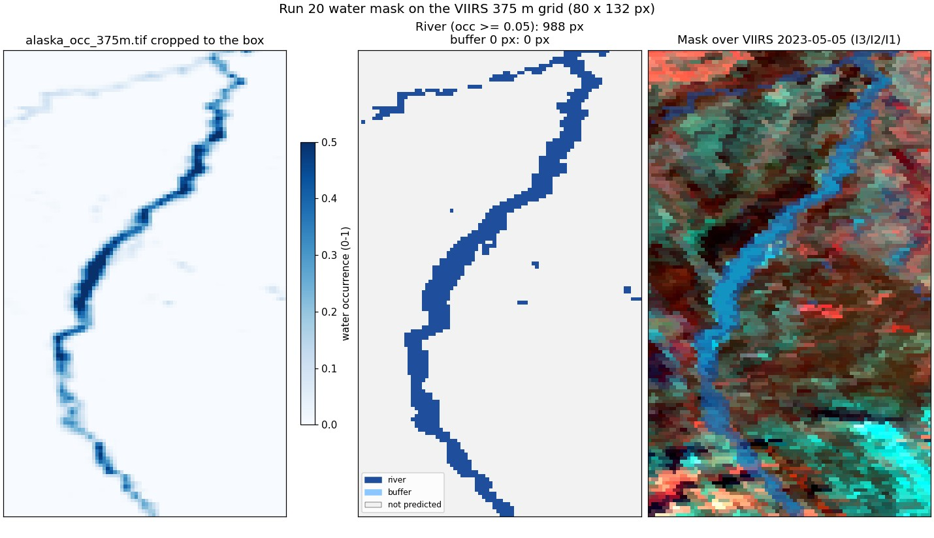
Run 20: the water mask cropped to the image and the predicted area.

rule50
model | accuracy | macro F1
RF | 0.731 | 0.580
UNet++ | 0.698 | 0.481
2D CNN | 0.751 | 0.588

state | true px | RF F1 | RF prec | RF rec | UNet++ F1 | UNet++ prec | UNet++ rec | 2D CNN F1 | 2D CNN prec | 2D CNN rec
1 open river, no-snow land | 2,314 | 0.88 | 0.93 | 0.83 | 0.80 | 0.84 | 0.77 | 0.87 | 0.95 | 0.80
2 open river, snow land | 119 | 0.14 | 0.08 | 0.41 | 0.03 | 0.08 | 0.02 | 0.10 | 0.08 | 0.17
3 ice river, no-snow land | 1,073 | 0.50 | 0.48 | 0.53 | 0.35 | 0.44 | 0.29 | 0.58 | 0.49 | 0.71
4 ice river, snow land | 2,211 | 0.80 | 0.88 | 0.74 | 0.75 | 0.66 | 0.86 | 0.79 | 0.85 | 0.75

RF confusion, rule50 (rows true, columns predicted)
true \ predicted | 1 | 2 | 3 | 4
1 open river, no-snow land | 1,918 | 59 | 323 | 14
2 open river, snow land | 19 | 49 | 40 | 11
3 ice river, no-snow land | 101 | 200 | 567 | 205
4 ice river, snow land | 22 | 295 | 251 | 1,643

UNet++ confusion, rule50 (rows true, columns predicted)
true \ predicted | 1 | 2 | 3 | 4
1 open river, no-snow land | 1,774 | 19 | 222 | 299
2 open river, snow land | 70 | 2 | 8 | 39
3 ice river, no-snow land | 130 | 4 | 307 | 632
4 ice river, snow land | 137 | 1 | 167 | 1,906

2D CNN confusion, rule50 (rows true, columns predicted)
true \ predicted | 1 | 2 | 3 | 4
1 open river, no-snow land | 1,860 | 10 | 419 | 25
2 open river, snow land | 28 | 20 | 29 | 42
3 ice river, no-snow land | 40 | 44 | 766 | 223
4 ice river, snow land | 27 | 190 | 345 | 1,649

rule90
model | accuracy | macro F1
RF | 0.799 | 0.600
UNet++ | 0.755 | 0.431
2D CNN | 0.825 | 0.602

state | true px | RF F1 | RF prec | RF rec | UNet++ F1 | UNet++ prec | UNet++ rec | 2D CNN F1 | 2D CNN prec | 2D CNN rec
1 open river, no-snow land | 1,923 | 0.88 | 0.92 | 0.83 | 0.78 | 0.72 | 0.86 | 0.88 | 0.88 | 0.89
2 open river, snow land | 207 | 0.20 | 0.13 | 0.43 | 0.05 | 0.11 | 0.03 | 0.18 | 0.23 | 0.14
3 ice river, no-snow land | 565 | 0.44 | 0.76 | 0.31 | 0.05 | 0.14 | 0.03 | 0.46 | 0.51 | 0.42
4 ice river, snow land | 3,022 | 0.89 | 0.89 | 0.89 | 0.84 | 0.82 | 0.87 | 0.88 | 0.86 | 0.91

RF confusion, rule90 (rows true, columns predicted)
true \ predicted | 1 | 2 | 3 | 4
1 open river, no-snow land | 1,603 | 255 | 1 | 64
2 open river, snow land | 94 | 89 | 2 | 22
3 ice river, no-snow land | 16 | 110 | 174 | 265
4 ice river, snow land | 24 | 243 | 52 | 2,703

UNet++ confusion, rule90 (rows true, columns predicted)
true \ predicted | 1 | 2 | 3 | 4
1 open river, no-snow land | 1,654 | 23 | 65 | 181
2 open river, snow land | 153 | 6 | 10 | 38
3 ice river, no-snow land | 155 | 13 | 18 | 379
4 ice river, snow land | 334 | 14 | 38 | 2,636

2D CNN confusion, rule90 (rows true, columns predicted)
true \ predicted | 1 | 2 | 3 | 4
1 open river, no-snow land | 1,708 | 39 | 85 | 91
2 open river, snow land | 124 | 30 | 13 | 40
3 ice river, no-snow land | 17 | 4 | 237 | 307
4 ice river, snow land | 95 | 57 | 126 | 2,744

Confusion matrices and other metrics
Rows = true state, columns = predicted state; each cell shows the pixel count and the % of that true state (recall). Balanced accuracy = mean recall over the states present; Cohen κ = agreement beyond chance; weighted F1 = F1 weighted by the number of true pixels per state.
rule | model | accuracy | balanced acc | Cohen κ | macro prec | macro rec | macro F1 | weighted F1
rule50 | RF | 0.731 | 0.628 | 0.608 | 0.592 | 0.628 | 0.580 | 0.763
rule50 | UNet++ | 0.698 | 0.483 | 0.522 | 0.504 | 0.483 | 0.481 | 0.680
rule50 | 2D CNN | 0.751 | 0.608 | 0.633 | 0.592 | 0.608 | 0.588 | 0.771
rule90 | RF | 0.799 | 0.616 | 0.669 | 0.674 | 0.616 | 0.600 | 0.815
rule90 | UNet++ | 0.755 | 0.448 | 0.564 | 0.445 | 0.448 | 0.431 | 0.716
rule90 | 2D CNN | 0.825 | 0.590 | 0.700 | 0.621 | 0.590 | 0.602 | 0.817

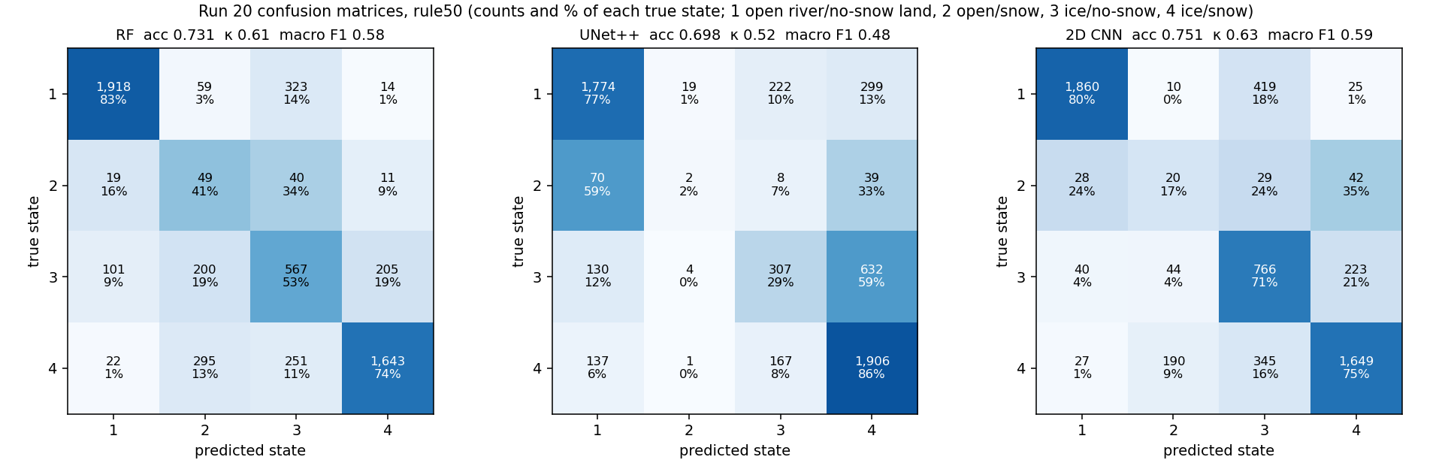
Run 20: confusion matrices, rule50, every model (leave-one-date-out).
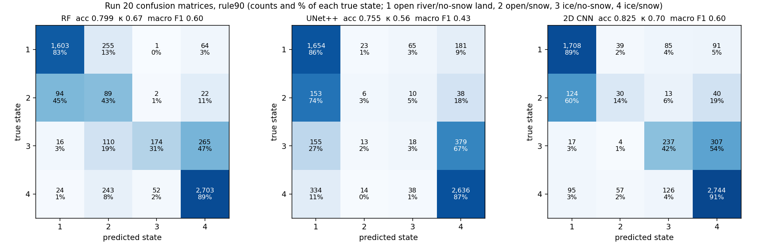
Run 20: confusion matrices, rule90, every model (leave-one-date-out).
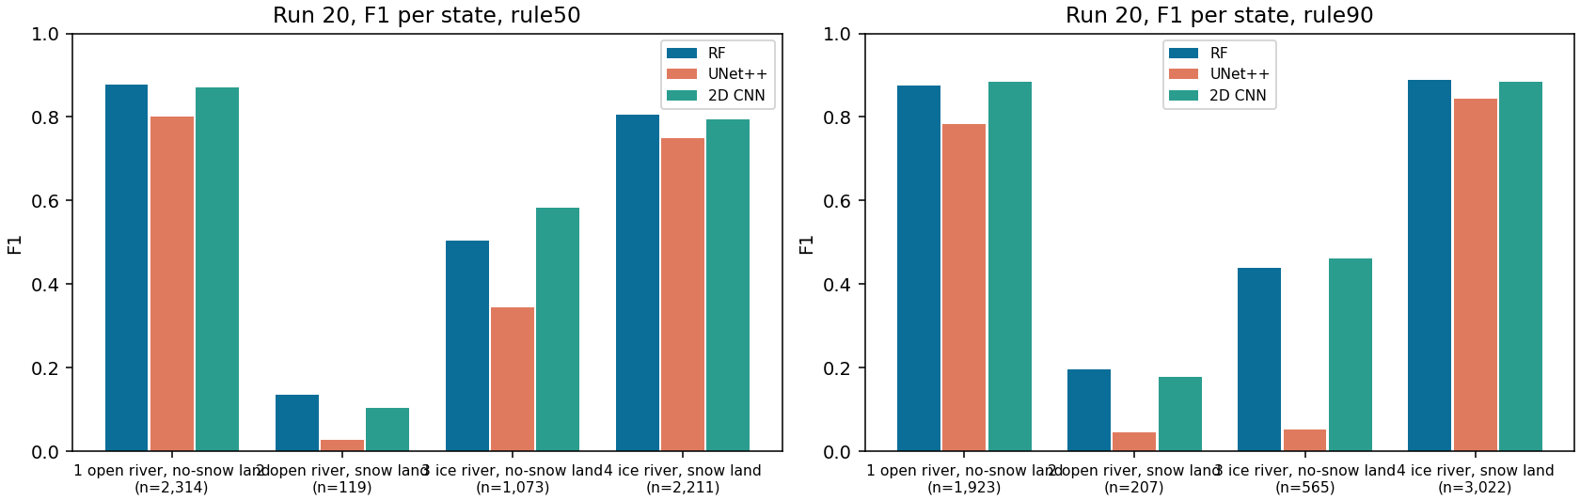
Run 20: F1 per state and model (n = true pixels).

Accuracy per date
date | px | RF 50 | RF 90 | UNet++ 50 | UNet++ 90 | 2D CNN 50 | 2D CNN 90
2023-05-05 | 951 | 0.75 | 0.96 | 0.78 | 0.90 | 0.79 | 0.96
2023-07-24 | 970 | 0.97 | 0.80 | 0.83 | 0.80 | 0.96 | 0.86
2023-10-04 | 931 | 0.50 | 0.44 | 0.25 | 0.30 | 0.59 | 0.48
2024-04-21 | 969 | 0.33 | 0.71 | 0.48 | 0.68 | 0.62 | 0.76
2024-06-22 | 970 | 0.99 | 0.91 | 0.95 | 0.86 | 0.94 | 0.92
2026-03-26 | 926 | 0.84 | 0.98 | 0.88 | 0.99 | 0.60 | 0.96

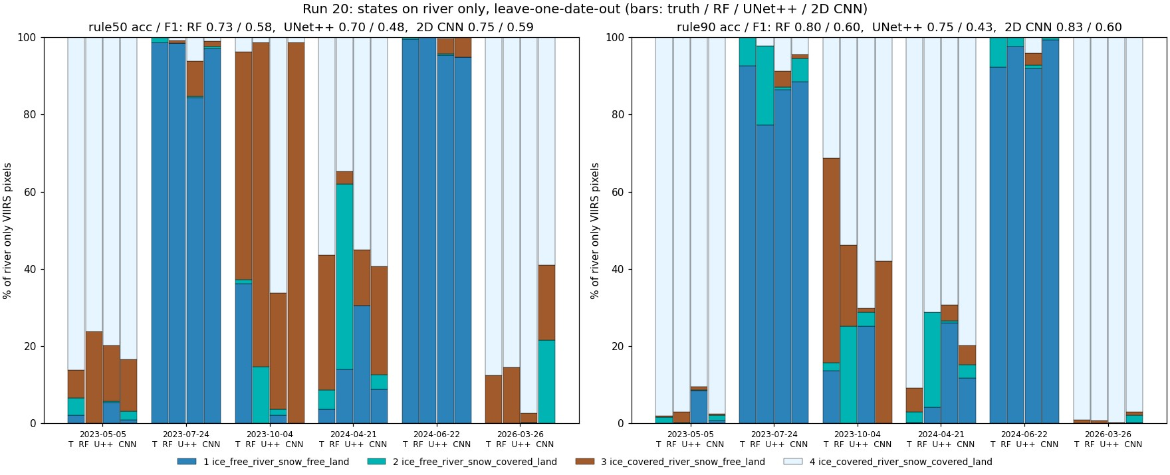
Run 20: states per date, truth and every model.

Prediction images with the water / land split
Each image starts with VIIRS (I3/I2/I1) and Landsat 30 m of the same day side by side, for visual checking. Landsat is shown in bands B6/B5/B4 (SWIR1 / NIR / red), the same bands as VIIRS I3/I2/I1, so colours compare directly: ice and snow are cyan, open water dark blue, vegetation green / red. Landsat exists for all 10 dates (the README of each Patches folder gives its time; VIIRS passed 21-69 min later). Our masks are drawn on both: yellow line = river (occurrence >= 0.05), orange dashed line = outer edge of the 1-pixel buffer (run 19 only). On days without a run 16 map, Landsat is only shown, never used as truth or input. Third panel: the run 16 Landsat 30 m map (six classes) - the label source on the 6 labelled days; on the 4 other days the run 16 model applied to that Landsat scene in run 17, shown for comparison only.
Then one map per model with all four predicted states. Yellow box: water (river) % vs land %, water split into open water / ice, land split into snow / no snow, for the predicted area and for the whole VIIRS image (the % comes from the run 18 % models; for the 2D CNN a % model of the same design). The six labelled days are left-out test days; the four VIIRS-only days are predicted by final models trained on all six labelled days.
date | source | area | water % | open / ice % of water | land % | snow / no snow % of land
2023-05-05 | Landsat truth | river only | 40.2 | 5 / 95 | 59.8 | 81 / 19
2023-05-05 | Landsat truth | whole VIIRS image | 4.0 | 5 / 95 | 96.0 | 73 / 27
2023-05-05 | RF | river only | 37.3 | 11 / 89 | 62.7 | 66 / 34
2023-05-05 | RF | whole VIIRS image | 6.7 | 20 / 80 | 93.3 | 64 / 36
2023-05-05 | UNet++ | river only | 28.5 | 3 / 97 | 71.5 | 74 / 26
2023-05-05 | UNet++ | whole VIIRS image | 3.0 | 6 / 94 | 97.0 | 66 / 34
2023-05-05 | 2D CNN | river only | 37.6 | 4 / 96 | 62.4 | 90 / 10
2023-05-05 | 2D CNN | whole VIIRS image | 3.8 | 5 / 95 | 96.2 | 84 / 16
2023-07-24 | Landsat truth | river only | 40.0 | 100 / 0 | 60.0 | 2 / 98
2023-07-24 | Landsat truth | whole VIIRS image | 3.9 | 100 / 0 | 96.1 | 0 / 100
2023-07-24 | RF | river only | 33.0 | 92 / 8 | 67.0 | 10 / 90
2023-07-24 | RF | whole VIIRS image | 4.4 | 92 / 8 | 95.6 | 6 / 94
2023-07-24 | UNet++ | river only | 33.2 | 90 / 10 | 66.8 | 14 / 86
2023-07-24 | UNet++ | whole VIIRS image | 4.7 | 78 / 22 | 95.3 | 11 / 89
2023-07-24 | 2D CNN | river only | 38.5 | 97 / 3 | 61.5 | 4 / 96
2023-07-24 | 2D CNN | whole VIIRS image | 3.9 | 96 / 4 | 96.1 | 4 / 96
2023-10-04 | Landsat truth | river only | 38.8 | 48 / 52 | 61.2 | 8 / 92
2023-10-04 | Landsat truth | whole VIIRS image | 3.7 | 49 / 51 | 96.3 | 6 / 94
2023-10-04 | RF | river only | 17.9 | 46 / 54 | 82.1 | 25 / 75
2023-10-04 | RF | whole VIIRS image | 1.9 | 48 / 52 | 98.1 | 13 / 87
2023-10-04 | UNet++ | river only | 14.7 | 53 / 47 | 85.3 | 23 / 77
2023-10-04 | UNet++ | whole VIIRS image | 1.5 | 51 / 49 | 98.5 | 11 / 89
2023-10-04 | 2D CNN | river only | 38.3 | 42 / 58 | 61.7 | 10 / 90
2023-10-04 | 2D CNN | whole VIIRS image | 4.0 | 40 / 60 | 96.0 | 10 / 90
2024-04-21 | Landsat truth | river only | 40.0 | 10 / 90 | 60.0 | 58 / 42
2024-04-21 | Landsat truth | whole VIIRS image | 3.9 | 11 / 89 | 96.1 | 36 / 64
2024-04-21 | RF | river only | 33.7 | 15 / 85 | 66.3 | 59 / 41
2024-04-21 | RF | whole VIIRS image | 6.6 | 50 / 50 | 93.4 | 29 / 71
2024-04-21 | UNet++ | river only | 27.3 | 15 / 85 | 72.7 | 58 / 42
2024-04-21 | UNet++ | whole VIIRS image | 3.1 | 20 / 80 | 96.9 | 32 / 68
2024-04-21 | 2D CNN | river only | 40.0 | 15 / 85 | 60.0 | 57 / 43
2024-04-21 | 2D CNN | whole VIIRS image | 8.3 | 37 / 63 | 91.7 | 38 / 62
2024-06-22 | Landsat truth | river only | 40.0 | 100 / 0 | 60.0 | 2 / 98
2024-06-22 | Landsat truth | whole VIIRS image | 3.9 | 100 / 0 | 96.1 | 0 / 100
2024-06-22 | RF | river only | 35.0 | 96 / 4 | 65.0 | 2 / 98
2024-06-22 | RF | whole VIIRS image | 3.7 | 97 / 3 | 96.3 | 1 / 99
2024-06-22 | UNet++ | river only | 30.7 | 97 / 3 | 69.3 | 2 / 98
2024-06-22 | UNet++ | whole VIIRS image | 3.0 | 95 / 5 | 97.0 | 0 / 100
2024-06-22 | 2D CNN | river only | 38.9 | 100 / 0 | 61.1 | 0 / 100
2024-06-22 | 2D CNN | whole VIIRS image | 4.5 | 99 / 1 | 95.5 | 0 / 100
2026-03-26 | Landsat truth | river only | 41.4 | 0 / 100 | 58.6 | 78 / 22
2026-03-26 | Landsat truth | whole VIIRS image | 4.2 | 0 / 100 | 95.8 | 68 / 32
2026-03-26 | RF | river only | 36.6 | 7 / 93 | 63.4 | 78 / 22
2026-03-26 | RF | whole VIIRS image | 5.1 | 8 / 92 | 94.9 | 66 / 34
2026-03-26 | UNet++ | river only | 45.8 | 1 / 99 | 54.2 | 86 / 14
2026-03-26 | UNet++ | whole VIIRS image | 5.0 | 2 / 98 | 95.0 | 78 / 22
2026-03-26 | 2D CNN | river only | 32.6 | 1 / 99 | 67.4 | 86 / 14
2026-03-26 | 2D CNN | whole VIIRS image | 3.3 | 1 / 99 | 96.7 | 76 / 24
2023-04-19 | RF | river only | 38.5 | 1 / 99 | 61.5 | 88 / 12
2023-04-19 | RF | whole VIIRS image | 4.4 | 2 / 98 | 95.6 | 78 / 22
2023-04-19 | UNet++ | river only | 38.6 | 1 / 99 | 61.4 | 86 / 14
2023-04-19 | UNet++ | whole VIIRS image | 4.0 | 4 / 96 | 96.0 | 77 / 23
2023-04-19 | 2D CNN | river only | 41.1 | 1 / 99 | 58.9 | 90 / 10
2023-04-19 | 2D CNN | whole VIIRS image | 4.2 | 4 / 96 | 95.8 | 76 / 24
2024-09-02 | RF | river only | 32.8 | 89 / 11 | 67.2 | 5 / 95
2024-09-02 | RF | whole VIIRS image | 3.5 | 89 / 11 | 96.5 | 3 / 97
2024-09-02 | UNet++ | river only | 34.4 | 97 / 3 | 65.6 | 3 / 97
2024-09-02 | UNet++ | whole VIIRS image | 3.7 | 90 / 10 | 96.3 | 1 / 99
2024-09-02 | 2D CNN | river only | 40.3 | 96 / 4 | 59.7 | 3 / 97
2024-09-02 | 2D CNN | whole VIIRS image | 4.4 | 91 / 9 | 95.6 | 2 / 98
2025-07-04 | RF | river only | 36.8 | 96 / 4 | 63.2 | 9 / 91
2025-07-04 | RF | whole VIIRS image | 6.4 | 98 / 2 | 93.6 | 5 / 95
2025-07-04 | UNet++ | river only | 41.5 | 99 / 1 | 58.5 | 4 / 96
2025-07-04 | UNet++ | whole VIIRS image | 4.8 | 91 / 9 | 95.2 | 3 / 97
2025-07-04 | 2D CNN | river only | 44.0 | 94 / 6 | 56.0 | 12 / 88
2025-07-04 | 2D CNN | whole VIIRS image | 6.4 | 81 / 19 | 93.6 | 22 / 78
2026-08-01 | RF | river only | 34.2 | 95 / 5 | 65.8 | 5 / 95
2026-08-01 | RF | whole VIIRS image | 3.6 | 96 / 4 | 96.4 | 2 / 98
2026-08-01 | UNet++ | river only | 39.8 | 98 / 2 | 60.2 | 3 / 97
2026-08-01 | UNet++ | whole VIIRS image | 4.5 | 91 / 9 | 95.5 | 1 / 99
2026-08-01 | 2D CNN | river only | 36.9 | 100 / 0 | 63.1 | 0 / 100
2026-08-01 | 2D CNN | whole VIIRS image | 3.5 | 100 / 0 | 96.5 | 0 / 100

States, % of predicted pixels (1 / 2 / 3 / 4), rule50
date | source | 1 | 2 | 3 | 4
2023-05-05 | Landsat truth | 2.2 | 4.4 | 7.3 | 86.1
2023-05-05 | RF | 0.0 | 0.0 | 23.8 | 76.2
2023-05-05 | UNet++ | 5.5 | 0.3 | 14.4 | 79.8
2023-05-05 | 2D CNN | 0.9 | 2.2 | 13.4 | 83.5
2023-07-24 | Landsat truth | 98.6 | 1.4 | 0.0 | 0.0
2023-07-24 | RF | 98.5 | 0.0 | 0.7 | 0.8
2023-07-24 | UNet++ | 84.3 | 0.3 | 9.1 | 6.3
2023-07-24 | 2D CNN | 97.0 | 0.6 | 1.3 | 1.0
2023-10-04 | Landsat truth | 36.2 | 1.0 | 59.1 | 3.8
2023-10-04 | RF | 0.0 | 14.7 | 83.9 | 1.4
2023-10-04 | UNet++ | 2.1 | 1.5 | 30.1 | 66.3
2023-10-04 | 2D CNN | 0.0 | 0.0 | 98.6 | 1.4
2024-04-21 | Landsat truth | 3.6 | 5.1 | 34.9 | 56.4
2024-04-21 | RF | 13.9 | 48.1 | 3.3 | 34.7
2024-04-21 | UNet++ | 30.4 | 0.1 | 14.4 | 55.0
2024-04-21 | 2D CNN | 8.8 | 3.9 | 28.0 | 59.3
2024-06-22 | Landsat truth | 99.5 | 0.5 | 0.0 | 0.0
2024-06-22 | RF | 100.0 | 0.0 | 0.0 | 0.0
2024-06-22 | UNet++ | 95.3 | 0.4 | 3.9 | 0.4
2024-06-22 | 2D CNN | 94.7 | 0.0 | 5.3 | 0.0
2026-03-26 | Landsat truth | 0.0 | 0.0 | 12.5 | 87.5
2026-03-26 | RF | 0.0 | 0.0 | 14.6 | 85.4
2026-03-26 | UNet++ | 0.2 | 0.1 | 2.3 | 97.4
2026-03-26 | 2D CNN | 0.1 | 21.5 | 19.3 | 59.1
2023-04-19 | RF | 0.0 | 0.0 | 6.3 | 93.7
2023-04-19 | UNet++ | 0.8 | 1.5 | 6.8 | 90.9
2023-04-19 | 2D CNN | 0.6 | 2.9 | 5.6 | 90.9
2024-09-02 | RF | 63.4 | 0.0 | 36.6 | 0.0
2024-09-02 | UNet++ | 38.7 | 0.1 | 60.1 | 1.1
2024-09-02 | 2D CNN | 67.8 | 0.1 | 32.0 | 0.1
2025-07-04 | RF | 100.0 | 0.0 | 0.0 | 0.0
2025-07-04 | UNet++ | 99.8 | 0.2 | 0.0 | 0.0
2025-07-04 | 2D CNN | 98.1 | 0.5 | 0.4 | 1.0
2026-08-01 | RF | 99.8 | 0.2 | 0.0 | 0.0
2026-08-01 | UNet++ | 99.8 | 0.2 | 0.0 | 0.0
2026-08-01 | 2D CNN | 100.0 | 0.0 | 0.0 | 0.0

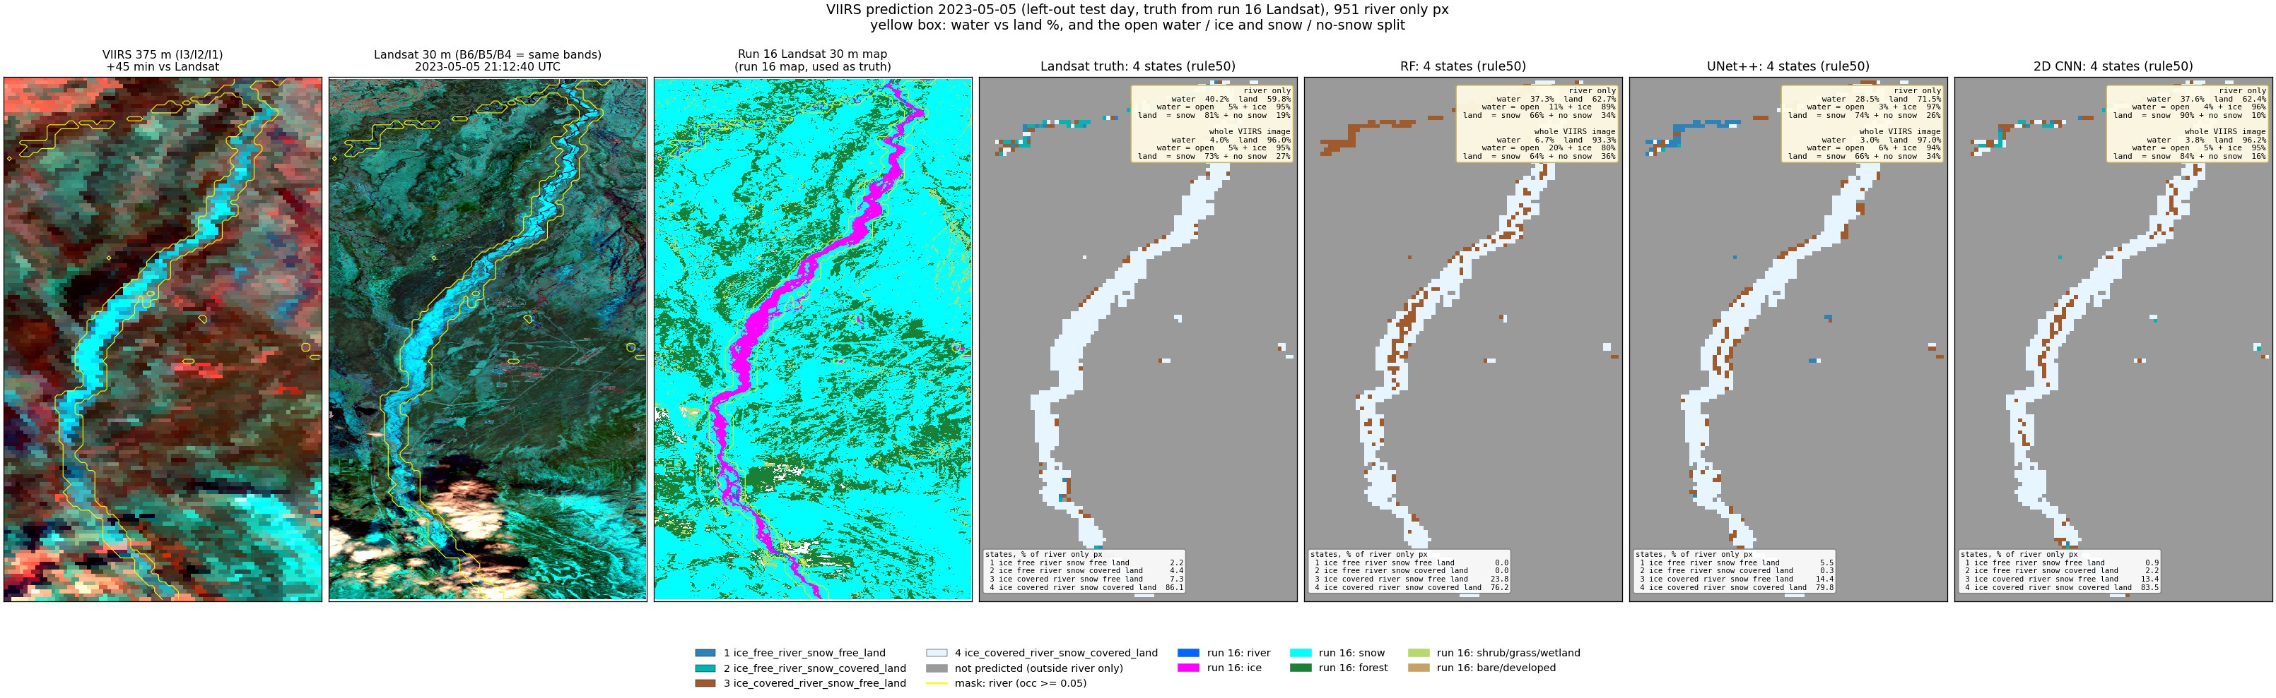
Run 20, 2023-05-05 (spring break-up, left-out test day): predicted states (rule50) and the water / land split.
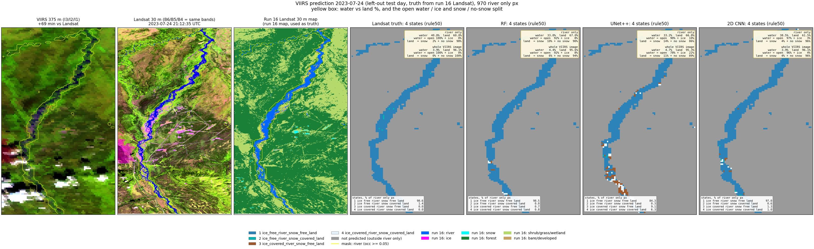
Run 20, 2023-07-24 (summer, left-out test day): predicted states (rule50) and the water / land split.
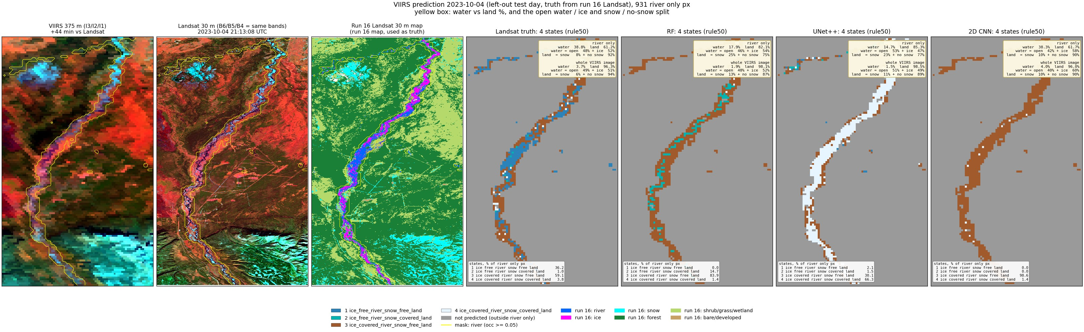
Run 20, 2023-10-04 (autumn freeze-up, left-out test day): predicted states (rule50) and the water / land split.
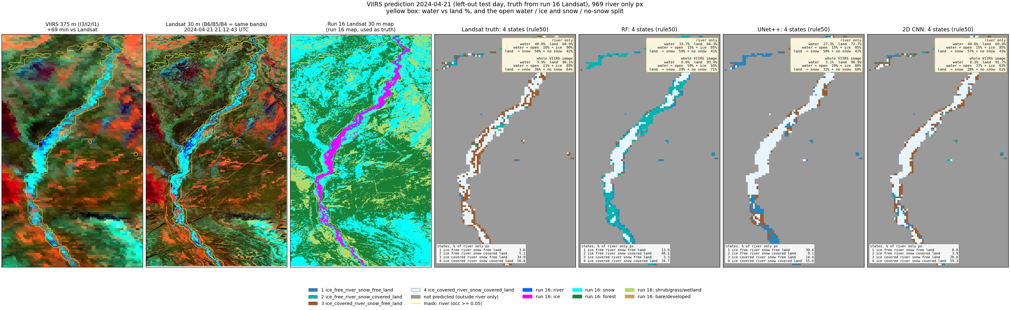
Run 20, 2024-04-21 (spring break-up, left-out test day): predicted states (rule50) and the water / land split.
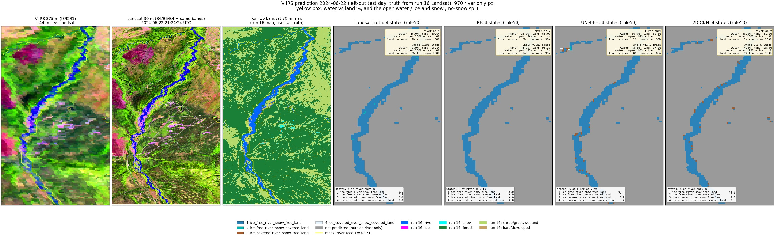
Run 20, 2024-06-22 (summer, left-out test day): predicted states (rule50) and the water / land split.
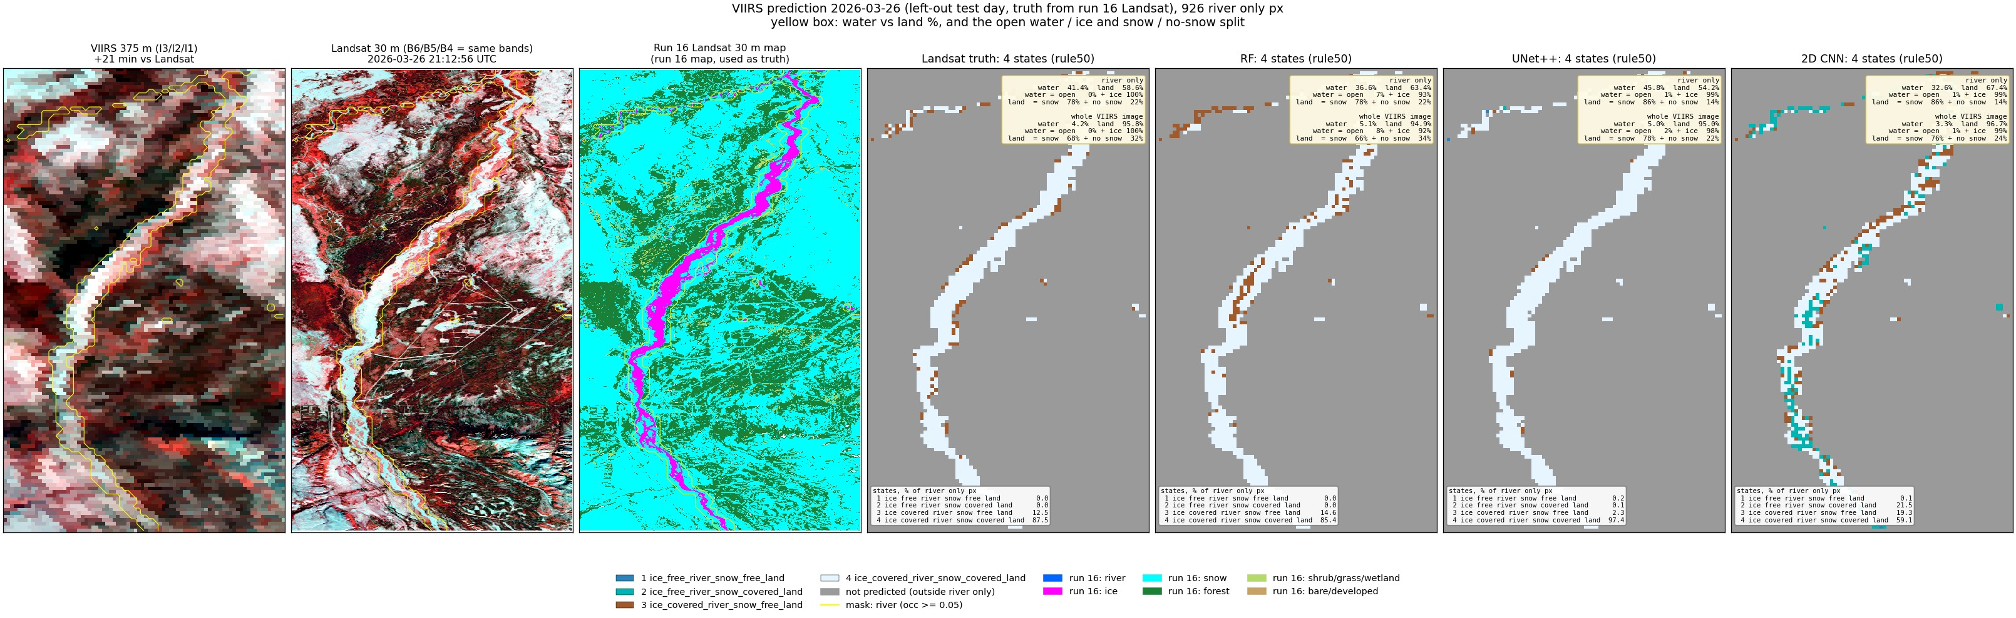
Run 20, 2026-03-26 (late winter, left-out test day): predicted states (rule50) and the water / land split.
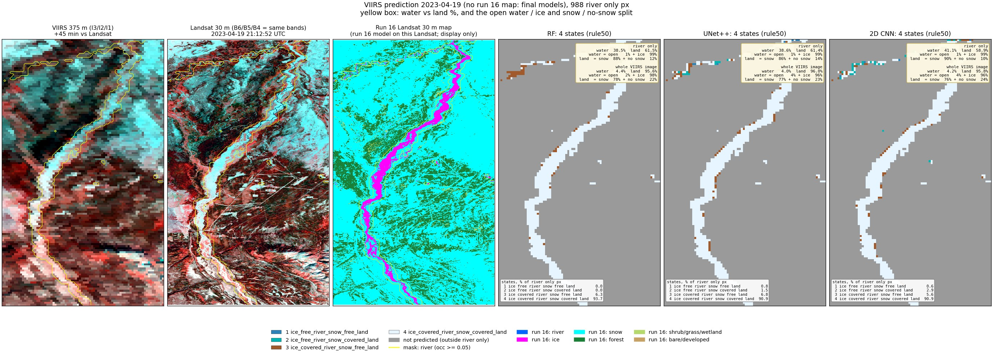
Run 20, 2023-04-19 (spring, snow, VIIRS only, final models): predicted states (rule50) and the water / land split.
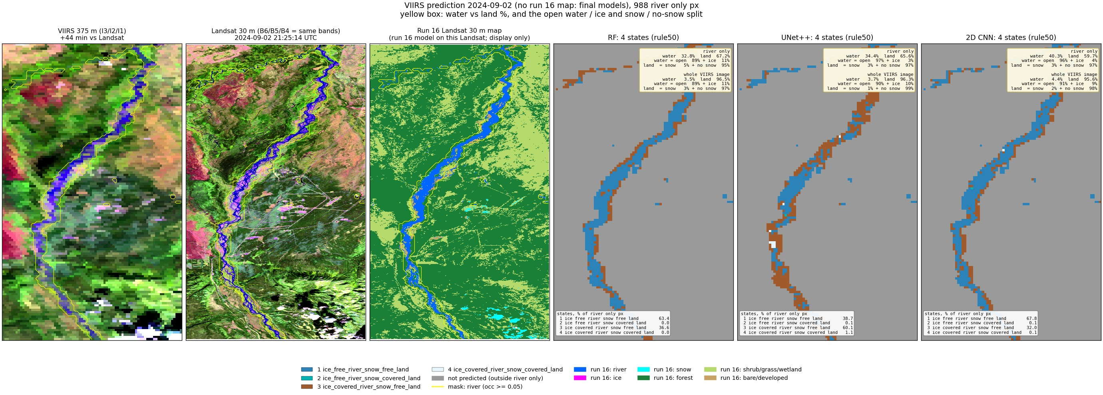
Run 20, 2024-09-02 (late summer, VIIRS only, final models): predicted states (rule50) and the water / land split.
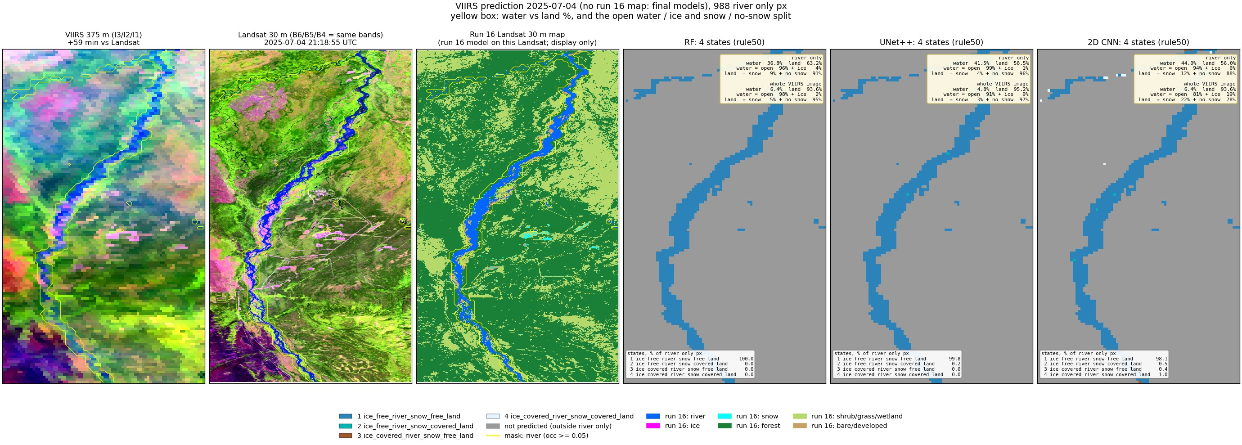
Run 20, 2025-07-04 (summer, VIIRS only, final models): predicted states (rule50) and the water / land split.
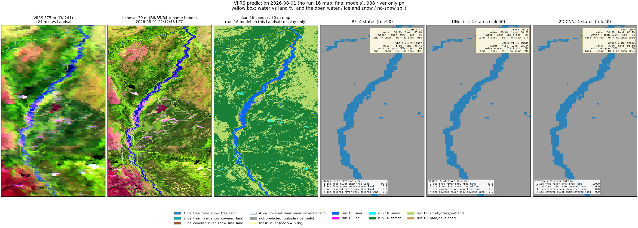
Run 20, 2026-08-01 (summer, VIIRS only, final models): predicted states (rule50) and the water / land split.

7. Runs 18-20 compared
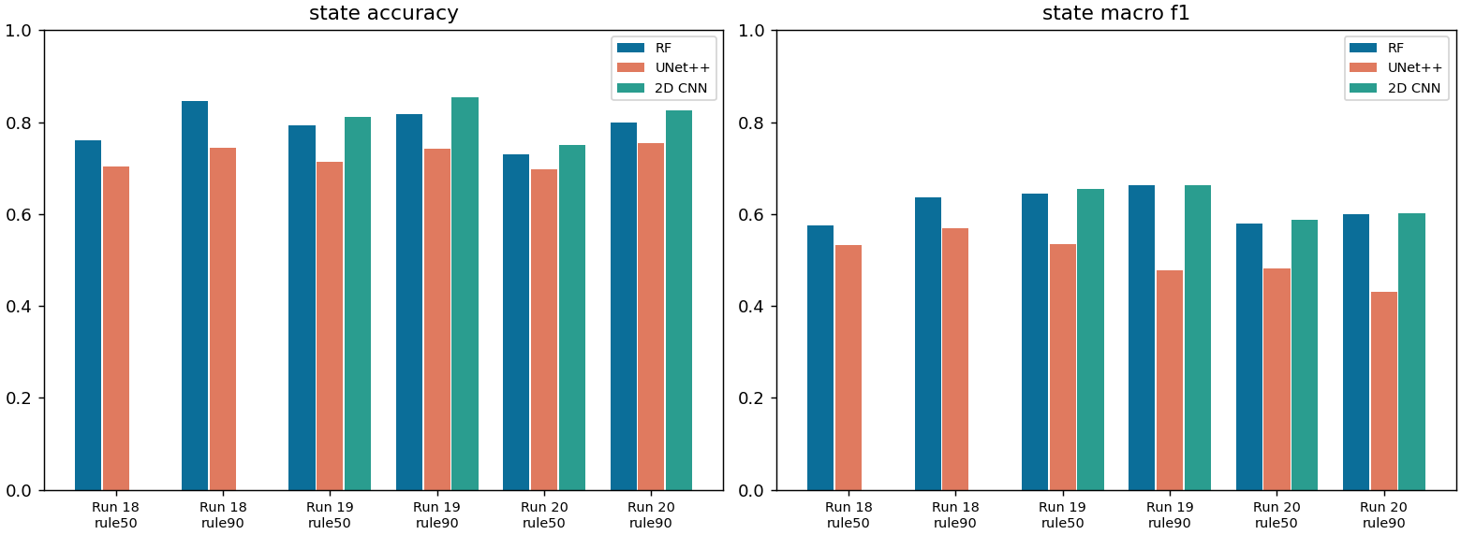
State accuracy and macro F1 per run, rule and model (leave-one-date-out).
date | season | run 18 RF | run 19 RF | run 20 RF
2023-05-05 | spring break-up | 0.71 | 0.76 | 0.75
2023-07-24 | summer | 0.96 | 0.97 | 0.97
2023-10-04 | autumn freeze-up | 0.93 | 0.68 | 0.50
2024-04-21 | spring break-up | 0.11 | 0.55 | 0.33
2024-06-22 | summer | 1.00 | 1.00 | 0.99
2026-03-26 | late winter | 0.87 | 0.80 | 0.84

All metrics, all runs (leave-one-date-out)
run | rule | model | accuracy | balanced acc | Cohen κ | macro prec | macro rec | macro F1 | weighted F1
run 18 | rule50 | RF | 0.759 | 0.585 | 0.643 | 0.615 | 0.585 | 0.574 | 0.757
run 18 | rule50 | UNet++ | 0.704 | 0.567 | 0.560 | 0.549 | 0.567 | 0.532 | 0.690
run 18 | rule90 | RF | 0.846 | 0.660 | 0.760 | 0.686 | 0.660 | 0.637 | 0.850
run 18 | rule90 | UNet++ | 0.744 | 0.584 | 0.604 | 0.609 | 0.584 | 0.570 | 0.739
run 19 | rule50 | RF | 0.794 | 0.676 | 0.696 | 0.638 | 0.676 | 0.644 | 0.805
run 19 | rule50 | UNet++ | 0.714 | 0.535 | 0.569 | 0.558 | 0.535 | 0.535 | 0.710
run 19 | rule50 | 2D CNN | 0.812 | 0.661 | 0.719 | 0.652 | 0.661 | 0.655 | 0.815
run 19 | rule90 | RF | 0.818 | 0.710 | 0.714 | 0.689 | 0.710 | 0.662 | 0.838
run 19 | rule90 | UNet++ | 0.742 | 0.481 | 0.565 | 0.495 | 0.481 | 0.477 | 0.715
run 19 | rule90 | 2D CNN | 0.854 | 0.665 | 0.766 | 0.672 | 0.665 | 0.664 | 0.853
run 20 | rule50 | RF | 0.731 | 0.628 | 0.608 | 0.592 | 0.628 | 0.580 | 0.763
run 20 | rule50 | UNet++ | 0.698 | 0.483 | 0.522 | 0.504 | 0.483 | 0.481 | 0.680
run 20 | rule50 | 2D CNN | 0.751 | 0.608 | 0.633 | 0.592 | 0.608 | 0.588 | 0.771
run 20 | rule90 | RF | 0.799 | 0.616 | 0.669 | 0.674 | 0.616 | 0.600 | 0.815
run 20 | rule90 | UNet++ | 0.755 | 0.448 | 0.564 | 0.445 | 0.448 | 0.431 | 0.716
run 20 | rule90 | 2D CNN | 0.825 | 0.590 | 0.700 | 0.621 | 0.590 | 0.602 | 0.817

- Runs 19 and 20 score only river (and buffer) pixels, run 18 the whole image: the numbers measure different things. Run 18 is easy on land (mostly the day's river state), hard where it matters.
- Per-pixel states (runs 19-20) follow the river: break-up days show a mix of open and ice reaches instead of one state for the whole day.
- 2023-10-04 (freeze-up) and 2024-04-21 (break-up) are the hard days; summer days are near perfect.
- 2024-09-02 (VIIRS only): check the state map against the % split before trusting it; ice in early September is unlikely.

8. Files
what | where (~/Desktop/nenana_crops/daksh/)
run 17 unmixing | rf_viirs_unmix.py -> output/17_viirs_unmix/ (results.json, summary.txt, <date>/weights_psf.tif, viirs_fit.tif, viirs_residual.tif)
run 18 whole image | viirs_states.py -> output/18_viirs_states/ (truth|rf|unetpp/pct_<date>.tif, <rule>/class_<date>.tif, images/)
run 18 images | make_run18_images.py -> output/18_viirs_states/images/
run 19 river + buffer | RIVER_BUFFER=1 viirs_river_states.py -> output/19_viirs_river_states/ (mask/, truth|rf|unetpp|cnn2d/<rule>/class_<date>.tif, images/)
run 20 river only | RIVER_BUFFER=0 viirs_river_states.py -> output/20_viirs_river_only/
prediction images | RIVER_BUFFER=1|0 viirs_river_predict.py -> <run>/predict/ (images/pred_<date>.jpg, pred_<date>_rule90.jpg, totals.json, VIIRS-only maps)
water mask | ~/Desktop/nenana_crops/alaska_occ_375m.tif; cropped copies in <run>/mask/
this report | report/word_content_viirs.py + report/build_word.js; deck presentation/build_deck_viirs.js

Every .tif is on the VIIRS grid (EPSG:4326) and opens in QGIS; class maps carry a .qml style (1-4 colours, 0 = not predicted).

9. Things to know
- Labels are the run 16 Landsat maps, not hand labels: any run 16 error (gravel as river, cloud as snow/ice) becomes a VIIRS label.
- Only 6 labelled days; each model sees 5 per fold. Ice and break-up states come from 3 days.
- State 2 (open river, snow land) has a few hundred pixels in total; its F1 is not reliable.
- The JRC occurrence behind the water mask ends in 2021; moved channels fall outside the mask.
- VIIRS view angle and clouds vary daily; no cloud mask is applied, so cloudy days give wrong states.
- The 30 m to 375 m shift (run 17) is small (<= ~60 m) and applied before the shares are computed.

