Nenana river ice: run 16, Random Forest with a water-zone rule
Landsat 30 m, six classes (river, ice, snow, forest, shrub/grass/wetland, bare/developed). The JRC Global Surface Water occurrence layer decides where river and ice may appear, and NLCD 2016 decides the land types. Random Forest only.

Contents

1. Summary
- Rule: where JRC water occurrence is at least 5 % (the water zone) a pixel can only be river or ice. Everywhere else it can only be snow or one of the three NLCD land types. No snow on the river, no ice or river on land.
- Two Random Forests, one per zone: river vs ice inside the water zone, snow / forest / shrub / bare outside it.
- Hand labels were moved onto the rule: snow inside the water zone became ice (snow lying on frozen river); labels the rule cannot hold (river or ice on land, land types inside the water zone) were left out of training.
- Against those rule labels, 5-fold spatial cross-validation gives accuracy 0.984 and macro F1 0.923 with the daksh dates (0.982 / 0.892 without them), higher than any earlier run (best before: run 10, 0.958 / 0.822).
- Against the original hand labels the same predictions score 0.863 / 0.687, because 19 % of the river labels lie where JRC says land (the channel moved) and most bare labels are gravel bars inside the water zone.
- On the unseen winter date 2024-03-12 (trained without it) every rule-label ice and snow pixel is right (accuracy 0.902); the 35 forest pixels there are called snow.
- The maps never show river on land or snow on the river, so they look much cleaner than runs 10-15.

2. Comparison with earlier runs
Accuracy / macro F1. Runs 10 and 15 are scored against the original six-class labels. Run 16 is shown both ways: the rule labels are what the model is asked to learn, the original labels show the cost of the rule.
run | exclude_daksh | with_daksh | external 2024-03-12
10 six classes, terrain (best before) | 0.962 / 0.826 | 0.958 / 0.822 | 0.312 / 0.144
15 six classes, forced river penalty | 0.947 / 0.808 | 0.942 / 0.797 | 0.307 / 0.142
16 water zone, rule labels | 0.982 / 0.892 | 0.984 / 0.923 | 0.902 / 0.471
16 water zone, original hand labels | 0.863 / 0.667 | 0.863 / 0.687 | 0.604 / 0.311

Macro F1 here averages only classes that have test pixels. On the external test that is ice, snow, forest and shrub; the 36 forest/shrub pixels are all missed, which pulls macro F1 down for every run.

3. The idea
Earlier runs let one forest choose any of the six classes anywhere, so river appeared on land and snow on the river. Run 16 uses a water mask instead: the JRC Global Surface Water occurrence layer (1984-2021), which gives for every 30 m pixel how often it was water. Pixels that were water in at least 5 % of observations form the water zone. Inside it the river is either open (river) or frozen (ice); snow on the frozen river counts as ice. Outside it the ground is land, which is either snow-covered (snow) or one of the NLCD 2016 land types.
zone | rule | classes allowed | model
water zone | JRC occurrence >= 5 % | river, ice | water RF (2 classes)
land | JRC occurrence < 5 % | snow, forest, shrub_grass_wetland, bare_developed | land RF (4 classes)

The water zone covers 3.8 % of the study box.
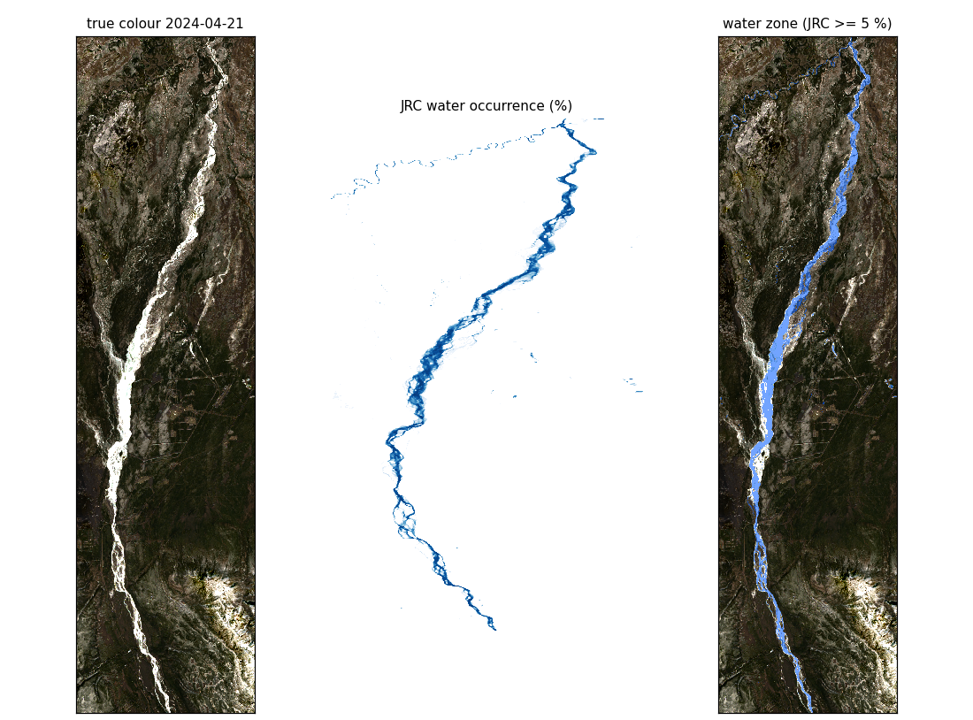
Left: Landsat true colour on 2024-04-21. Middle: JRC water occurrence. Right: the water zone (blue).

4. Data

4.1 Datasets
dataset | dates | Landsat bands | use
exclude_daksh | 2023-07-24, 2023-10-04, 2024-04-21, 2024-06-22 | 7: blue, green, red, NIR, SWIR1, SWIR2, thermal (ST_B10) | 5-fold spatial CV
with_daksh | those + 2024-03-12, 2024-04-20, 2024-04-29 | 5: blue, green, red, NIR, SWIR1 (daksh tiffs have no SWIR2 or thermal) | 5-fold spatial CV
external_test | train on the 4 patch dates, test on 2024-03-12 | 5 | unseen-date test

Labels are hand-drawn polygons (river, ice, snow, land); land is split into forest, shrub/grass/wetland and bare/developed with NLCD 2016, as in runs 06-15. Unlabelled dates 2026-03-26 and 2023-05-05 are only mapped.

4.2 Label changes for the rule
exclude_daksh: labelled pixels per class, how many lie in the water zone, how many became ice, how many were left out.
class | labelled | in water zone | became ice | left out
river | 39991 | 32251 | 0 | 7740
ice | 1732 | 1506 | 0 | 226
snow | 564 | 375 | 375 | 0
forest | 22173 | 70 | 0 | 70
shrub_grass_wetland | 15626 | 82 | 0 | 82
bare_developed | 2726 | 1616 | 0 | 1616

with_daksh: labelled pixels per class, how many lie in the water zone, how many became ice, how many were left out.
class | labelled | in water zone | became ice | left out
river | 39991 | 32251 | 0 | 7740
ice | 2074 | 1687 | 0 | 387
snow | 714 | 387 | 387 | 0
forest | 22208 | 70 | 0 | 70
shrub_grass_wetland | 15627 | 82 | 0 | 82
bare_developed | 2726 | 1616 | 0 | 1616

external_test: labelled pixels per class, how many lie in the water zone, how many became ice, how many were left out.
class | labelled | in water zone | became ice | left out
river | 0 | 0 | 0 | 0
ice | 342 | 181 | 0 | 161
snow | 150 | 12 | 12 | 0
forest | 35 | 0 | 0 | 0
shrub_grass_wetland | 1 | 0 | 0 | 0
bare_developed | 0 | 0 | 0 | 0

River and ice left out lie where JRC occurrence is below 5 %: mostly where the Nenana channel has moved since the JRC years. Bare/developed left out are gravel bars inside the water zone. Forest and shrub left out are a few edge pixels.

4.3 Labelled pixels per date and class
with_daksh (includes every exclude_daksh date). Each cell: original hand labels / after the rule. 2024-04-20 and 2024-04-29 have empty label files and are only mapped.
date | river | ice | snow | forest | shrub | bare | all
2023-07-24 | 31,021 / 25,495 | 0 / 0 | 0 / 0 | 5 / 5 | 2 / 2 | 0 / 0 | 31,028 / 25,502
2023-10-04 | 974 / 611 | 1,308 / 1,494 | 521 / 158 | 2,184 / 2,183 | 2,703 / 2,699 | 157 / 132 | 7,847 / 7,277
2024-03-12 | 0 / 0 | 342 / 193 | 150 / 138 | 35 / 35 | 1 / 1 | 0 / 0 | 528 / 367
2024-04-21 | 1,886 / 1,174 | 424 / 387 | 43 / 31 | 654 / 652 | 53 / 53 | 0 / 0 | 3,060 / 2,297
2024-06-22 | 6,110 / 4,971 | 0 / 0 | 0 / 0 | 19,330 / 19,263 | 12,868 / 12,790 | 2,569 / 978 | 40,877 / 38,002
total | 39,991 / 32,251 | 2,074 / 2,074 | 714 / 327 | 22,208 / 22,138 | 15,627 / 15,545 | 2,726 / 1,110 | 83,340 / 73,445

5. Inputs
Same input pool as runs 13-15: every band, the normalised difference and difference of every band pair, indices (NDWI, NDSI, NDVI, SAVI, MSAVI, EVI, BSI, AWEI, tasseled cap brightness/greenness/wetness, visible brightness), 3x3 and 7x7 mean and standard deviation textures, per-pixel illumination (slope, northness, eastness, cos incidence, shadow, from the Copernicus DEM) and NLCD 2016 as 10 yes/no inputs. The per-date sun elevation and azimuth are left out (one value per date, they would tell the forest the date). JRC occurrence is not an input; it only picks the zone.
dataset | Landsat bands | inputs in the pool | inputs used per forest
exclude_daksh | 7 | 83 | 25
with_daksh | 5 | 66 | 25
external_test | 5 | 66 | 25

Each forest ranks the pool with a quick 100-tree forest on its own training pixels (never the test fold) and keeps the top 25.
forest | 25 inputs chosen (exclude_daksh, final model)
water RF | vis_brightness, blue_std7, tc_wetness, green, blue_mean3, red, thermal, blue_std3, blue, diff_green_swir1, cos_incidence, diff_green_swir2, blue_mean7, diff_blue_swir1, AWEI_sh, diff_red_swir2, tc_brightness, nir_plus_swir1, diff_red_swir1, diff_nir_swir1, nir_std7, tc_greenness, nir_std3, swir2, NDVI_std7
land RF | nlcd_barren, nlcd_woody_wetland, nlcd_deciduous_forest, green, nlcd_evergreen_forest, vis_brightness, tc_wetness, red, blue, diff_red_swir1, nd_blue_swir1, nlcd_shrub, blue_mean3, nir_std7, nd_blue_nir, diff_blue_green, nd_red_swir2, diff_red_swir2, blue_std3, swir2, blue_mean7, diff_green_swir1, diff_green_swir2, nd_red_swir1, NDWI_std7

forest | 25 inputs chosen (with_daksh, final model)
water RF | blue, blue_mean3, blue_mean7, blue_std7, red, green, cos_incidence, blue_std3, vis_brightness, nd_blue_green, diff_green_swir1, nir, diff_red_swir1, nd_blue_red, diff_nir_swir1, nir_mean3, diff_green_red, nir_std3, diff_blue_swir1, nir_std7, nir_mean7, nd_green_red, diff_blue_red, nd_red_swir1, NDVI_std7
land RF | nlcd_barren, nlcd_woody_wetland, blue, nlcd_deciduous_forest, nlcd_evergreen_forest, green, diff_red_swir1, vis_brightness, red, blue_mean3, nd_red_swir1, nd_blue_nir, nir_std7, nd_red_nir, nlcd_shrub, blue_mean7, diff_green_swir1, NDSI_mean3, diff_blue_green, nd_blue_green, nd_blue_swir1, nd_green_nir, diff_blue_swir1, SAVI, nd_green_swir1

forest | 25 inputs chosen (external_test, final model)
water RF | blue_mean3, blue, blue_mean7, blue_std7, red, green, blue_std3, cos_incidence, vis_brightness, nd_blue_green, diff_nir_swir1, diff_red_swir1, nir, diff_green_swir1, nd_blue_red, nir_mean3, diff_green_red, nir_std3, diff_blue_red, nd_blue_nir, nir_mean7, NDWI_std7, NDVI_std7, nir_plus_swir1, diff_blue_green
land RF | nlcd_barren, nlcd_woody_wetland, blue, nlcd_deciduous_forest, nlcd_evergreen_forest, red, diff_red_swir1, green, vis_brightness, nd_red_swir1, blue_mean3, nd_blue_nir, diff_green_swir1, nd_blue_swir1, nd_red_nir, nir_std7, nlcd_shrub, blue_mean7, nd_green_nir, nd_blue_green, NDSI_mean3, diff_blue_green, SAVI, diff_blue_swir1, nd_green_swir1

The water forest relies on visible brightness, blue texture and SWIR differences (open water is dark, ice bright). The land forest relies on NLCD for the land type and on visible/SWIR contrast and NDSI for snow (snow is bright in visible light and dark in SWIR).

5.1 How much each input matters
Importance of each of the 25 inputs in the final forests (mean decrease in impurity; each forest's values add up to 1). Higher means the forest splits on that input more often and more usefully.
exclude_daksh:
# | water RF input | importance | land RF input | importance
1 | blue_std7 | 0.220 | nlcd_barren | 0.214
2 | blue_mean3 | 0.149 | nlcd_woody_wetland | 0.146
3 | thermal | 0.108 | nlcd_deciduous_forest | 0.079
4 | green | 0.099 | green | 0.067
5 | blue_std3 | 0.077 | nlcd_evergreen_forest | 0.057
6 | red | 0.068 | blue | 0.049
7 | diff_red_swir2 | 0.054 | diff_red_swir2 | 0.046
8 | vis_brightness | 0.049 | vis_brightness | 0.046
9 | blue | 0.042 | red | 0.041
10 | blue_mean7 | 0.032 | diff_red_swir1 | 0.038
11 | tc_wetness | 0.026 | tc_wetness | 0.030
12 | diff_green_swir2 | 0.016 | nlcd_shrub | 0.028
13 | diff_red_swir1 | 0.014 | nd_red_swir1 | 0.022
14 | cos_incidence | 0.013 | diff_blue_green | 0.020
15 | tc_brightness | 0.007 | nir_std7 | 0.016
16 | diff_green_swir1 | 0.006 | blue_mean3 | 0.015
17 | swir2 | 0.006 | nd_red_swir2 | 0.015
18 | diff_nir_swir1 | 0.004 | swir2 | 0.012
19 | diff_blue_swir1 | 0.004 | nd_blue_swir1 | 0.011
20 | nir_plus_swir1 | 0.003 | NDWI_std7 | 0.010
21 | NDVI_std7 | 0.002 | blue_mean7 | 0.009
22 | nir_std7 | 0.002 | nd_blue_nir | 0.008
23 | AWEI_sh | 0.001 | diff_green_swir2 | 0.006
24 | tc_greenness | 0.000 | blue_std3 | 0.006
25 | nir_std3 | 0.000 | diff_green_swir1 | 0.006

with_daksh:
# | water RF input | importance | land RF input | importance
1 | blue_mean3 | 0.166 | nlcd_barren | 0.206
2 | blue_std7 | 0.163 | nlcd_woody_wetland | 0.150
3 | vis_brightness | 0.125 | nlcd_deciduous_forest | 0.087
4 | red | 0.122 | blue | 0.062
5 | green | 0.118 | vis_brightness | 0.060
6 | blue_mean7 | 0.078 | green | 0.059
7 | blue_std3 | 0.061 | nlcd_evergreen_forest | 0.058
8 | cos_incidence | 0.040 | red | 0.050
9 | blue | 0.040 | diff_red_swir1 | 0.044
10 | diff_green_swir1 | 0.020 | nd_red_swir1 | 0.033
11 | nd_blue_green | 0.013 | nlcd_shrub | 0.027
12 | diff_red_swir1 | 0.012 | diff_blue_green | 0.022
13 | diff_blue_swir1 | 0.007 | blue_mean3 | 0.021
14 | nir | 0.007 | nir_std7 | 0.017
15 | nd_blue_red | 0.005 | nd_red_nir | 0.016
16 | nir_mean3 | 0.005 | blue_mean7 | 0.013
17 | NDVI_std7 | 0.005 | nd_blue_swir1 | 0.013
18 | diff_nir_swir1 | 0.004 | nd_blue_nir | 0.012
19 | nir_std7 | 0.002 | nd_green_swir1 | 0.010
20 | nd_red_swir1 | 0.002 | diff_green_swir1 | 0.010
21 | diff_blue_red | 0.002 | nd_green_nir | 0.009
22 | diff_green_red | 0.001 | diff_blue_swir1 | 0.008
23 | nd_green_red | 0.001 | SAVI | 0.005
24 | nir_std3 | 0.000 | NDSI_mean3 | 0.005
25 | nir_mean7 | 0.000 | nd_blue_green | 0.003

external_test:
# | water RF input | importance | land RF input | importance
1 | blue_std7 | 0.175 | nlcd_barren | 0.204
2 | blue_std3 | 0.135 | nlcd_woody_wetland | 0.155
3 | blue_mean3 | 0.111 | nlcd_deciduous_forest | 0.084
4 | red | 0.109 | green | 0.060
5 | green | 0.098 | blue | 0.060
6 | vis_brightness | 0.097 | vis_brightness | 0.057
7 | blue_mean7 | 0.077 | nlcd_evergreen_forest | 0.057
8 | blue | 0.075 | diff_red_swir1 | 0.047
9 | diff_red_swir1 | 0.033 | red | 0.044
10 | cos_incidence | 0.027 | blue_mean3 | 0.032
11 | diff_green_swir1 | 0.013 | nlcd_shrub | 0.029
12 | diff_nir_swir1 | 0.010 | nd_red_swir1 | 0.028
13 | nir_mean3 | 0.007 | nir_std7 | 0.021
14 | nir | 0.006 | diff_blue_green | 0.018
15 | nd_blue_green | 0.006 | nd_blue_swir1 | 0.018
16 | NDVI_std7 | 0.005 | nd_green_nir | 0.014
17 | nir_plus_swir1 | 0.004 | blue_mean7 | 0.013
18 | NDWI_std7 | 0.004 | nd_green_swir1 | 0.010
19 | diff_blue_red | 0.002 | diff_green_swir1 | 0.010
20 | nd_blue_nir | 0.002 | nd_blue_nir | 0.009
21 | diff_blue_green | 0.001 | nd_red_nir | 0.009
22 | diff_green_red | 0.001 | diff_blue_swir1 | 0.007
23 | nd_blue_red | 0.001 | SAVI | 0.006
24 | nir_std3 | 0.000 | nd_blue_green | 0.004
25 | nir_mean7 | 0.000 | NDSI_mean3 | 0.003

6. Method
- Two scikit-learn Random Forests per training set: 300 trees, max_depth 16, min_samples_leaf 20, max_features sqrt, class_weight balanced_subsample (same limited settings as runs 13-15, so they cannot memorise pixels).
- Each forest trains only on its own zone's rule labels; a pixel is predicted by the forest of its zone.
- 5-fold spatial cross-validation: the box is cut into east-west bands of 64 rows (about 1.9 km), band i is fold i mod 5, the same fold on every date, and training pixels within 12 rows of a test band are dropped.
- External test: train on the four patch dates only, predict the labelled daksh date 2024-03-12.
- Maps: the final forests (trained on all labelled pixels of the dataset) predict every pixel of every date.

7. Results

7.1 exclude_daksh (5-fold spatial CV)
Rule labels: accuracy 0.982, macro F1 0.892.
class | pixels | precision | recall | F1
river | 32,251 | 0.991 | 0.994 | 0.992
ice | 1,881 | 0.887 | 0.848 | 0.867
snow | 189 | 0.378 | 0.931 | 0.537
forest | 22,103 | 0.988 | 0.983 | 0.985
shrub_grass_wetland | 15,544 | 0.984 | 0.975 | 0.980
bare_developed | 1,110 | 0.995 | 0.986 | 0.990

Confusion, rule labels (rows true, columns predicted):
true \ predicted | river | ice | snow | forest | shrub | bare
river | 32,047 | 204 | 0 | 0 | 0 | 0
ice | 286 | 1,595 | 0 | 0 | 0 | 0
snow | 0 | 0 | 176 | 4 | 6 | 3
forest | 0 | 0 | 144 | 21,719 | 238 | 2
shrub_grass_wetland | 0 | 0 | 130 | 260 | 15,154 | 0
bare_developed | 0 | 0 | 16 | 0 | 0 | 1,094

Original hand labels: accuracy 0.863, macro F1 0.667.
class | pixels | precision | recall | F1
river | 39,991 | 0.940 | 0.801 | 0.865
ice | 1,732 | 0.683 | 0.715 | 0.699
snow | 564 | 0.114 | 0.312 | 0.167
forest | 22,173 | 0.838 | 0.980 | 0.903
shrub_grass_wetland | 15,626 | 0.879 | 0.970 | 0.922
bare_developed | 2,726 | 0.495 | 0.401 | 0.443

Confusion, original hand labels:
true \ predicted | river | ice | snow | forest | shrub | bare
river | 32,047 | 204 | 877 | 3,921 | 1,832 | 1,110
ice | 267 | 1,239 | 204 | 13 | 8 | 1
snow | 19 | 356 | 176 | 4 | 6 | 3
forest | 70 | 0 | 144 | 21,719 | 238 | 2
shrub_grass_wetland | 81 | 1 | 130 | 260 | 15,154 | 0
bare_developed | 1,602 | 14 | 16 | 0 | 0 | 1,094

Per date (accuracy / macro F1):
date | season | rule px | rule labels | original labels
2023-07-24 | summer | 25,502 | 1.000 / 1.000 | 0.822 / 0.303
2023-10-04 | autumn, first ice | 7,277 | 0.937 / 0.877 | 0.823 / 0.725
2024-04-21 | spring break-up | 2,297 | 0.802 / 0.648 | 0.602 / 0.460
2024-06-22 | summer | 38,002 | 0.990 / 0.994 | 0.920 / 0.812

7.2 with_daksh (5-fold spatial CV)
Rule labels: accuracy 0.984, macro F1 0.923.
class | pixels | precision | recall | F1
river | 32,251 | 0.995 | 0.993 | 0.994
ice | 2,074 | 0.901 | 0.927 | 0.913
snow | 327 | 0.527 | 0.951 | 0.678
forest | 22,138 | 0.988 | 0.982 | 0.985
shrub_grass_wetland | 15,545 | 0.984 | 0.977 | 0.981
bare_developed | 1,110 | 0.993 | 0.986 | 0.989

Confusion, rule labels (rows true, columns predicted):
true \ predicted | river | ice | snow | forest | shrub | bare
river | 32,039 | 212 | 0 | 0 | 0 | 0
ice | 152 | 1,922 | 0 | 0 | 0 | 0
snow | 0 | 0 | 311 | 4 | 7 | 5
forest | 0 | 0 | 164 | 21,732 | 240 | 2
shrub_grass_wetland | 0 | 0 | 99 | 257 | 15,188 | 1
bare_developed | 0 | 0 | 16 | 0 | 0 | 1,094

Original hand labels: accuracy 0.863, macro F1 0.687.
class | pixels | precision | recall | F1
river | 39,991 | 0.944 | 0.801 | 0.867
ice | 2,074 | 0.716 | 0.742 | 0.729
snow | 714 | 0.175 | 0.436 | 0.249
forest | 22,208 | 0.840 | 0.979 | 0.904
shrub_grass_wetland | 15,627 | 0.867 | 0.972 | 0.917
bare_developed | 2,726 | 0.528 | 0.401 | 0.456

Confusion, original hand labels:
true \ predicted | river | ice | snow | forest | shrub | bare
river | 32,039 | 212 | 829 | 3,874 | 2,068 | 969
ice | 148 | 1,539 | 363 | 15 | 8 | 1
snow | 4 | 383 | 311 | 4 | 7 | 5
forest | 70 | 0 | 164 | 21,732 | 240 | 2
shrub_grass_wetland | 81 | 1 | 99 | 257 | 15,188 | 1
bare_developed | 1,602 | 14 | 16 | 0 | 0 | 1,094

Per date (accuracy / macro F1):
date | season | rule px | rule labels | original labels
2023-07-24 | summer | 25,502 | 1.000 / 0.859 | 0.822 / 0.302
2023-10-04 | autumn, first ice | 7,277 | 0.942 / 0.886 | 0.827 / 0.728
2024-03-12 | winter | 367 | 0.902 / 0.471 | 0.604 / 0.311
2024-04-21 | spring break-up | 2,297 | 0.859 / 0.717 | 0.642 / 0.497
2024-06-22 | summer | 38,002 | 0.990 / 0.994 | 0.920 / 0.813

7.3 external_test (trained without 2024-03-12)
Rule labels: accuracy 0.902, macro F1 0.471.
class | pixels | precision | recall | F1
ice | 193 | 1.000 | 1.000 | 1.000
snow | 138 | 0.793 | 1.000 | 0.885
forest | 35 | 0.000 | 0.000 | 0.000
shrub_grass_wetland | 1 | 0.000 | 0.000 | 0.000

Confusion, rule labels (rows true, columns predicted):
true \ predicted | ice | snow | forest | shrub
ice | 193 | 0 | 0 | 0
snow | 0 | 138 | 0 | 0
forest | 0 | 35 | 0 | 0
shrub_grass_wetland | 0 | 1 | 0 | 0

Original hand labels: accuracy 0.604, macro F1 0.311.
class | pixels | precision | recall | F1
ice | 342 | 0.938 | 0.529 | 0.677
snow | 150 | 0.412 | 0.920 | 0.569
forest | 35 | 0.000 | 0.000 | 0.000
shrub_grass_wetland | 1 | 0.000 | 0.000 | 0.000

Confusion, original hand labels:
true \ predicted | ice | snow | forest | shrub
ice | 181 | 161 | 0 | 0
snow | 12 | 138 | 0 | 0
forest | 0 | 35 | 0 | 0
shrub_grass_wetland | 0 | 1 | 0 | 0

7.4 Overfitting check: training vs held-out accuracy
For each cross-validation fold: accuracy of the forests on their own training pixels and on the held-out fold (rule labels), per zone. A small gap means the forests learned general patterns rather than memorising pixels.
exclude_daksh (training / held-out):
fold | water RF | land RF | both
1 | 0.995 / 0.960 | 0.996 / 0.964 | 0.996 / 0.962
2 | 0.993 / 0.991 | 0.988 / 0.996 | 0.990 / 0.994
3 | 0.992 / 1.000 | 0.991 / 0.997 | 0.991 / 0.998
4 | 0.993 / 0.994 | 0.991 / 0.993 | 0.992 / 0.993
5 | 0.994 / 0.986 | 0.993 / 0.958 | 0.993 / 0.971
mean | 0.993 / 0.986 | 0.992 / 0.981 | 0.993 / 0.984

Mean gap exclude_daksh: water 0.007, land 0.010, both 0.009.
with_daksh (training / held-out):
fold | water RF | land RF | both
1 | 0.995 / 0.979 | 0.995 / 0.963 | 0.995 / 0.969
2 | 0.993 / 0.991 | 0.992 / 0.999 | 0.992 / 0.996
3 | 0.991 / 1.000 | 0.991 / 0.997 | 0.991 / 0.998
4 | 0.992 / 0.993 | 0.992 / 0.994 | 0.992 / 0.993
5 | 0.994 / 0.986 | 0.992 / 0.956 | 0.993 / 0.969
mean | 0.993 / 0.990 | 0.992 / 0.982 | 0.993 / 0.985

Mean gap with_daksh: water 0.004, land 0.011, both 0.007.

7.5 Which JRC cutoff
The same training and 5-fold spatial CV with the water zone at different JRC occurrence cutoffs. A low cutoff makes the zone wider (more river labels fit the rule, but more land and gravel bars inside it); a high cutoff narrows it to the main channel. Rule-label scores are on different pixel sets for each cutoff; the original-label scores are on the same pixels and are the fair comparison.
exclude_daksh:
cutoff | box in zone | rule-label px | rule acc / mF1 | original acc / mF1 | river F1 (orig)
1 % | 4.27 % | 73,218 of 82,812 | 0.981 / 0.886 | 0.863 / 0.643 | 0.870
5 % | 3.85 % | 73,078 of 82,812 | 0.982 / 0.892 | 0.863 / 0.667 | 0.865
10 % | 3.63 % | 72,529 of 82,812 | 0.982 / 0.894 | 0.856 / 0.666 | 0.857
25 % | 3.13 % | 70,240 of 82,812 | 0.982 / 0.901 | 0.829 / 0.649 | 0.820
50 % | 2.36 % | 65,135 of 82,812 | 0.981 / 0.917 | 0.769 / 0.620 | 0.726

with_daksh:
cutoff | box in zone | rule-label px | rule acc / mF1 | original acc / mF1 | river F1 (orig)
1 % | 4.27 % | 73,606 of 83,340 | 0.987 / 0.923 | 0.867 / 0.666 | 0.871
5 % | 3.85 % | 73,445 of 83,340 | 0.984 / 0.923 | 0.863 / 0.687 | 0.867
10 % | 3.63 % | 72,882 of 83,340 | 0.982 / 0.924 | 0.854 / 0.680 | 0.858
25 % | 3.13 % | 70,548 of 83,340 | 0.984 / 0.930 | 0.829 / 0.663 | 0.821
50 % | 2.36 % | 65,404 of 83,340 | 0.984 / 0.943 | 0.769 / 0.627 | 0.727

Best cutoff on the original labels (with_daksh macro F1): 5 %. Run 16 uses 5 %.
Reading the results: inside the water zone river vs ice is very reliable. The weakest class is snow: the land forest calls a few hundred forest and shrub pixels snow, mostly bright, sparse canopy in spring. Against the original labels the losses are exactly the labels the rule cannot reproduce: river outside the JRC zone, gravel bars (bare) inside it, and snow on the river (now ice).

8. Ground truth vs prediction (with_daksh)
Each figure zooms on the labels of one date. Panels: Landsat true colour; the original hand labels; the rule labels used for training; the cross-validated test prediction (each pixel predicted by forests that never saw its fold), with its accuracy against the rule labels; and the final map.
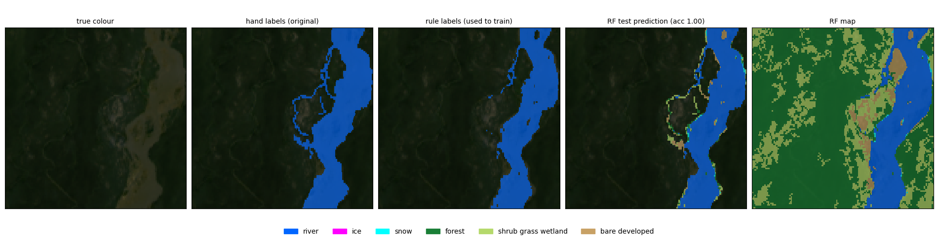
2023-07-24 (summer), run 16 with_daksh. Test accuracy on rule labels 1.00.
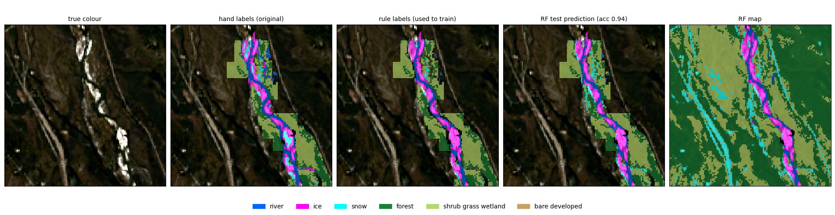
2023-10-04 (autumn, first ice), run 16 with_daksh. Test accuracy on rule labels 0.94.
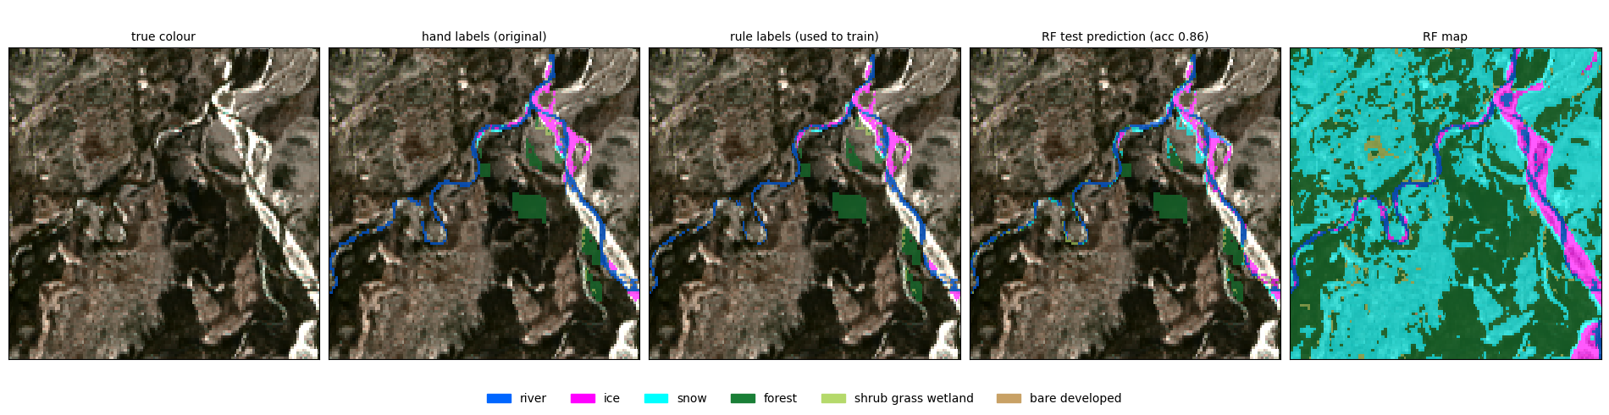
2024-04-21 (spring break-up), run 16 with_daksh. Test accuracy on rule labels 0.86.
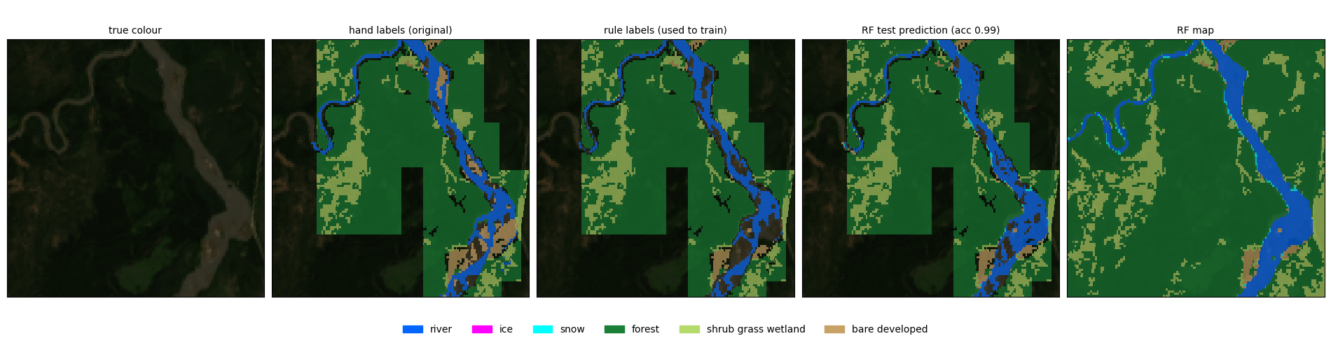
2024-06-22 (summer), run 16 with_daksh. Test accuracy on rule labels 0.99.
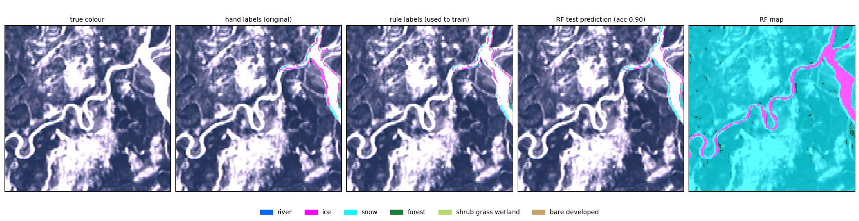
2024-03-12 (winter), run 16 with_daksh. Test accuracy on rule labels 0.90.

External test
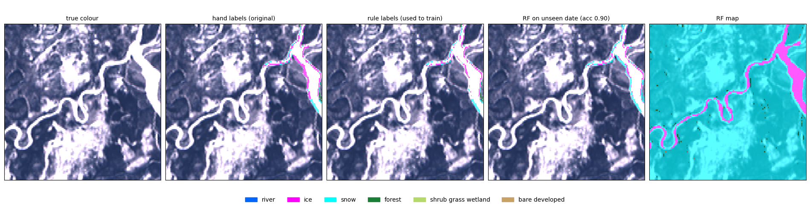
2024-03-12 (winter), run 16 trained on the four patch dates only. Accuracy on rule labels 0.90.

9. Every map
All map images run 16 wrote, whole study box. Each figure is one date: per dataset the Landsat true colour and the run 16 map (class colours over true colour), side by side: exclude_daksh, with_daksh, external_test (where the dataset has that date).
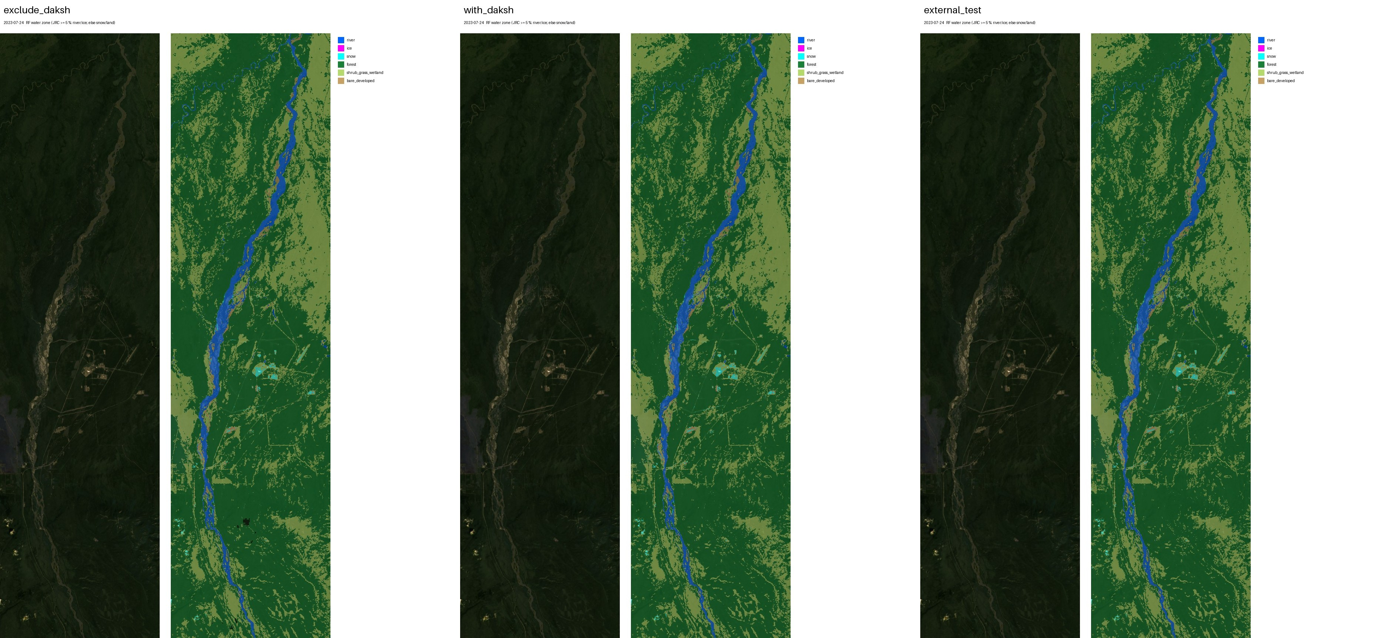
2023-07-24 (summer): exclude_daksh, with_daksh, external_test.
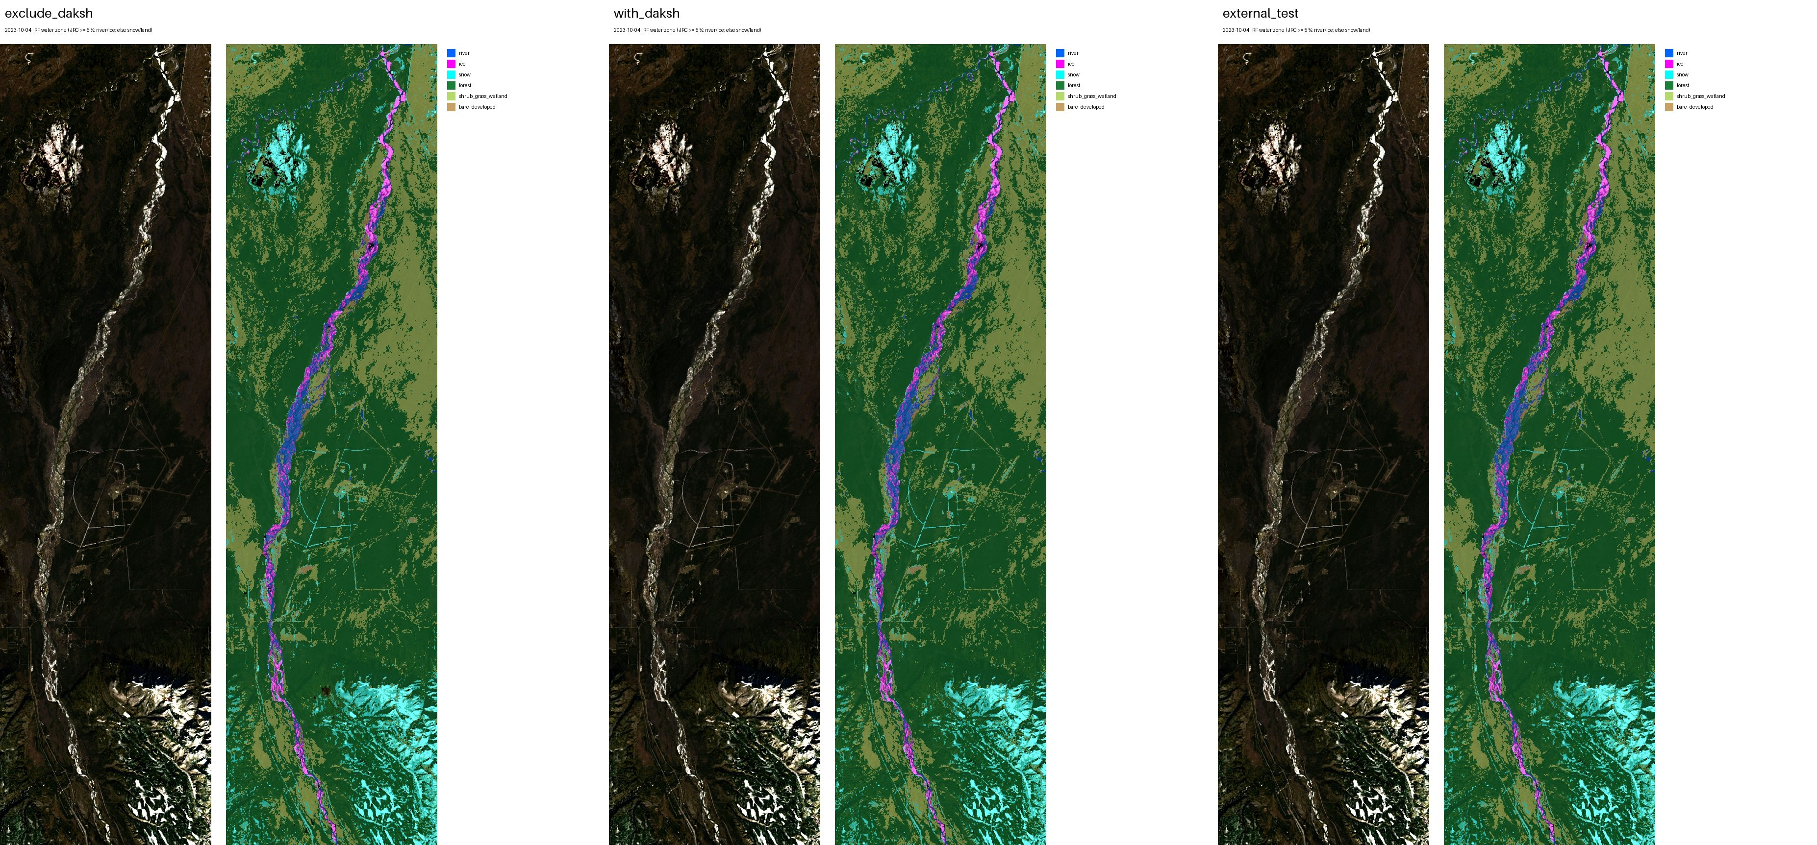
2023-10-04 (autumn, first ice): exclude_daksh, with_daksh, external_test.
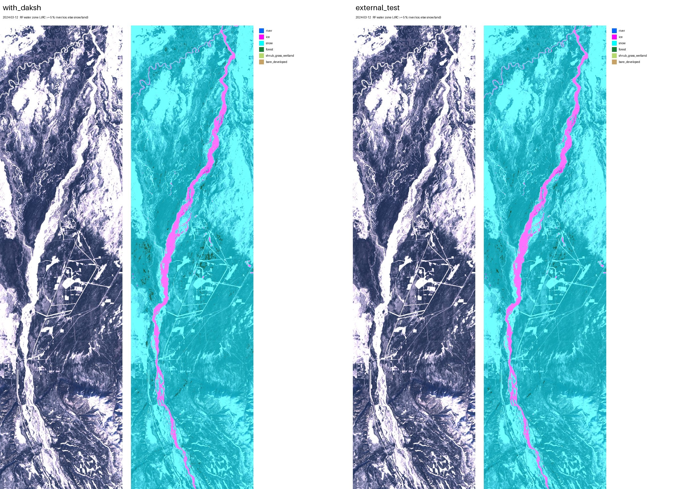
2024-03-12 (winter): with_daksh, external_test.
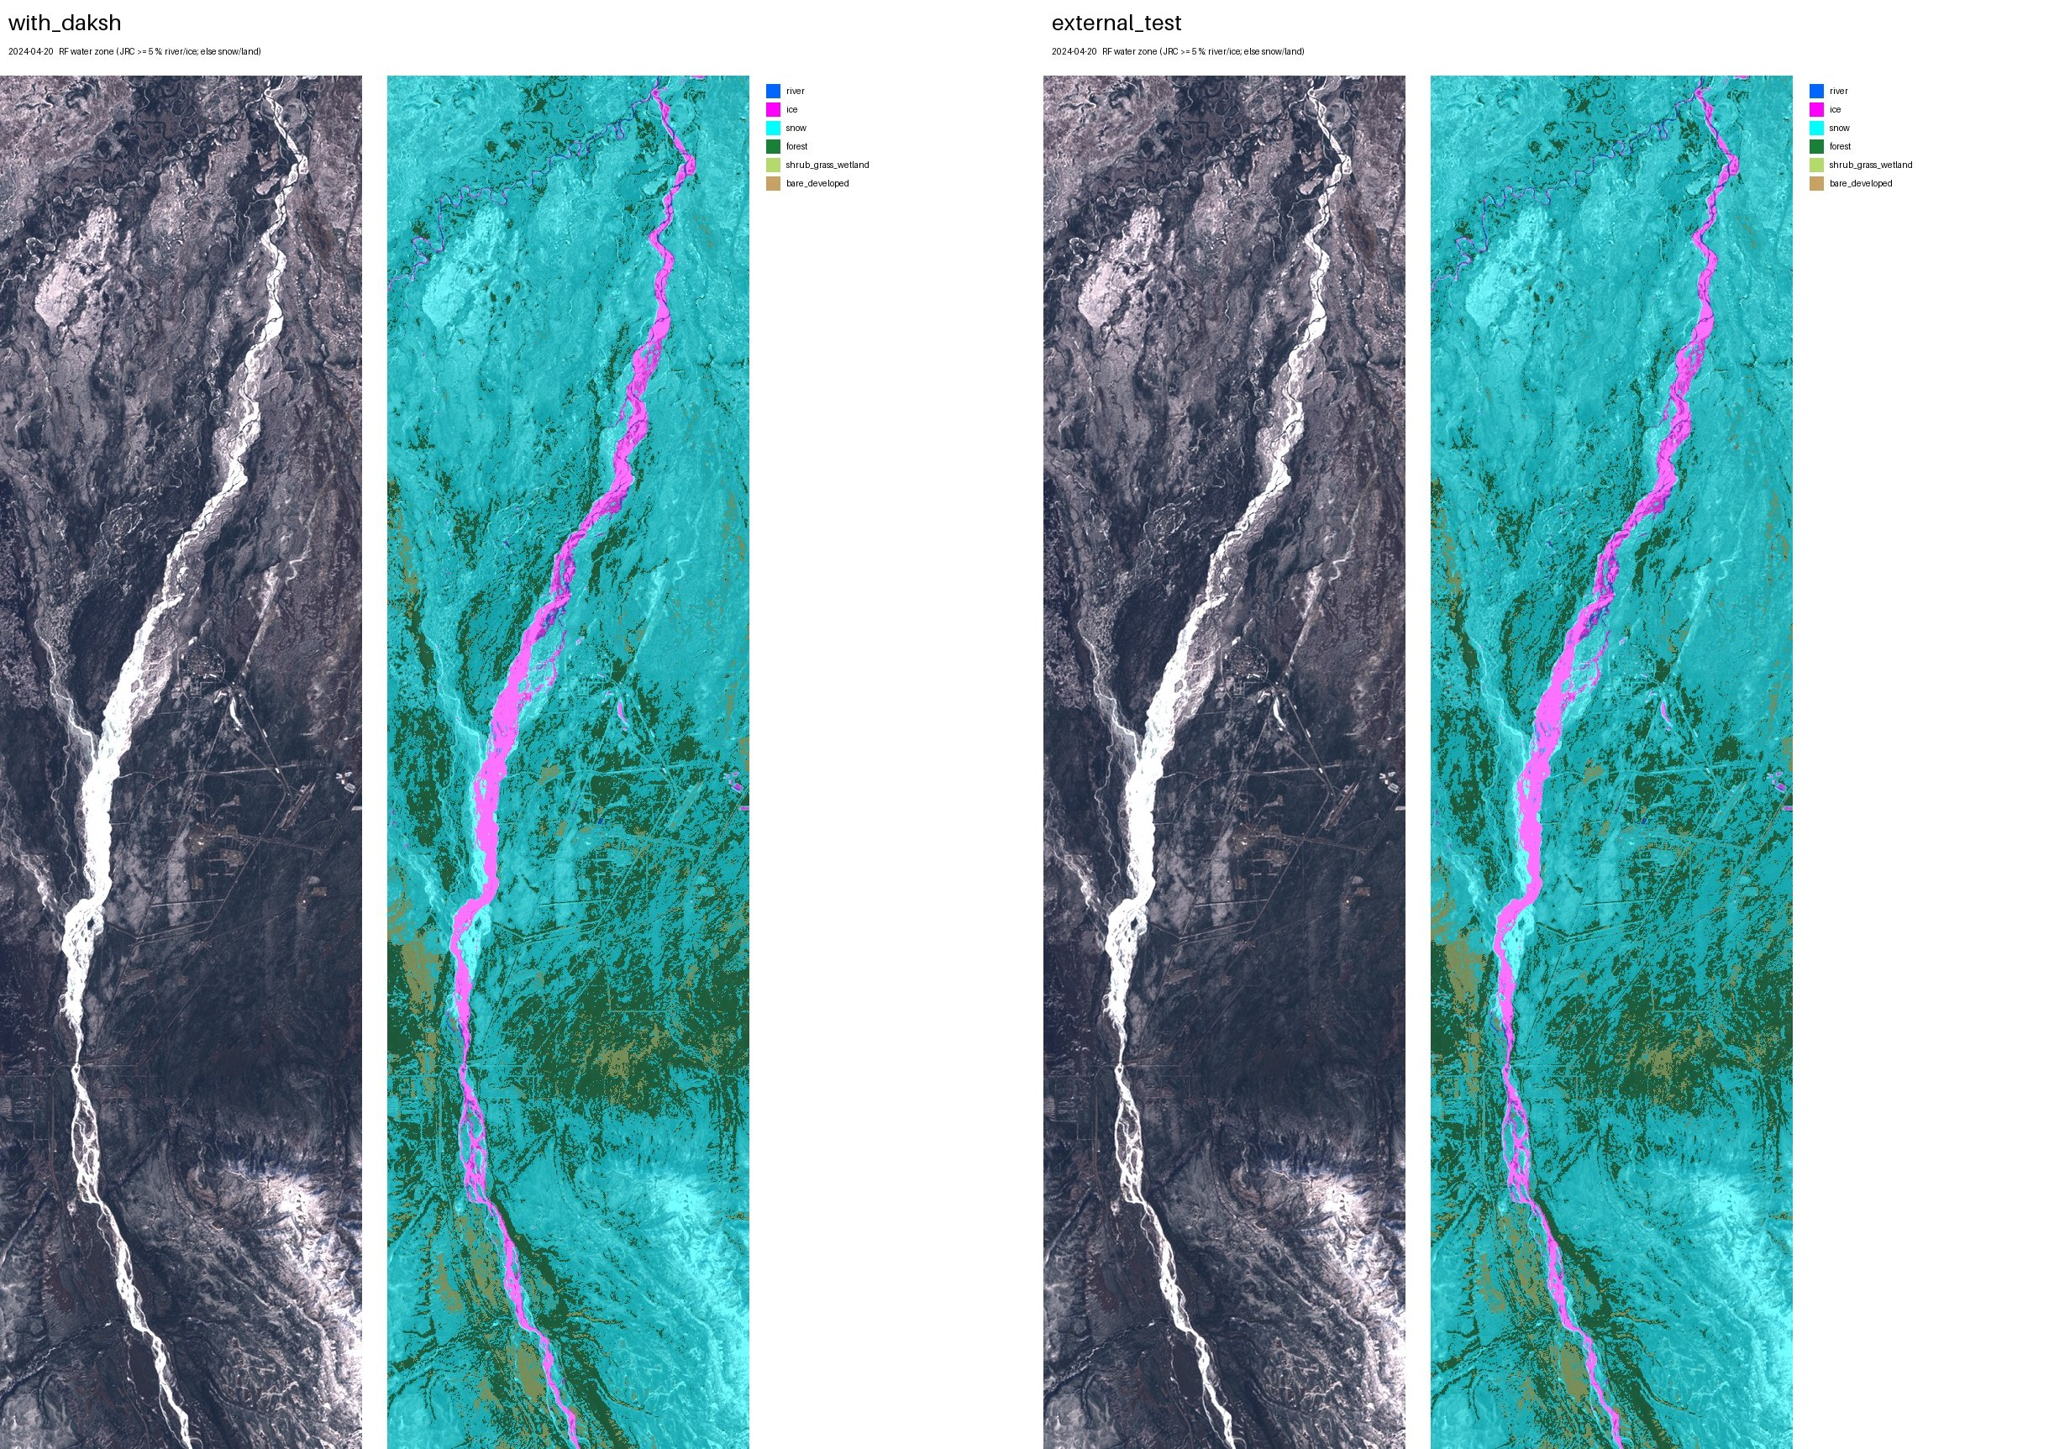
2024-04-20 (spring): with_daksh, external_test.
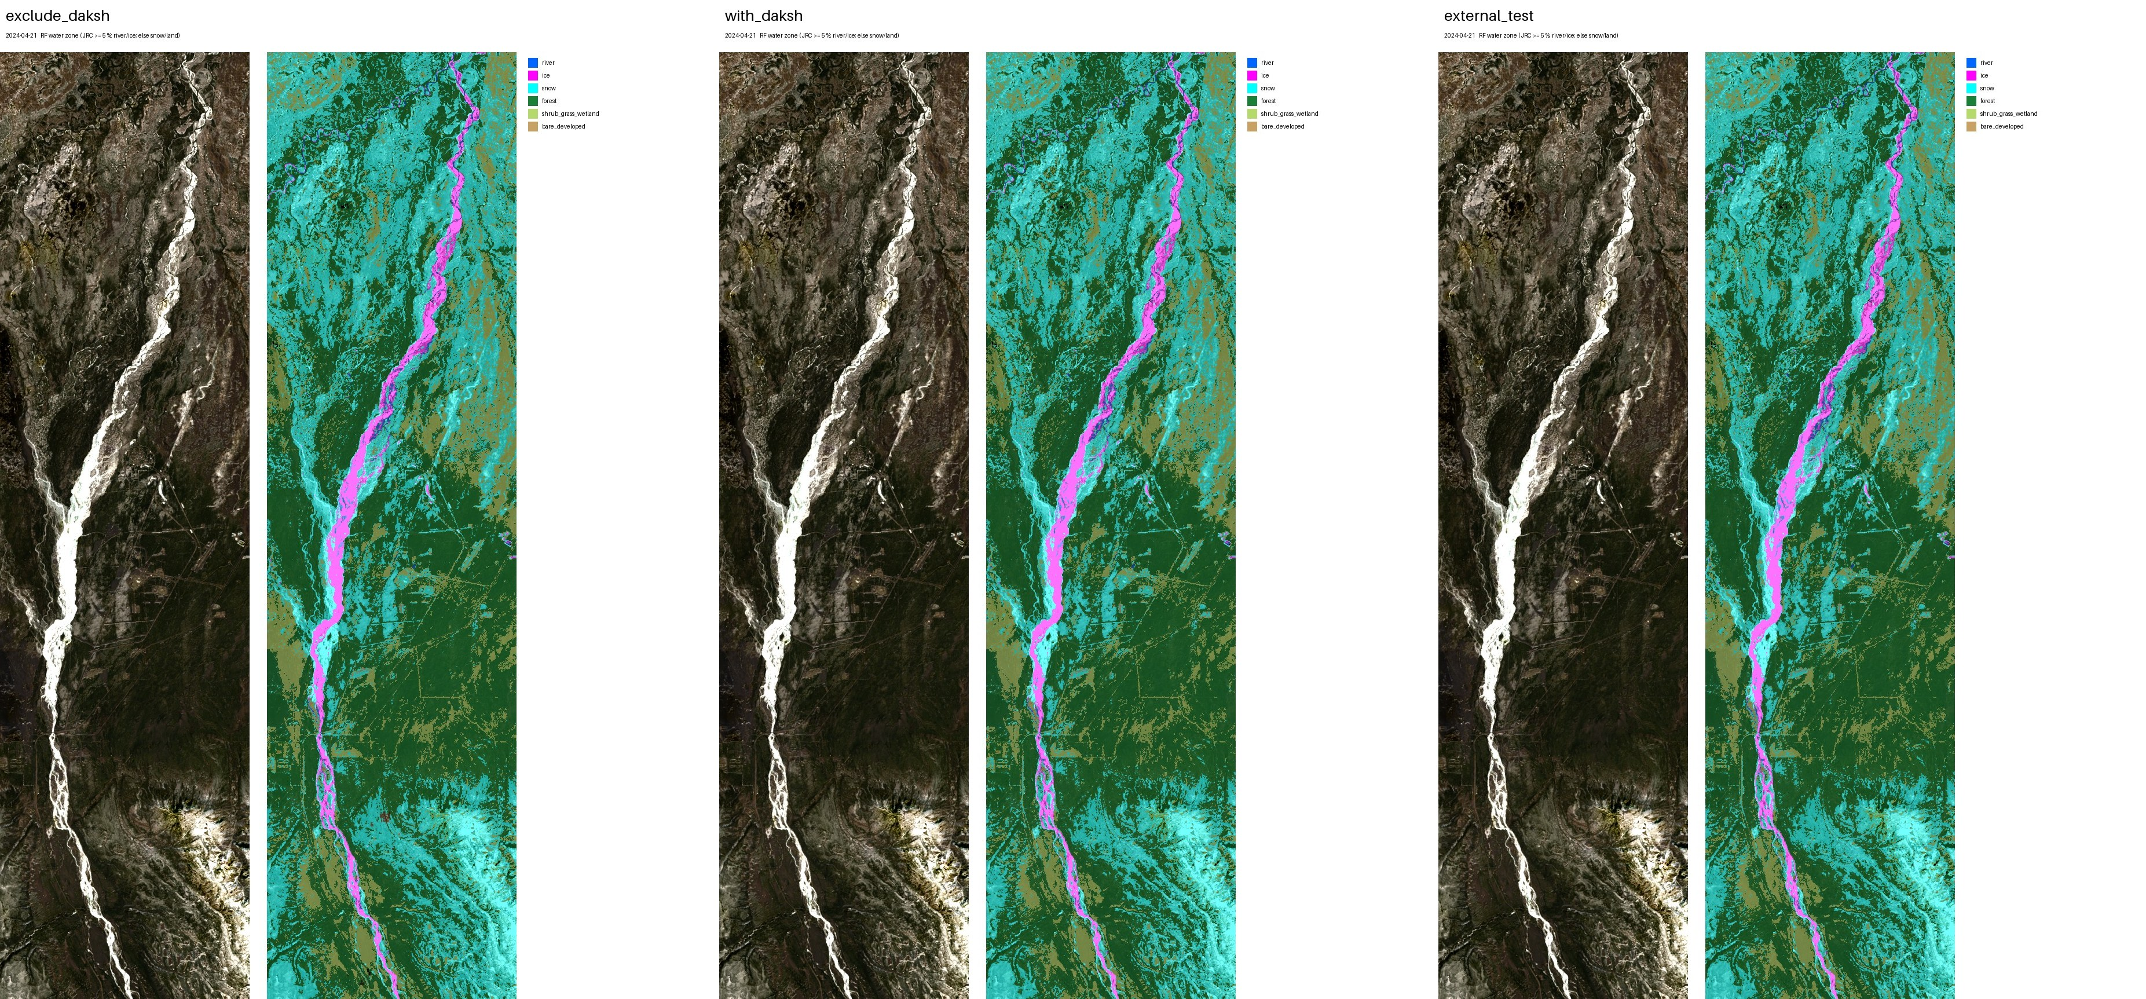
2024-04-21 (spring break-up): exclude_daksh, with_daksh, external_test.
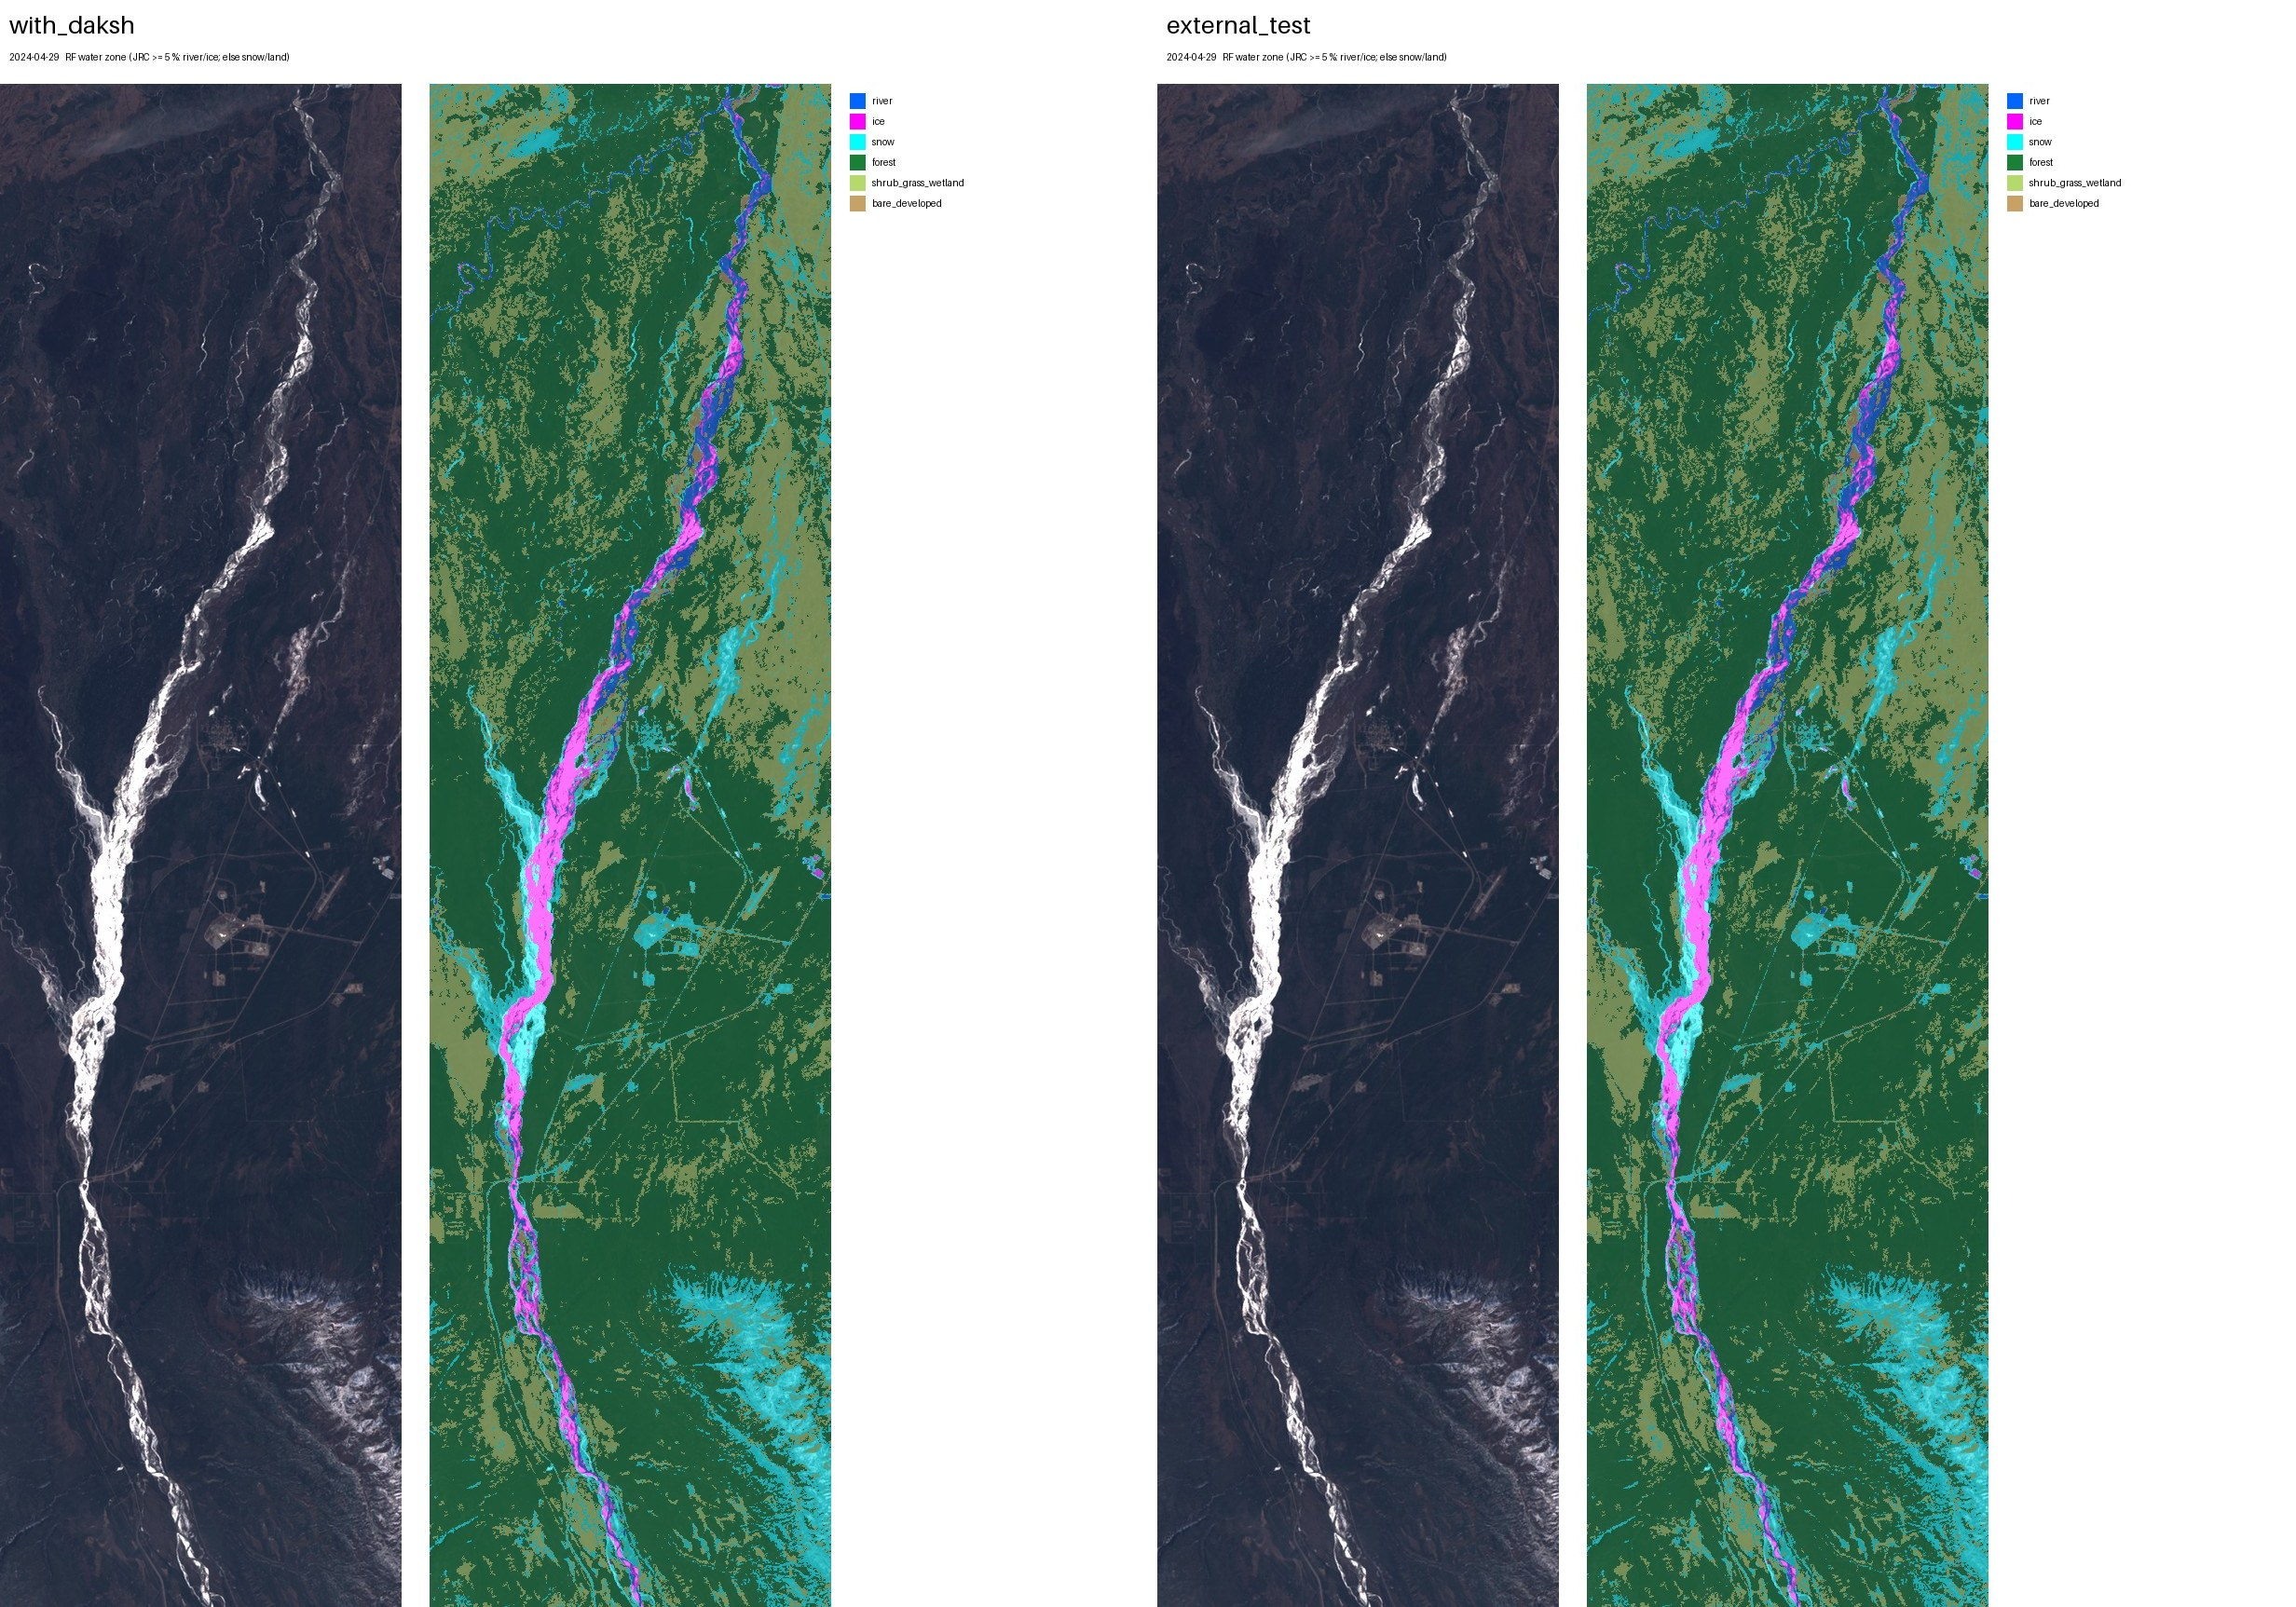
2024-04-29 (spring break-up): with_daksh, external_test.
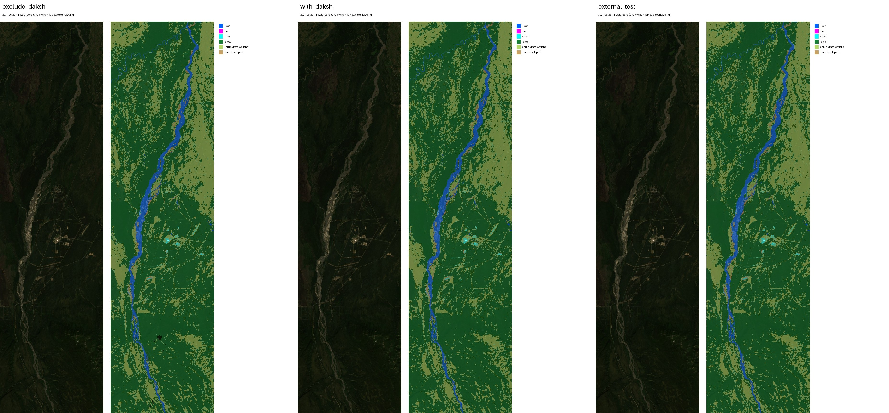
2024-06-22 (summer): exclude_daksh, with_daksh, external_test.
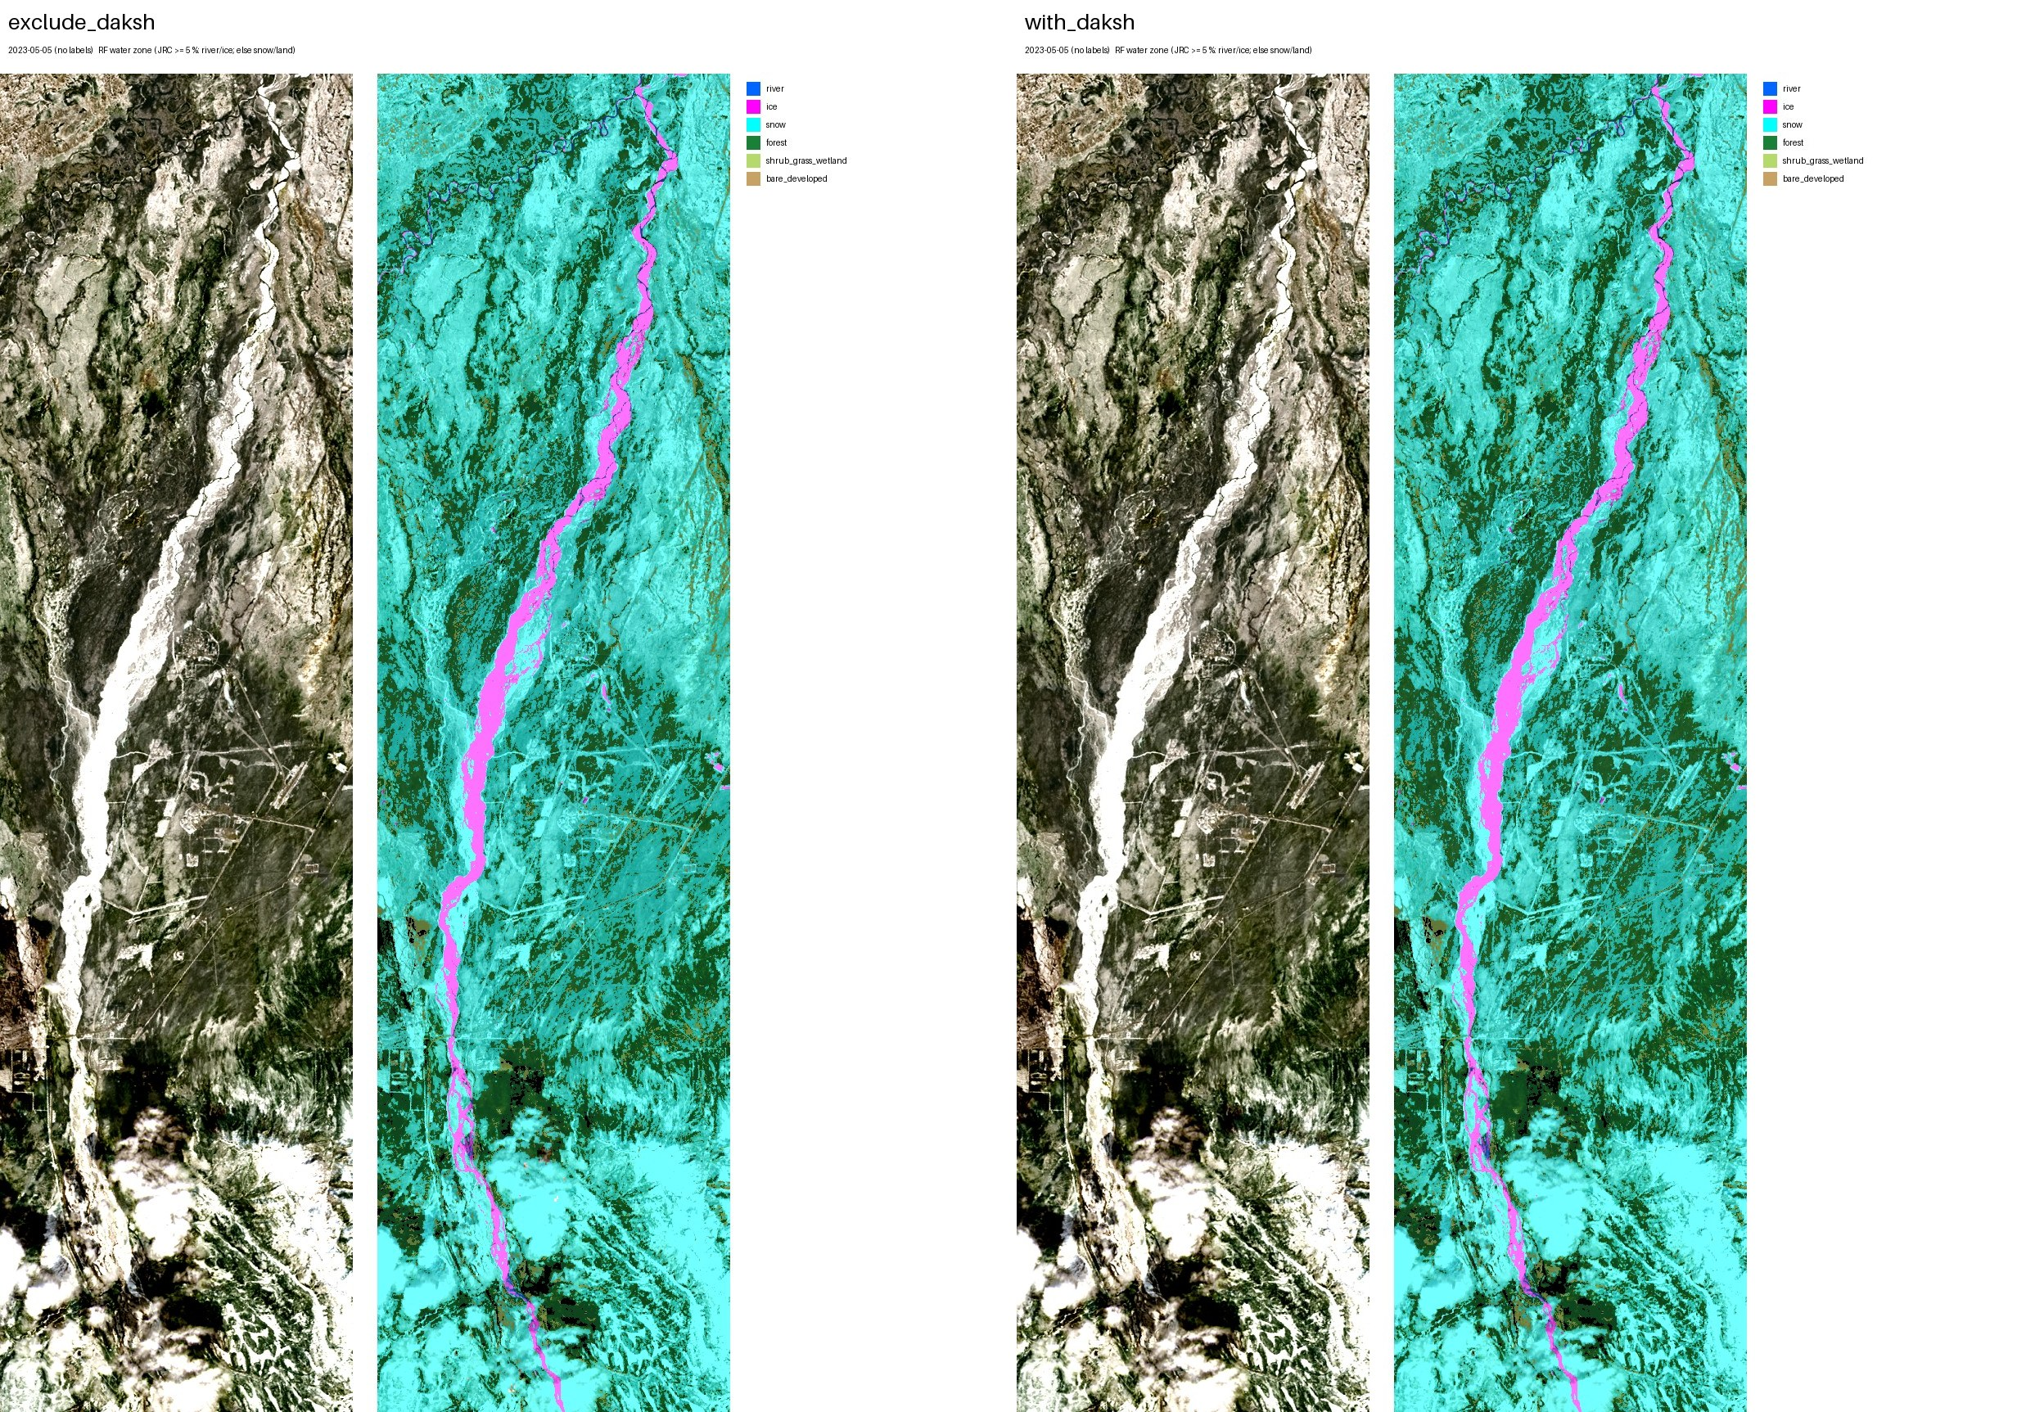
2023-05-05 (spring, no labels): exclude_daksh, with_daksh.
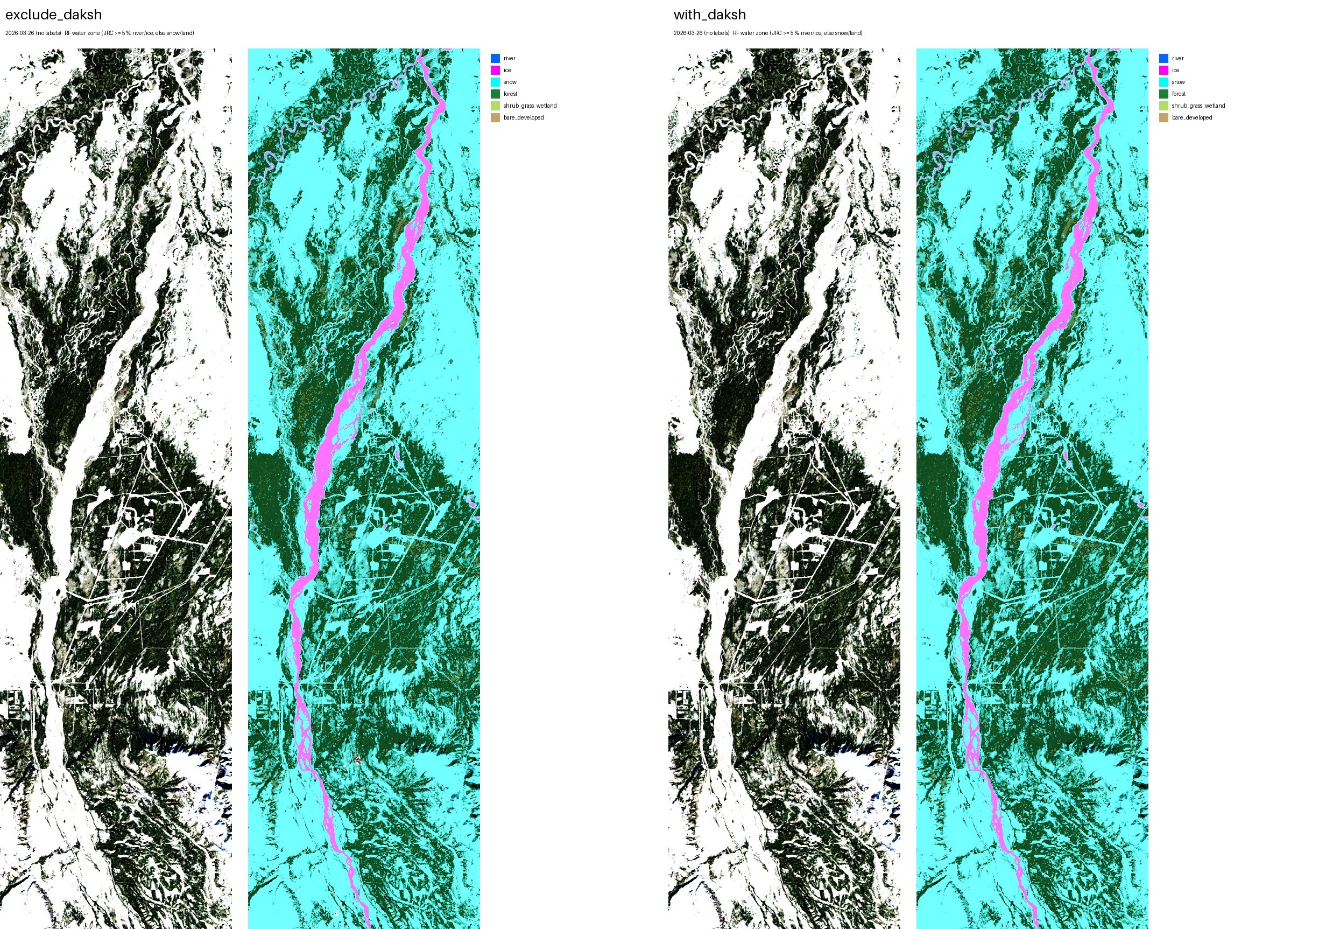
2026-03-26 (winter, no labels): exclude_daksh, with_daksh.

10. Run 16 next to runs 10 and 15
The same date mapped by run 10 (best scores before), run 15 (river penalty) and run 16 (water zone), whole study box, with_daksh models (exclude_daksh where with_daksh has no map). Run 16 never puts river on land or snow on the river.
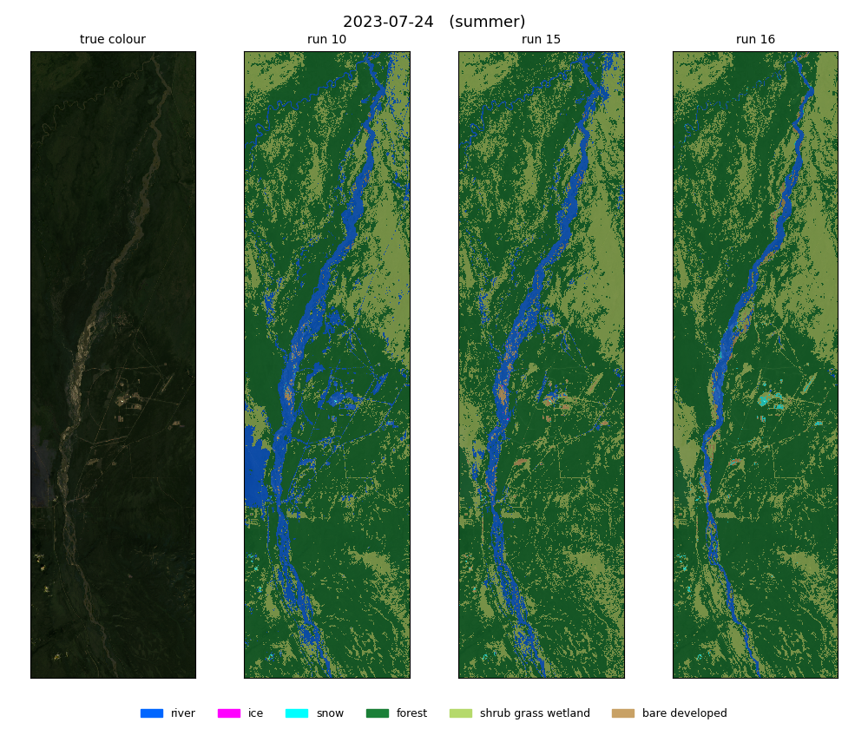
2023-07-24 (summer): true colour, run 10, run 15, run 16.
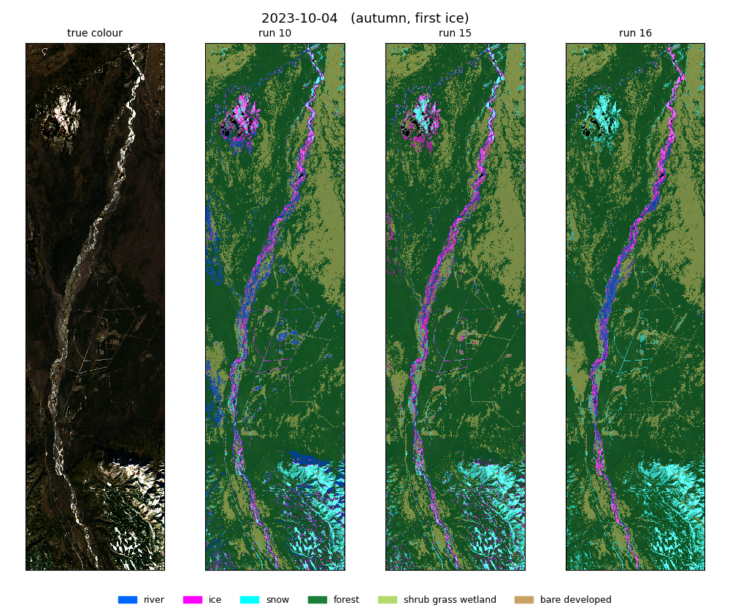
2023-10-04 (autumn, first ice): true colour, run 10, run 15, run 16.
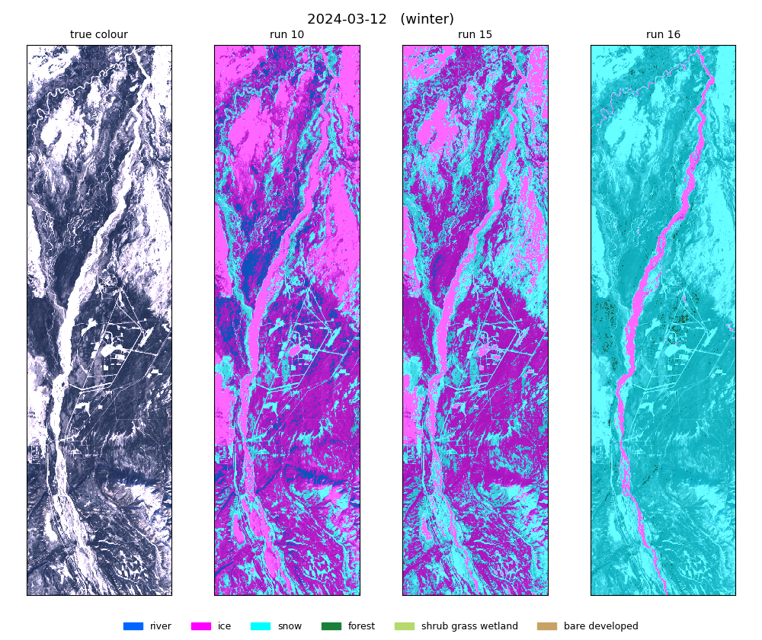
2024-03-12 (winter): true colour, run 10, run 15, run 16.
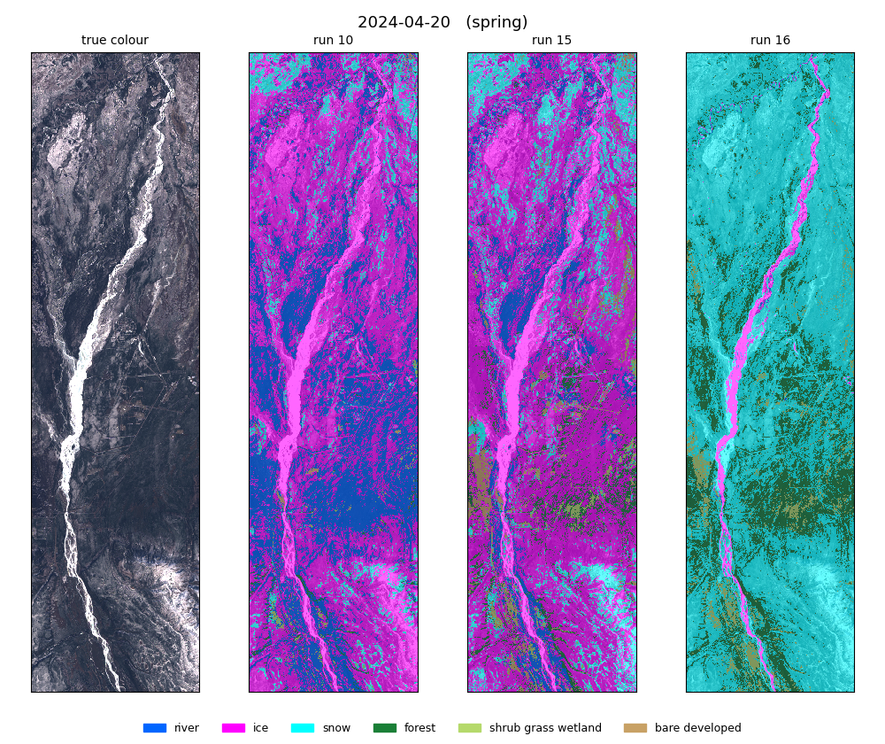
2024-04-20 (spring): true colour, run 10, run 15, run 16.
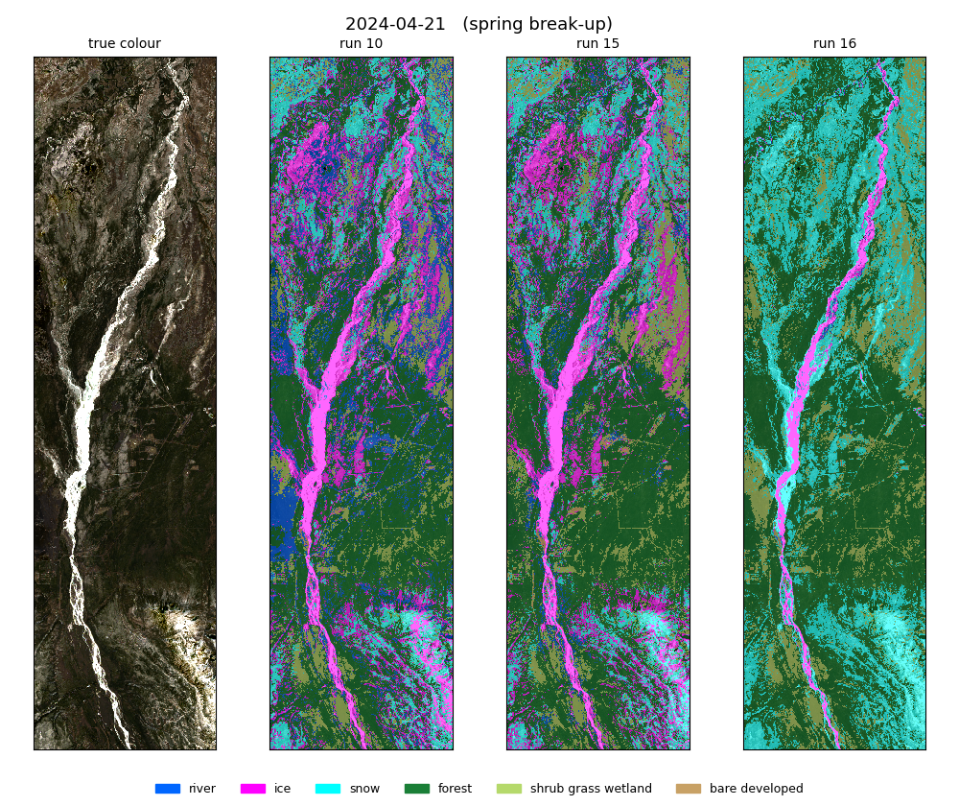
2024-04-21 (spring break-up): true colour, run 10, run 15, run 16.
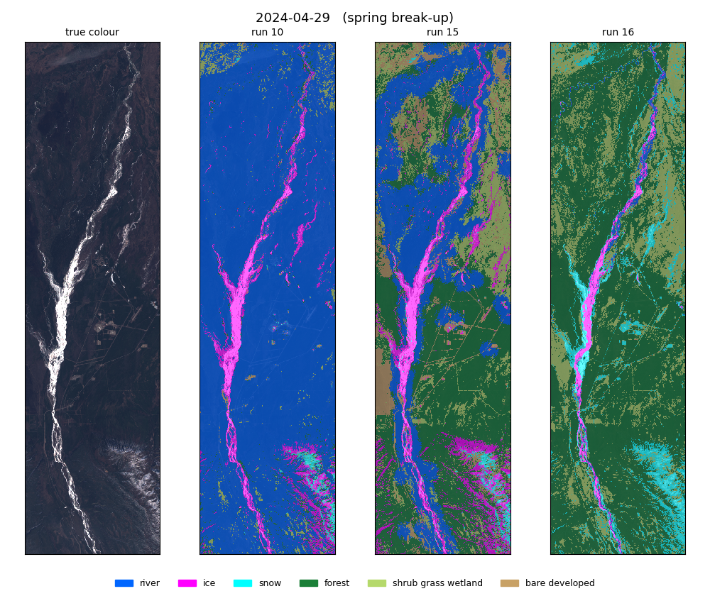
2024-04-29 (spring break-up): true colour, run 10, run 15, run 16.
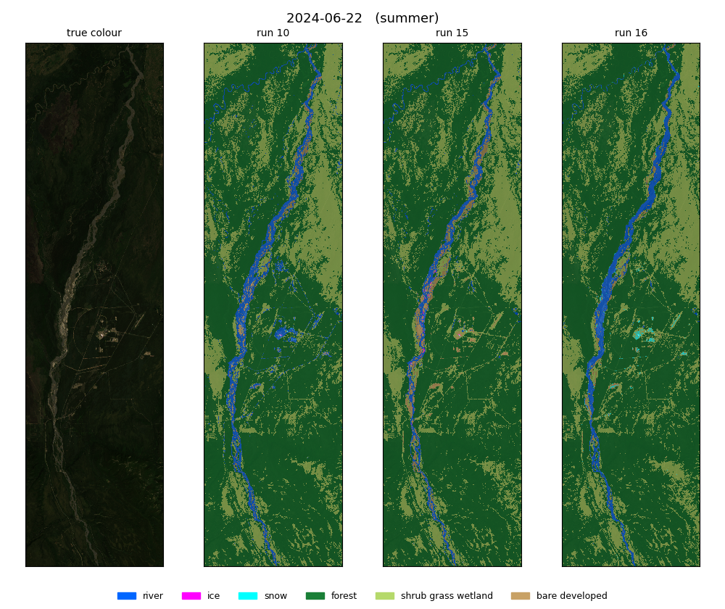
2024-06-22 (summer): true colour, run 10, run 15, run 16.
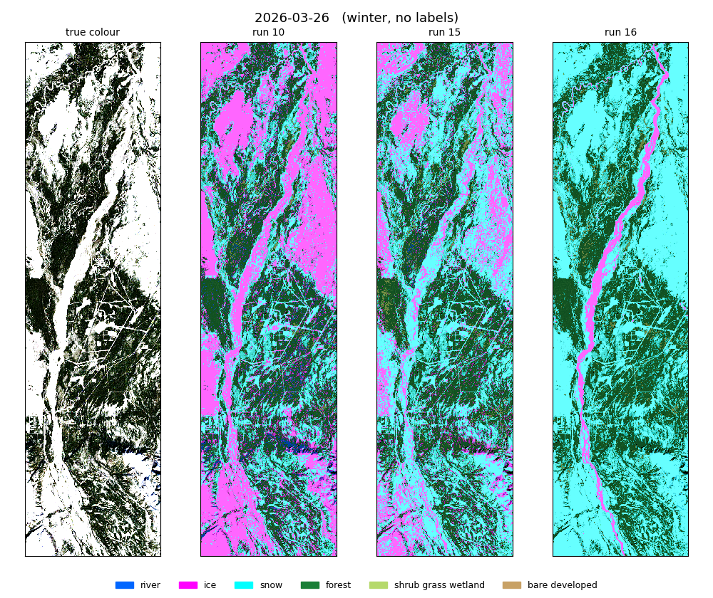
2026-03-26 (winter, no labels): true colour, run 10, run 15, run 16.
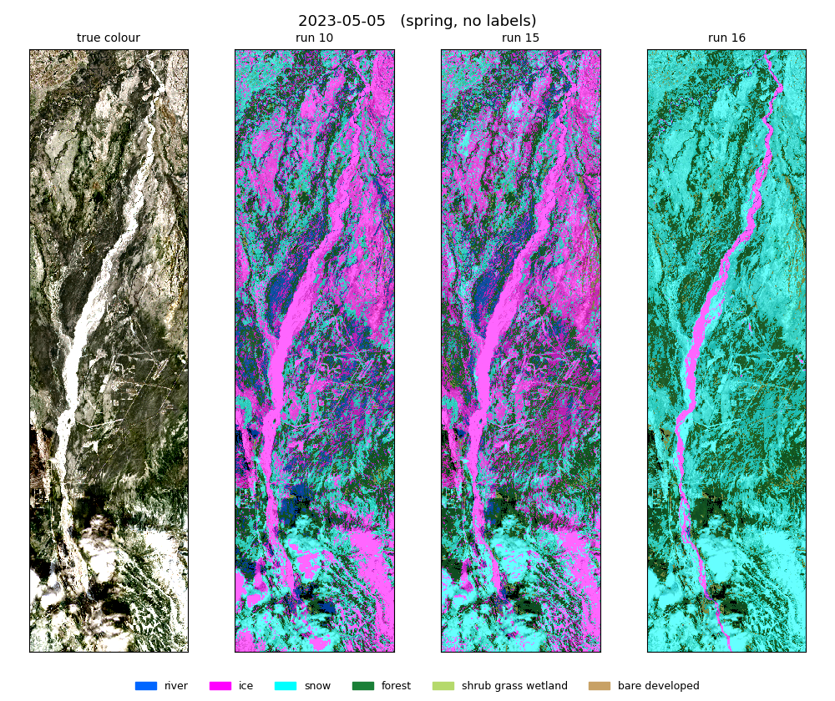
2023-05-05 (spring, no labels): true colour, run 10, run 15, run 16.

11. Files and QGIS
what | where
script | ~/Desktop/nenana_crops/daksh/rf_water_zone.py
results | ~/Desktop/nenana_crops/daksh/output/16_rf_water_zone/<dataset>/six_class/random_forest/ (metrics.txt, oof.npz, pred_<date>.tif, new_dates/, images/)
water zone | output/16_rf_water_zone/water_zone.tif (1 = water zone)
QGIS project (run 16 only) | ~/Desktop/nenana_river_models/qgis_run16/run16.qgz (full paths, this computer); run16_portable.qgz (relative paths, for sending); zipped: qgis_run16.zip
extra analysis | rf_water_zone_extra.py -> output/16_rf_water_zone/extra.json (cutoff scan, training vs held-out, importances, label counts)
QGIS builder | make_run16_project.py
this report | report/word_content_run16.py + report/build_word.js

The QGIS project holds, per date: labels, study box, Landsat (true colour, SR, SWIR, thermal, NDVI, JRC, QA) and Sentinel-2 where the date has it, plus a run16_water_zone group with the with_daksh, exclude_daksh and external maps. reference_layers holds the water zone, JRC water occurrence and NLCD 2016. run16.qgz stores full paths; run16_portable.qgz stores relative paths, so the unzipped folder opens anywhere.

12. Things to know
- The rule-label scores are not directly comparable with runs 01-15: pixels the rule cannot hold are left out of them. The original-label scores are the like-for-like comparison.
- The JRC layer ends in 2021; where the channel has moved since, real river lies outside the water zone and is mapped as land or snow.
- Gravel bars inside the water zone can only be river or ice in this run.
- Ice and snow come from few dates (2023-10-04, 2024-04-21, 2024-03-12), so their scores move a lot with each polygon.
- NLCD is an input of the land forest, so forest/shrub/bare scores partly measure agreement with NLCD.
- Clouds were never labelled; on cloudy dates they become snow (land) or ice (water zone).

