Assignment 1

Name: Neha Uttamrao Torkad MIS: 111903049
Course Teacher : Rohoni Sarode

AIM : To learn Git and gitnub and Implement git command on respective OS

Git :

-Git is an Open Source Distributed Version Control System.
-This basically means that Git is a content tracker. So Git can be used to store content it is mostly used to store code due to the other features it provides.
-Git has a remote repository which is stored in a server and a local repository which is stored in the computer of each developer.

Some Useful Git Coomand

1. git config - to set your user name and email address with git.

git config - -global user.name "username"
git config --global user.email xyz@xyz.com
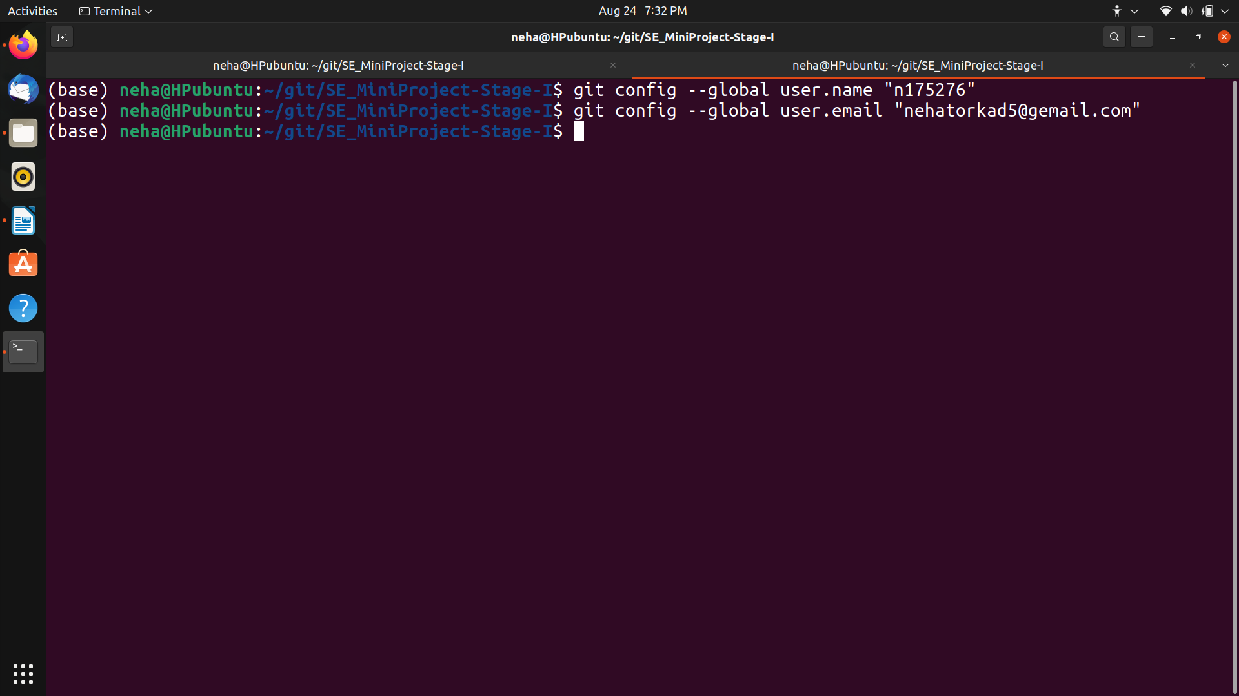

2. git clone - clone the git repository for your project to start with and only then you can commit your changes.

git clone https://gitlab.com/xyz/abc.git

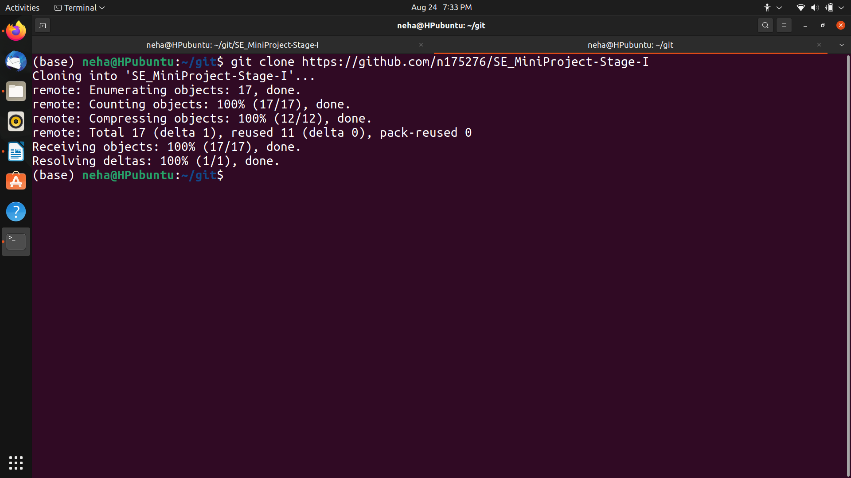

3.git init- Initialize a new Git repository

git init
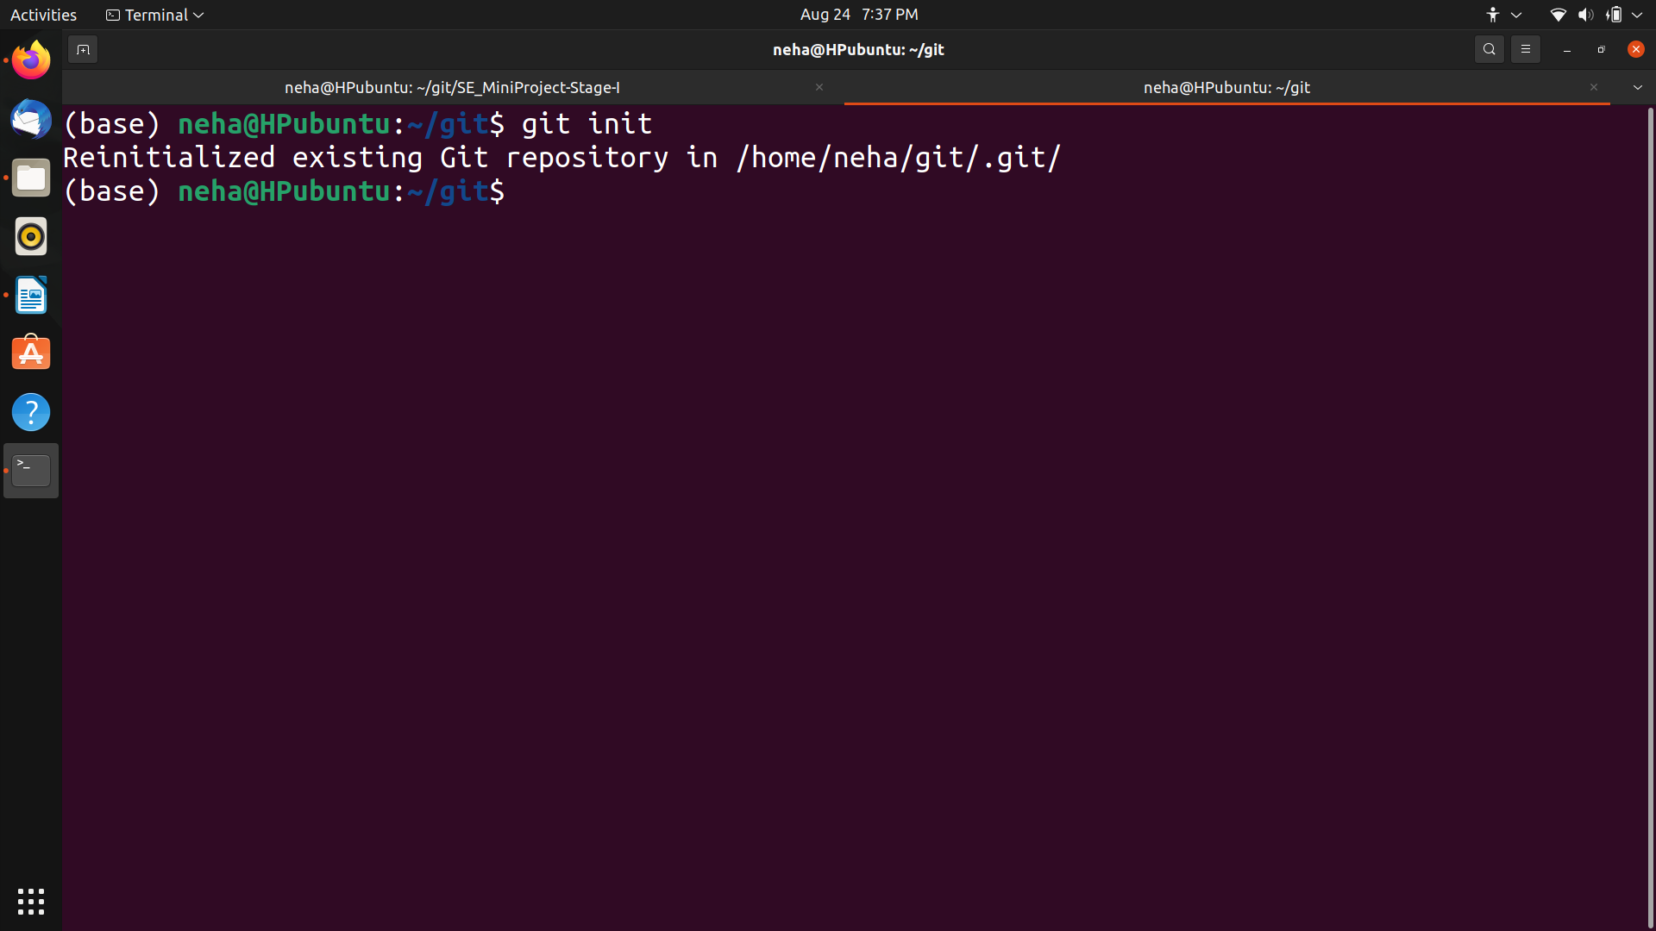

4.git status-Checking Git status

git status
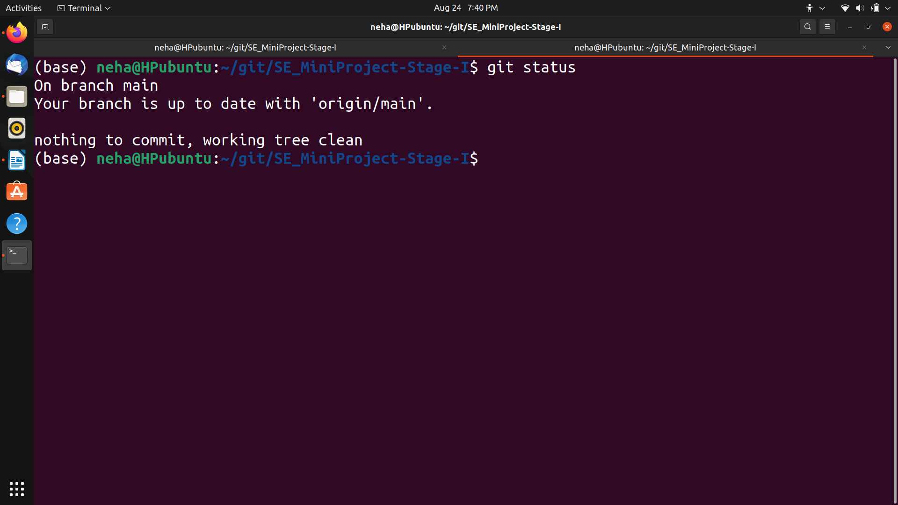
5.git add-Add a new file to Git repository
git add demo.txt

6.git commit-Now, we need to commit this to your git repo by using
git commit -m 'first commit'

7.git push-Now, push the changes to the repository.
git push
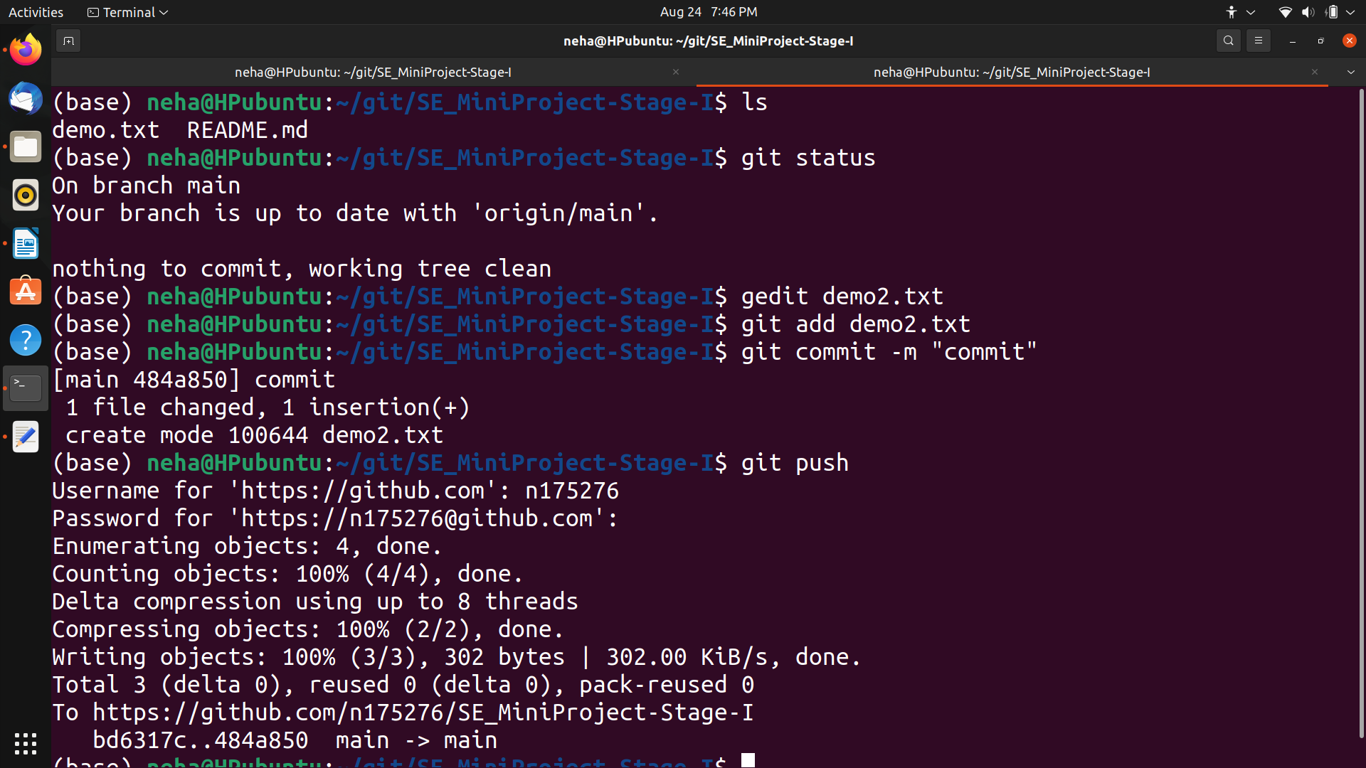
8.git pull-It will fetches files from the remote repository and merges it with your local one.

git pull

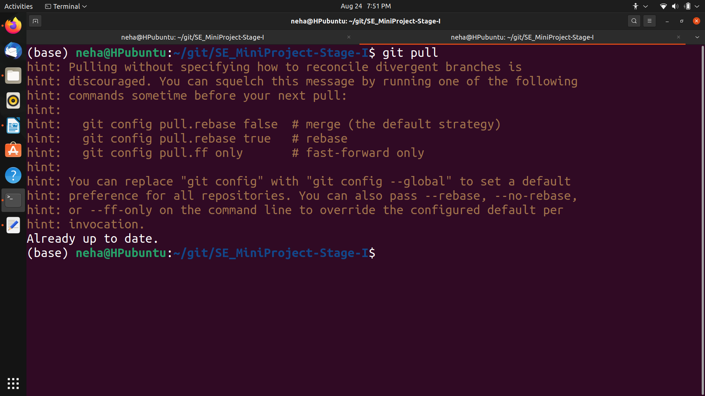
9.git branch-To know your git branch

git branch

11.git checkout-ets you navigate between the branches created by git branch

git checkout brachname

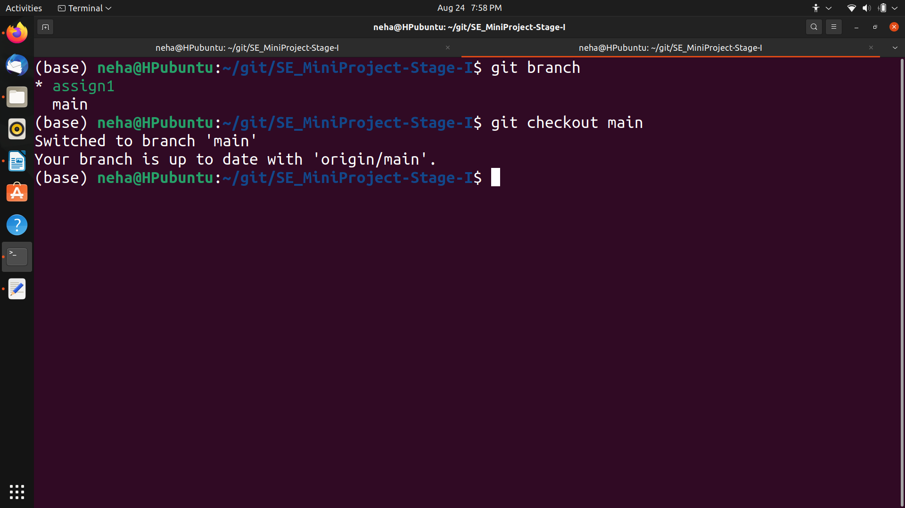

10.install git-

sudo apt-get install git

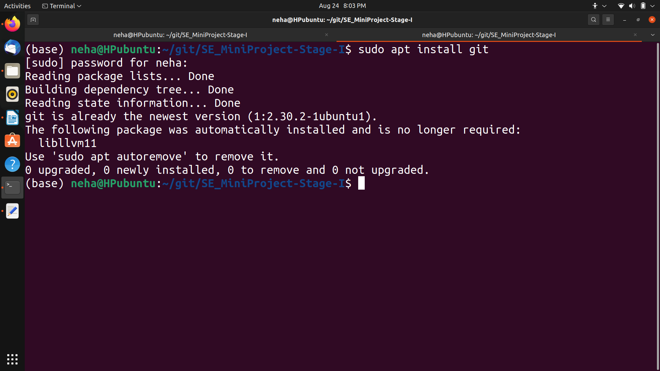

12.merge-ets you navigate between the branches created by git branch

git merge branchname

