ASSIGNMENT 2 :

Study and Install Debian Operating System

NAME : Neha Uttamrao Torkad
MIS : 111903049
Teacher : Rohini Sarode
________________________________________________________________________________________________________________________________

Debian OS

Debian OS Architecture :

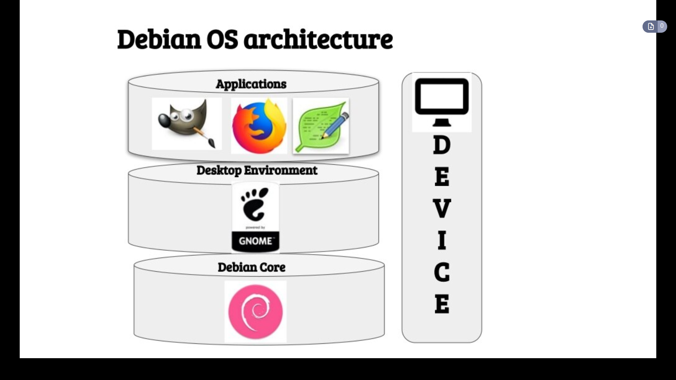

- Debian also known as Debian GNU/Linux.
- Debian is a Linux distribution composed of free and open-source software.
- Debian developed by the community-supported Debian Project, which was established by Ian Murdock on August 16, 1993.
- The first version of Debian (0.01) was released on September 15, 1993 .
- The first stable version (1.1) was released on June 17, 1996.

Look of Debian OS :

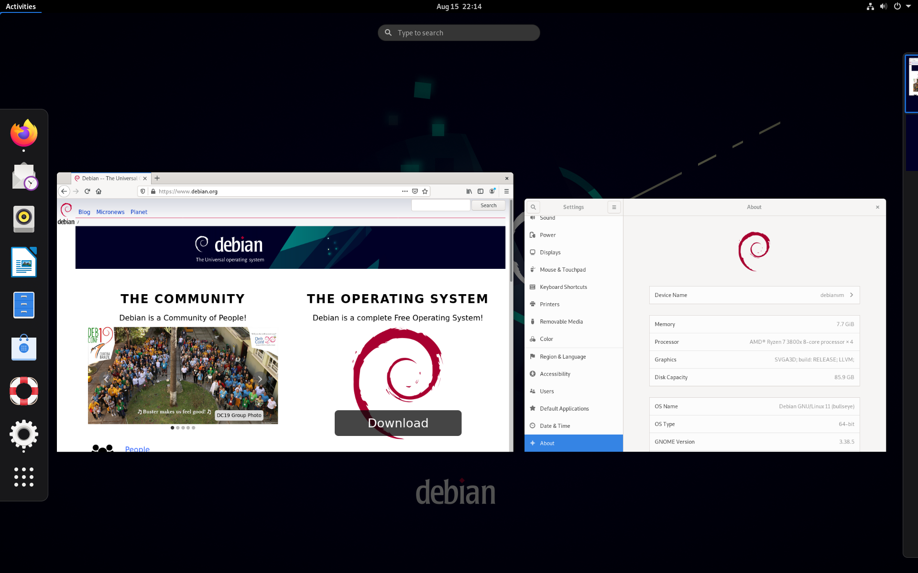
Features :

- Debian is one of the oldest operating systems based on the Linux kernel.
- Debian has access to online repositories that contain over 51000 packages.
- Debian officially contains only free software, but non-free software can be downloaded and installed from the Debian repositories.
- Debian includes popular free programs such as LibreOffice,Firefox web browser, Evolution mail, K3b disc burner, VLC media player, GIMP image editor, and Evince document viewer.
- Debian is a popular choice for servers, for example as the operating system component of a LAMP stack.
- Debian offers CD and DVD images specifically built for XFCE, GNOME, KDE, MATE, Cinnamon, LXDE, and LXQT.
XFCE is default on CD images and non-Linux ports
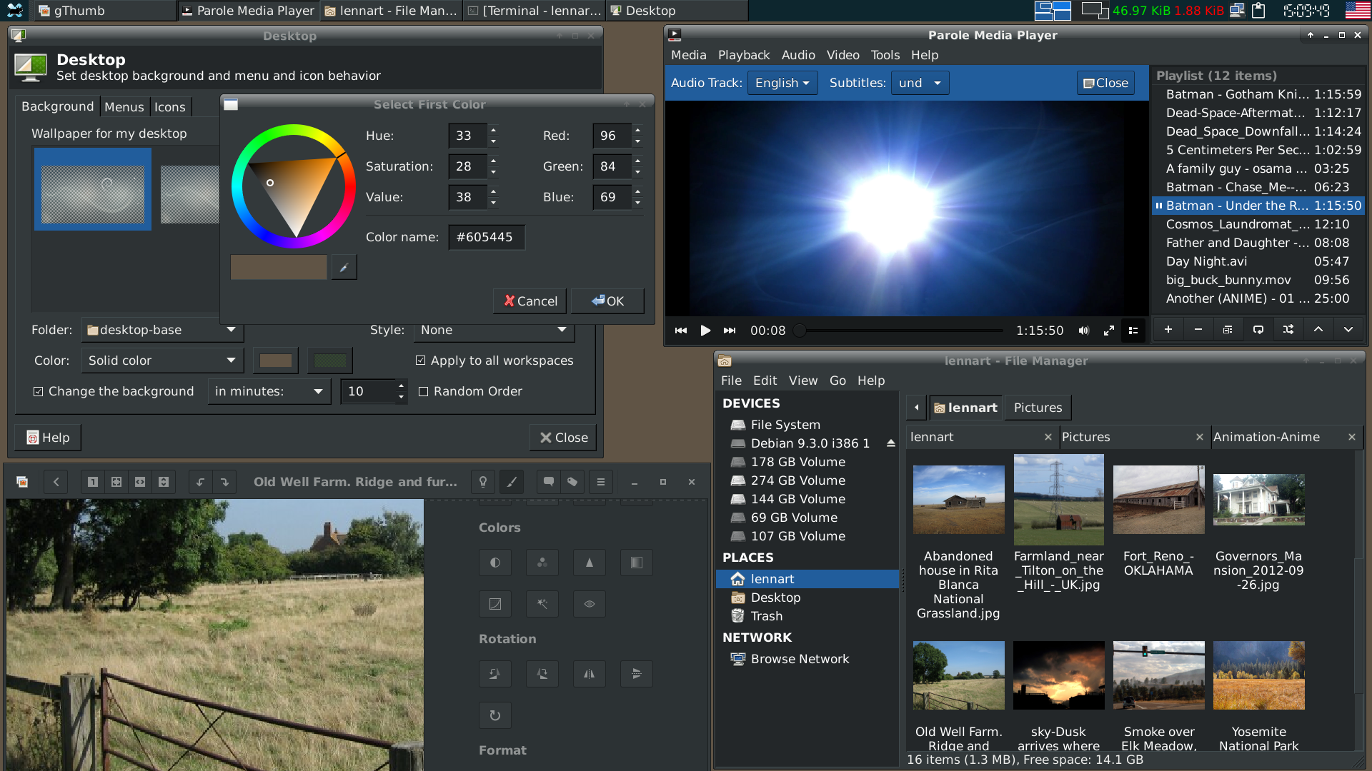
- Several parts of Debian are translated into languages other than American English, including package descriptions, configuration messages, documentation and the website. (The Debian 10 installer is available in 76 languages.)

Packages
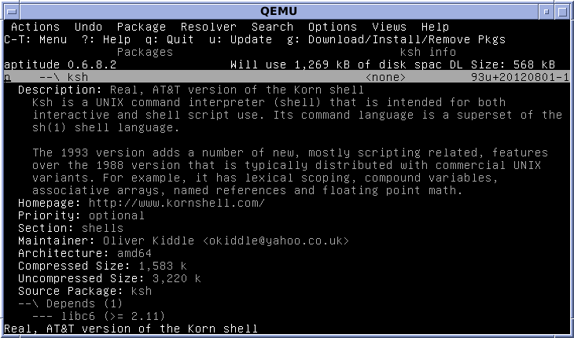
Using Aptitude to view Debian package details
Package management operations can be performed with different tools available on Debian, from the lowest level command dpkg to graphical front-ends like Synaptic.
DPKG :
- dpkg provides the low-level infrastructure for package management.
- The dpkg database contains the list of installed software on the current system.
- The dpkg command tool does not know about repositories.

APT tools :
An Advanced Packaging Tool (APT) allows administering an installed Debian system to retrieve and resolve package dependencies from repositories. APT share dependency information and cached packages.
- The apt command itself is intended as an end user interface and enables some options better suited for interactive usage by default compared to more specialized APT like apt-get and apt-cache explained below.
- apt-get and apt-cache are command tools of the standard apt package. apt-get installs and removes packages, and apt-cache is used for searching packages and displaying package information.
- Aptitude is a command line tool that also offers a text-based user interface. The program comes with enhancements such as better search on package metadata.
Package installed with Aptitude:-
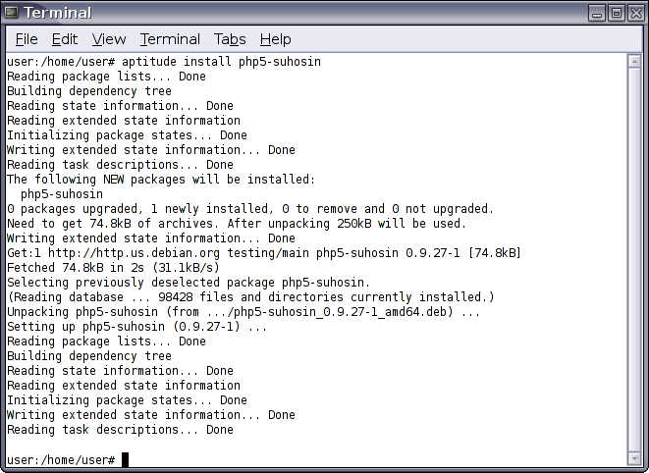

GDebi and other front-ends
- GDebi is an APT tool which can be used in command-line and on the GUI.
- GDebi can install a local .deb file via the command line like the dpkg command, but with access to repositories to resolve dependencies.
- Other graphical front-ends for APT include Software Center, Synaptic and Apper.
- GNOME Software is a graphical front-end for PackageKit, which itself can work on top of various software packaging systems.

Hardware
Hardware requirements are at least those of the kernel and the GNU toolsets. Debian's recommended system requirements depend on the level of installation, which corresponds to increased numbers of installed components:
Type | Minimum RAM size | Recommended RAM size | Minimum processor clock speed (IA-32) | Hard-drive capacity
Non-desktop | 256 MB | 512 MB |  | 2 GB
Desktop | 512 MB | 2 GB | 1 GHz | 10 GB

Steps to Install Debian OS :
Step 1 : Back up any important files on your computer. Whether you plan to wipe out another operating system (such as Windows) and replace it with Debian or you want to set up a dual-boot situation, back up any existing data just in case something goes wrong.
- These steps will work best if you're using Windows 10 or 8.1 on the PC already, whether you plan to keep Windows installed or not.
- If you're going to dual-boot Debian with Windows or another operating system, make sure you have that operating system's installation or recovery media in case you ever need to reinstall it.
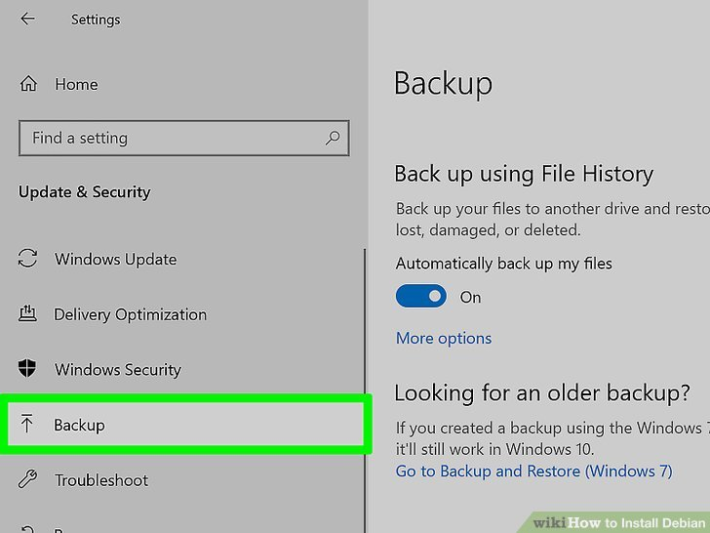

Step 2 : Back up the contents of your USB flash drive. You can copy the Debian installation image to a USB drive and use it to install Debian. Since the drive will need to be bootable, everything on it now will be formatted and erased before you install Debian—make sure to save any files you wish to keep.
- Your USB drive should be at least 2 GB so there's enough room for the CD installer.
- If you'd rather install Debian from a bootable CD-R, you can do that instead. We'll focus on USB drives as not too many PCs come with optical drives anymore
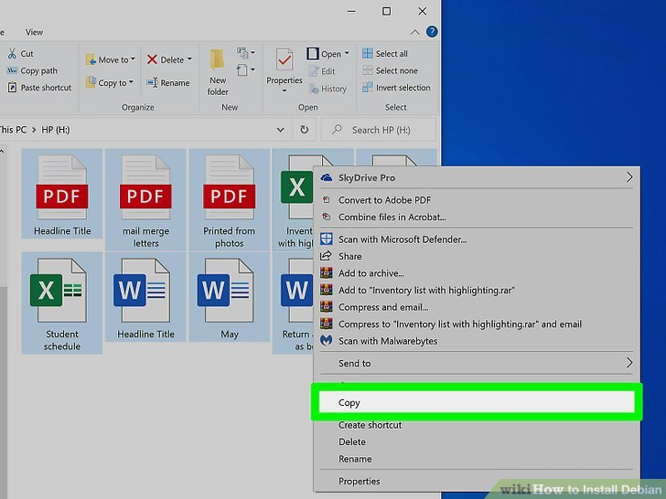

Step 3 : Download a Debian image from https://www.debian.org/CD/http-ftp/#stable. Debian 10 offers a variety of installation media for different platforms. Download the image you know you need, or use this info to get you started:
- Debian installers are based on your hardware. So, if you have a 64-bit PC with an Intel or AMD processor, select amd64 under the "CD" header. If you have a 64-bit system with an ARM processor, click arm64 instead. If you have a 32-bit system, click i386.
- In the resulting file list, click the file that ends with xfce-CD-1.iso to download the full ISO of the installer. Or, if you have speedy broadband (or higher) internet, you can select the one ending with netinst.iso to get a smaller file that requires an internet connection during installation.
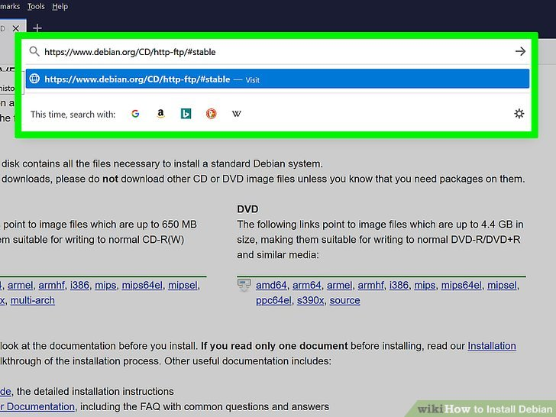

Step 4 : Create a bootable USB drive using the downloaded ISO file. This process is simple but requires installing some free software. See How to Make a USB Bootable to learn about using Rufus (for Windows) to flash the downloaded ISO file onto your USB drive.
- You can use Rufus and other similar software to create a bootable CD-R as well.
- If you're installing Debian on a virtual machine (like VirtualBox), you can skip this step—after creating your Debian virtual machine, you can mount the downloaded ISO as a virtual optical drive and boot from it.
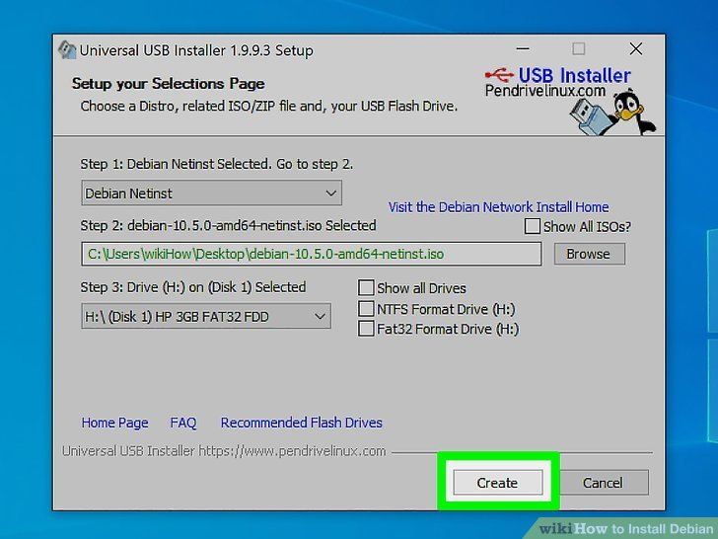

Step 5 : Configure your PC so that it can boot from a USB or optical drive. Now that you have your Debian installer ready to go, you'll need to make sure you can boot from it. This must be done in your PC's BIOS. All BIOS are different, but what you'll need to do is find the section labeled "Boot Order" (it will be a list of drives connected to your computer) and move the USB controller (or the optical drive) to the top of the list. Getting to the BIOS varies by system:
- If you're using Windows 10 or 8.1, you can usually enter the BIOS from the desktop:
  - Click the Start menu and select Settings.
  - Navigate to Update & Security > Recovery.
  - Click Restart now under "Advanced startup."
  - Click Troubleshoot when the PC comes back up.
  - Go to Advanced options > UEFI Firmware Settings.
- You can also reboot your PC and quickly (and repeatedly) press the BIOS hotkey for your manufacturer. The hotkey appears on the first screen you see after rebooting near something like "Enter Setup." Some common hotkeys are F2 (Acer, Asus, Lenovo, Dell, Origin PC, Samsung, Sony, Toshiba), F1 (Lenovo desktops and ThinkPad models, Sony), F10 (HP), and the Del key (Acer, Asus, MSI).
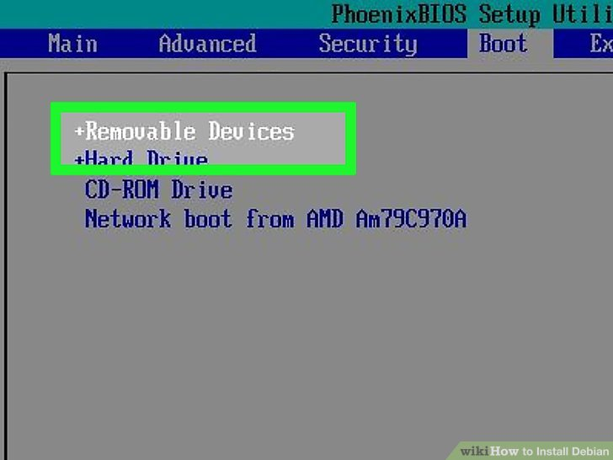

Step 6 : Insert your bootable USB install drive and reboot your PC. If you created an installation CD-R, insert that instead.

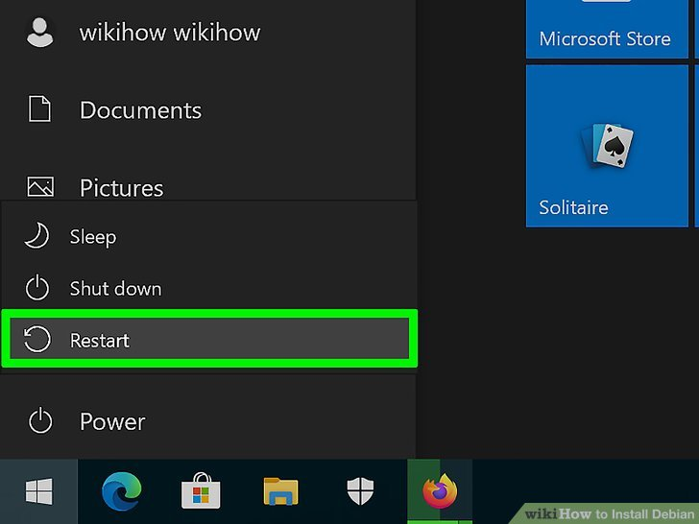

Step 7 : Select the option to boot from USB or CD-ROM drive when prompted. This option appears once you reboot the PC. The PC will then boot into the first installation screen.

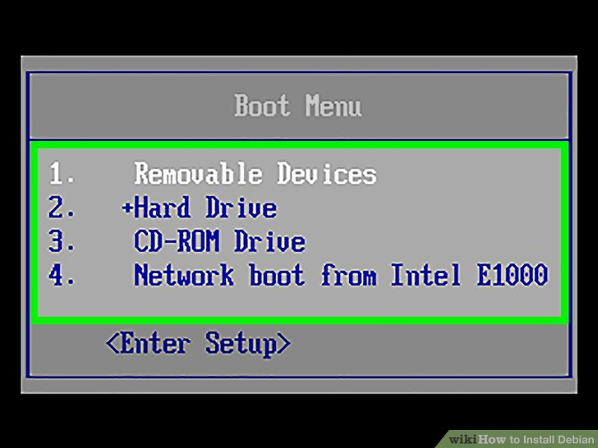

Step 8 : Select Graphical Installer. Use the arrow key to make the selection, and then press the Enter key to select it.

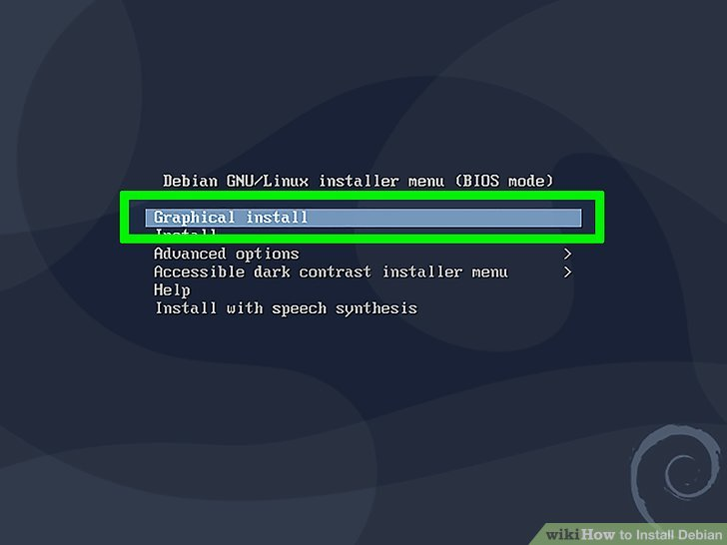

Step 9 : Select a language and region. The first three screens will ask you to choose your language, location, and keyboard region. Once you've made your selections, the installer will ask you to configure your network.
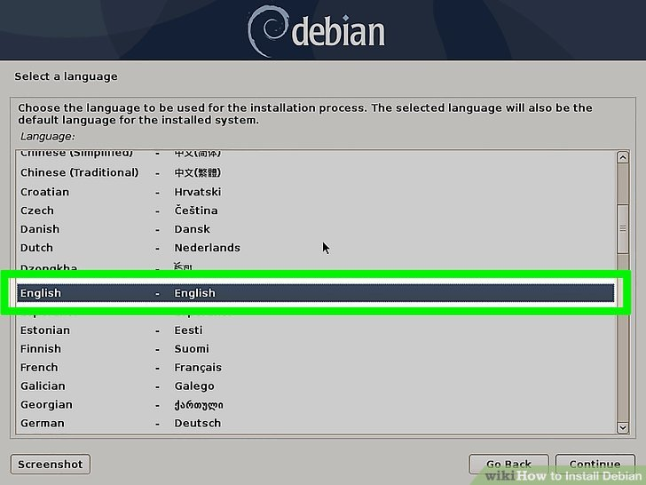

Step 10 : Enter the requested network information. This will look different depending on how you're installing Debian (full CD image or over the network).
- In both cases, you'll be asked to enter a hostname and domain name. The domain name can be left blank if your local network doesn't require it.
- If you're installing over the internet (this is the case if you downloaded the smaller ISO file), you'll also be walked through instructions on connecting your PC to the internet. If you receive an error about your Wi-Fi adapter, use an ethernet cable in the meantime.
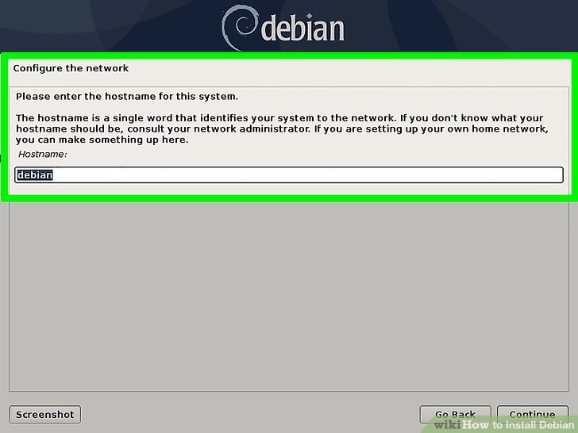

Step 11 : Create (or skip) a root password. Although it was once required to create a root (admin) account and password when installing Debian, you can now skip this step.[4] Skipping the root password step means sudo will automatically be set up for your user account—this will give you administrative access. It's actually safer to not have a root password since you won't need to share a root password with other admins. You can then just elevate other accounts that also need administrative access.

- To skip creating a root password, leave the "Set up users and passwords" screen blank and click Continue.
- If you create a root password now, you won't have sudo access set up immediately, which means you'll need to use "su root" every time you want to do something administrative rather than "sudo." But if you do want to create a root password, you can do so and then install the sudo package later.

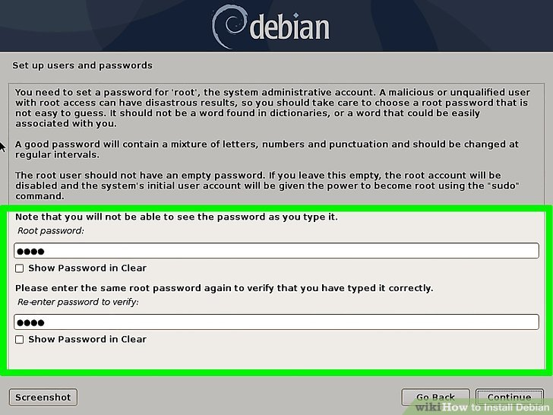

Step 12 : Create a user account. Now you can create your personal account, which is how you'll log in to Debian. On the next several screens:
- Enter your full name and click Continue.
- Type a username (all lowercase letters, but you can also use numbers if you'd like) and click Continue.
- Enter and confirm a secure password, and then click Continue. As long as you skipped adding a root account, this new account will be given sudo rights.

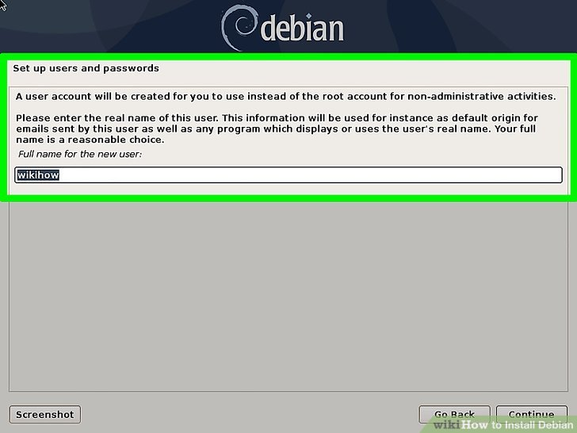

Step 13 : Select your time zone and click Continue. This ensures your system clock is set properly.
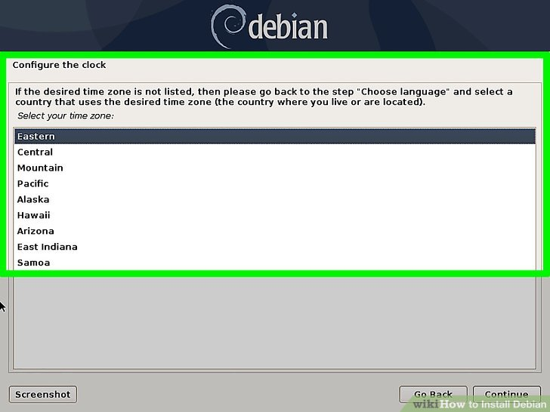

Step 14 : Select a partition option. The option you choose for partitioning depends on your needs:
- If you just want to install Debian on existing unused drive space, select Guided – use the largest continuous free space.
- If you want only want to use Debian on this drive and not anything else, select Guided – use entire disk.
- Select Manual if you want to retain other partitions on the computer, such as your Windows installation.
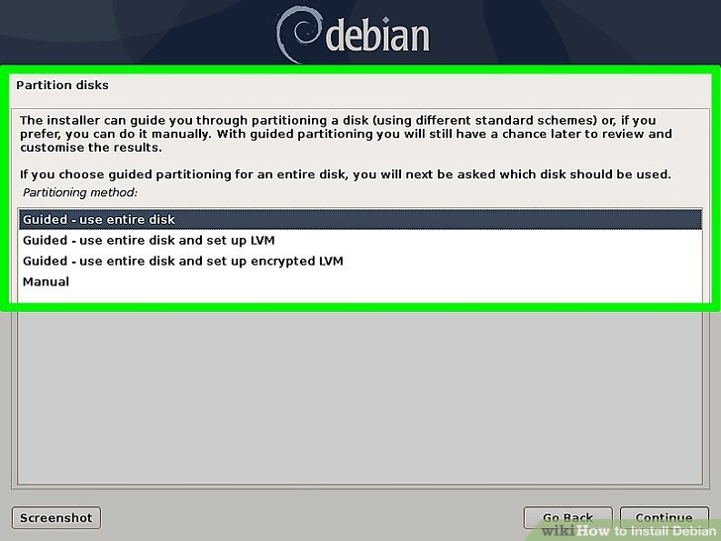

Step 15 : Follow the on-screen instructions to partition your drive(s). This process varies depending on how you're installing Debian. If you chose one of the Guided options, let the on-screen instructions walk you through the process. When given the option to choose a file system, select Ext4 journaling file system. When the partitioning is complete, Debian will start installing.

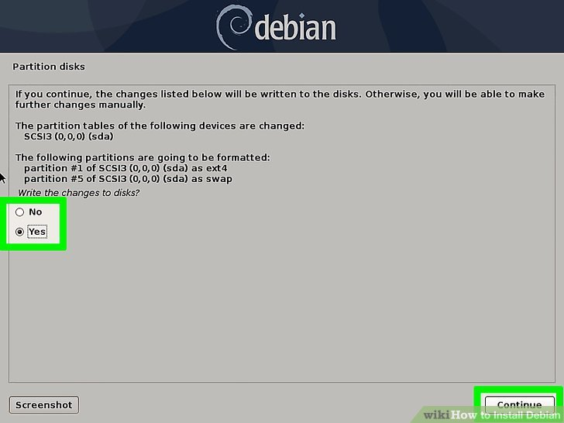

Step 16 : Select "No" when asked to scan another CD/DVD and click Continue. This pops up after Debian is already partially installed.

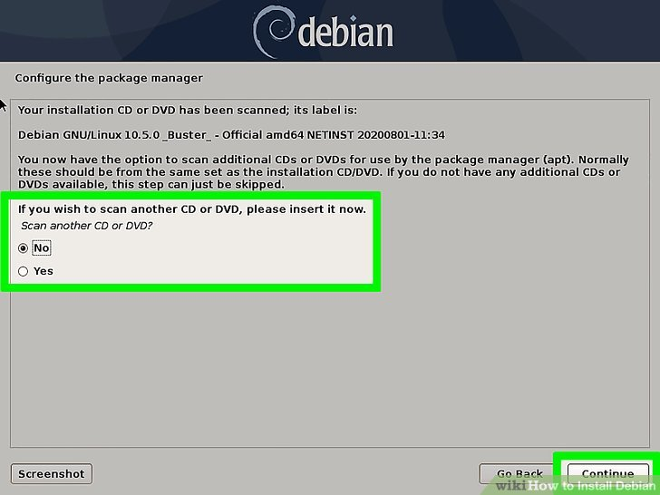

Step 17 : Choose a network mirror and select Continue. When asked if you'd like to use a network mirror to complete the installation, you can opt to do so.

- Select No to continue the installation from the downloaded image.
- Select Yes if you'd like to finish the installation over the internet, and then follow the on-screen instructions to set up your network preferences.

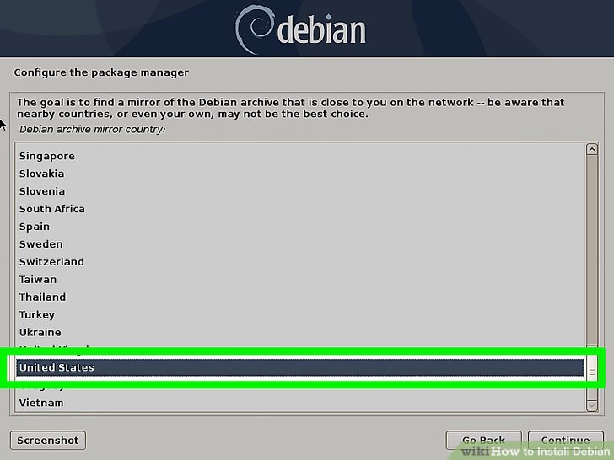

Step 18 : Select software to install and click Continue. Make sure to select at least once desktop environment, such as GNOME or KDE, as well as the option for "standard system utilities." If you want to be able to connect to your Debian system remotely through SSH, select the "SSH server" option.

- Any software you install can be updated at any time later.
- Once you click Continue, Debian will begin the bulk of the installation process.

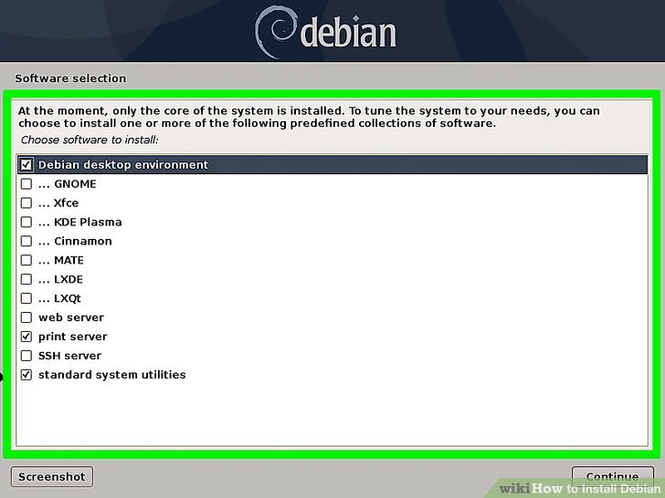

Step 19 : Click Continue when the installation is complete. It can take several minutes for this to appear, depending on the speed of your computer (and network speed, if you installed over the internet). This will immediately reboot the computer into the GRUB bootloader.

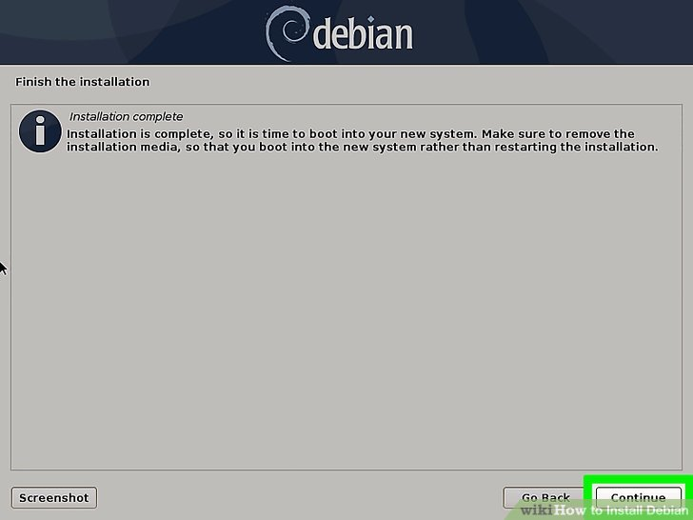

Step 20 : Select Debian GNU/Linux to boot into Debian. It should be the first option. The GRUB bootloader was installed with Debian and will come up any time the computer is rebooted. Once you select this option, you'll be brought to the Debian login screen. Congratulations, you've installed Debian!
- If you have Windows installed and wanted to boot into it instead, choose Windows Boot Manager.
- To access your system BIOS from Grub, choose the System setup option.

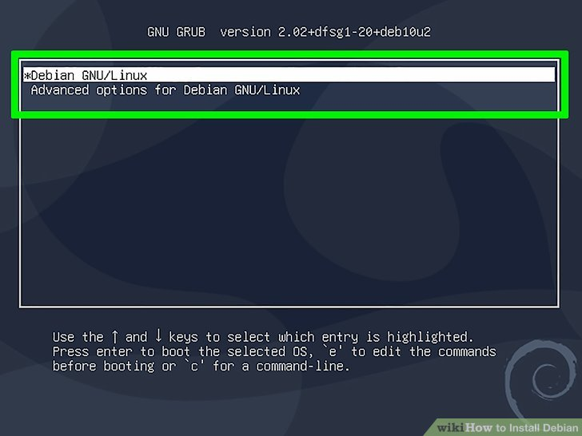

All done! You should now see the Debian desktop screen. This confirms you have successfully installed Debian on your machine.

