1. Write MIPS assembly code in your text editor then save it into project root folder for example:

beq $zero, $zero, MAIN

FUNCTION: addi $s0, $zero, 125

END_FUNCTION: jr $ra

MAIN: jal 1

addi $t0, $zero, 0

addi $t1, $zero, 10

FOR: slt $t2, $t0, $t1

beq $t2, $zero, END

lw $s0, 0($t0)

addi $t0, $t0, 1

beq $zero, $zero, FOR

END: sll $zero, $zero, 0

EXIT_MAIN:

1. Open terminal in project’s folder then run assembler by running this command (given that you named the code file “code.mips”)

java –jar assemble.jar code.mips

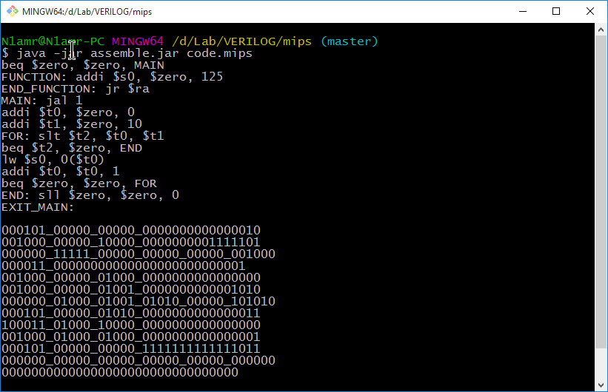

Note: You can alternatively run “assemble ‘code.mips’” file.

1. Write data memory contents in “data-memory.mem” in binary one byte in a line for example

00000000

00000001

00000010

00000011

00000100

00000101

00000110

00000111

00001000

00001001

00001010

00001011

00001100

00001101

1. Open project in ModelSim.
2. Compile source code by selecting “Compile All” from “Compile” menu.

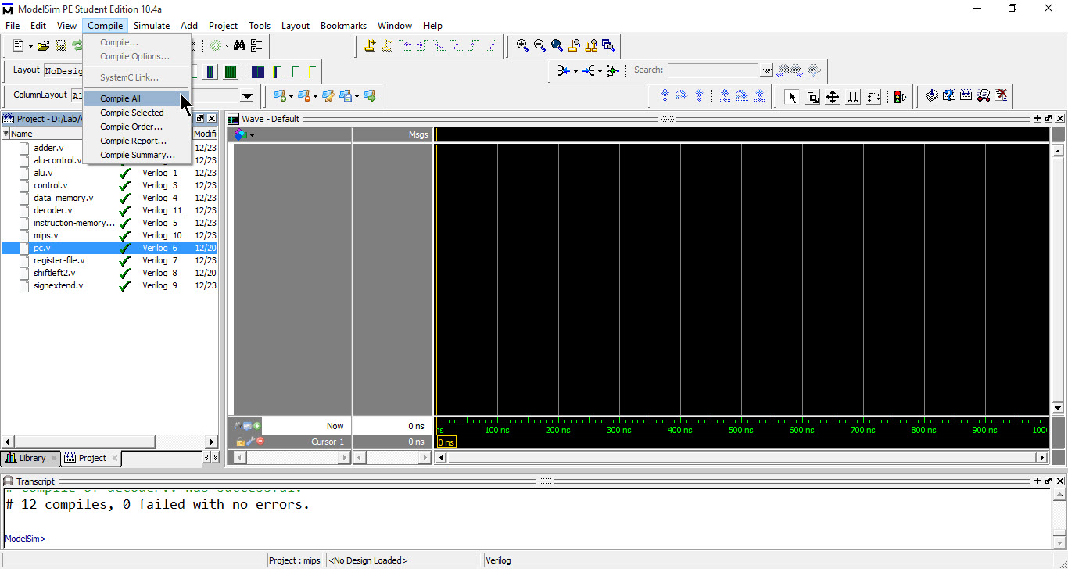

1. Start simulation by selecting “Start Simulation...” from “Simulate” menu. From work directory choose ‘MIPS’

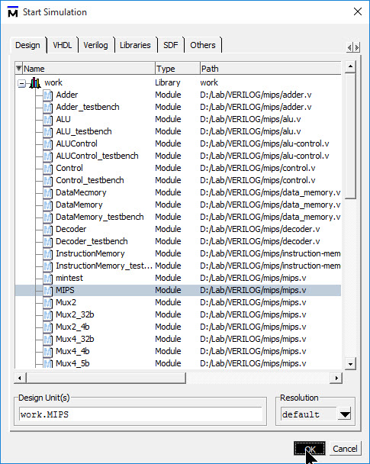

1. If wave form view is not displayed check ‘Wave’ from ‘View’ menu. Select all the signals that you want to trace from ‘Objects’ view then drag them to ‘Wave’ view

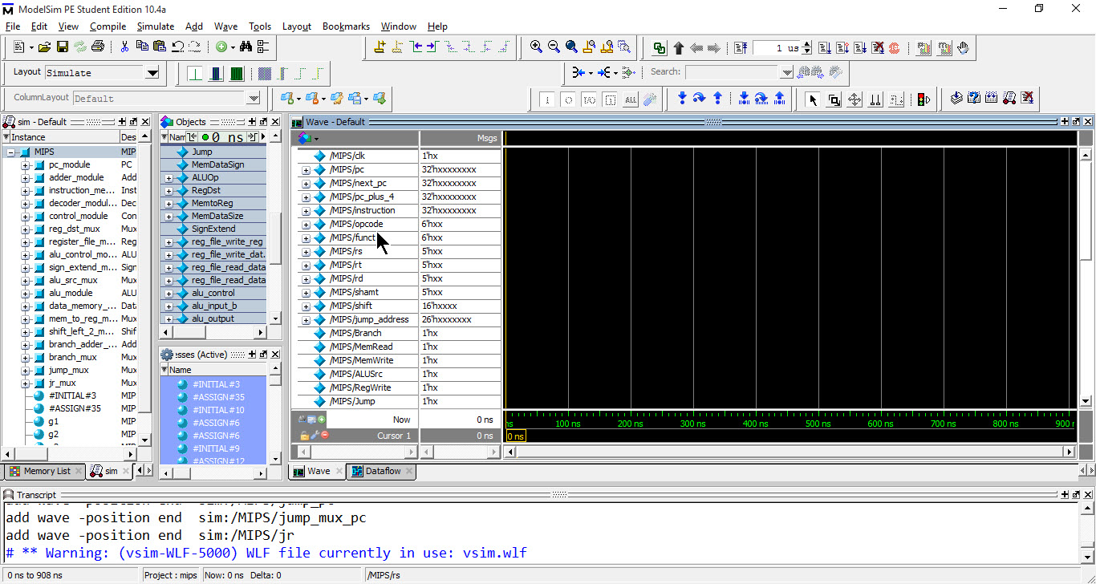

1. Set simulation run step to 1000 ns then click run

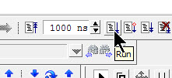

1. Continuously click run to simulate next clock cycle

