AMBARI SETUP IN GCP

Installation of Apache Ambari is very easy. SSH to your server and become root, add Ambari repository file to /etc/apt/sources.list.d

**wget -O /etc/apt/sources.list.d/ambari.list** [**http://public-repo-1.hortonworks.com/ambari/ubuntu16/2.x/updates/2.7.3.0/ambari.list**](http://public-repo-1.hortonworks.com/ambari/ubuntu16/2.x/updates/2.7.3.0/ambari.list)

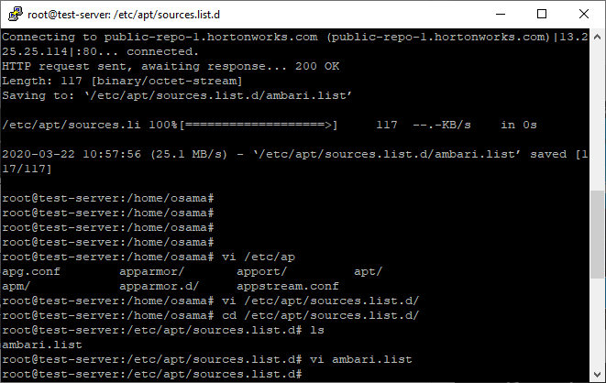

Then we have to add the ambari.list

**apt-key adv --recv-keys --keyserver keyserver.ubuntu.com B9733A7A07513CAD**

* Run the update

**apt-get update**

* Confirm that Ambari packages downloaded successfully by checking the package name list.

**apt-cache showpkg ambari-server**

**apt-cache showpkg ambari-agent**

**apt-cache showpkg ambari-metrics-assembly**

**The above checking should give you the following result :-**

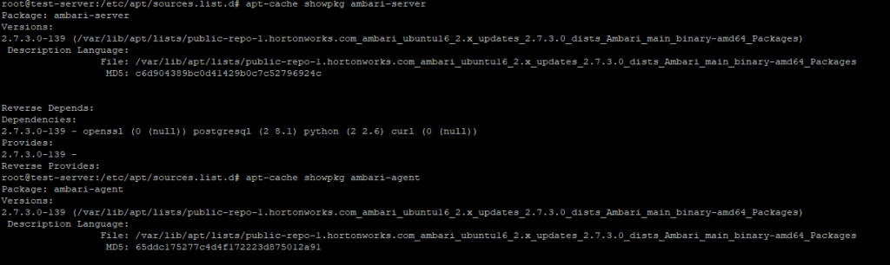

Now we will install the Ambari server which will also install the above said default PostgreSQL Ambari database :

apt-get install ambari-server

* Next part is running the command to set up the Ambari Server :

ambari-server setup

The above command will start configure Ambari to connect the database, the default database is PostgreSQL, then install JDK, and the Ambrai daemon, then the account, you could choose advance setting for database in case you want to change the database type, ambari gives you different options such as Oracle, MySQL, Microsoft and DB2, the default database username and password is

Username : Ambari

Password : bigdata

And the The Dashboard Link (<https://hostname:8080/>) :-

admin

admin

Now we have start the ambaris server using command

**Ambari_server. start**

**RESOURCES**

**On Localhost**

[**https://www.youtube.com/watch?v=nC6mBbLVlzs**](https://www.youtube.com/watch?v=nC6mBbLVlzs)

[**https://www.youtube.com/watch?v=nC6mBbLVlzs**](https://www.youtube.com/watch?v=nC6mBbLVlzs)

**On GCP**

[**https://www.youtube.com/watch?v=h5_EBZ8vGZ0**](https://www.youtube.com/watch?v=h5_EBZ8vGZ0)