ZOOKEEPER SETUP:---------------------------

GO TO ROOT USER:-

sudo -i

Give all permission to hadoopuser

chown -R hduser:hduser /opt

change directory to “opt”

cd /opt

Here we create a directory under directory

mkdir zookeeper

cd /opt /zookeeper

mkdir data

Download the zookeeper bin tar file

cd /opt

wget [https://archive.apache.org/dist/zookeeper/zookeeper-3.6.1/apache-zookeeper-3.6.1-bin.tar.g](https://archive.apache.org/dist/zookeeper/zookeeper-3.6.1/apache-zookeeper-3.6.1-bin.tar.gz)

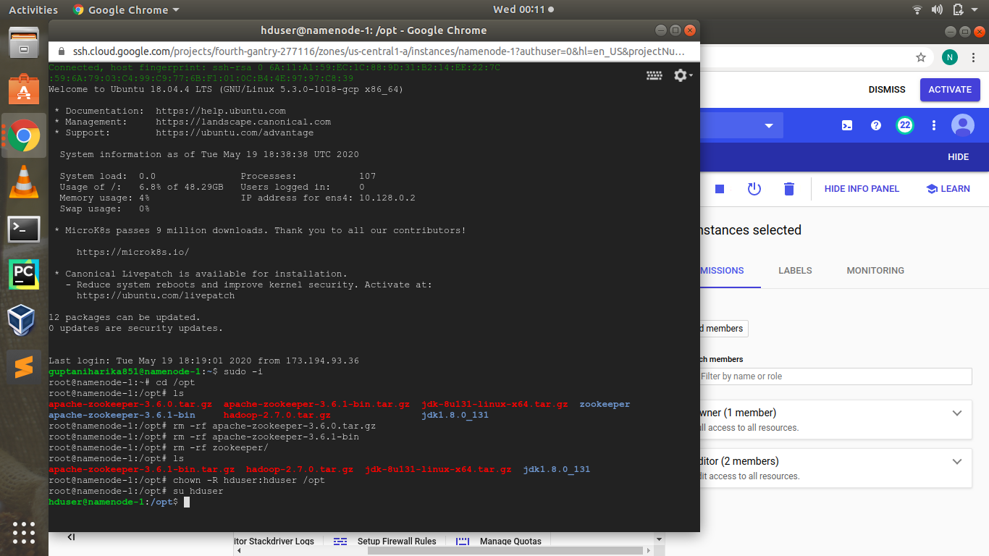

untar the file

tar -xvzf apache-zookeeper-3.6.1-bin.tar.gz

configure the file copy the sample file to new zoo.cfg

cd */opt /apache-zookeeper-3.6.1-bin*

*cd /conf*

*cp zoo_sample.cfg zoo.cfg*

*now enter into hadoopuser:---*

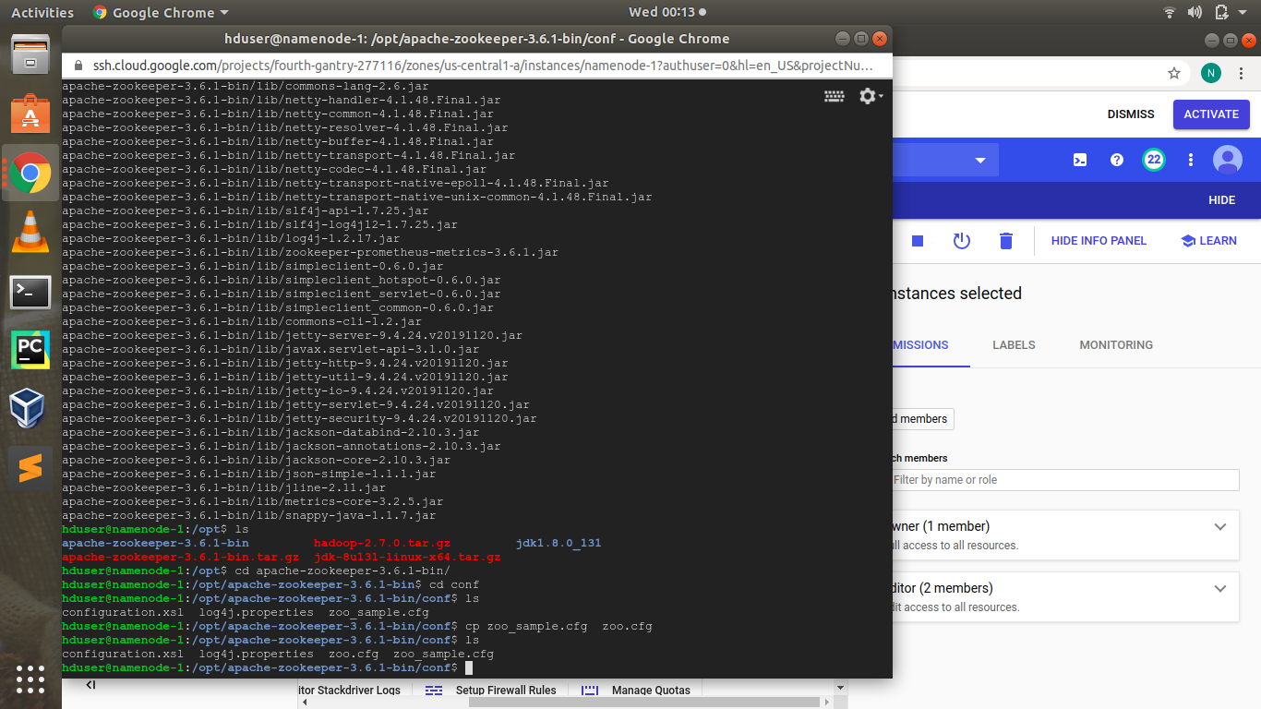

*now cd /opt /apache-zookeeper-3.6.1-bin /conf*

*nano zoo.cfg*

*check this also:-*

*tickTime=2000*

*clientPort=2181*

*maxClientCnxns=60*

*initLimit=10*

*syncLimit=5*

*change the datadir path which we given above:-*

datadir =/home/hduser/opt/zookeeper/data

now go to cd --

nano ~/.bashrc

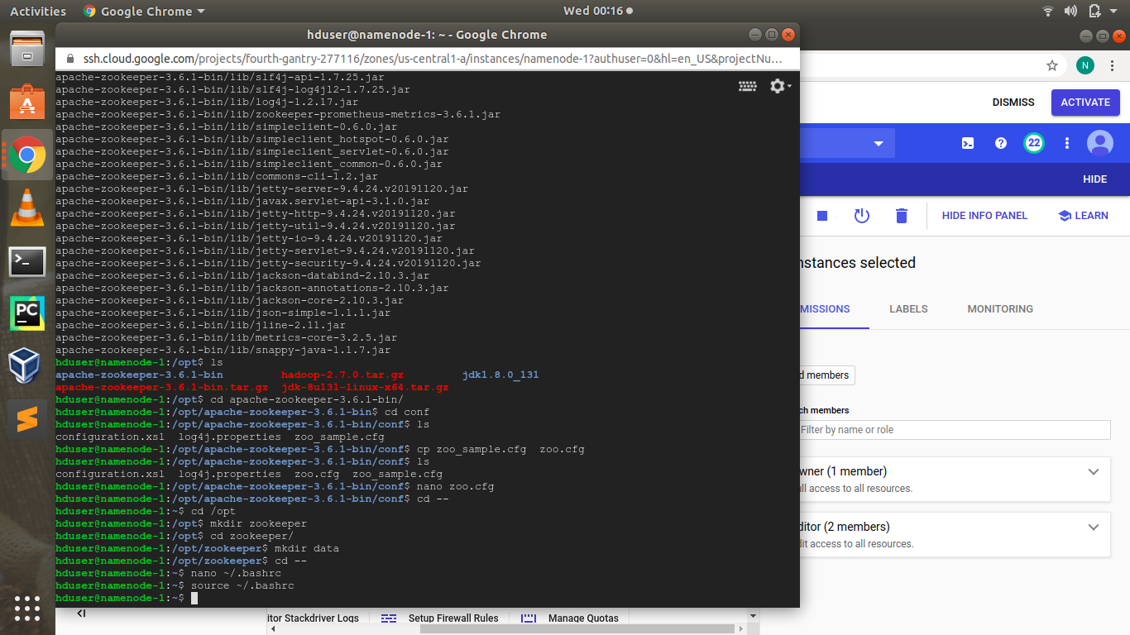

add the zookeeper home in bashrc

export ZOOKEEPER_HOME = /home /hduser /*opt / apache-zookeeper-3.6.1-bin*

*export PATH=$PATH:$ZOOKEEPER_HOME/bin*

*source ~/.bashrc*

*now its time to start the server of zookeeper:---*

*cd /opt/apache-zookeeper-3.6.1-bin/bin*

*run the command:-*

*zkServer.sh start*

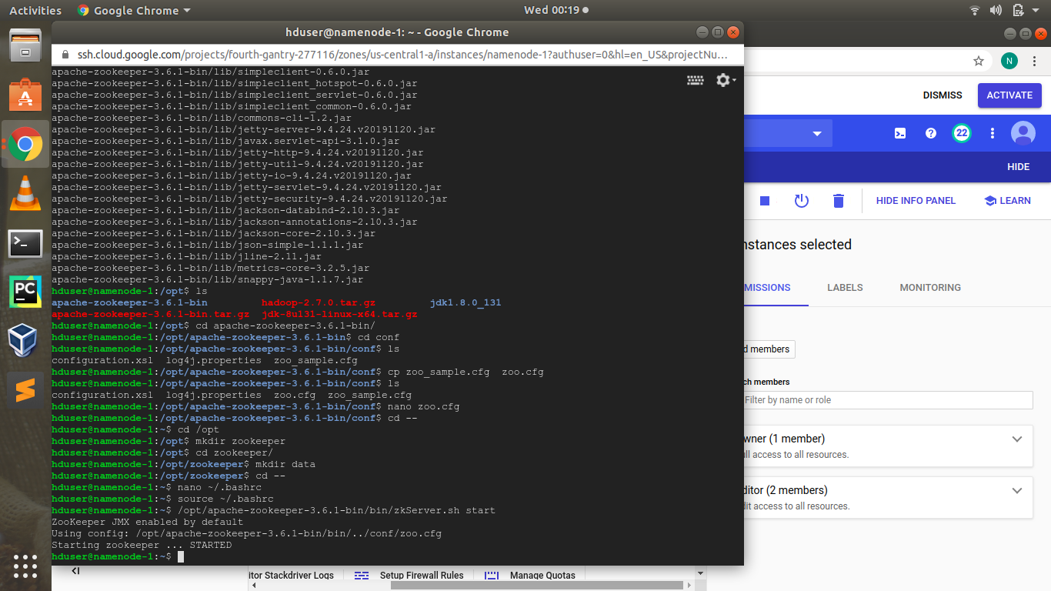

*now the server STARTED*

*Go to zookeeper dir – bin*

*$ zkServer.sh start*

*Zookeeper started.*

*$ zkServer.sh status*

*Zookeeper status.*

*$ zkServer.sh stop*

*Zookeeper stopped.*

*WE HAVE TO DO SAME PROCESS TO ALL THE NODES:----*

*first we have to start the server of all nodes:-*

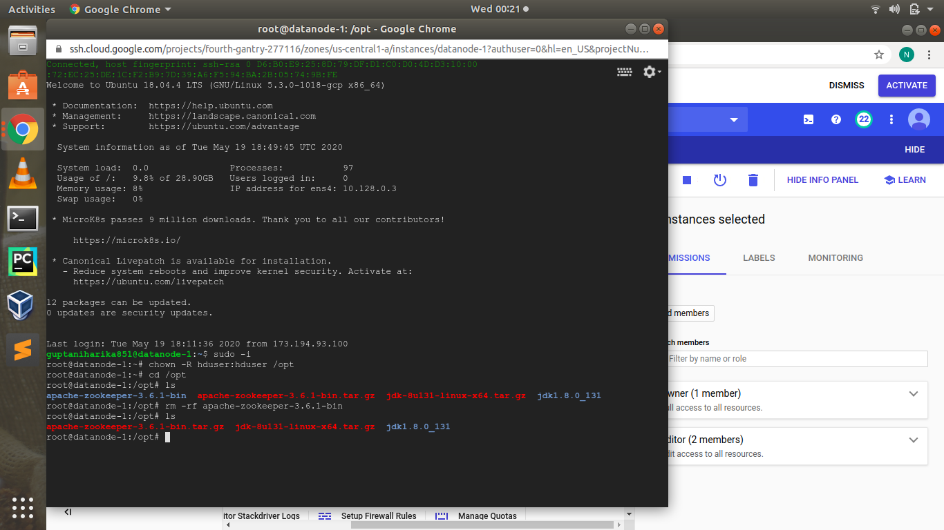

*do same in datanode1*

*start the server of datanode1*

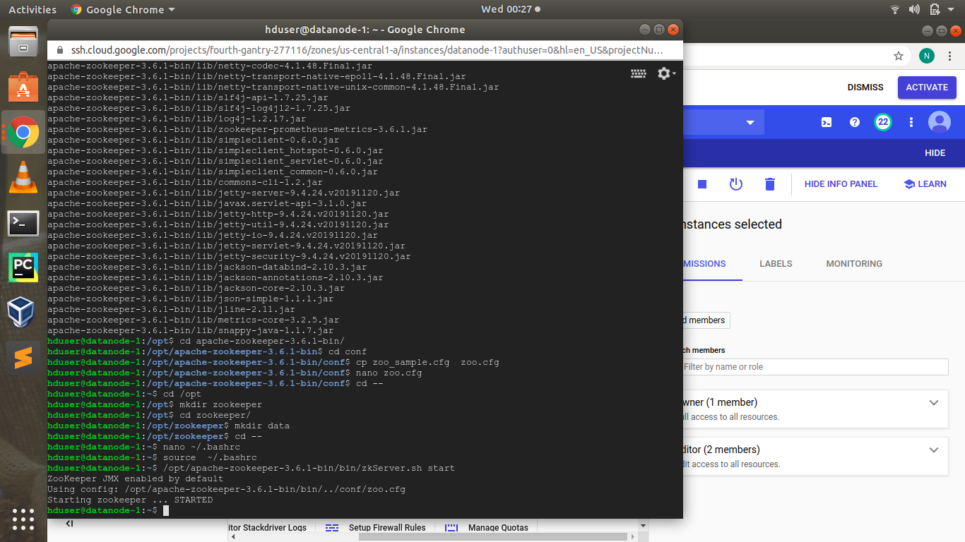

*we have to do same in datanode2*

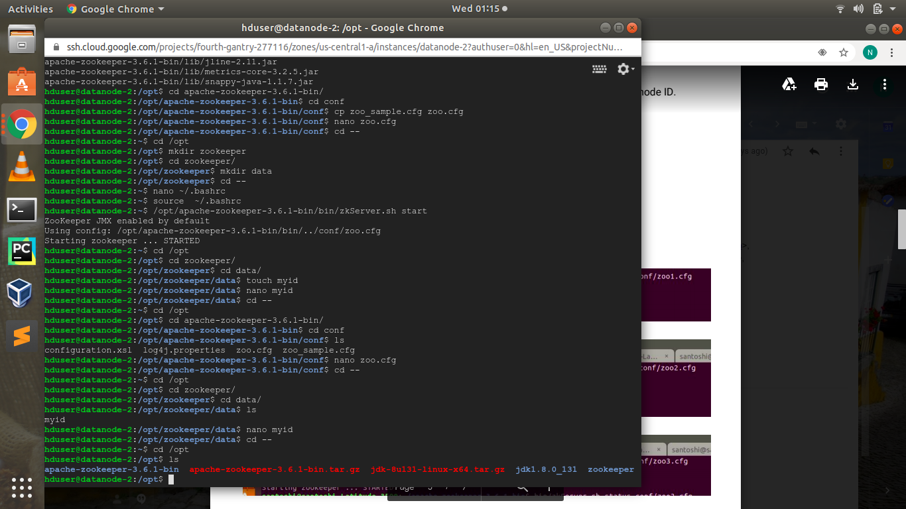

*now........*

*Configuring a Multi-Node ZooKeeper Cluster*

*All nodes in a quorum will need the same configuration file. In your ​zoo.cfg file on each of the three*

*nodes, add the additional configuration parameters and values for ​initLimit, ​syncLimit, and the*

*servers in the quorum, at the end of the file.*

*/conf/zoo.cfg*

*tickTime=2000*

*clientPort=2181*

*maxClientCnxns=60*

*initLimit=10*

*syncLimit=5*

*server.1=your_zookeeper_node_1:2888:3888*

*server.2=your_zookeeper_node_2:2888:3888*

*server.3=your_zookeeper_node_3:2888:3888*

*On ​your_zookeeper_node_1​, create the ​myid file that will specify the node ID:*

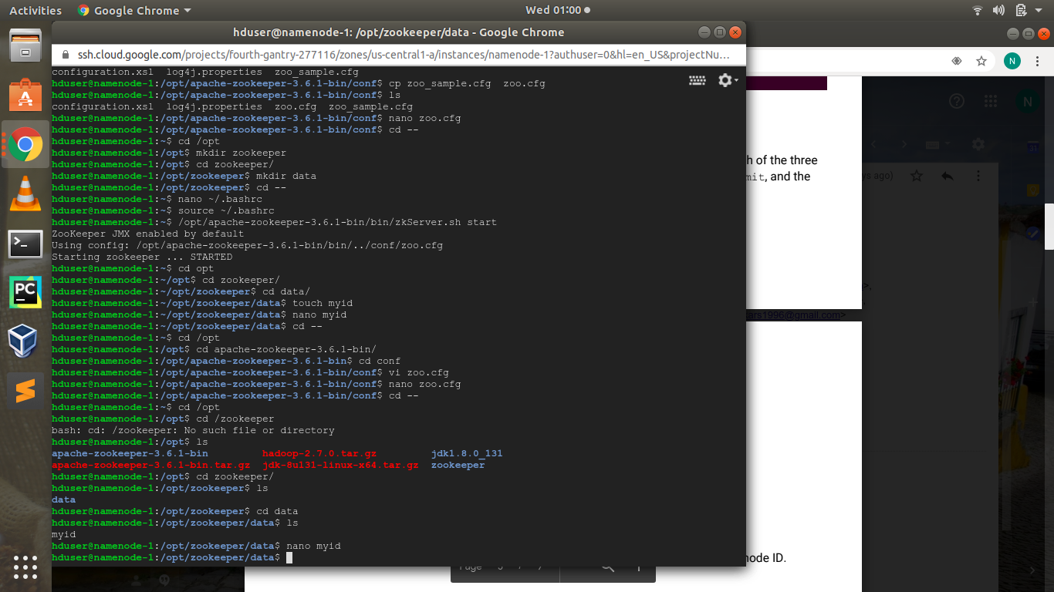

*$ sudo nano /data/zookeeper/myid*

*Since ​your_zookeeper_node_1​ is identified as ​server.1, you will enter ​1 to define the node ID.*

*Follow the same steps for the remaining nodes.*

*For ​your_zookeeper_node_2 --- myid contains id - 2*

*For ​your_zookeeper_node_3 --- myid contains id – 3*

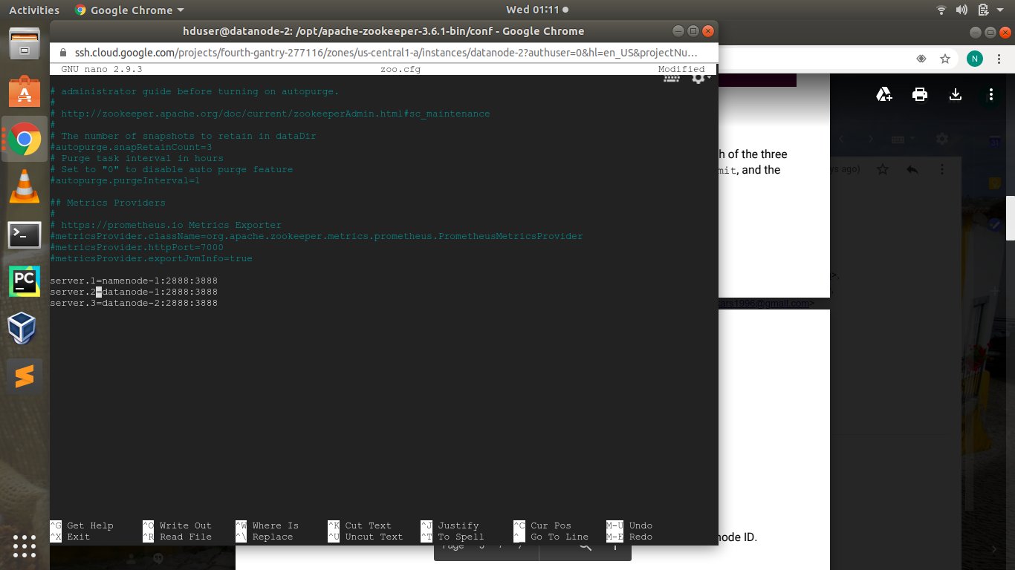

*Start ur zookeeper with -- their config file*

*cd opt/apache_home*

*run the command*

*bin/zkServer.sh start conf/zoo.cfg*

*after running the server of all node:-*

*Connect to zookeeper client:*

*$ bin/zkCli.sh -server your_zookeeper_node_1:2181*

*You will see the familiar prompt with the ​CONNECTED label,*

*Next, you will create, list, and then delete a ​znode​. The znodes are the fundamental abstractions in*

*ZooKeeper that are analogous to files and directories on a file system. ZooKeeper maintains its data*

*in a hierarchical namespace, and znodes are the data registers of this namespace.*

*Testing that you can successfully create, list, and then delete a znode is essential to establishing that*

*your ZooKeeper cluster is installed and configured correctly.*

*With commands:*

*create /zk_znode_1 sample_data*

*ls /*

*get /zk_znode_1*

*delete /zk_znode_1*

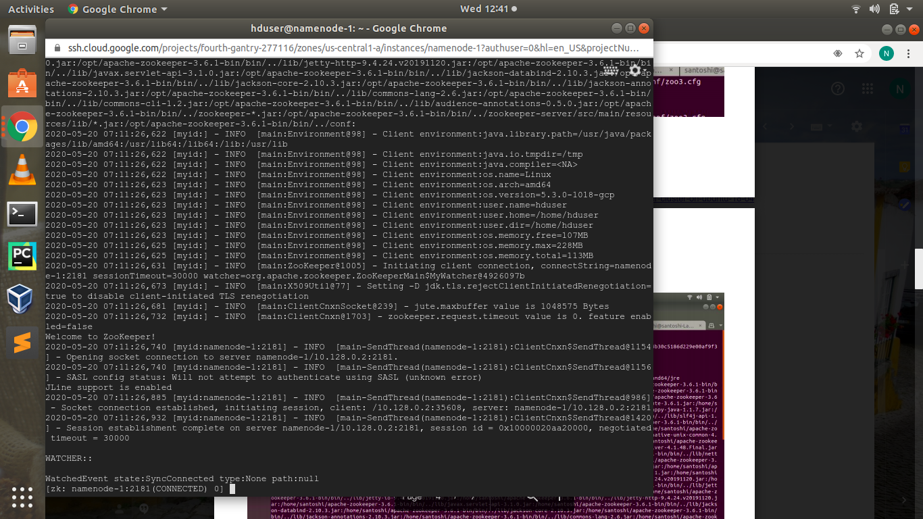*Stop zookeeperser server*

*we have to follow all the steps in all the nodes:-----*