Case study – Fitbit data analysis( Bellabeat)

Ask

The main business task here is to analyze smart device usage and identify trends that can then be applied to the Bellabeat product and influence the marketing strategy.

They key stakeholders are Urska srsen - Chief Creative Officer, Bellabeat executive team and Bellabeat marketing analytics team.

Prepare

The Fitbit fitness tracker data is used for analysis. It is a public dataset on Kaggle. It has data about various parameters such as heart rate, calories consumed, steps completed, etc. But the data is not current data and it is a few years old which does affect the analysis to a certain extent.

Also the sample size is not large enough for a complete analysis since there are only thirty people involved in this dataset. Thus the data is not too reliable. Also it is not clear how the participants have been chosen so there is an element of sampling bias as well.

The data was downloaded and all datasets were saved in Fitabase data folder.

Process

The data was uploaded to Bigquery in order to do the processing and analysis of it using SQL. Also the datasets that were uploaded were daily activity merged, sleep day merged, hourly calories merged, hourly intensities merged, hourly steps merged and minute METs narrow merged.

Based on this very low sample size of 'weight_loginfo' data providers, this dataset is not considered for analysis. Some datasets had a minute level analysis which cannot provide good insights and hence were not considered

The other datasets were not uploaded because it was already present in the uploaded ones.

First we checked for null values in all 6 datasets and some were found and they were removed.

Then we checked for duplicates and again none were found.

Analysis

First we look at the average steps distance and calories burned to see the relation between them

select Id,AVG(TotalSteps) AS Total_steps_avg,AVG(TotalDistance) AS Total_distance_avg,AVG(Calories) AS Total_calories_avg

FROM `fitbit1.dailyActivity_merged`

group by Id;

|  |  |  |  |  |
| --- | --- | --- | --- | --- |
| No. | Id | Total_steps_avg | Total_distance_avg | Total_calories_avg |
| 1 | 1624580081 | 5743.903 | 3.914839 | 1483.355 |
| 2 | 1844505072 | 2580.065 | 1.706129 | 1573.484 |
| 3 | 1927972279 | 916.129 | 0.634516 | 2172.806 |
| 4 | 3372868164 | 6861.65 | 4.707 | 1933.1 |
| 5 | 4057192912 | 3838 | 2.8625 | 1973.75 |
| 6 | 4319703577 | 7268.839 | 4.892258 | 2037.677 |
| 7 | 4388161847 | 10813.94 | 8.393226 | 3093.871 |
| 8 | 4445114986 | 4796.548 | 3.245806 | 2186.194 |
| 9 | 4558609924 | 7685.129 | 5.080645 | 2033.258 |
| 10 | 4702921684 | 8572.065 | 6.955161 | 2965.548 |
| 11 | 6117666160 | 7046.714 | 5.342143 | 2261.143 |
| 12 | 6290855005 | 5649.552 | 4.272414 | 2599.621 |
| 13 | 6775888955 | 2519.692 | 1.813462 | 2131.769 |
| 14 | 8792009665 | 1853.724 | 1.186552 | 1962.31 |
| 15 | 8253242879 | 6482.158 | 4.667368 | 1788 |
| 16 | 7086361926 | 9371.774 | 6.388065 | 2566.355 |
| 17 | 8583815059 | 7198.516 | 5.615484 | 2732.032 |
| 18 | 8877689391 | 16040.03 | 13.2129 | 3420.258 |
| 19 | 2026352035 | 5566.871 | 3.454839 | 1540.645 |
| 20 | 7007744171 | 11323.42 | 8.015385 | 2544 |
| 21 | 8053475328 | 14763.29 | 11.47516 | 2945.806 |
| 22 | 2320127002 | 4716.871 | 3.187742 | 1724.161 |
| 23 | 1503960366 | 12116.74 | 7.809677 | 1816.419 |
| 24 | 2347167796 | 9519.667 | 6.355556 | 2043.444 |
| 25 | 5553957443 | 8612.581 | 5.639677 | 1875.677 |
| 26 | 2022484408 | 11370.65 | 8.084193 | 2509.968 |
| 27 | 6962181067 | 9794.806 | 6.585806 | 1982.032 |
| 28 | 4020332650 | 2267.226 | 1.626129 | 2385.806 |
| 29 | 8378563200 | 8717.71 | 6.913548 | 3436.581 |
| 30 | 5577150313 | 8304.433 | 6.213333 | 3359.633 |
| 31 | 3977333714 | 10984.57 | 7.517 | 1513.667 |
| 32 | 2873212765 | 7555.774 | 5.101613 | 1916.968 |
| 33 | 1644430081 | 7282.967 | 5.295333 | 2811.3 |

The calories burned are not related to steps or distance in any manner but the avg distance covered increases with increase in avg steps.

Next , the average distances are compared for all types

select Id,AVG(VeryActiveDistance) AS Very_active_dist_avg,AVG(ModeratelyActiveDistance) AS Moderate_active_dist_avg,AVG(LightActiveDistance) AS Light_active_dist_avg,AVG(SedentaryActiveDistance) AS Sedentary_active_dist_avg

from `fitbit1.dailyActivity_merged`

group by Id;

|  |  |  |  |  |  |
| --- | --- | --- | --- | --- | --- |
| No. | Id | Very_active_dist_avg | Moderate_active_dist_avg | Light_active_dist_avg | Sedentary_active_dist_avg |
| 1 | 1624580081 | 0.939355 | 0.360645 | 2.606774 | 0.006129 |
| 2 | 1844505072 | 0.008387 | 0.049032 | 1.647419 | 0 |
| 3 | 1927972279 | 0.095806 | 0.03129 | 0.507097 | 0 |
| 4 | 3372868164 | 0.6295 | 0.153 | 3.91 | 0.011 |
| 5 | 4057192912 | 0.0525 | 0.065 | 2.6875 | 0 |
| 6 | 4319703577 | 0.278065 | 0.502258 | 3.76871 | 0 |
| 7 | 4388161847 | 1.719355 | 0.901935 | 5.396129 | 0 |
| 8 | 4445114986 | 0.523226 | 0.075484 | 2.644839 | 0 |
| 9 | 4558609924 | 0.549355 | 0.682258 | 3.847742 | 0 |
| 10 | 4702921684 | 0.417419 | 1.304839 | 5.225484 | 0 |
| 11 | 6117666160 | 0.128214 | 0.083929 | 4.843214 | 0 |
| 12 | 6290855005 | 0.085517 | 0.128276 | 4.048621 | 0.008621 |
| 13 | 6775888955 | 0.709231 | 0.384231 | 0.711538 | 0 |
| 14 | 8792009665 | 0.024828 | 0.058276 | 1.103448 | 0 |
| 15 | 8253242879 | 2.21421 | 0.695789 | 1.754737 | 0.000526 |
| 16 | 7086361926 | 2.78129 | 0.773226 | 2.81871 | 0 |
| 17 | 8583815059 | 0.798065 | 1.020645 | 2.617419 | 0 |
| 18 | 8877689391 | 6.637419 | 0.337742 | 6.18871 | 0.005161 |
| 19 | 2026352035 | 0.006129 | 0.01129 | 3.436129 | 0 |
| 20 | 7007744171 | 2.415 | 0.738462 | 4.861538 | 0.000769 |
| 21 | 8053475328 | 8.514839 | 0.423871 | 2.533871 | 0 |
| 22 | 2320127002 | 0.106774 | 0.097742 | 2.980323 | 0 |
| 23 | 1503960366 | 2.858387 | 0.794194 | 4.152903 | 0 |
| 24 | 2347167796 | 1.059444 | 1.075 | 4.221667 | 0 |
| 25 | 5553957443 | 1.464194 | 0.669032 | 3.504516 | 0 |
| 26 | 2022484408 | 2.421613 | 0.72 | 4.942581 | 0 |
| 27 | 6962181067 | 1.616452 | 0.96 | 4.001613 | 0.006774 |
| 28 | 4020332650 | 0.142258 | 0.129677 | 1.308387 | 0.005484 |
| 29 | 8378563200 | 2.503548 | 0.519032 | 3.889355 | 0 |
| 30 | 5577150313 | 3.113667 | 0.658 | 2.428 | 0 |
| 31 | 3977333714 | 1.615 | 2.751 | 3.134333 | 0 |
| 32 | 2873212765 | 0.676129 | 0.276129 | 4.143548 | 0.005161 |
| 33 | 1644430081 | 0.73 | 0.951 | 3.609 | 0.004 |

For most people, if they have high very active distance avg, they also have a high avg for moderate and light distance. But the sedentary distance avg is very low to almost negligible for all.

Looking at the calories burned average for every day of the week

select day_of_week,AVG(Calories) AS Total_calories_avg

from `fitbit1.dailyActivity_merged`

group by day_of_week

order by day_of_week;

| Row | day_of_week | Total_calories_avg |  |
| --- | --- | --- | --- |
| 1 | 1 | 2324.208333333333 |  |
| 2 | 2 | 2356.0131578947385 |  |
| 3 | 3 | 2302.6200000000003 |  |
| 4 | 4 | 2199.57142857143 |  |
| 5 | 5 | 2331.7857142857147 |  |
| 6 | 6 | 2354.9677419354834 |  |
| 7 | 7 | 2263.0 |  |

There is a slight dip around the 4th day but overall it is consistent across all seven days

Looking at the average for all type of active minutes

select Id,AVG(VeryActiveMinutes) AS Very_active_minutes_avg,AVG(FairlyActiveMinutes) AS Fairly_active_mintues_avg,AVG(LightlyActiveMinutes) AS Lightly_active_minutes_avg,AVG(SedentaryMinutes) AS Sedentary_minutes_avg

from `fitbit1.dailyActivity_merged`

group by Id;

|  |  |  |  |  |  |
| --- | --- | --- | --- | --- | --- |
| No. | Id | Very_active_minutes_avg | Fairly_active_mintues_avg | Lightly_active_minutes_avg | Sedentary_minutes_avg |
| 1 | 1624580081 | 8.677419 | 5.806452 | 153.4839 | 1257.742 |
| 2 | 1844505072 | 0.129032 | 1.290323 | 115.4516 | 1206.613 |
| 3 | 1927972279 | 1.322581 | 0.774194 | 38.58065 | 1317.419 |
| 4 | 3372868164 | 9.15 | 4.1 | 327.9 | 1077.55 |
| 5 | 4057192912 | 0.75 | 1.5 | 103 | 1217.25 |
| 6 | 4319703577 | 3.580645 | 12.32258 | 228.7742 | 735.8065 |
| 7 | 4388161847 | 23.16129 | 20.35484 | 229.3548 | 836.6774 |
| 8 | 4445114986 | 6.612903 | 1.741935 | 209.0968 | 829.9032 |
| 9 | 4558609924 | 10.3871 | 13.70968 | 284.9677 | 1093.613 |
| 10 | 4702921684 | 5.129032 | 26.03226 | 237.4839 | 766.4194 |
| 11 | 6117666160 | 1.571429 | 2.035714 | 288.3571 | 796.2857 |
| 12 | 6290855005 | 2.758621 | 3.793103 | 227.4483 | 1193.034 |
| 13 | 6775888955 | 11 | 14.80769 | 40.15385 | 1299.423 |
| 14 | 8792009665 | 0.965517 | 4.034483 | 91.7931 | 1060.483 |
| 15 | 8253242879 | 20.52632 | 14.31579 | 116.8947 | 1287.368 |
| 16 | 7086361926 | 42.58065 | 25.35484 | 143.8387 | 850.4516 |
| 17 | 8583815059 | 9.677419 | 22.19355 | 138.2903 | 1267.226 |
| 18 | 8877689391 | 66.06452 | 9.935484 | 234.7097 | 1112.871 |
| 19 | 2026352035 | 0.096774 | 0.258065 | 256.6452 | 689.4194 |
| 20 | 7007744171 | 31.03846 | 16.26923 | 280.7308 | 1055.346 |
| 21 | 8053475328 | 85.16129 | 9.580645 | 150.9677 | 1148 |
| 22 | 2320127002 | 1.354839 | 2.580645 | 198.1935 | 1220.097 |
| 23 | 1503960366 | 38.70968 | 19.16129 | 219.9355 | 848.1613 |
| 24 | 2347167796 | 13.5 | 20.55556 | 252.5 | 687.1667 |
| 25 | 5553957443 | 23.41935 | 13 | 206.1935 | 668.3548 |
| 26 | 2022484408 | 36.29032 | 19.35484 | 257.4516 | 1112.581 |
| 27 | 6962181067 | 22.80645 | 18.51613 | 245.8065 | 662.3226 |
| 28 | 4020332650 | 5.193548 | 5.354839 | 76.93548 | 1237.258 |
| 29 | 8378563200 | 58.67742 | 10.25806 | 156.0968 | 716.129 |
| 30 | 5577150313 | 87.33333 | 29.83333 | 147.9333 | 754.4333 |
| 31 | 3977333714 | 18.9 | 61.26667 | 174.7667 | 707.5333 |
| 32 | 2873212765 | 14.09677 | 6.129032 | 308 | 1097.194 |
| 33 | 1644430081 | 9.566667 | 21.36667 | 178.4667 | 1161.867 |

The sedentary minutes are making up the biggest part and then lightly active minutes also make a decent part. The fairly active and very active minutes consist of a very small part overall.

Looking at the average of all type of minutes across the seven days of a week

select AVG(VeryActiveMinutes) AS Very_active_minutes_avg,AVG(FairlyActiveMinutes) AS Fairly_active_mintues_avg,AVG(LightlyActiveMinutes) AS Lightly_active_minutes_avg,AVG(SedentaryMinutes) AS Sedentary_minutes_avg,day_of_week

from `fitbit1.dailyActivity_merged`

group by day_of_week

order by day_of_week;

|  |
| --- |
|  |
| Row | Very_active_minutes_avg | Fairly_active_mintues_avg | Lightly_active_minutes_avg | Sedentary_minutes_avg | day_of_week |  |
| 1 | 23.108333333333327 | 13.999999999999998 | 192.05833333333331 | 1027.9416666666668 | 1 |  |
| 2 | 22.953947368421048 | 14.335526315789465 | 197.34210526315792 | 1007.3618421052632 | 2 |  |
| 3 | 20.780000000000008 | 13.099999999999998 | 189.85333333333335 | 989.48000000000036 | 3 |  |
| 4 | 19.408163265306118 | 11.959183673469392 | 185.421768707483 | 961.99319727891168 | 4 |  |
| 5 | 20.055555555555543 | 12.111111111111109 | 204.19841269841271 | 1000.3095238095237 | 5 |  |
| 6 | 21.919354838709687 | 15.201612903225806 | 207.14516129032256 | 964.2822580645161 | 6 |  |
| 7 | 19.983471074380169 | 14.528925619834713 | 173.97520661157029 | 990.25619834710767 | 7 |  |

Again we see the same trend across all days that sedentary minutes make the biggest part and then lightly active minutes cover a decent part of it. The fairly active and very active comprise a small part only.

Looking at the calories burned average across the 24 hours of a day

select TIME(ActivityHour) AS Hours ,AVG(Calories) AS Total_calories_avg

from `fitbit1.hourlyCalories_merged`

group by TIME(ActivityHour);

|  |  |
| --- | --- |
| Hours | Total_calories_avg |
| 0:00:00 | 71.80514 |
| 1:00:00 | 70.16506 |
| 2:00:00 | 69.1865 |
| 3:00:00 | 67.53805 |
| 4:00:00 | 68.2618 |
| 5:00:00 | 81.70815 |
| 6:00:00 | 86.99678 |
| 7:00:00 | 94.47798 |
| 8:00:00 | 103.3373 |
| 9:00:00 | 106.1429 |
| 10:00:00 | 110.4607 |
| 11:00:00 | 109.8069 |
| 12:00:00 | 117.1974 |
| 13:00:00 | 115.3094 |
| 14:00:00 | 115.7329 |
| 15:00:00 | 106.6372 |
| 16:00:00 | 113.3275 |
| 17:00:00 | 122.7528 |
| 18:00:00 | 123.4923 |
| 19:00:00 | 121.4845 |
| 20:00:00 | 102.3576 |
| 21:00:00 | 96.05635 |
| 22:00:00 | 88.26549 |
| 23:00:00 | 77.59358 |

The calories burned in early morning are consistently low and then it starts increasing as the day goes on. Then it plateaus around afternoon after which it increases again in the evening and finally starts falling at night.

Looking at the average steps covered across the 24 hours of a day

select TIME(ActivityHour) AS Hours,AVG(StepTotal) AS Total_steps_avg

from `fitbit1.hourlySteps_merged`

group by TIME(ActivityHour);

|  |  |
| --- | --- |
| Hours | Total_steps_avg |
| 0:00:00 | 42.18844 |
| 1:00:00 | 23.10289 |
| 2:00:00 | 17.1104 |
| 3:00:00 | 6.426581 |
| 4:00:00 | 12.69957 |
| 5:00:00 | 43.8691 |
| 6:00:00 | 178.5081 |
| 7:00:00 | 306.0494 |
| 8:00:00 | 427.5446 |
| 9:00:00 | 433.3018 |
| 10:00:00 | 481.6652 |
| 11:00:00 | 456.8867 |
| 12:00:00 | 548.6421 |
| 13:00:00 | 537.6982 |
| 14:00:00 | 540.5136 |
| 15:00:00 | 406.3191 |
| 16:00:00 | 496.8456 |
| 17:00:00 | 550.2329 |
| 18:00:00 | 599.17 |
| 19:00:00 | 583.3907 |
| 20:00:00 | 353.9051 |
| 21:00:00 | 308.1381 |
| 22:00:00 | 237.9878 |
| 23:00:00 | 122.1329 |

The steps have a sharp increase around 5 AM and it continues till 9 AM and plateaus and has a slight drop in the afternoon. It increases again in the early evening hours before dropping sharply after 7 PM.

Looking at the average of intensity shown across 24 hours of a day

select TIME(ActivityHour) AS Hours,AVG(TotalIntensity) AS Total_intensity_avg

from `fitbit1.hourlyIntensities_merged`

group by TIME(ActivityHour);

|  |  |
| --- | --- |
| Hours | Total_intensity_avg |
| 0:00:00 | 2.12955 |
| 1:00:00 | 1.419078 |
| 2:00:00 | 1.043944 |
| 3:00:00 | 0.44373 |
| 4:00:00 | 0.633047 |
| 5:00:00 | 4.950644 |
| 6:00:00 | 7.771214 |
| 7:00:00 | 10.73362 |
| 8:00:00 | 14.6681 |
| 9:00:00 | 15.38776 |
| 10:00:00 | 17.6437 |
| 11:00:00 | 16.92125 |
| 12:00:00 | 19.84707 |
| 13:00:00 | 18.77524 |
| 14:00:00 | 18.86862 |
| 15:00:00 | 15.5847 |
| 16:00:00 | 17.71665 |
| 17:00:00 | 21.65563 |
| 18:00:00 | 21.92163 |
| 19:00:00 | 21.38521 |
| 20:00:00 | 14.33996 |
| 21:00:00 | 12.07293 |
| 22:00:00 | 9.063053 |
| 23:00:00 | 4.996678 |

The intensity avg increases sharply around 4 AM and keeps increasing till 12 noon. It drops off a little and then increases again in the early evening hours.Then there is sharp drop after 7 PM.

Looking at the time that was spent in bed when not sleeping

select Id, AVG(TotalTimeInBed-TotalMinutesAsleep) AS Total_wasted_minutes

from `fitbit1.sleepDay_merged`

group by Id;

|  |  |  |
| --- | --- | --- |
| No. | Id | Total_wasted_minutes |
| 1 | 1503960366 | 22.92 |
| 2 | 1644430081 | 52 |
| 3 | 1844505072 | 309 |
| 4 | 1927972279 | 20.8 |
| 5 | 2026352035 | 31.46429 |
| 6 | 2320127002 | 8 |
| 7 | 2347167796 | 44.53333 |
| 8 | 3977333714 | 167.5 |
| 9 | 4020332650 | 30.375 |
| 10 | 4319703577 | 25.30769 |
| 11 | 4388161847 | 23.04348 |
| 12 | 4445114986 | 31.64286 |
| 13 | 4558609924 | 12.4 |
| 14 | 4702921684 | 20.74074 |
| 15 | 5553957443 | 42.3871 |
| 16 | 5577150313 | 28.61538 |
| 17 | 6117666160 | 31.38889 |
| 18 | 6775888955 | 19.33333 |
| 19 | 6962181067 | 18.12903 |
| 20 | 7007744171 | 3 |
| 21 | 7086361926 | 13.29167 |
| 22 | 8053475328 | 4.666667 |
| 23 | 8378563200 | 40.80645 |
| 24 | 8792009665 | 18.13333 |

Most of the people spent less than an hour in bed when not sleeping and a couple of outliers are present.

Looking at the relation between time asleep and calories burned

select temp1.Id,avg(temp2.TotalMinutesAsleep) AS Total_minutes_asleep_avg,avg(temp1.Calories) AS Total_calories_avg

from `fitbit1.dailyActivity_merged` as temp1

INNER JOIN `fitbit1.sleepDay_merged` as temp2 ON temp1.Id = temp2.Id

group by temp1.Id;

|  |  |  |  |
| --- | --- | --- | --- |
| No. | Id | Total_minutes_asleep_avg | Total_calories_avg |
| 1 | 1844505072 | 652 | 1573.484 |
| 2 | 1927972279 | 417 | 2172.806 |
| 3 | 4319703577 | 476.6538 | 2037.677 |
| 4 | 4388161847 | 400.1739 | 3093.871 |
| 5 | 4445114986 | 385.1786 | 2186.194 |
| 6 | 4558609924 | 127.6 | 2033.258 |
| 7 | 4702921684 | 417.4815 | 2965.548 |
| 8 | 6117666160 | 478.7778 | 2261.143 |
| 9 | 6775888955 | 349.6667 | 2131.769 |
| 10 | 8792009665 | 435.6667 | 1962.31 |
| 11 | 7086361926 | 453.125 | 2566.355 |
| 12 | 2026352035 | 506.1786 | 1540.645 |
| 13 | 7007744171 | 68.5 | 2544 |
| 14 | 8053475328 | 297 | 2945.806 |
| 15 | 2320127002 | 61 | 1724.161 |
| 16 | 1503960366 | 360.28 | 1816.419 |
| 17 | 2347167796 | 446.8 | 2043.444 |
| 18 | 5553957443 | 463.4839 | 1875.677 |
| 19 | 6962181067 | 448 | 1982.032 |
| 20 | 4020332650 | 349.375 | 2385.806 |
| 21 | 8378563200 | 445.129 | 3436.581 |
| 22 | 5577150313 | 432 | 3359.633 |
| 23 | 3977333714 | 293.6429 | 1513.667 |
| 24 | 1644430081 | 294 | 2811.3 |

People with sleeping minutes between 400 and 500 generally have a higher calories burned count and those with sleeping time less than that or more than that are not able to burn a lot of calories.

Looking at the relation between METs and calories burned

select temp1.Id,avg(temp2.METs) AS METs_avg,avg(temp1.Calories) AS Total_calories_avg

from `fitbit1.dailyActivity_merged` as temp1

INNER JOIN `fitbit1.minuteMETsNarrow_merged` as temp2 ON temp1.Id = temp2.Id

group by temp1.Id;

|  |  |  |  |
| --- | --- | --- | --- |
| No. | Id | METs_avg | Total_calories_avg |
| 1 | 1644430081 | 14.10767 | 2811.3 |
| 2 | 4558609924 | 15.35023 | 2033.258 |
| 3 | 4319703577 | 14.0829 | 2037.677 |
| 4 | 2320127002 | 13.16299 | 1724.161 |
| 5 | 1503960366 | 16.66855 | 1816.419 |
| 6 | 2347167796 | 15.72049 | 2043.444 |
| 7 | 4388161847 | 16.37567 | 3093.871 |
| 8 | 6775888955 | 11.84183 | 2131.769 |
| 9 | 5553957443 | 14.50744 | 1875.677 |
| 10 | 3372868164 | 14.57302 | 1933.1 |
| 11 | 7086361926 | 14.1228 | 2566.355 |
| 12 | 2873212765 | 15.28508 | 1916.968 |
| 13 | 6290855005 | 13.19263 | 2599.621 |
| 14 | 5577150313 | 18.74226 | 3359.633 |
| 15 | 4445114986 | 13.38729 | 2186.194 |
| 16 | 4020332650 | 12.19822 | 2385.806 |
| 17 | 6117666160 | 14.73003 | 2261.143 |
| 18 | 2026352035 | 13.93684 | 1540.645 |
| 19 | 7007744171 | 16.95391 | 2544 |
| 20 | 1927972279 | 10.64828 | 2172.806 |
| 21 | 2022484408 | 16.95537 | 2509.968 |
| 22 | 6962181067 | 15.59026 | 1982.032 |
| 23 | 4057192912 | 12.05303 | 1973.75 |
| 24 | 3977333714 | 15.45146 | 1513.667 |
| 25 | 4702921684 | 14.95887 | 2965.548 |
| 26 | 1844505072 | 11.87798 | 1573.484 |
| 27 | 1624580081 | 12.52201 | 1483.355 |

Overall there is a trend that when METs average is higher then calories burned average is also higher

Share

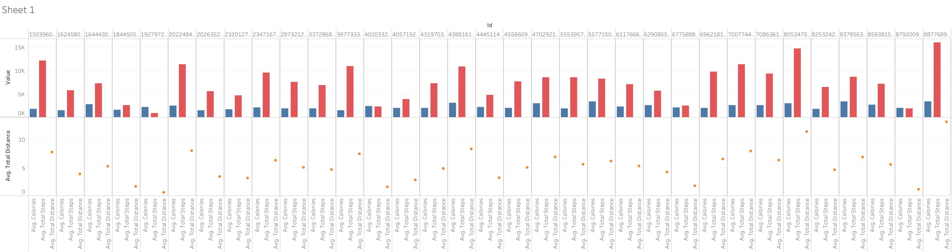For some people, the calories burned increases with total steps but not for all. But the total steps average is directly related to total distance average.

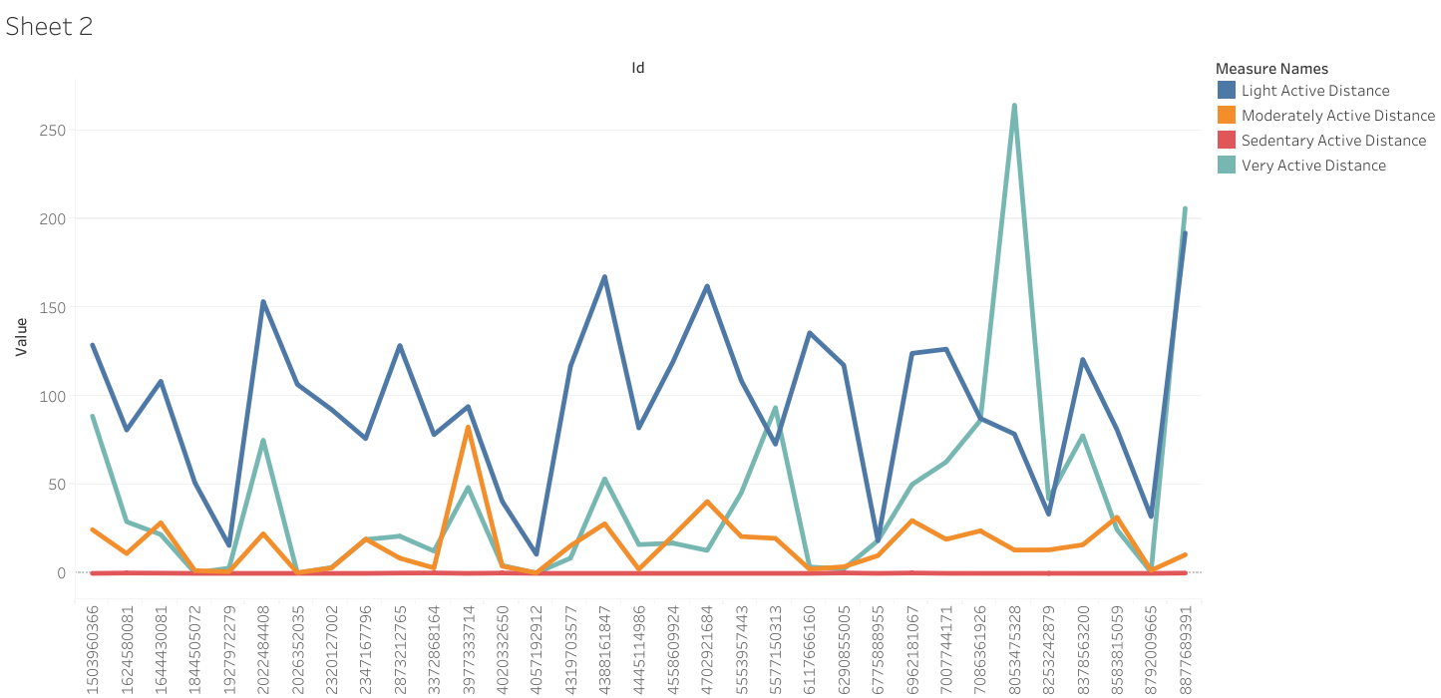Comparing the type of distances covered, mostly light active distance was covered. Then very active and moderately active distance are mostly similar for many participants. Finally the sedentary active distance is very low for all the participants.

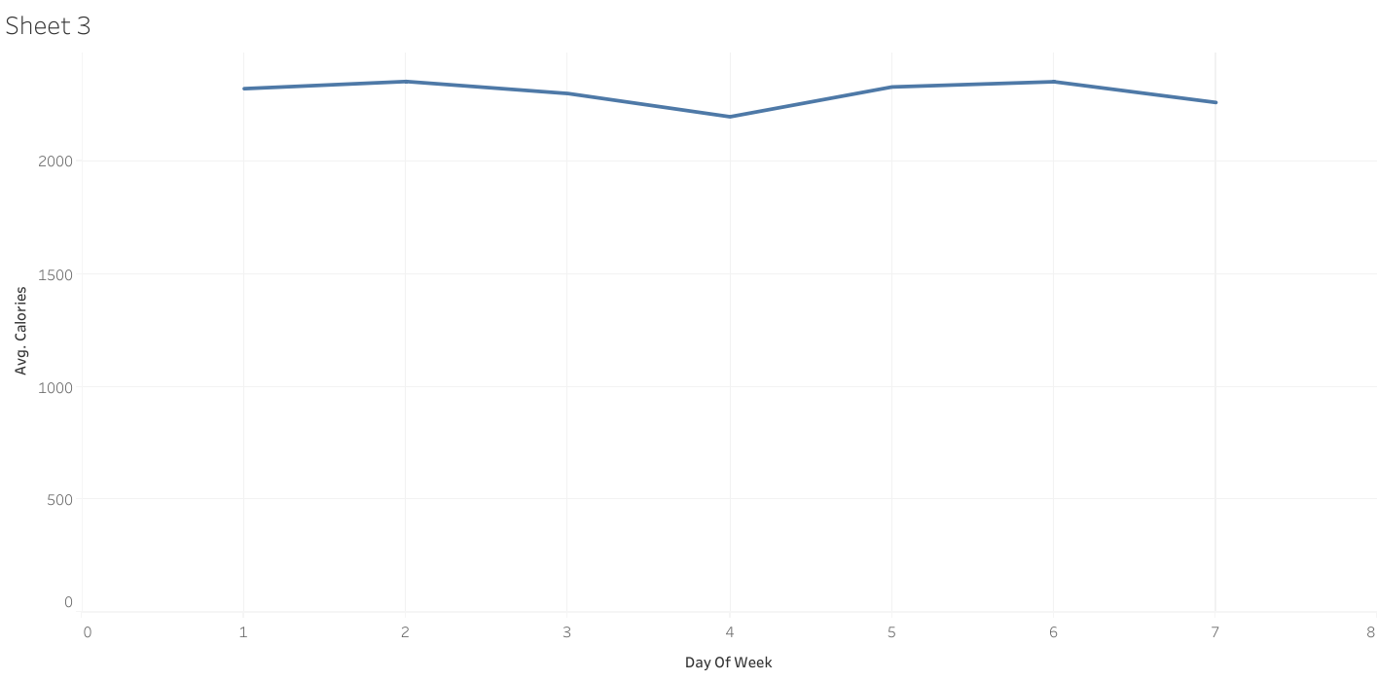The calories burned average is almost consistent throughout all seven days of the week and above 2000 calories.

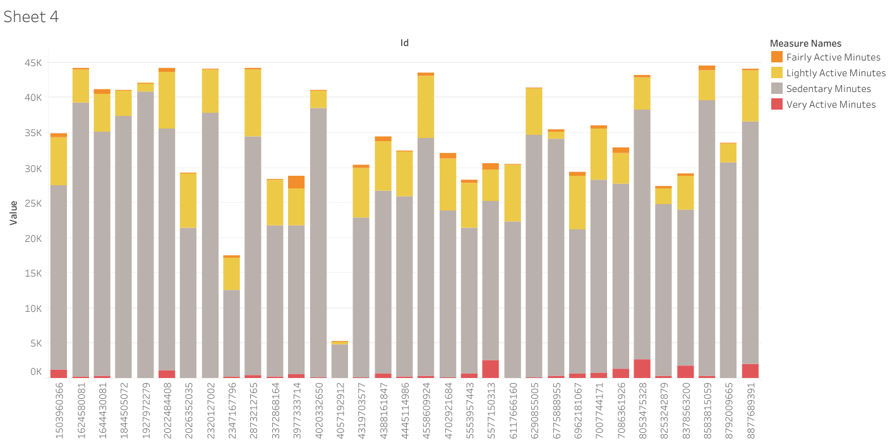The sedentary minutes comprise a big part for all and then lightly active minutes also make up a decent part for everyone. The fairly active and very active minutes are very low for every participant

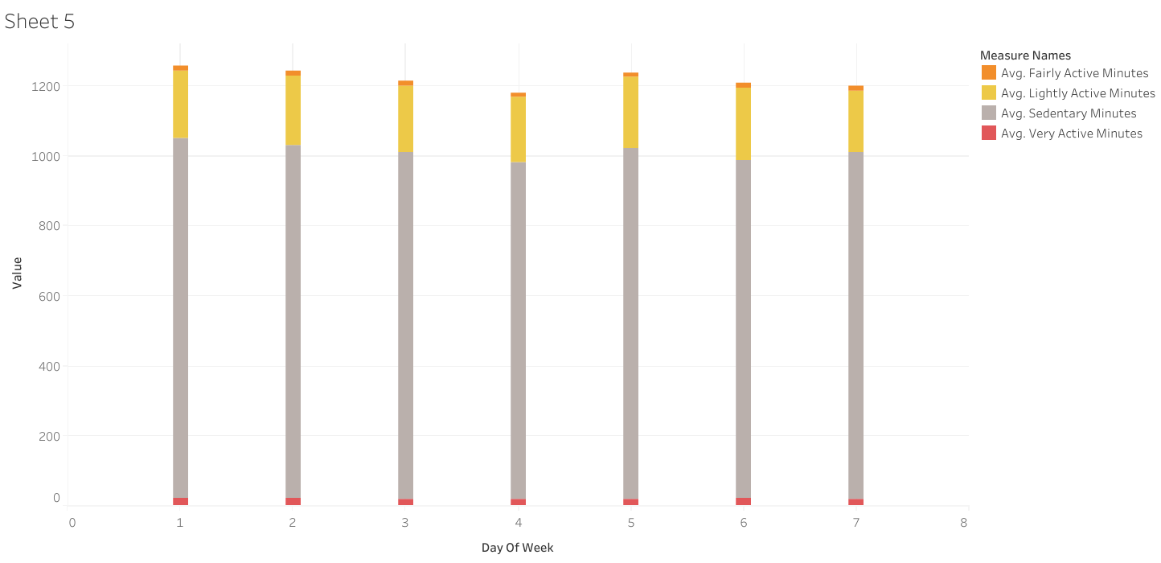Looking at how the active minutes are spread across the week, it is similar like before where very active and fairly active make a small part and sedentary minutes makes the largest part for all seven days.

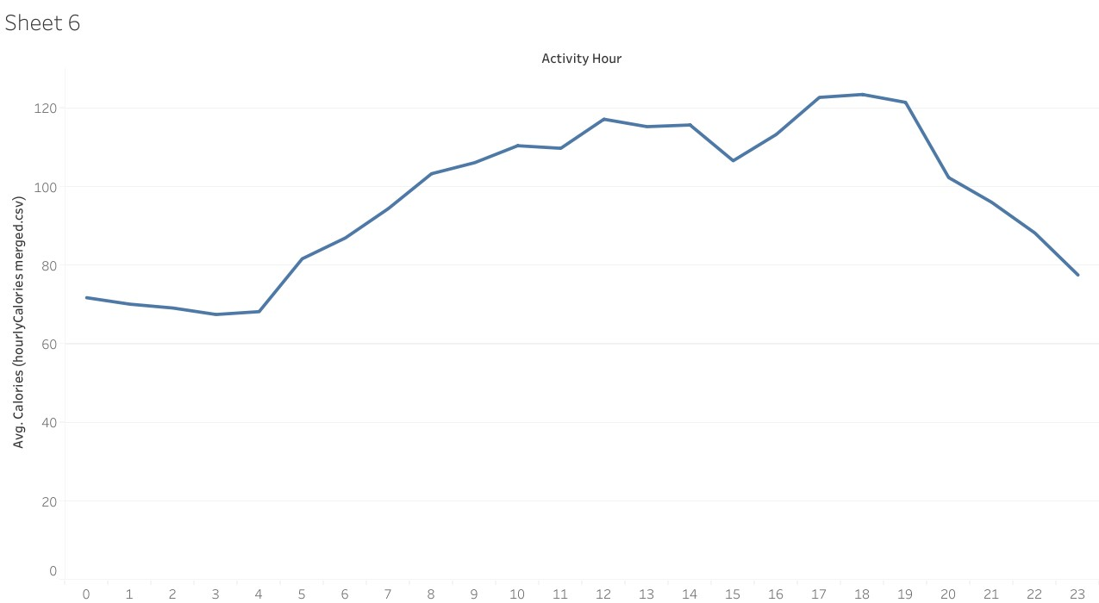The calories burned keep increasing from morning 5 AM till noon and then plateau before increasing again in early evening and then dropping after 7 PM

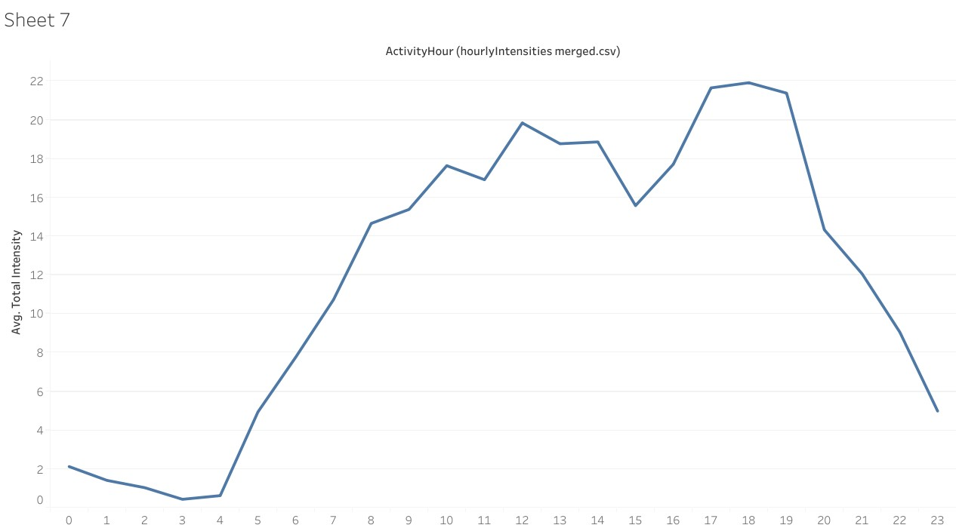The intensities start increasing around 4 AM and then drop a little after noon before rising again. Finally there is a drop off after 7 PM.

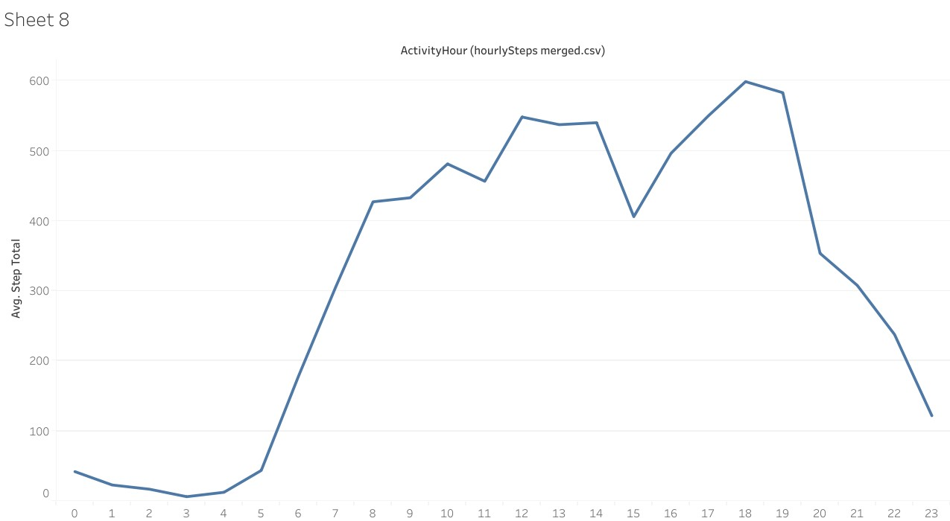The steps start increasing at 5 AM and then plateau around noon. Then there is an increase in the early evening before dropping sharply after 7 PM.

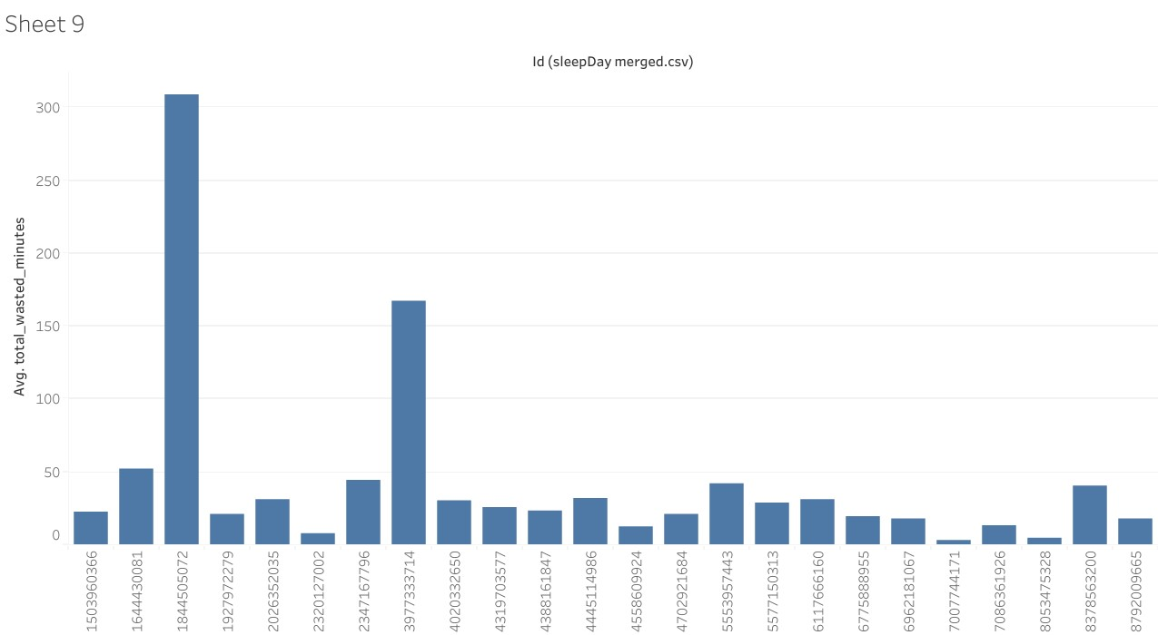Looking at the time spent in bed not sleeping, participants usually wasted less than an hour but there are a couple of outliers.

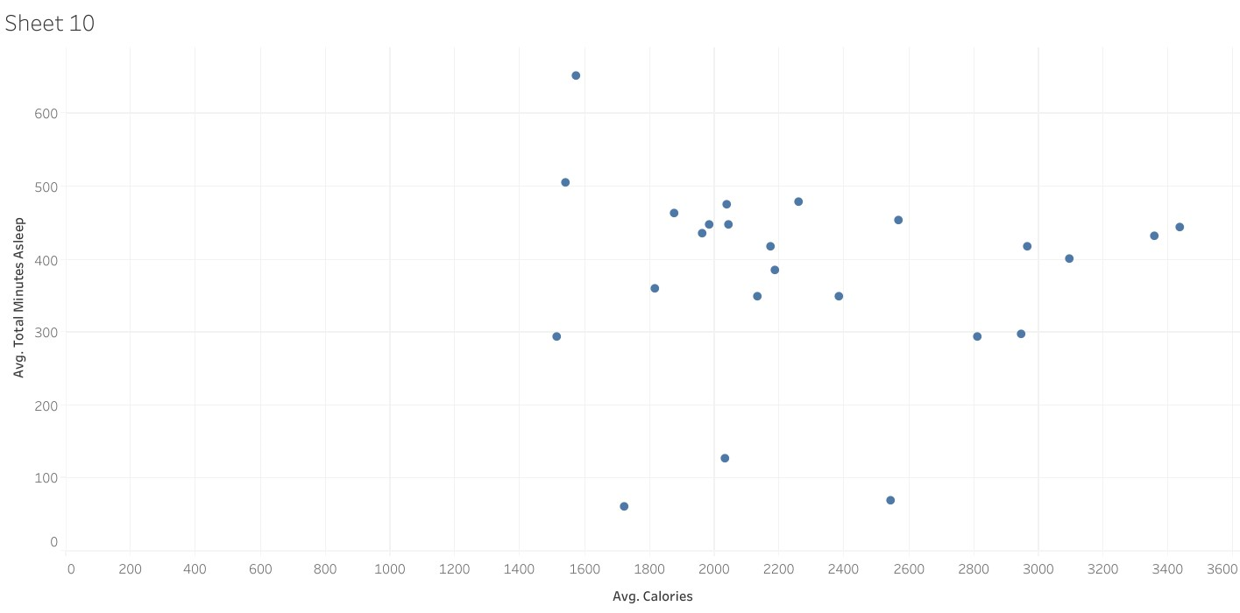We can see that most people slept between 400 and 500 minutes and their calories burned count is generally higher compared to the rest who slept more or less than that.

Looking at the METs and calories burned, there is a direct relation between them that when METs are higher, the calories burned are higher.

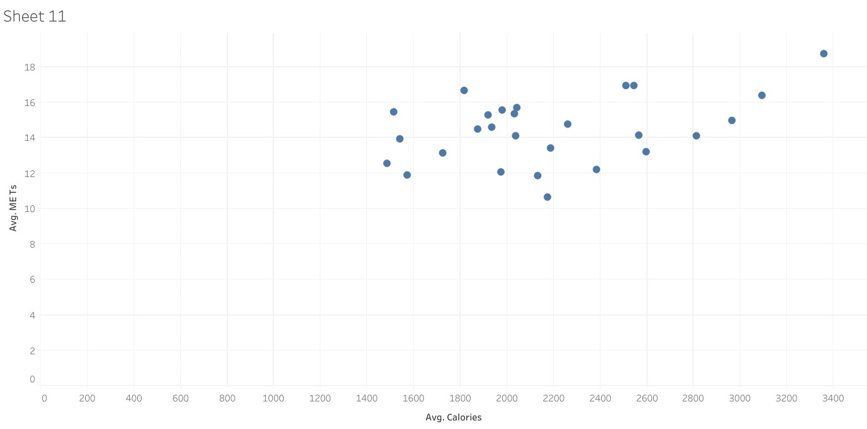A MET is the ratio of the rate of energy expended during an activity to the rate of energy expended at rest. For example, 1 MET is the rate of energy expenditure while at rest. A 4 MET activity expends 4 times the energy used by the body at rest.

Recommendations

1. The METs have a strong relation with calories burned and thus an METs tracking feature should be included on the smart device app and more awareness spread about MET values.

2. Most people have a sedentary lifestyle and should be reminded about exercise through notifications on app from 5 AM to 7 PM as that looks to be the most active time.

3. People should be reminded about their time spent sleeping as a good amount of sleep is necessary in order to burn sufficient calories.

4. People should be reminded about the time they spent in bed when not sleeping as it is time that was wasted and could be utilized better.

5. People should be given targets to be completed for exercising and some kind of reward should be given to the ones who complete the targets.