English Premier League results Data Analysis

Prepare

The English Premier League results dataset has been downloaded from Kaggle and contains data about the matches that happened in the English premier league from 1993-94 season to 2021-22 season. The data has thousands of rows and fairly recent data as well. So it is highly reliable data as it a public dataset.

But the data from 2022-23 season and some matches from 2021-22 are not there and also in the dataset, the rows from 1993-94 to 1999-00 season are missing a lot of data.

Process

The data from the 1993-94 to 1999-00 season is removed from the dataset since it has a lot of values missing and wont be helpful in the analysis. So the timeline will be from 2000-01 to 2021-22 season.

The data is checked for duplicates and none were found

The data is checked for blank values and none were found.

Also blank spaces were checked for and none were found in the dataset.

The columns have the appropriate data types and don’t nee any changes

The Total_goals column was created adding the full time home and away goals

The Total_shots column was created adding the home shots and away shots

The Total_shots on target was created adding the home and away shots on target

The Total_yellow_cards was created adding the home and away yellow cards

The Total_red_cards was created adding the home and away red cards

The Total_fouls was created adding the home and away fouls

The Total_corners was created adding the home and away corners

Analysis

The data is first sorted on the Datetime column in the ascending order from 2000-01 season to 2021-22 season.

The total goals across all seasons are analyzed and the average for each season is considered. We can see that overall the average has increased with time even though there have been some dips in some years. This suggests that the teams have gotten more attacking with time to score goals

|  |  |
| --- | --- |
| **Row Labels** | **Average of Total_goals** |
| 2000-01 | 2.61 |
| 2001-02 | 2.63 |
| 2002-03 | 2.63 |
| 2003-04 | 2.66 |
| 2004-05 | 2.57 |
| 2005-06 | 2.48 |
| 2006-07 | 2.45 |
| 2007-08 | 2.64 |
| 2008-09 | 2.48 |
| 2009-10 | 2.77 |
| 2010-11 | 2.80 |
| 2011-12 | 2.81 |
| 2012-13 | 2.80 |
| 2013-14 | 2.77 |
| 2014-15 | 2.57 |
| 2015-16 | 2.70 |
| 2016-17 | 2.80 |
| 2017-18 | 2.68 |
| 2018-19 | 2.82 |
| 2019-20 | 2.72 |
| 2020-21 | 2.69 |
| 2021-22 | 2.79 |
| **Grand Total** | **2.67** |
|  |  |

Now since fouls are essentially given as yellow or red cards for the extreme fouls, lets look at the relation between fouls, yellow cards and red cards over the seasons. The average has been considered for all three parameters.

The fouls have overall decreased over the seasons but the yellow cards have increased with time and the red cards have decreased with time overall even though there have been some peaks.

|  |  |  |  |
| --- | --- | --- | --- |
| **Row Labels** | **Average of Total_fouls** | **Average of Total_yellow_cards** | **Average of Total_red_cards** |
| 2000-01 | 26.92 | 3.14 | 0.17 |
| 2001-02 | 26.61 | 3.07 | 0.19 |
| 2002-03 | 25.44 | 3.01 | 0.20 |
| 2003-04 | 25.77 | 2.84 | 0.15 |
| 2004-05 | 26.09 | 2.71 | 0.16 |
| 2005-06 | 26.31 | 3.09 | 0.20 |
| 2006-07 | 25.05 | 3.22 | 0.14 |
| 2007-08 | 24.38 | 3.20 | 0.16 |
| 2008-09 | 23.22 | 3.15 | 0.17 |
| 2009-10 | 24.19 | 3.26 | 0.18 |
| 2010-11 | 22.42 | 3.25 | 0.17 |
| 2011-12 | 20.36 | 3.10 | 0.17 |
| 2012-13 | 20.93 | 3.12 | 0.14 |
| 2013-14 | 21.53 | 3.19 | 0.14 |
| 2014-15 | 22.69 | 3.59 | 0.19 |
| 2015-16 | 21.52 | 3.10 | 0.16 |
| 2016-17 | 22.72 | 3.63 | 0.11 |
| 2017-18 | 20.70 | 3.04 | 0.10 |
| 2018-19 | 20.46 | 3.21 | 0.12 |
| 2019-20 | 21.47 | 3.35 | 0.12 |
| 2020-21 | 21.77 | 2.87 | 0.12 |
| 2021-22 | 20.46 | 3.48 | 0.11 |
| **Grand Total** | **23.25** | **3.16** | **0.15** |

Now to look at the chances that have been created, we consider the corners, shots and shots on target(shots that were going in the direction of goal). The average has been considered for all 3 parameters.

The corners being given has remained fairly consistent throughout the season. The shots being taken has increased overall compared to earlier. While the shots on target has decreased overall with a big drop off in the 2013-14 season

|  |  |  |  |
| --- | --- | --- | --- |
| **Row Labels** | **Average of Total_corners** | **Average of Total_shots** | **Average of Total_shots_on_target** |
| 2000-01 | 10.94 | 22.17 | 10.69 |
| 2001-02 | 11.05 | 21.48 | 10.15 |
| 2002-03 | 11.59 | 22.42 | 11.87 |
| 2003-04 | 11.15 | 23.18 | 12.57 |
| 2004-05 | 10.78 | 22.21 | 11.76 |
| 2005-06 | 10.66 | 21.56 | 11.19 |
| 2006-07 | 11.28 | 22.51 | 11.45 |
| 2007-08 | 11.06 | 23.11 | 12.49 |
| 2008-09 | 11.10 | 24.36 | 13.16 |
| 2009-10 | 11.19 | 24.45 | 13.65 |
| 2010-11 | 11.04 | 24.87 | 13.61 |
| 2011-12 | 11.39 | 25.97 | 14.67 |
| 2012-13 | 11.15 | 25.14 | 14.24 |
| 2013-14 | 10.77 | 26.88 | 8.92 |
| 2014-15 | 10.69 | 25.91 | 8.41 |
| 2015-16 | 10.83 | 25.71 | 8.51 |
| 2016-17 | 10.41 | 25.50 | 8.67 |
| 2017-18 | 10.29 | 24.45 | 8.39 |
| 2018-19 | 10.26 | 25.28 | 8.71 |
| 2019-20 | 10.71 | 24.72 | 8.55 |
| 2020-21 | 10.19 | 24.18 | 8.63 |
| 2021-22 | 10.45 | 25.47 | 8.79 |
| **Grand Total** | **10.87** | **24.15** | **10.89** |

Looking at the average home and away goals, Arsenal, Man city, Man united, Chelsea and Liverpool have been the top scorers by a considerable margin over others.

|  |  |  |  |  |  |
| --- | --- | --- | --- | --- | --- |
| **Row Labels** | **Average of Full_time_home_goals** |  |  | **Row Labels** | **Average of Full_time_away_goals** |
| Arsenal | 2.13 |  |  | Man United | 1.66 |
| Man City | 2.10 |  |  | Arsenal | 1.61 |
| Chelsea | 2.09 |  |  | Liverpool | 1.60 |
| Man United | 2.09 |  |  | Chelsea | 1.60 |
| Liverpool | 2.02 |  |  | Man City | 1.57 |
| Tottenham | 1.81 |  |  | Leeds | 1.37 |
| Blackpool | 1.58 |  |  | Tottenham | 1.35 |
| Everton | 1.57 |  |  | Blackpool | 1.32 |
| Leeds | 1.47 |  |  | Brentford | 1.31 |
| Leicester | 1.46 |  |  | Leicester | 1.30 |
| Newcastle | 1.45 |  |  | Ipswich | 1.24 |
| West Ham | 1.44 |  |  | Coventry | 1.16 |
| Bournemouth | 1.43 |  |  | Reading | 1.14 |
| Southampton | 1.40 |  |  | Crystal Palace | 1.13 |
| Portsmouth | 1.38 |  |  | Aston Villa | 1.13 |
| Blackburn | 1.38 |  |  | Bournemouth | 1.11 |
| Charlton | 1.35 |  |  | Blackburn | 1.10 |
| Swansea | 1.35 |  |  | Everton | 1.07 |
| Ipswich | 1.34 |  |  | West Ham | 1.07 |
| Fulham | 1.33 |  |  | Southampton | 1.05 |
| Bolton | 1.33 |  |  | Bolton | 1.04 |
| Middlesbrough | 1.32 |  |  | Newcastle | 1.02 |
| Stoke | 1.31 |  |  | Wigan | 0.97 |
| Aston Villa | 1.27 |  |  | Wolves | 0.97 |
| Reading | 1.25 |  |  | QPR | 0.96 |
| Birmingham | 1.22 |  |  | Swansea | 0.95 |
| Wolves | 1.20 |  |  | Charlton | 0.92 |
| Norwich | 1.20 |  |  | Burnley | 0.91 |
| West Brom | 1.19 |  |  | Watford | 0.90 |
| Watford | 1.19 |  |  | Brighton | 0.89 |
| Crystal Palace | 1.13 |  |  | Fulham | 0.88 |
| Hull | 1.13 |  |  | Sunderland | 0.87 |
| Brentford | 1.13 |  |  | West Brom | 0.87 |
| Wigan | 1.11 |  |  | Middlesbrough | 0.86 |
| Sunderland | 1.08 |  |  | Birmingham | 0.83 |
| Cardiff | 1.08 |  |  | Portsmouth | 0.81 |
| Burnley | 1.05 |  |  | Stoke | 0.79 |
| Bradford | 1.05 |  |  | Hull | 0.78 |
| Sheffield United | 1.05 |  |  | Norwich | 0.71 |
| QPR | 1.05 |  |  | Cardiff | 0.66 |
| Brighton | 1.03 |  |  | Huddersfield | 0.63 |
| Derby | 0.96 |  |  | Derby | 0.61 |
| Coventry | 0.74 |  |  | Sheffield United | 0.54 |
| Huddersfield | 0.68 |  |  | Bradford | 0.53 |
| **Grand Total** | **1.52** |  |  | **Grand Total** | **1.16** |

As far chances that were created at home is concerned, Arsenal, Chelsea, Liverpool, Man united and Man city are again leading the numbers which is also translating into more goals scored for them. One more team i.e. Tottenham also have similar numbers to the other 5 but they scored less than them.

|  |  |  |  |
| --- | --- | --- | --- |
| **Row Labels** | **Average of Home_corners** | **Average of Home_shots** | **Average of Home_shots_on_target** |
| Arsenal | 7.32 | 15.64 | 7.76 |
| Aston Villa | 6.15 | 11.86 | 5.38 |
| Birmingham | 5.62 | 10.26 | 5.32 |
| Blackburn | 5.77 | 12.66 | 6.43 |
| Blackpool | 4.95 | 13.32 | 7.05 |
| Bolton | 6.16 | 13.33 | 7.40 |
| Bournemouth | 5.68 | 12.54 | 4.20 |
| Bradford | 5.68 | 11.63 | 5.32 |
| Brentford | 4.31 | 11.63 | 4.06 |
| Brighton | 5.51 | 12.88 | 3.49 |
| Burnley | 4.78 | 11.25 | 3.91 |
| Cardiff | 5.39 | 12.05 | 3.74 |
| Charlton | 5.50 | 10.80 | 5.80 |
| Chelsea | 6.79 | 16.37 | 7.60 |
| Coventry | 6.68 | 11.21 | 5.00 |
| Crystal Palace | 5.49 | 12.22 | 4.17 |
| Derby | 4.70 | 9.40 | 4.51 |
| Everton | 6.21 | 13.32 | 6.12 |
| Fulham | 5.37 | 12.05 | 5.96 |
| Huddersfield | 4.92 | 10.79 | 2.95 |
| Hull | 4.83 | 11.64 | 4.61 |
| Ipswich | 7.05 | 13.89 | 6.87 |
| Leeds | 6.36 | 13.67 | 5.93 |
| Leicester | 5.72 | 12.66 | 4.86 |
| Liverpool | 7.33 | 17.18 | 7.75 |
| Man City | 7.33 | 15.76 | 7.23 |
| Man United | 6.93 | 16.29 | 7.90 |
| Middlesbrough | 5.64 | 11.77 | 5.88 |
| Newcastle | 5.92 | 13.44 | 6.15 |
| Norwich | 5.19 | 12.18 | 5.07 |
| Portsmouth | 6.31 | 13.73 | 7.43 |
| QPR | 5.00 | 14.79 | 6.25 |
| Reading | 6.70 | 10.00 | 5.21 |
| Sheffield United | 6.05 | 10.88 | 4.40 |
| Southampton | 5.73 | 13.39 | 5.36 |
| Stoke | 5.27 | 11.48 | 4.49 |
| Sunderland | 5.40 | 12.05 | 5.55 |
| Swansea | 5.44 | 12.38 | 5.10 |
| Tottenham | 6.54 | 15.40 | 7.33 |
| Watford | 4.84 | 11.98 | 4.02 |
| West Brom | 5.50 | 11.88 | 5.18 |
| West Ham | 5.70 | 12.86 | 5.60 |
| Wigan | 5.72 | 13.07 | 6.74 |
| Wolves | 5.65 | 12.29 | 5.26 |
| **Grand Total** | **6.08** | **13.50** | **6.12** |

Again, the same five teams as mentioned above are leading the numbers on away chance creation too.

|  |  |  |  |  |
| --- | --- | --- | --- | --- |
| **Row Labels** | **Average of Away_corners** | **Average of Away_shots** | | **Average of Away_shots_on_target** |
| Arsenal | 5.22 | 12.22 | 5.84 | |
| Aston Villa | 4.99 | 10.17 | 4.76 | |
| Birmingham | 4.25 | 8.00 | 4.13 | |
| Blackburn | 4.96 | 9.57 | 5.01 | |
| Blackpool | 4.84 | 10.16 | 5.32 | |
| Bolton | 4.64 | 9.58 | 4.83 | |
| Bournemouth | 5.00 | 10.75 | 3.65 | |
| Bradford | 3.74 | 7.89 | 3.84 | |
| Brentford | 3.50 | 10.19 | 3.81 | |
| Brighton | 4.19 | 10.01 | 3.33 | |
| Burnley | 3.94 | 9.30 | 3.32 | |
| Cardiff | 4.18 | 9.95 | 2.89 | |
| Charlton | 4.65 | 8.17 | 4.15 | |
| Chelsea | 5.61 | 13.54 | 6.11 | |
| Coventry | 4.16 | 9.26 | 4.32 | |
| Crystal Palace | 4.53 | 9.84 | 3.42 | |
| Derby | 3.67 | 6.98 | 3.60 | |
| Everton | 4.76 | 10.37 | 4.76 | |
| Fulham | 4.22 | 9.40 | 4.49 | |
| Huddersfield | 3.68 | 9.21 | 3.08 | |
| Hull | 4.08 | 9.43 | 3.61 | |
| Ipswich | 4.26 | 9.61 | 4.05 | |
| Leeds | 4.86 | 10.39 | 4.79 | |
| Leicester | 4.92 | 10.35 | 4.08 | |
| Liverpool | 5.69 | 13.25 | 6.17 | |
| Man City | 5.71 | 13.23 | 5.89 | |
| Man United | 5.63 | 12.68 | 6.16 | |
| Middlesbrough | 3.85 | 8.93 | 4.41 | |
| Newcastle | 4.44 | 9.72 | 4.41 | |
| Norwich | 4.15 | 9.48 | 3.68 | |
| Portsmouth | 4.21 | 9.25 | 4.72 | |
| QPR | 4.54 | 11.39 | 5.33 | |
| Reading | 5.70 | 8.82 | 4.26 | |
| Sheffield United | 3.82 | 8.09 | 2.89 | |
| Southampton | 5.12 | 11.15 | 4.49 | |
| Stoke | 3.74 | 8.95 | 3.40 | |
| Sunderland | 4.19 | 9.34 | 4.28 | |
| Swansea | 4.19 | 9.90 | 3.92 | |
| Tottenham | 5.12 | 11.60 | 5.43 | |
| Watford | 4.43 | 9.92 | 3.44 | |
| West Brom | 4.22 | 9.83 | 4.22 | |
| West Ham | 4.64 | 10.30 | 4.35 | |
| Wigan | 4.20 | 10.54 | 5.53 | |
| Wolves | 4.87 | 9.78 | 4.12 | |
| **Grand Total** | **4.78** | **10.64** | **4.77** | |

Some teams like Blackburn, Bradford, Charlton, Derby, Hull, Leeds, Portsmouth and Sunderland have a high average of fouls and yellow cards compared to other. The red cards average is similar for all

|  |  |  |  |
| --- | --- | --- | --- |
| **Row labels** | **Average of Home_fouls** | **Average of Home_yellow** | **Average of Home_red** |
| Arsenal | 10.82 | 1.39 | 0.06 |
| Aston Villa | 11.82 | 1.42 | 0.07 |
| Birmingham | 12.29 | 1.44 | 0.10 |
| Blackburn | 13.81 | 1.64 | 0.11 |
| Blackpool | 11.37 | 1.16 | 0.00 |
| Bolton | 12.52 | 1.42 | 0.08 |
| Bournemouth | 9.18 | 1.60 | 0.05 |
| Bradford | 13.42 | 1.42 | 0.00 |
| Brentford | 9.75 | 1.56 | 0.06 |
| Brighton | 10.95 | 1.70 | 0.05 |
| Burnley | 10.41 | 1.55 | 0.00 |
| Cardiff | 9.53 | 1.53 | 0.00 |
| Charlton | 12.32 | 1.19 | 0.10 |
| Chelsea | 10.87 | 1.32 | 0.06 |
| Coventry | 13.00 | 1.32 | 0.16 |
| Crystal Palace | 11.45 | 1.58 | 0.04 |
| Derby | 13.49 | 1.70 | 0.04 |
| Everton | 11.67 | 1.43 | 0.07 |
| Fulham | 11.39 | 1.33 | 0.08 |
| Huddersfield | 10.37 | 1.39 | 0.13 |
| Hull | 12.42 | 1.51 | 0.13 |
| Ipswich | 10.05 | 0.66 | 0.03 |
| Leeds | 14.01 | 1.81 | 0.05 |
| Leicester | 10.91 | 1.27 | 0.06 |
| Liverpool | 10.14 | 0.99 | 0.04 |
| Man City | 10.79 | 1.27 | 0.06 |
| Man United | 10.89 | 1.33 | 0.03 |
| Middlesbrough | 12.18 | 1.43 | 0.06 |
| Newcastle | 11.68 | 1.41 | 0.07 |
| Norwich | 10.55 | 1.42 | 0.05 |
| Portsmouth | 12.71 | 1.46 | 0.09 |
| QPR | 10.56 | 1.53 | 0.16 |
| Reading | 10.23 | 1.14 | 0.09 |
| Sheffield United | 11.33 | 1.63 | 0.04 |
| Southampton | 11.56 | 1.28 | 0.09 |
| Stoke | 11.53 | 1.67 | 0.07 |
| Sunderland | 12.07 | 1.68 | 0.06 |
| Swansea | 9.62 | 1.41 | 0.05 |
| Tottenham | 11.01 | 1.32 | 0.05 |
| Watford | 12.66 | 1.99 | 0.10 |
| West Brom | 11.29 | 1.45 | 0.05 |
| West Ham | 11.30 | 1.55 | 0.05 |
| Wigan | 11.87 | 1.51 | 0.06 |
| Wolves | 10.77 | 1.56 | 0.04 |
| **Grand Total** | **11.38** | **1.42** | **0.06** |

Some teams like Birmingham, Blackburn, Bolton, Bradford, Coventry, Derby, Leeds, Middlesborough, Portsmouth have a high average of fouls and yellow cards when playing away. The red card average is similar for all.

|  |  |  |  |
| --- | --- | --- | --- |
| **Row Labels** | **Average of Away_fouls** | **Average of Away_yellow** | **Average of Away_red** |
| Arsenal | 11.03 | 1.70 | 0.12 |
| Aston Villa | 12.92 | 1.92 | 0.06 |
| Birmingham | 12.68 | 1.81 | 0.11 |
| Blackburn | 13.63 | 1.97 | 0.13 |
| Blackpool | 9.84 | 1.32 | 0.11 |
| Bolton | 13.23 | 2.05 | 0.09 |
| Bournemouth | 9.51 | 1.46 | 0.04 |
| Bradford | 13.79 | 1.58 | 0.05 |
| Brentford | 10.06 | 1.75 | 0.06 |
| Brighton | 11.11 | 1.31 | 0.12 |
| Burnley | 10.42 | 1.80 | 0.05 |
| Cardiff | 9.58 | 1.47 | 0.05 |
| Charlton | 12.36 | 1.35 | 0.06 |
| Chelsea | 11.32 | 1.81 | 0.09 |
| Coventry | 14.84 | 2.68 | 0.05 |
| Crystal Palace | 11.95 | 1.69 | 0.05 |
| Derby | 13.82 | 2.00 | 0.07 |
| Everton | 12.37 | 1.65 | 0.10 |
| Fulham | 12.06 | 1.62 | 0.06 |
| Huddersfield | 11.11 | 1.66 | 0.05 |
| Hull | 12.08 | 1.97 | 0.13 |
| Ipswich | 12.58 | 1.24 | 0.05 |
| Leeds | 13.81 | 2.13 | 0.11 |
| Leicester | 11.63 | 1.71 | 0.11 |
| Liverpool | 11.23 | 1.61 | 0.07 |
| Man City | 11.49 | 1.80 | 0.10 |
| Man United | 11.55 | 1.79 | 0.09 |
| Middlesbrough | 13.49 | 1.81 | 0.11 |
| Newcastle | 11.76 | 1.77 | 0.12 |
| Norwich | 11.05 | 1.59 | 0.07 |
| Portsmouth | 13.20 | 1.63 | 0.06 |
| QPR | 10.84 | 1.82 | 0.11 |
| Reading | 11.12 | 1.42 | 0.07 |
| Sheffield United | 11.89 | 1.91 | 0.09 |
| Southampton | 12.21 | 1.56 | 0.06 |
| Stoke | 11.99 | 1.95 | 0.08 |
| Sunderland | 12.51 | 1.96 | 0.13 |
| Swansea | 10.20 | 1.37 | 0.06 |
| Tottenham | 11.39 | 1.73 | 0.09 |
| Watford | 12.59 | 1.65 | 0.08 |
| West Brom | 11.57 | 1.66 | 0.09 |
| West Ham | 11.35 | 1.82 | 0.10 |
| Wigan | 12.41 | 1.90 | 0.12 |
| Wolves | 11.37 | 1.74 | 0.07 |
| **Grand Total** | **11.87** | **1.75** | **0.09** |

The percentage of draws played has remained consistent over the years but the away wins have increased suggesting that teams are looking to fight for wins more now when playing away. The home wins have not varied much but in the recent seasons there has been a downward trend.

|  |  |  |  |  |
| --- | --- | --- | --- | --- |
| **Percentage of Full_time_result** | **Column Labels** |  |  |  |
| **Row Labels** | **A** | **D** | **H** | **Grand Total** |
| 2000-01 | 25.00% | 26.58% | 48.42% | 100.00% |
| 2001-02 | 30.00% | 26.58% | 43.42% | 100.00% |
| 2002-03 | 27.11% | 23.68% | 49.21% | 100.00% |
| 2003-04 | 27.63% | 28.42% | 43.95% | 100.00% |
| 2004-05 | 25.53% | 28.95% | 45.53% | 100.00% |
| 2005-06 | 29.21% | 20.26% | 50.53% | 100.00% |
| 2006-07 | 26.32% | 25.79% | 47.89% | 100.00% |
| 2007-08 | 27.37% | 26.32% | 46.32% | 100.00% |
| 2008-09 | 28.95% | 25.53% | 45.53% | 100.00% |
| 2009-10 | 23.95% | 25.26% | 50.79% | 100.00% |
| 2010-11 | 23.68% | 29.21% | 47.11% | 100.00% |
| 2011-12 | 30.53% | 24.47% | 45.00% | 100.00% |
| 2012-13 | 27.89% | 28.42% | 43.68% | 100.00% |
| 2013-14 | 32.37% | 20.53% | 47.11% | 100.00% |
| 2014-15 | 30.26% | 24.47% | 45.26% | 100.00% |
| 2015-16 | 30.53% | 28.16% | 41.32% | 100.00% |
| 2016-17 | 28.68% | 22.11% | 49.21% | 100.00% |
| 2017-18 | 28.42% | 26.05% | 45.53% | 100.00% |
| 2018-19 | 33.68% | 18.68% | 47.63% | 100.00% |
| 2019-20 | 30.53% | 24.21% | 45.26% | 100.00% |
| 2020-21 | 40.26% | 21.84% | 37.89% | 100.00% |
| 2021-22 | 34.63% | 23.30% | 42.07% | 100.00% |
| **Grand Total** | **29.16%** | **24.96%** | **45.88%** | **100.00%** |

Share

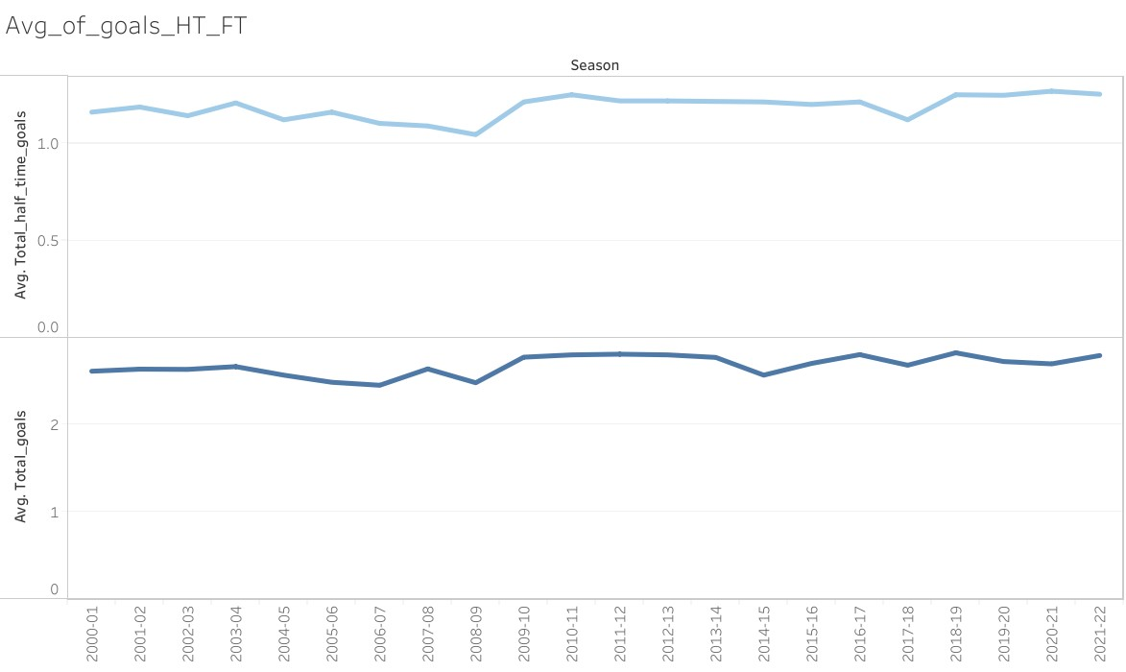We can see that teams overall have scored more over the seasons for both half time and full time even though there are some dips.

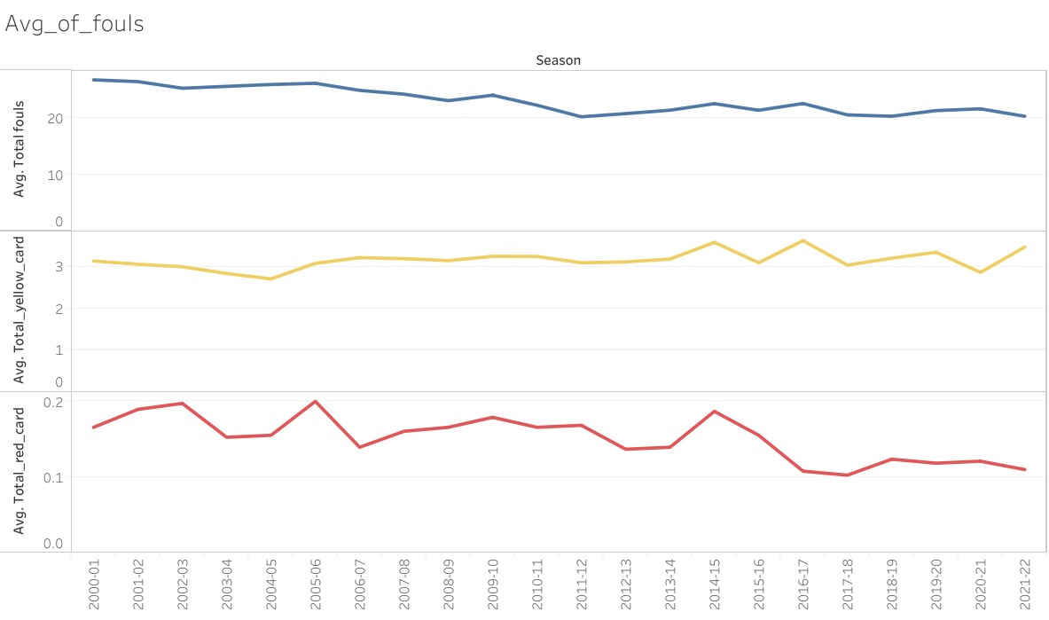The fouls and red cards have decreased with time but yellow cards have slightly increased

The total corners have stayed consistent but total shots have increased slightly but the average total shots on target have a big drop off from 2013-14 season onwards.

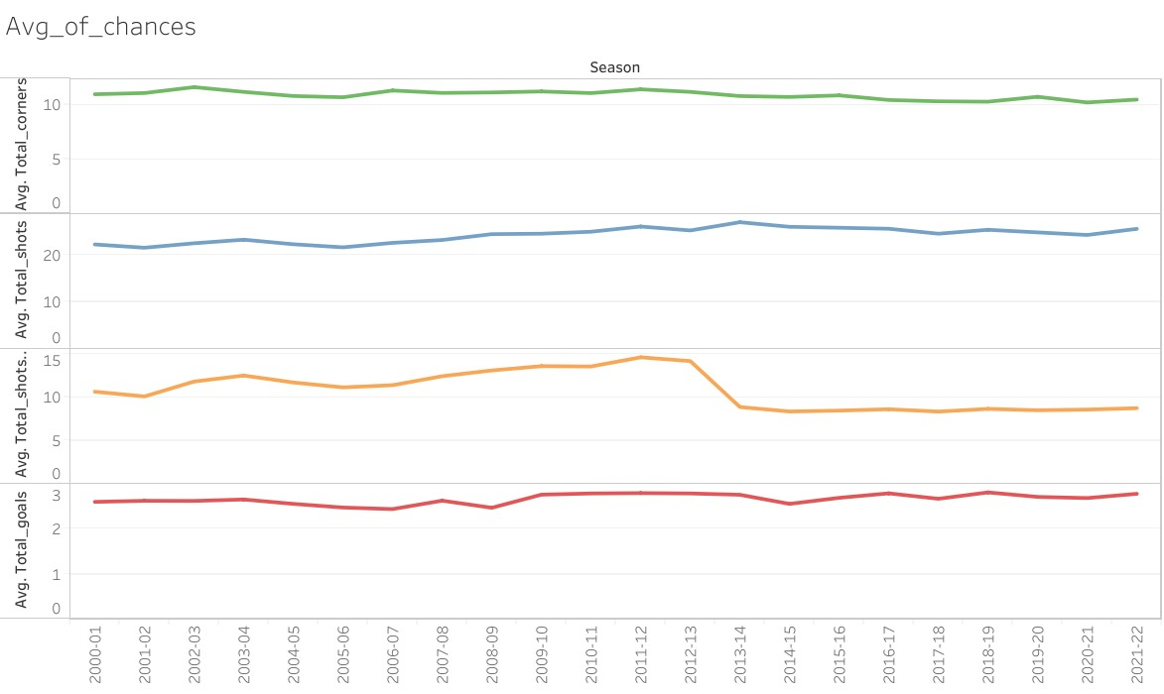

The away wins have overall increased while the home wins have overall decreased and the draws have stayed almost consistent

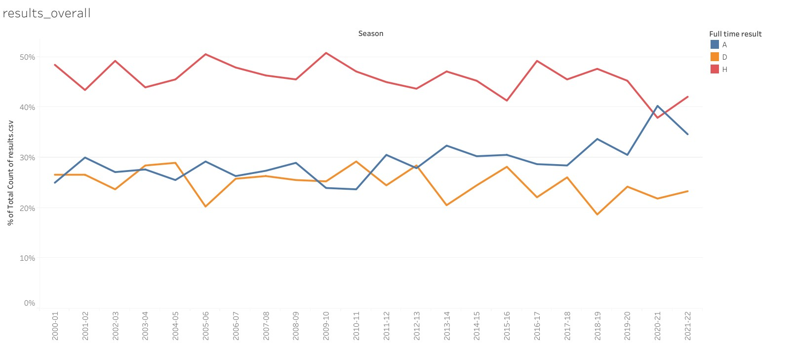

Arsenal, Chelsea, Liverpool, Man United, Man City are all leading the home goals average.

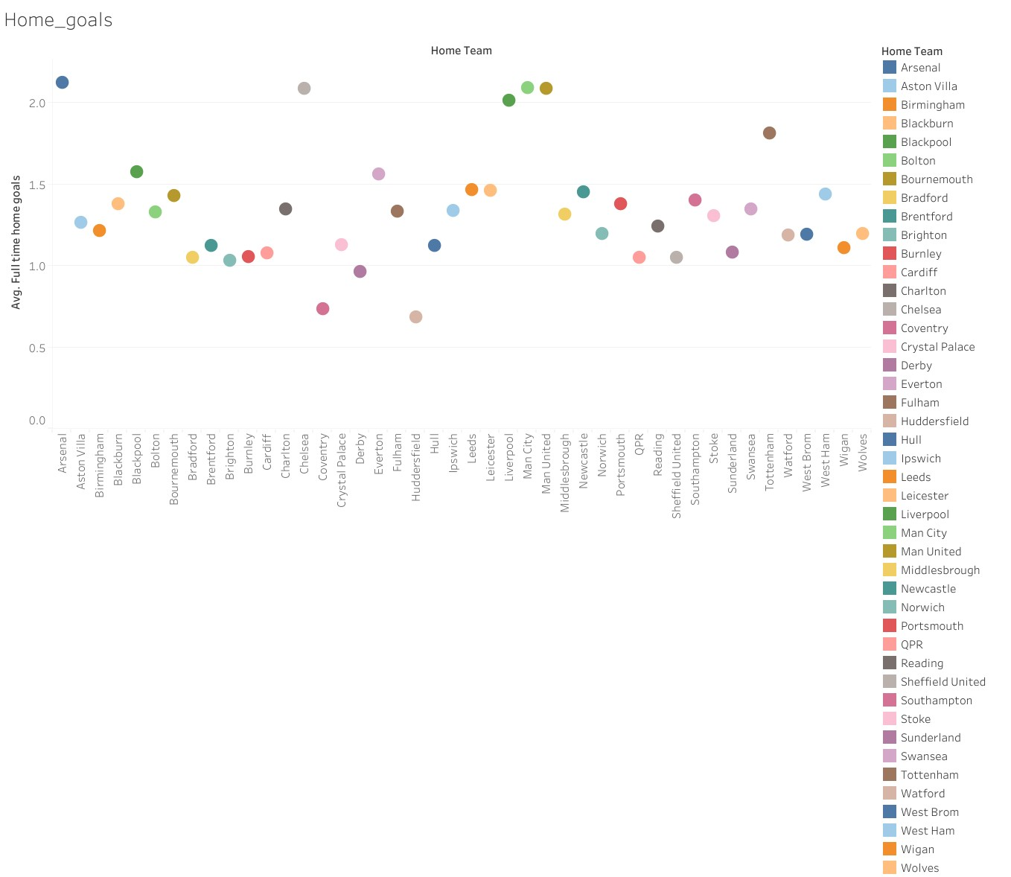

Arsenal, Chelsea, Liverpool, Man United and Man City are also leading on away goals average.

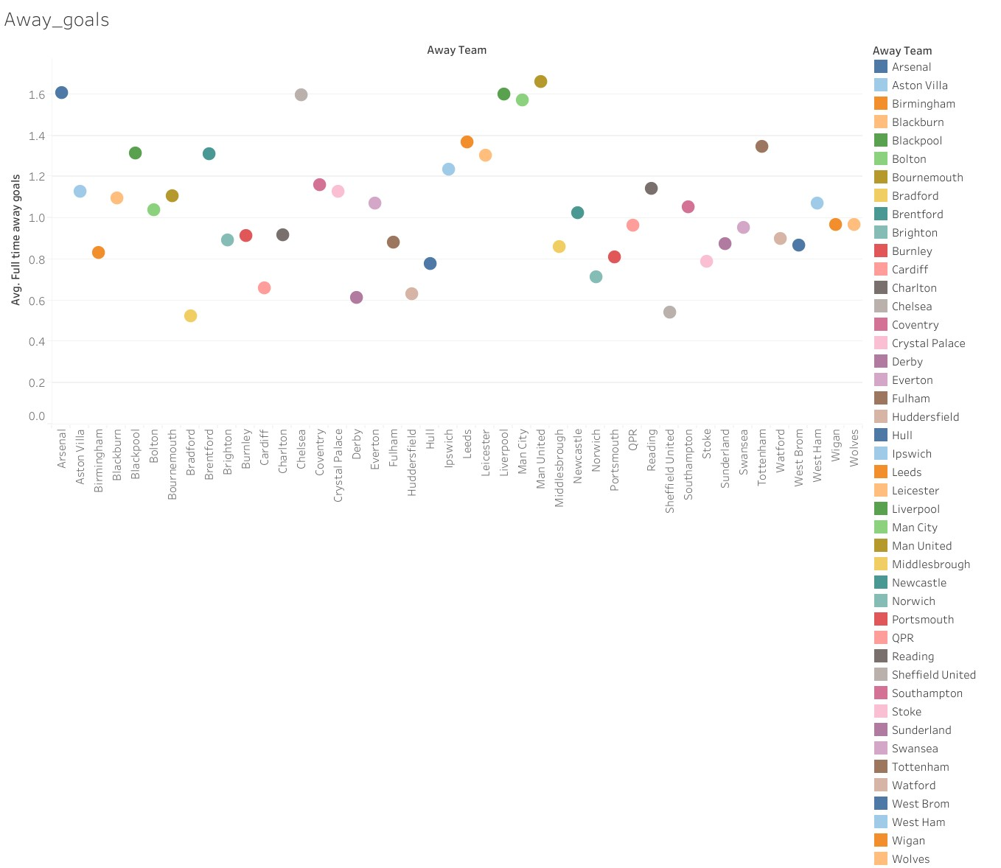

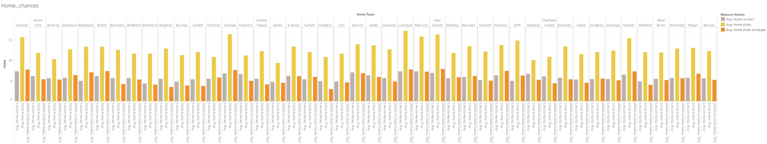The same five teams mentioned above are leading in chance creation averages at home.

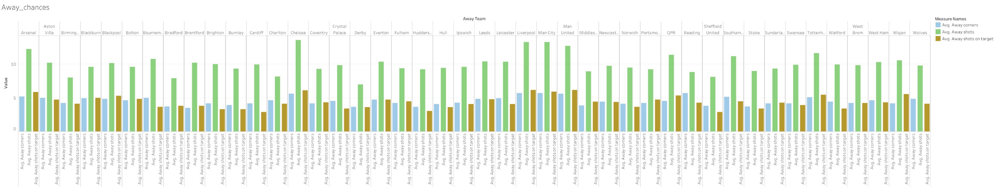The same five teams also leading in chance creation averages away from home.

The teams with high average fouls and yellow cards at home are Blackburn, Bradford, Charlton, Derby, Hull, Leeds, Portsmouth and Sunderland. Red cards average are similar for all

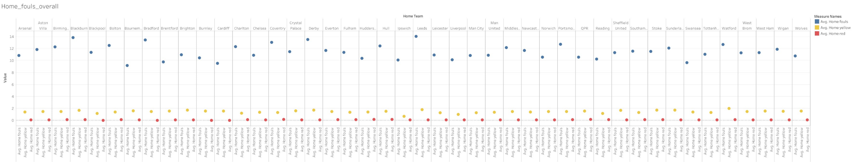

The teams with high average fouls and yellow cards away from home are Birmingham, Blackburn, Bolton, Bradford, Coventry, Derby, Leeds, Middlesborough, Portsmouth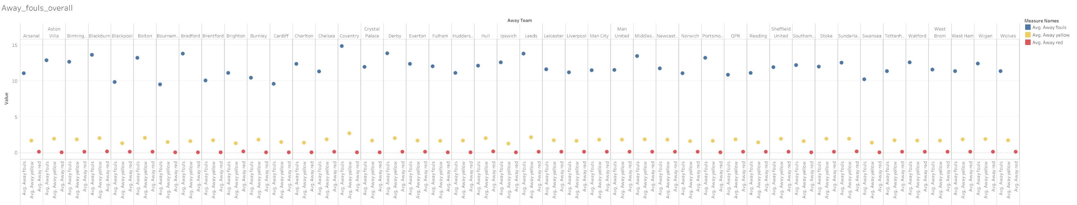. Red cards are similar for all.

Observations

1. The five teams Arsenal, Chelsea, Liverpool, Man City, Man United have scored more goals and created more chances than others and it reflects that they have been the successful teams in the last 20 years.

2. The teams have scored more over the seasons suggesting that they have played more attacking football and are trying to go for the win.

3. The fouls are decreasing which suggests that teams are playing less rough football compared to earlier, but the yellow card average increasing can be due to referees becoming more strict with fouls

4. The away wins increasing in recent seasons suggests that teams are trying to win at their opponents home rather than play for a draw.

5. The teams with high average fouls are the low table teams or those who got relegated suggesting they might play rough football to overcome the gap between them and the big teams.