**Microprocessor and Computer Architecture**

**UE21CS251B**

**4th Semester, Academic Year 2022-23**

Date:

|  |  |  |
| --- | --- | --- |
| Name: Nihal T M | SRN: PES2UG21CS333 | Section:F |

Week#____1_______ Program Number: ____1___

Title of the Program

**Write an ALP using ARM instruction set to check if a number stored in a register is even or odd. If even, store 00 in R0, else store FF in R0**

1. Code:

.text

LDR R0,=a

LDR R1,[r0]

AND R2,R1,#1

CMP R2, #0

BEQ even

BNE odd

even: MOV R0,#00

B END

odd: MOV R0, #255

B END

END:

.data

a:.word 10

1. Screen Shot:
2. when number is even

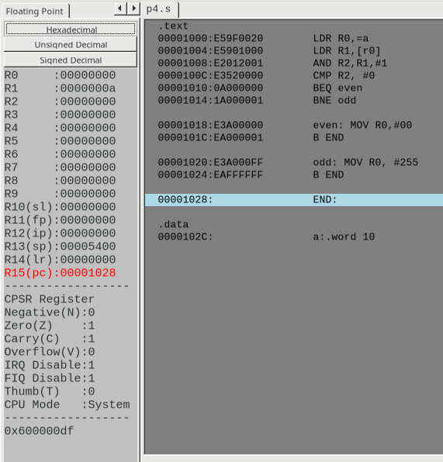

1. when number is odd

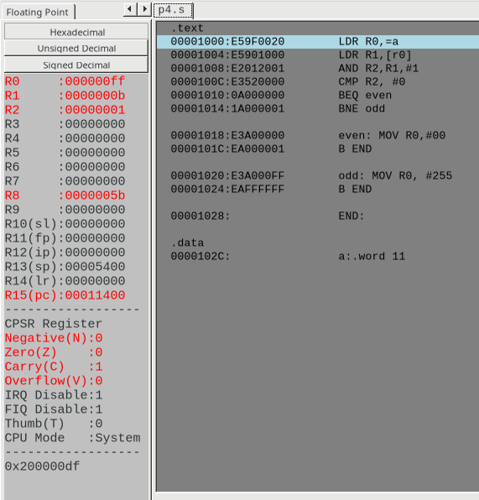

1. Output Table:

|  |  |
| --- | --- |
| Input | Output |
| R1=10 | R0=00 |
| R1=11 | R0=ff (255) |

Week#____1_______ Program Number: ____2___

Title of the Program

**Write an ALP to compare the value of R0 and R1, add if R0 = R1, else subtract**

1. ARM Assembly Code:

.text

LDR R0,=a

LDR R1,=b

LDR R2,=c

LDR R3,[r0]

LDR R4,[r1]

CMP R3,R4

beq add

sub r5,r3,R4

STR r5,[r2]

B END

add:

add r5,r3,R4

STR r5,[r2]

END:

.data

a:.word 10

b:.word 6

c:.word 0

II. Output Screen Shot (Two)

The output should be verified for both equal and nor equal values

1. when r0 and r1 are equal:

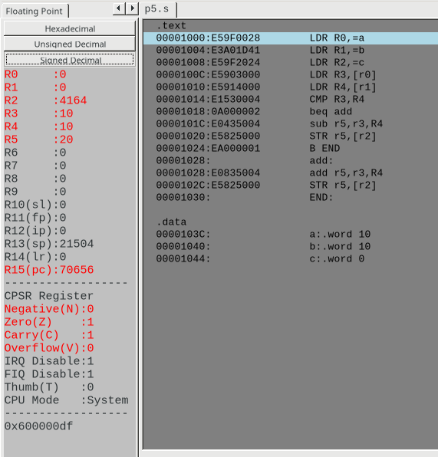

1. when r0 and r1 are not equal:

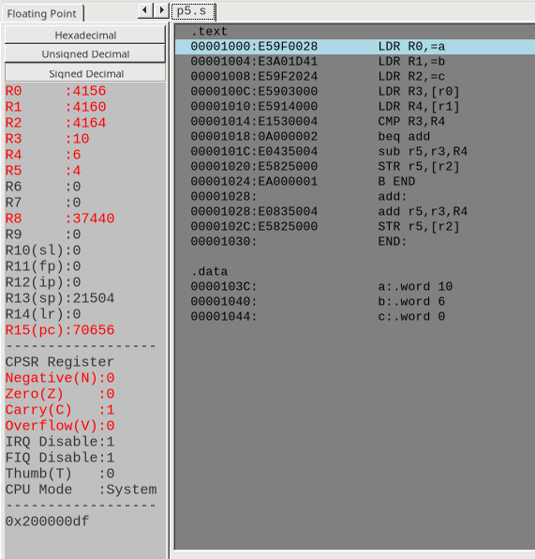

III.Output Table:

|  |  |
| --- | --- |
| Input | Output |
| R3=10, R4=10 | R5=20 |
| R3=10, R4=6 | R5=4 |

Week#____1_______ Program Number: ____3___

Title of the Program

**Based on the value of the number in R0, Write an ALP to store 1 in R1 if R0 is zero, Store 2 in R1 if R0 is positive, Store 3 in R1 if R0 is negative. (Program shown in class)**

1. ARM Assembly Code:

.text

ldr r0,=a

ldr r2,[r0]

CMP r2,#0

BEQ zero

BPL plus

BMI negative

zero: mov r1,#1

B END

plus: mov r1,#2

B END

negative: mov r1,#3

B END

END:

.data

a:.word 0

II. Output Screen Shot (Three)

The output should be verified for zero, positive and negative cases.

1. when the number is 0:

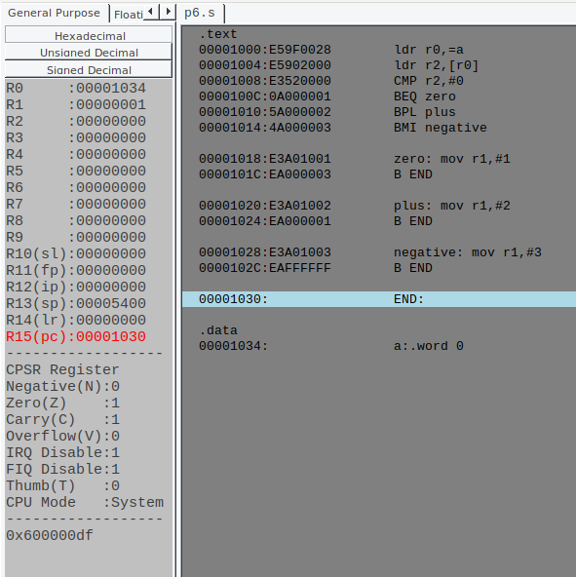

1. when number is positive:

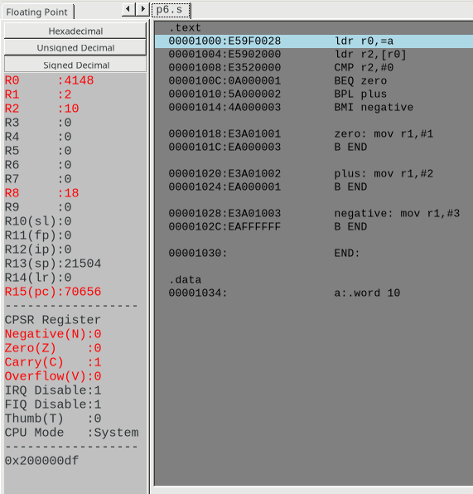

1. when number is negative:

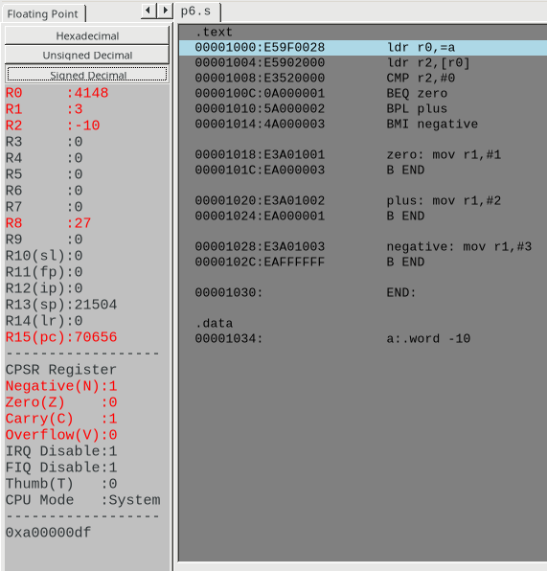

III.Output Table

|  |  |
| --- | --- |
| Input | Output |
| R0=0 | R1=1 |
| R0=10 | R1=2 |
| R0=-10 | R1=3 |

**Disclaimer:**

* The programs and output submitted is duly written, verified and executed by me.
* I have not copied from any of my peers nor from the external resource such as internet.
* If found plagiarized, I will abide with the disciplinary action of the University.

Signature:

Name:Nihal T M

SRN:PES2UG21CS333

Section: F

Date:16/01/2023