**Microprocessor and Computer Architecture**

**UE21CS251B**

**4th Semester, Academic Year 2022-23**

Date:

|  |  |  |
| --- | --- | --- |
| Name:Nihal T M | SRN:PES2UG21CS333 | Section:F |

Week#____2_______ Program Number: ____1___

Title of the Program

**Write a program in ARM7TDMI-ISA to copy a block of N data items from Location A to Location B.**

**a. Use Full word (.word directive)**

**b. Use Half word(.hword directive)**

**c. Use Byte wise (.Byte directive)**

1. ARM Assembly Code

Code:

@ this program copies a block of n data(word) items from location A to location B

.text

ldr r0,=a

ldr r1,=b

ldmia r0!,{r2-r6}

stmia r1!,{r2-r6}

swi 0x11

.data

a:.word 10,20,30,40,50

b:.word 0,0,0,0,0

1. Output Screen Shots (Three)

The output should be verified for word, half word, byte

1. word:

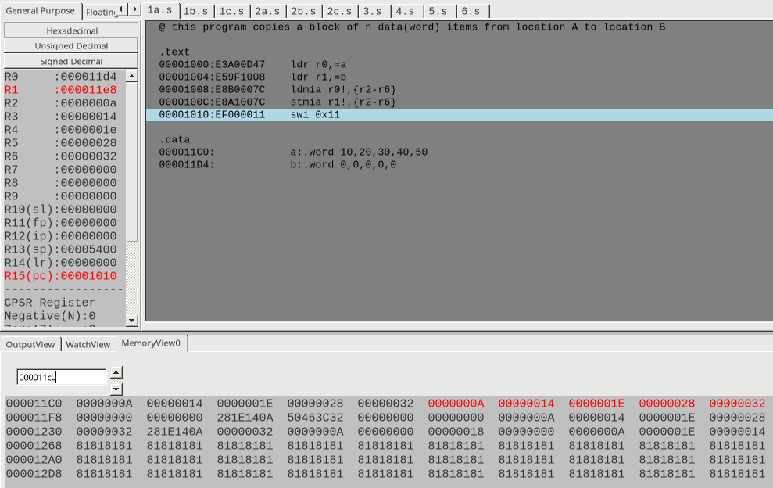

1. half-word

code:

@ this program copies a block of n data(half-word) items from location A to location B

.text

ldr r0,=a

ldr r1,=b

ldmia r0!,{r2-r4}

stmia r1!,{r2-r4}

swi 0x11

.data

a:.hword 10,20,30,40,50,60

b:.hword 0,0,0,0,0,0

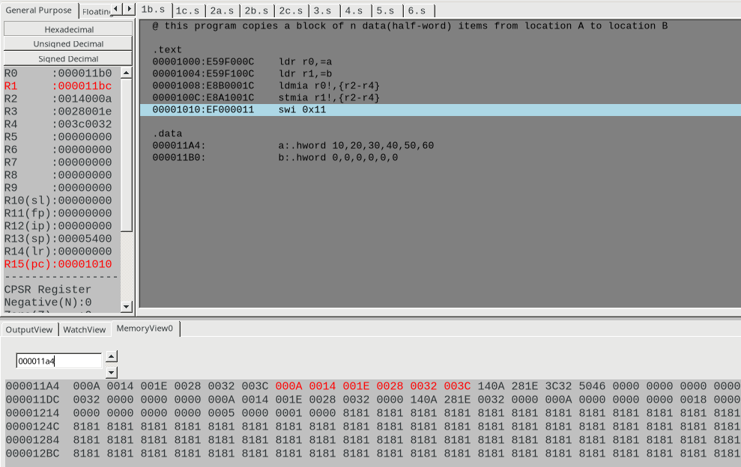

1. byte

code:

@ this program copies a block of n data(byte) items from location A to location B

.text

ldr r0,=a

ldr r1,=b

ldmia r0!,{r2-r3}

stmia r1!,{r2-r3}

swi 0x11

.data

a:.byte 10,20,30,40,50,60,70,80

b:.byte 0,0,0,0,0,0,0,0

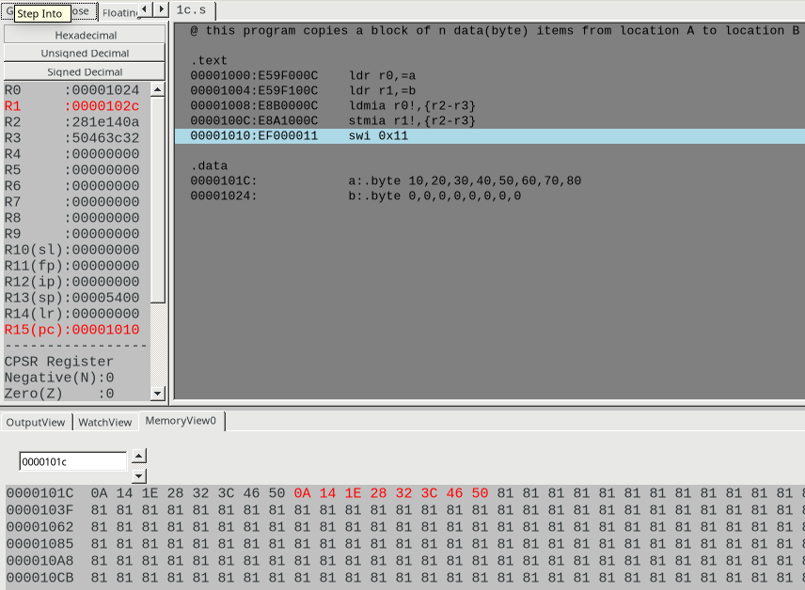

Week#____2_______ Program Number: ____2___

Title of the Program

**Write a program in ARM7TDMI-ISA to find the sum of N data items in the memory. Store the result in the memory location.**

**a. Use Full word (.word directive)**

**b. Use Half word(.hword directive)**

**c. Use Byte wise (.Byte directive)**

I.ARM Assembly Code

Code:

1. word:

@ find sum of n words

.text

ldr r0,=a

ldr r1,=sum

mov r2,#5

mov r3,#0

loop:

ldr r4,[r0]

add r3,r3,r4

add r0,r0,#4

subs r2,r2,#1

bne loop

str r3,[r1]

.data

a:.word 10,20,30,40,50

sum:.word 0

1. half-word:

@ find sum of n half-words

.text

ldr r0,=a

ldr r1,=sum

mov r2,#5

mov r3,#0

loop:

ldrh r4,[r0]

add r3,r3,r4

add r0,r0,#2

subs r2,r2,#1

bne loop

strh r3,[r1]

.data

a:.hword 10,20,30,40,50

sum:.hword 0

1. byte:

@ find sum of n bytes

.text

ldr r0,=a

ldr r1,=sum

mov r2,#5

mov r3,#0

loop:

ldrb r4,[r0]

add r3,r3,r4

add r0,r0,#1

subs r2,r2,#1

bne loop

strb r3,[r1]

.data

a:.byte 10,20,30,40,50

sum:.byte 0

II. Output Screen Shots (Three)

The output should be verified for word, half word, byte

1. word:

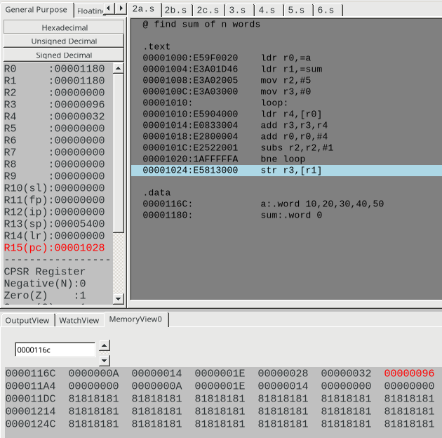

1. half-word:

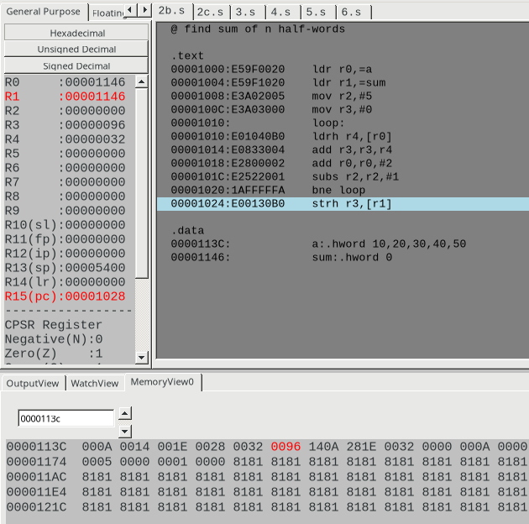

1. byte: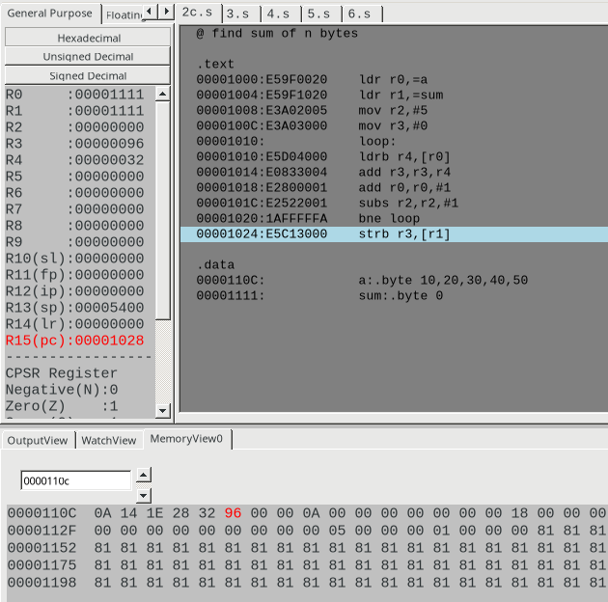

Week#____2_______ Program Number: ____3___

Title of the Program

**Write a program in ARM7TDMI-ISA to find the sum of N natural numbers. Store the result in the memory location.**

1. ARM Assembly Code

Code:

@ sum of n natural numbers

.text

ldr r0,=n

ldr r1,[r0]

mov r2,#0

loop:

add r2,r2,r1

subs r1,r1,#1

bne loop

ldr r3,=sum

str r2,[r3]

.data

n:.word 10

sum:.word 0

II. Output Screen Shots (One)

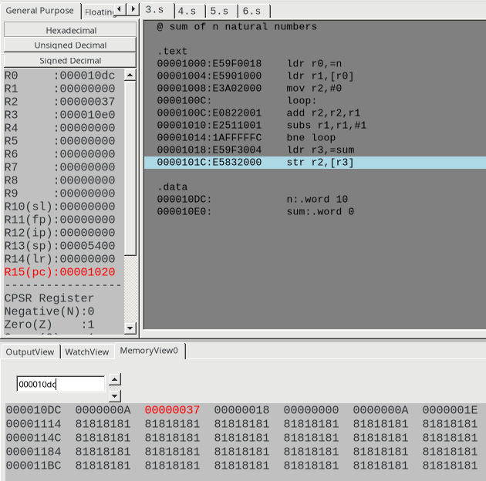

Week#____2_______ Program Number: ____4___

Title of the Program

**Write a program in ARM7TDMI-ISA to find the product of two 32bit numbers using barrel shifter.**

1. ARM Assembly Code

Code:@ find product of two 32-bit numbers using barrel shifter (here we multiply 24 and 33)

.text

ldr r0,=a

ldr r1,[r0]

mov r2,#33

ldr r3,=res

add r1,r1,r1,LSL #5

str r1,[r3]

.data

a:.word 24

res:.word 0

1. Output Screen Shot (One)

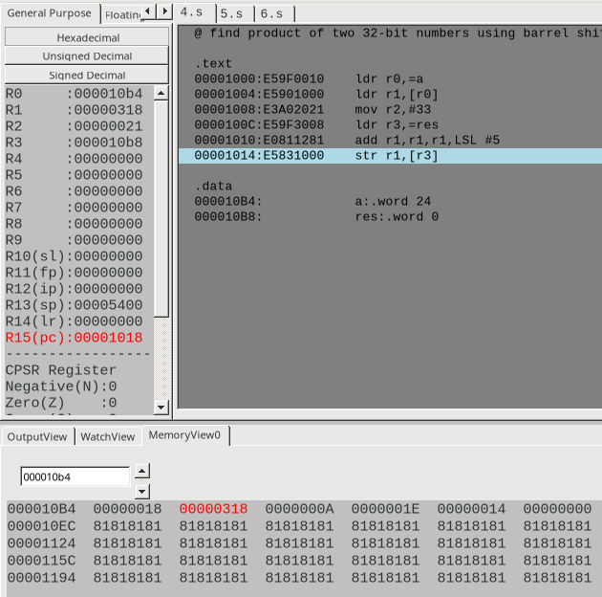

Week#____2_______ Program Number: ____5___

Title of the Program

**Convert the following statement in C language into an ALP using ARM7TDMI – ISA.**

**IF([A]==[B]) then C=[A]+[B];**

**ELSE IF ([B]==[C]) D=[A]-[B];**

**ELSE E=[A]*[B]**

**Where A,B C, D & E are memory locations.**

1. ARM Assembly Code

Code:

@ if([A]==[B]) then [C]=[A]+[B]

@ else if [B]==[C] then [D]=[A]-[B]

@ else [E]=[A]*[B]

.text

ldr r0,=a

ldr r1,=b

ldr r2,=c

ldr r3,[r0]

ldr r4,[r1]

ldr r5,[r2]

cmp r3,r4

beq case1

cmp r4,r5

beq case2

b default

case1:

add r6,r3,r4

str r6,[r2]

b end

case2:

ldr r6,=d

sub r7,r3,r4

str r7,[r6]

b end

default:

ldr r6,=e

mul r7,r3,r4

str r7,[r6]

end:

.data

a:.word 10

b:.word 30

c:.word 20

d:.word 0

e:.word 0

1. Output Screen Shot (One)

case1: when a==b

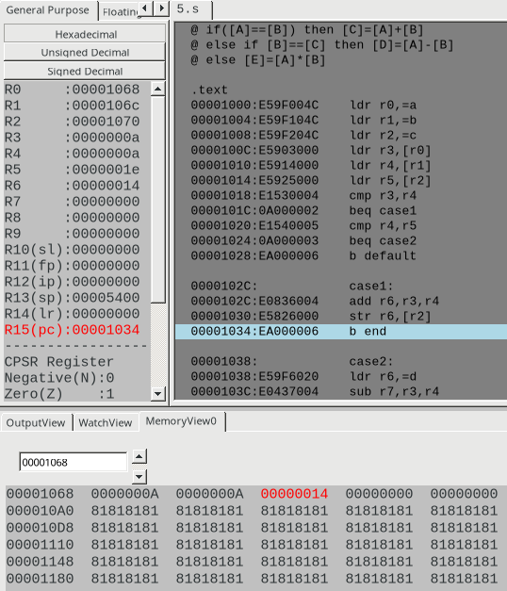

case2: when b==c

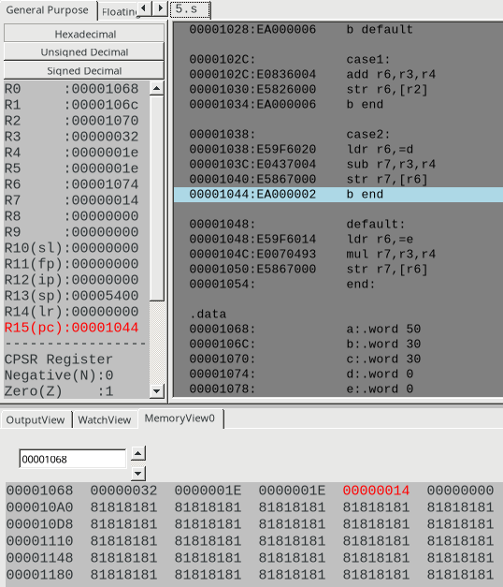

default:

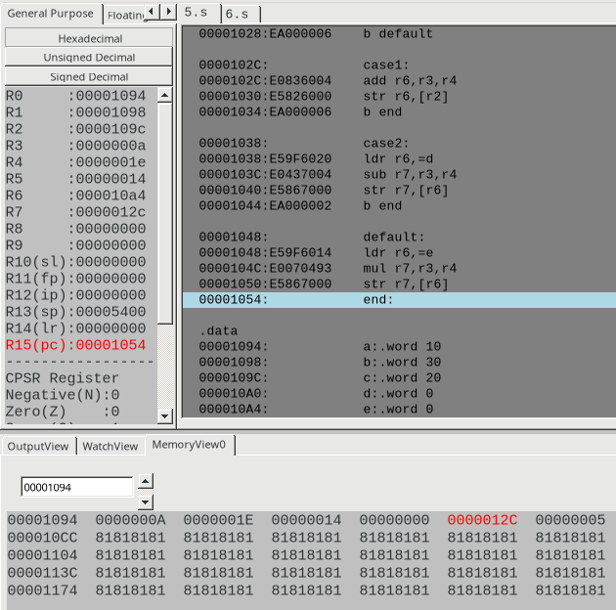

Week#____2_______ Program Number: ____6__

Title of the Program

**Write a program in ARM7TDMI-ISA to find the factorial of a number.**

1. ARM Assembly Code

Code:

@ factorial of n

.text

ldr r0,=n

ldr r1,=fact

ldr r2,[r0]

mov r3,#1

loop:

mov r4,r3

mul r3,r4,r2

subs r2,r2,#1

bne loop

str r3,[r1]

.data

n:.word 5

fact:.word 1

1. Output Screen Shot (One)

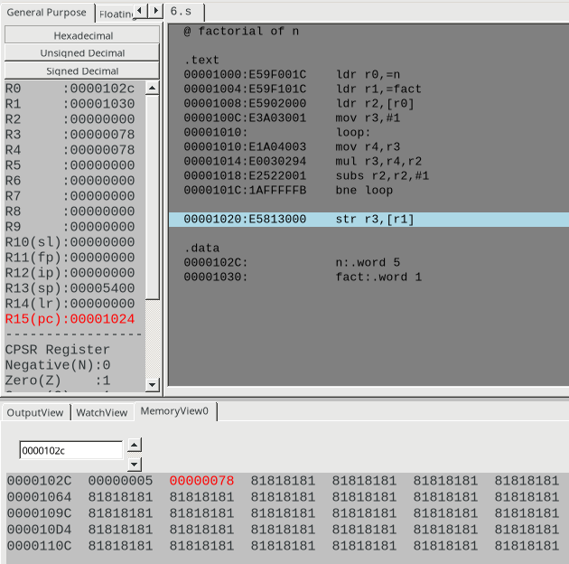

**Disclaimer:**

* The programs and output submitted is duly written, verified and executed by me.
* I have not copied from any of my peers nor from the external resource such as internet.
* If found plagiarized, I will abide with the disciplinary action of the University.

Signature:

Name: Nihal T M

SRN: PES2UG21CS333

Section: F

Date: 25/01/2023