A Geographic Information System for
Line-of-Sight Radio Communications.
Jeffrey B. Otterson
CS485
March 19, 1998
Abstract:
This paper discusses a Geographic Information System for Line-of-Sight Radio Communications. This application was developed in the Java Programming Language. It can import United States Geographical Survey Digital Elevation Model data that is freely available on the Internet. It draws diagrams that indicate elevation of terrain, and whether any point on the map shown has an obscured line-of-sight to a specified transmitter location.
Table of Contents
1. Introduction 1
2. Description of Software 1
2.1 Choice of Java Programming Language 1
2.2 Object-Oriented Architecture of the Software 2
2.2.1 “Significant” classes 3
2.2.2 GUI classes 4
2.3 Manipulation of DEMs 5
2.4 Analysis of LOS radio shadowing 7
2.5 Display of Map Images 8
2.5.1 General 8
2.5.2 Color system used for display 9
3. Operation of Software 9
3.1 Runtime Environment 9
3.2 Starting the software 10
3.3 The Main Window 10
3.4 File Menu Options 11
3.4.1 Open USGS DEM 11
3.4.2 Open DEM 12
3.4.3 Save DEM 12
3.4.4 View DEM 13
3.4.5 Merge 2 DEMs 13
3.4.6 Extract Region 14
3.4.7 View Coverage 15
3.4.8 Print Image 16
3.4.9 Exit 16
3.5 Common Tasks 17
3.5.1 Displaying terrain 17
3.5.2 Displaying radio shadowing 17
3.5.3 Creating custom DEMs 18
4. Summary 18

1. Introduction
Terrain features, as well as the curvature of the earth itself, play an important part in very-high frequency (VHF) and higher frequency radio propagation. Radio operations in this part of the spectrum are based on “line-of-sight” (LOS) propagation, where the transmitting and receiving antennas must have an unobstructed path between them. In particular, terrain can completely obstruct or “shadow” a location from another, rendering it unsuitable for VHF and higher frequency radio operation. Analysis of terrain to determine shadowing can be done manually with a tedious process involving topographical maps, or automatically with a computer and very expensive geographic information system (GIS) software. The goal of this project is to create software that can quickly, easily, and inexpensively provide diagrams of the radio horizon based on a fixed transmitting antenna at a given location and elevation.
The United States Geological Survey provides digitized topographic data for all 50 states on the Internet, available as 1:250000 scale Digital Elevation Models (DEMs) These DEM files contain elevation data, typically in meters, on a 3 arc-second grid, for a 1-degree square. These DEM files are used as the terrain model for the LOS calculations.
The intent of this project is to produce diagrams that indicate LOS shadowing, rather than the considerably more complicated indication of RF field strength at each point on the model. The software could be used as a base for modification to produce these charts.

2. Description of Software

2.1 Choice of Java Programming Language
The software was developed with the Java programming language, using the Java Development Kit version 1.1.5. Java was chosen for several reasons:
1. The most compelling reason is the richness of the API supplied with the Java Development Kit (JDK). The JDK provides classes for image creation from in-memory data (the MemoryImageSource class), compression and decompression of data (the ZipInputStream and ZipOutputStream classes in the java.util.zip package), and an entire set of GUI primitives (the java.awt package).
2. Another compelling reason that Java was chosen is the portability of the language. Implementations of the Java “virtual machine” are available for many different platforms, including AIX, Linux, MacOS, and Win32. A carefully constructed GUI application should be able to run on all of these platforms, using their native windowing system.
3. Java is an object-oriented language, and proper construction of the Java classes that make up the software allow the classes to be re-used for other projects. In fact, two classes used in this application (the MultiLineLabel and GroupLayout classes) are re-used from an earlier application.
4. Java source code is nearly self-documenting. A bit of effort expended in embedding “doc comments” in the source allows the source code to be processed with “javadoc,” which produces HTML documentation for the classes by interpreting the source code and the doc comments. This documentation greatly increases the re-usability of the Java classes.

2.2 Object-Oriented Architecture of the Software
The software is built from 14 different Java classes. For the purposes of this paper, these classes have been divided into three groups: the “significant” classes which implement much of the special behavior of the software, the “GUI” classes which provide GUI tools and controls for the GUI implementation, and a set of “support” classes which provide miscellaneous functions used throughout the application. Each class will be discussed with its group.

2.2.1 “Significant” classes
The DEMmain class is the “glue” that holds the application together. It provides the “main” routine that starts the application, builds and manages the GUI, as well as the overall flow of control throughout the application. This class receives events from the AWT (abstract window toolkit) when the user activates the various GUI controls, and uses a separate thread of execution to process the user’s request.
The DEM class provides all the Digital Elevation Model file functionality required by the application. This class has methods to load USGS format and binary compressed format DEMs, save DEMs, merge adjacent DEMs, and extract DEM data for a selected region from a larger region’s DEM file. In addition, the DEM class has data access and information methods that allow the size, resolution, units, location, and actual elevation data to be retrieved from the DEM.
GeoCoordinate is a class that manipulates geospatial coordinates using methods that convert to and from degrees of latitude and longitude, the arc-second format used by the DEM files, and a text format that is directly usable by people. GeoCoordinate also provides a method to test for equality with another GeoCoordinate, and a text formatter for an arbitrary location.
The Map class is used for displaying elevation models and calculating LOS shadowing on these models. It is extended from (is a subclass of) java.awt.Canvas, which provides a drawing area for the map and allows mouse input to be captured. Map includes methods to create a display colormap, create an elevation image, create a LOS shadowing image, and display the created image. A discussion of the LOS shadowing algorithm follows in the “Analysis of LOS Radio Shadowing” section, below.
The Map class also includes various methods for the calculation of geospatial data. For example, Map calculates the effective drop in elevation at a given distance from the transmitter, the diameter of the earth at a plane on the current latitude, and the circumference of this circle. These functions are used in the calculation of shadowing, and in placing tick marks on the displayed image on a specified grid.

2.2.2 GUI classes
There are several GUI classes in the application that are quite generic and could easily be re-used in future applications. These generic GUI classes will be discussed first.
ErrorBox is a class that provides a pop-up dialog box that displays a message, and has an “Ok” button that is used to dismiss the dialog box. Its purpose is to quickly display an error message to the user. ErrorBox is extended from java.awt.Dialog.
GroupLayout is a class that is extended from Java’s “GridBagLayout” class. It is designed to simplify the use of the GridBagLayout. GroupLayout (and GridBagLayout) is a Java AWT “layout manager” that controls the placement of GUI controls inside a panel. GroupLayout allows automatic placement of these controls on a grid inside a panel without requiring the programmer to calculate pixel offsets based on physical display devices. It increases the degree of portability of the application by reducing device dependency that would be brought on by a fixed x,y pixel calculated layout.
MultiLineLabel is a Java AWT “lightweight control” that allows a Label (text on a GUI panel) to contain more than one line. Lines are separated with a newline character. MultiLineLabel is extended from java.awt.Component.
ProgressIndicator is another Java AWT lightweight control. ProgressIndicator provides a horizontal bar graph that indicates the progress of an operation that may take a significant amount of real time, so the user is reassured that the application is actually doing something. ProgressIndicator is extended from java.awt.Component.
StatusBar is a class that manages a Label and a ProgressIndicator. It is used to place a status area at the bottom of an application’s main window. StatusBar is extended from java.awt.Panel.
The application includes several custom dialog boxes implemented as Java classes that extend the Dialog class.
The AntennaLocationDialog is a class that provides a dialog box for the LOS shadowing calculation data entry. This dialog allows the entry of the antenna location, elevation above sea level (ASL), antenna height above ground level (AGL), the height of the receiving antenna, and 2 parameters that control the resolution of the shadowing calculations: the vector angle increment and vector distance increment. These two parameters will be discussed below in the “Calculation of Radio Shadowing” section.
CoordinateDialog provides a dialog box that allows the program’s user to easily specify a pair or geographic coordinates, that are returned in a GeoCoordinate object. The AntennaLocationDialog and the ExtractDialog use this dialog.
ExtractDialog is used to display and manage a dialog box that allows the user to select a file and two opposite corners of the region to extract from a larger DEM in the named file.
MergeDialog allows the user to specify two input files and one output file for the merge DEMs operation.
Util is a class that provides some useful static methods for miscellaneous operations. This class should never be instantiated; it has no non-static members.

2.3 Manipulation of DEMs
The files available on the USGS ftp site are 1:250000 1-degree digital elevation models (DEMs). These files contain an elevation datum for each point on a 3-arc-second grid, including each edge, for a total of 1,442,401 points. Each point is represented in the file as an ASCII encoded single-precision floating-point number in scientific notation format. Geographic coordinates stored in the DEM are represented as pairs of double-precision floating-point numbers, also in scientific notation format. The number of points, combined with the storage format, result in extremely large file sizes for the 1-degree DEMs, typically approaching 10MB in size. In addition, unless the location of interest (the transmitter site) is located somewhere near the center of the 1-degree maps, the utility of the map for a shadowing analysis is limited.
The software uses its own private data format for the DEM data. The DEM data is stored using pairs of 32-bit integers for geographic coordinates and 16-bit integers for elevation data. Disk files are written in a compressed format, resulting in DEM data files with sizes approximately 1.4 MB for a 1-degree square. The software can read USGS-format DEMs in order to acquire data, but will only save data in its private format.
In order to generate DEMs that contain the appropriate area of interest, the software allows DEMs to be combined and regions to be extracted from DEMs to form new, smaller DEMs. A “merge DEMs” feature has been implemented that can merge any two DEMs that share an adjacent edge of the same length. The merge request is verified to make sure that the DEMs are adjacent and that they are of the same resolution. The files are read, and a new DEM file is created as output of the merge process. (Note that the merge process does not load the resulting DEM, it may be far too large to be loaded into memory.)
Because the merged DEM is too large to be useful, too large to load, or may contain a larger area than the user is interested in, the software provides a means to extract a region from a larger DEM. Extract requires that the user select the source DEM, and two corners of the region to extract. The corners are checked to make sure that they are contained in the source DEM, then the region is extracted and loaded into the software for analysis. The extracted region is not saved until the user explicitly saves it.

2.4 Analysis of LOS radio shadowing
LOS radio shadowing is calculated based on the geospatial data in the DEM object and the parameters entered in the AntennaLocationDialog. The transmitter is considered a point source located at the coordinates and elevation specified in the AntennaLocationDialog. The AntennaLocationDialog also allows the receiving antenna to be set a fixed distance above ground level to allow for the diagrams to reflect shadowing of mobile (low antenna) or fixed (elevated antenna) receiving stations.
Two important parameters for the analysis are specified in the AntennaLocationDialog. These parameters are the “Analysis Angle Increment” and the “Analysis Distance Increment.” The analysis angle increment sets the difference between the angles of subsequent vectors orignating from the transmitter location, and the analysis distance increment set the difference in distance between points along these vectors from the transmitter. The analysis distance increment is in units of the DEM file’s maximum resolution, typically 3 arc-seconds. Together, they set the number of points on the DEM that are analyzed for shadowing. For example, analysis of a transmitter location near the center of a 1.5-degree square DEM, using an analysis angle increment of 0.1 degrees and a distance increment of 1 required about 4 minutes of real time on a 200 MHz Pentium-class workstation. The same analysis with a 1-degree angle increment required about 40 seconds.
The program calculates shadowing by analyzing vectors originating at the transmitter location. The number of vectors is calculated based on the following formula:
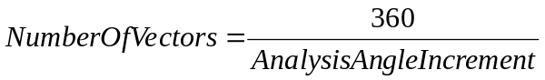
Each vector is analyzed at successive distances from the transmitter location, based on the Analysis Distance Increment. Each point analyzed has it’s antenna height calculated based on the elevation from the DEM, the receive antenna height, and the effective loss in elevation based on the curvature of the Earth at the distance of this point from the transmitter. (The curvature of the Earth used in this calculation is based on a diameter equal to 4/3 of the actual diameter to compensate for atmospheric diffraction of the radio signal.) Every point for a receiving antenna analyzed has an imaginary line created from the transmitting location to that point and the slope is calculated for the imaginary line. The elevation of every point analyzed on the current vector is then compared to the imaginary line by calculating the elevation of the imaginary line at that point. If any prior point on the analysis vector is higher than the point on the calculated line, the receiver location is marked as shadowed, and the analysis continues at the next point on the analysis vector. Since the analysis can take a significant amount of real time, after each vector’s calculations complete, the ProgressIndicator is updated with the percentage of vectors analyzed. After all the vectors are calculated, a circle is drawn on the map image at the transmitter location, and tick marks in the shape of a plus sign are drawn on a grid selected by the “Tick Distance (KM)” setting in the AntennaLocationDialog.

2.5 Display of Map Images

2.5.1 General
The map images are shown with a resolution of one pixel per elevation datum. The pixel color is selected based on the elevation and shadowing from a palette of 48 possible colors. The color palette contains 24 colors for unshadowed elevations, and 24 colors for shadowed elevations. The elevation increment between colors is calculated as follows:

2.5.2 Color system used for display
Early versions of this software used a wide spectrum of colors to display elevation, and used a reduced intensity of color to indicate shadowing. This color scheme sounded good as a concept, but was somewhat difficult to interpret, and looked awful. After some research into graphic display of information, the current scheme was chosen., This color scheme has a simplified multi-variate system: the elevation is indicated by increasing lightness; unshadowed terrain is displayed in shades of green, and shadowed terrain (when calculated) is shown in shades of brown.

3. Operation of Software
The software is implemented with a graphical user interface (GUI), with pull-down menus, dialog boxes, pushbuttons, etc., and should be easily operable by anyone who has experience with GUI software.

3.1 Runtime Environment
The software will run on any platform that has the Java 1.1.x runtime environment installed (either the Java Development Kit or the Java Runtime Environment), has a color display that is usable by the Java Abstract Window Toolkit, and at least 10 MB of free memory. Very large DEMs will require more memory to load. Good results have been obtained on Pentium-class systems running at 100 MHz or more, with 32 MB or more memory.

3.2 Starting the software
The software is delivered packaged in a Java Archive (.jar) file. Startup methods differ, depending on whether the Java Development Kit or the Java Runtime Environment is installed.
In either case, the name of the directory where the dem.jar file is installed must be known. With the JDK, the name of the directory where the Java classes.zip file is installed must also be known. To start the program using the JDK java interpreter, type:
java –classpath <path&filename to classes.zip>;<path&filename to dem.jar> DEMmain
To start the program using the Java Runtime Environment jre interpreter, type:
jre –cp <path&filename to dem.jar> DEMmain

3.3 The Main Window
When the program starts up, the main window will be displayed. The main window is composed of three separate regions: the menu bar on top, the display area in the middle, and the status bar on the bottom. (The menu bar contains the “File” menu, which is described in the next section). The display area is where the elevation or shadowing maps are displayed. If the map image is larger than the size of the display area shown, then horizontal and vertical scrollbars will appear to allow the viewed area of the map image to be changed to any part of the image. The status bar contains a status text message on the left side, which will display messages about what the software is doing, and a progress indicator bar graph on the right. The progress indicator will be updated continuously while the various functions in the software are active, displaying the relative completion percentage of that function. When any map image is displayed, the status bar will display the geographic coordinates of the location pointed at by the mouse pointer. The main window is shown below:
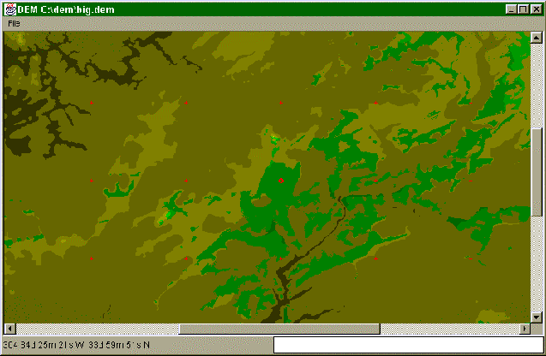

3.4 File Menu Options
The software provides eight different functions, in addition to “exit”, on the “File” menu. These functions are discussed in the following sections.

3.4.1 Open USGS DEM
The “Open USGS DEM” function is used to load a DEM file in USGS format. The USGS files are quite large and take a relatively long amount of time to load. These files are distributed from the USGS ftp site in either “gzip” compressed or uncompressed format. The software cannot read the compressed format directly; these files must be expanded with the “gunzip” program prior to being read by the software.
Selecting “Open USGS DEM” will open a dialog box, which prompts the user to select the file to load. At this time, the user can either select a file and press the “Open” button, or press the “Cancel” button to abandon the load operation. If a valid file is selected, the title bar of the application will change to display “DEM (loading)”, the status bar’s message will change to “loading <filename>”, and the progress indicator will begin showing the percentage of the load that is complete.
If the file cannot be loaded, a small popup box will appear displaying a message describing the error.

3.4.2 Open DEM
The “Open DEM” function loads a DEM in the software’s private format from a disk file. Selecting this function will cause the “Open DEM” file dialog box to appear. The user can select a file and press the “Open” button to load the file, or press the “Cancel” button to abort the operation.
If a valid file is selected, the title bar of the application will change to display “DEM (loading)”, the status bar’s message will change to “loading <filename>”, and the progress indicator will begin showing the percentage of the load that is complete.
An error box with a message describing the error will appear if the file cannot be loaded for any reason.

3.4.3 Save DEM
“Save DEM” will create a data file of DEM data, in the software’s private format. This function is useful for saving DEMs loaded from USGS format (in effect, converting the file into the software’s private format), and for saving DEMs of regions extracted from larger DEMs (creating a DEM for a smaller area of interest).
Selecting “Save DEM” will cause the “Save DEM” file dialog box to appear. The user can either specify a file to save and press the “Save” button, or press the “Cancel” button to abandon the save operation.
If save is selected, then the title bar of the application will change to display “DEM (saving)”, the status bar’s message will change to “saving <filename>”, and the progress indicator will begin showing the percentage of the save that is complete.
If the file cannot be saved, a small popup box will appear displaying a message describing the error.

3.4.4 View DEM
“View DEM” allows the user to display a shaded map image of the DEM, without any shadowing calculations performed or shown. This map is displayed in shades of green; the darker shades indicate lower elevations, and the brighter shades indicate higher elevations.

3.4.5 Merge 2 DEMs
The “Merge 2 DEMs” function allows the user to create DEMs that are larger than the 1-degree square DEMs provided by the USGS. The DEM files must have an adjacent edge of the same length in order to be merged. DEM files that do not meet these parameters cannot be merged.
Selecting “Merge 2 DEMs” will cause the “Merge DEMs” dialog to appear. This dialog allows the user to select two source DEMs using the “Open DEM” dialog, and one output DEM using the “Save DEM” dialog. After the 3 DEM files are selected, the merge can be started by pressing the “OK” button, or the “Cancel” button can be pressed to abandon the operation.
If the merge is started, then the title bar of the application will change to display “DEM (merging)”, the status bar’s message will change to “Merging DEMs”, and the progress indicator will begin showing the percentage of the merge that is complete. Since the new merged DEM is potentially very large, the new DEM is not loaded. If the user wants to use the new DEM, it must be loaded with the “Open DEM” selection. (Note that the software can only merge DEM files that are already in its private data format, USGS DEMs cannot be merged.)

3.4.6 Extract Region
“Extract Region” is used to create a smaller DEM from a larger DEM. It is particularly useful to extract an area of interest from a large DEM created by one or more merge operations. The extracted region’s DEM data is loaded into the software for immediate analysis. The extracted data is not automatically saved; to save it the user must perform a “Save DEM” operation.
Selecting “Extract Region” will cause the “Extract Smaller DEM” dialog to appear. This dialog allows the user to select the DEM file name to extract from, as well as the South-West and North-East corners for the region to be extracted. Pressing the “Cancel” button at any time allows the user to abandon the operation.
When the extraction parameters are all specified, and the OK button is pressed, the software will begin the extraction process. The program’s title bar will change to display “DEM (extracting)”, the status bar’s message will change to “Loading <filename>”, and the progress indicator will begin showing the percentage of the extract that is complete.
If the region is not in the specified file, or the file cannot be read for any reason, a small popup box will appear displaying a message describing the error.

3.4.7 View Coverage
“View Coverage” is used to compute and view map images representing elevation and shadowing status of a DEM file. This dialog is the where the parameters for the LOS shadowing analysis are entered, and the analysis is started. Selecting “View Coverage” will cause the “Enter Antenna Location” dialog to appear. The “Enter Antenna Location” dialog is shown below:
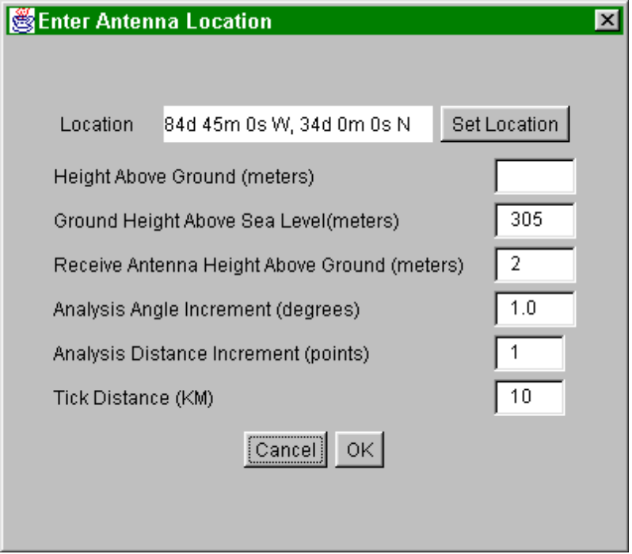
The “Enter Antenna Location” dialog requires that several parameters for the analysis be entered.
The Antenna Location is the location where the transmitter antenna is placed. Press the “Set Location” button to change the geographic coordinates for the antenna location.
The Height Above Ground is the height of the antenna above ground at the current location. This elevation must be specified in meters.
The Ground Height Above Sea Level is the elevation of the ground at the antenna location. The system will get the elevation of the antenna location from the DEM whenever the antenna location is changed, but this value can be overridden by replacing the value in this field. This can be used to enter a measured or engineered height that is more accurate than the data in the DEM. This elevation must be specified in meters.
Receive Antenna Height is the height of the antenna at the receiving station. A fixed receiving station may have a tower-mounted antenna, or a mobile station may have a roof or bumper mounted antenna; this field allows the shadowing analysis to include this. This elevation must be specified in meters.
The Analysis Angle Increment (degrees) and the Analysis Distance Increment (points) parameters are used together to select the resolution of the shadowing analysis. Large values for these parameters will cause the analysis to compute faster, at the expense of the resolution of the image because fewer calculations are required to create the image.. Small values (0.1 degrees and 1 point) for these values will cause the analysis to compute maximum resolution for the image, at the expense of longer compute time.
Tick Distance (KM) is the distance to mark “ticks” (actually + signs) on the displayed map image at the specified interval. These ticks are useful for correlating the map image with other maps.

3.4.8 Print Image
“Print Image” will cause the map image displayed to be printed on the selected printer. This may take a considerable amount of real time, and, on some printers, the printed copy may not be very readable because of printer resolution and graphics dithering issues..

3.4.9 Exit
The “Exit” function allows the user to terminate the program.

3.5 Common Tasks
This section of this document will describe how to perform some common tasks with the software.

3.5.1 Displaying terrain
The program can display a shaded map of terrain without doing any shadowing analysis. This is useful to select locations for possible transmitter sites, or simply to find where a good place to view the surrounding countryside. To view the terrain map, first load the desired DEM file, using either the File→Open USGS DEM or File→Open DEM options. Then select the File→View DEM option. The DEM file will be displayed in shades of green, with the darkest shades representing lower elevations, and the lighter shades representing higher elevations.

3.5.2 Displaying radio shadowing
The display of radio shadowing is the goal and purpose of the software. To produce a shadowing analysis, first load the desired DEM file, as described in Section . Next, enter all the fields in the Enter Antenna Location dialog. (If you like, you can click on the map at the antenna’s location to set the coordinates in the Enter Antenna Location dialog. The left button will simply preload the value in the dialog box, the right mouse button will load the coordinates and pop the dialog up.) After all the parameters in the Antenna Location dialog are filled in, press the OK button. The shadowing analysis will start, and the progress indicator will periodically update to show the progress of the operation. When the analysis is complete, the shadowing analysis image will be displayed. This image shows shadowed areas in shades of brown, and non-shadowed areas in shades of green. Increasing elevation is indicated by increasing brightness of the colors.

3.5.3 Creating custom DEMs
The USGS DEM files cover 1-degree square blocks of terrain, originating and ending on whole degree lines. In many cases, the regions in these squares are not suitable for the shadowing analysis; the transmitter location is located too close to an edge, or the desired survey region includes more area than one 1-degree DEM contains. For these reasons, the software can merge and extract regions from DEM files to create “custom” regions for analysis. For example, in the case of the transmitter location that is too close to the edge of the DEM, two DEMs could be merged, and then the region of interest extracted from the merged result. Similarly, two files created by merging two DEMs each could be merged to create a 4-degree square DEM, from which a larger region, or a region centered on a point near the intersection of the four DEMs could be extracted to form a new DEM for subsequent analysis.

4. Summary
The software uses USGS DEM files to analyze shadowing or coverage for a given transmitter location. It has already proven useful to determine why some amateur radio UHF radio systems have poor coverage.
The use of the Java programming language proved instrumental in reducing development time and promoting reusability for this project. Approximately 80 hours of time was spent designing, developing, and testing the software. The software is easily extensible. It is relatively easy to add features and functionality to the software with no impact to the existing functionality.

“USGS: Geo Data”. January 16, 1998. <http://edcwww.cr.usgs.gov/doc/edchome/ndcdb/ndcdb.html> (21 January 1998)
United States Department of the Interior, U.S. Geological Survey, Digital Elevation Models Data Users Guide 5, Reston VA 1993, <ftp://mapping.usgs.gov/pub/ti/DEM/demguide/dugdem.txt> (December 30, 1997).
“1-Degree USGS Digital Elevation Models”, February 15, 1996, <http://edcwww.cr.usgs.gov/glis/hyper/guide/1_dgr_dem> (December 30,1997)
Geoff Grayer, G3NAQ, “VHF/UHF Propagation,” The VHF/UHF DX BOOK, ed. Ian White, G3SEK, (Bath, Avon, UK: Bath Press,) pp. 2.2-2.12.
Edward R. Tufte, Envisioning Information, (Cheshire, CT.: Graphics Press, 1990), pp.88-95.
Edward R. Tufte, Visual Explanations, (Cheshire, CT.: Graphics Press, 1997), pp. 75-77.

