**Develop a dynamic PHP application to efficiently manage and store customer information, encompassing key fields like Customer Number, Customer Name, Item Purchased, and Mobile Number in Database. This application should provide a userfriendly interface with strategically placed buttons to trigger specific functionalities. These functionalities include:**

**1. Add Customer Information: Clicking this button should dynamically reveal a form for entering new customer details. Include proper validation checks for mobile numbers (10 digits), and also for Customer id ensuring accuracy in data input.**

**2. Delete Customer Records: Triggering this button should prompt the appearance of a form, specifically requesting the Customer ID to identify and delete the corresponding customer record. And provide appropriate messages for incorrect inputs.**

**3. Search for Particular Entries: This function should unveil a search form when activated, allowing users to input Customer id to find specific customer records.**

**4. Sort Database Based on Customer Id: Clicking this button should facilitate the sorting of the entire database based on customer id.**

**5. Display Complete Set of Records: Activating this function should present a comprehensive display of all customer records.**

**6. Interface Design: Initially, the interface should only showcase functional buttons. Upon clicking a button, the respective form should dynamically appear, offering a tailored and focused user experience.**

**7. Give proper messages after every transaction.**

**\*\*\*\*\*\*\*\*\*\*\*\*\*\*\*\*\*\*\*\*\*\*\*\*\*\*\*\*\*\*\*\*\*\*\*\*\*\*\*\*\*\*\*\*\*\*\*\*\*\*\*\*\*\*\*\*\*\*\*\*\*\*\*\*\*\*\*\*\*\*\*\*\*\*\*\*\*\*\*\***

CREATE DATABASE partb6;

USE customerdetails;

CREATE DATABASE partb6(customer_id INT PRIMARY KEY,

customer_name VARCHAR(30),

item_purchased VARCHAR(50),

mobile_number VARCHAR(11) );

<?php

$servername = "localhost";

$username = "root";

$password = "";

$dbname = "partb6";

$conn = new mysqli($servername, $username, $password, $dbname);

if ($conn->connect_error)

{

die("Connection failed: " . $conn->connect_error);

}

function addCustomer($name, $item, $mobile)

{

global $conn;

$sql = "INSERT INTO customers (customer_name, item_purchased, mobile_number) VALUES ('$name', '$item', '$mobile')";

if ($conn->query($sql) === TRUE)

echo "Customer information added successfully.";

else

echo "Error: " . $sql . "<br>" . $conn->error;

}

function deleteCustomer($id)

{

global $conn;

//$id = mysqli_real_escape_string($conn, $id);

$sql = "DELETE FROM customers WHERE customer_id = $id";

if ($conn->query($sql))

{

if($conn->affected_rows>0)

echo "Customer record deleted successfully!";

else

echo "Error deleting record: " . $conn->error;

}

}

function searchCustomer($id)

{

global $conn;

$sql = "SELECT * FROM customers WHERE customer_id = $id";

$result = $conn->query($sql);

if ($result->num_rows > 0)

{

while ($row = $result->fetch_assoc())

{

echo "Customer ID: " . $row["customer_id"] . "<br>";

echo "Customer Name: " . $row["customer_name"] . "<br>";

echo "Item Purchased: " . $row["item_purchased"] . "<br>";

echo "Mobile Number: " . $row["mobile_number"] . "<br>";

}

}

else

{

echo "No matching records found.";

}

}

function sortById()

{

global $conn;

$sql = "SELECT * FROM customers ORDER BY customer_id";

$result = $conn->query($sql);

if ($result->num_rows > 0)

{

while ($row = $result->fetch_assoc())

{

echo "Customer ID: " . $row["customer_id"] . ", ";

echo "Customer Name: " . $row["customer_name"] . ", ";

echo "Item Purchased: " . $row["item_purchased"] . ", ";

echo "Mobile Number: " . $row["mobile_number"] . "<br>";

}

}

else

{

echo "No records found.";

}

}

function displayRecords()

{

global $conn;

$sql = "SELECT * FROM customers";

$result = $conn->query($sql);

if ($result->num_rows > 0)

{

while ($row = $result->fetch_assoc())

{

echo "Customer ID: " . $row["customer_id"] . ", ";

echo "Customer Name: " . $row["customer_name"] . ", ";

echo "Item Purchased: " . $row["item_purchased"] . ", ";

echo "Mobile Number: " . $row["mobile_number"] . "<br>";

}

}

else

{

echo "No records found.";

}

}

if ($_SERVER["REQUEST_METHOD"] == "POST")

{

if (isset($_POST["add_customer"]))

addCustomer($_POST["customer_name"], $_POST["item_purchased"], $_POST["mobile_number"]);

elseif (isset($_POST["delete_record"]))

deleteCustomer($_POST["customer_id"]);

elseif (isset($_POST["search_entry"]))

searchCustomer($_POST["customer_id"]);

}

?>

<html>

<head>

<title>Customer Information Management</title>

</head>

<body>

<button onclick="document.getElementById('add_form').style.display='block'">Add Customer Information</button>

<div id="add_form" style="display:none;">

<form method="post">

Customer Name: <input type="text" name="customer_name" required><br>

Item Purchased: <input type="text" name="item_purchased" required><br>

Mobile Number: <input type="text" name="mobile_number" pattern="[0-9]{10}" title="Enter a 10-digit mobile number" required><br>

<input type="submit" name="add_customer" value="Add Customer">

</form>

</div>

<!-- Delete Customer Records Form -->

<button onclick="document.getElementById('delete_form').style.display='block'">Delete Customer Records</button>

<div id="delete_form" style="display:none;">

<form method="post">

Customer ID: <input type="text" name="customer_id" required><br>

<input type="submit" name="delete_record" value="Delete Record">

</form>

</div>

<!-- Search for Particular Entries Form -->

<button onclick="document.getElementById('search_form').style.display='block'">Search for Particular Entries</button>

<div id="search_form" style="display:none;">

<form method="post">

Customer ID: <input type="text" name="customer_id" required><br>

<input type="submit" name="search_entry" value="Search">

</form>

</div>

<!-- Sort Database Based on Customer Id -->

<button onclick="document.getElementById('sort_btn').style.display='block'">Sort Database Based on Customer Id</button>

<div id="sort_btn" style="display:none;">

<?php sortById(); ?>

</div>

<!-- Display Complete Set of Records -->

<button onclick="document.getElementById('display_records').style.display='block'">Display Complete Set of Records</button>

<div id="display_records" style="display:none;">

<?php displayRecords(); ?>

</div>

</body>

</html>

<?php

$conn->close();

?>

**OUTPUT:**



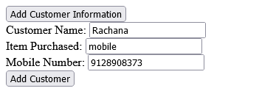



//Add customer information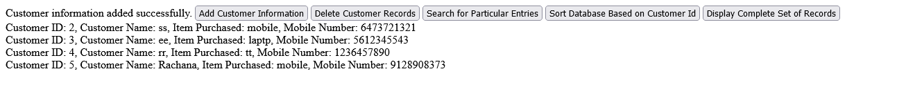//Display Complete Set of Records

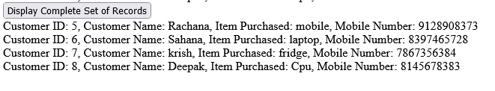

//Delete Customer Records

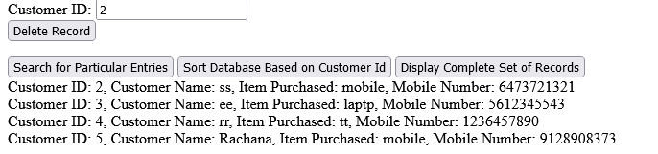

//Search for Particular Entries

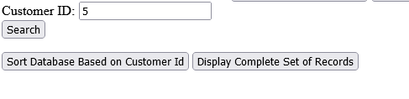

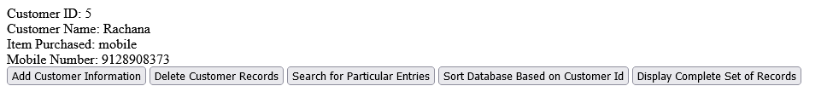

//Sort Database Based on Customer Id

