Network Filtering & Circumvention Detection System
NETS1037 - Project 2 | Transparent proxy filtering with logged bypass-attempt testing

1. Overview
- Transparent filtering + logging gateway (OPNsense) sitting between the client VM and the internet
- Logs client web traffic; blocks selected domains over both HTTP and HTTPS
- Layered controls against client-side circumvention: DNS server changes, DoH/DoT, Tor Browser, free VPNs
- Every control below was built AND actually tested on the client VM - not just configured (see Section 4)

2. Software Bill of Materials & Licenses
- All components: free/open-source, or (community IP/domain feeds) freely redistributable public data
- No commercial or trial software used anywhere in this build
Component | Role in this system | License
OPNsense | Core firewall / router OS (FreeBSD-based); hosts pf, Unbound, Squid, NAT | BSD 2-Clause
pf (packet filter) | Firewall engine - NAT redirects, port/IP/alias block rules | BSD License (FreeBSD base)
Squid Web Proxy | Transparent HTTP/HTTPS proxy; domain blacklist; access logging | GNU GPL v2
Unbound DNS (NLnet Labs) | Recursive resolver; all client DNS forced here via NAT | BSD 3-Clause
Firefox | Client browser used for testing (incl. built-in VPN, DoH) | Mozilla Public License 2.0
Tor Browser | Used to test Tor circumvention (not a defensive component) | BSD-style (Tor Project)
Tor Project bulk exit list | Data feed - official Tor exit-node IPs (check.torproject.org) | Public data (Tor Project)
maycon/tor-nodes-list | Data feed - Tor guard/entry-node IPs, hourly refresh | Public domain (Tor relay data)
X4BNet/lists_vpn | Data feed - aggregated known VPN-provider IP ranges | GNU GPL v3
tn3w/ProtonVPN-IPs | Data feed - ProtonVPN entry/exit IPs, scraped daily from Proton's API | No license file published (public data mirror)
Oracle VM VirtualBox | Hypervisor for the lab (OPNsense + client VMs) | GNU GPL v2
Ubuntu Desktop (client VM) | Client operating system used for all bypass testing | Various open-source (GPL and others)
- Note: the two community IP-list repos (Tor nodes, VPN IPs) are data mirrors, not licensed software - flagged as a dependency in Section 5

3. System Architecture
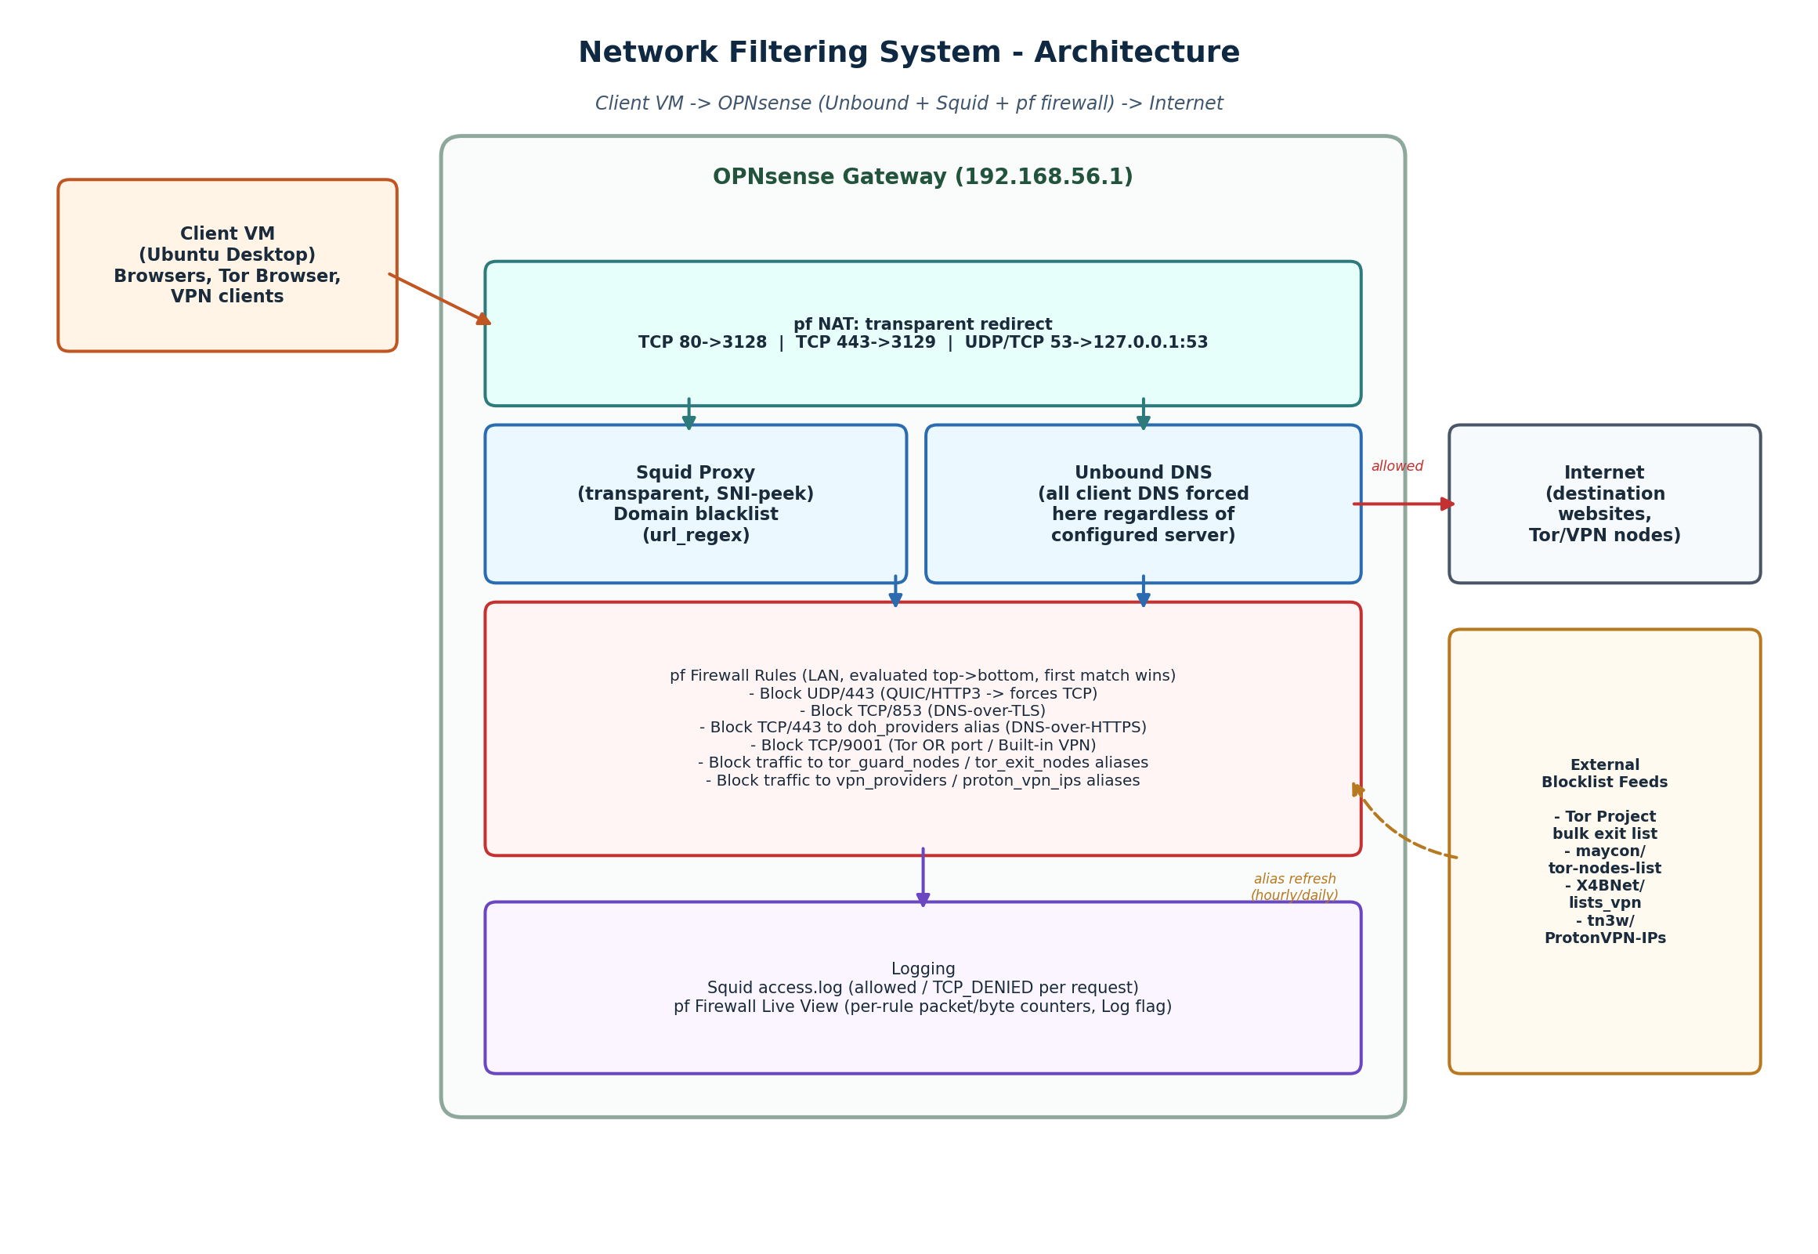

3.1 How traffic is intercepted and processed
- Client → NAT redirect: every LAN client's outbound TCP 80/443 and TCP+UDP 53 is silently redirected by pf destination-NAT rules to Squid (127.0.0.1:3128/3129) and Unbound (127.0.0.1:53) respectively - no proxy or DNS settings are configured on the client itself.
- Squid inspects the HTTPS ClientHello (SNI) without decrypting the connection (“peek” mode via a locally-issued CA), so it can see and log the destination hostname and check it against a domain blacklist without installing anything on the client.
- Unbound answers every DNS query redirected to it, regardless of what DNS server the client believes it is using - this is what makes the “change your DNS settings” bypass attempt fail.
- pf firewall rules run after Squid/Unbound, in a fixed top-to-bottom order (first match wins), blocking: QUIC/HTTP3 (forces browsers back onto inspectable TCP), DNS-over-TLS (port 853), DNS-over-HTTPS (known provider IPs on port 443), the Tor OR port (9001), and known Tor/VPN relay IP ranges pulled from external alias feeds.
- Both Squid and pf write logs: Squid's access.log records every HTTP(S) request with an allow/deny verdict; pf's Live View records every packet a block rule matches, once logging is enabled on that rule.

4. Bypass-Attempt Test Results
- Each row = an attempt actually carried out against the running system on the client VM, not a theoretical assessment
Bypass attempt | Result | Mechanism
Load a blocked domain (HTTP) | Blocked | Squid domain blacklist (url_regex)
Load a blocked domain (HTTPS) | Blocked | Squid SNI-peek + domain blacklist + NAT redirect on 443
Change client DNS server to 8.8.8.8 | Blocked domain stayed blocked | NAT-redirected DNS forces Unbound regardless of configured resolver; Squid still blocks by SNI
DNS-over-TLS (port 853) | Connection blocked | pf rule: block TCP/853
DNS-over-HTTPS (known providers) | Blocked for listed providers | pf rule: block TCP/443 to doh_providers alias (IP-list based - incomplete by nature)
QUIC / HTTP/3 | Blocked, browser falls back to TCP | pf rule: block UDP/443
Tor Browser | Blocked | tor_guard_nodes + tor_exit_nodes alias blocks, plus a port 9001 block once the specific relay port was identified via packet capture
Firefox’s built-in VPN (Firefox 149+ browser-native proxy) | Not blocked | Undisclosed proxy backend; adapts away from the blocked port 9001; see Shortcomings

5. Shortcomings & Limitations

5.1 Maintenance burden / is this permanent?
- No. Every IP-based alias (Tor exit, Tor guard, VPN providers, Proton entry IPs) depends on a third-party feed that must keep being refreshed. Tor relays and VPN server pools rotate constantly - during testing, a fresh Tor guard relay and a fresh Proton VPN server both slipped through until the underlying list next refreshed.
- The domain blacklist requires manual maintenance to add new sites; it does not learn or categorize automatically.
- Squid's url_regex blacklist syntax has a specific gap: a rule written with a leading dot (e.g. “.facebook.com”) matches subdomains but not the bare apex domain. Both a dotted and non-dotted entry are required per domain to close this - an easy mistake to make and a real maintenance trap.

5.2 Dependencies to keep this working
- Relies on three external, unauthenticated data feeds (Tor Project, a community GitHub mirror for Tor nodes, and a community GitHub mirror for VPN IPs) that could go offline, change format, or stop being maintained without notice.
- SNI-based HTTPS filtering depends on the client not using Encrypted Client Hello (ECH); as ECH adoption grows, SNI will no longer be visible to Squid at all.
- The internal CA used for SNI peeking must remain valid and correctly referenced in Squid's configuration; an earlier deployment mistake (referencing an end-entity certificate instead of a true CA) caused Squid to crash outright, which is easy to reintroduce.

5.3 Other ways a client could still bypass this system
- Firefox's newest built-in VPN feature (a browser-native, port-adaptive proxy with an undisclosed backend) was not reliably blocked. It appears to fall back away from the blocked Tor-style port toward ordinary port 443 traffic that is indistinguishable from normal HTTPS without deep packet inspection - a capability this OPNsense build does not have (the Suricata IDS/IPS plugin was unavailable in this repository).
- Browser disk caching can make a domain appear reachable immediately after a block is applied, if the client already has content from that domain cached from before the block - the network layer cannot retroactively invalidate local browser storage.
- Encrypted DNS providers not present in the doh_providers IP alias are not blocked; this list is inherently incomplete.
- Tor pluggable transports / bridges (e.g. obfs4) are specifically designed to have unlisted IPs and to disguise their traffic as ordinary HTTPS, and would not be caught by either the IP-alias or the port-9001 rule used here.
- A sufficiently informed user could still install a VPN client whose provider is not yet present in the aggregated IP list, or use a private/self-hosted VPN with no published server range at all.

5.4 Summary judgement
- Blocks + logs the large majority of common circumvention paths tested: DNS changes, DoT, QUIC, most DoH providers, Tor Browser
- Where a method isn't fully blocked (Firefox's built-in VPN), the system still produces clear log evidence of the attempt - the outcome the assignment asks for when filtering is overcome
- No IP- or domain-list-based filtering system can be fully airtight against adaptive circumvention tools without deep packet inspection, which was outside the scope of what this OPNsense build could provide

