AI-driven autonomous job scheduler for Azure Data Platform (PoC)
Objective: build an AI-powered autonomous scheduler for Azure Data Factory and Azure Databricks that optimizes resource allocation, predicts failures, minimizes cost, and continuously learns.

1. Architecture overview
Text summary: ADF trigger → Event Grid → AI scheduler → Decision engine → Databricks → Metrics → Feedback loop (back into AI scheduler).
Azure services used: ADF, Azure Databricks, Event Grid, Azure Monitor, Log Analytics, ADLS Gen2, Azure SQL, Azure ML, Azure Functions/Container Apps, Service Bus, Key Vault, Entra ID, Power BI.

2. Runtime data flow diagram
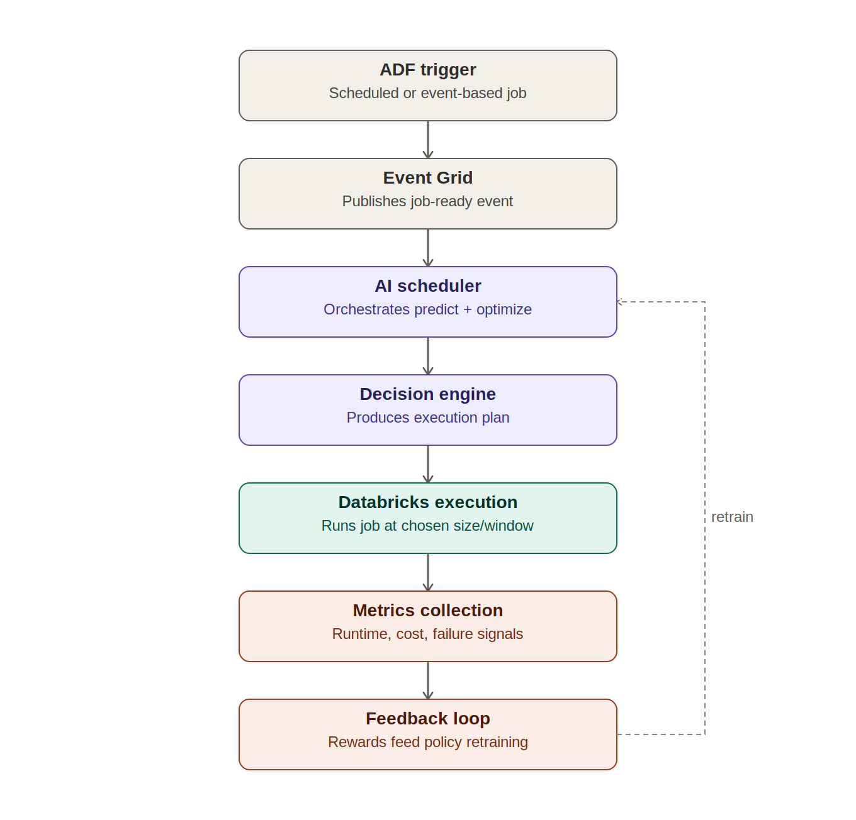
A scheduled or event-based job enters through ADF and is announced on Event Grid. The AI scheduler orchestrates prediction and optimization, the decision engine turns that into a concrete execution plan, and Databricks runs the job. Metrics from that run feed back as a reward signal that retrains the AI scheduler's models — the dashed loop on the right.

3. PoC phase pipeline diagram
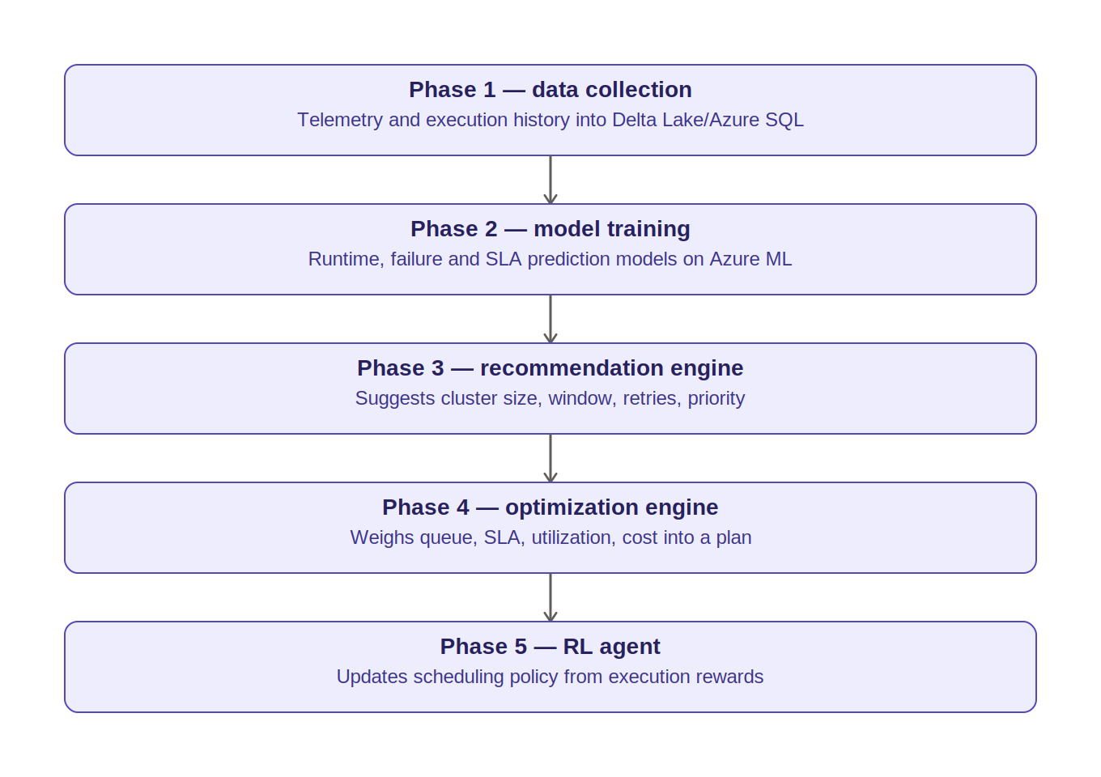

4. Phase briefings

Phase 1 — Data collection
Pulls historical run data from ADF, Databricks, Azure Monitor, and Cost Management into a Delta Lake / Azure SQL store. This is the training set every later phase depends on.

Phase 2 — Model training
Uses Azure ML to train three predictive models — expected runtime, failure probability, and SLA-breach risk — from Phase 1's history.

Phase 3 — Recommendation engine
Turns those predictions into concrete suggestions: cluster size, best execution window, retry count, job priority.

Phase 4 — Optimization engine
Takes all pending jobs at once and balances queue depth, dependencies, SLAs, cluster utilization, and cost to produce a single execution plan (the Decision engine in the runtime diagram).

Phase 5 — RL agent
Closes the loop — actual outcomes (on-time vs late, actual cost, failures) become rewards that continuously tune the scheduling policy, so the system improves without manual retraining.

5. Decision flow
Trigger → Predict runtime → Predict failure → Check SLA → Optimize → Execute/Delay → Collect metrics → Retrain.

6. Suggested schedule (12-week PoC)
A PoC of this scope needs enough historical data to train usable models before phases 2–5 can start, so Phase 1 runs partly in parallel with early Phase 2 groundwork rather than as a strict waterfall.
Week | Phase | Key activities | Exit criteria
1–2 | Phase 1 — Data collection | Stand up ADLS Gen2 + Azure SQL, connect ADF/Databricks/Monitor/Cost Management telemetry, backfill 30–90 days of history if available | Delta Lake tables populated; schema validated; at least one full week of live telemetry flowing
3–4 | Phase 1 (cont.) + Phase 2 kickoff | Continue telemetry accumulation; feature engineering (job type, data volume, time-of-day, cluster config, historical duration/cost); baseline EDA | Feature store ready; 500+ historical job runs available
5–6 | Phase 2 — Model training | Train/validate runtime, failure and SLA-breach prediction models in Azure ML; register models | Models meet baseline accuracy thresholds agreed with stakeholders
7 | Phase 3 — Recommendation engine | Build service consuming model outputs to emit cluster size, window, retry, priority suggestions | Recommendations validated against held-out past jobs
8–9 | Phase 4 — Optimization engine | Implement plan generator considering queue, dependencies, SLAs, utilization, cost; wire into Decision Engine | Engine produces a full plan for a simulated multi-job queue within acceptable latency
10 | Integration | Connect AI Scheduler, Decision Engine, Event Grid path, Databricks execution end-to-end; add Service Bus + Key Vault | End-to-end trigger → plan → execute → metrics loop runs without manual intervention
11 | Phase 5 — RL agent | Define reward function; implement policy update loop; run in shadow mode alongside static rules | Shadow recommendations logged and compared to baseline; no live control yet
12 | Evaluation & reporting | Run AI-scheduled vs baseline comparison; build Power BI dashboard; document findings | Cost/SLA/utilization deltas quantified; PoC report delivered

Notes on timing:
- Weeks are elapsed, not effort — actual person-days depend on team size (2–3 people is typical for a PoC of this scope).
- If historical telemetry already exists before the PoC starts, Weeks 1–4 can compress significantly.
- The RL agent (Phase 5) runs in shadow mode for the PoC — direct production control is a post-PoC decision.

7. Glossary of terms

Azure services
Term | What it is in this project
ADF (Azure Data Factory) | Orchestration service that defines and triggers the data pipeline jobs being scheduled.
Azure Databricks | Spark-based compute platform where the actual data jobs execute; cluster size and timing are what the AI layer optimizes.
Event Grid | Pub/sub eventing service that routes the ‘job ready to run’ signal from ADF to the AI Scheduler without tight coupling.
Azure Monitor | Collects operational telemetry (execution logs, resource metrics, alerts) used as model input.
Log Analytics | Query layer over Azure Monitor data; used to extract structured telemetry for the Delta Lake/SQL store.
ADLS Gen2 | Storage layer backing Delta Lake, holding raw and curated execution history.
Azure SQL | Relational store used alongside/instead of Delta Lake for structured execution metadata, useful for fast lookups.
Azure ML | Machine learning platform used to train, version, and serve the prediction models.
Azure Functions / Container Apps | Lightweight compute hosting options for the AI Scheduler and Decision Engine services.
Service Bus | Reliable messaging layer for passing execution plans and status between components.
Key Vault | Secrets and credential store referenced by all services instead of hardcoding secrets.
Entra ID | Identity provider handling authentication/authorization between services.
Power BI | Dashboarding layer for visualizing scheduling outcomes, cost savings, and SLA performance.

Architecture / flow terms
Term | Meaning
Delta Lake | Open table format (ACID transactions on ADLS Gen2) storing execution history reliably and supporting time-travel queries for retraining.
AI Scheduler | The orchestrating service that receives trigger events and coordinates prediction, optimization, and execution.
Decision Engine | Component that turns recommendations and system state (queue, SLAs, cost) into a concrete execution plan.
Feedback loop | Mechanism by which actual job outcomes are captured and fed back to retrain models and RL policy.
Execution plan | The Decision Engine's output: which jobs run, on what cluster size, in what window, at what priority.

ML / RL terms
Term | Meaning
Runtime prediction model | Regression model estimating how long a job will take given its features.
Failure prediction model | Classification model estimating probability a job run fails.
SLA prediction model | Model estimating probability a job will breach its deadline under current conditions.
SLA | The target deadline or quality bar a job must meet.
Recommendation engine | Suggests concrete scheduling parameters (cluster size, window, retries, priority) from model outputs.
Optimization engine | Reconciles recommendations across all pending jobs, resolving trade-offs (cost vs SLA vs utilization).
Reinforcement learning (RL) agent | A model that learns a scheduling policy by trial and reward rather than supervised labels.
Reward | Scalar feedback signal (e.g. weighted SLA adherence, cost, accuracy) used to judge a scheduling decision.
Policy | The current strategy the RL agent uses to decide scheduling actions; updated as rewards come in.
Shadow mode | Running a model's recommendations alongside the live system for comparison, without controlling production.

Decision flow terms
Term | Meaning
Trigger | The initiating signal — typically a scheduled or event-based ADF pipeline start request.
Predict runtime / Predict failure | The two inference calls made against the trained models before a job is scheduled.
Check SLA | Step where the Decision Engine verifies whether the plan keeps the job within its deadline.
Optimize | Step where the Optimization Engine balances this job's needs against the full queue.
Execute/Delay | Outcome of optimization for a given job — run now, or push to a later window.
Collect metrics | Post-execution step capturing actual runtime, cost, and success/failure for feedback.
Retrain | Periodic refresh of the prediction models and RL policy using newly collected metrics.

