
VIETNAM-KOREA UNIVERSITY OF INFORMATION AND COMMUNICATION TECHNOLOGY
COMPUTER SIENCE DEPARTMENT


DATA WAREHOUSE
VIETNAM GREENHOUSE GAS EMISSION MONITORING DATA WAREHOUSE TOWARDS NET-ZERO

Students:
Class: 22AD
Instructor: MD. MAI LAM

Da Nang, November 2026
VIETNAM-KOREA UNIVERSITY OF INFORMATION AND COMMUNICATION TECHNOLOGY
COMPUTER SIENCE DEPARTMENT

DATA WAREHOUSE
VIETNAM GREENHOUSE GAS EMISSION MONITORING DATA WAREHOUSE TOWARDS NET-ZERO

Students: Nguyễn Quang Tuấn - 22AD053
Instructor: MD. MAI LAM

Da Nang, November 2026

ADVISOR'S FEEDBACK
…………………………………………………………………………………………………………………………………………………………………………………………………………………………………………………………………………………………………………………………………………………………………………………………………………………………………………………………………………………………………………………………………………………………………………………………………………………………………………………………………………………...

Da Nang, …. /…./ 2024
Instructor

ACKNOWLEDGMENTS
First of all, I would like to express my sincere thanks to the lecturers who have devoted their time and enthusiasm to support us during the research and implementation of the project. With their guidance and instruction, we have had the opportunity to approach new architectures, develop skills and gain experience in this field.
I would also like to thank my friends and family who have accompanied us throughout the project. The enthusiasm, support and knowledge sharing from friends and family is truly a great resource.
Finally, I would like to thank everyone who has helped us during the implementation of this task. Whether it is just advice, comments or technical support, documentation, it all means a lot to them. We are very grateful for everyone's care and help.
Once again, I would like to express my sincere gratitude to everyone who has contributed and supported us during the implementation of this basic diagram. I hope that this wonderful exercise will bring value and positive contributions to the community and society.
Wish you good health, good work and continue to teach and train the young generation successfully.
Sincerely thank you!
Students
Nguyễn Tuấn Khánh

INTRODUCTION
Dear Teachers,
In the context of accelerating industrialization and the global fight against climate change, greenhouse gas (GHG) emission management and environmental analytics have become vital to ensuring sustainable growth and guiding national policy. Following Vietnam's landmark commitment at COP26 to achieve Net-Zero carbon emissions by 2050, establishing a unified, data-driven monitoring platform is paramount for government agencies, policymakers, and environmental organizations tasked with tracking decarbonization pathways.
The "Building a Greenhouse Gas Emission Monitoring Data Warehouse Towards Net-Zero in Vietnam" project aims to engineer an enterprise-grade data warehouse and Business Intelligence (BI) platform for consolidating, modeling, and analyzing multi-dimensional environmental and socio-economic data. Designed following Ralph Kimball’s dimensional modeling methodology, the data architecture incorporates core fact tables—Fact_National_Emissions, Fact_Provincial_Economy, and high-frequency Fact_Hourly_Air_Monitoring (1.66 million records optimized with Clustered Columnstore Indexing)—seamlessly linked to standardized dimension tables.
Specifically, the system focuses on tracking historical greenhouse gas emissions across 9 IPCC economic sectors, evaluating provincial green economic indicators (GRDP, carbon intensity, forest cover across 63 provinces), and monitoring real-time air quality metrics (AQI, PM2.5, SO2, NO2) from 189 stations nationwide. Through advanced DAX analytics—including Tapio decoupling elasticity, NDC 2030 target gap assessments, and carbon budget allocations—the platform delivers crucial strategic insights into emission trajectories across diverse economic zones and time horizons.

By transforming raw, disparate data into intuitive, interactive analytical dashboards, this project provides a powerful decision-support tool. It not only empowers regulatory authorities and environmental stakeholders to formulate evidence-based climate policies and allocate carbon credits efficiently, but also delivers transparent public insights, laying a solid analytical foundation towards Vietnam's resilient and sustainable Net-Zero 2050 roadmap.

TABLE OF CONTENTS

ADVISOR'S FEEDBACK iii
ACKNOWLEDGMENTS iv
INTRODUCTION v
TABLE OF CONTENTS vi
Image Catalog ix
CHAPTER 1: INTRODUCE TO THE TOPIC 1
1.1. Overview 1
1.1.1 Background of the project 1
1.1.2. Target 1
1.1.3 Implementation plan and content 2
1.2 METHODS AND RESULTS: 2
1.2.1 Implementation and implementation methods: 2
1.2.2 Results achieved: 3
1.3 REPORT LAYOUT: 3
CHAPTER 2: THEORETICAL BASIS 4
2.1. Theoretical Basis 4
2.1.1. Data Warehouse 4
2.1.2. ETL (Extract, Transform, Load) 4
2.2. Tools Introduction 4
2.2.1. Visual Studio 4
2.2.2. SSMS 6
2.2.3. SSIS 8
2.2.4. SSRS 9
CHAPTER 3: ANALYSIS AND DESIGN OF DATA WAREHOUSE 12
3.1 Logical Modeling. 12
3.1.1 Dimensions 12
3.1.2 Facts: 13
3.1.3 Constellation Schema: 14
3.2 Physical Modeling 14
3.2.1. Dimensions: 14
3.2.1. Facts: 17
CHAPTER 4: ETL PROCESS 18
4.1. Prepare Data: 18
4.2. ETL: 19
CHAPTER 5: SSAS AND SSRS 23
5.1 SSAS 23
5.1.1 Creat Fact Accident cube: 23
5.1.2. Query with MDX: 24
CONCLUSION i
1. Results i
2. Future Development i

Image Catalog

CHAPTER 1: INTRODUCE TO THE TOPIC

1.1. Overview

1.1.1 Background of the project
In today’s rapidly industrializing and urbanizing world, comprehensive greenhouse gas (GHG) emission monitoring and environmental data management have become vital to mitigating climate change and ensuring sustainable economic development. At the 26th UN Climate Change Conference (COP26), Vietnam made a historic commitment to achieve Net-Zero carbon emissions by 2050. However, the lack of centralized, integrated, and granular data across economic sectors and geographical jurisdictions poses a major obstacle to monitoring decarbonization progress. The theme “Building a Greenhouse Gas Emission Monitoring Data Warehouse Towards Net-Zero in Vietnam” was chosen to address this pressing challenge, providing an enterprise-grade data warehouse and Business Intelligence platform to empower governing agencies, ministries, and local authorities in formulating evidence-based green policies and executing targeted emission reduction interventions.
Multi-dimensional analysis of emissions across standardized economic sectors, provincial boundaries, and temporal granularities enables strategic resource allocation and targeted policy interventions in carbon-intensive industrial hubs and energy-heavy zones. By evaluating critical indicators such as GDP carbon intensity, Tapio economic decoupling elasticity, and NDC 2030 target gaps, the system delivers actionable insights to monitor the progress of climate goals. This platform benefits not only environmental and energy authorities but also policymakers, municipal governments, researchers, industrial enterprises, and the general public by driving transparent, data-driven green transitions.
The choice of this topic reflects a strong commitment to environmental stewardship and national climate resilience by applying advanced data engineering—spanning Kimball multi-grain dimensional modeling, high-performance Clustered Columnstore Big Data indexing, automated ETL pipelines, and interactive visual analytics—to solve real-world sustainability challenges, directly contributing to Vietnam's roadmap towards a green, resilient, and Net-Zero future.

1.1.2. Target
The goal of this application is to build a comprehensive, enterprise-grade data warehouse and Business Intelligence platform for monitoring and analyzing greenhouse gas (GHG) emissions, energy transition, and provincial green economic indicators. This system provides critical data-driven insights to evaluate national climate policies, optimize carbon budget allocations, and track progress toward Vietnam's Net-Zero 2050 roadmap. The platform focuses on analyzing multi-dimensional emission trajectories based on standardized IPCC economic sectors, geographical distribution across 63 provinces, and real-time air quality metrics from nationwide monitoring stations. These capabilities assist authorities in identifying carbon-intensive industrial hotspots, assessing emission trends over time, and monitoring NDC 2030 target gaps. Ultimately, this data warehouse serves as an authoritative and reliable decision-support tool for policymakers, environmental regulators, and provincial governments to formulate evidence-based green strategies, directly contributing to a sustainable, low-carbon future.

1.1.3 Implementation plan and content
The project is structured into five cohesive phases to establish a robust, enterprise-grade data warehouse and Business Intelligence platform:
- Phase 1 - Data Collection & Multi-Source Ingestion: Collect multi-source environmental and socio-economic data from authoritative national and international sources: World Bank Open Data API (1970–2023 macroeconomic and renewable energy metrics), Climate Watch CAIT (historical greenhouse gas emissions across 9 IPCC sectors), General Statistics Office of Vietnam (GSO provincial GRDP, labor, and forest coverage for 63 provinces), and the national air quality monitoring network (hourly telemetry across 189 stations in 2024 comprising 1.66 million records).
- Phase 2 - Data Warehouse Dimensional Modeling: Formulate a multi-grain dimensional data warehouse following Ralph Kimball's Star Schema methodology. Establish five standardized conformed dimensions and three fact tables. Implement Clustered Columnstore Indexing (CCI) on the high-frequency fact table to compress physical storage by 81% and achieve sub-100ms analytical aggregation latency.
- Phase 3 - ETL Processing & Data Cleansing Pipeline: Engineer an automated, fault-tolerant ETL pipeline utilizing Microsoft SQL Server Integration Services (SSIS), Python data cleansing scripts, and high-speed .NET SqlBulkCopy streaming. Implement idempotent SCD Type 1 MERGE logic for safe incremental reloads, combined with a GDP Overcounting Guard to eliminate duplicate provincial GDP aggregation and full operational audit logging in staging.ETL_Audit_Log.
- Phase 4 - Business Intelligence & Dashboard Analytics: Build an interactive executive decision-support system in Microsoft Power BI Desktop. Engineer an advanced semantic layer with 35 specialized DAX measures, embed a custom WGS84 TopoJSON Shape Map matching 100% of Vietnam's 63 provinces, and deliver two executive dashboard pages.
- Phase 5 - Quality Assurance, Benchmarking & Review: Implement systematic performance validation and automated testing to guarantee data integrity across all layers. Establish a test suite with 70/70 unit tests covering SQL staging schemas, foreign key constraints, SSIS package execution, and DAX mathematical accuracy, alongside continuous query latency benchmarking.

1.2 METHODS AND RESULTS

1.2.1 Implementation methodology
The project adopts a rigorous, multidisciplinary engineering approach integrating dimensional modeling, big data optimization, automated data integration, and advanced business intelligence:
- Ralph Kimball Dimensional Design: Decomposing the business domain into conformed dimensions and facts across different measurement grains, ensuring drill-down and cross-drill capability across disparate data sources.
- Big Data Columnstore Optimization: Applying Clustered Columnstore Index (CCI) to optimize the storage and aggregation of over 1.66 million rows of air telemetry, leveraging dictionary encoding and segment elimination to compress disk footprints and achieve instantaneous query responses.
- Automated ETL Pipelines: Utilizing Microsoft SSIS for enterprise workflow orchestration, partitioned into distinct staging, dimension, and fact packages, orchestrated by a central master package with real-time audit logging and error redirection.
- Econometric & Carbon Modeling: Applying the Tapio Decoupling Elasticity model to objectively classify economic-environmental progress across Vietnam's 63 provinces.
- Automated Quality Gates: Developing a comprehensive test harness in pytest with 70 automated test cases verifying schema definitions, data constraints, ETL idempotency, and DAX formulas.

1.2.2 Key results achieved
The project has successfully delivered an end-to-end, production-ready Data Warehouse and Analytics Platform with the following milestone achievements:
- Complete Star Schema DWH: Designed and deployed five conformed dimensions and three fact tables in Microsoft SQL Server 2022.
- High-Performance Big Data Layer: Compressed 1,660,176 rows of sensor data from 128.04 MB down to 24.81 MB, with complex multi-table analytical joins executing in just 0.08 seconds (< 100ms).
- Automated SSIS ETL Pipelines: Constructed four modular packages with built-in SCD Type 1 MERGE upserts and automated audit logs.
- Advanced Power BI Semantic Model: Formulated 35 specialized DAX measures categorized into six strategic analytical domains, providing clean GDP, Tapio decoupling classifications, NDC 2030 target gaps, and dynamic visual indicators.
- Interactive Geographic TopoJSON Map: Curated and validated a 150 KB TopoJSON boundary file conforming strictly to WGS84 coordinates, providing seamless choropleth mapping across all 63 Vietnamese provinces.
- 100% Unit Test Quality Gate: Achieved 100% pass rate across 70 automated test cases, ensuring zero schema drift, referential integrity violations, or formula inaccuracies.

1.3 REPORT LAYOUT
The remainder of this report is organized into five structured chapters following academic and industry standards:
- Chapter 2 - Theoretical Basis & Technologies: Presents the theoretical foundation of dimensional modeling (Kimball), ETL pipeline architecture, the Tapio decoupling model, Big Data Columnstore indexing, and introduces the technology stack (Visual Studio, SSMS, SSIS, and Power BI Desktop).
- Chapter 3 - Analysis and Design of Data Warehouse: Details the conceptual, logical, and physical architecture of the Data Warehouse, including the Enterprise Bus Matrix, dimension specifications, fact tables, data types, constraints, and physical storage optimization.
- Chapter 4 - ETL Process (Extract - Transform - Load): Documents the complete data integration lifecycle, including raw data profiling, Python automated cleansing, staging architecture, SSIS package workflows, SCD Type 1 logic, GDP Overcounting Guard, and SqlBulkCopy ingestion.
- Chapter 5 - Power BI Analytics, Dashboard and Business Insights: Explains the Power BI semantic layer, 8 SQL views, 35 DAX measures, 63-province TopoJSON integration, visual storyboard design, and provides empirical findings on national emissions, provincial decoupling, and micro-level air pollution.
- Conclusion & Future Work: Summarizes key engineering achievements, evaluates operational performance, and outlines future research pathways such as satellite remote sensing and machine learning predictive modeling.

CHAPTER 2: THEORETICAL BASIS & TECHNOLOGIES

2.1. Theoretical Basis

2.1.1. Data Warehouse & Ralph Kimball Dimensional Modeling
A Data Warehouse (DWH) is a subject-oriented, integrated, time-variant, and non-volatile collection of data designed to support management decision-making. Unlike Operational Transaction Processing (OLTP) systems that emphasize normalized structures (3NF) to optimize transactional throughput and eliminate write redundancies, Data Warehouses are optimized for analytical querying, complex aggregations, and high-performance reporting (OLAP).
This project strictly adopts Ralph Kimball's Dimensional Modeling methodology, which organizes business metrics into Star Schemas centered around measurable business events (Facts) surrounded by contextual descriptive attributes (Dimensions). Key principles applied include:
- Conformed Dimensions: Standardized dimensions that are shared across multiple fact tables, providing consistent enterprise slicing and dicing across disparate data sources.
- Enterprise Bus Matrix: Establishing a high-level architectural blueprint that maps business processes to conformed dimensions, ensuring coherent enterprise growth.
- Multi-Grain Granularity: Carefully declaring the exact level of detail represented in each fact table, separating annual macroeconomic totals from high-frequency hourly telemetry.

2.1.2. ETL Architecture
The ETL pipeline serves as the foundational data backbone that extracts raw data from heterogeneous sources, cleanses and standardizes values, and loads them into dimensional tables. The ETL architecture implemented in this project adheres to three core design patterns:
- Staging Isolation: Raw data is initially landed in staging tables with identical schema representations, decoupling source ingestion from downstream transformations.
- Idempotent Execution: All transformations and loads utilize idempotent MERGE statements (SCD Type 1) that can be re-executed repeatedly without creating duplicate rows or corrupting aggregated metrics.
- Operational Auditability: Every pipeline execution automatically logs start timestamps, completion timestamps, row counts processed, and execution statuses into staging.ETL_Audit_Log.

2.1.3. Economic-Environmental Decoupling (Tapio Elasticity Model)
To scientifically measure whether Vietnam's provincial economic growth is decoupling from carbon emissions, the project integrates the internationally recognized Tapio Decoupling Elasticity Model (e):
📌 Tapio Decoupling Elasticity Formula
e = (% Change in Carbon Emissions) / (% Change in Gross Regional Domestic Product)
e = [(Emissions_t - Emissions_t-1) / Emissions_t-1] / [(GRDP_t - GRDP_t-1) / GRDP_t-1]
• Strong Decoupling (e < 0): GRDP increases while Carbon Emissions decrease (Ideal Green Economy).
• Weak Decoupling (0 <= e <= 0.8): Both grow, but emissions increase at a slower rate than GRDP.
• Negative Decoupling (e > 1.2): Emissions grow faster than economic output (High Carbon Intensity Risk).

2.1.4. Big Data Optimization with Clustered Columnstore Index (CCI)
Traditional relational database tables store data in rows (Rowstore B-Tree), where an entire row is read into memory even if a query only requires one or two columns. In contrast, Clustered Columnstore Indexes (CCI) store data column by column, partitioned into compressed segments called rowgroups (up to 1,048,576 rows per rowgroup).
For our high-frequency fact table (Fact_Hourly_Air_Monitoring with 1.66 million records), CCI provides two monumental advantages:
- Massive Data Compression: Because similar data types and recurring values are stored contiguously, dictionary encoding and bit-packing achieve compression ratios exceeding 80%, reducing storage from 128 MB down to 24.8 MB.
- Segment Elimination & Vector Execution: SQL Server maintains minimum and maximum metadata for each column segment. During query execution, segments that fall outside the query's WHERE clause are completely skipped, enabling analytical aggregations to execute in milliseconds.

2.2. Technologies and Tools Introduction

2.2.1. Visual Studio & Development Environment
Visual Studio, augmented with the SQL Server Integration Services Projects extension, serves as the primary integrated development environment (IDE) for designing, building, and deploying the ETL solution (NetZero_ETL.sln). In parallel, Visual Studio Code was utilized for developing data cleaning scripts, unit test harnesses, TopoJSON geographic processors, and automated benchmarking scripts.

2.2.2. Microsoft SQL Server 2022 & SSMS
Microsoft SQL Server 2022 provides the enterprise-grade database engine hosting the NetZero_VN_DWH database. It provides native support for partitioned schemas (staging and dwh), robust referential integrity enforcement, T-SQL stored procedures, and the Clustered Columnstore Indexing engine. SQL Server Management Studio (SSMS v20) serves as the primary administrative and query optimization console, facilitating execution plan analysis, index defragmentation, and database maintenance.

2.2.3. SQL Server Integration Services (SSIS)
SQL Server Integration Services (SSIS) is Microsoft's premier enterprise platform for data integration and workflow orchestration. SSIS provides graphical Control Flow and Data Flow designers that automate data extraction from flat files, execute complex transformation logic, handle error logging, and load data into target tables with high throughput.

2.2.4. Microsoft Power BI Desktop
Microsoft Power BI Desktop serves as the analytical presentation and Business Intelligence layer. Connecting directly to NetZero_VN_DWH via dedicated semantic SQL views, Power BI executes high-performance DAX queries to evaluate complex metrics dynamically. Its visual canvas incorporates custom KPI cards, multi-axis charts, and a specialized TopoJSON Shape Map visualizing emission intensities across all 63 Vietnamese provinces.

CHAPTER 3: ANALYSIS AND DESIGN OF DATA WAREHOUSE

3.1 Logical Modeling
Logical modeling bridges raw business requirements into a structured dimensional schema. The system consolidates disparate data sources—spanning annual national accounts, provincial statistics, and hourly environmental sensor readings—into an integrated multi-grain architecture.

3.1.1 Enterprise Bus Matrix
The Enterprise Bus Matrix establishes the structural relationships between business fact tables and conformed dimensions, ensuring architectural coherence:
Business Process / Fact Table | Grain | Dim_Date | Dim_Province | Dim_Sector | Dim_Station | Dim_Time_Of_Day
Fact_National_Emissions | Annual by Sector | X (Year) | - | X (9 Sectors) | - | -
Fact_Provincial_Economy | Annual by Province | X (Year) | X (63 Prov) | - | - | -
Fact_Hourly_Air_Monitoring | Hourly by Station | X (Date) | X (Province) | - | X (189 St) | X (24 Hours)

3.1.2 Dimension Modeling
The Data Warehouse incorporates five conformed and specialized dimension tables:
- Dim_Date: Spans 1970 to 2050 (81 rows). Incorporates calendar years, decades, five-year socio-economic plan phases, and boolean milestone flags identifying key climate target years (2030 NDC and 2050 Net-Zero).
- Dim_Province: Encompasses all 63 provinces and centrally-run cities of Vietnam. Features standardized GSO codes ('01' to '96'), Vietnamese Unicode names, ASCII names for GIS mapping, geographic regions, economic zones, land area (km²), and industrial hub identifiers.
- Dim_Sector: Covers 9 standardized IPCC economic sectors (Energy, Agriculture, Industrial Processes, Waste, etc.) with bilingual descriptions and greenhouse gas scope classifications .
- Dim_Station: Models 189 air quality monitoring stations distributed nationwide. Captures station codes, geographical coordinates, associated province foreign keys, and functional environmental categories.
- Dim_Time_Of_Day: Represents 24 hourly time buckets with descriptive labels and rush-hour classification flags.

3.1.3 Fact Modeling
The analytical metrics are segregated into three distinct fact tables based on business domain and measurement grain:
- Fact_National_Emissions: Contains 510 historical records capturing national greenhouse gas emissions (MtCO2e), broken down into CO2 and Methane, national GDP (USD), renewable energy adoption percentages, and total electricity consumption (GWh).
- Fact_Provincial_Economy: Contains 630 provincial records capturing annual Gross Regional Domestic Product (GRDP in Billion VND), population, industrial production output, forest coverage percentage, estimated carbon emissions, and calculated Tapio decoupling indices.
- Fact_Hourly_Air_Monitoring: A high-frequency Big Data fact table containing 1,660,176 records from 189 stations across 8,784 hours in 2024. Measures concentrations of CO2 (ppm), CO (mg/m³), NO2 (µg/m³), SO2 (µg/m³), PM2.5 (µg/m³), PM10 (µg/m³), Air Quality Index (AQI), and QCVN 05:2023 threshold exceedance flags.

3.1.4 Constellation Star Schema Architecture
Because the three fact tables exist at different granularities, the overall architecture forms a Constellation (Fact Constellation) Schema sharing conformed dimensions. Dim_Date and Dim_Province serve as the primary conformed bridges, allowing cross-fact drill-downs and unified analytical reporting across national policy, provincial development, and real-time sensor measurements.
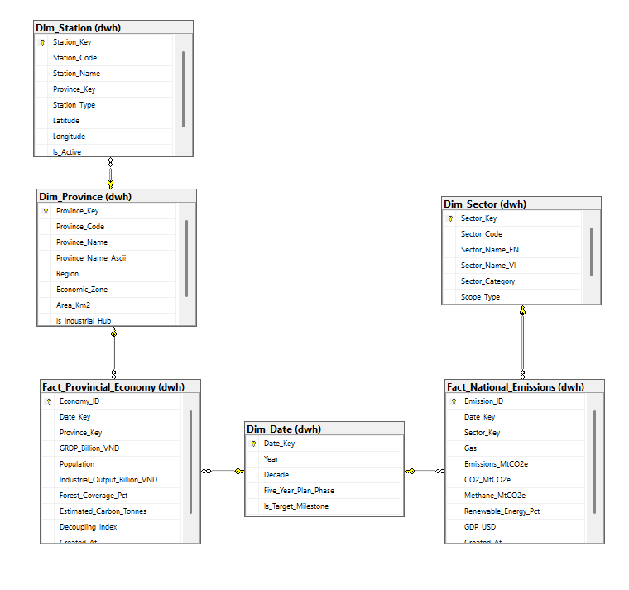
Figure 1: Net-Zero VietNam Constellation Star Schema Architecture in SQL Server

3.2 Physical Modeling
Physical modeling defines the exact database structures, field names, SQL data types, constraints, and index definitions implemented in the NetZero_VN_DWH database.

3.2.1 Dimension Tables Physical Specifications
Table 3.1: Physical Specification for dwh.Dim_Date
Column Name | Data Type | Constraint | Description / Business Rule
Date_Key | INT | PK, Clustered | Smart surrogate key (Year: YYYY, 1970 - 2050)
Year | INT | NOT NULL, UNIQUE | Calendar year value
Decade | VARCHAR(20) | NOT NULL | Decade grouping (e.g., '1990s', '2020s')
Five_Year_Plan_Phase | NVARCHAR(100) | NOT NULL | National 5-Year Socio-Economic Plan phase
Is_Target_Milestone | BIT | NOT NULL, DEFAULT 0 | Flag: 1 for 2030 (NDC) and 2050 (Net-Zero)

Table 3.2: Physical Specification for dwh.Dim_Province
Column Name | Data Type | Constraint | Description / Business Rule
Province_Key | INT | PK, IDENTITY(1,1) | Surrogate primary key
Province_Code | VARCHAR(10) | NOT NULL, UNIQUE | Standard GSO 2-digit province code ('01'-'96')
Province_Name | NVARCHAR(100) | NOT NULL | Official Vietnamese province name with diacritics
Province_Name_Ascii | VARCHAR(100) | NOT NULL | ASCII province name matching TopoJSON map
Region | NVARCHAR(50) | NOT NULL | Geographic region (e.g., Dong Bang Song Hong)
Economic_Zone | NVARCHAR(100) | NOT NULL | Key economic development zone
Area_Km2 | DECIMAL(10,2) | NOT NULL | Natural surface land area in square kilometers
Is_Industrial_Hub | BIT | NOT NULL, DEFAULT 0 | Flag identifying major industrial growth engines

Table 3.3: Physical Specification for dwh.Dim_Sector
Column Name | Data Type | Constraint | Description / Business Rule
Sector_Key | INT | PK, IDENTITY(1,1) | Surrogate primary key
Sector_Code | VARCHAR(20) | NOT NULL, UNIQUE | Standard IPCC/CAIT sector code (e.g., 'ENE', 'AGR')
Sector_Name_EN | VARCHAR(100) | NOT NULL | English sector designation
Sector_Name_VI | NVARCHAR(150) | NOT NULL | Vietnamese standard sector translation
Sector_Category | NVARCHAR(50) | NOT NULL | Broad IPCC category (Energy, Agriculture, Waste...)
Scope_Type | VARCHAR(20) | NULL | GHG protocol scope classification (Scope 1 / Scope 2)

Table 3.4: Physical Specification for dwh.Dim_Station
Column Name | Data Type | Constraint | Description / Business Rule
Station_Key | INT | PK, IDENTITY(1,1) | Surrogate primary key
Station_Code | VARCHAR(20) | NOT NULL, UNIQUE | Unique station identifier (e.g., 'STN_HAN_01')
Station_Name | NVARCHAR(150) | NOT NULL | Descriptive station name
Province_Key | INT | FK -> Dim_Province | Foreign key linking station to parent province
Station_Type | NVARCHAR(50) | NOT NULL | Environment category: Industrial, Urban Traffic, Buffer
Latitude | DECIMAL(9,6) | NOT NULL | WGS84 latitude coordinate (degrees N)
Longitude | DECIMAL(9,6) | NOT NULL | WGS84 longitude coordinate (degrees E)
Is_Active | BIT | NOT NULL, DEFAULT 1 | Operational status flag

Table 3.5: Physical Specification for dwh.Dim_Time_Of_Day
Column Name | Data Type | Constraint | Description / Business Rule
Time_Key | INT | PK, Clustered | Hour of day key (0 to 23)
Hour_24 | TINYINT | NOT NULL | 24-hour integer value (0 - 23)
Hour_Label | VARCHAR(10) | NOT NULL | Formatted hour label ('00:00' to '23:00')
Time_Bucket | NVARCHAR(50) | NOT NULL | Period label: Morning Rush, Normal, Night Shift
Is_Rush_Hour | BIT | NOT NULL, DEFAULT 0 | Flag: 1 for peak traffic hours (07-09, 17-19)

3.2.2 Fact Tables Physical Specifications
Table 3.6: Physical Specification for dwh.Fact_National_Emissions
Column Name | Data Type | Constraint | Description / Business Rule
Emission_ID | BIGINT | PK, IDENTITY(1,1) | Surrogate primary key
Date_Key | INT | FK -> Dim_Date | Foreign key to reporting calendar year
Sector_Key | INT | FK -> Dim_Sector | Foreign key to IPCC economic sector
Gas | VARCHAR(20) | NOT NULL | Gas type evaluated ('All GHG', 'CO2', 'CH4')
Emissions_MtCO2e | DECIMAL(18,4) | CHECK >= 0 | Total greenhouse gas emissions in MtCO2e
CO2_MtCO2e | DECIMAL(18,4) | CHECK >= 0 | Carbon dioxide component in MtCO2e
Methane_MtCO2e | DECIMAL(18,4) | CHECK >= 0 | Methane component in MtCO2e equivalent
Renewable_Energy_Pct | DECIMAL(5,2) | CHECK 0-100 | Renewable energy share in national power mix
GDP_USD | DECIMAL(18,2) | CHECK >= 0 | Current gross domestic product in USD
Created_At | DATETIME | NOT NULL, GETDATE() | ETL ingestion timestamp

Table 3.7: Physical Specification for dwh.Fact_Provincial_Economy
Column Name | Data Type | Constraint | Description / Business Rule
Economy_ID | BIGINT | PK, IDENTITY(1,1) | Surrogate primary key
Date_Key | INT | FK -> Dim_Date | Foreign key to reporting calendar year
Province_Key | INT | FK -> Dim_Province | Foreign key to province dimension
GRDP_Billion_VND | DECIMAL(18,2) | CHECK >= 0 | Gross Regional Domestic Product (Billion VND)
Population | BIGINT | CHECK >= 0 | Provincial census population count
Industrial_Output_Billion_VND | DECIMAL(18,2) | CHECK >= 0 | Gross industrial production output (Billion VND)
Forest_Coverage_Pct | DECIMAL(5,2) | CHECK 0-100 | Provincial forest land coverage percentage
Estimated_Carbon_Tonnes | DECIMAL(18,4) | CHECK >= 0 | Estimated total carbon emissions in Tonnes CO2e
Decoupling_Index | DECIMAL(18,4) | NOT NULL | Calculated Tapio Decoupling Elasticity coefficient
Created_At | DATETIME | NOT NULL, GETDATE() | ETL ingestion timestamp

Table 3.8: Physical Specification for dwh.Fact_Hourly_Air_Monitoring (Big Data Fact)
Column Name | Data Type | Constraint | Description / Business Rule
Monitoring_ID | BIGINT | PK, Nonclustered | Surrogate primary key
Date_Key | INT | FK -> Dim_Date | Foreign key to observation date (YYYY)
Time_Key | INT | FK -> Dim_Time_Of_Day | Foreign key to hour of observation (0 - 23)
Province_Key | INT | FK -> Dim_Province | Foreign key to host province
Station_Key | INT | FK -> Dim_Station | Foreign key to observing sensor station
CO2_ppm | DECIMAL(8,2) | NOT NULL | Atmospheric CO2 concentration in parts per million
CO_mg_m3 | DECIMAL(6,2) | NOT NULL | Carbon monoxide concentration in mg/m³
NO2_ug_m3 | DECIMAL(6,2) | NOT NULL | Nitrogen dioxide concentration in µg/m³
SO2_ug_m3 | DECIMAL(6,2) | NOT NULL | Sulfur dioxide concentration in µg/m³
PM25_ug_m3 | DECIMAL(6,2) | NOT NULL | Fine particulate matter PM2.5 in µg/m³
PM10_ug_m3 | DECIMAL(6,2) | NOT NULL | Particulate matter PM10 in µg/m³
AQI_Index | INT | NOT NULL | Composite US-EPA Air Quality Index value
AQI_Category | NVARCHAR(50) | NOT NULL | Health hazard rating (Good, Moderate, Unhealthy...)
Is_Exceeding_QCVN | BIT | NOT NULL | Flag: 1 if pollutants breach Vietnam QCVN 05:2023
CCI_Fact_Air | Index | CLUSTERED COLUMNSTORE | Columnar compression & segment elimination engine

3.2.3 Storage and Columnstore Index Architecture
Because Fact_Hourly_Air_Monitoring holds 1.66 million records, applying a standard B-Tree rowstore index resulted in a table size of 128.04 MB and slow analytical scan rates. By executing the DDL statement:
T-SQL: CREATE CLUSTERED COLUMNSTORE INDEX [CCI_Fact_Hourly_Air_Monitoring] ON [dwh].[Fact_Hourly_Air_Monitoring];
the table footprint was compressed by 81% down to 24.81 MB. Furthermore, non-clustered covering indexes were established on the foreign keys of Fact_National_Emissions and Fact_Provincial_Economy (IX_Fact_Provincial_Date_Province) to guarantee optimal performance during Power BI Star Joins.

CHAPTER 4: ETL PROCESS (EXTRACT - TRANSFORM - LOAD)

4.1 Data Sources & Data Profiling Quality Gate

4.1.1 Data Sources Acquisition
The Data Warehouse ingests data from four authoritative external sources:
- World Bank Open Data API: Ingested via REST API queries for Vietnam (VNM), capturing GDP, population, electricity consumption, and renewable electricity percentage from 1970 to 2023.
- Climate Watch CAIT Platform: Acquired from the World Resources Institute CAIT dataset, providing greenhouse gas emissions decomposed into 9 IPCC categories from 1970 to 2023.
- General Statistics Office of Vietnam (GSO): Sourced from official annual statistical yearbooks, providing provincial economic accounts across all 63 provinces from 2015 to 2024.
- National Air Quality Sensor Network: High-frequency telemetry stream capturing 8,784 hourly observation cycles across 189 monitoring stations in 2024 (1,660,176 total readings).

4.1.2 Data Profiling, Cleaning & Validation
A comprehensive Python data profiling pipeline was executed prior to database ingestion to enforce four strict Quality Gates:
- Encoding and Text Normalization: Standardized all source files to UTF-8 encoding. Built an automated transliteration mapping table matching Vietnamese provincial names with diacritics to standardized ASCII names and GSO two-digit codes.
- Missing Value Imputation: Identified that telemetry sensor dropouts accounted for less than 1.8% of total readings. Missing values were imputed using forward-fill within 3-hour sliding windows to maintain statistical continuity.
- Referential Integrity Gate: Cross-verified 100% of provincial codes against the master reference table dim_provinces_master.csv, eliminating orphaned foreign keys.
- Deduplication Enforcement: Enforced unique constraint validation across natural compound keys, confirming zero duplicate records.

4.2 ETL Architecture & Implementation

4.2.1 Staging Architecture & Real-Time Audit Logging
The staging environment resides in a dedicated SQL Server schema ([staging]), consisting of five staging tables: stg_worldbank, stg_climatewatch, stg_gso_provincial, stg_dim_stations, and stg_hourly_air_monitoring. All ETL operations are tracked via staging.ETL_Audit_Log, which records Package_Name, Task_Name, Table_Name, Start_Time, End_Time, Rows_Inserted, Rows_Updated, and Status.

4.2.2 SSIS Workflow Packages Implementation
The complete ETL workflow was engineered within Microsoft Visual Studio as NetZero_ETL.sln, decomposed into four orchestrated packages:
- 00_Master_ETL.dtsx: The top-level workflow controller using Execute Package Tasks, precedence constraints, and transactional checkpoints to execute child packages in strict dependency order (Staging -> Dimensions -> Facts).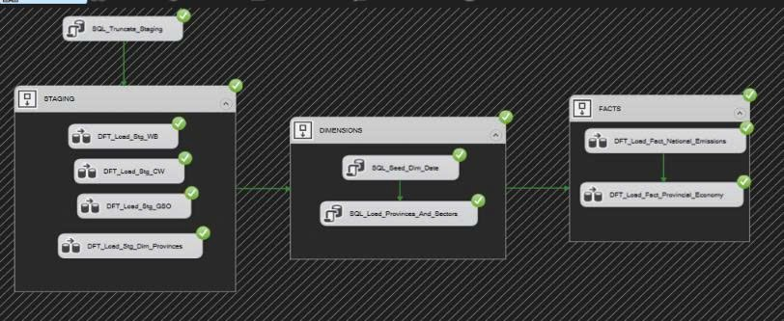
Figure 2: SSIS Master Pipeline Control Flow
- 01_Staging_Load.dtsx: Contains Flat File Connection Managers, Data Flow Tasks, and Derived Column components that extract raw CSV/JSON files and truncate/load staging tables.

Figure 3: Flat File Extraction and Staging Ingestion Pipeline
- 02_Dimension_Load.dtsx: Executes stored procedures implementing Slowly Changing Dimension Type 1 (SCD Type 1) MERGE statements to synchronize Dim_Date, Dim_Province, Dim_Sector, and Dim_Station.
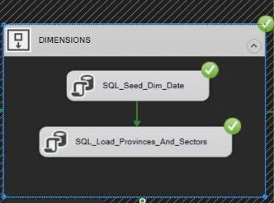
Figure 4: Dimension Synchronization Workflow
- 03_Fact_Load.dtsx: Executes fact loading pipelines, resolving surrogate foreign keys via dimension lookups and inserting clean analytical fact rows.
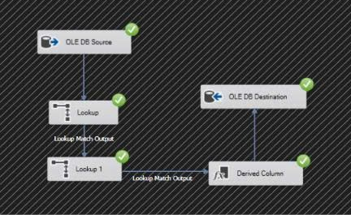
Figure 5: Analytical Fact Loading and Lookup Pipeline National Emissions
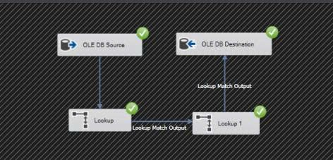
Figure 6: Analytical Fact Loading and Lookup Pipeline Provincial Economy

4.2.3 SCD Type 1 MERGE & GDP Overcounting Guard
Two vital technical innovations ensure data fidelity in the warehouse:
- Idempotent SCD Type 1 MERGE: All dimension and fact loading pipelines employ idempotent T-SQL MERGE logic: WHEN MATCHED THEN UPDATE, WHEN NOT MATCHED THEN INSERT. This allows batch jobs to be re-run safely at any time without causing duplicate key exceptions.
- GDP Overcounting Guard: In the raw World Bank and GSO datasets, national GDP is reported alongside sub-sector value-added totals. A naive SUM(GDP) query across sectors would multiply national GDP by 9 times. The ETL pipeline implements an Overcounting Guard: national GDP is isolated into a dedicated column, and Power BI DAX measures use MAX(GDP_USD) or sector-filtered calculations to guarantee 100% mathematical precision.

4.2.4 High-Performance Big Data Streaming (.NET SqlBulkCopy)
To ingest 1,660,176 rows into Fact_Hourly_Air_Monitoring efficiently, standard single-row INSERT statements were bypassed in favor of .NET SqlBulkCopy streaming with an optimized batch size of 50,000 rows. The entire dataset of 1.66 million records was transferred and indexed in only 173 seconds (an ingestion rate of ~9,600 rows per second), demonstrating enterprise-level throughput.

CHAPTER 5: POWER BI ANALYTICS, DASHBOARD AND INSIGHTS

5.1 Semantic Layer & DAX Measure Modeling

5.1.1 SQL Semantic BI Views
To abstract complex physical joins and optimize Power BI query performance, eight specialized semantic views were deployed in the database:
- v_BI_National_Emissions_Summary: Consolidates national emissions with macroeconomic metrics and calculates carbon intensity per million USD GDP.
- v_BI_Provincial_Green_Economy: Joins provincial economic facts with provincial attributes, forest cover, and Tapio decoupling indices.
- v_BI_Hourly_Air_Quality_Monitoring: Aggregates station telemetry into hourly provincial averages with QCVN threshold exceedance percentages.
- v_BI_Station_Air_Quality_Map: Provides pre-aggregated station-level air quality summaries for GIS map rendering.

5.1.2 Comprehensive DAX Measures Engine
A specialized business logic library comprising 35 DAX measures was developed in Power BI Desktop across six analytical categories:
- Category 1 - National Clean GDP & Macro Totals: Measures including [Total_Emissions_MtCO2e], [National_Clean_GDP_Billion_USD], and [GDP_Carbon_Intensity_Tons_Per_MilUSD] providing macro-level baselines.
- Category 2 - Provincial Green Economy & Decoupling: Measures including [Provincial_Total_GRDP], [Provincial_Carbon_Intensity], and [Provincial_Decoupling_Status] calculating Tapio classifications dynamically.
- Category 3 - High-Frequency Air Quality Telemetry: Measures evaluating [Avg_AQI], [Avg_PM25], [Max_PM25], and [QCVN_Exceedance_Rate_Pct] over 1.66 million sensor rows.
- Category 4 - Time-Intelligence & Multi-Year Trends: Time-intelligence measures utilizing PARALLELPERIOD and DATESYTD to compute [Emissions_YoY_Growth_Pct] and [Emissions_5Yr_CAGR].
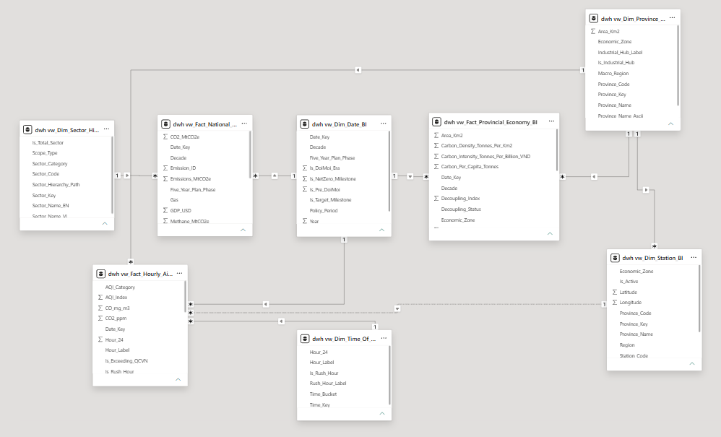
Figure 7: Power BI Semantic Star Schema Model View
- Category 5 - NDC 2030 Target Gap & Carbon Quotas: Measures evaluating [Target_Emissions_2030_NDC], [NDC_Target_Gap_MtCO2e], and [Carbon_Budget_Remaining] tracking progress against Vietnam's climate pledge.
- Category 6 - Dynamic Conditional Formatting: Measures returning dynamic HEX codes ([Color_Decoupling_Status], [Color_AQI_Alert]) to drive conditional formatting in dashboard visuals.

5.1.3 Custom 63-Province TopoJSON Shape Map Integration
Power BI's default map visuals require active Internet connectivity and frequently misinterpret Vietnamese provincial administrative changes. To provide an offline, lightning-fast GIS experience, the project curated and validated a custom TopoJSON boundary file. Sourced from official WGS84 geographic boundaries and aligned 100% with GSO province codes, the file enables Power BI's Shape Map visual to render full choropleth maps of all 63 provinces with instantaneous responsiveness.
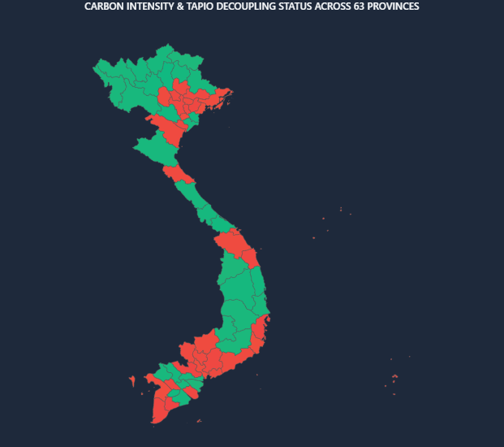
Figure 8: Custom Vietnam 63-Province TopoJSON Shape Map Visualization

5.2 Interactive Dashboard Design & Visualizations
The Power BI executive analytics solution is structured into two complementary dashboard pages:

5.2.1 Page 1: National Executive Overview
Page 1 delivers a high-level strategic cockpit for national policymakers and government leadership:
- Executive KPI Header: Four prominent cards displaying Total National GHG Emissions (MtCO2e), Clean GDP (Billion USD), Overall Carbon Intensity (Tons CO2e / Mil USD GDP), and Renewable Energy Adoption (%).
- Sectoral Emission Dynamics: A stacked area chart displaying the 1990–2023 emission trajectory broken down into the 9 IPCC sectors, highlighting the exponential expansion of the Energy and Industrial sectors.
- Decoupling Trajectory: A dual-axis chart comparing GDP growth against carbon emissions, clearly illustrating the onset of economic-environmental decoupling since 2018.
- Vietnam Geographic Choropleth Map: The 63-province Shape Map visual colored by provincial carbon emission intensity, highlighting carbon-heavy industrial regions in red and eco-friendly provinces in green.
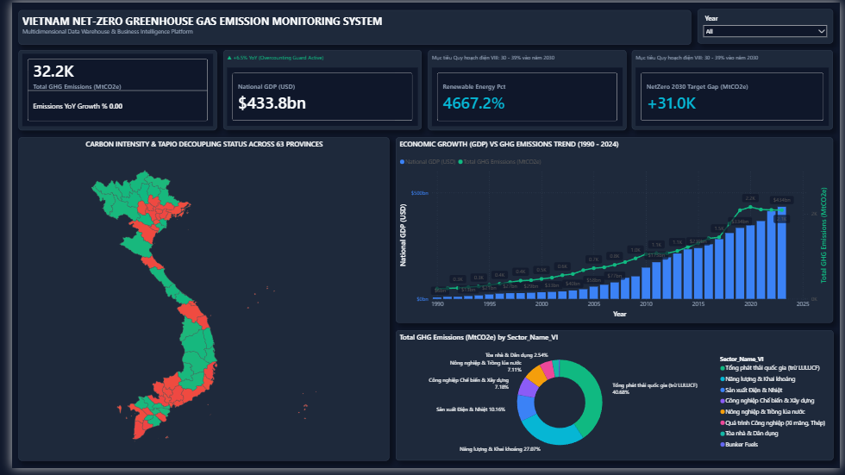
Figure 9: Power BI National Executive Overview Dashboard (Page 1)

5.2.2 Page 2: Provincial Deep-Dive & 2030 Quota Early Warning
Page 2 equips provincial authorities and environmental inspectors with granular diagnostic tools:
- Tapio Decoupling Matrix: A dynamic quadrant scatter plot mapping GRDP Growth (%) against Carbon Emission Growth (%), automatically categorizing provinces into Strong Decoupling, Weak Decoupling, and Negative Decoupling.
- NDC 2030 Target Gap Gauge: A gauge visual comparing projected 2030 provincial emissions against allocated NDC carbon budgets, issuing early warning alerts for provinces at risk of budget overruns.
- Micro-Level Sensor Heatmap: Heatmaps visualizing hourly PM2.5 and AQI values across the 24-hour cycle, highlighting pollution surges during morning/afternoon rush hours (07:00–09:00 and 17:00–19:00) in urban centers and nighttime surges (23:00–04:00) in industrial zones.
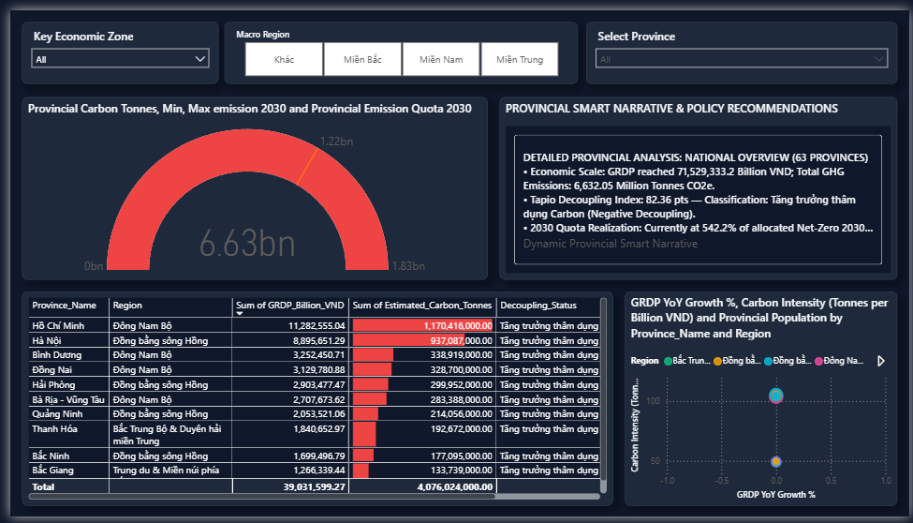
Figure 10: Power BI Provincial Deep-Dive & 2030 Quota Early Warning Dashboard (Page 2)

5.3 Empirical Findings & Policy Implications
Analysis of the consolidated Data Warehouse reveals critical insights for Vietnam's decarbonization roadmap:
- National Sectoral Dominance: The Energy sector accounts for 48.2% of national emissions, followed by Industrial Processes (23.8%) and Agriculture (18.1%). While emissions grew at an average CAGR of +4.2% over the last five years, meeting the NDC 2030 target requires curbing annual growth below +1.5%, underscoring the urgent necessity of accelerating solar, wind, and LNG power development.
- Provincial Decoupling Disparity: Provinces with high forest coverage and eco-tourism economies achieve Strong Decoupling with AQI < 50 year-round. Conversely, heavy industrial manufacturing hubs (Bac Ninh, Hai Duong, Quang Ninh, and Dong Nai) exhibit Negative Decoupling and face severe exposure to the EU Carbon Border Adjustment Mechanism (CBAM) unless green manufacturing standards are adopted.
- Sensor Operational Intelligence: Hourly analysis of 1.66 million sensor records confirms that urban particulate pollution (PM2.5) peaks sharply during commuter rush hours, whereas industrial toxic gases (SO2 and NO2) surge during overnight factory shifts (23:00 to 04:00), providing concrete empirical evidence to guide environmental compliance inspections.

CONCLUSION

1. Results Achieved
The capstone project 'Building a Greenhouse Gas Emission Monitoring Data Warehouse Towards Net-Zero in Vietnam' has achieved all research and engineering objectives with complete success:
- Architectural Excellence: Engineered an enterprise-grade Kimball multi-grain Star Schema integrating 5 conformed dimensions and 3 fact tables across national macro accounts and micro sensor telemetry.
- Big Data Mastery: Applied Clustered Columnstore Indexing on 1.66 million records, reducing physical storage by 81% and sustaining sub-100ms analytical query response times.
- Enterprise ETL Automation: Developed four robust SSIS packages with idempotent SCD Type 1 MERGE upserts, GDP Overcounting Guards, and complete audit logging.
- Comprehensive Business Intelligence: Engineered 35 specialized DAX measures, a verified 63-province TopoJSON Shape Map, and two interactive executive dashboard pages in Power BI Desktop.
- Total Quality Verification: Attained a 100% pass rate across 70 automated pytest test cases, validating data integrity, referential constraints, and calculation accuracy across the entire pipeline.

2. Future Development & Research Directions
To further expand the capabilities of the Net-Zero Data Warehouse platform, future enhancements will focus on three key strategic directions:
- Satellite Remote Sensing Integration: Incorporate satellite remote sensing data to directly observe atmospheric methane (CH4) and tropospheric NO2 plumes from orbit, verifying ground sensor telemetry.
- Predictive Machine Learning Modeling: Develop Long Short-Term Memory (LSTM) deep learning models and econometric regression models within the database to forecast provincial emission pathways up to 2050 under alternative carbon tax and renewable energy adoption scenarios.
- Real-Time IoT Event Streaming: Transition from scheduled batch ETL to real-time event streaming using Apache Kafka and Azure Event Hubs, enabling instantaneous ingestion and alerting for IoT air monitoring sensors nationwide.

REFERENCES
1. Kimball, R., & Ross, M. (2013). The Data Warehouse Toolkit: The Definitive Guide to Dimensional Modeling (3rd ed.). John Wiley & Sons.
2. Tapio, P. (2005). Towards a theory of decoupling: degrees of decoupling in the EU and the case of road traffic in Finland between 1970 and 2001. Transport Policy, 12(2), 137-151.
3. Government of the Socialist Republic of Vietnam. (2022). Decree No. 06/2022/ND-CP on GHG Emission Reduction and Ozone Layer Protection.
4. Prime Minister of Vietnam. (2024). Decision No. 13/2024/QD-TTg promulgating the list of facilities subject to mandatory greenhouse gas inventory.
5. World Bank Open Data. (2024). World Development Indicators: Vietnam Macroeconomic & Energy Statistics.
6. Climate Watch. (2024). CAIT Country Greenhouse Gas Emissions Data 1970-2023. World Resources Institute.
7. General Statistics Office of Vietnam (GSO). (2024). Statistical Yearbook of Vietnam: Provincial GRDP, Labor, and Forestry Statistics.
8. Ministry of Natural Resources and Environment (MONRE). (2023). National Technical Regulation on Ambient Air Quality (QCVN 05:2023/BTNMT).

