**Chapter - 7**

**SNAPSHOTS**

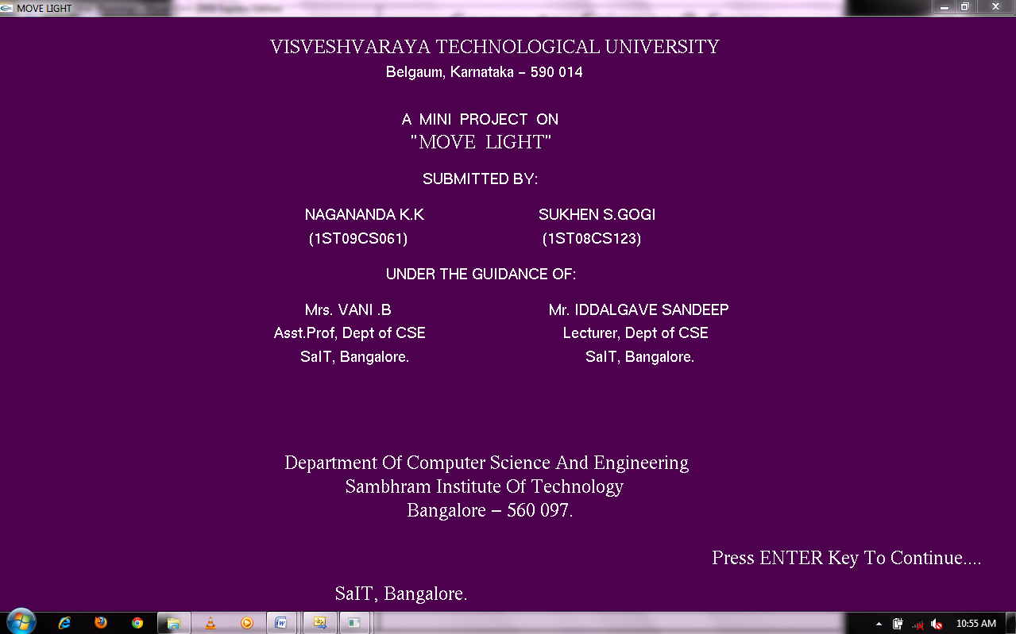

**SNAPSHOT 7.1**:Front screen view

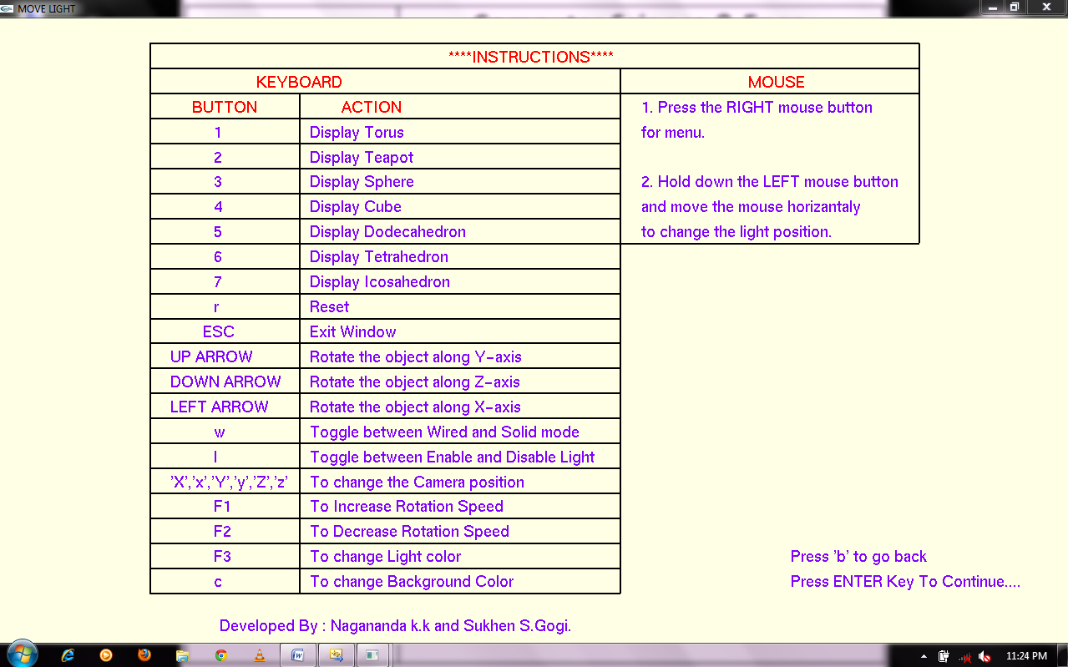

**SNAPSHOT 7.2**: Instruction page

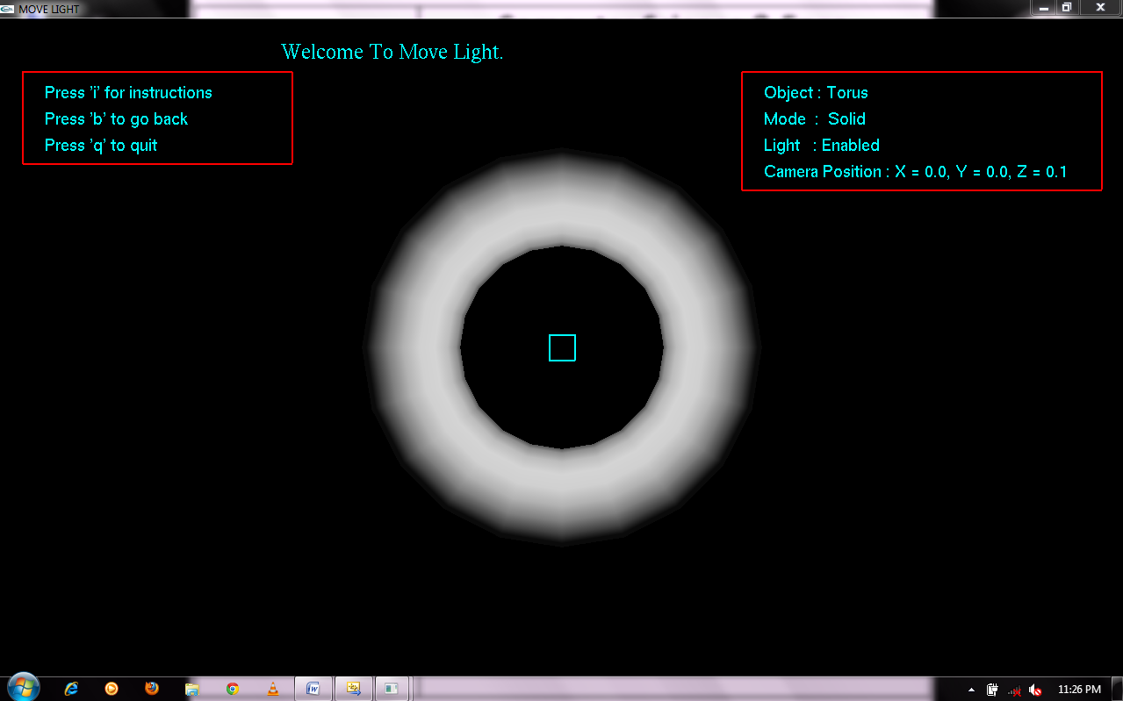

**SNAPSHOT 7.3**: moving the light around torus

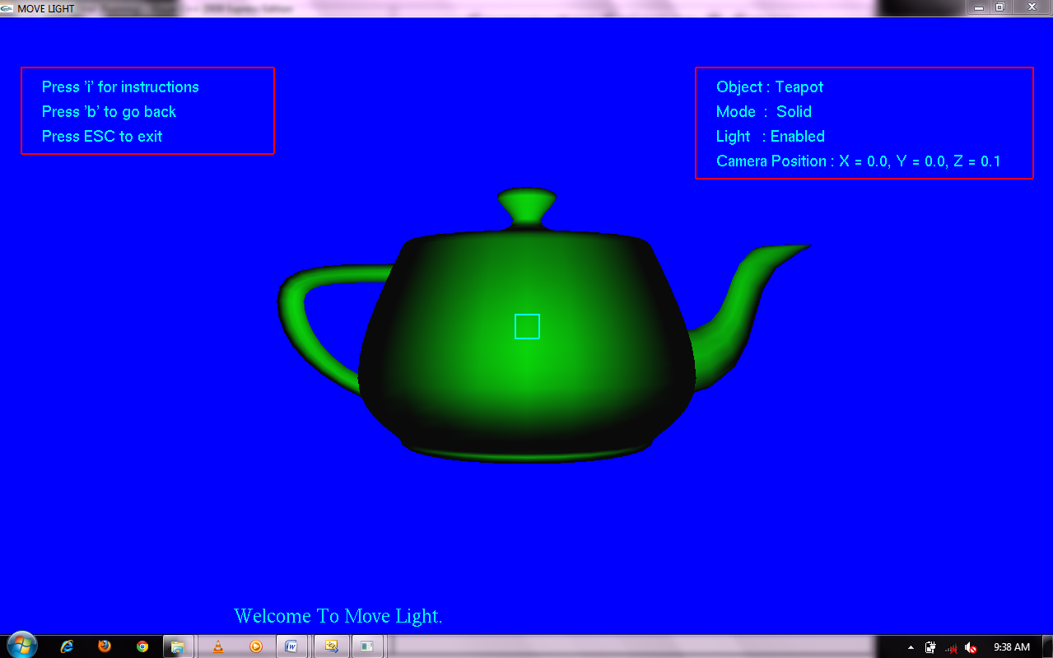

**SNAPSHOT 7.4**: moving the light around teapot

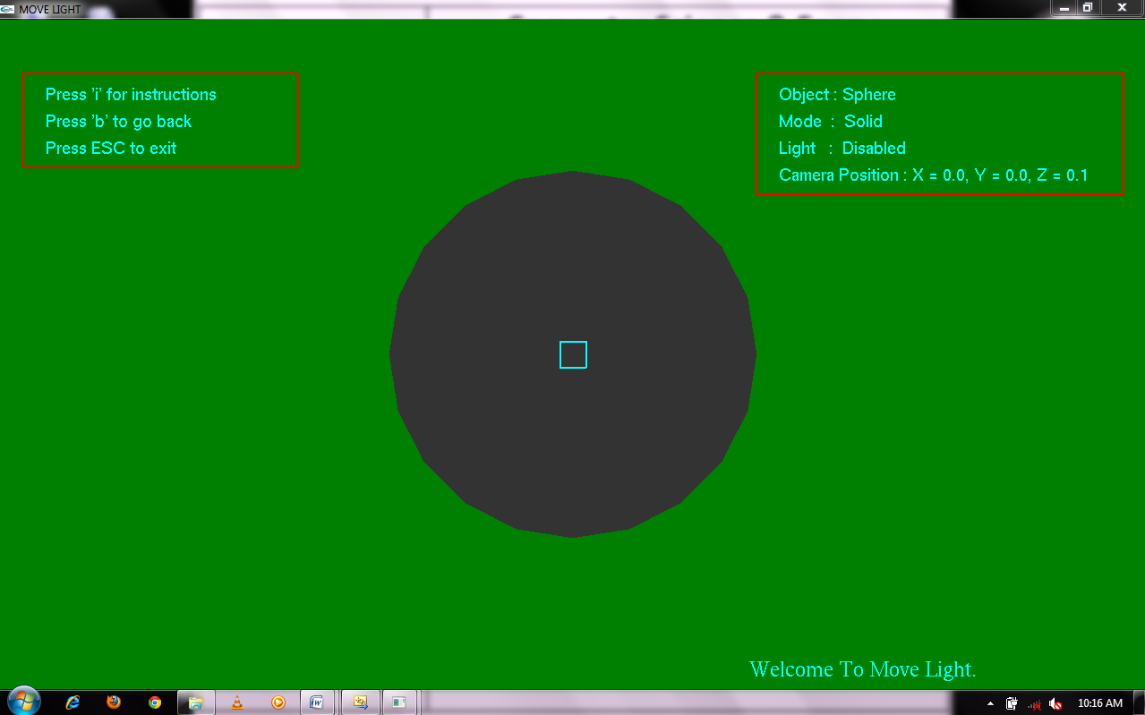

**SNAPSHOT 7.5**: moving the light around sphere

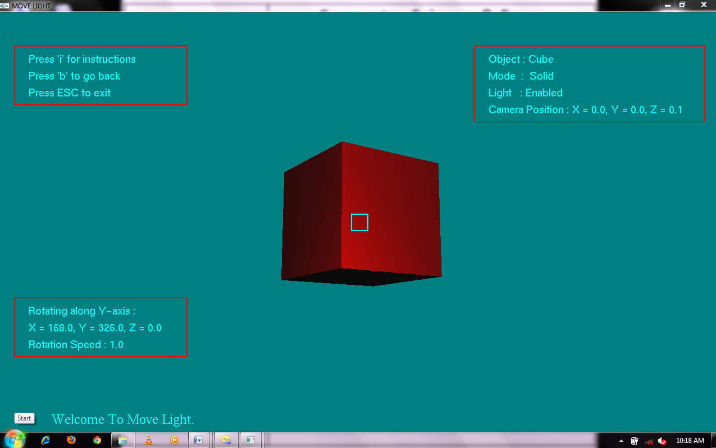**SNAPSHOT 7.6**: moving the light around cube

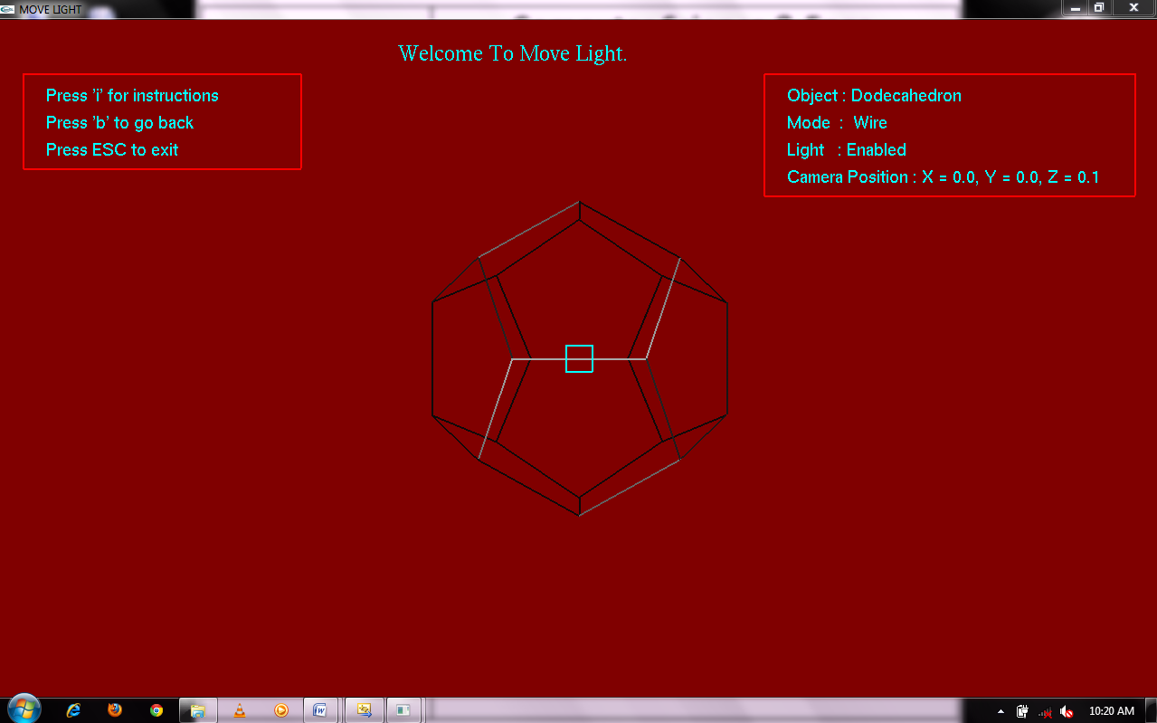**SNAPSHOT 7.7**: moving the light around dodecahedron

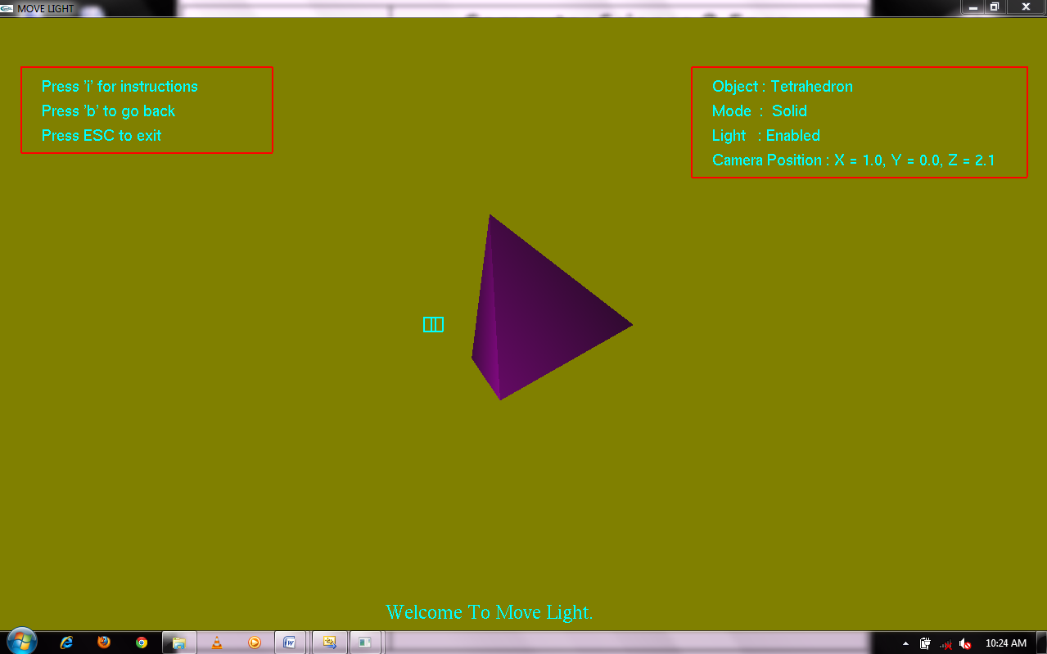

**SNAPSHOT 7.8**: moving the light around tetrahedron

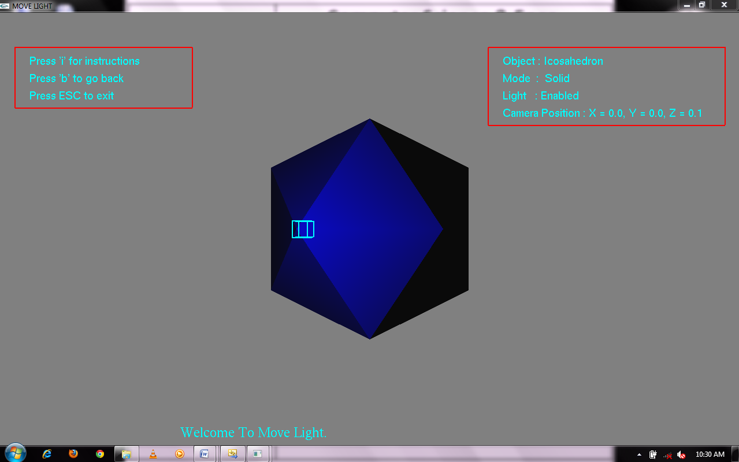

**SNAPSHOT 7.9**: moving the light around icosahedrons