DATABASE PROJECT PROGRESS REPORT

Supply Chain and Warehouse Logistics Network
  - Phase 1 Conceptual Design
This report presents the conceptual design of a database that tracks inventory across warehouses in different geographical locations, supplier orders, shipments, and delivery events. The model addresses two central requirements: multi-level product structures and restock alerts when inventory falls below its reorder level.
The Phase 1 result defines the system scope, 11 functional requirements, 15 business rules, 13 entities, and 17 relationships with explicit cardinality and participation. It also provides a complete EER model and conceptual logic for recursive product components and inventory alerts.
Information | Details
Course | Database Systems
Topic | 6 Supply Chain and Warehouse Logistics Network
Stage | Phase 1 Conceptual Design
Submission | Progress report and EER model

Completed Work
- Defined the problem, users, scope, and assumptions of the system.
- Modelled warehouses, products, suppliers, supplier orders, shipments, tracking events, and inventory.
- Represented multi-level product structures through the recursive ProductComponent entity.
- Specified when a restock alert must be created, retained, closed, and opened again.
- Checked completeness with acceptance cases at the end of the report.

1 Problem Context and Scope

Problem Statement
The organization operates warehouses in different cities or countries. A product may be stored in several warehouses, a supplier may provide several products, and one supplier order may be delivered through several shipments. Fragmented records make it difficult to confirm the stock held at each location, compare ordered and delivered quantities, track shipments, and identify products that require replenishment.
Some finished products are assembled from components that may contain their own subcomponents. A flat product list cannot represent this structure or support material requirement calculations. The database must support an unlimited number of component levels while preventing a product from containing itself directly or indirectly.

Objectives
- Manage warehouses, products, suppliers, and supplier product details in one system.
- Maintain one inventory balance for every warehouse and product combination.
- Track supplier orders, order items, partial shipments, and shipment events over time.
- Represent multi-level product structures with the quantity required at each level.
- Record every stock movement and issue an alert when inventory is below its reorder level.
- Provide a clear EER model that can be mapped to a relational design in Phase 2.

Users and Main Workflow
User Role | Main Responsibility
Purchasing staff | Manage suppliers, supplier prices, and supplier orders.
Warehouse staff | Confirm receipts, issues, adjustments, and current quantities.
Logistics staff | Create shipments and update shipment tracking events.
Inventory manager | Review reorder levels, low-stock alerts, and replenishment decisions.

A typical workflow starts when purchasing staff create a supplier order. Logistics staff then create one or more shipments and record tracking events. When warehouse staff confirm receipt, the system records a stock movement, updates the inventory quantity, and evaluates the restock condition within the same transaction.

Scope and Assumptions
Category | Details
In scope | Geographical warehouses; products and suppliers; current supplier prices; supplier orders; partial shipments; tracking events; inventory; stock movements; multi-level product structures; restock alerts.
Outside Phase 1 | Customer sales; route optimization; production batches; serial numbers; returns; warehouse transfers; unit conversion; BOM version history; payments and accounting.
Order assumptions | Each order has one supplier and one destination warehouse. A product appears at most once in the same order.
Data assumptions | Each product uses one base unit; prices use one common currency; event times use the same standard time zone.

2 Functional Requirements
ID | Function | Requirement
FR01 | Warehouse management | Store the code, name, address, city, country, and capacity of every warehouse.
FR02 | Product management | Store product details, base unit, and product type.
FR03 | Supplier management | Store contact details and the products currently offered by each supplier.
FR04 | Supplier orders | Create an order for one supplier, one destination warehouse, and several product lines.
FR05 | Partial deliveries | Allocate one order item to several shipments without exceeding the ordered quantity.
FR06 | Shipment tracking | Store a tracking number, dispatch date, expected date, arrival date, status, and chronological events.
FR07 | Inventory management | Store the current quantity and reorder level for each warehouse and product pair.
FR08 | Stock movements | Create one StockMovement whenever a balance is opened, received, issued, or adjusted.
FR09 | Product structure | Store the parent product, component product, and required quantity at every level.
FR10 | BOM cycle prevention | Prevent a product from containing itself directly or indirectly.
FR11 | Restock alerts | Create one open alert when Quantity is below ReorderLevel and close it after stock recovers.

FR11 defines the required alert behavior. Automatic purchase order creation is outside the scope because an inventory manager must still select the supplier, order quantity, and date.

3 Business Rules
ID | Business Constraint
BR01 | Each Inventory record belongs to exactly one Warehouse and one Product. A warehouse or product may have zero or many inventory records. WarehouseID and ProductID must be unique as a pair.
BR02 | Supplier and Product have a many-to-many relationship through SupplierProduct. Each supplier product record stores the current UnitPrice and LeadTimeDays.
BR03 | Each SupplierOrder refers to exactly one Supplier and one destination Warehouse. A supplier or warehouse may have zero or many orders.
BR04 | A draft order may have no items, but a submitted order must have at least one. Each SupplierOrderItem belongs to exactly one order and one product, and a product cannot repeat in the same order.
BR05 | The order supplier must have a SupplierProduct record for every ordered product. UnitPrice on SupplierOrderItem is the agreed historical price and does not change with the current supplier price.
BR06 | An order may have zero or many Shipments. Each Shipment belongs to exactly one order and inherits the destination warehouse from that order.
BR07 | A draft shipment may have no items, but a dispatched shipment must have at least one ShipmentItem. Each ShipmentItem refers to a SupplierOrderItem from the same order as the shipment.
BR08 | A SupplierOrderItem may be divided among several shipments. The total quantity of non-cancelled ShipmentItems must not exceed the ordered quantity.
BR09 | Each TrackingEvent belongs to exactly one Shipment. A shipment may have zero or many events. TrackingEventID distinguishes events that occur at the same time.
BR10 | Product contains Product is a recursive many-to-many relationship. ProductComponent stores the parent product, component product, and a QuantityRequired value greater than zero.
BR11 | A product must not contain itself directly or indirectly. A product without components is a leaf item, while a component may still contain lower-level components.
BR12 | Inventory.Quantity and ReorderLevel cannot be negative. A stock issue is rejected if it would make Quantity negative. Each successful change creates exactly one StockMovement.
BR13 | A Receipt movement refers to exactly one ShipmentItem, and each ShipmentItem may be received at most once. Other movement types do not refer to a shipment item.
BR14 | Low stock occurs when Quantity is less than ReorderLevel. Each Inventory record may have at most one unresolved RestockAlert. Repeated low-stock updates must not create duplicate alerts.
BR15 | When Quantity is greater than or equal to ReorderLevel, the open alert is resolved. If Quantity later falls below the threshold, a new alert period begins. A change to ReorderLevel must also be evaluated.

4 Entities Attributes and Relationships

Entity List
Technical names are kept in English so they match the Phase 2 relational schema and SQL implementation. Associative entities store facts about many-to-many relationships or allocation relationships.
Technical Name | Entity Type | Meaning | Identifier | Conceptual Attributes
Warehouse | Strong (independent) entity | Storage location | WarehouseID | WarehouseName, Address, City, Country, CapacityM3
Product | Strong (independent) entity | Stocked or assembled item | ProductID | ProductName, Description, Unit, ProductType
Inventory | Associative / weak entity (depends on Warehouse and Product) | Stock by location | InventoryID | Quantity, ReorderLevel, LastUpdated; one Warehouse and Product pair
Supplier | Strong (independent) entity | Product source | SupplierID | SupplierName, ContactName, Phone, Email, Address
SupplierProduct | Associative entity (many-to-many: Supplier x Product) | Supplier offering | SupplierID + ProductID | UnitPrice, LeadTimeDays
SupplierOrder | Strong entity (transaction header) | Purchase order | OrderID | OrderDate, ExpectedDeliveryDate, Status; Supplier and destination Warehouse
SupplierOrderItem | Weak entity (depends on SupplierOrder) | Purchase order line | OrderItemID | Product, Quantity, UnitPrice
Shipment | Strong entity (transaction header, depends on SupplierOrder) | Physical delivery | ShipmentID | TrackingNumber, ShipmentDate, EstimatedArrival, ActualArrival, Status
ShipmentItem | Weak / associative entity (depends on Shipment and SupplierOrderItem) | Shipment allocation | ShipmentItemID | SupplierOrderItem, Quantity
TrackingEvent | Weak entity (depends on Shipment) | Shipment status event | TrackingEventID | EventTime, Location, Status, Description
ProductComponent | Recursive associative entity (Product x Product) | BOM relationship | ParentProductID + ComponentProductID | QuantityRequired
StockMovement | Weak entity (depends on Inventory; optionally on ShipmentItem) | Inventory transaction | MovementID | Inventory, optional ShipmentItem, MovementTime, MovementType, QuantityDelta
RestockAlert | Weak entity (depends on Inventory) | Low-stock alert period | AlertID | Inventory, AlertDate, QuantityAtAlert, ReorderLevelAtAlert, ResolvedAt, Message
Attribute Definitions and Data Dictionary
The following definitions explain the meaning of every conceptual attribute in the model. The Key and Rule column identifies primary keys, foreign keys, optional values, snapshots, and constraints already established by the business rules.
Warehouse
Attribute | Data Type / Domain | Definition | Key and Rule
WarehouseID | INT, PK, surrogate key | Unique identifier assigned to a warehouse location. | Primary key; required and unique.
WarehouseName | VARCHAR(100) | Business name used to identify the warehouse. | Required descriptive attribute.
Address | VARCHAR(200) | Street or site address of the warehouse. | Location attribute.
City | VARCHAR(100) | City in which the warehouse operates. | Geographical attribute.
Country | VARCHAR(100) | Country in which the warehouse operates. | Geographical attribute.
CapacityM3 | DECIMAL(10,2) | Maximum storage capacity of the warehouse in cubic metres. | Non-negative when provided.
Product
Attribute | Data Type / Domain | Definition | Key and Rule
ProductID | INT, PK, surrogate key | Unique identifier assigned to a stocked, purchased, or assembled product. | Primary key; required and unique.
ProductName | VARCHAR(150) | Name used to identify the product in business operations. | Required descriptive attribute.
Description | TEXT | Additional text describing the product and its purpose. | Optional descriptive attribute.
Unit | VARCHAR(20) | Base unit used to measure inventory and order quantities, such as piece or kilogram. | Required; one base unit per product.
ProductType | VARCHAR(30) | Classification that distinguishes finished products, components, and other item types. | Classification attribute.
Inventory
Attribute | Data Type / Domain | Definition | Key and Rule
InventoryID | INT, PK, surrogate key | Unique identifier for one inventory balance record. | Primary key; required and unique.
WarehouseID | INT, FK -> Warehouse | Warehouse at which the product quantity is held. | Foreign key to Warehouse; required.
ProductID | INT, FK -> Product | Product represented by the inventory balance. | Foreign key to Product; required.
Quantity | DECIMAL(12,2) | Current on-hand quantity of the product at the warehouse. | Non-negative; updated through StockMovement.
ReorderLevel | DECIMAL(12,2) | Minimum acceptable quantity used to determine whether replenishment is required. | Non-negative; alert when Quantity is lower.
LastUpdated | DATETIME | Date and time when the inventory balance was last changed. | Updated after a successful stock transaction.
Supplier
Attribute | Data Type / Domain | Definition | Key and Rule
SupplierID | INT, PK, surrogate key | Unique identifier assigned to a supplier. | Primary key; required and unique.
SupplierName | VARCHAR(150) | Registered or trading name of the supplier. | Required descriptive attribute.
ContactName | VARCHAR(100) | Name of the main contact person at the supplier. | Contact attribute.
Phone | VARCHAR(20) | Telephone number used to contact the supplier. | Contact attribute.
Email | VARCHAR(100) | Email address used for supplier communication. | Contact attribute.
Address | VARCHAR(200) | Business or mailing address of the supplier. | Location attribute.
SupplierProduct
Attribute | Data Type / Domain | Definition | Key and Rule
SupplierID | INT, FK -> Supplier | Supplier that offers the product. | Foreign key to Supplier; part of the composite primary key.
ProductID | INT, FK -> Product | Product offered by the supplier. | Foreign key to Product; part of the composite primary key.
UnitPrice | DECIMAL(12,2) | Current price quoted by the supplier for one base unit of the product. | Non-negative current quotation.
LeadTimeDays | INT | Expected number of days between placing an order and receiving it. | Non-negative whole number.
SupplierOrder
Attribute | Data Type / Domain | Definition | Key and Rule
OrderID | INT, PK, surrogate key | Unique identifier assigned to a supplier order. | Primary key; required and unique.
SupplierID | INT, FK -> Supplier | Supplier from which the order is placed. | Foreign key to Supplier; required.
WarehouseID | INT, FK -> Warehouse | Warehouse designated to receive all shipments for the order. | Foreign key to Warehouse; required.
OrderDate | DATE | Date on which the supplier order is created or placed. | Order timeline attribute.
ExpectedDeliveryDate | DATE | Planned date by which the order is expected to arrive. | Planning attribute.
Status | VARCHAR(20) | Current lifecycle state of the supplier order. | Controls rules for draft and submitted orders.
SupplierOrderItem
Attribute | Data Type / Domain | Definition | Key and Rule
OrderItemID | INT, PK, surrogate key | Unique identifier assigned to an individual order line. | Primary key; required and unique.
OrderID | INT, FK -> SupplierOrder | Supplier order that contains the line. | Foreign key to SupplierOrder; required.
ProductID | INT, FK -> Product | Product requested on the order line. | Foreign key to Product; cannot repeat in the same order.
Quantity | DECIMAL(12,2) | Number of product units ordered on the line. | Positive ordered quantity.
UnitPrice | DECIMAL(12,2) | Agreed unit price recorded when the order is placed. | Historical price snapshot; non-negative.
Shipment
Attribute | Data Type / Domain | Definition | Key and Rule
ShipmentID | INT, PK, surrogate key | Unique identifier assigned to a physical shipment. | Primary key; required and unique.
OrderID | INT, FK -> SupplierOrder | Supplier order fulfilled wholly or partly by the shipment. | Foreign key to SupplierOrder; required.
TrackingNumber | VARCHAR(50) | External carrier or logistics reference used to track the shipment. | Tracking attribute.
ShipmentDate | DATE | Date on which the shipment leaves the supplier or origin point. | Dispatch timeline attribute.
EstimatedArrival | DATETIME | Current expected arrival date and time for the shipment. | Planning attribute.
ActualArrival | DATETIME | Confirmed date and time at which the shipment reaches the destination. | Empty until arrival is confirmed.
Status | VARCHAR(20) | Current logistics state of the shipment. | Updated as tracking events occur.
ShipmentItem
Attribute | Data Type / Domain | Definition | Key and Rule
ShipmentItemID | INT, PK, surrogate key | Unique identifier assigned to a line within a shipment. | Primary key; required and unique.
ShipmentID | INT, FK -> Shipment | Shipment that carries the allocated quantity. | Foreign key to Shipment; required.
OrderItemID | INT, FK -> SupplierOrderItem | Supplier order item from which the shipped quantity is allocated. | Foreign key to SupplierOrderItem; must belong to the same order.
Quantity | DECIMAL(12,2) | Quantity of the order item allocated to this shipment. | Positive; total allocations cannot exceed the ordered quantity.
TrackingEvent
Attribute | Data Type / Domain | Definition | Key and Rule
TrackingEventID | INT, PK, surrogate key | Unique identifier assigned to a shipment tracking event. | Primary key; distinguishes events at the same time.
ShipmentID | INT, FK -> Shipment | Shipment to which the event belongs. | Foreign key to Shipment; required.
EventTime | DATETIME | Date and time at which the tracking event occurs. | Chronological event attribute.
Location | VARCHAR(150) | Place at which the event is recorded. | Geographical event attribute.
Status | VARCHAR(30) | Shipment state reported by the event. | Event status attribute.
Description | TEXT | Additional details about the event or handling activity. | Optional descriptive attribute.
ProductComponent
Attribute | Data Type / Domain | Definition | Key and Rule
ParentProductID | INT, FK -> Product | Product that is assembled from one or more component products. | Foreign key to Product; part of the composite primary key.
ComponentProductID | INT, FK -> Product | Product used directly as a component of the parent product. | Foreign key to Product; part of the composite primary key; cannot create a cycle.
QuantityRequired | DECIMAL(12,2) | Number of component units required to produce one unit of the parent product. | Must be greater than zero.
StockMovement
Attribute | Data Type / Domain | Definition | Key and Rule
MovementID | INT, PK, surrogate key | Unique identifier assigned to an inventory transaction. | Primary key; required and unique.
InventoryID | INT, FK -> Inventory | Inventory balance changed by the transaction. | Foreign key to Inventory; required.
ShipmentItemID | INT, FK -> ShipmentItem | Shipment item that caused a receipt movement. | Optional foreign key to ShipmentItem; used only for Receipt and at most once.
MovementTime | DATETIME | Date and time at which the stock transaction is recorded. | Transaction timeline attribute.
MovementType | VARCHAR(20) | Category of stock change, such as Opening, Receipt, Issue, or Adjustment. | Determines how the movement is interpreted.
QuantityDelta | DECIMAL(12,2) | Signed quantity added to or removed from the inventory balance. | Positive adds stock; negative removes stock; result cannot be negative.
RestockAlert
Attribute | Data Type / Domain | Definition | Key and Rule
AlertID | INT, PK, surrogate key | Unique identifier assigned to one low-stock alert period. | Primary key; required and unique.
InventoryID | INT, FK -> Inventory | Inventory balance whose quantity fell below its reorder level. | Foreign key to Inventory; required.
AlertDate | DATETIME | Date and time at which the low-stock condition is first detected. | Alert timeline attribute.
QuantityAtAlert | DECIMAL(12,2) | Snapshot of Inventory.Quantity when the alert is created. | Historical snapshot; does not change later.
ReorderLevelAtAlert | DECIMAL(12,2) | Snapshot of Inventory.ReorderLevel when the alert is created. | Historical snapshot; does not change later.
ResolvedAt | DATETIME | Date and time at which the stock level recovers to the reorder level or higher. | Null means the alert is still open.
Message | VARCHAR(200) | Human-readable explanation of the low-stock condition. | Descriptive alert attribute.

Stored and Derived Facts
Inventory.Quantity is the operational balance updated from StockMovement records. QuantityAtAlert and ReorderLevelAtAlert are snapshots captured when an alert is created and do not change with the current balance. An alert is open when ResolvedAt is null. Order totals and received quantities are derived from related items instead of being stored twice.

Relationship Cardinality and Participation
ID | Entities | Cardinality | Participation and Meaning
R01 | Warehouse Inventory | 1 to 0..N | Every Inventory record must belong to one Warehouse.
R02 | Product Inventory | 1 to 0..N | Every Inventory record must belong to one Product.
R03 | Supplier SupplierProduct | 1 to 0..N | Every supplier product record must have one Supplier.
R04 | Product SupplierProduct | 1 to 0..N | Every supplier product record must have one Product.
R05 | Supplier SupplierOrder | 1 to 0..N | Every order must have one Supplier.
R06 | Warehouse SupplierOrder | 1 to 0..N | Every order must have one destination Warehouse.
R07 | SupplierOrder SupplierOrderItem | 1 to 0..N | A draft order may be empty; a submitted order has at least one item.
R08 | Product SupplierOrderItem | 1 to 0..N | Every order item must select one Product.
R09 | SupplierOrder Shipment | 1 to 0..N | Every Shipment must belong to one order.
R10 | Shipment ShipmentItem | 1 to 0..N | A draft shipment may be empty; a dispatched shipment has at least one item.
R11 | SupplierOrderItem ShipmentItem | 1 to 0..N | Every shipment item must be allocated from one order item.
R12 | Shipment TrackingEvent | 1 to 0..N | Every tracking event must belong to one Shipment.
R13 | Parent Product ProductComponent | 1 to 0..N | Every component relationship must have one parent Product.
R14 | Component Product ProductComponent | 1 to 0..N | Every component relationship must have one component Product.
R15 | Inventory StockMovement | 1 to 0..N | Every movement must belong to one inventory balance.
R16 | Inventory RestockAlert | 1 to 0..N | Every alert must belong to one inventory balance.
R17 | ShipmentItem StockMovement | 0..1 to 0..1 | Only Receipt uses this link; a shipment item is received at most once.

Important Modelling Decisions
- SupplierProduct and ProductComponent store attributes of many-to-many relationships.
- The Warehouse on SupplierOrder gives every related Shipment the same destination.
- ShipmentItem obtains its Product through SupplierOrderItem, avoiding a second ProductID.
- StockMovement stores history, Inventory stores the current balance, and RestockAlert stores alert periods.

Entity Function Definitions
This section defines, for each entity, which functions (operations) an actor uses that entity for — for example, which functions Supplier supports or which functions Warehouse supports. Each function is traced back to the Functional Requirement (FRxx) or Business Rule (BRxx) that defines it in Sections 2 and 3.
Summary: Function List per Entity
Entity (Actor / Object) | Functions Available
Warehouse | Register / update warehouse; View warehouse inventory; Confirm shipment receipt; Act as order destination
Product | Register / update product; Define product structure (BOM); View stock across warehouses
Inventory | Maintain inventory balance; Record stock movement; Evaluate restock condition
Supplier | Register / update supplier; Manage product catalog & pricing; Receive supplier orders
SupplierProduct | Quote / update price; Record lead time
SupplierOrder | Create order; Add / remove order items; Submit order; Track order status
SupplierOrderItem | Record order line; Check allocation limit
Shipment | Create shipment; Allocate order item to shipment; Dispatch shipment; Confirm arrival
ShipmentItem | Validate matching order; Trigger receipt
TrackingEvent | Log tracking event
ProductComponent | Add component link; Validate cycle prevention; Calculate multi-level requirement
StockMovement | Log transaction; Reject invalid issue
RestockAlert | Create alert; Close alert; Prevent duplicate alerts

Detailed Function Definitions
Functions for Warehouse
ID | Function | Definition | Related FR/BR
F-WH1 | Register / update warehouse | Purchasing staff create or edit a warehouse's code, name, address, city, country and capacity. | FR01
F-WH2 | View warehouse inventory | Warehouse staff and the inventory manager list current Quantity and ReorderLevel for every product held at the warehouse. | FR07
F-WH3 | Confirm shipment receipt | Warehouse staff confirm arrival of a ShipmentItem, which creates a Receipt StockMovement and updates Inventory. | FR08
F-WH4 | Act as order destination | The warehouse is set as the single destination of a SupplierOrder; every Shipment on that order inherits it. | FR04, BR06

Functions for Product
ID | Function | Definition | Related FR/BR
F-PR1 | Register / update product | Purchasing or inventory staff manage product name, description, base unit and type. | FR02
F-PR2 | Define product structure (BOM) | Add or remove a parent-component link with the quantity required per unit; system validates against cycles. | FR09, FR10
F-PR3 | View stock across warehouses | Inventory manager checks a product's Quantity at every warehouse that holds it. | FR07

Functions for Inventory
ID | Function | Definition | Related FR/BR
F-IN1 | Maintain inventory balance | System stores and exposes the current Quantity and ReorderLevel for each warehouse-product pair. | FR07
F-IN2 | Record stock movement | Every opening, receipt, issue or adjustment creates exactly one StockMovement and updates Quantity in the same transaction. | FR08
F-IN3 | Evaluate restock condition | After any change to Quantity or ReorderLevel, the system checks the threshold and opens or closes a RestockAlert. | FR11

Functions for Supplier
ID | Function | Definition | Related FR/BR
F-SU1 | Register / update supplier | Purchasing staff manage a supplier's contact details. | FR03
F-SU2 | Manage product catalog & pricing | Purchasing staff add or update the products a supplier offers, its current UnitPrice and LeadTimeDays via SupplierProduct. | FR03, BR02
F-SU3 | Receive supplier orders | A supplier is set as the single source of a SupplierOrder; the order supplier must already offer every ordered product. | FR04, BR05

Functions for SupplierProduct
ID | Function | Definition | Related FR/BR
F-SP1 | Quote / update price | Purchasing staff record the supplier's current UnitPrice for a product. | FR03
F-SP2 | Record lead time | Purchasing staff record the expected LeadTimeDays used for delivery planning. | FR03

Functions for SupplierOrder
ID | Function | Definition | Related FR/BR
F-SO1 | Create order | Purchasing staff open a draft order for one supplier and one destination warehouse. | FR04
F-SO2 | Add / remove order items | Purchasing staff add product lines with quantity; a product cannot repeat within the same order. | FR04, BR04
F-SO3 | Submit order | Change Status from Draft to Submitted once at least one order item exists. | BR04
F-SO4 | Track order status | Inventory/purchasing staff monitor an order's status as shipments are created and received. | FR04

Functions for SupplierOrderItem
ID | Function | Definition | Related FR/BR
F-OI1 | Record order line | System stores the product, ordered quantity and agreed price for one order line. | FR04, BR05
F-OI2 | Check allocation limit | System ensures total non-cancelled ShipmentItem quantity against this line never exceeds Quantity. | BR08

Functions for Shipment
ID | Function | Definition | Related FR/BR
F-SH1 | Create shipment | Logistics staff create a shipment against a specific supplier order. | FR05
F-SH2 | Allocate order item to shipment | Logistics staff split a SupplierOrderItem quantity across one or more shipments, never exceeding the ordered quantity. | FR05, BR08
F-SH3 | Dispatch shipment | Change Status to Dispatched once at least one ShipmentItem exists. | BR07
F-SH4 | Confirm arrival | Logistics/warehouse staff set ActualArrival and Status when the shipment is delivered. | FR06

Functions for ShipmentItem
ID | Function | Definition | Related FR/BR
F-SI1 | Validate matching order | System rejects a ShipmentItem whose order item belongs to a different order than the shipment. | BR07
F-SI2 | Trigger receipt | Warehouse staff mark a ShipmentItem received at most once, creating one Receipt StockMovement. | FR08, BR13

Functions for TrackingEvent
ID | Function | Definition | Related FR/BR
F-TE1 | Log tracking event | Logistics staff append a chronological status/location update to a shipment. | FR06

Functions for ProductComponent
ID | Function | Definition | Related FR/BR
F-PC1 | Add component link | Product manager defines a parent-component pair with the quantity required per unit. | FR09
F-PC2 | Validate cycle prevention | System rejects a link that would make a product contain itself directly or indirectly, on insert and update. | FR10, BR11
F-PC3 | Calculate multi-level requirement | System computes the total component quantity needed for one parent unit by multiplying required quantities along every valid path. | Section 6

Functions for StockMovement
ID | Function | Definition | Related FR/BR
F-SM1 | Log transaction | System creates exactly one StockMovement for every successful opening, receipt, issue or adjustment. | FR08, BR12
F-SM2 | Reject invalid issue | System rejects a stock issue that would make Inventory.Quantity negative. | BR12

Functions for RestockAlert
ID | Function | Definition | Related FR/BR
F-RA1 | Create alert | System opens a new alert when Quantity < ReorderLevel and no open alert exists for that inventory record. | FR11, BR14
F-RA2 | Close alert | System sets ResolvedAt when Quantity returns to at least ReorderLevel while an alert is open. | FR11, BR15
F-RA3 | Prevent duplicate alerts | System keeps the existing open alert rather than creating a second one while the condition persists. | BR14

5 Extended Entity Relationship Model
The diagram below is the complete Phase 1 EER model. The symbol 1 means exactly one record, and 0..N means zero to many records. Relationships R01 through R17 are defined precisely in Section 4.
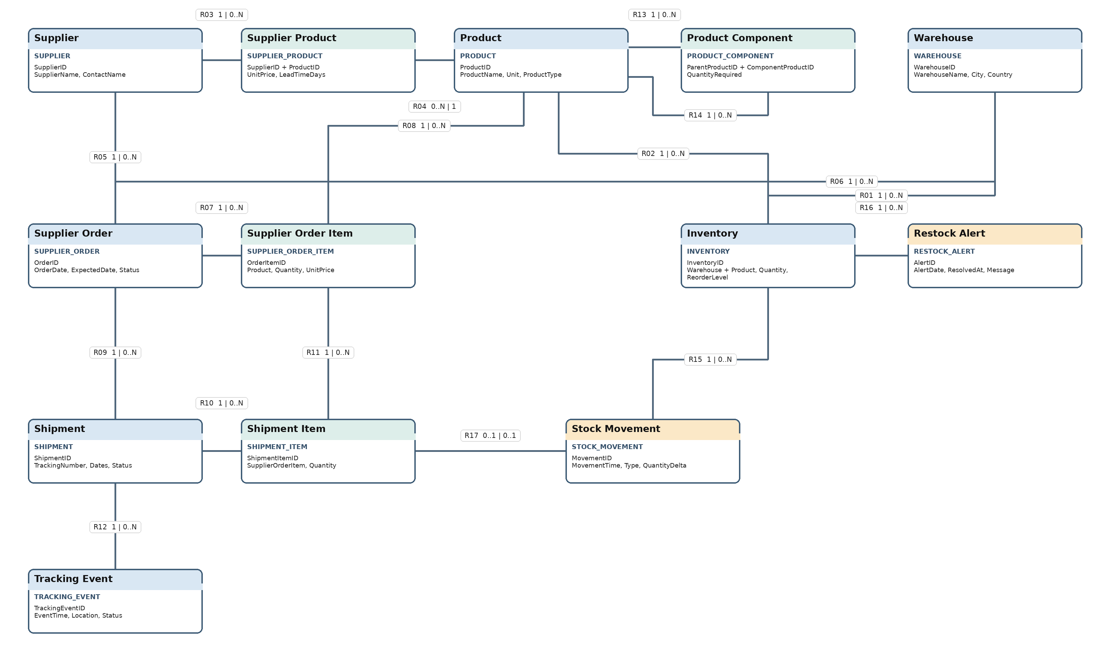
Figure 1 Complete EER model for warehouse logistics product structures and restock alerts3

6 Recursive Relationships and Inventory Alerts

Recursive Product Structure
Product participates in two roles within the same structure. The first role is the parent product that must be assembled. The second role is the component product that is consumed. ProductComponent is the associative entity that records a direct edge between these roles and stores QuantityRequired.
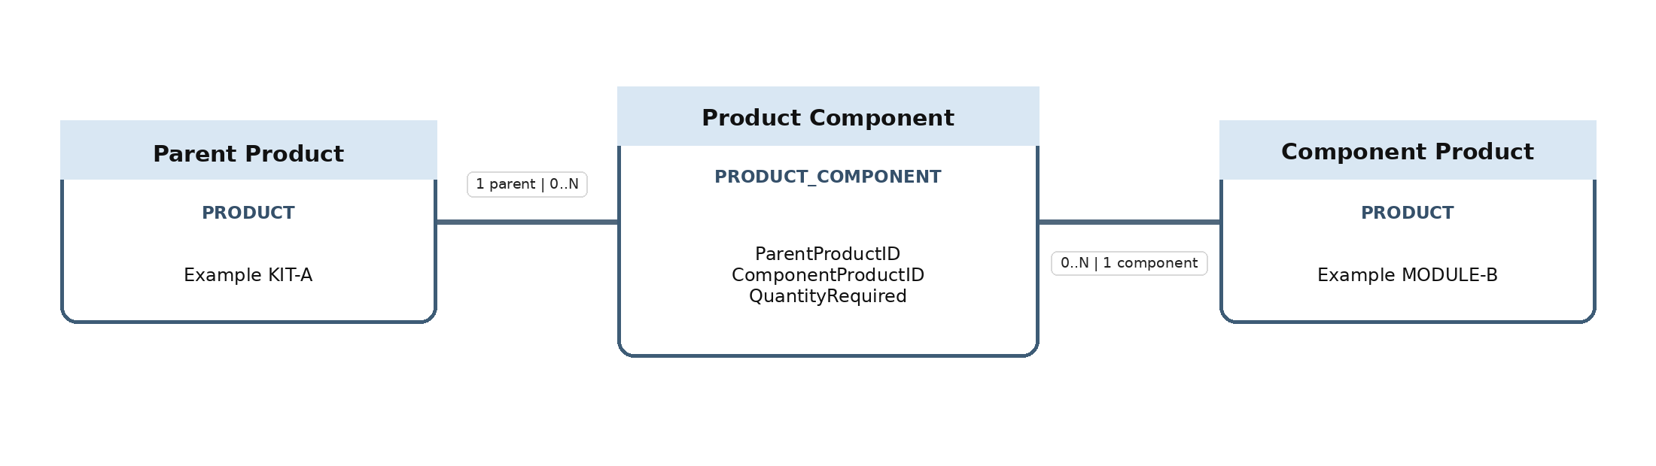
Figure 2 ProductComponent represents two Product roles in the recursive relationship
For example, KIT-A contains 2 MODULE-B units, and each MODULE-B contains 4 SCREW-C units. One KIT-A therefore requires 2 x 4 = 8 SCREW-C units along this path. If SCREW-C also appears on another valid branch, the system adds the requirements from those paths.
Before adding a Parent to Component link, the system must reject equal product identifiers and recursively search from the proposed Component through its existing descendants. If the proposed Parent is found, the new link would create a cycle and must be rejected. This rule applies to both inserts and updates.

Restock Alert Logic
Condition After Inventory Change | Required Action
Quantity < ReorderLevel and no open alert exists | Create a new RestockAlert, capture the quantity and threshold, and leave ResolvedAt null.
Quantity < ReorderLevel and an open alert exists | Keep the existing alert and do not create a duplicate record.
Quantity >= ReorderLevel and an open alert exists | Set ResolvedAt to the transaction time to close the alert.
Quantity >= ReorderLevel and no open alert exists | Take no alert action.

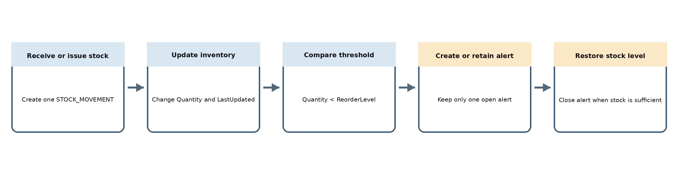
Figure 3 Inventory update and restock alert evaluation flow
The alert condition is evaluated when Inventory is created, Quantity changes, or ReorderLevel changes. Updates to StockMovement, Inventory, and RestockAlert must all commit or all roll back. The database must maintain at most one unresolved alert for each Inventory record even when concurrent transactions occur.
Phase 1 specifies the required trigger behavior. The SQL trigger, row-locking method, and concurrency tests will be implemented after the group selects a database management system.

7 Validation Cases and Completion Status

Acceptance Cases
Case | Data or Action | Expected Result
Unique inventory | Add a second record for the same Warehouse and Product. | Reject the duplicate pair.
Multi-level structure | KIT to MODULE = 2 and MODULE to SCREW = 4. | Calculate 8 SCREW units for one KIT along this path.
Cycle prevention | After the structure above, add SCREW to KIT. | Reject the link because it creates an indirect cycle.
Partial delivery | Order 100 units and allocate 40 to SH1 and 60 to SH2. | Accept both; reject one additional unit.
Wrong order | A ShipmentItem refers to an item from another order. | Reject it even though the individual records exist.
No duplicate alert | Threshold 50; quantity changes 60 to 20 to 15. | Create one alert at 20 and no second alert at 15.
Close and reopen | Quantity changes 15 to 50 to 49. | Close the alert at 50 and create a new period at 49.
Duplicate receipt | Submit the same ShipmentItem for receipt twice. | Only the first receipt may change inventory.

Phase 1 Requirements Checklist
Required Content | Status | Location
Problem description and objectives | Complete | Section 1
Scope users and assumptions | Complete | Section 1
Functional requirements | Complete | Section 2
Business rules | Complete | Section 3
Entities attributes and identifiers | Complete | Section 4
Relationship cardinality and participation | Complete | Section 4
Complete EER model | Complete | Section 5
Multi-level recursive relationship | Complete | Section 6
Restock alert trigger logic | Complete | Section 6

Next Work
Phase 2 will map the EER model to relational tables, define keys and integrity constraints, and check normalization. Implementation will add SQL tables, stock triggers, sample data, and validation tests.
Before submission, the group must enter member details, nominate one representative, and upload the report through the form provided by the lecturer.

