Nmap - Network Mapper
Purpose: Port scanning, service detection, OS fingerprinting
Basic Scans
# Ping sweep (discover live hosts)
nmap -sn 192.168.213.128
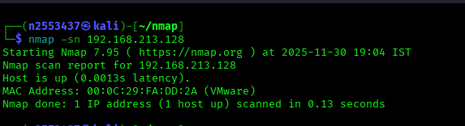
# Basic port scan
nmap 192.168.213.128
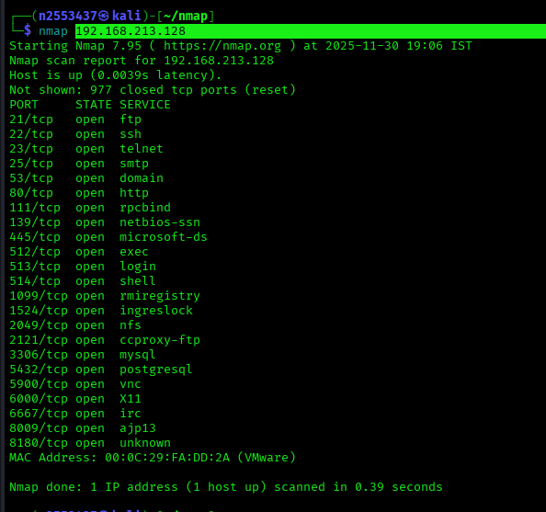
# Scan specific ports
nmap -p 21,22,223,111,445,1099,1524 192.168.213.128
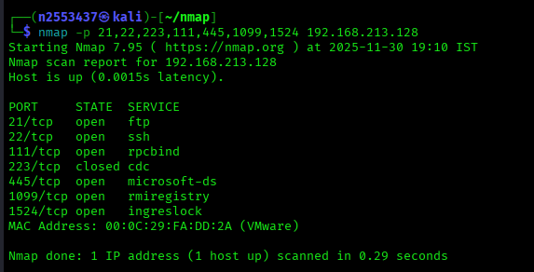
# Scan port range
nmap -p 1000-65535 192.168.213.128
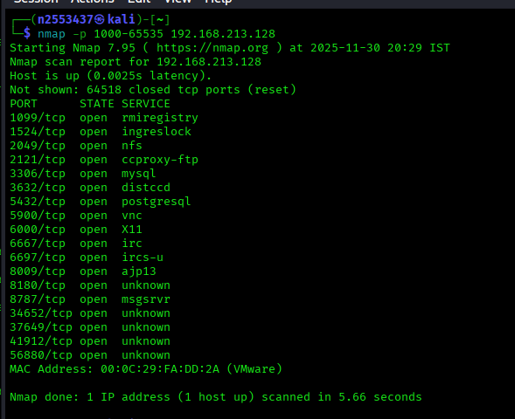

# Scan all ports
nmap -p- 192.168.213.128
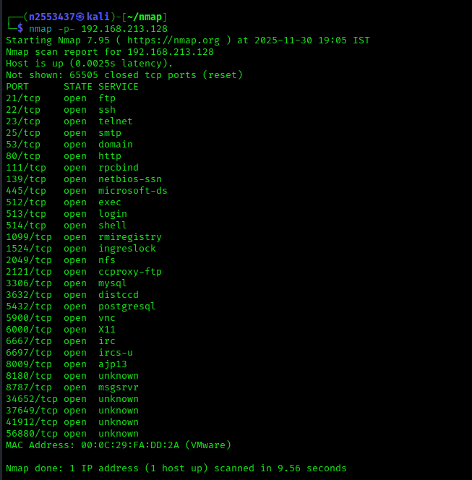

Service Detection
# Service version detection
nmap -sV 192.168.213.128
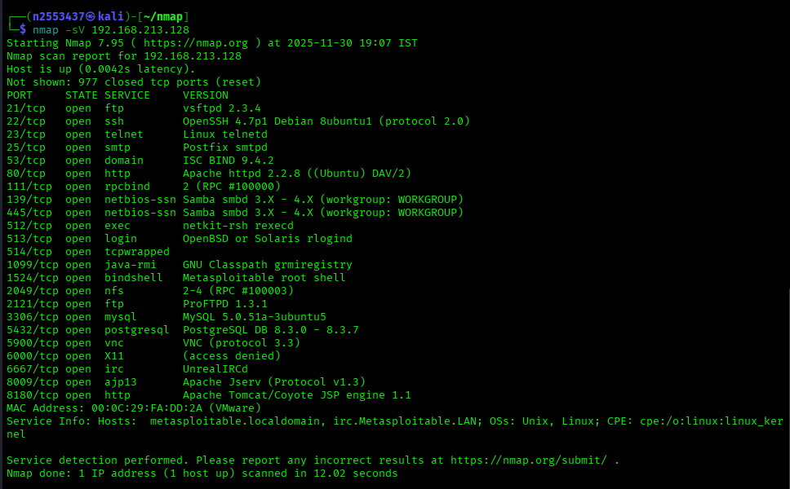
# OS detection
nmap -O 192.168.213.128
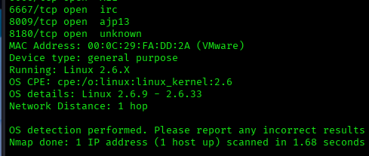
# Aggressive scan (OS, version, scripts, traceroute)
nmap -A 192.168.213.128
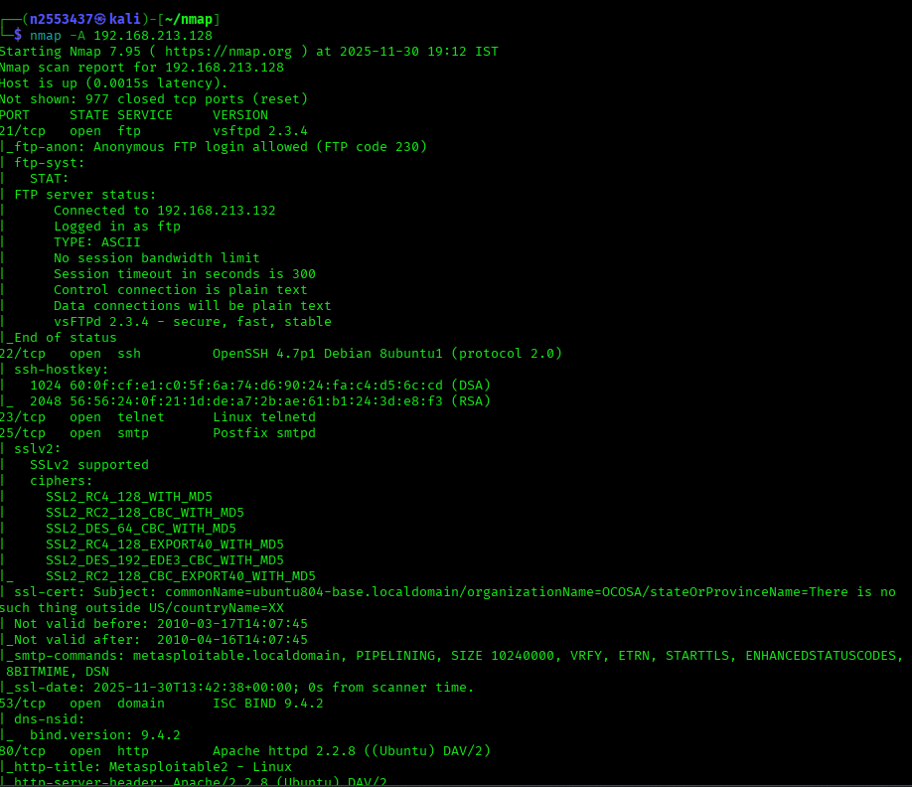
Advanced Scanning
# TCP SYN scan (stealth)
nmap -sS 192.168.213.128
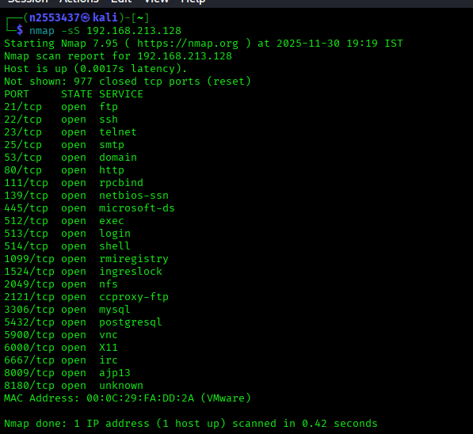
# UDP scan
nmap -sU 192.168.213.128
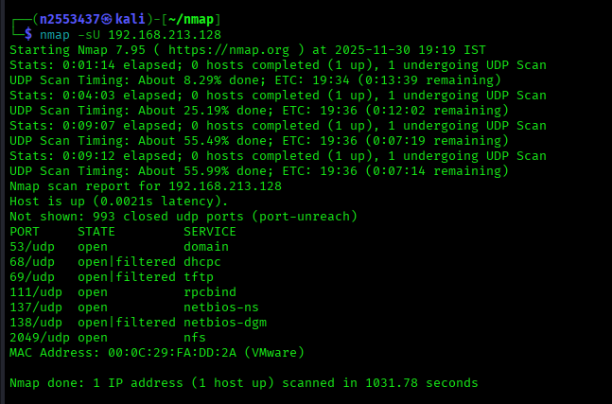
# TCP connect scan
nmap -sT 192.168.213.128
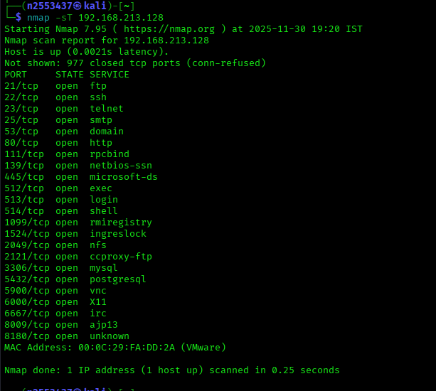
# Bypass firewall
nmap -f 192.168.213.128 # Fragment packets
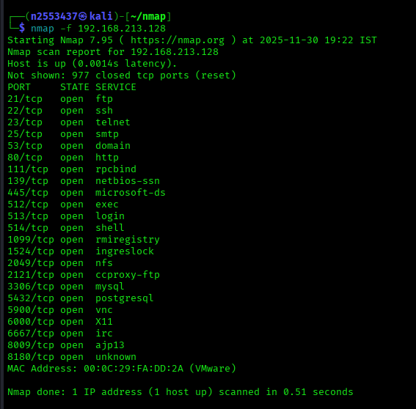
nmap -D RND:10 192.168.213.128 # Decoy scan
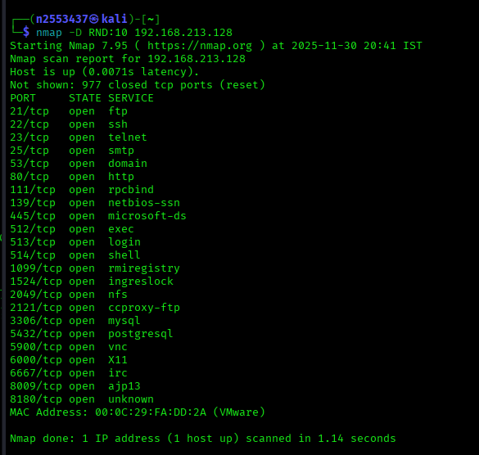
# Timing templates (faster to slower)T5-T0
nmap -T4 192.168.213.128 # Faster
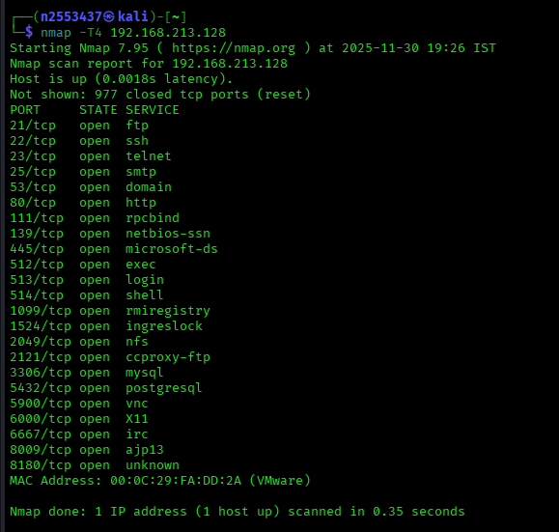
NSE Scripts (Nmap Scripting Engine)
# Default scripts
nmap -sC 192.168.213.128
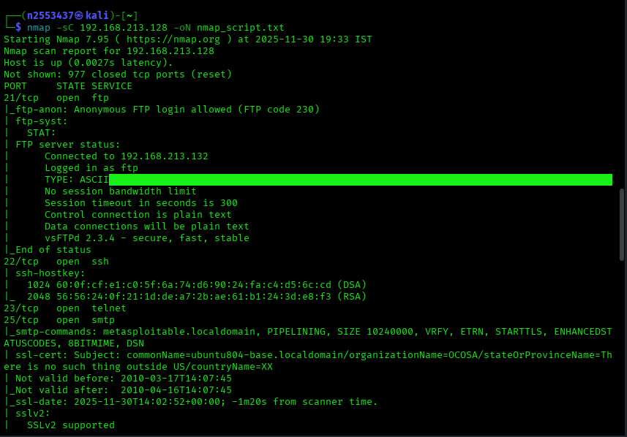
# Vulnerability scripts
nmap --script vuln 192.168.213.128
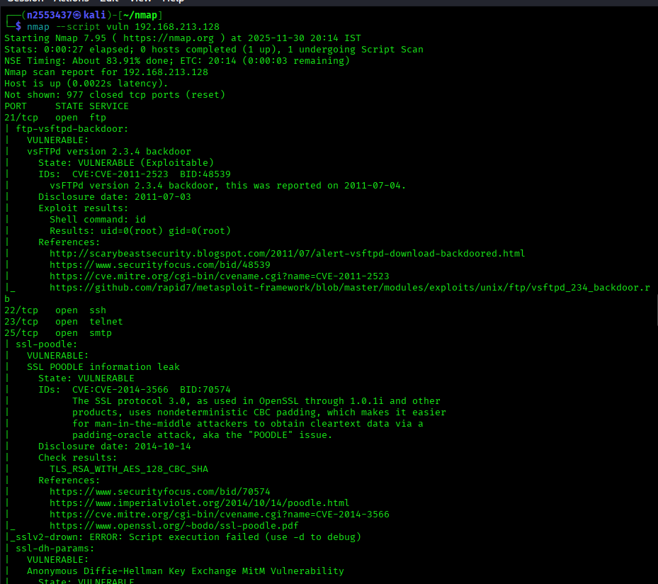
# Specific script categories
nmap --script=auth 192.168.213.128
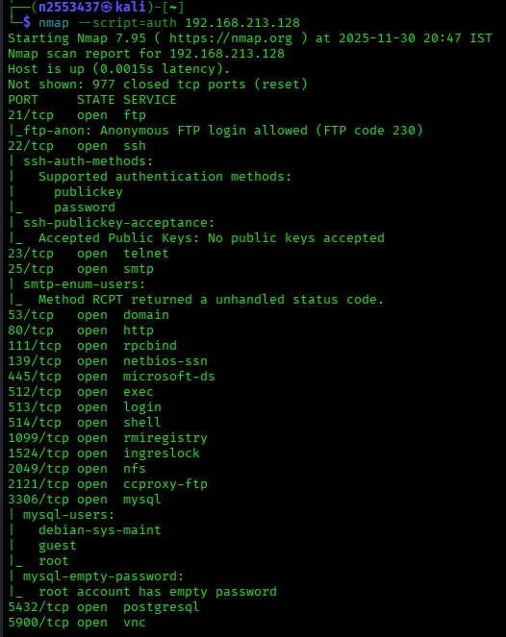
nmap --script=discovery 192.168.213.128
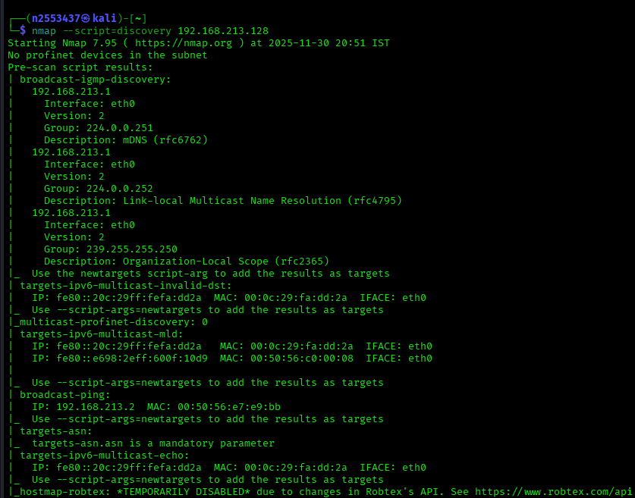
nmap --script=exploit 192.168.213.128
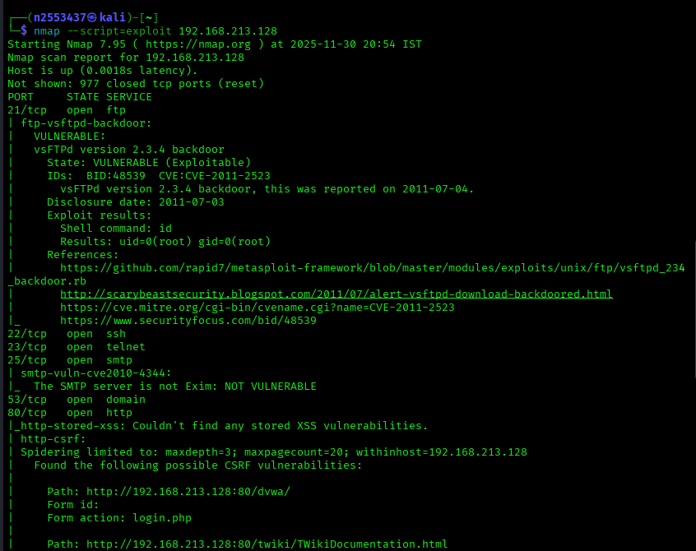
# Specific script
nmap --script=http-sql-injection 192.168.213.128
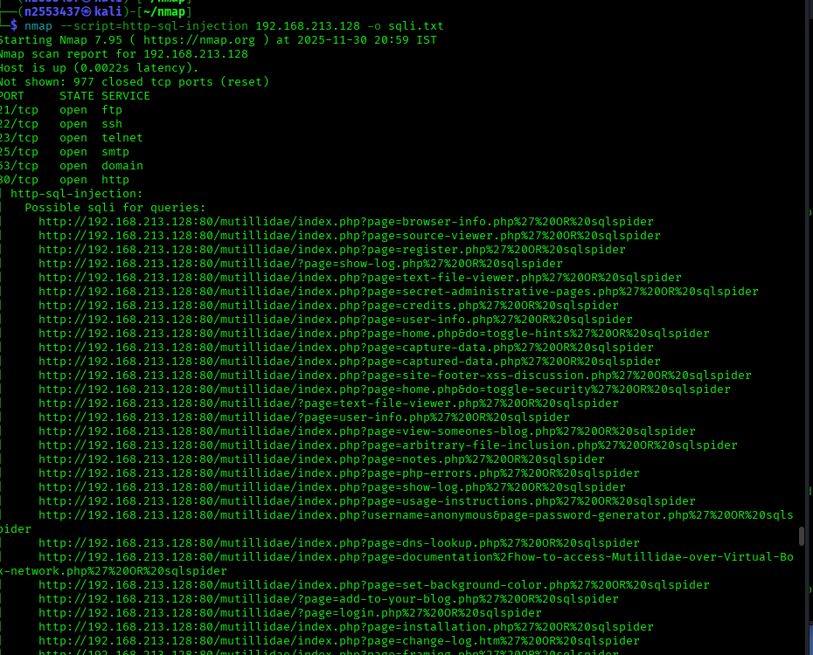
# SMB enumeration
nmap --script smb-enum-shares,smb-enum-users 192.168.1.100
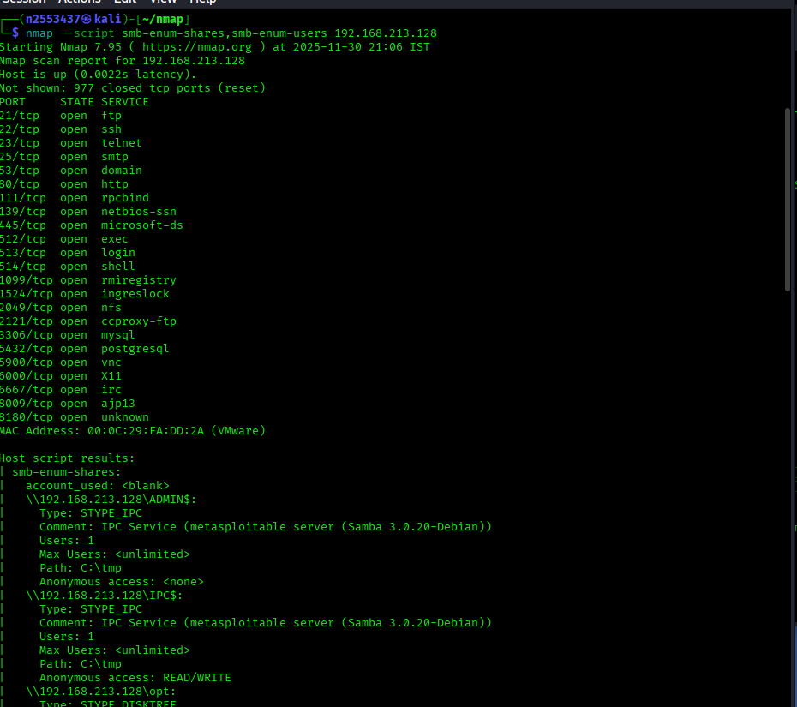
Practical Nmap Workflow
# Step 1: Discover live hosts
nmap -sn 192.168.213.128 -oN live_hosts.txt
# Step 2: Quick scan of common ports
nmap -iL live_hosts.txt -F -oN quick_scan.txt 192.168.213.128
# Step 3: Full port scan on interesting hosts
nmap -p- 192.168.213.128 -oN full_scan.txt
# Step 4: Service detection
nmap -p <open_ports> -sV -sC -oN detailed_scan.txt 192.168.213.128
# Step 5: Vulnerability scanning
nmap --script vuln -p <open_ports> 192.168.213.128 -oN vuln_scan.txt

