Feasibility Model Design

F2019 – Edit this document into a deliverable.

|  |  |  |  |
| --- | --- | --- | --- |
| Lab Section: | 3 | Group: | 20 |

# System-Level Design

Our ECE 298 projects start with a conceptual architecture.

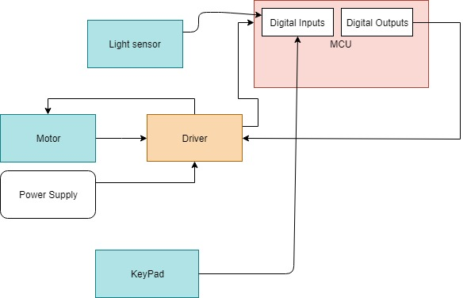

## Project Design Requirements

In PD 21 you learned about engineering requirements. They fall into three major categories, as follows:

1. **Functional requirements** are quantities that specify the performance of a design. They are related to the functions of the design, identified as answers to the question, "What does it do?" For example, a functional requirement for a coffee maker may specify the time required to brew a pot of coffee, a DC power supply may specify its maximum voltage, and a vehicle alarm system may specify how much noise it makes when it is set off
2. **Non-functional requirements** specify characteristics of the design that are not performance based. Theses are typically features or qualities that are desirable to the client. For example, ease of use, ease of manufacturing, and use of recycled materials.
3. **Constraint requirements** place limits on the design space, and often reflect budget or other project limitations. For example, cost, weight, and noise.

The basic form of most of these requirements is the same: a short description, followed by a relationship (equals, less than, or greater than) and a value.

**State three to five major Functional Requirements that your project must meet to successfully solve your problem statement.**

## Project Sensors and User Inputs

* Light sensor. REFL light sensor module.
* REFL light sensor requires 3 connections. One to ground, one to 3V power supply, and one on port 8 pin 1. This pin is already mapped to the code that will determine the value of the light intensity. Darker means lower number.

## Project Actuators and Indicators

* List the types of actuators and indicators you may require (e.g. light, sound, mechanical motion)
* 2 Stepper Motors (5V).
* For now we connect 4 pins to the Stepper Motor Driver module. These pins drive the pattern necessary in our code to turn the motor. Those 4 pins on the driver are connected to the MSP, with 4 output signals coming from the MSP.
* 1 pin on the driver is connected to an external power supply via the breadboard. This pin is used to provide a 5V power supply to the driver, which supplies power to the motor.
* A common ground needs to be established between the driver, the breadboard, the power supply, and the MSP.

## Project MCU Peripherals

* Keypad.
* 7 pins are connected between the keypad and the MSP. Pin 1, 3, 5 on the keypad are connected to 3 output pins on the MSP. These 3 pins correspond to the columns on the keypad. The rest of the pins on the keypad are connected to the Input pins on the MSP. These ones correspond to the rows of the keypad.

## Project Testing Methodology

* For this project we need 2 motors to rotate in either directions (clockwise and counter-clockwise), a limiter (the light sensor) to tell the motor to stop rotating, or a keypad that enables the user to input coordinates.
* To test that the limiter works, we can see the input data that we receive actually decrease when we cover it with our fingers.
* To test that the keypad works, we will press each and see if we get a valid corresponding numerical value. We can use the LCD to print our results. We may alternatively test each pin to see if we are getting a valid input.
* For the motor, we simply need to run the code to see if the motor spins clockwise or counter-clockwise. We can test the voltage using the oscilloscope in case the motor is not receiving the correct 5V power supply.
* So as long as the above occurs, the Project Design Requirement will have been met.

# Feasibility Model Diagram and Software Flowchart (High-Level)

Feasibility model diagram and Software Flowchart in Figure 2 and Figure 3 below respectively.

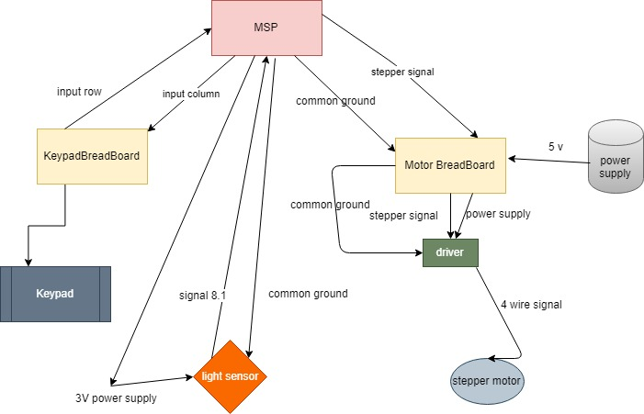

Figure 2: Simple Sketch of a Feasibility Model Design

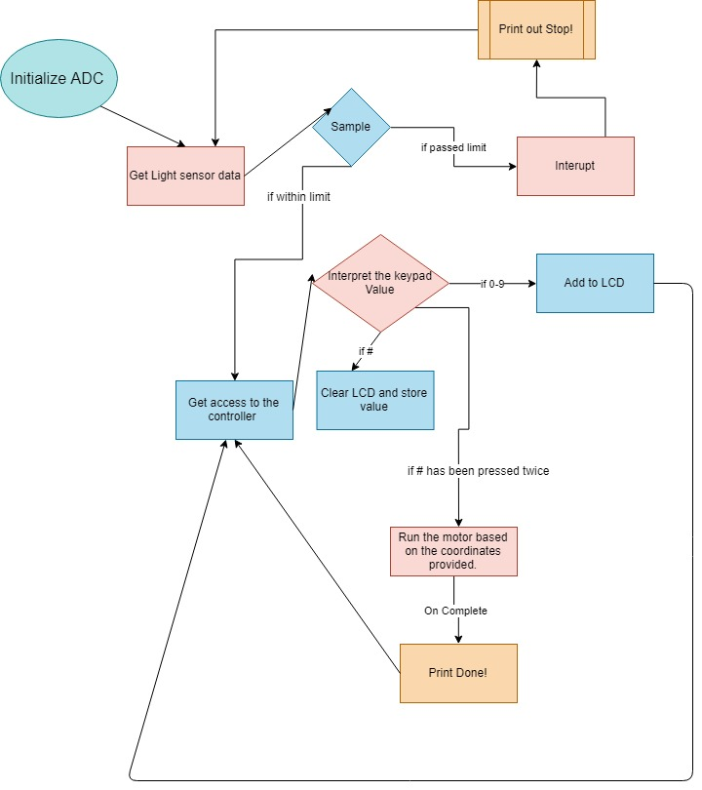

Figure 3: Simple Sketch of a Software Flowchart