Class4.R
nathanjoseph
2026-01-16
x <- 1:50
plot(x)
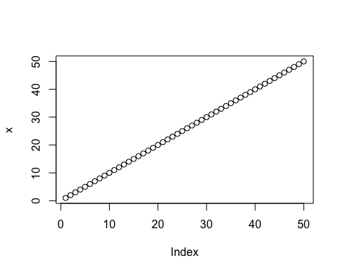
plot(x, sin(x), typ='l', col = 'red', lwd = 3,
xlab="Is it lunch time yet?")
