FORM1
This framework would be good for:
- The “Counting” program
- School program
- Office filing

Definitions:
Term | Definition
Custom Forms | Forms created using Open Office Writer or Calc. These forms may pull data from the system.
Filed Forms | Scanned forms (PDF or JPG), other image files(*.pdf, *.jpg, *.gif), text files (*.txt), Open Office files that were “generated” (*.odt, *.ods).
Forms | Visual Studio forms that are part of the system.
Generated Forms | Open Office forms that have macros to bring in data from the system to per-populate fields on the form. When “saved” they will be filed into persons “tab”.
Tab | Folders analogous to manila folders

Overview:

The general layout is that the user can “define” people/companies of various “types”. “Tabs”, are user defined to organize and contain data in the form of scanned or otherwise generated forms for each of the people/companies. Other “forms” will be supplied to perform “work” based on the use of the program. The user will also be able to define “custom forms” in Open Office that when “generated” will be able to be filed in the tabs.

The “work” area “ pnlHosting”, is where the program comes to life. It can host the code for the counting program (with changes to have the people defined as part of “Clone”), School specific forms as well as the “Custom Forms” that would do just about anything else.

Main Form:

This picture of the main form shows the various panels with short descriptions of what will be the main use of the panel.

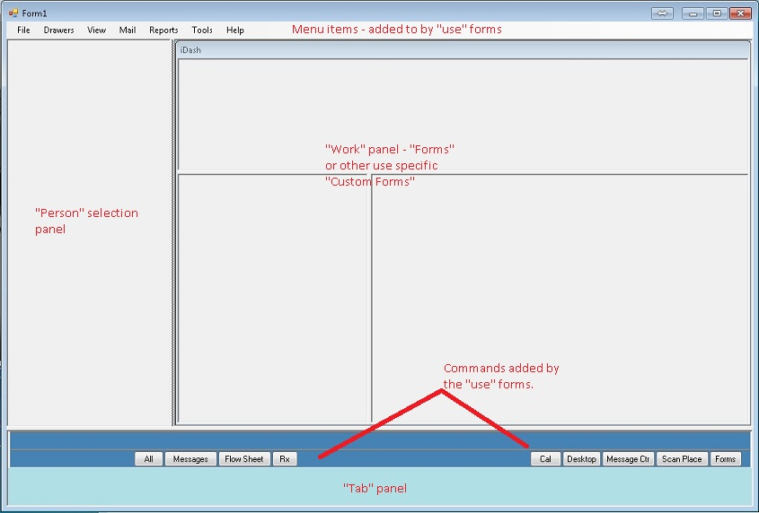

The person selection panel will be filled in with a variety of forms:
- Simple “alphabetic tabbed alphabetic list (i.e. Phone book)
- Appointment list with search
- Tree view (i.e. for “classes”, “grades” etc.

The “Work” panel will hold the various “Forms” to …

The “Tab” panel is where the tabs will be displayed. Selecting a tab will bring a list of the forms up in the “Work” panel. The user will be allowed to select the “form” to be displayed, also in the “Work” panel.

Programming Guidelines:
The “Clone” project provides the following:
- Form1 frameworks
- “Person” data (Persons are maintained from here
- “Users” are defined in the Tools->Settings
- “Tabs” are defined in the Tools->Settings
- The “pnlHosting” panel is where most of the “work” is done, but when necessary “work” forms can spread left into the “pnlPeople” and down into the “flowLayoutPanel1”. NOTE: need to go back and add a panel in the flowLayoutPanel1 here.
- The custom forms piece needs to be done in “Clone”

TO DO:
- Get the Adding/Editing people to work.
- Get the Search/Display people to work
- Get a custom form to work
- Get Tab creation working
- Display the tabs
- Be able to put the output of the custom forms to a tab
- How to handle the buttons at the bottom
- Display the currently selected person

