Assignment #1 Report — HTML & CSS Basics
Student name | Yershadi Nurassyl
Group | SE-2523
Assignment | Assignment #1 — HTML & CSS Basics
Published URL | [Insert your published page URL here, e.g. GitHub Pages or Netlify link]

Profile photo used on the personal webpage (Yershadi Nurassyl, Group SE-2523).

1. Objective
The objective of this project was to build and publish one personal webpage using HTML and an external CSS stylesheet, demonstrating structured content, basic HTML elements, custom selectors, typography, colors, and the CSS box model. Bootstrap, JavaScript, and responsive layout techniques were not used, since they are outside the scope of this assignment.

2. Part 1 — HTML Structure
The webpage (index.html) was organized into a header, a navigation bar, a main content area with five sections, and a footer. The following tasks were completed:
- Project setup: created index.html, style.css, and an images folder; set the HTML5 doctype, language (en), UTF-8 encoding, and the page title “My First Webpage.”
- Page structure: used h1 for my name, h2 for my group/course line and each section title, and h3 for sub-headings (Hobbies, Favorite Websites).
- Lists, image and links: added an ordered list of hobbies and an unordered list of favorite websites with three working external links (GitHub, freeCodeCamp, YouTube); added a personal avatar image with descriptive alt text, referenced with a relative path.
- Navigation and button: built a navigation bar linking to matching section IDs (#about-me, #hobbies, #schedule, #mood, #contact) and added a “Click Me” button with no JavaScript action.
- Schedule table: created a three-column table (Subject, Day, Time) with proper <th> header cells and a caption, listing my weekly classes.
- Mood paragraph: added a short paragraph describing my mood using three emojis.
- Basic form: added Name, Email, and Favorite Color inputs, each associated with a visible <label>, plus a Submit button.

3. Part 2 — CSS Styling
All styling was written in an external stylesheet (style.css) linked from the document head. The following tasks were completed:
- Selectors: demonstrated all four required selector types — element selectors (h1, p, a), class selectors (.profile-card, .site-nav, .schedule-table), an ID selector for the unique #about-me section, and a descendant selector (.site-nav a) for links inside the navigation.
- Typography: set distinct font families for headings (Oswald) and body text (Inter), a clear type scale, left-aligned body text, and a custom link color with an underline-on-hover treatment.
- Colors and backgrounds: used a consistent dark palette (charcoal background, off-white text, emerald-green accent) with a lighter surface color for cards and sections, keeping text contrast readable throughout.
- Box model and sizing: used margin, padding, and border to separate the header, sections, cards, table cells, and the form; set explicit width/height on the avatar image and the form's color input.
- Navigation states: added spacing between nav links, a visible color change on :hover, and a custom outline on :focus for links, buttons, and form controls.
- Image styling: constrained the avatar to a fixed circular size with object-preserving proportions, plus a colored border and a drop shadow.

4. HTML & CSS Code with Output
For each part of the page below, the relevant HTML markup and CSS rules are shown first, followed by a screenshot of how that part actually renders in the browser.

4.1 Header & Navigation
HTML:
<header class="site-header">
<div class="header-inner">
<h1 class="site-title">Yershadi Nurassyl</h1>
<h2 class="site-subtitle">Software Engineering Student &middot; Group SE-2523</h2>
<nav class="site-nav" aria-label="Section navigation">
<ul>
<li><a href="#about-me">About</a></li>
<li><a href="#hobbies">Hobbies</a></li>
<li><a href="#schedule">Schedule</a></li>
<li><a href="#mood">Mood</a></li>
<li><a href="#contact">Contact</a></li>
</ul>
</nav>
</div>
</header>

CSS:
.site-nav ul {
list-style: none;
padding: 0;
margin: 0;
border-top: 1px solid var(--color-border);
padding-top: 16px;
}

.site-nav li {
display: inline-block;
margin: 0 14px;
}

.site-nav a {
font-family: var(--font-heading);
color: var(--color-text);
padding-bottom: 4px;
}

.site-nav a:hover {
color: var(--color-accent);
border-bottom-color: var(--color-accent);
}


Figure 1. Output — header with name, course line, and section navigation.

4.2 About Me
HTML:
<section id="about-me" class="section">
<div class="profile-card">
<img class="profile-photo" src="images/avatar.svg"
alt="Illustrated avatar of Yershadi Nurassyl">
<div class="profile-text">
<h2 class="section-title">About Me</h2>
<p>Hi, I am Nurassyl, a first-year Software
Engineering student in group SE-2523...</p>
<button type="button" class="btn btn-primary">Click Me</button>
</div>
</div>
</section>

CSS:
#about-me {
background-color: var(--color-surface);
padding: 40px 32px;
margin-top: 40px;
border: 1px solid var(--color-border);
border-radius: 8px;
}

.profile-photo {
width: 140px;
height: 140px;
border: 3px solid var(--color-accent);
border-radius: 50%;
box-shadow: 0 6px 18px rgba(0, 0, 0, 0.4);
}

.btn-primary {
background-color: var(--color-accent);
color: #0D1210;
}

.btn-primary:hover {
background-color: var(--color-accent-dark);
}

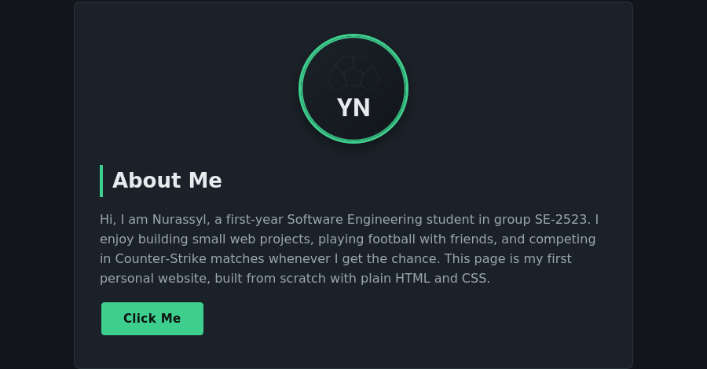
Figure 2. Output — About Me section with avatar, introduction, and Click Me button.

4.3 Hobbies & Favorite Sites
HTML:
<h3 class="subsection-title">My Hobbies</h3>
<ol class="hobby-list">
<li>Playing football with my university team</li>
<li>Competing in Counter-Strike (CS) with friends</li>
<li>Training at the gym</li>
</ol>

<h3 class="subsection-title">Favorite Websites</h3>
<ul class="site-list">
<li><a href="https://github.com" target="_blank"
rel="noopener noreferrer">GitHub</a> &mdash; hosting my code</li>
...
</ul>

CSS:
.hobby-list,
.site-list {
padding-left: 22px;
}

.hobby-list li,
.site-list li {
margin-bottom: 8px;
color: var(--color-text-muted);
}

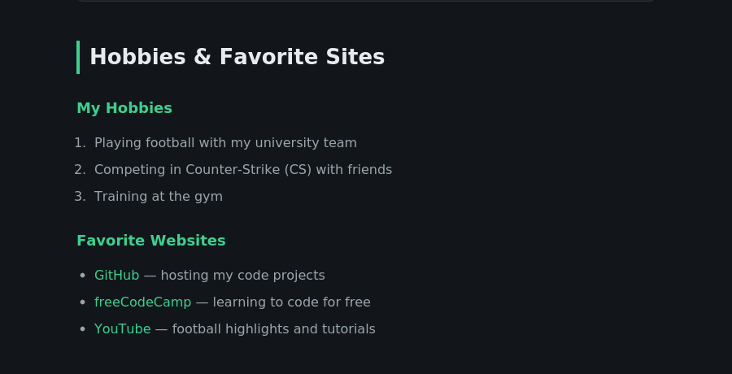
Figure 3. Output — hobbies list and favorite websites with external links.

4.4 Class Schedule
HTML:
<table class="schedule-table">
<caption>Weekly class schedule, Group SE-2523</caption>
<thead>
<tr>
<th scope="col">Subject</th>
<th scope="col">Day</th>
<th scope="col">Time</th>
</tr>
</thead>
<tbody>
<tr>
<td>Web Programming</td>
<td>Monday</td>
<td>09:00 &ndash; 10:30</td>
</tr>
...
</tbody>
</table>

CSS:
.schedule-table {
width: 100%;
border-collapse: collapse;
margin-top: 16px;
}

.schedule-table th,
.schedule-table td {
border: 1px solid var(--color-border);
padding: 10px 14px;
text-align: left;
}

.schedule-table th {
background-color: var(--color-surface);
font-weight: 600;
}


Figure 4. Output — weekly class schedule table.

4.5 Mood
HTML:
<section id="mood" class="section">
<h2 class="section-title">My Mood</h2>
<p class="mood-text">Most days I feel focused and motivated
at my laptop &#9889;, especially after a good gym
session &#128170;. When my team wins a close CS
match, the excitement is real &#127918;&#128293;!</p>
</section>

CSS:
.mood-text {
background-color: var(--color-surface);
border: 1px solid var(--color-border);
border-radius: 8px;
padding: 20px 24px;
font-size: 1.05rem;
}


Figure 5. Output — mood paragraph with emojis.

4.6 Contact Form
HTML:
<form class="contact-form" action="#" method="get">
<div class="form-group">
<label for="name">Name</label>
<input type="text" id="name" name="name">
</div>
<div class="form-group">
<label for="email">Email</label>
<input type="email" id="email" name="email">
</div>
<div class="form-group">
<label for="favorite-color">Favorite Color</label>
<input type="color" id="favorite-color" value="#3ecf8e">
</div>
<button type="submit" class="btn btn-primary">Submit</button>
</form>

CSS:
.contact-form {
background-color: var(--color-surface);
border: 1px solid var(--color-border);
border-radius: 8px;
padding: 28px;
max-width: 420px;
}

.form-group input {
width: 100%;
padding: 10px 12px;
background-color: var(--color-bg);
border: 1px solid var(--color-border);
color: var(--color-text);
}

a:focus,
button:focus,
input:focus {
outline: 3px solid var(--color-focus);
outline-offset: 2px;
}

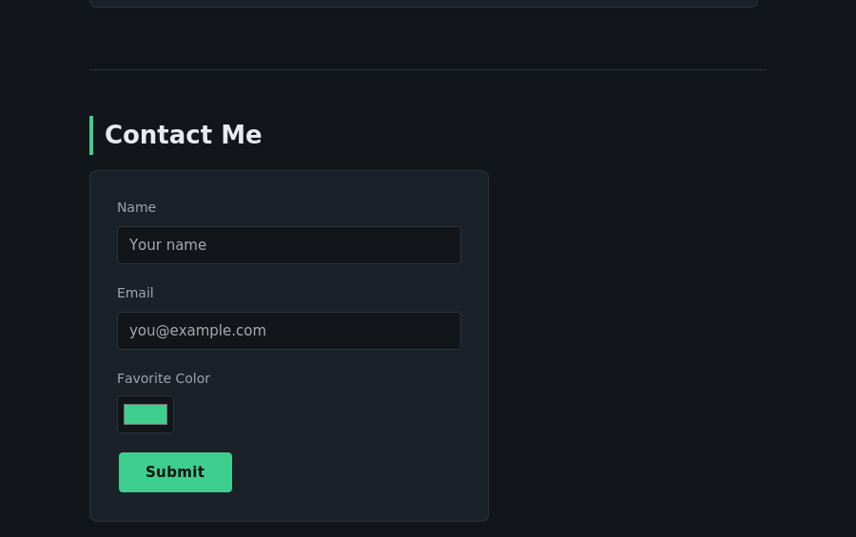
Figure 6. Output — contact form with Name, Email, and Favorite Color inputs.

5. Work Process and What I Learned
I started by planning the page structure on paper, then built the HTML skeleton before adding any styling, which made it easier to check that headings, lists, the table, and the form were all in a logical order first. Working on Part 2 afterward, I learned the practical difference between class and ID selectors: classes let me reuse one style across the schedule table and the form card, while the single #about-me ID let me give that one section a distinct background and border without affecting anything else. I also learned how the box model controls spacing between elements, and why keeping padding and border widths consistent keeps a page looking organized. The most useful accessibility lesson was pairing every form input with a real <label> and keeping a visible focus outline, since both make the page usable without a mouse.

