**CST-341 Design Report Template**

|  |  |  |
| --- | --- | --- |
| **Topic:** | Milestone 3 | |
| **Date:** | 10/14/2018 | |
| **Revision:** | 3.0 | |
| **Team:** | 1. Ali Cooper | |
| 1. Anthony Natividad | |
|  | |
|  | |
| **Weekly Team Status Summary:** | |  |  |  |  | | --- | --- | --- | --- | | **User Story** | **Team**  **Member** | **Hours**  **Worked** | **Hours Remaining** | | JSP pages (Deck and Card) | Anthony | 2 | *0* | | Navigation Bar | Anthony | 1 | *0* | | CSS | Anthony | 2 | *0* | | Updates to Design Report | Anthony | 1 | *0* | | Home and Deck controllers | *Ali C. & Anthony N* | *2* | *0* | | Business Interfaces | *Ali* | 1 | *0* | | Business Services | *Ali* | 1 | *0* | | Refactored Models | *Ali* | 1 | *0* | | Server Configurations | *Ali* | 1 | *0* | |  |  |  |  | |  |  |  |  | |  |  |  |  | |  |  |  |  | | |
| **GIT URL:** | <https://github.com/n4n0byte/CardsCLC> . | |
| **Peer Review:** | *Y* | We acknowledge that our team has reviewed this report and we agree to the approach we are all taking. |
| **Screen Cast** | https://www.useloom.com/share/104c777dc8734dd3961ea640229189cf | |

**Planning Documentation**

**Agile Scrum Product Backlog:**

N/A

**Agile Scrum Sprint Backlog:**

N/A*.*

**Agile Scrum Burn Down Chart:**

N/A

**Agile Retrospective Results:**

*The following table should be completed after each Retrospective on Things That Went Well (Keep Doing). An alternative to the following table is to use a Mind Mapping tool such as Coggle. If you use a Mind Mapping tool, you must include a URL or Image File.*

|  |
| --- |
| **What Went Well** |
| Coding the JSP’s, Models, and Controller |
|  |
|  |

*The following table should be completed after each Retrospective on Things That Didn’t Go Well (Stop Doing) and What Would Be Done Differently Next Time with an Action Plan to Improve (Try Doing and Continuous Improvement). An alternative to the following table is to use a Mind Mapping tool such as Coggle. If you use a Mind Mapping tool, you must include a URL or Image File.*

|  |  |  |
| --- | --- | --- |
| **What Did Not Go Well** | **Action Plan** | **Due Date** |
|  |  |  |
|  |  |  |
|  |  |  |

**Design Documentation**

**Install Instructions:**

*Include step-by-step instructions for setting up your database, configuring, and deploying/installing your application. This section should also include detailed instructions for what configuration files are required by your application, what configuration settings need to be adjusted for various runtime (development or production) environments, and where the files need to be deployed to. This section should also contain detailed instructions for how to clone your application source code from BitBucket and deploy the application to an externally hosted site.*

**General Technical Approach:**

Naming conventions:

* Grammar: Camel Case
  + Ex.
    - Class
      * Card
    - Interface
      * IdeckUpdater
    - Method
      * getCardById(int id)
    - Variable
      * Card currentCard
    - Views
      * Collection.jsp
      * URLs: Camel Case
  + Ex.
    - <Application Title>/myCollection/showDecks

Configuration:

* Java Based

Dependency Manager:

* Maven

CSS:

* Layout System: CSS Grid, Shadow DOM, CSS Variables
* Theming: Bootstrap

Database Technologies & Frameworks:

* MySQL
* Spring Data

Git:

* Git ignore: ide files.

**Key Technical Design Decisions:**

Decided to us CSS instead of Grid containers because the grid container would break the format of views

Decided to make home page display list of decks and user will be able to add a new deck or card from their

**Known Issues:**

Issues with Git; updates to project would not be pulled correctly.

**Risks:**

|  |  |  |
| --- | --- | --- |
| **Risk** | **Details** | **Countermeasures** |
| **Features of project is too ambitious** | Features such as the deck copy and or search filter will take too long to finish along side the main features of application. | Scale back some features of the project and add additional features when the core of the project is done. |
| **Personal Emergencies** | Team member has family or personal emergency like: ill, funeral, wedding, ect. and cant finish workload. | Allow team member too know as soon as possible so that work can be taken care of before Milestones are due. |
| **Internet Problems/Issues** | Internet at GCU down or under maintenance. Loud Cloud down | Work from another location or use a hotspot to submit work.  Email Professor work explaing that we cant upload to Loud Cloud |
| **Time management for tasks** | The estimated amount of time for particular tasks for the milestone taking longer than estimated. | Practice SCRUM so that the team can properly manage tasks as efficient as possible. |

**ER Diagram:**

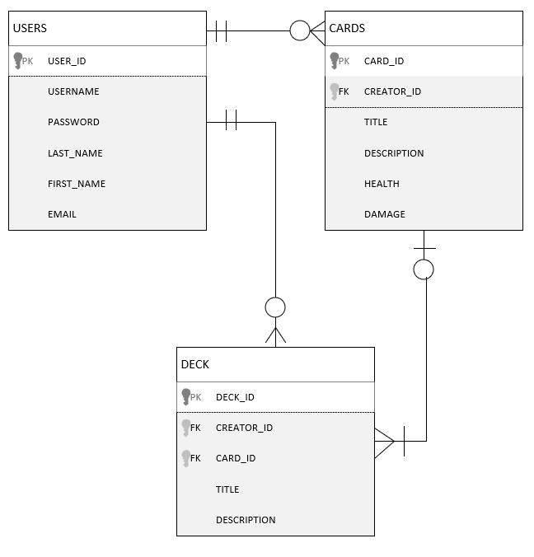

**DDL Scripts:**

N/A

**Sitemap Diagram:**

*.* 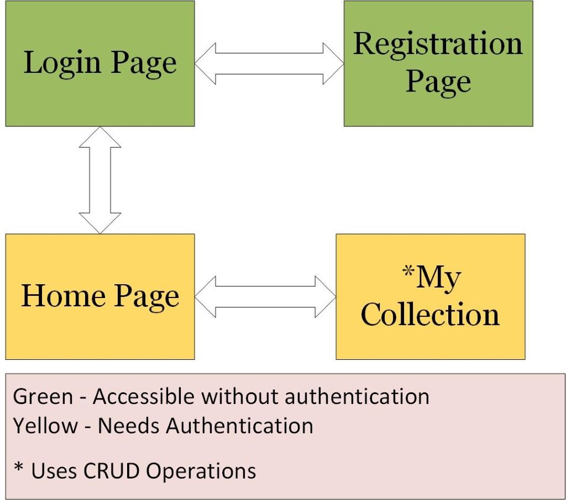

**User Interface Diagrams**

Index(may change index uri later)

**:** 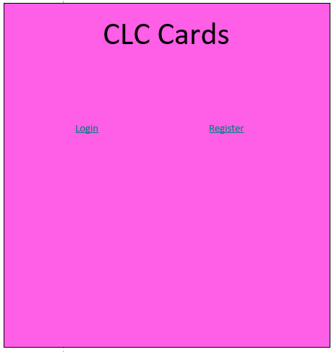

Login

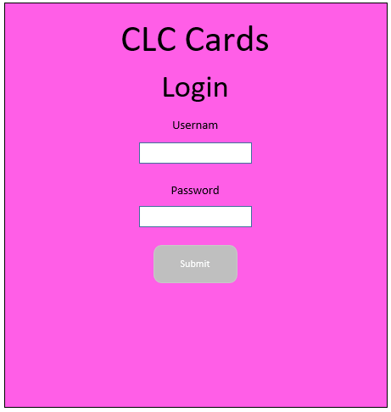

Registration

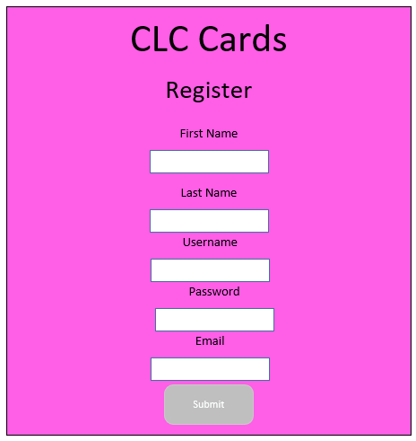

**New Deck**

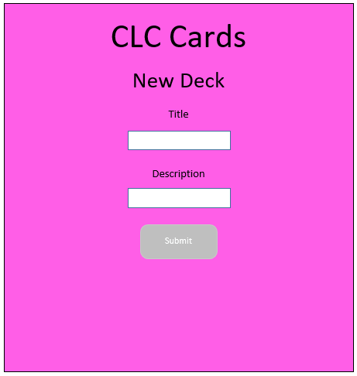

**AddCard**

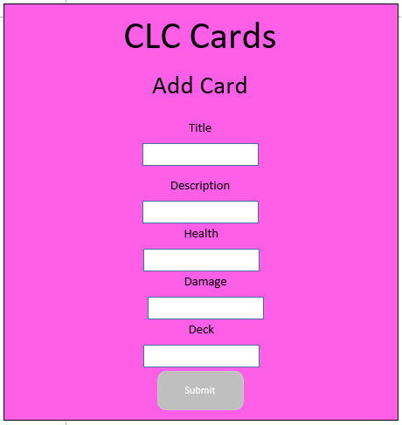

**Home**

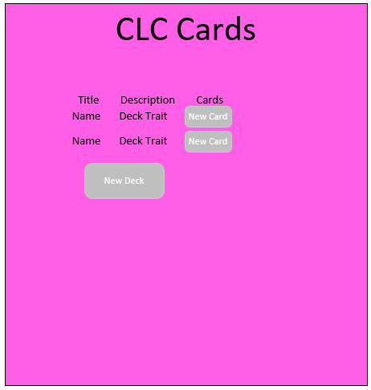

**Class Diagrams:**

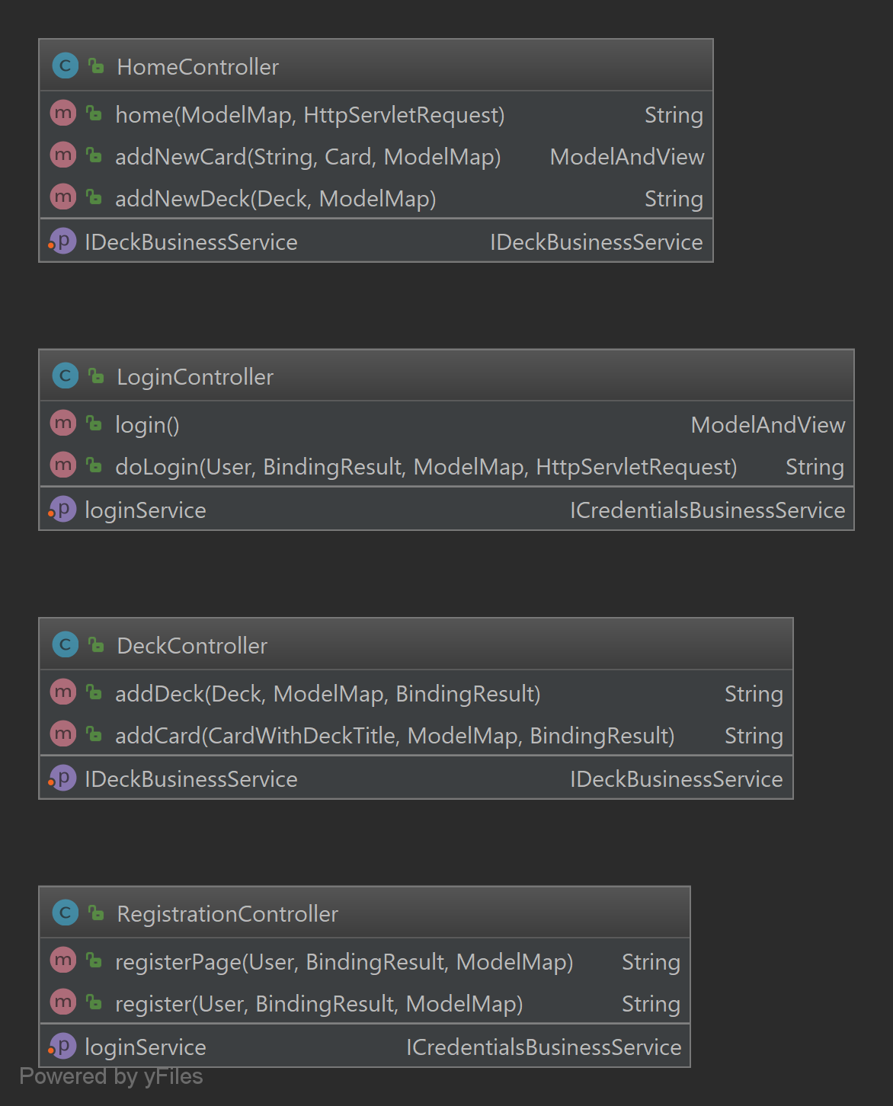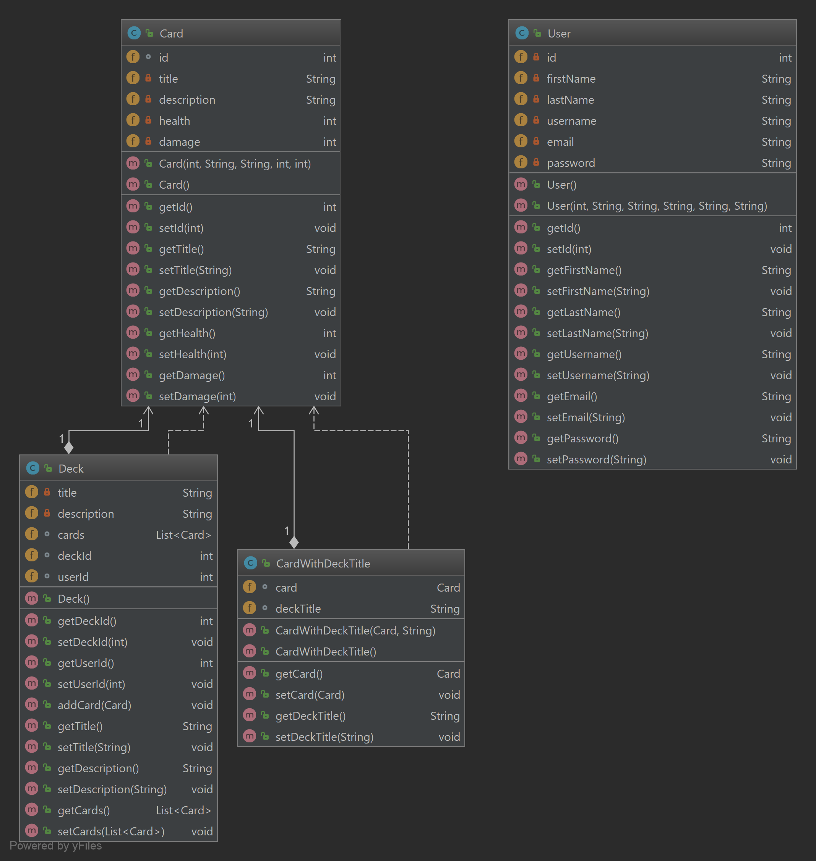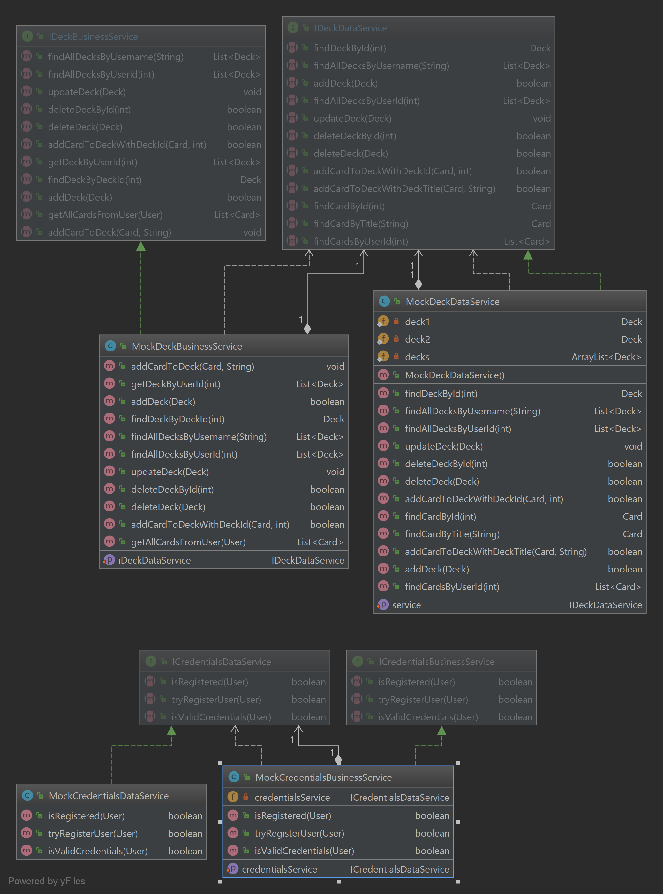

**Service API Design:**

*N/A*

**Security Design:**

*N/A*

**Other Documentation:**

N/A