Ali Cooper

01/14/17

CST-247

Professor Mark Reha

**ICA 1**

ASP .NET MVC:

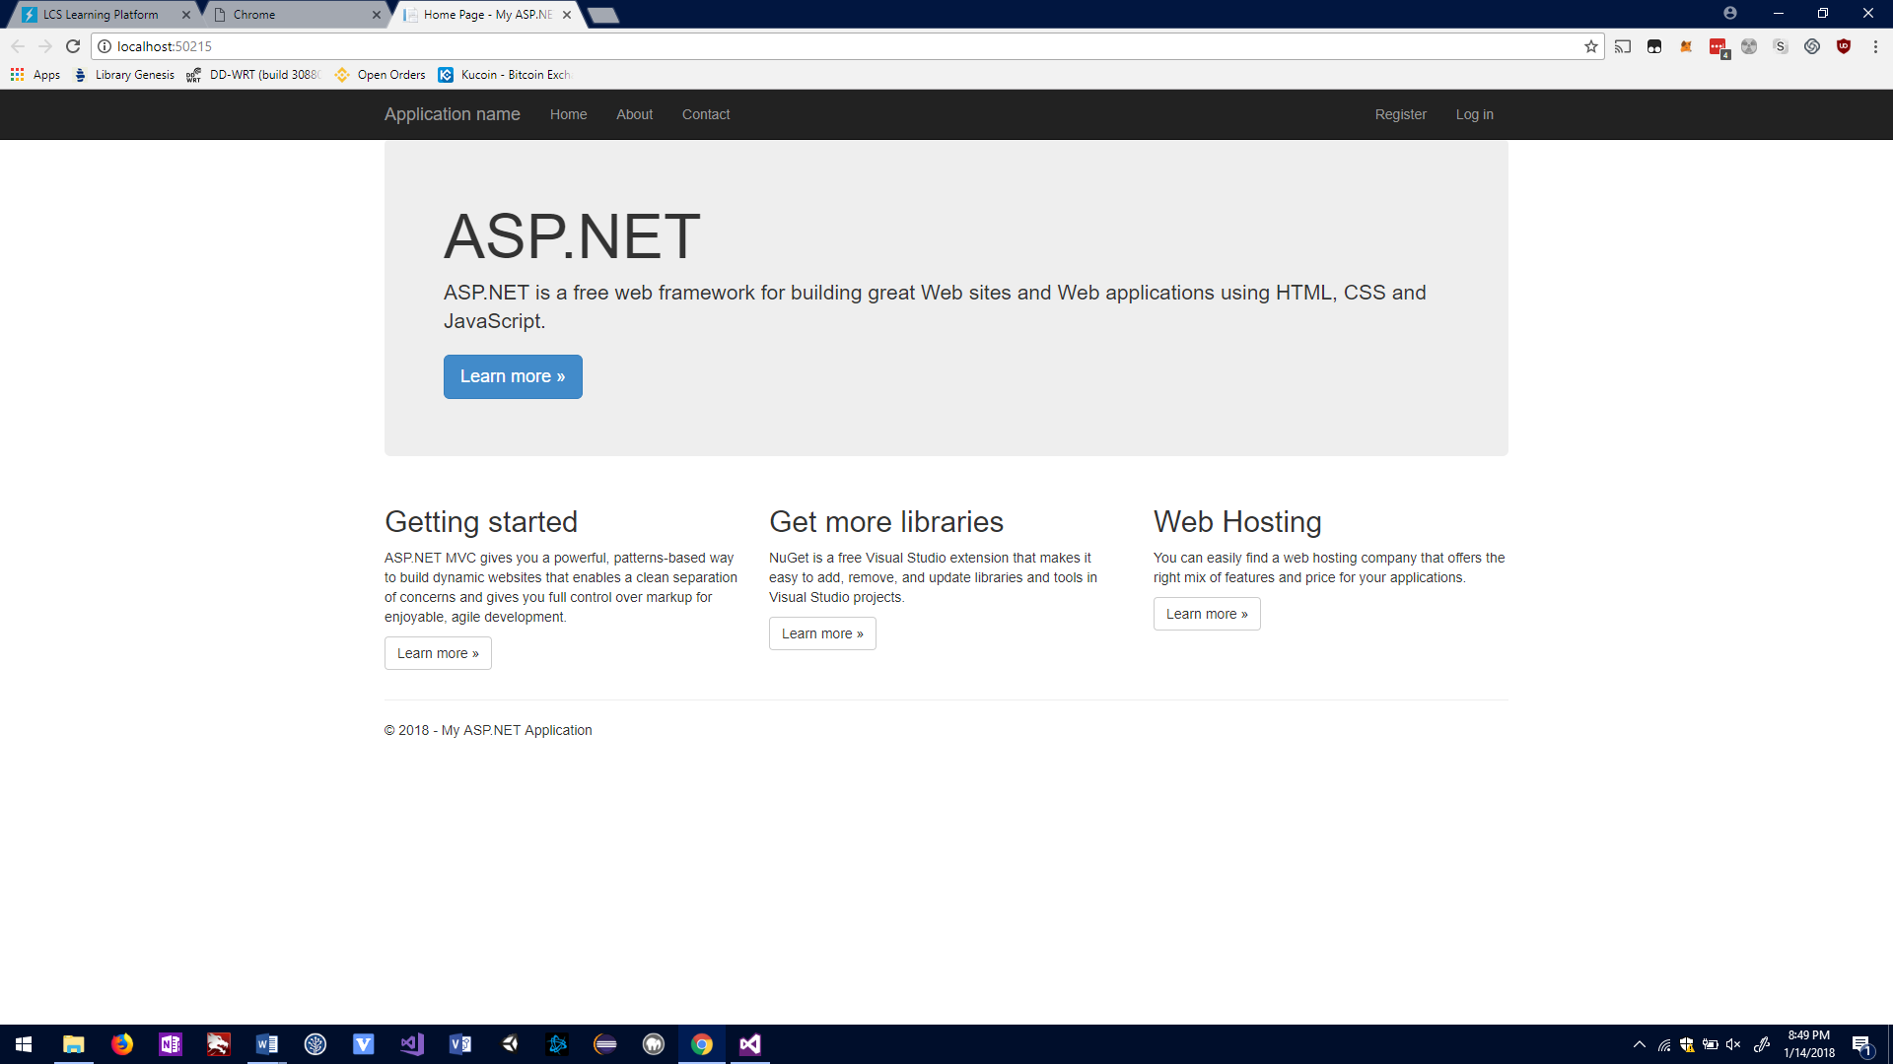

What I learned:

1. .NET MVC is separated into 3 different concerns, the model, the view and the controller/
2. Model classes contain variables store information for entities such as customers and employees.
3. Views are responsible for displaying HTML content to the user.
4. Controllers take in requests, get model info then pass it on to a view that is displayed to a user.
5. Routes are used to send requests to controllers, the URL will contain information that corresponds to a controller, a specific method defined within that controller and an id.
6. There are two life cycles within the MVC framework, the application and request life cycles.