ICA 2

Ali Cooper

CST 247

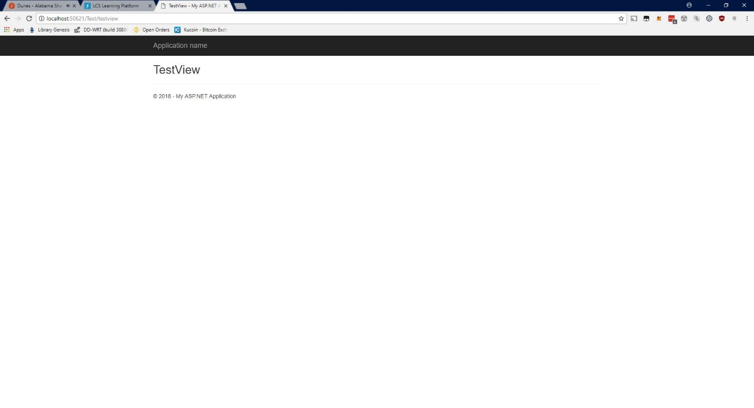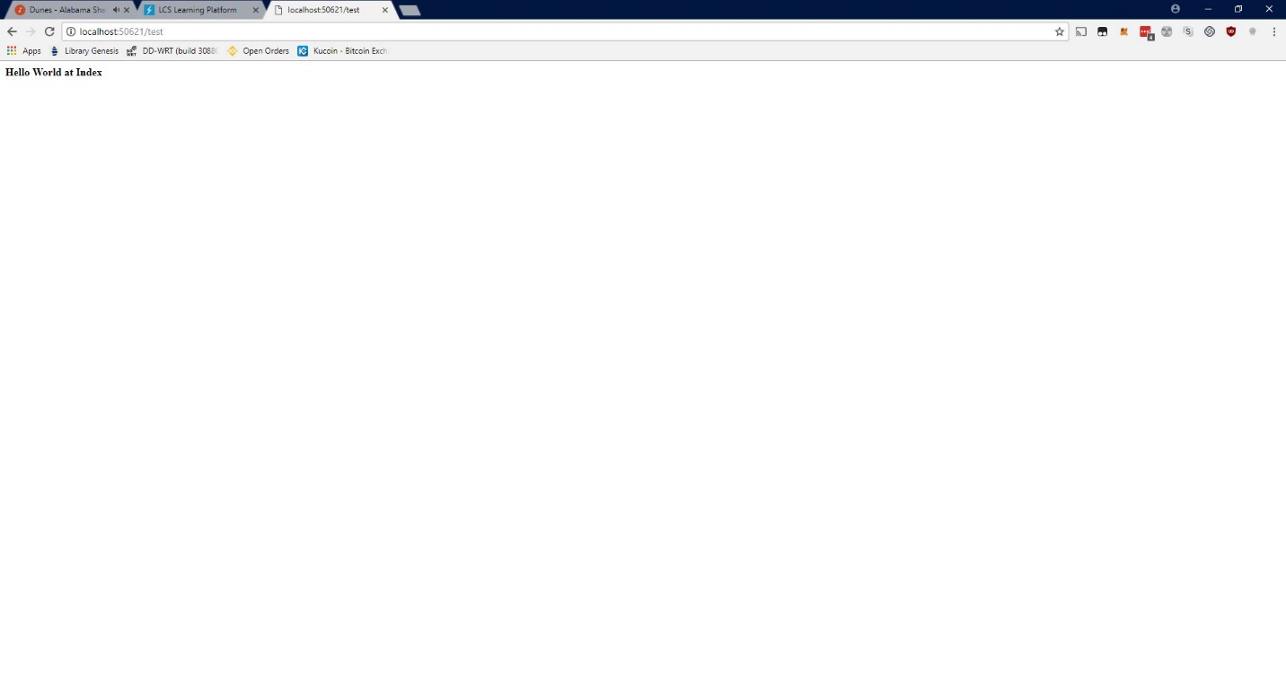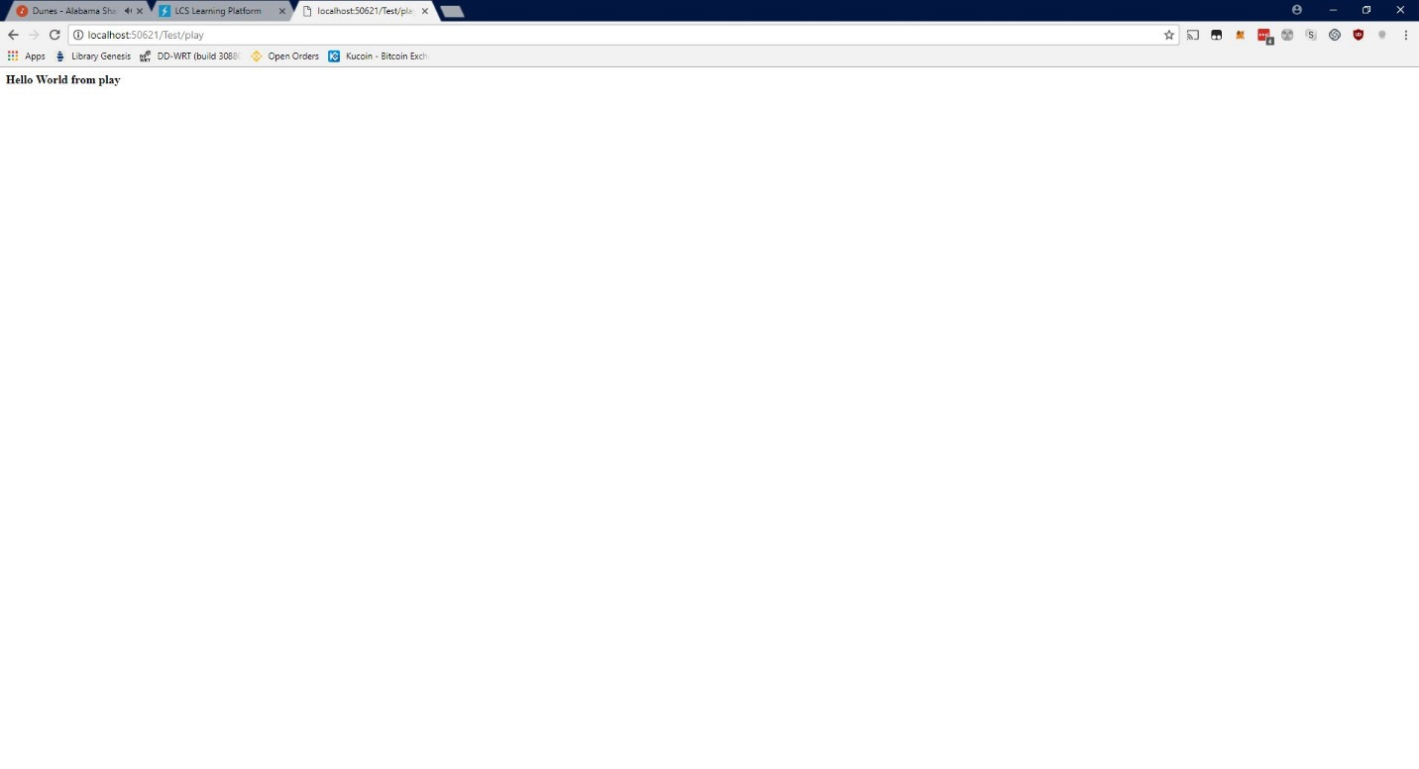

6 things that I learned from the tutorial

1. You can call methods defined in one controller from another using RedirectToAction
2. There is a hierarchy for the 4 types of built in filters with Authorization filters being ran first and Exception Filters being ran last.
3. It is possible to cache the result of actions.
4. Filters can be applied on both the method and class level.
5. The ActionName attribute is used to call an action by another name specified within the above attribute.
6. The NonAction attribute is used to prevent an action from being called from the url.