Database Project Documentation

Principles of Database Design and Management

Group Members:

Napo Qheku 202101679
Kabelo Thesele 202101668
Boitumelo Jase 202201099
Hlompho Ntoko 202201130
Motlalehi Mafohla 202201257

Instructor: Likeleli Letsie (PhD)

Submission date: 26th April 2025



Business Case:

In the modern era, veterinary clinics and pet-related businesses are increasingly relying on technology to manage the growing demands of animal healthcare, customer service, and retail operations. The traditional paper-based or manually operated systems used by many small to mid-sized veterinary practices and pet shops are inefficient, prone to human error, and lack integration across various services.
This project proposes the development of a Vet/Animal Hospital Management System—a digital platform aimed at improving the operational efficiency of a veterinary clinic.
The system will centralize the management of pet medical records, appointments, treatments, and prescriptions, while also supporting the sale of pet-related products such as food, accessories, and medication through a built-in inventory and order management module.
Key users of the system include veterinarians, administrative staff, pet owners and system administrators. The interface will provide features tailored to each type of user, ensuring secure and role-based access to the system.
The overall goal of this system is to:
- Streamline the booking and management of vet appointments.
- Improve the accuracy and accessibility of pet medical records.
- Provide data-driven reports to support operational decisions.
- Enhance customer experience through efficient service and transparency.
By integrating multiple core functions into a single, user-friendly application, the Vet/Animal Hospital Management System will not only improve the internal workflow of the clinic but also deliver better service to pet owners and system admins. The project provides a practical and robust opportunity to apply relational database principles, normalization, ERD modeling, and CRUD operations—core concepts in the study of database design and management.

Business Rules:

Veterinary Clinic Module
- Each pet must be registered under one and only one owner.
(One-to-Many: An owner can have multiple pets.)
- A pet can have multiple appointments over time, but each appointment must be associated with one pet and one vet.
- Each appointment must include a reason, status (e.g., pending, completed), and date.
- Each pet can undergo multiple treatments, and each treatment must be administered during a valid appointment.
(Many-to-Many: Pets ↔ Treatments)
- Each prescription must be linked to a pet and must specify the medication, dosage, and duration.

System Access and Security
- Each user (Vet, Admin, Customer) must have unique login credentials.
- Access to system modules and operations must be restricted based on user role.
- All input from users must be validated to prevent incorrect or malicious data entry.

Entity Relationship Diagram (ERD):

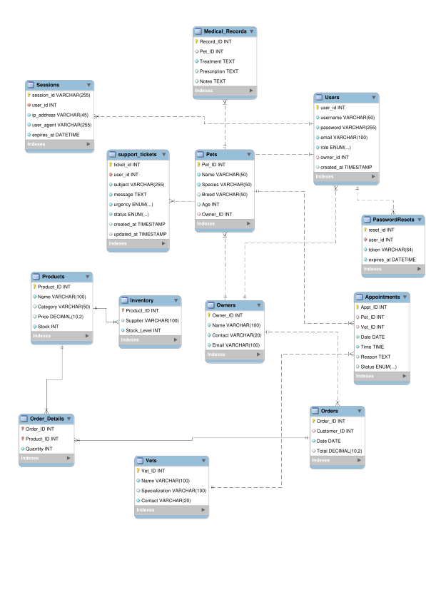
Database Design:

Tables and Relationships

Core Entities
- Owners
- Stores pet owner information
- Related to: Pets (one-to-many), Orders (one-to-many), Users (one-to-one)
- Pets
- Stores pet information
- Related to: Owners (many-to-one), Appointments (one-to-many), Medical_Records (one-to-many)
- Vets
- Stores veterinarian information
- Related to: Appointments (one-to-many)
- Products
- Stores product information
- Related to: Inventory (one-to-one), Order_Details (one-to-many)

Transactional Tables
- Appointments
- Manages veterinary appointments
- Related to: Pets (many-to-one), Vets (many-to-one)
- Medical_Records
- Stores pet medical history
- Related to: Pets (many-to-one)
- Orders
- Manages customer orders
- Related to: Owners (many-to-one), Order_Details (one-to-many)
- Order_Details
- Contains line items for orders
- Related to: Orders (many-to-one), Products (many-to-one)

- Inventory
- Tracks product stock levels
- Related to: Products (one-to-one)

User Management
- Users
- Manages system user accounts
- Related to: Owners (one-to-one), Sessions (one-to-many), PasswordResets (one-to-many), support_tickets (one-to-many)
- Sessions
- Tracks user sessions
- Related to: Users (many-to-one)
- PasswordResets
- Manages password reset tokens
- Related to: Users (many-to-one)
- support_tickets
- Handles customer support requests
- Related to: Users (many-to-one)

Schema Overview

CREATE TABLE `Appointments` (
`Appt_ID` int NOT NULL AUTO_INCREMENT,
`Pet_ID` int DEFAULT NULL,
`Vet_ID` int DEFAULT NULL,
`Date` date NOT NULL,
`Time` time NOT NULL,
`Reason` text,
`Status` enum('Scheduled','Completed','Cancelled') DEFAULT 'Scheduled',
PRIMARY KEY (`Appt_ID`),
KEY `Pet_ID` (`Pet_ID`),
KEY `Vet_ID` (`Vet_ID`),
CONSTRAINT `Appointments_ibfk_1` FOREIGN KEY (`Pet_ID`) REFERENCES `Pets` (`Pet_ID`) ON DELETE CASCADE,
CONSTRAINT `Appointments_ibfk_2` FOREIGN KEY (`Vet_ID`) REFERENCES `Vets` (`Vet_ID`) ON DELETE SET NULL);

CREATE TABLE `Inventory` (
`Product_ID` int NOT NULL,
`Supplier` varchar(100) DEFAULT NULL,
`Stock_Level` int NOT NULL,
PRIMARY KEY (`Product_ID`),
CONSTRAINT `Inventory_ibfk_1` FOREIGN KEY (`Product_ID`) REFERENCES `Products` (`Product_ID`) ON DELETE CASCADE);

CREATE TABLE `Medical_Records` (
`Record_ID` int NOT NULL AUTO_INCREMENT,
`Pet_ID` int DEFAULT NULL,
`Treatment` text NOT NULL,
`Prescription` text,
`Notes` text,
PRIMARY KEY (`Record_ID`),
KEY `Pet_ID` (`Pet_ID`),
CONSTRAINT `Medical_Records_ibfk_1` FOREIGN KEY (`Pet_ID`) REFERENCES `Pets` (`Pet_ID`) ON DELETE CASCADE
);

CREATE TABLE `Order_Details` (
`Order_ID` int NOT NULL,
`Product_ID` int NOT NULL,
`Quantity` int NOT NULL,
PRIMARY KEY (`Order_ID`,`Product_ID`),
KEY `Product_ID` (`Product_ID`),
CONSTRAINT `Order_Details_ibfk_1` FOREIGN KEY (`Order_ID`) REFERENCES `Orders` (`Order_ID`) ON DELETE CASCADE,
CONSTRAINT `Order_Details_ibfk_2` FOREIGN KEY (`Product_ID`) REFERENCES `Products` (`Product_ID`) ON DELETE CASCADE
);

CREATE TABLE `Orders` (
`Order_ID` int NOT NULL AUTO_INCREMENT,
`Customer_ID` int DEFAULT NULL,
`Date` date NOT NULL,
`Total` decimal(10,2) DEFAULT NULL,
PRIMARY KEY (`Order_ID`),
KEY `Customer_ID` (`Customer_ID`),
CONSTRAINT `Orders_ibfk_1` FOREIGN KEY (`Customer_ID`) REFERENCES `Owners` (`Owner_ID`) ON DELETE CASCADE
);

CREATE TABLE `Owners` (
`Owner_ID` int NOT NULL AUTO_INCREMENT,
`Name` varchar(100) NOT NULL,
`Contact` varchar(20) NOT NULL,
`Email` varchar(100) NOT NULL,
PRIMARY KEY (`Owner_ID`),
UNIQUE KEY `Email` (`Email`)
);

CREATE TABLE `PasswordResets` (
`reset_id` int NOT NULL AUTO_INCREMENT,
`user_id` int NOT NULL,
`token` varchar(64) NOT NULL,
`expires_at` datetime NOT NULL,
PRIMARY KEY (`reset_id`),
UNIQUE KEY `token` (`token`),
KEY `user_id` (`user_id`),
CONSTRAINT `PasswordResets_ibfk_1` FOREIGN KEY (`user_id`) REFERENCES `Users` (`user_id`) ON DELETE CASCADE
);

CREATE TABLE `Pets` (
`Pet_ID` int NOT NULL AUTO_INCREMENT,
`Name` varchar(50) NOT NULL,
`Species` varchar(50) NOT NULL,
`Breed` varchar(50) DEFAULT NULL,
`Age` int DEFAULT NULL,
`Owner_ID` int DEFAULT NULL,
PRIMARY KEY (`Pet_ID`),
KEY `Owner_ID` (`Owner_ID`),
CONSTRAINT `Pets_ibfk_1` FOREIGN KEY (`Owner_ID`) REFERENCES `Owners` (`Owner_ID`) ON DELETE CASCADE
);

CREATE TABLE `Products` (
`Product_ID` int NOT NULL AUTO_INCREMENT,
`Name` varchar(100) NOT NULL,
`Category` varchar(50) DEFAULT NULL,
`Price` decimal(10,2) DEFAULT NULL,
`Stock` int NOT NULL,
PRIMARY KEY (`Product_ID`)
);

CREATE TABLE `Sessions` (
`session_id` varchar(255) NOT NULL,
`user_id` int NOT NULL,
`ip_address` varchar(45) NOT NULL,
`user_agent` varchar(255) NOT NULL,
`expires_at` datetime NOT NULL,
PRIMARY KEY (`session_id`),
KEY `user_id` (`user_id`),
CONSTRAINT `Sessions_ibfk_1` FOREIGN KEY (`user_id`) REFERENCES `Users` (`user_id`) ON DELETE CASCADE
);

CREATE TABLE `Users` (
`user_id` int NOT NULL AUTO_INCREMENT,
`username` varchar(50) NOT NULL,
`password` varchar(255) NOT NULL,
`email` varchar(100) NOT NULL,
`role` enum('admin','vet','staff','client') NOT NULL,
`owner_id` int DEFAULT NULL,
`created_at` timestamp NULL DEFAULT CURRENT_TIMESTAMP,
PRIMARY KEY (`user_id`),
UNIQUE KEY `username` (`username`),
UNIQUE KEY `email` (`email`),
KEY `owner_id` (`owner_id`),
CONSTRAINT `Users_ibfk_1` FOREIGN KEY (`owner_id`) REFERENCES `Owners` (`Owner_ID`) ON DELETE CASCADE
);

CREATE TABLE `Vets` (
`Vet_ID` int NOT NULL AUTO_INCREMENT,
`Name` varchar(100) NOT NULL,
`Specialization` varchar(100) DEFAULT NULL,
`Contact` varchar(20) NOT NULL,
PRIMARY KEY (`Vet_ID`)
);

CREATE TABLE `support_tickets` (
`ticket_id` int NOT NULL AUTO_INCREMENT,
`user_id` int NOT NULL,
`subject` varchar(255) NOT NULL,
`message` text NOT NULL,
`urgency` enum('low','medium','high','critical') NOT NULL DEFAULT 'medium',
`status` enum('open','in_progress','resolved','closed') NOT NULL DEFAULT 'open',
`created_at` timestamp NULL DEFAULT CURRENT_TIMESTAMP,
`updated_at` timestamp NULL DEFAULT CURRENT_TIMESTAMP ON UPDATE CURRENT_TIMESTAMP,
PRIMARY KEY (`ticket_id`),
KEY `user_id` (`user_id`),
CONSTRAINT `support_tickets_ibfk_1` FOREIGN KEY (`user_id`) REFERENCES `Users` (`user_id`)
);

Application Description:

The Vet Management System is a web-based application developed to manage veterinary clinic operations. It integrates a structured relational database with an intuitive front-end interface to support the day-to-day activities of a modern veterinary practice and pet shop.

Technology Stack
- Frontend: HTML, CSS
- Backend: PHP (for server-side logic and database interaction)
- Database: MySQL (to store all structured data)
- Local Server Environment: XAMPP (Apache + MySQL + PHP)
- Design Tools: Lucidchart/Draw.io (for ERD and diagrams)

Application Modules
The application is modularly designed with the following core sections:

Veterinary Clinic Module
- Pet Registration: Add, update, and view pet information and link each pet to an owner.
- Appointment Management: Schedule appointments with vets, update statuses, and filter by date or vet.

User Roles and Access Control
- Administrator: Full access to all modules; manages users, data, and reports.
- Vet/Staff: Access to medical and appointment modules only.
- Customer: Can view information about their pets.
All roles authenticate via a secure login system with password protection.

Core Functionalities
- CRUD Operations: Implemented across all major modules (Create, Read, Update, Delete).
- Search and Filter: Easily search for pets, appointments, or products.
- Data Validation: Ensures accurate data entry using input constraints, validation scripts, and error messages.
- Forms and Controls: User-friendly interfaces with combo boxes, masked inputs, and pop-up alerts.

Why This Application?
This application provides an efficient, all-in-one solution for vet clinics. It reduces paperwork, minimizes errors, and improves user experience. Designed using best practices in database design, it demonstrates core concepts such as ER modeling, normalization, and database-driven web development.

User Interface Design:

The User Interface (UI) of the Vet/Animal Hospital/Animal Shop Management System is designed to be user-friendly, intuitive, and consistent across all modules. It provides role-based access to different features for administrators, veterinarians, and customers. The interface prioritizes usability, aesthetics, and form functionality to support all CRUD operations and improve user efficiency.

Design Principles
- Consistency: All forms and navigation elements follow a uniform layout and color scheme for ease of use.
- Clarity: Input labels, instructions, and button names are clear and descriptive.
- Accessibility: Designed for ease of use on desktops and tablets, with clear visual hierarchy and adequate contrast.
- Validation: Form inputs are on server-side (PHP) to prevent incorrect or malicious data entry.

Main Interface Components

1. Login Page
- Role-based login (Admin, Vet/Staff, Customer). Automatically assigns a user to the correct dashboard depending on their role
- Secure password fields
- Validation for incorrect login attempts

2. Pet Registration Form
- Fields: Pet Name, Species, Breed, Age, Owner (dropdown from Owner Table)
- Features: Input validation, combo box for species/breed, message alerts on successful registration or errors

3. Appointment Scheduling Form
- Fields: Pet (dropdown), Vet (dropdown), Date, Time, Reason
- Features:
  - Date picker for appointment date
  - Dropdowns linked to database
  - Form submission validates empty fields and date format

4. Reports Interface
- Dropdown to select report type (Appointments, Sales, Treatments, Adoptions)
- Date filters for report generation
- Generated reports can be exported or printed

UI Snapshots
Screenshots of each major form and interface will be included to visually demonstrate the layout, structure, and design patterns used.
The UI ensures smooth navigation and minimizes user error by implementing clean design standards and interactive controls. It serves as the core interaction layer between users and the underlying database.

USER INTERFACE
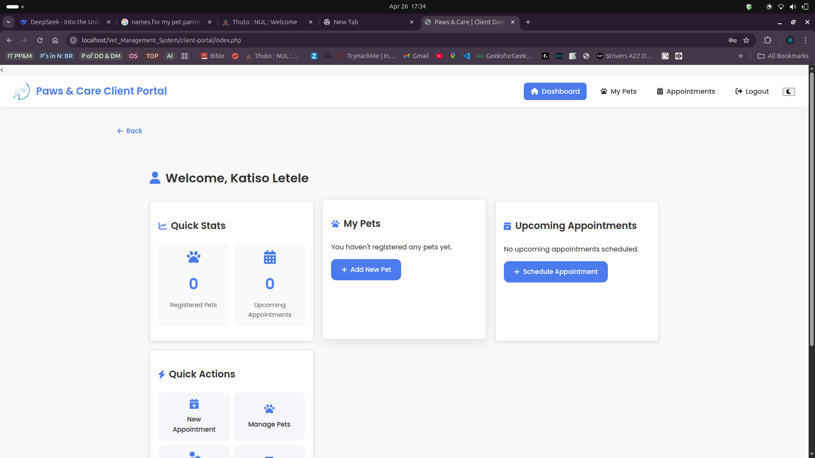

LOGIN INTERFACE

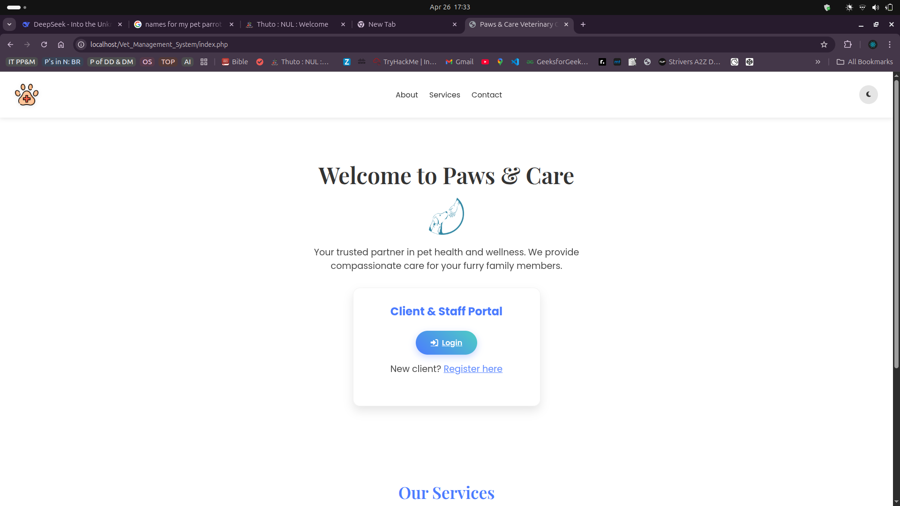

ADMIN INTERFACE
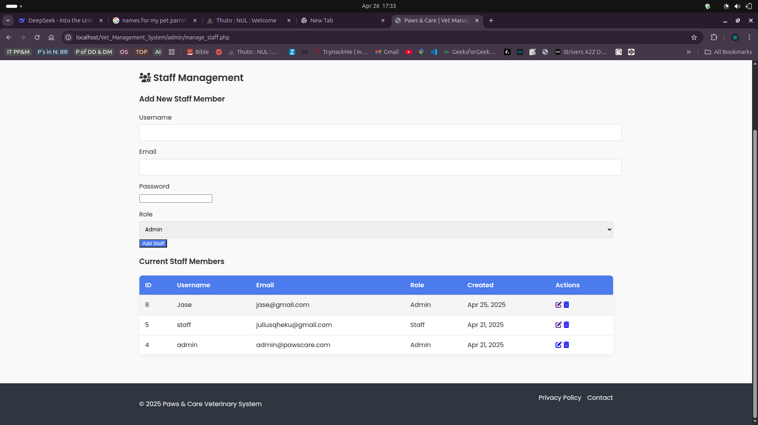

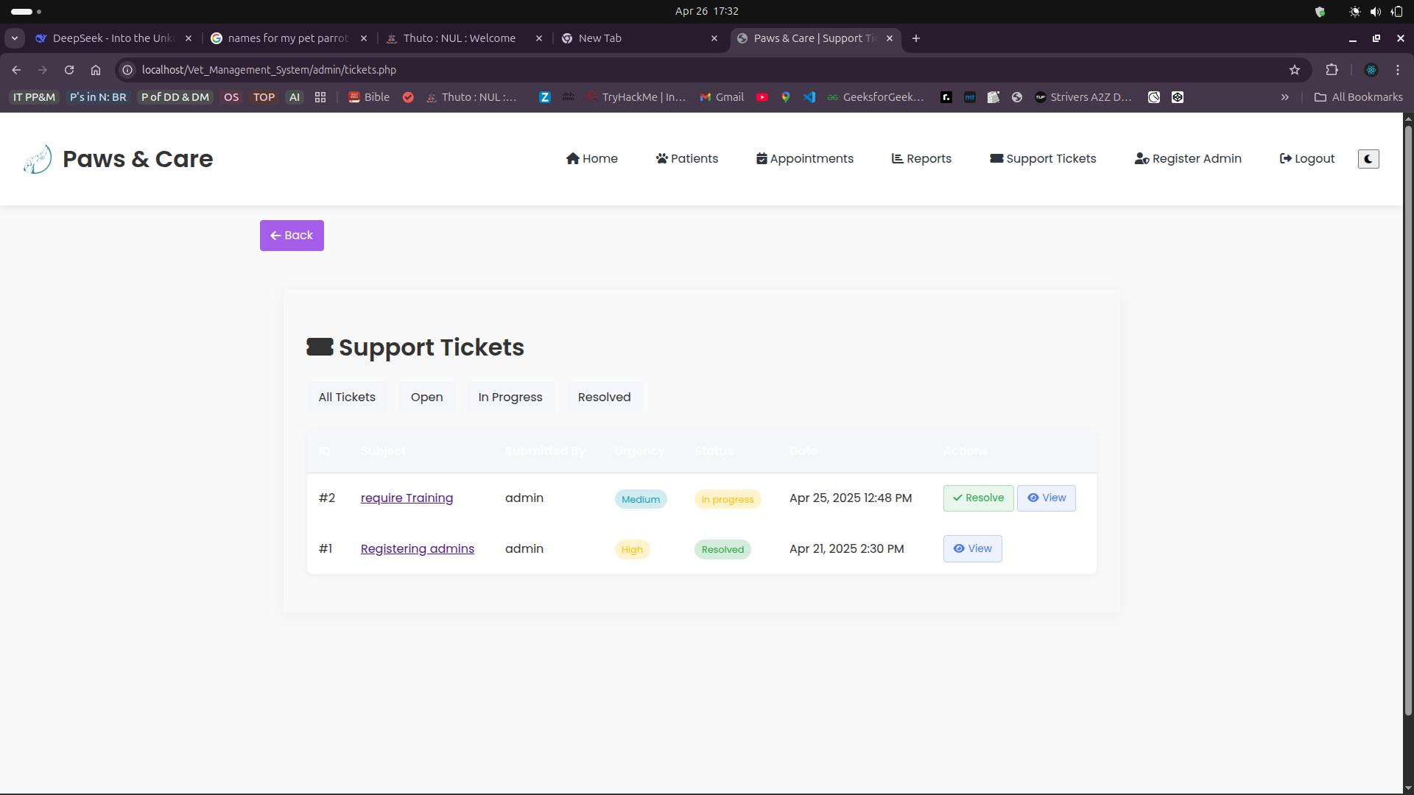

Reports:

The system includes a Reports Module designed to provide real-time, meaningful insights to support decision-making and streamline management operations. Each report draws data from two or more related tables, ensuring relational database principles are applied effectively.

1. Daily Appointments Report
Purpose: To help veterinarians and staff quickly review scheduled appointments each day.
Data Source:
- Appointments
- Pets
- Vets
Displayed Fields:
- Appointment Date & Time
- Pet Name
- Owner Name
- Vet Assigned
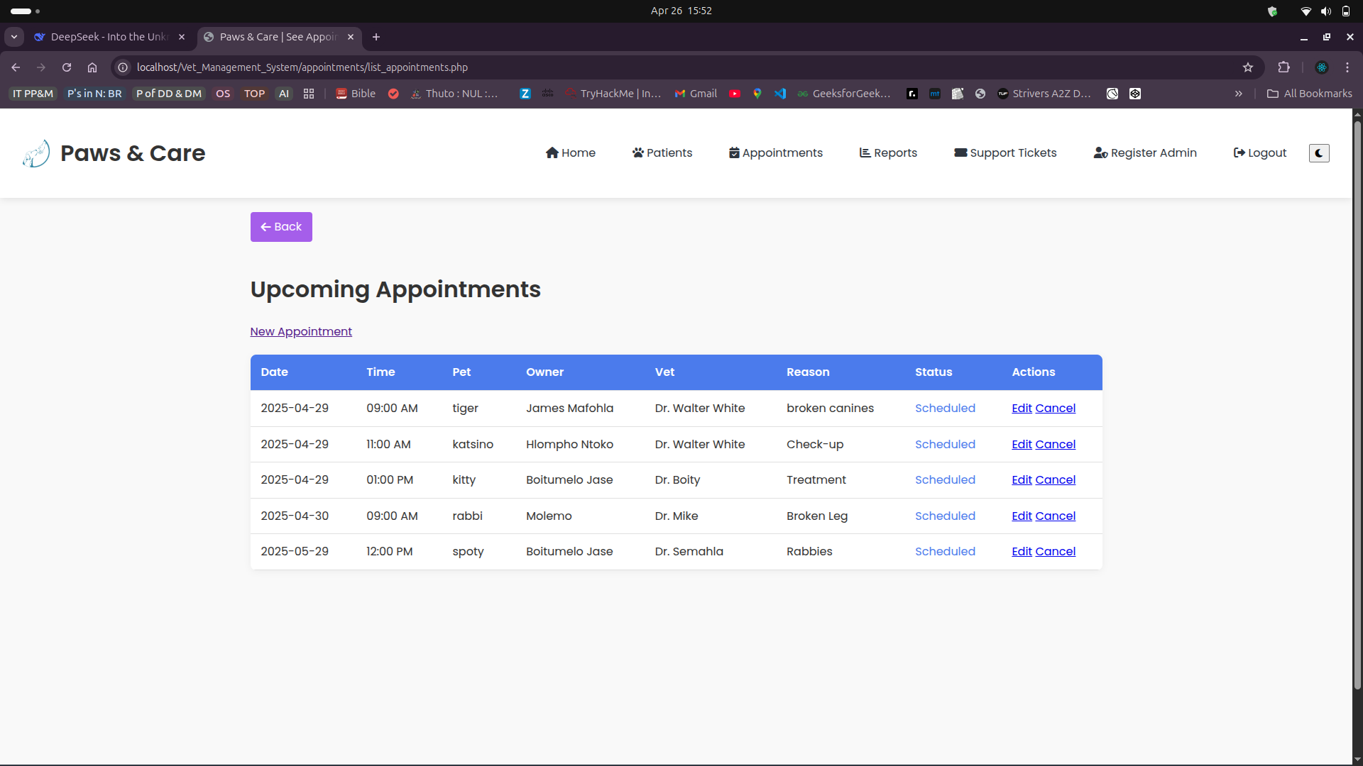
- Reason for Visit
- Status (e.g., Pending, Completed)
Use Case:
Doctors can check their daily schedule and prepare accordingly.

2. Pet List Report

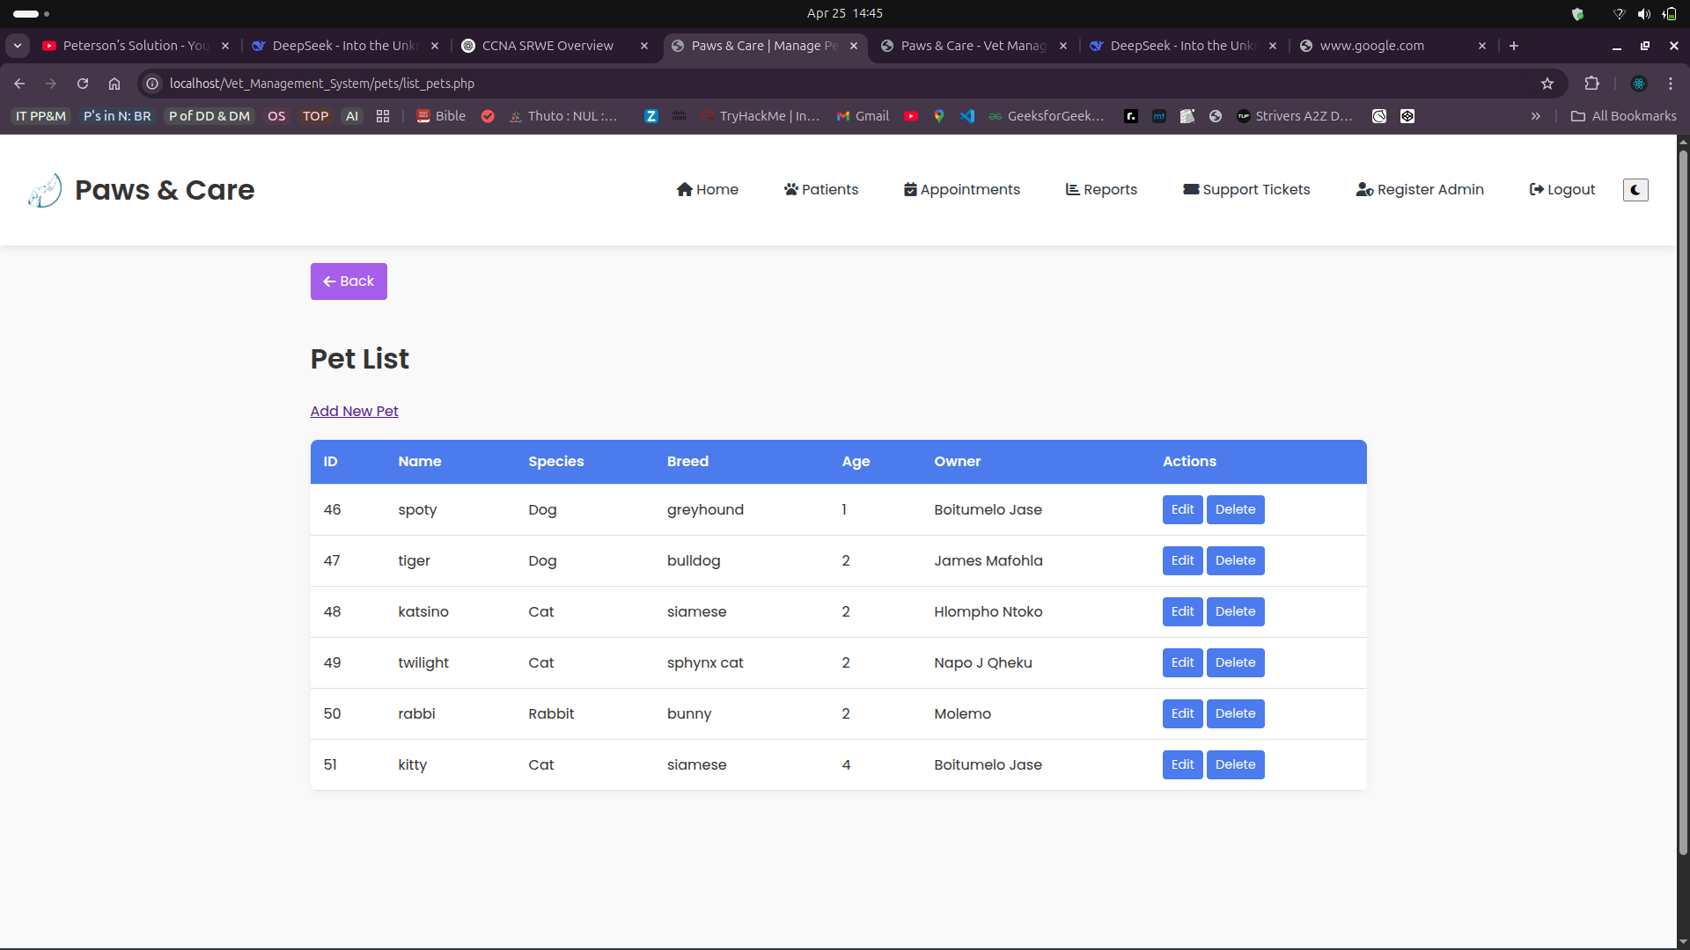
Purpose: To help veterinarians review registered pets for each user.
Data Source:
- Pets
- Owners

Displayed Fields:

- Pet Name
- Owner Name
- Pet Attributes

3. inventory Status Report

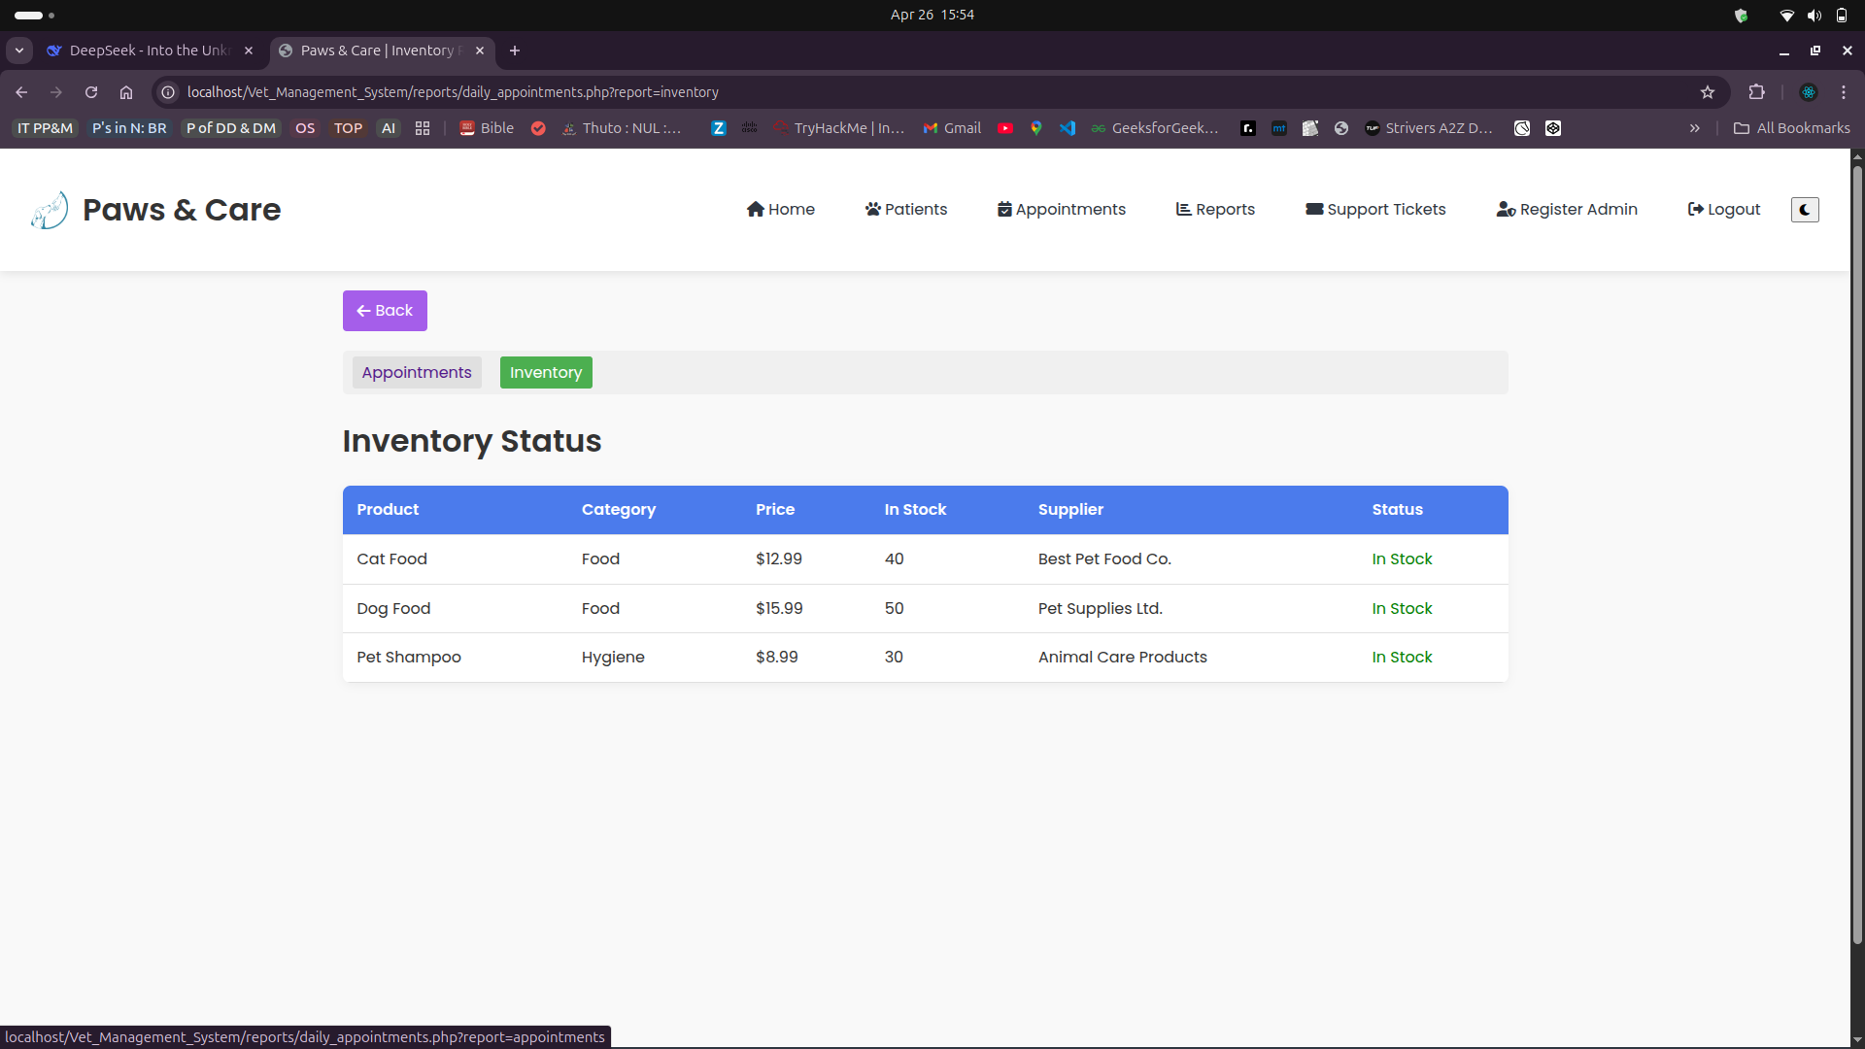
Purpose: To help admin quickly review and keep track of inventory and manage it with ease.
Data Source:

- Products
- Order_Details
Displayed Fields:
- Supplier
- Product_name
- stock count

Owner’s Pet List Report

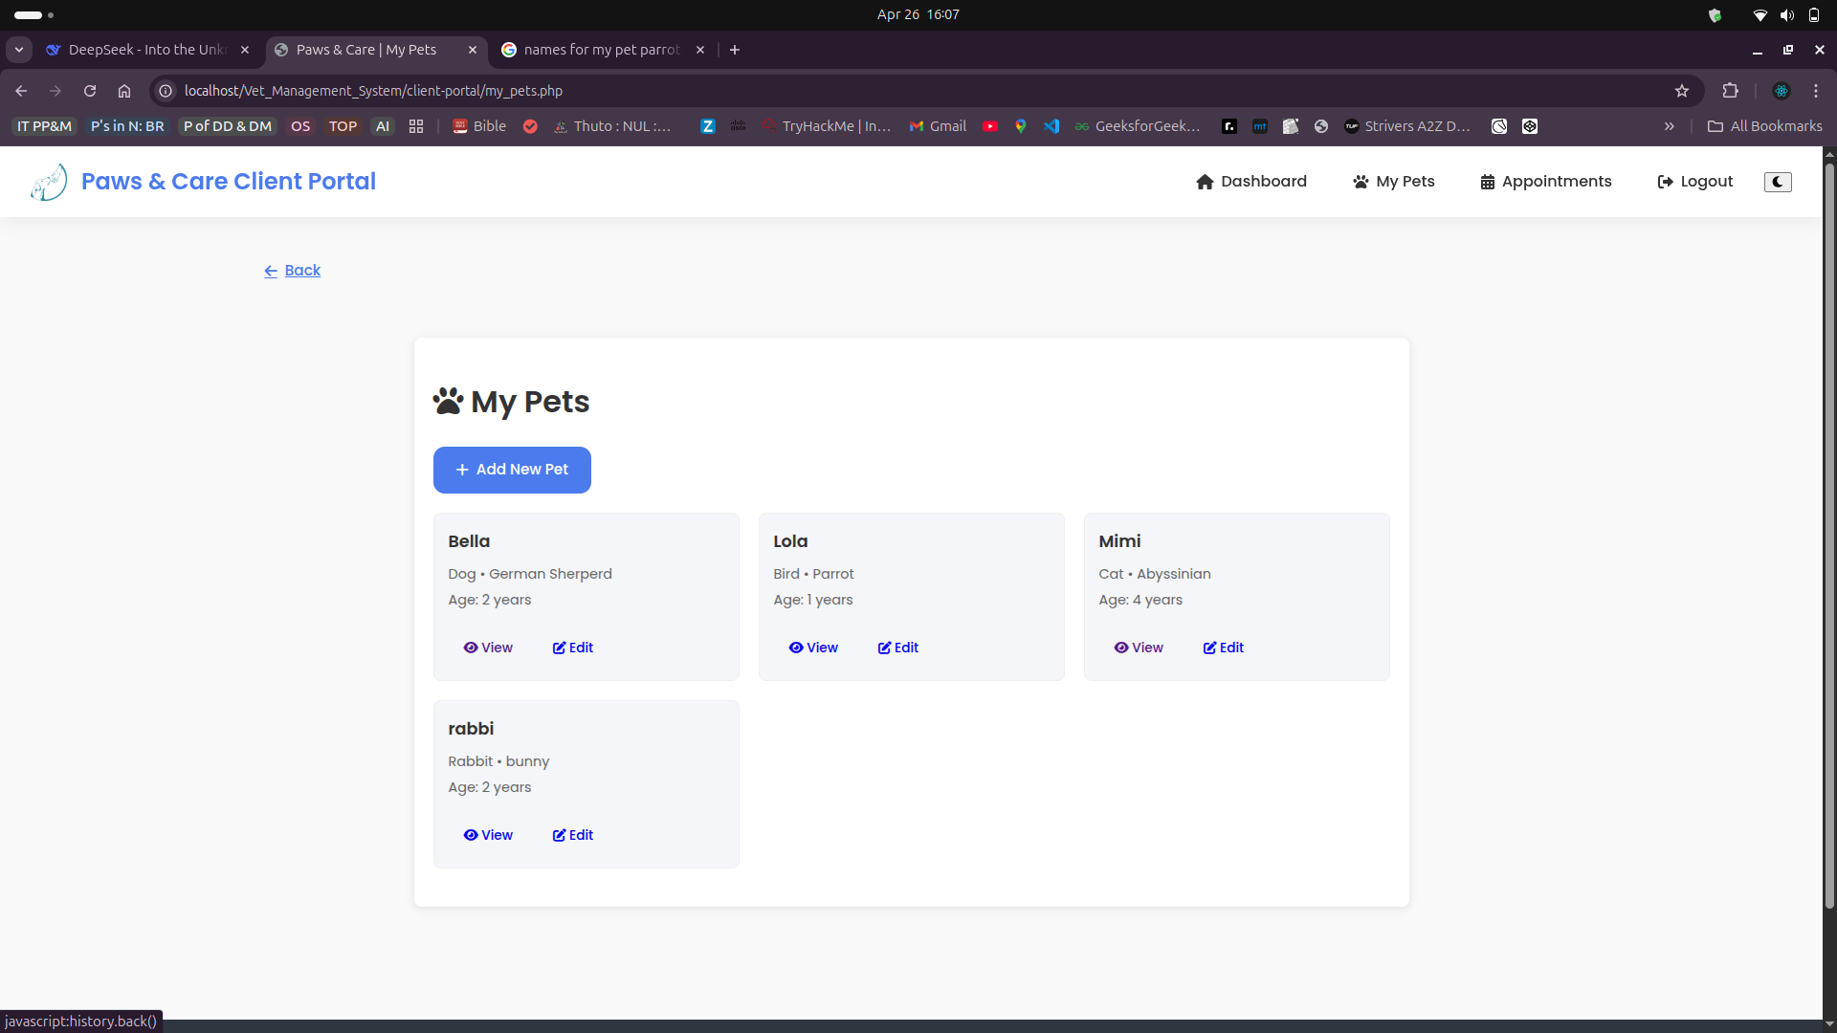
Purpose: To help users/clients keep track of the pets they registered.
Data Source:
- Pets
- Owner
Displayed Fields:
- Pet Name

Security:

Security is a critical aspect of the Vet/Animal Hospital Management System to ensure that sensitive information such as medical records and customer details are protected from unauthorized access or data breaches. This section outlines the key measures implemented to enhance the system’s security and access control.

1. User Authentication and Access Control
The system employs a login-based authentication mechanism that grants access based on user roles:

User Roles:
- Administrator: Full access to all modules (CRUD operations, reports, user management).
- Veterinarian/Staff: Access limited to appointments, treatments, and prescriptions.
- Customer/User: Access limited to adoption requests, order placement, and viewing available products or pets.

Features:
- Unique username and password required for each user.
- Passwords are securely stored in the database using hashing techniques (e.g., SHA-256 or bcrypt, depending on implementation).
- Session management prevents unauthorized access to pages via URL without login.
- Access control ensures users can only access features relevant to their role.

2. Database-Level Security
To protect data at the storage level:
- The MySQL database is password-protected with limited access granted to only the application through a secure DB user account.
- SQL queries are handled using prepared statements or parameterized queries (in PHP) to prevent SQL injection attacks.
- Direct access to the database is restricted through XAMPP/MySQL user permissions, ensuring that only authenticated sessions can interact with the DB.

3. Input Validation and Error Handling
- All form inputs are validated on the server-side (PHP) to prevent incorrect or malicious data entries.
- Examples of validations include:
  - Required fields (e.g., no empty names or appointment dates)
  - Format checks (e.g., phone numbers, emails)
  - Length restrictions and sanitization of inputs
- Error messages are user-friendly and informative, helping users correct issues without exposing technical system information.

4. Additional Measures
- Logout functionality automatically destroys session data to prevent session hijacking.
- Secure directory permissions prevent direct access to sensitive files such as configuration or SQL backups.
- Admin users are the only ones allowed to add/remove users or update system-level data.

Future Security Improvements (Optional)
- Implement Two-Factor Authentication (2FA) for Admins
- HTTPS deployment for encrypted data transmission
- Role-based logs and audit trails for tracking user activities
These layered security practices help safeguard both system data and user privacy, ensuring the system remains robust and secure under typical use cases.

Testing:

1. Testing Objectives
- Ensure that all CRUD operations work as expected across modules.
- Verify that all forms validate user input correctly.
- Confirm that system navigation is smooth and intuitive.
- Check that user roles restrict or allow access to specific modules.
- Test the accuracy and generation of reports.
- Validate database interactions and data integrity.

2. Test Data Setup
A test database was populated with at least 7 sample records per table. This data allowed the team to simulate real-world operations such as:
- Booking appointments
- Registering new pets and owners

3. Types of Testing Performed

🔹 Functional Testing
- Verified that all system functions performed as intended.
- Example: Booking an appointment successfully stores data and updates vet availability.

🔹 Input Validation Testing
- Ensured that required fields cannot be left blank.
- Invalid inputs (e.g., text in numeric fields) trigger appropriate error messages.
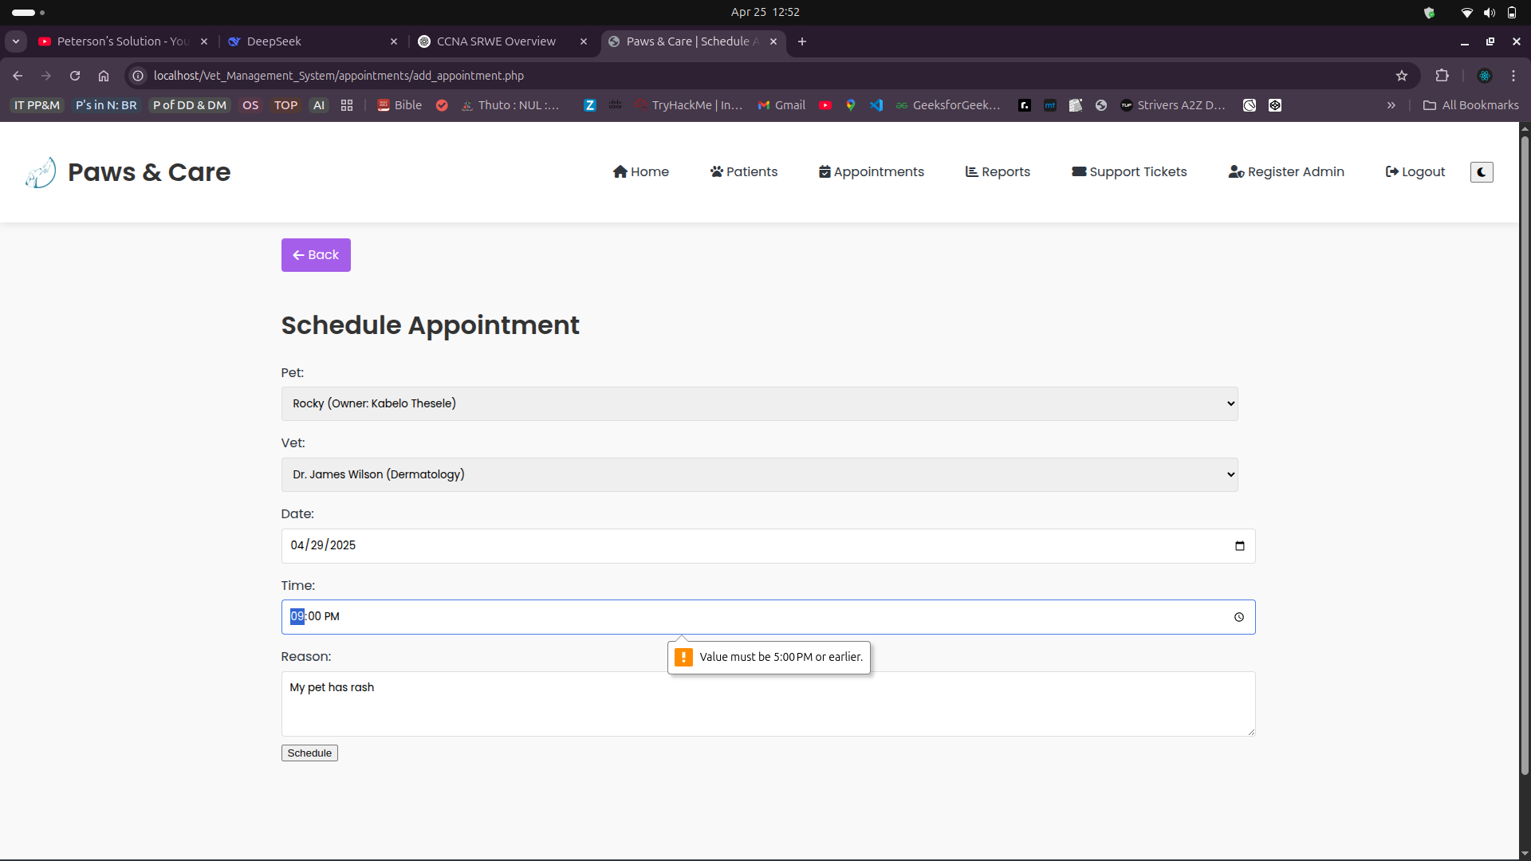

🔹 Role-Based Access Testing
- Admins had full system access.
- Vets had limited access to medical records and appointments.
- Customers could only view available products, pets, or submit adoption requests.

🔹 CRUD Testing
Each module was tested for:
- Create: Add new pets, appointments, treatments, products, and users.
- Read: View lists, details, and filters.
- Update: Edit existing records.
- Delete: Remove records with confirmation prompts.

🔹 Report Generation Testing
- Reports were generated using data across multiple tables.
- Filters such as date ranges and categories worked correctly.
- All four required reports displayed accurate, relevant information.

🔹 Error Trapping & Recovery
- System displayed friendly error messages for invalid submissions.
- Form submissions failed gracefully without crashing the system.

4. Sample Screenshots of Test Cases
(Include the following screenshots in your report with brief captions):
- Successful appointment booking
- Form validation error (e.g., blank fields or incorrect input type)
- Role-based login screens
- Generated report preview

Conclusion
The system passed all major functional and validation tests using realistic test data. Edge cases and invalid data were handled appropriately. Any minor issues discovered were corrected during the development cycle. The system is ready for deployment and user presentation.

User Documentation:

This section provides a comprehensive guide for end-users and administrators to install, set up, and use the Vet/Animal Hospital/Animal Shop Management System. It covers the essential steps to get started and operate the system’s core features.

1. Installation Guide (Getting Started)

System Requirements
- Operating System: Windows/Linux/Mac
- Local Server Environment: XAMPP (includes Apache, MySQL, PHP)
- Web Browser: Chrome, Firefox, or Edge

Installation Steps
- Download and Install XAMPP:
  - Download from the official website.
  - Install with default settings.
- Set Up the Project Files:
- Place your project folder (e.g., vet_system) inside the htdocs directory:
C:\xampp\htdocs\vet_system
- Import the Database:
- Open phpMyAdmin via your browser (http://localhost/phpmyadmin)
- Create a new database (e.g., vet_db)
- Import the provided .sql file from your project folder into this database.
- Configure Database Connection:
- Open the config.php or equivalent file inside your project.
- Update the following values:
$host = 'localhost';
$user = 'root';
$password = '';
$dbname = 'VetManagement_db';

Run the Application:
  - Open your browser and navigate to:
http://localhost/vet_system

2. User Manual (Using the System)

Logging In
- Navigate to the login page.
- Enter your username and password based on your role.
  - Admins have full access.
  - Vets can manage appointments and treatments.
  - Customers can browse products, view adoptable pets, and submit requests.

Managing Pets
- Register a New Pet: Go to "Pet Management" > "Add New Pet"
- Fill in pet details and assign an owner.
- Save to register the pet into the system.

Booking Appointments
- Navigate to "Appointments" > "Schedule"
- Select pet and vet, choose date/time, and enter reason.
- Submit the form. Appointments can be viewed, edited, or canceled.

Security Features
- Password-protected login.
- Role-based access control.
- Form validation for all inputs.
- Logout available from top-right navigation.

Support and Troubleshooting
- Login Issues: Ensure username/password is correct and case-sensitive.
- Database Errors: Check config.php and ensure MySQL is running in XAMPP.
- Missing Data: Confirm that you have inserted sample data into the database.
This user documentation ensures both technical and non-technical users can successfully install and interact with the system. Additional features or changes can be added as the system evolves.

Appendices:

This section contains additional material referenced in the main report. These resources support the design, implementation, and testing of the system, and provide further technical insight into the project.

Appendix A: Entity-Relationship Diagram (ERD)
- Description: Visual representation of all entities and their relationships, based on the business rules.
- Format: PNG or PDF export from Draw.io, MySQL Workbench.
- Location: See attached diagram: db.png

Appendix B: SQL Script (Database Creation & Sample Data)
- Description: Full SQL script used to create and populate the database.
- File: create_vet_db.sql
- Contents:
  - Table creation scripts
  - Foreign key constraints
  - INSERT statements for at least 7 sample records per table

Appendix C: Code Snippets
- Login Validation (PHP Example):
if(isset($_POST['login'])) {
$username = $_POST['username'];
$password = $_POST['password'];
$query = "SELECT * FROM users WHERE username = ? LIMIT 1";
$stmt = $conn->prepare($query);
$stmt->bind_param("s", $username);
$stmt->execute();
$result = $stmt->get_result();
...
}

Appendix E: Sample Screenshots
- Login Page
- Pet Registration Form
- Appointment Scheduling Interface
- Sales Page
- Generated Reports
- Error Messages / Input Validation

