Homework 8

***Nathan Cauwet - 873271826***

**Due Date:** November 8th 2020 (Tuesday)

# Problem 1 – The performance consequences of channel fading in multi- hop wireless networks

1. Consider the scenario shown below, in which there are four wireless nodes, A, B, C, and D. The radio coverage of the four nodes is shown via the shaded ovals; all nodes share the same frequency. When A transmits, it can only be heard/received by B; when B transmits, both A and C can hear/receive from B; when C transmits both B and D (but not A) can hear/receive from C; when D transmits, only C can hear/receive from D. Now suppose that node A has an infinite supply of messages that it wants to send to D; there are no other messages in the network. A message from A must first be sent to B, which then sends the message to C, which then sends the message to D. Time is slotted, with a message transmission time taking exactly one time slot, for example, as in slotted Aloha. During a slot, a node can do one of the following: (i) send a message (if it has a message to be forward toward D); (ii) receive a message (if exactly one is being sent to it), (iii) remain silent. As always, if a node hears two or more simultaneous transmissions, a collision occurs and none of the transmitted messages are received successfully. You can assume that there are no bit level errors, and thus, if exactly one message is sent, it will be received correctly by those within the transmission radius of the sender.

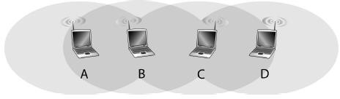

Now suppose that an omniscient controller (that is, a controller that knows the state of every node in the network) can command each node to do whatever it (the omniscient controller) wishes, that is, to send a message, to receive a message, or to remain silent. Given this omniscient controller, what is the maximum rate at which messages can be transferred from A to D?

*Options of operation are:*

1. *send a message (if it has a message to be forward toward D)*
2. *receive a message (if exactly one is being sent to it)*
3. *remain silent*

*Potential conflicts: B cannot be sending or receiving when C is sending. Same goes for C (because B and C are in the middle)*

*Transmission sequence = A->B->C->D->C->B->A*

*a)*

1. *1 message/slot*
2. *2 messages/slot*
3. *2 messages/slot*
4. Now suppose that the wireless links in the figure above are replaced by wired links. Again, a node can send exactly one message per time slot over a link, but now a node can send a message while it is receiving a message, and simultaneous transmission over two different links do not interfere. In this wired scenario, what is the maximum rate at which messages can be transferred from A to D?
5. *2 messages/slot*
6. *4 messages/slot*
7. *4 messages/slot*
8. Now suppose we are again in the wireless scenario, and that for every data message going from A to D, D will send an ACK message that must be forwarded back to A. What is the maximum rate at which data messages can be transferred from A to D?
9. *1 message / 4 slots*
10. *Slot 1: message A->B & message C->D*

*Slot 2: ACK B->A*

*Slot3: ACK D->C*

*Therefore 2 messages / 3 slots*

1. *Slot 1: message C->D*

*Slot 2: ACK D->C, message A->B (repeated)*

*Slot3: ACK B->A*

*Therefore 2 messages / 3 slots*

# Problem 2 – 802.11 network using different channels

Let us return to Review Question 1. We learned on page 516 of the textbook that an 802.11 network can choose to operate using any of the 11 different available channels (frequency bands). Consider again the figure shown in Review Question 1. Can you assign channels to nodes such that the wireless network achieves the same throughput as in the wired case? (Note: you may assume that each node has two interfaces, with each interface having a different channel).

*For our 802.11 nodes, ~~let’s assign node A to channel 4, node B to channel 9, and node C to channel 11~~*

*Let node A send on channel 4, node B receive from channel 4 and send on channel 9, node C listen on channel 9 and send on channel 11, and node D receive on channel 11. Because of this setup, the channels do not interfere with each other so messages can be transmitted simultaneously.*

# Problem 3 – RTS / CTS

Consider the scenario shown below, in which node D sends an RTS to node C at 𝑡0. Node C responds to the RTS with a CTS (which is heard by nodes B and C) in accordance with 802.11 protocol, and node D begins the transmission of its message at 𝑡2. In the meantime, node A sends an RTS message to B at time t1.

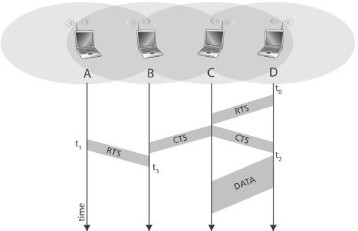

1. If node A were to begin transmitting to node B at some point after 𝑡3 would A’s transmission be

successfully received at B?

*~~Yes. As we can see in the image above, the CTS (clear to send) arrives at B before t~~~~3~~ ~~(appears to be at t­~~~~2~~~~).~~ There is a possibility of collision with the DATA from D to C sending at the same time as the transmission A sends after t3, however it is unlikely. Therefore, I say yes A’s transmission would be successfully received at B after t3.*

1. If node A were to begin transmitting to node B at some point after 𝑡3 would A’s transmission interfere

with the ongoing transmission from D-to-C?

*The transmission from A to B after t3 would not interfere with the ongoing transmission from D to C. There would only be possible interference if the transmission from D to C was then forwarded from C to B.*

1. At 𝑡3 can B respond to A’s RTS message with a CTS message? Why or why not?

*No, when B receives the CTS from C at t3 node B puts all transmission on hold until it gets the data from C and an ACK from D before it responds to the RTS from node A.*