**COMP-6908 Project 1**

**Database SQL Query Web Application using Python**

**Name: Xiaolong Liu**

**Student number: 200981140**

**Date: Oct 17, 2019**

**Run the application:**

1. Ensure Apache server and MySql server is up and running, open browser, go to “ <http://localhost:80/xl0471.html>” , default port is ‘80’.
2. There are 5 sections on the ‘xl0471.html’ web page, each one corresponds to a query. Simply input the query parameters and click ‘submit’ button, the application will lead you to the result page.

**Screen shot of the runs:**

**Query A:**

Input:

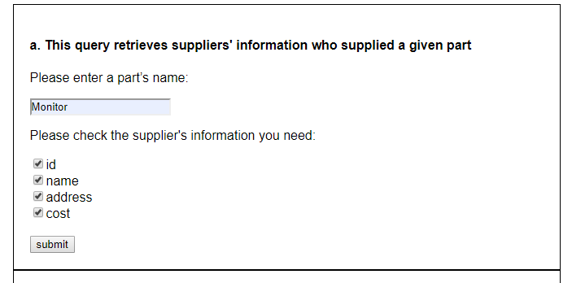

Result:

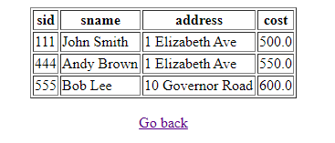

**Query B:**

Input:

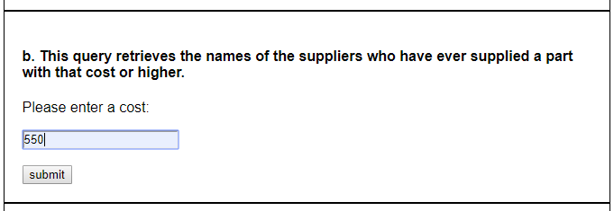

Result:

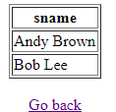

**Query C:**

Input:

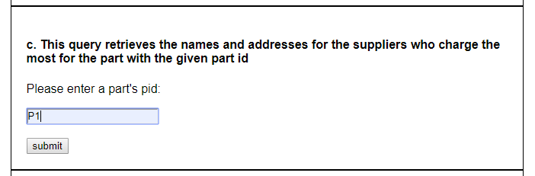

Result:

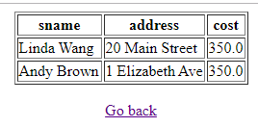

**Query D:**

Input:

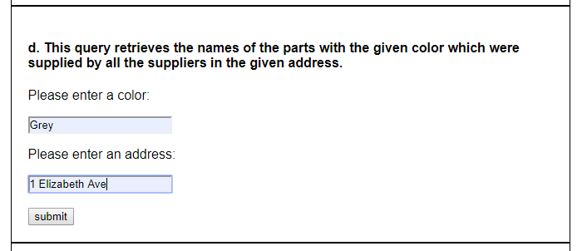

Result:

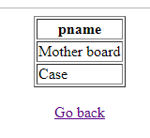

**Query E:**

Input:

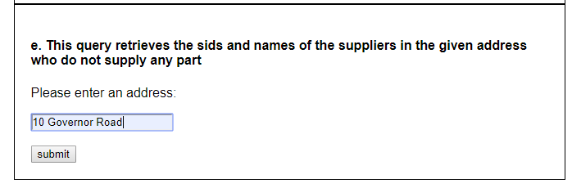

Result:

