**CSCI 4125/5125**

**Data Models and Database Systems**

**Fall 2021**

**Course Project**

**Phase 2: E-R Mapping (9/20)**

**Due: Thursday, 9/30 @ 11:59pm**

**Reading:** SilberschatzChapters 6 and 2

**Submission Guidelines:**

1. This assignment is worth 100 points for all students.

2. All answers in the form of images or screenshots must be readable. Any additional files must be clearly referenced and labeled.

3. It is your responsibility to make sure all files are readable and submitted on time.

**Submission:**

- Part A requires you to answer a total of 2 short answer questions worth 10 points total.

- Part B requires you to submit a relational schema (containing primary keys and foreign keys) worth 40 points.

- Part C requires you to submit a csv file for ever relation in Part B containing valid records. This is worth 30 points.

- Part D requires you to submit a single screenshot of a successfully ran change password command in SQL Developer worth 20 points.

**Part A. Short Answer (10 points)**

Answer the two questions given the following database schema and relational database instance containing three relations:

ITEM (ID, Name, Size)

ID is the primary key for ITEM.

PURCHASE (CustomerID, ItemID, PurchaseDate)

CustomerID, ItemID, and PurchaseDate is the (composite) primary key for PURCHASE.

CustomerID is a foreign key that references CUSTOMER.ID.

ItemID is a foreign key that references ITEM.ID.

CUSTOMER (ID, Name, Address)

ID is the primary key for CUSTOMER.

ITEM records:

(1, Monster Truck, 12)

(2, Jet Pack, 8)

(3, Flux Capacitor, 20)

(4, Royale with Cheese, 5)

(5, Bat Mobile, 22)

(6, Sword, 6)

PURCHASE records:

(2, 3, 1/1/2018)

(3, 3, 1/1/2018)

(1, 4, 5/30/2016)

(1, 4, 9/5/2018)

(3, 1, 12/31/2017)

(3, 5, 6/1/2016)

(4, 6, 11/12/2000)

CUSTOMER records:

(1, Dr. Jones, Chicago)

(2, Doc Brown, Los Angeles)

(3, Dr. Venkman, New York)

(4, Dr. Samurai, New Orleans)

1. For each table, construct a new tuple that does not violate any constraints. Make sure that you consider the existing values

It is highlighted in red above.

2. Which records can be removed from ITEM without violating any constraints?

The jet pack can be removed because no one bought it.

**Part B. E-R Mapping (40 pts)**

Your task is to generate a complete logical schema for your E-R diagram from Phase 1 of the project. You may submit a drawing using your favorite software (e.g., PowerPoint, Visio) or a written representation (like the one in Part A of the assignment). Remember that all primary keys are to be underlined with a solid line (or clearly stated), all foreign keys use a dotted underline (or clearly stated), and foreign keys must point to the primary key they reference.

**Part C. Build a Small Dataset (30 pts)**

For each relation you created in Part B, create a csv file. Each csv file must contain at least five records. Records should have unique primary key values and foreign keys must match a primary key value. Each line must only contain one record. In later project phases, you will read these csv files using Java to build SQL insert statements.

**Part D. SQL Developer Connection (20 points)**

In Phase 3 of the project, you will execute SQL DDL to build your tables and SQL DML to populate your tables and execute queries. This task has you setup your database connection to perform Phase 3. We will use a popular IDE supported by Oracle to connect to our database.

**Step 1. Download SQL Developer**

Download the relevant SQL Developer for your platform at this [link](https://www.oracle.com/tools/downloads/sqldev-downloads.html). To download SQL Developer, you may need to create an account using whatever email and password you like (note: this account is not related to the account you will use to connect to the database). Also, notice that SQL Developer requires you to have JDK 8 or 11 installed.

**Step 2. Run SQL Developer**

Unzip your download and run the application, sqldeveloper.exe. Your application should look like the screenshot below:

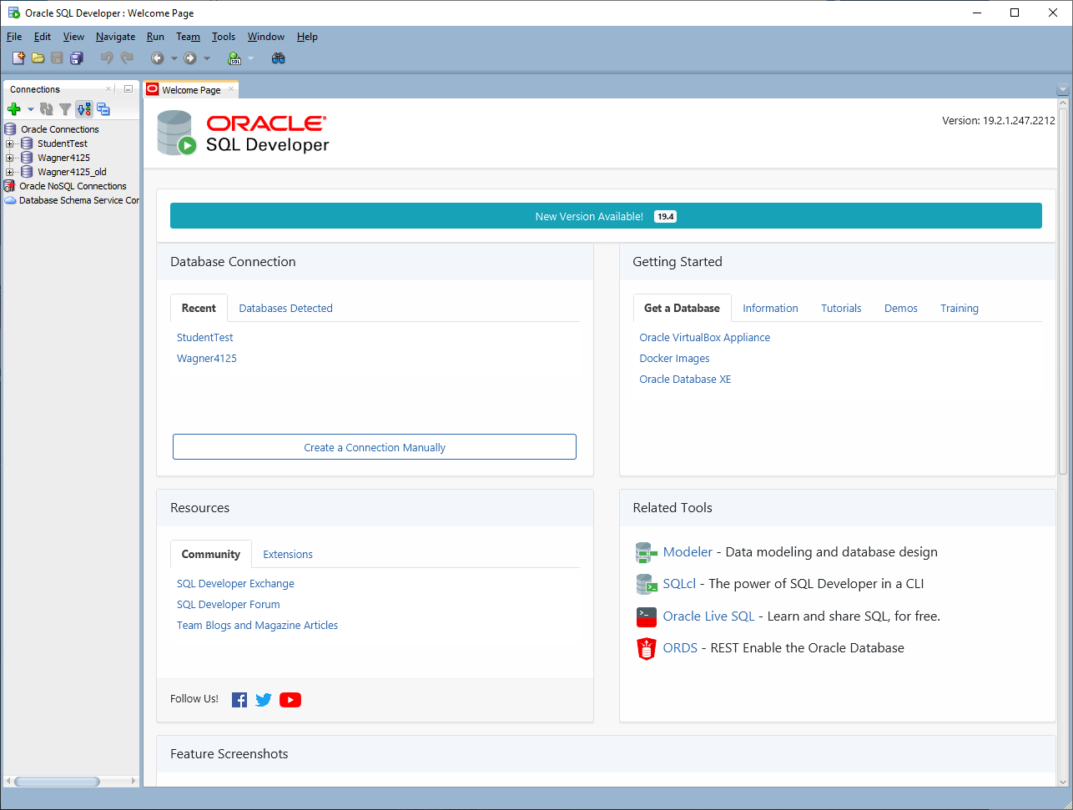

**Step 3. Create a connection.**

In the upper left-hand side of the application, there is a green plus symbol. Click this to create a new database connection. Fill in the following fields:

* + **Name:** Name your connection “[Your UNO username]4125/5125”.
  + **Username:** Use your UNO username.
  + **Password:** Use “NewOrleans123” (you will change this later).
  + **Save Password:** You can check this if you want to, but you will need to update this if you change your password.
  + **Hostname:** dbserver.cs.uno.edu
  + **Port:** 1521
  + **SID:** check the “ServiceName” field below this field. We won’t use the SID field.
  + **ServiceName:** ORCL
  + Click the “Test” box at the bottom. If everything is correct, the “Status” and the lower left-hand corner should say “Success”.
  + Click the “Save” box at the bottom to save your connection.
  + Click the “Connect” box.

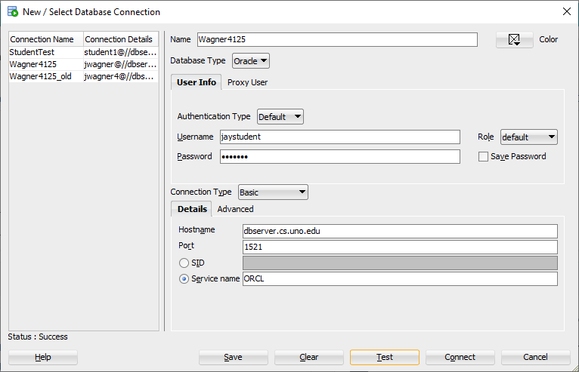

**Step 4. Change your password.**

Click on your connection on the left-hand side of SQL Developer. This should open up a blank script in the center of SQL Developer.

Type in the following command. Note the semicolon at the end and do not use the brackets:

ALTER USER [your username] IDENTIFIED BY [your new password];

Click the green arrow directly above the script window to run the command.

If your command properly runs, you should get a message in the script output: “User [your username] altered.”

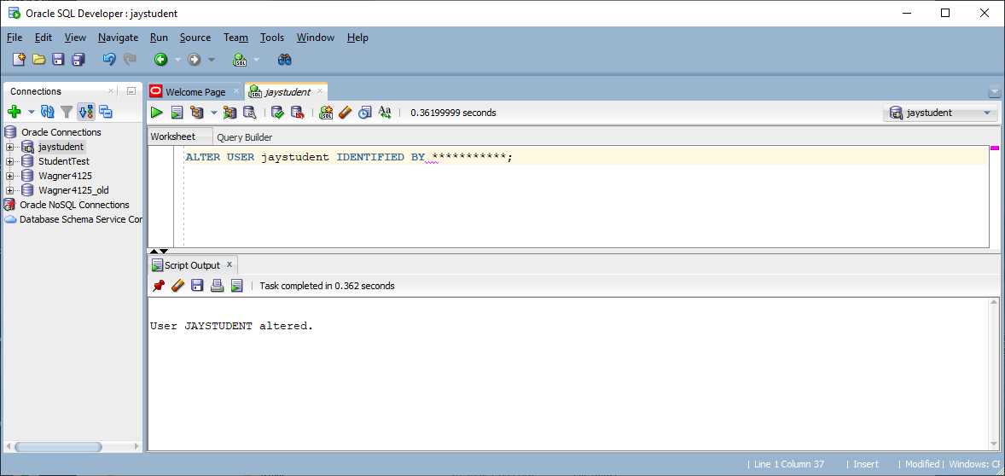

**Submit:** A screenshot (like mine) that shows that your command properly ran. Note: you can obfuscate or erase your new password in the script if you would like. Your screenshot must use the “Print Screen” command. DO NOT submit a picture of your computer using your phone.