Software Behaviour
This section describes the behaviour of software components implemented in SDL.
The behaviour of each SDL function is documented using state machine diagrams generated from the SDL implementation.
The following functions are implemented in SDL and their behaviour is documented below:

Counter
Description: No description available.
Behavioural Diagrams:
The following diagrams illustrate the behaviour of the Counter function:
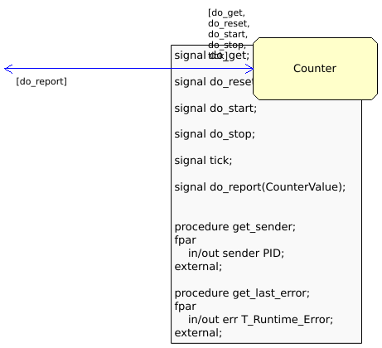
0 Counter block main
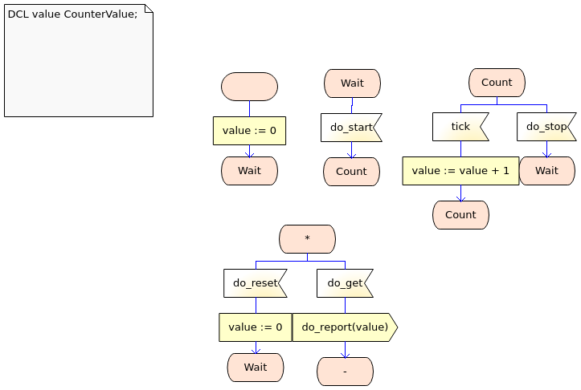
1 Counter process Counter
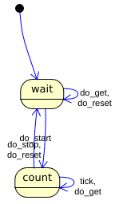
sc Counter

Harness
Description: No description available.
Behavioural Diagrams:
The following diagrams illustrate the behaviour of the Harness function:
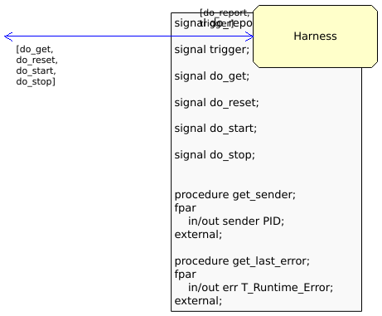
0 Harness block main
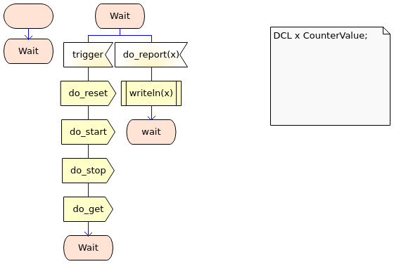
1 Harness process Harness
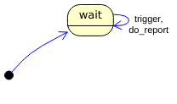
sc Harness

