AI Research Assistant Platform

Workflow documentation

1. Introduction

The AI Research Assistant using n8n is an AI-powered workflow automation system designed to simplify and automate research management activities. Researchers, students, and academic professionals often spend significant time searching for research papers, organizing references, and preparing research summaries. This project integrates n8n, OpenAI, OpenAlex API, Google Sheets, Google Docs, and Gmail into a unified platform that automates research paper collection, AI-powered summarization, keyword extraction, reference management, and scheduled research digest emails. The primary goal of this project is to reduce manual effort, improve productivity, and demonstrate how AI-driven workflow automation can solve real-world research management challenges

2. Problem Analysis –

2.1 Business Context
Research organizations, universities, educational institutions, and students rely on scientific literature to stay updated with recent developments. However, research management is often a manual and time-consuming process involving multiple tools and repetitive tasks.
Researchers spend considerable time searching for papers, organizing references, preparing summaries, and tracking new publications. This reduces productivity and delays research work. The AI Research Assistant using n8n addresses these challenges by automating research paper collection, AI-powered summarization, keyword extraction, reference management, and research notifications through interconnected workflows.

3. Stakeholders

Researchers

Researchers are the primary users of the AI Research Assistant. They use the system to search for research papers, generate AI-powered summaries, organize references, and stay updated with the latest publications. The platform helps researchers by providing the following services:

- Search for relevant research papers efficiently.
- Receive AI-generated summaries and extracted keywords.
- Organize references automatically.
- Save time by reducing manual research activities.
- Stay updated through weekly research digest emails.

Students
Students use the platform to perform literature reviews for academic projects, assignments, and research activities. The platform provides student with:
- To perform literature reviews more effectively.
- Quick access to organized research papers and summaries.
- Improve productivity during academic projects.
- Reduce time spent searching and organizing research materials.

Faculty Members

Faculty members use the platform to monitor recent research developments, guide students, and maintain organized research resources. The platform supports faculty members by providing:
- Access to the latest research publications
- Organized research documentation
- AI-generated summaries
- Weekly research reports
- Efficient reference management
Educational Institutions

Educational institutions benefit from the implementation of the AI Research Assistant by improving research productivity and promoting the adoption of AI-powered automation. The platform provides institutions with:
- Improved research management
- Reduced manual workload
- Better organization of research data
- Increased productivity
- Support for AI-driven academic research

4. Existing Problems and Challenges
Before automation, researchers commonly face the following challenges:
- Searching for research papers manually across multiple platforms.
- Spending excessive time reading and summarizing lengthy research papers.
- Maintaining research references using different applications.
- Missing newly published research due to lack of continuous monitoring.
- Preparing weekly or periodic research reports manually.
- Managing duplicate research records.
- Limited automation and lack of centralized research management.
- Difficulty in identifying workflow failures without proper monitoring and notifications.
These challenges reduce productivity and increase the possibility of errors and inconsistent research management.

5. Project Objectives

The primary objective of the AI Research Assistant using n8n is to automate the complete research management process using AI and workflow automation.
The specific objectives are:
- Automate research topic registration.
- Retrieve relevant research papers and generate summaries using the OpenAlex API.
- Extract important keywords automatically.
- Organize research references in Google Docs.
- Store research information in Google Sheets.
- Send automated weekly research digest emails.
- Monitor workflow execution through automated error logging and notifications.
- Reduce manual effort and improve research productivity.
- Demonstrate the practical use of AI-driven workflow automation for academic and research environments.
6. System Architecture
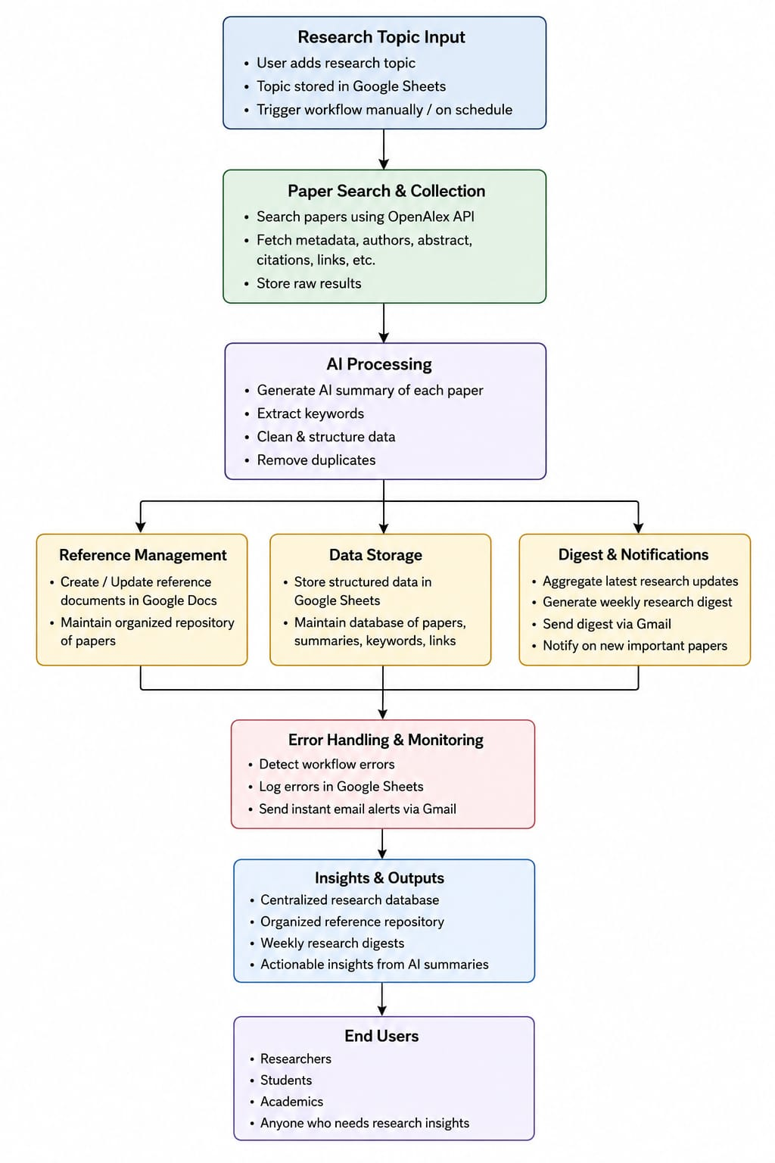
Architecture Explanation
The AI Research Assistant follows a workflow-based architecture in which n8n acts as the central automation platform. Every workflow performs a dedicated task while sharing data through Google Sheets and integrating with external services such as OpenAlex API, OpenAI, Google Docs, and Gmail.
The architecture is organized into multiple logical layers that together automate the complete research management lifecycle.

6.1 User Interaction Layer

This layer provides the entry point for users to interact with the system. It includes:
- Research topic submission
- Google Forms / Manual topic entry
- Google Sheets for topic storage
- Scheduled workflow execution
Users submit research topics, which automatically trigger the required research automation workflows.

6.2 Automation & Integration Layer

This layer represents the core automation engine built using n8n workflows. It is responsible for:
- Executing workflow automation
- Triggering connected workflows
- Integrating external APIs
- Managing workflow execution
- Synchronizing data between services
This layer ensures seamless communication between different components of the system.
6.3 AI Processing Layer
Artificial Intelligence powers the intelligent capabilities of the platform. AI is used for:
- Research paper summarization
- Keyword extraction
- Data structuring
- Duplicate paper detection
- Generating research insights
The OpenAI model converts raw research data into meaningful and easy-to-understand information.

6.4 Data Management Layer

This layer stores and organizes all processed research information. It includes:
- Google Sheets database
- Google Docs repository
- Research metadata
- AI-generated summaries
- Keywords and references
The layer maintains an organized repository for future access and analysis.

6.5 Notification & Monitoring Layer

This layer monitors workflow execution and keeps users informed. It provides:
- Weekly research digest emails
- Gmail notifications
- Error logging
- Workflow failure alerts
- Scheduled notifications
Any workflow failure is automatically recorded and reported to ensure reliable system operation.
6.6 Output Layer

The final processed information is delivered to end users. The outputs include
- AI-generated research summaries
- Organized reference repository
- Weekly research digests
- Structured research database
- Actionable research insights
The system enables researchers, students, and academicians to access organized and up-to-date research information efficiently.
7. Workflow Implementation
The platform contains six independent automated workflows.
Workflow 1: Research Topic Registration
Purpose: Collects research topics submitted by users and stores them in Google Sheets to trigger the research automation process.
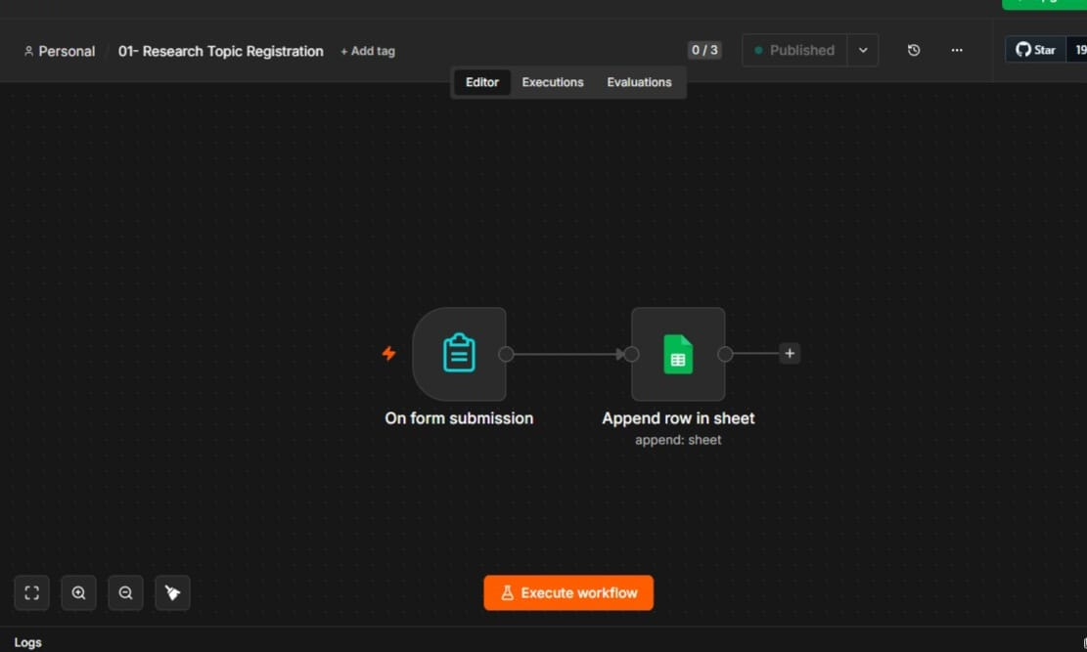

Workflow flow
User
↓
n8n Form Submission
↓
Google Sheets
↓
Research Topic Stored

Implementation details
This workflow is initiated when the user submits a research topic through the n8n form. The submitted information is validated to ensure that the required fields are completed before processing. Once validated, the topic is automatically stored in Google Sheets, which acts as the central database for the project. This workflow serves as the entry point and triggers the subsequent workflows for research paper collection and processing.

Key Features
- Simple research topic submission.
- Automatic data storage.
- Validated user input.
- Centralized topic management.
- Starts downstream workflows.

Workflow 2 – Research Paper Search & Collection

Purpose: Searches research papers using the OpenAlex API and stores structured paper information.

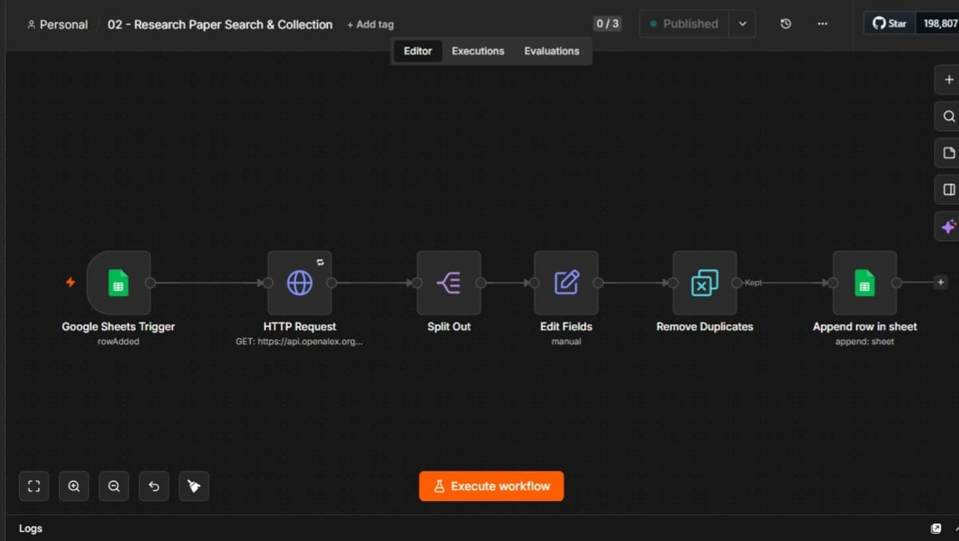

Workflow flow
Google Sheets Trigger
↓
HTTP Request (OpenAlex API)
↓
Split Results
↓
Edit Fields
↓
Remove Duplicates
↓
Google Sheets

Implementation details
After a new research topic is added to Google Sheets, this workflow is automatically triggered. It sends a request to the OpenAlex API to retrieve research papers related to the selected topic. The retrieved metadata, including the paper title, authors, publication year, abstract, DOI, and paper link, is processed and organized. Duplicate records are removed before the final data is stored in Google Sheets for further AI processing.

Key features
- Automated paper search.
- Duplicate removal.
- Metadata extraction.
- Structured storage.
- Fast research collection.
Workflow 3 – AI Summarization & Keyword Extraction
Purpose: Generates AI-powered summaries and extracts important keywords from collected research papers.
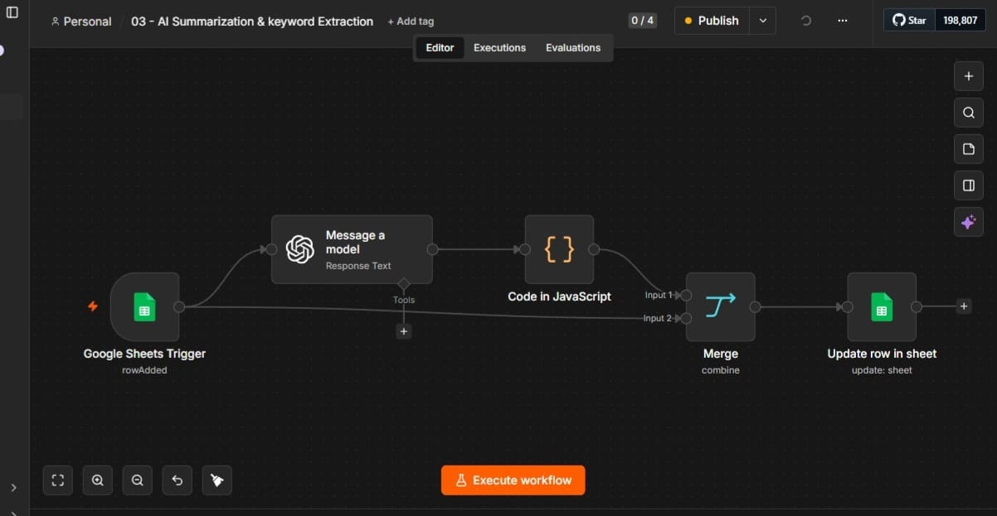
Workflow flow
Google Sheets Trigger
↓
OpenAI Model
↓
JavaScript Processing
↓
Merge Data
↓
Update Google Sheets

Implementation Details
This workflow retrieves the collected research papers from Google Sheets and processes them using the OpenAI model. The AI generates concise summaries and extracts important keywords from each paper to improve readability and understanding. The processed information is merged with the original research data and automatically updated in Google Sheets, creating a structured dataset for future workflows.

Key features
- AI-generated summaries.
- Automatic keyword extraction.
- Structured output.
- Improved readability.
- Reduced manual effort.

Workflow 4 – Reference Management & Repository

Purpose: Creates and maintains an organized reference repository using Google Docs.
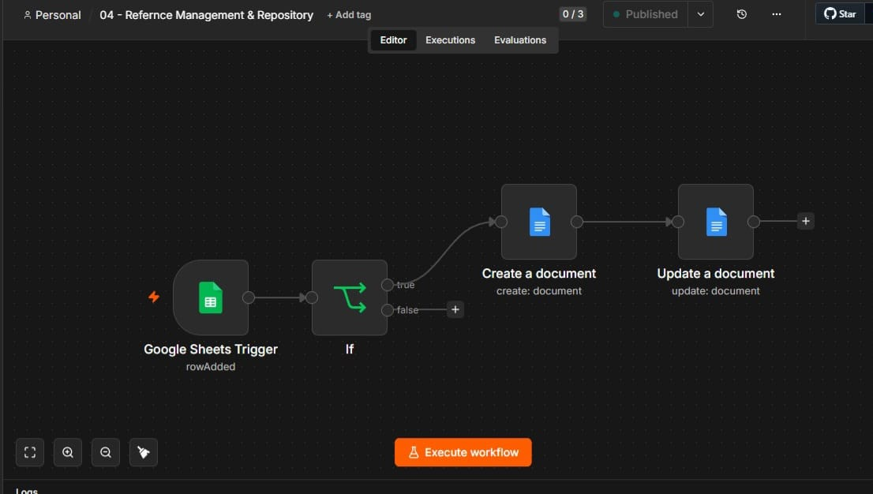
Workflow flow

Google Sheets Trigger
↓
Condition Check
↓
Create Google Doc
↓
Update Google Doc

Implementation details
This workflow organizes the processed research information into a structured reference repository using Google Docs. It checks whether a document already exists for the selected research topic and creates a new document if required. The workflow then formats and stores the paper details, AI-generated summaries, keywords, and references, providing users with a well-organized research repository.

Key features
- Automatic reference management.
- Organized repository.
- Google Docs integration.
- Easy document updates.
- Centralized storage.

Workflow 5 – Weekly Research Digest & Notifications

Purpose: Generates a weekly digest of research updates and sends it through Gmail.

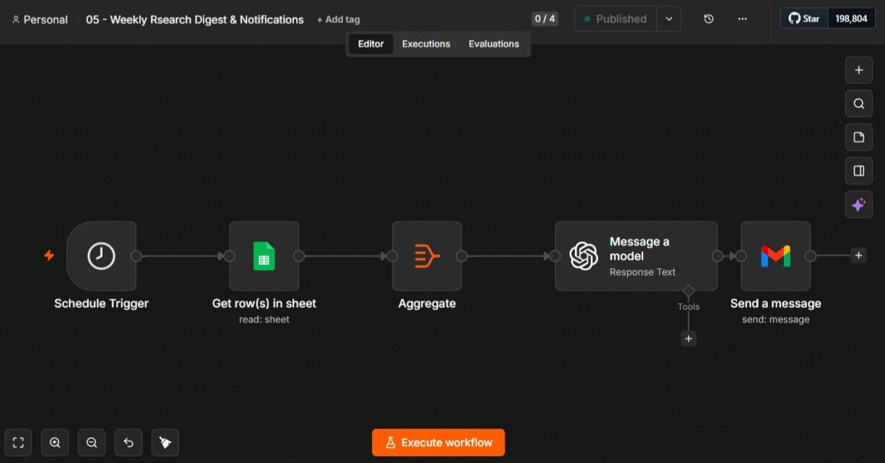

Workflow flow

Schedule Trigger
↓
Google Sheets
↓
Aggregate Data
↓
OpenAI Model
↓
Gmail

Implementation details
This workflow is executed automatically based on a predefined schedule using the Schedule Trigger node. It retrieves the latest research records from Google Sheets and compiles them into a weekly digest. The digest is enhanced using OpenAI to generate a clear and concise summary before being sent to users via Gmail. This ensures that researchers receive regular updates without manually reviewing all collected papers.

Key features
- Scheduled automation.
- AI-generated digest.
- Email notifications.
- Research updates.
- Time-saving reporting.

Workflow 6 – Error Logging & Email Alerts

Purpose: Monitors workflow failures, records error information, and immediately notifies the administrator.

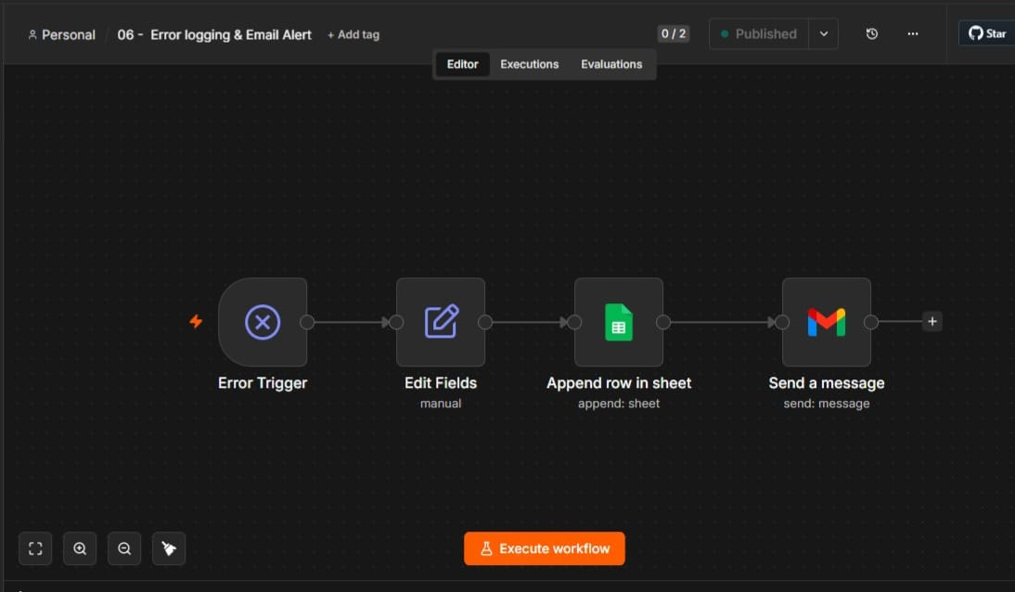

Workflow flow
Error Trigger
↓
Edit Fields
↓
Google Sheets
↓
Gmail Alert

Implementation details
This workflow is activated whenever an error occurs during the execution of any workflow in the system. It captures essential information such as the workflow name, error message, execution time, and node where the failure occurred. The error details are stored in Google Sheets for future analysis, and an email notification is immediately sent to the administrator through Gmail, enabling quick identification and resolution of issues.

Key features
- Automatic error detection.
- Error logging.
- Instant email alerts.
- Improved monitoring.
- Better workflow reliability.

8. Technology stack
The AI Research Assistant integrates multiple technologies that work together to automate research paper collection, AI processing, data management, and user notifications.

8.1 n8n workflow automation
n8n is the core workflow automation platform used to build and connect all workflows in the project. It enables seamless integration between different applications and automates the complete research management process.
Key Functions:
- Automates workflow execution.
- Integrates multiple applications and APIs.
- Supports scheduling and event-based triggers.
- Manages data flow between workflows.
- Reduces manual intervention.

8.2 OpenAI GPT
OpenAI GPT provides the artificial intelligence capabilities of the system. It processes research papers to generate concise summaries and extract meaningful keywords automatically.
Key Functions:
- Generates AI-powered summaries.
- Extracts relevant keywords.
- Improves research readability.
- Reduces manual analysis.
- Enhances research insights.

8.3 OpenAlex API
OpenAlex API is used to retrieve scholarly research papers based on the user's research topic. It provides structured metadata required for further processing and analysis.

Key Functions:
- Searches research papers.
- Retrieves paper metadata.
- Provides DOI and publication details.
- Supplies author information.
- Supports automated paper collection.

8.4 Google Sheets
Google Sheets serves as the centralized database for storing research topics, paper details, AI-generated summaries, and workflow logs. It enables efficient data management throughout the automation process.
Key Functions:
- Stores research topics.
- Maintains paper metadata.
- Saves summaries and keywords.
- Records workflow logs.
- Supports data sharing.

8.5 Google Docs
Google Docs is used to create and maintain a structured repository of research references. It automatically organizes paper details, summaries, and keywords into a readable document.
Key Functions:
- Creates research repository.
- Stores references automatically.
- Organizes research documents.
- Maintains AI summaries.
- Enables easy access and sharing.

8.6 Gmail
Gmail is integrated to send automated notifications and weekly research digest emails. It also informs the administrator whenever a workflow execution fails.
Key Functions:
- Sends weekly research digests.
- Delivers workflow notifications.
- Sends error alert emails.
- Supports automated communication.
- Improves user awareness.

8.7 JavaScript
JavaScript is used within n8n to process data, implement custom logic, and transform API responses. It helps automate complex operations that require additional processing.
Key Functions:
- Processes API responses.
- Formats and transforms data.
- Implements custom workflow logic.
- Validates data.
9. AI Integration and Intelligent Features
Artificial Intelligence is a core component of the AI Research Assistant. The project integrates OpenAI to automate research analysis by generating summaries, extracting keywords, and improving the organization of research information, making the overall workflow faster and more efficient.

9.1 OpenAI Integration
The project integrates the OpenAI API within n8n workflows to process research papers automatically. The AI model analyzes the collected research data and generates meaningful outputs without requiring manual intervention.
Capabilities:
- Generates AI-powered research summaries.
- Extracts important keywords.
- Processes research content automatically.
- Integrates seamlessly with n8n workflows.
- Reduces manual analysis.

9.2 Intelligent Features
The AI-powered features enhance the efficiency and usability of the research assistant by automating repetitive research tasks and providing structured insights.
Key Intelligent Features:
- AI-generated research paper summaries.
- Automatic keyword extraction.
- Automated research paper analysis.
- Structured reference generation.
- Weekly AI-generated research digest.
- Intelligent workflow automation.
- Reduced manual effort.
- Improved research productivity.
10. Workflow integration and data flow
The Workflow Integration and Data Flow illustrates how different n8n workflows communicate and exchange data to automate the complete research management process from user input to final output.
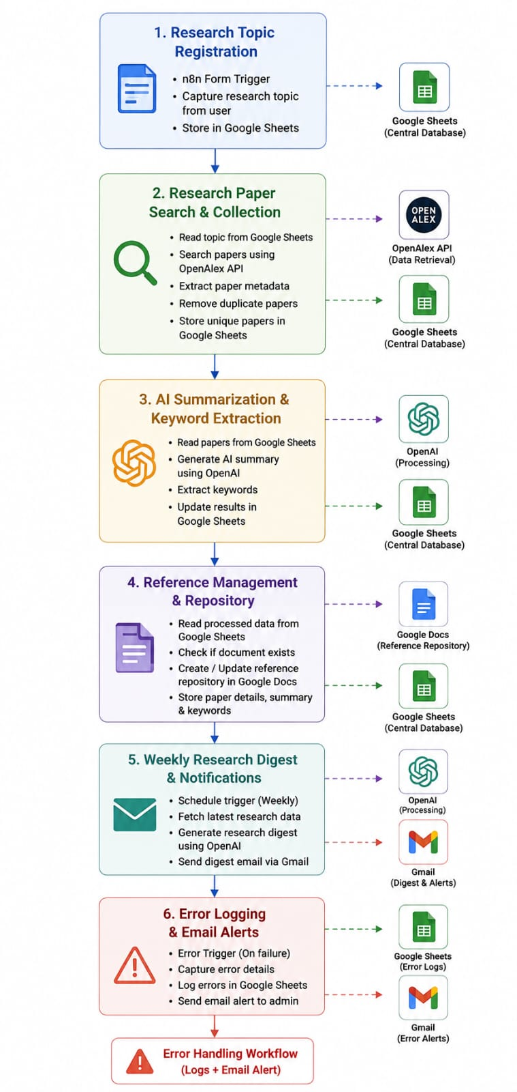

11. Advanced Features Implemented
The AI Research Assistant includes advanced AI and automation features that improve research efficiency and minimize manual effort.

AI-Powered Research Summarization
Automatically generates concise summaries of research papers using OpenAI.

Automatic Keyword Extraction
Extracts important keywords from each paper for better organization and search.

Automated Research Paper Collection
Retrieves relevant research papers automatically using the OpenAlex API.

Duplicate Paper Detection
Identifies and removes duplicate research papers before storing them.

Automated Reference Repository
Creates and updates organized research references in Google Docs automatically.

Weekly Research Digest
Generates and emails a weekly summary of newly collected research papers.

Error Logging and Email Alerts
Records workflow errors in Google Sheets and sends instant Gmail notifications.

End-to-End Workflow Automation
Connects all six n8n workflows into a fully automated research management system.
Top of Form

12. Testing and validation

12.1 Research Topic Registration Testing
Input:
Research topic submitted through the registration form.
Expected Output:
- Research topic stored in Google Sheets.
- Workflow triggered successfully.
- Topic ready for paper search.
Result:
Successful execution.

12.2 Research Paper Search & Collection Testing
Input:
Stored research topic in Google Sheets.
Expected Output:
- Relevant papers fetched from OpenAlex API.
- Metadata collected successfully.
- Results stored in Google Sheets.
Result:
Successful execution.

12.3 AI Summarization & Keyword Extraction Testing
Input:
Research paper abstracts.
Expected Output:
- AI-generated summaries created.
- Keywords extracted correctly.
- Sheet updated with processed data.
Result:
Successful execution.

12.4 Reference Management & Repository Testing
Input:
Processed research paper information.
Expected Output:
- Google Docs reference document created.
- References organized automatically.
- Repository updated successfully.
Result:
Successful execution.

12.5 Weekly Research Digest & Notifications Testing
Input:
Latest research papers stored in the repository.
Expected Output:
- Weekly digest generated.
- AI summary prepared.
- Digest email sent via Gmail.
Result:
Successful execution.

12.6 Error Logging & Email Alert Testing
Input:
Simulated workflow execution error.
Expected Output:
- Error logged in Google Sheets.
- Alert email sent automatically.
- Workflow failure recorded successfully.
Result:
Successful execution.
13. Future Enhancements
The current system provides an automated AI-powered research management solution. In the future, several enhancements can be implemented to improve its functionality, scalability, and user experience.

13.1 Multi-Database Integration
Support additional research databases such as IEEE Xplore, Springer, ACM Digital Library, and PubMed.

13.2 PDF Analysis
Enable automatic downloading and AI-based analysis of complete research papers instead of only abstracts.

13.3 Research Recommendation System
Recommend relevant research papers based on users' interests and previous searches.

13.4 Interactive Dashboard
Develop a web dashboard to visualize research trends, statistics, and workflow status.

13.5 Multi-Language Support
Allow users to search, summarize, and receive research insights in multiple languages.

13.6 Cloud Database Integration
Replace Google Sheets with scalable databases such as Firebase, PostgreSQL, or MongoDB for better performance.

13.7 Collaboration Features
Enable multiple researchers to share references, notes, and research repositories within the platform.

13.8 Advanced AI Capabilities
Integrate more advanced AI models for deeper summarization, citation generation, and intelligent research insights.

14. Project Outcomes
The AI Research Assistant successfully automates the research management process by integrating AI, APIs, and workflow automation, resulting in improved efficiency and reduced manual effort.
Automated Research Workflow
Successfully automated the complete research process from topic registration to research digest generatio

Faster Literature Review
Reduced the time required to search, summarize, and organize research papers.

AI-Powered Insights
Generated accurate research summaries and extracted meaningful keywords using AI.

Centralized Research Repository
Created an organized repository of research papers, summaries, references, and metadata.

Improved Productivity
Minimized repetitive manual tasks, allowing researchers to focus on analysis and innovation.

Reliable Workflow Execution

Implemented automated error logging and email notifications to ensure reliable workflow performance.

15. Conclusion
The AI Research Assistant using n8n successfully demonstrates how workflow automation and Artificial Intelligence can simplify the research management process. By integrating n8n, OpenAI, OpenAlex API, Google Sheets, Google Docs, and Gmail, the system automates research paper collection, AI-powered summarization, reference management, and weekly research notifications. The implementation of six interconnected workflows reduces manual effort, improves productivity, and ensures efficient research organization.
The project also demonstrates the practical use of AI, API integration, and cloud-based services to build an intelligent automation solution. Its modular workflow architecture makes it easy to maintain, extend, and integrate additional features in the future. Overall, the AI Research Assistant provides a scalable, reliable, and efficient platform that supports researchers in managing research activities more effectively while showcasing the real-world potential of AI-driven workflow automation.

