
MTronic XT Traction Elevator Controller

Installation and Maintenance Manual
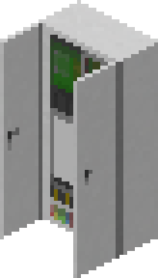
Table of Contents
Introduction 4
Installation Checklist 5
About the Controller 6
About the Dispatcher 7
Installation 8
Placing the controller and drive 8
Placing the car in the hoistway 9
Placing the guide rails (optional) 10
Placing the positioning system tape (optional) 11
Placing the buffers (optional) 12
Placing the machine 13
Placing the doors 14
Placing the dispatcher (group operation only) 15
Selecting simplex or group operating mode 16
Configuring the controller floor table (simplex operation only) 17
Configuring the dispatcher floor table (group operation only) 19
Connecting to the controllers (group operation only) 22
Testing the floor stops 24
Pairing the PIs and lanterns to the controller 25
Pairing the call buttons 26
Pairing the fire recall keyswitch 27
Controller Interface 28
Car Status 28
Fault History 32
Edit Parameters 33
Car Call Security 35
Dispatcher Interface 36
Group Display 36
Main Menu 38
Third-Party Device Connections 39
mView Computer Interface (“laptop” mod) 40
Setup 40
Controller 44
Dispatcher 45
Mesecons Input/Output (“mesecons” mod) 46
Controller Input 47
Controller Output 48
Dispatcher Input 49
Dispatcher Output 50
Digilines Input/Output (“digilines” mod) 51
CARCALL 51
UPCALL 51
DOWNCALL 52
SWINGUPCALL 52
SWINGDOWNCALL 52
GET 52
Controller Messages 57

Introduction
Thank you for selecting the MTronic XT traction elevator controller system! This is the most advanced elevator controller available in Minetest today.

This manual will help you understand, install, and configure your new elevator system. After installation, keep this manual with the controller in the event that it is needed for future reference, such as troubleshooting or configuration changes.

If you are an experienced user, following the installation checklist on the next page may be the fastest way to complete the installation. If you are not, or if you need assistance with any of the steps mentioned, continue reading and each step will be explained in detail.

Installation Checklist
□ Place controller and drive
□ Place car level with bottom floor
□ Place machine above car, above highest floor
□ Place guide rails, tape, magnets, and buffers
□ Place doors
□ Pair machine with controller
□ (Group operation) Place dispatcher
□ Select group mode at controller
□ Enter floor table at controller (simplex) or dispatcher (group)
□ (Group operation) Connect dispatcher to controllers and set floors served
□ Test floor stops
□ Place PIs and lanterns and pair to controller
□ Place call buttons and pair to controller (simplex) or dispatcher (group)
□ (Group operation) Place swing call buttons and pair to controller (optional)
□ Place fire recall keyswitch and pair to controller (simplex) or dispatcher (group)

About the Controller
The MTronic XT controller is a traction elevator controller with the following features:
- 2 to 100 landings
- Total rise from 3 to 490 meters
- Speed from 0.2 to 20 meters/second
- Selective-collective operation
- Simplex or group (when connected to dispatcher) configurations
- Fire service
- Independent service
- Machine room and car-top inspection operation
- Swing operation
- Graphical configuration menus
- Easy setup wizard
- Touchscreen status display

As shipped, the controller is fully preassembled and prewired. The only actions needed before normal operation can begin are the connection of external devices and entry of parameters.

About the Dispatcher
The MTronic XT dispatcher connects to two or more MTronic XT controllers to enable group operation. It supports the following features:
- Group size from 2 to 16 cars
- True ETA-based dispatching algorithm
- Group recall for fire service
- Automatic reassignment of calls from busy/out of service cars
- Homogeneous or heterogeneous groups (not all cars have to serve all floors)
- Automatic configuration of controller floor tables from dispatcher settings
- Unlimited number of hall call risers
- Swing hall call risers for no, some, or all cars

Like the controller, the dispatcher is also shipped preassembled and prewired. The only actions needed are to enter the necessary parameters, connect the controllers for each car in the group, and connect any external devices needed.

Installation

Placing the controller and drive
The controller should be placed on the machine room floor in a location that provides access to its front for installation and service.

Please observe the following when selecting a location:
- Allow adequate space above and next to the controller. The cabinet is 2m tall and 1m wide, and the drive will occupy space to the right of the cabinet near the top.
- Allow space in front of the controller for access during installation and service. While the controller doors do not protrude past 1m even when open, placing objects in front of the controller may make service difficult. Leaving an empty, accessible space of at least 2m (measured with doors closed) in front of the controller is recommended.
- The machine room door should be of a type that locks. The controller cabinet is lockable (following area protection), however if it is accidentally left open, then anyone gaining access to the machine room will be able to modify parameters or change operating modes.

Place the controller and drive as shown here:
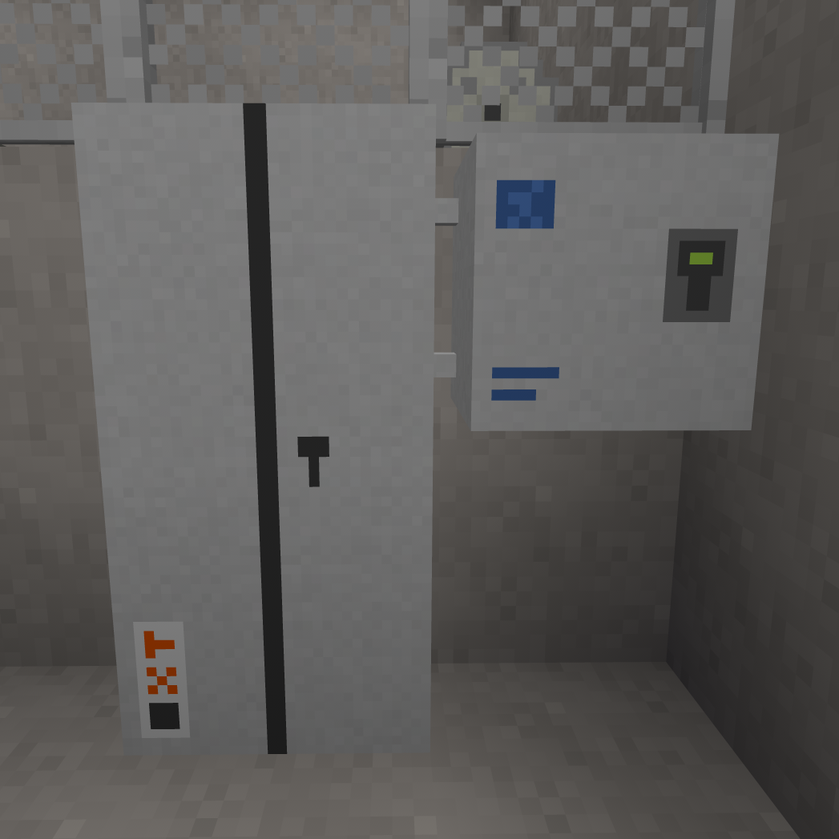

Placing the car in the hoistway
In order to be suitable for use, the hoistway must be 2m wide (side to side) and 3m deep (front to back). Any material may be used for its construction. The total height may be any desired value, however it must not be more than approximately 490m tall in total.
Doorways should be located on a narrow (2m wide) side of the hoistway. Each doorway should be 2m wide and 3m tall. They may be at any desired vertical spacing from each other, so long as they do not overlap.
At the bottom of the hoistway, leave at least 1m of extra height below the floor level of the lowest landing in order to accommodate the car floor and toe guard.
At the top, leave at least 2m of extra height (3m recommended) in order to have adequate headroom when operating the car on car top inspection mode.
Place the car in the hoistway at the lowest landing. When placing the car, face into the hoistway and point at the left wall, just inside the door, at the level of the lowest portion of the door, as shown:
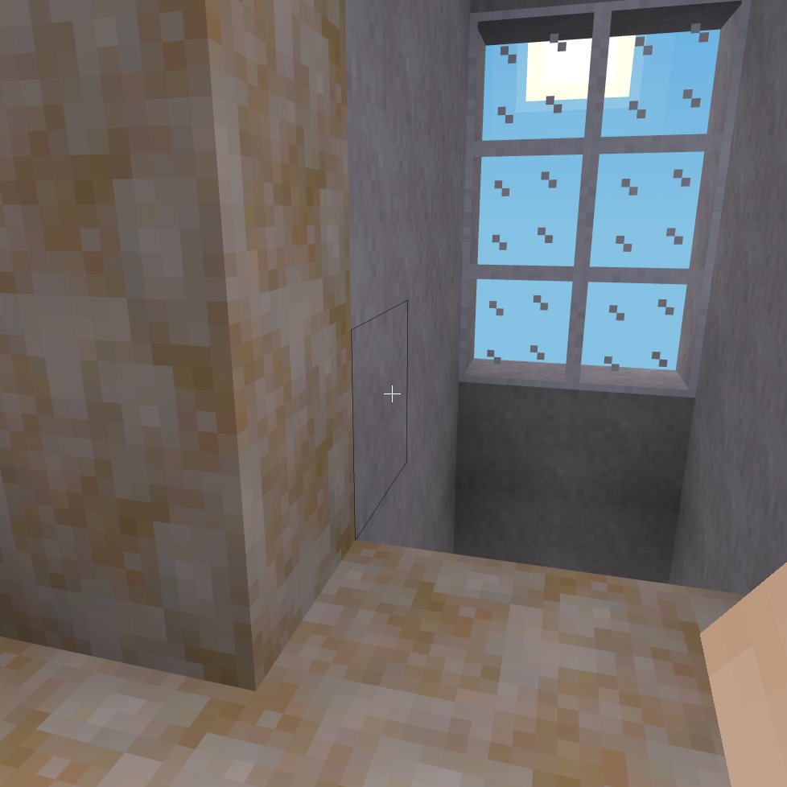
If you need to remove the car, hold the sneak key (by default, the shift key) and punch (left-click by default) the panel of key switches in the bottom left.

Placing the guide rails (optional)
This is an optional step and will not affect the operation of the car.
Place the guide rails as shown, making sure that a gap of 2 meters remains between the faces of the opposing rails. Center the rails front to back in the hoistway.
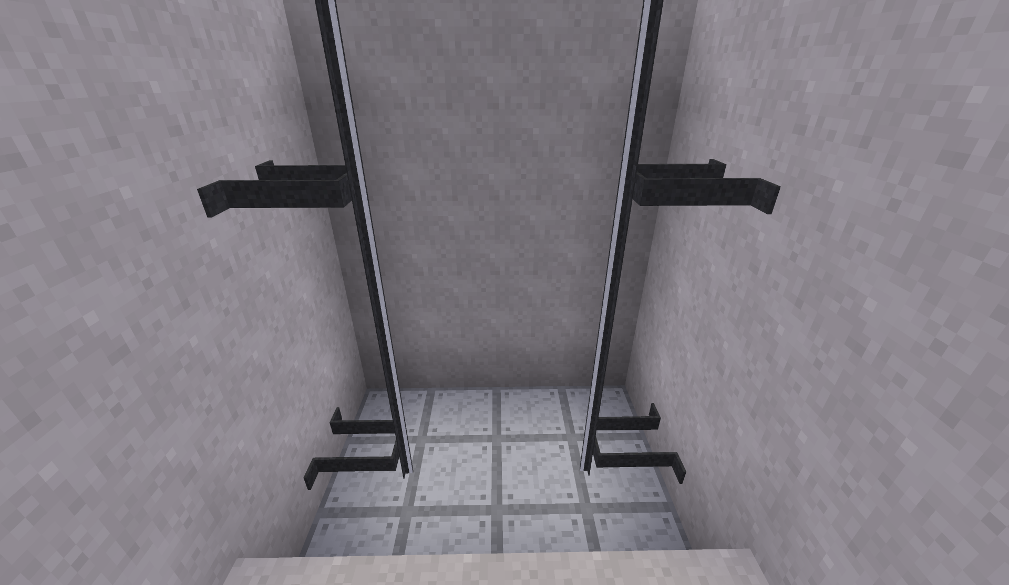
Brackets can be placed at any desired interval along the rails. One bracket every 3 meters is recommended.

Placing the positioning system tape (optional)
This is an optional step and will not affect the operation of the car.
On the right side of the hoistway, place the tape behind the guide rail as shown:
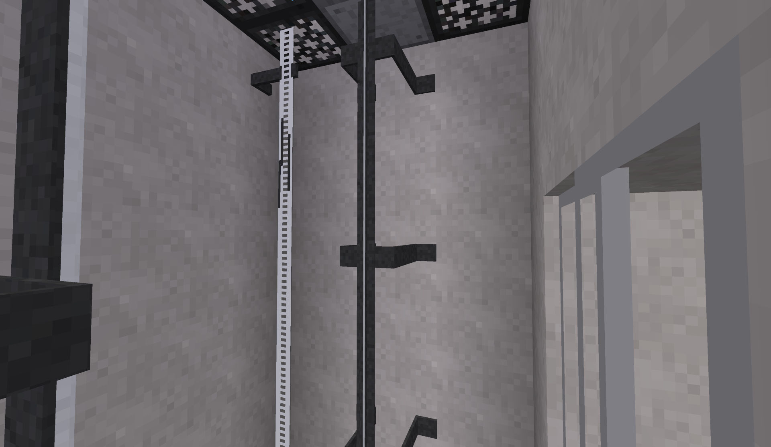
Install magnets above the top of the door at each landing. Brackets are available for supporting the ends of the tape.
If the car has already been placed, a tape head will automatically be added:
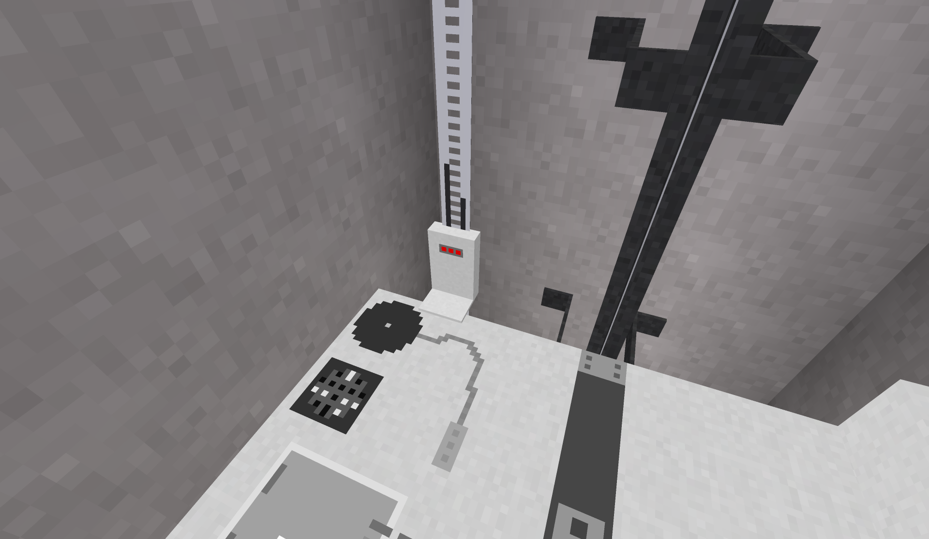
Three LEDs are available on the front of the tape head to indicate the car position relative to the magnets. From left to right, these are:
ULM (Up Leveling Marker) - Illuminates when the car is between 45cm below and 5cm above floor level.
DLM (Down Leveling Marker) - Illuminates when the car is between 5cm below and 45cm above floor level.
DZ (Door Zone) - Illuminates when the car is within 30cm of floor level in either direction.

Placing the buffers (optional)
This is an optional step and will not affect the operation of the car.
Place two buffers in the bottom of the pit, centered between the guide rails, as shown:
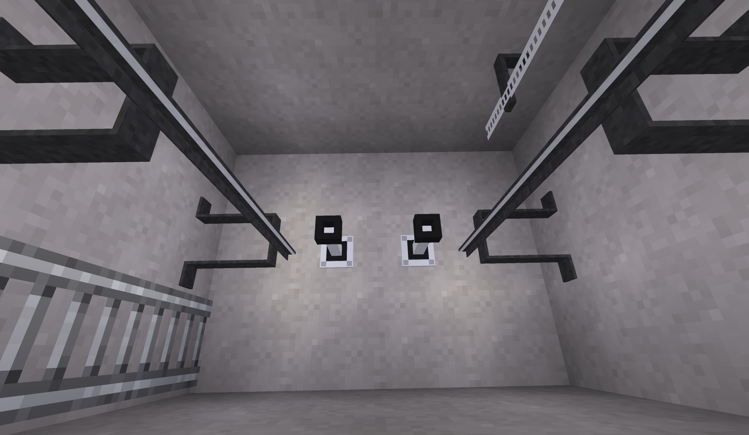
Two types of buffers are available:
Elastomeric - Recommended for low-speed use. Requires at least 1 meter pit depth, 2 meters recommended. This is the type shown in the image.
Oil-Filled - Recommended for medium and high-speed usage. Requires at least 2 meters pit depth, 3 meters recommended.

Placing the machine
Place the machine directly above the top of the hoistway. The placement location must be directly above some part of the car, with a gap of no more than 500 meters.
When the machine is placed, the motor and brake will be automatically placed to the left of the machine, and the traction sheave will face towards you.
Recommended placement of the hoist machine (steel and grating is directly above the car):
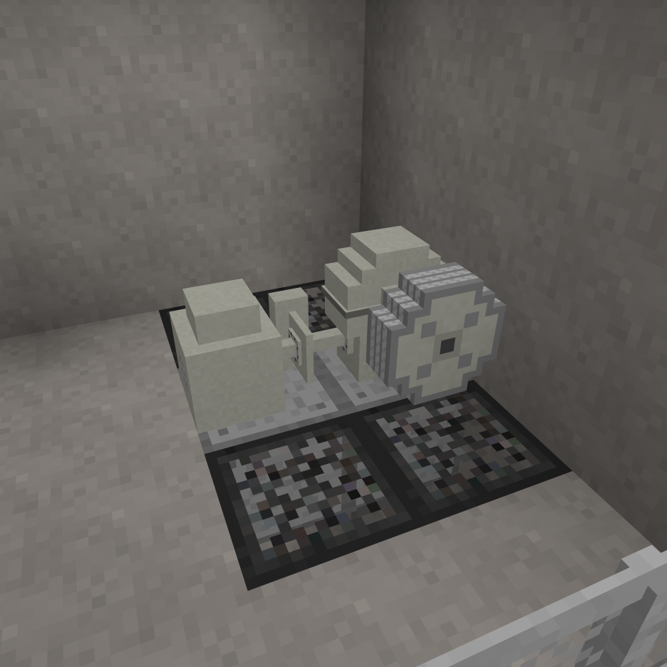
After placement, open the form on the machine (right-click by default) and enter the ID number of the controller it will be used with. The ID number can be obtained by pointing at the controller.
Next, verify that the text shown when pointing at the machine indicates the coordinates of the car. If it states that no car was found, make the necessary adjustments and punch (left-click by default) the machine to try again.

Placing the doors
Place a set of hoistway doors at each floor that will be served, including the floor the car was placed at. The car is equipped with a door restrictor, so if the car attempts to stop at a floor that is missing hoistway doors, the car doors will remain closed and the controller will report a fault and shut down.
Car doors are provided with the car and do not need to be placed manually.
To place the doors, point at the left side of the floor in the doorway, as shown:
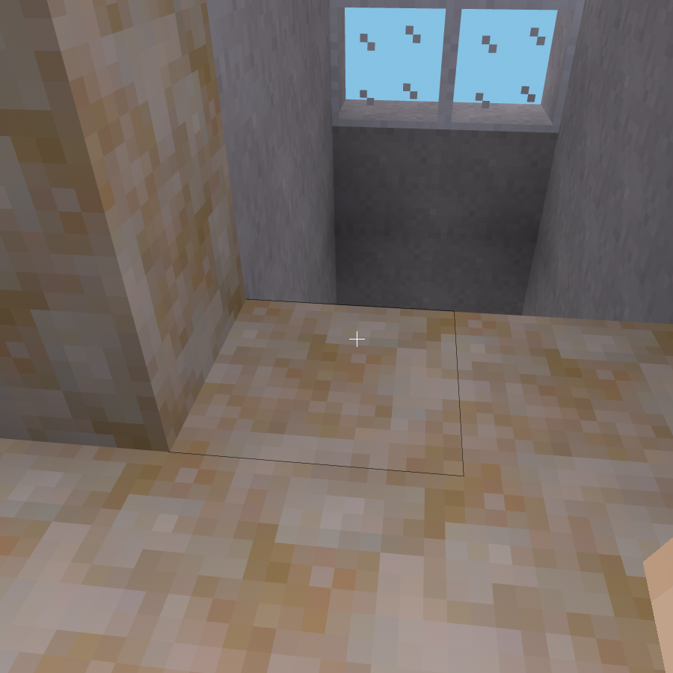
If you later need to remove a set of doors, dig the lower left corner as viewed from outside.

Placing the dispatcher (group operation only)
A dispatcher is only needed for group (more than one car) operation. Skip this step if you will be using simplex (single car) operation.
The dispatcher should be placed on the machine room floor in a location that provides access to its front for installation and service.
Please observe the following when selecting a location:
- Allow adequate space above and next to the dispatcher. The cabinet is 2m tall and 1m wide.
- Allow space in front of the dispatcher for access during installation and service. While the dispatcher doors do not protrude past 1m even when open, placing objects in front of the dispatcher may make service difficult. Leaving an empty, accessible space of at least 2m (measured with doors closed) in front of the dispatcher is recommended.
- The machine room door should be of a type that locks. The dispatcher cabinet is lockable (following area protection), however if it is accidentally left open, then anyone gaining access to the machine room will be able to modify parameters.
Place the dispatcher as shown:
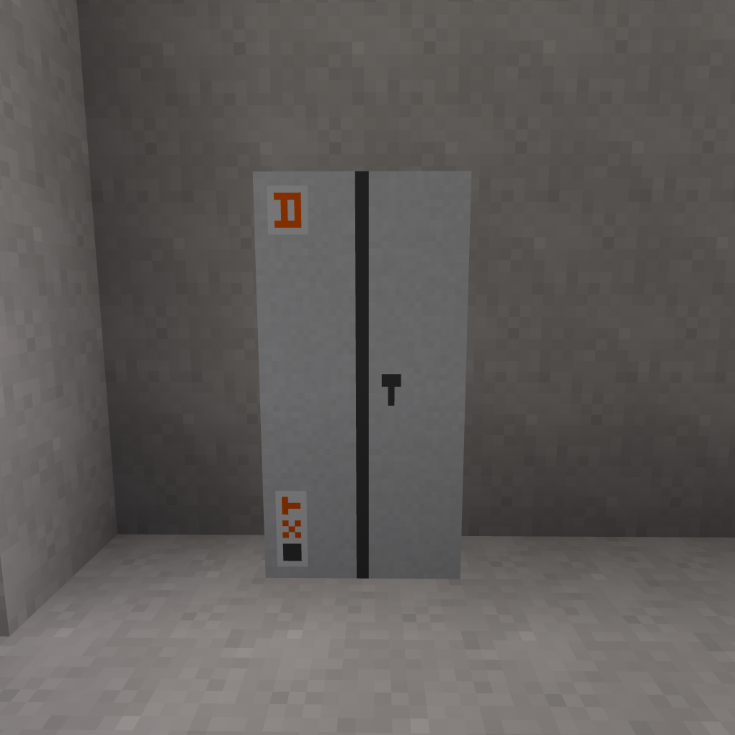

Selecting simplex or group operating mode
Punch (left-click by default) the controller cabinet to open the door, then open (right-click by default) the controller display.
The following screen should appear:
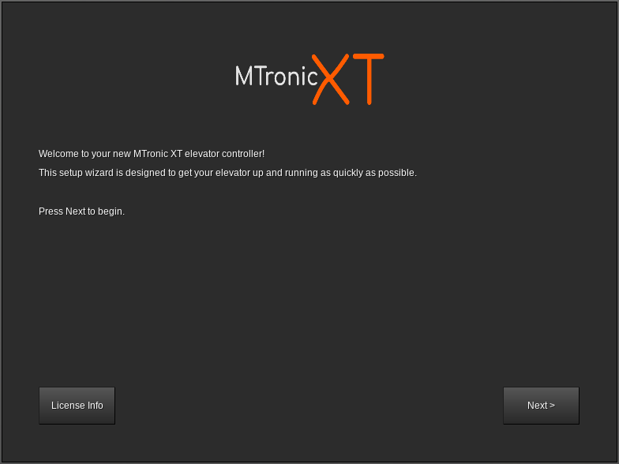
Click Next. The screen should change to the following:
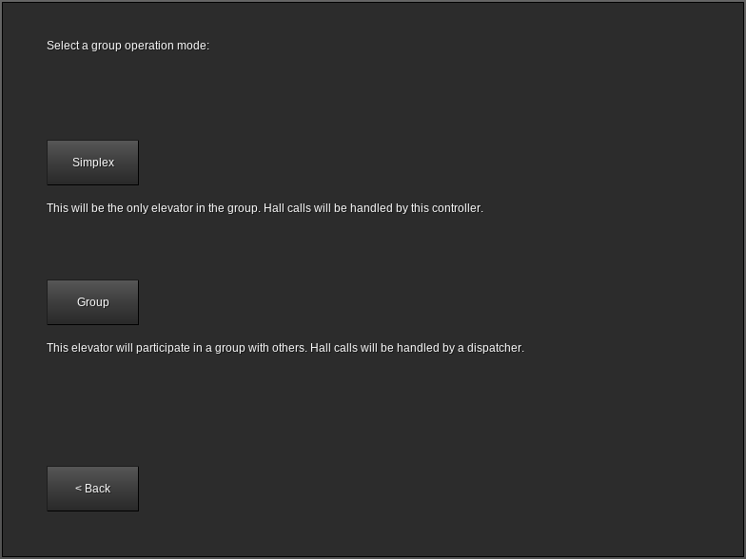
If this car will be operating in a simplex configuration (meaning this is the only car), click Simplex. If this car will operate in a group (multiple cars), click Group.

Configuring the controller floor table (simplex operation only)
Cars using group operation have the floor table sent by the dispatcher. This section is only applicable to simplex cars.
After clicking Simplex at the group mode selection screen, the floor table editor will appear:
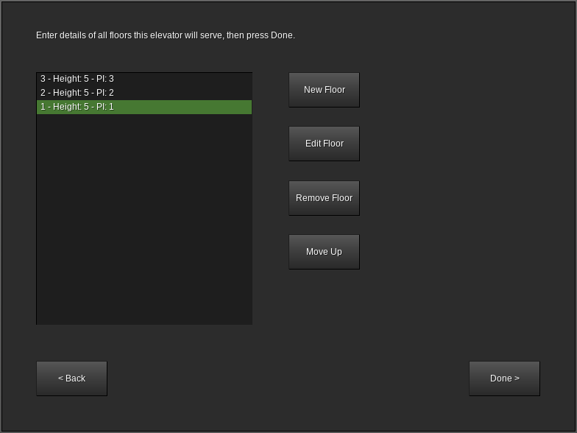
The list at the left shows each floor the elevator will serve. By default, three floors are present, each 5 meters tall, numbered from 1 to 3.
The number on the far left of each line (to the left of Height) is the landing number. This always starts at 1 for the lowest landing and increases by 1 with each landing upwards.
Height indicates the distance from floor level at this floor to floor level at the next floor (not applicable at the top floor). For example, if standing on floor 1 shows your height as +10.5 and standing on floor 2 shows your height as +15.5, then the height of floor 1 is 5. For the topmost floor, the height value is unimportant and any number can be entered.
PI is the text that will be used when displaying this floor, as well as the text that will be on the button for this floor. For example, if landing 1 has PI set to L, then when the car is at landing 1, the position indicator(s) will show L. This value can be one to three characters long and can contain any printable ASCII characters, including uppercase and lowercase letters, numbers, symbols, and spaces. For best results, use numbers and uppercase letters.
New Floor adds an extra floor to the top of the list. You can create up to 100 floors.
Remove Floor removes the highlighted floor from the list and renumbers the remaining floors appropriately. You can only remove a floor if you have at least three floors.
Move Up and Move Down move the highlighted floor up or down in the list. These buttons only appear if the highlighted floor is not already at the respective end of the list.
Edit Floor opens the floor editor:
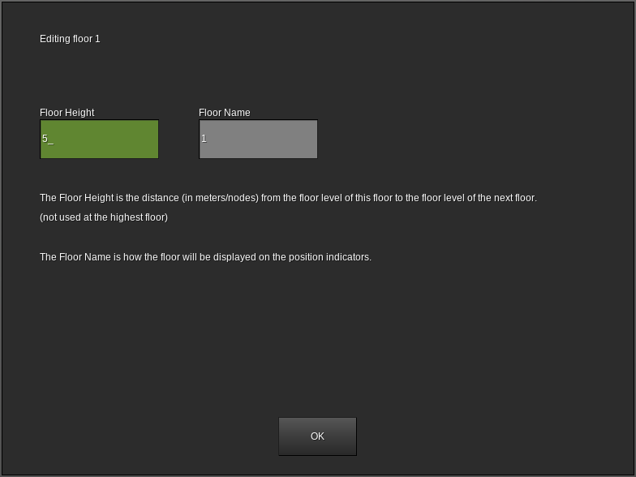
Floor Height sets the height of this floor (see Height on the previous page).
Floor Name sets the name of this floor (see PI on the previous page).
When the values are correct, click OK to return to the previous floor table editor screen.
When the floor table is complete and accurate, click Done to save your changes.

Configuring the dispatcher floor table (group operation only)
Simplex cars have the floor table created at the controller. This section is only applicable to cars using group operation.
Punch (left-click by default) the dispatcher to open the door, then open (right-click by default) the form. The following screen should appear:
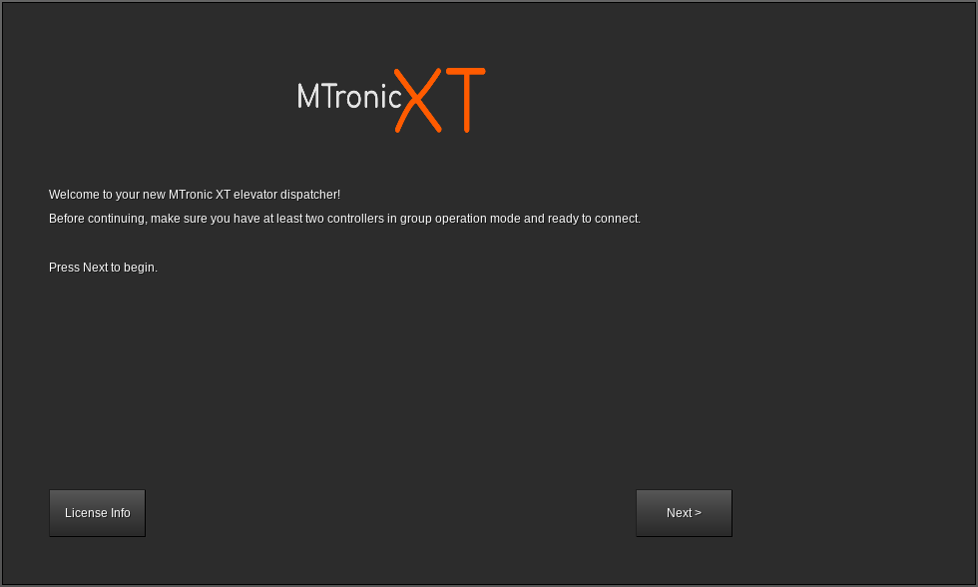
Click Next. The floor table editor will appear:
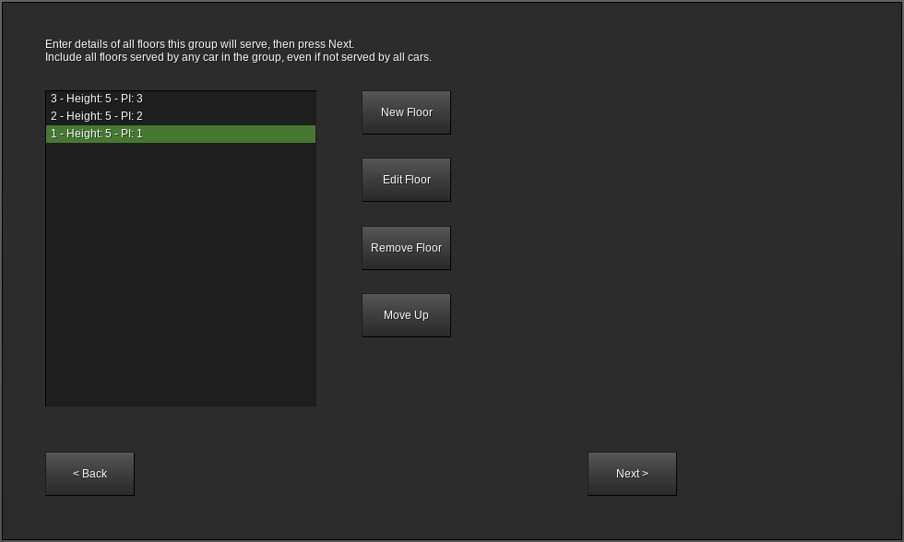
The list at the left shows each floor the elevator will serve. By default, three floors are present, each 5 meters tall, numbered from 1 to 3.
The number on the far left of each line (to the left of Height) is the landing number. This always starts at 1 for the lowest landing and increases by 1 with each landing upwards.
Height indicates the distance from floor level at this floor to floor level at the next floor (not applicable at the top floor). For example, if standing on floor 1 shows your height as +10.5 and standing on floor 2 shows your height as +15.5, then the height of floor 1 is 5. For the topmost floor, the height value is unimportant and any number can be entered.
PI is the text that will be used when displaying this floor, as well as the text that will be on the button for this floor. For example, if landing 1 has PI set to L, then when the car is at landing 1, the position indicator(s) will show L. This value can be one to three characters long and can contain any printable ASCII characters, including uppercase and lowercase letters, numbers, symbols, and spaces. For best results, use numbers and uppercase letters.
New Floor adds an extra floor to the top of the list. You can create up to 100 floors.
Remove Floor removes the highlighted floor from the list and renumbers the remaining floors appropriately. You can only remove a floor if you have at least three floors.
Move Up and Move Down move the highlighted floor up or down in the list. These buttons only appear if the highlighted floor is not already at the respective end of the list.
Edit Floor opens the floor editor (see next page).
Floor Height sets the height of this floor (see Height on the previous page).
Floor Name sets the name of this floor (see PI on the previous page).
When the values are correct, click OK to return to the previous floor table editor screen.
Note that all floors served by any car in the group must be entered, even if not all cars in the group will serve all floors. You will have an opportunity in the next step to choose which floors are served by each car.
When the floor table is complete and accurate, click Next to save your changes.

Connecting to the controllers (group operation only)
Simplex cars do not have a dispatcher. This section is applicable to cars using group operation only.
After the floor table has been saved, the following screen should appear:
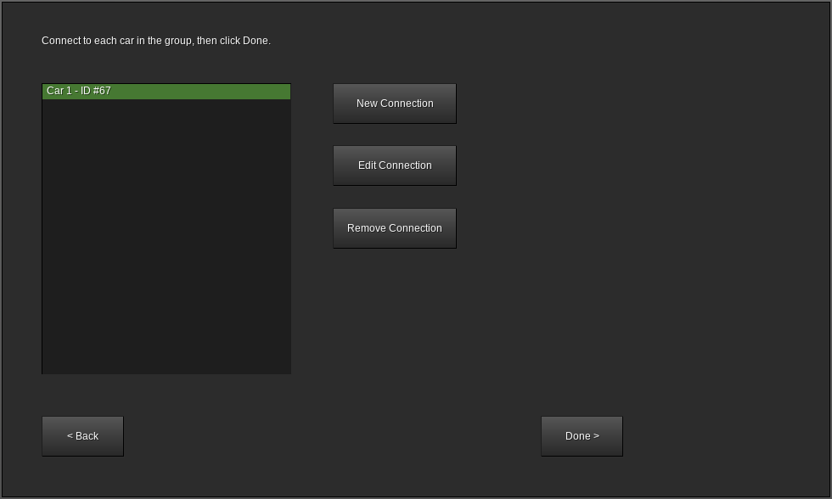
This screen lists all of the current connections from this dispatcher to the controllers of the cars in its group.
ID is the ID number of the controller. This can be obtained by pointing at the controller.
Remove Connection removes the highlighted car from the group.
New Connection adds a new car to the group.
Edit Connection is used to change the floors served by the highlighted car.
Clicking New Connection or Edit Connection opens the following screen:
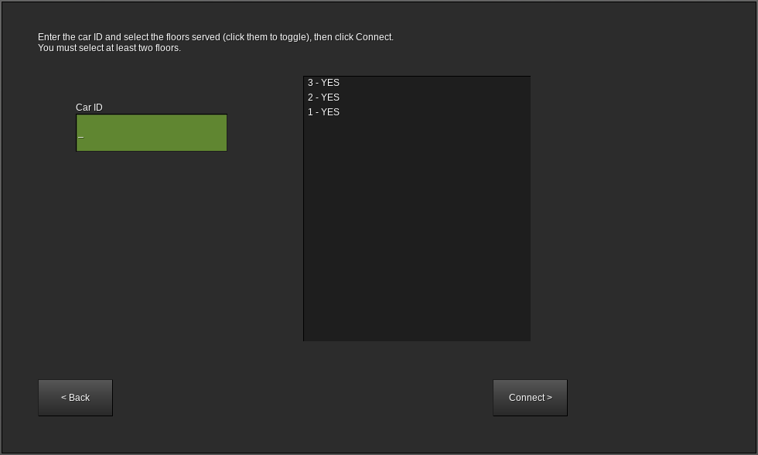
Car ID is the ID number of the controller to be added to the group. This can be obtained by pointing at the controller, or if the controller is ready to pair then the ID number will also be shown on the controller display.
The list on the right side controls which floors will be served by this car. This should show YES for floors that exist on this car and NO for floors which do not. Click a floor in the list to toggle it to YES or NO. At least two floors must be set to YES.
When the floor list is correct and the car ID has been entered, click Connect. If the connection was successful, the previous screen should reappear.
If the connection fails, check the following:
- Is the car ID correct? The controller should show its ID number on its display.
- Is the controller already in a group? Controllers can only be connected to if they have not already been connected.
- Is the controller ready to connect? The group mode should be set to Group and the controller display should show Waiting for connection from dispatcher...
When all controllers in the group are connected, click Done.

Testing the floor stops
Before continuing, set the TEST switch on the controller (located under the display) to the on position. This will disable all hall calls and prevent the doors from opening.
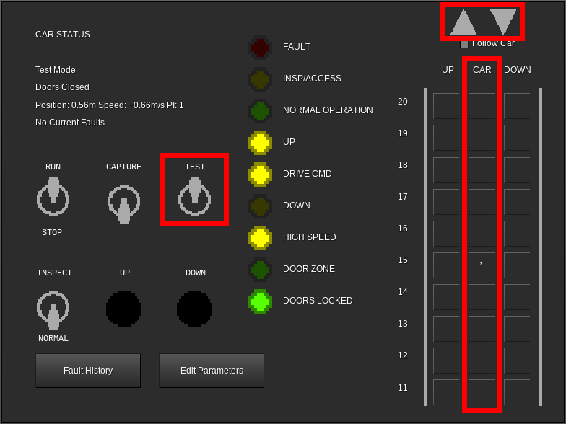
One at a time, click each floor in the CAR column. This will place a car call (indicated by an asterisk) on that floor. After placing each call, observe the car and verify that it stops properly at the floor, then continue on to the next floor. Due to test mode being enabled, the doors will not open when the car stops.
If the car serves more than ten floors, up and down arrow buttons will become available in the top right corner of the controller display. Use these to scroll the view up and down in order to place car calls above the 10th floor.
When satisfied with the performance, set the TEST mode switch to the off position. The green NORMAL OPERATION LED should light. The doors will now open in response to calls. If desired, the test may be repeated in this mode in order to verify proper door operation.

Pairing the PIs and lanterns to the controller
PIs (position indicators), lanterns, and PI/lantern combinations may be placed in any desired location.
A typical configuration is:
- Down lantern near the doorway on the topmost floor
- Up/down combination lanterns near the doorway on all intermediate floors
- Up lantern near the doorway on the bottommost floor
- PI/lantern combination in place of the lantern on the lobby floor
- PI in the building security office, if one exists
Any number of these items can be used per car.
After placing each item, open its form (right-click by default):
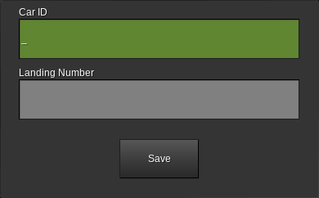
Car ID is the ID number of the controller that this device will be connected to. This can be obtained by pointing at the controller.
Landing Number is the number of the landing that this device is installed on. This comes from the leftmost number in the floor table, not the name of the floor. For example, the lowest floor is always “1”, the next lowest floor is always “2”, etc.
For cars using group operation, skip counting any floors this car does not serve. For example, if the group spans floors LL, G, and M, but this car only serves LL and M (and does not serve G), then if this device is on floor M, the landing number would be 2.
Not all device types will request a landing number.
When the values are correct, click Save.

Pairing the call buttons
Call buttons may be placed in any desired location. Typically, the topmost floor will have a down button, the bottommost floor will have an up button, and intermediate floors will have both up and down buttons.
For simplex cars:
Placement and pairing is identical to lanterns. See the previous page.
For cars using group operation:
Placement and pairing is identical to lanterns (see the previous page), except as follows:
- For normal call buttons, enter the ID of the dispatcher in the Car ID field. This can be obtained by pointing at the dispatcher.
- For swing call buttons (call buttons that will always call a specific car), enter the ID number of the associated controller in the Car ID field. This can be obtained by pointing at the controller.

Pairing the fire recall keyswitch
The fire recall keyswitch can be placed in any desired location, however it is typically located on the lobby floor and near the elevator or group of elevators.
Use only one of these keyswitches per car (simplex) or group (group).
After placing the switch, open its form (right-click by default):
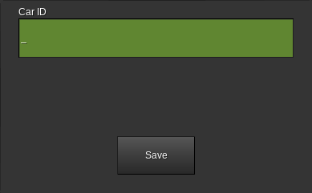
For simplex cars:
Enter the ID number of the controller. This can be obtained by pointing at the controller.
For cars using group operation:
Enter the ID number of the dispatcher. This can be obtained by pointing at the dispatcher.

Controller Interface

Car Status
This is the main screen that is normally displayed on the controller.
It is divided into five sections as follows:
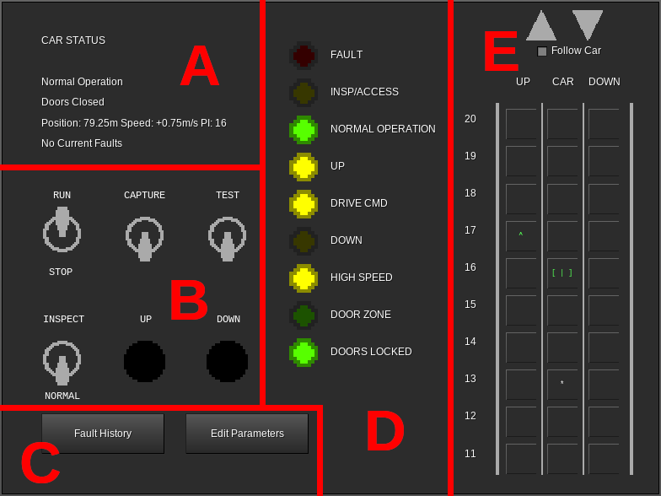
Section A (Status Display)
Line 1 of this section shows the current operation mode of the car. See the Controller Messages section on page 57 for information on possible values.
Line 2 of this section shows the current state of the doors (opening, open, closing, or closed).
Line 3 shows the position of the car in meters above the lowest floor, the speed at which the car is moving in meters per second (positive is up, negative is down), and the floor number that the car is currently at.
Line 4 indicates if there is any fault information in the controller memory.

Section B (Switches)
This section contains the following switches and buttons:
RUN/STOP - When set to the STOP position, the car stops immediately, all calls are canceled, and the car is no longer allowed to move. When set to the RUN position, if the car is otherwise allowed to move, it will move downwards to the nearest floor unless it is already level with a floor.
CAPTURE - When set to the on position, all hall calls are canceled (if the controller is in group operation, the dispatcher will reassign them to other cars, provided that any are available) and new hall calls cannot be established. The car will still serve car calls normally.
TEST - When set to the on position, all hall calls are canceled (if the controller is in group operation, the dispatcher will reassign them to other cars, provided that any are available) and new hall calls cannot be established. The car will still serve car calls, but the doors will not open.
INSPECT/NORMAL - When set to the INSPECT position, the car stops immediately, all calls are canceled, and the car enters machine room inspection operation. The car can be moved by using the UP and DOWN buttons. When set to the RUN position, if the car is otherwise allowed to move, it will move downwards to the nearest floor unless it is already level with a floor.
UP - When the INSPECT/NORMAL switch is set to the INSPECT position, the car will move upwards by one meter at reduced speed each time this button is pressed.
DOWN - When the INSPECT/NORMAL switch is set to the INSPECT position, the car will move downwards by one meter at reduced speed each time this button is pressed.
Section C (Other Screens)
Fault History - Opens the list of stored faults. See the Fault History section on page 32.
Edit Parameters - Opens the parameter editor. See the Edit Parameters section on page 33.
Section D (LEDs)
FAULT - Lights red when a fault is stored in memory.
INSP/ACCESS - Lights yellow when the car is in machine room inspection or car top inspection operation.
NORMAL OPERATION - Lights green when no faults are present and no special operation modes are enabled.
UP - Lights yellow when the car is moving upwards.
DRIVE CMD - Lights yellow when the car is moving or attempting to move. If DRIVE CMD is lit but UP and DOWN are not, then the drive is enabled but the car is moving at zero speed.
DOWN - Lights yellow when the car is moving downwards.
HIGH SPEED - Lights yellow when the car is moving at a significant portion of contract speed.
DOOR ZONE - Lights green when the car is within 50cm of any landing.
DOORS LOCKED - Lights green when the doors are fully closed.
Section E (Call Status and Registration)
UP Column - For simplex cars, shows a green up arrow at each landing where an up hall call exists. Clicking on a landing in this column places an up hall call at that landing.
For cars using group operation, shows a green up arrow at each landing where an up hall call exists, and shows a yellow up arrow at each landing where a swing up call (up hall call specific to this car) exists. Clicking on a landing in this column places a swing up call at that landing.
DOWN Column - For simplex cars, shows a red down arrow at each landing where a down hall call exists. Clicking on a landing in this column places a down hall call at that landing.
For cars using group operation, shows a red down arrow at each landing where a down hall call exists, and shows a yellow down arrow at each landing where a swing down call (down hall call specific to this car) exists. Clicking on a landing in this column places a swing down call at that landing.
CAR Column - Shows the current car calls. Car calls are shown by an asterisk in this column at each landing where a car call exists. Clicking on a landing in this column places a car call at that landing.
Additionally, the position of the car is shown in this column. The appearance of the car symbol reflects the state of the doors:
- [ | ] - Doors closed
- [< >] - Doors opening
- [> <] - Doors closing
- [ ] - Doors open
The color of the car symbol represents the current collector state. The car appears green when collecting up calls, red when collecting down calls, and white when idle. This may not always reflect the actual direction of travel.
Large Gray Up/Down Arrows - Only shown when more than ten landings exist. Clicking these scrolls the UP/CAR/DOWN columns in the appropriate direction. If Follow Car is selected, clicking either of these will unselect it.
Follow Car - Only shown when more than ten landings exist. When selected, the UP/CAR/DOWN columns scroll automatically to keep the current position of the car on the screen. Manually scrolling will automatically deselect this option.

Fault History
Displays any faults currently stored in the controller memory:
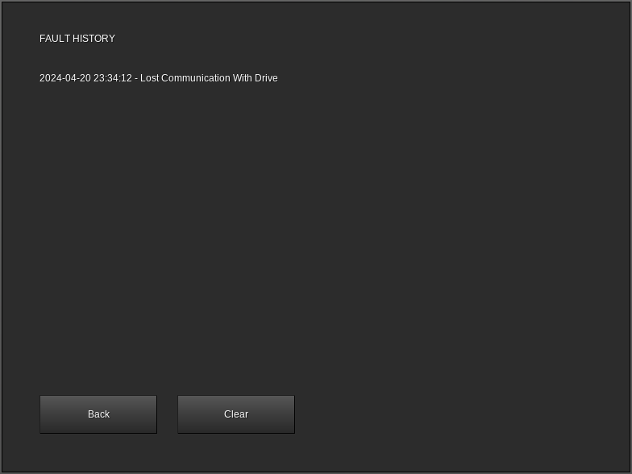
For information on a specific fault, see the Controller Messages section on page 57.
Back - Returns to the Car Status screen.
Clear - Removes all entries from the fault log.

Edit Parameters
Displays and enables editing of parameters, as well as offering options for recovering from certain problems:
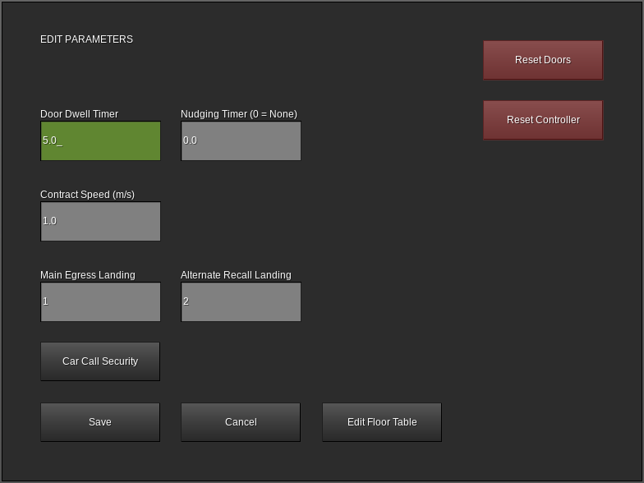
Door Dwell Timer - When in normal operation, the length of time the doors will stay open in response to a call before beginning to close.
Nudging Timer - When in normal operation, the length of time after the doors reach full open before nudging begins.
Contract Speed - The maximum speed of the car in meters per second.
Main Egress Landing - The landing number (not floor name) that the car will return to when fire service phase 1 is activated. The car call button for this landing on the COP will also be marked with a star.
Alternate Recall Landing - The landing number (not floor name) that the car will return to when fire service phase 1 is activated with alternate landing mode (typically used when smoke is detected on the main egress landing) specified.
Save - Saves changes to the above three parameters and returns to the car status display.
Cancel - Returns to the car status display without saving any changes to the above three parameters.
Edit Floor Table - Available on simplex cars only. Allows for editing the list of floors served by the car. See the Configuring the controller floor table section on page 17.
Car Call Security - Allows designating car call buttons as usable for all users, usable following area protection, or entirely disabled. See the Car Call Security section on page 35.
Reset Doors - Attempts to resynchronize the state of the doors in the controller memory with the actual physical state of the doors. This can help with recovering from conditions where the doors were unable to open.
Reset Controller - Cancels all calls, immediately closes the doors, and causes the car to return to the lowest landing.

Car Call Security
Displays and allows editing of car call security settings. Each car call button in the COP can be designated as usable by all users, usable following area protection, or completely disabled.
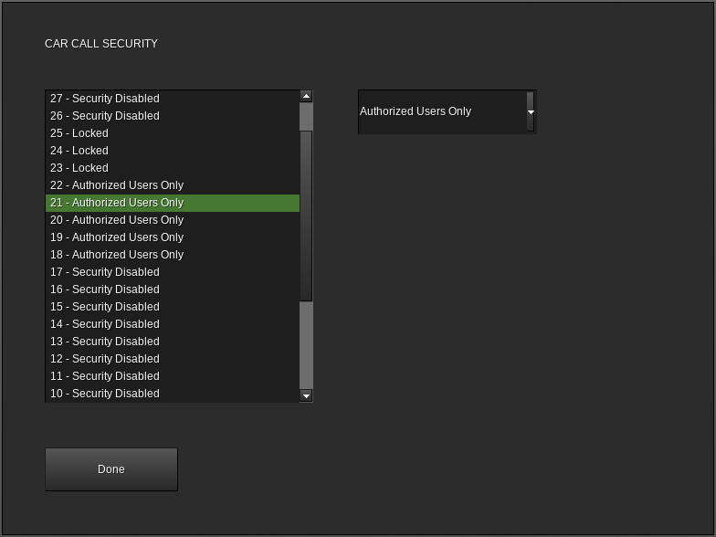
The list on the left side of the screen shows all of the currently known floors and their current security settings. The drop-down box on the right side is used to change the security mode of the currently selected floor.
The valid security modes are:
- Security Disabled - No security checking is performed. Car calls are accepted regardless of user.
- Authorized Users Only - Car calls are accepted only from users with the necessary privileges to build in the area in which the COP is located. Typically, this means any user with ownership of the area or the ability to bypass area protection.
- Locked - Car calls are not accepted regardless of user or area protection
The main egress landing cannot have security settings applied and will always display Security Disabled.

Dispatcher Interface

Group Display
This screen shows the status of all of the cars in the group:
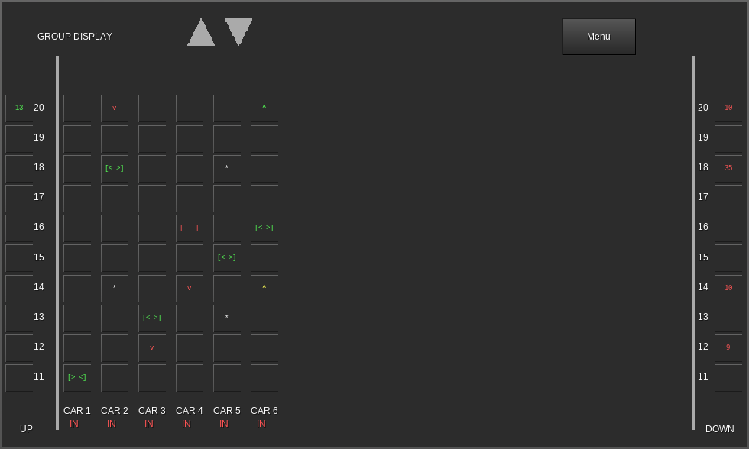
UP Column - At landings where an up hall call exists, shows a green number representing the estimated time (in seconds) until a car arrives to answer the call. Clicking in this column at one of the landings will place an up hall call at that landing.
DOWN Column - At landings where a down hall call exists, shows a red number representing the estimated time (in seconds) until a car arrives to answer the call. Clicking in this column at one of the landings will place a down hall call at that landing.
CAR Columns - Each column is labeled at the bottom to indicate which car in the group it corresponds to. Below the car number, IN is displayed if the car is in normal operation and able to receive calls from the dispatcher, or OUT if it is currently not participating in the group.
At each landing, five indicators can be displayed in each car column:
- Green Up Arrow - An up hall call exists at this landing and is currently assigned to this car.
- Red Down Arrow - A down hall call exists at this landing and is currently assigned to this car.
- Yellow Up Arrow - A swing up call (up hall call specific to this car) exists for this car at this landing.
- Yellow Down Arrow - A swing down call (down hall call specific to this car) exists for this car at this landing.
- White Asterisk - A car call exists for this car at this landing.
At the landing where the car is present, a symbol representing the car is displayed instead. The appearance of this symbol indicates the state of the doors as follows:
- [ | ] - Doors closed
- [< >] - Doors opening
- [> <] - Doors closing
- [ ] - Doors open
This symbol is also colored to represent the current collector state of the car. When the car is collecting up calls, the symbol is colored green. When the car is collecting down calls, the symbol is colored red. If the car is idle, the symbol is white. The color of the symbol may not reflect the actual travel direction of the car.
Menu - Shows the main menu screen.

Main Menu
Allows access to dispatcher configuration options:
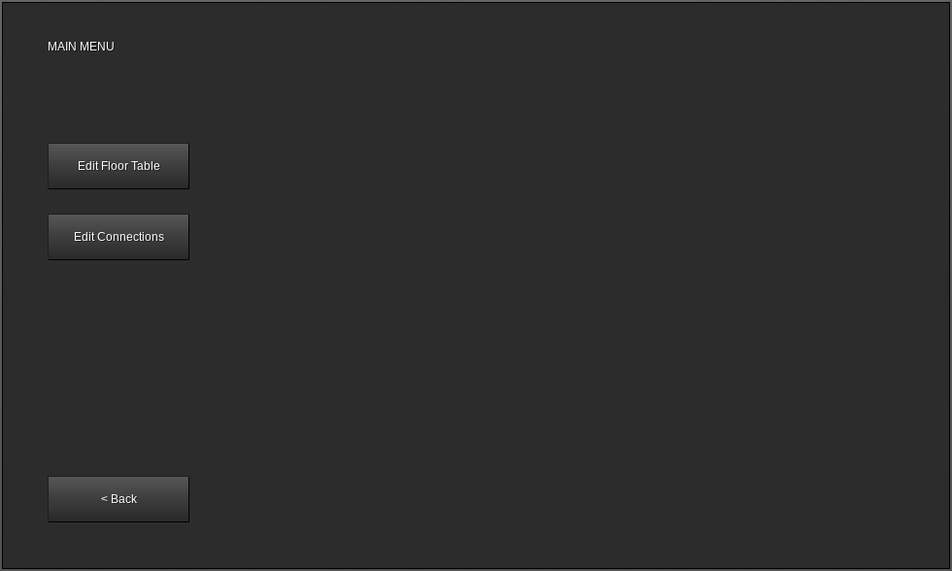
Back - Returns to the group display screen.
Edit Floor Table - Displays the edit floor table screen. See the Configuring the dispatcher floor table section on page 19. Hall calls are not accepted while this option is in use.
Edit Connections - Displays the edit connections screen. See the Connecting to the controllers section on page 22. Hall calls are not accepted while this option is in use.

Third-Party Device Connections
Both the controller and dispatcher may be connected to devices supplied by various third parties, allowing the addition of remote monitoring and control as well as arbitrary user-defined functionality.
These functions are intended for advanced users only. None of them are required to be used in order to install and run a functioning elevator system.
If the required device is not available, the connection to it will also not be available, however basic functionality and other connection types will remain operational.
The device types supported are:
- mView computer interface (“laptop” mod)
- Mesecons input and output (“mesecons” mod)
- Digilines input and output (“digilines” mod)

mView Computer Interface (“laptop” mod)
If the “laptop” mod is installed, the mView software will automatically be installed on the desktop of all supported computers.
System requirements:
- MTOS (CS-BOS-only systems are not compatible)
- Hard disk drive
mView can be used to view the status of controllers and dispatchers, as well as to enter calls. Each computer can be connected to any number of controllers and/or dispatchers in any combination, and each controller or dispatcher can be connected to from any number of computers running mView.

Setup
To use mView, first launch the software by clicking the mView icon on the desktop.
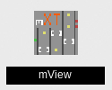
The mView software will open. If this is the first time mView has been used on this computer, a welcome page will be displayed:
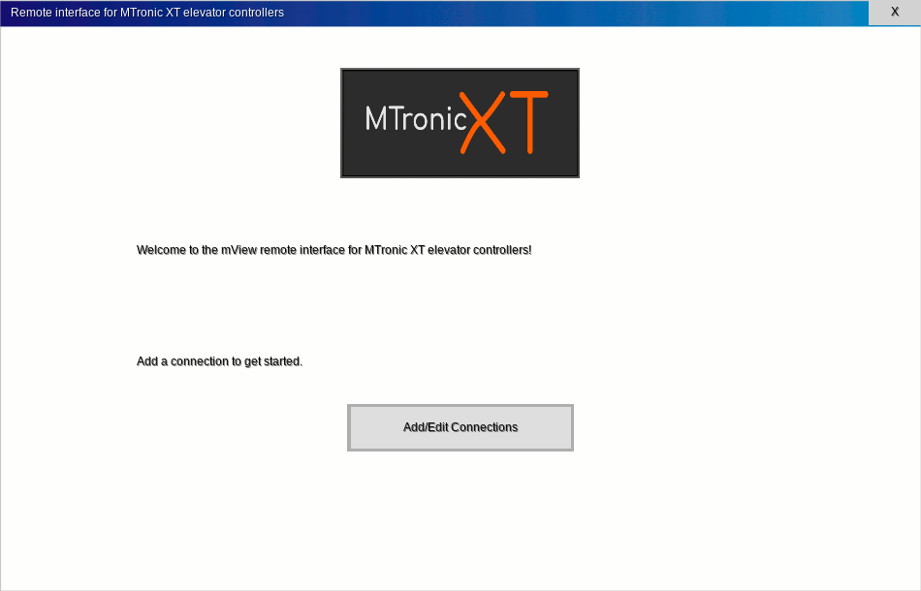
Click Add/Edit Connections to open the connection manager:
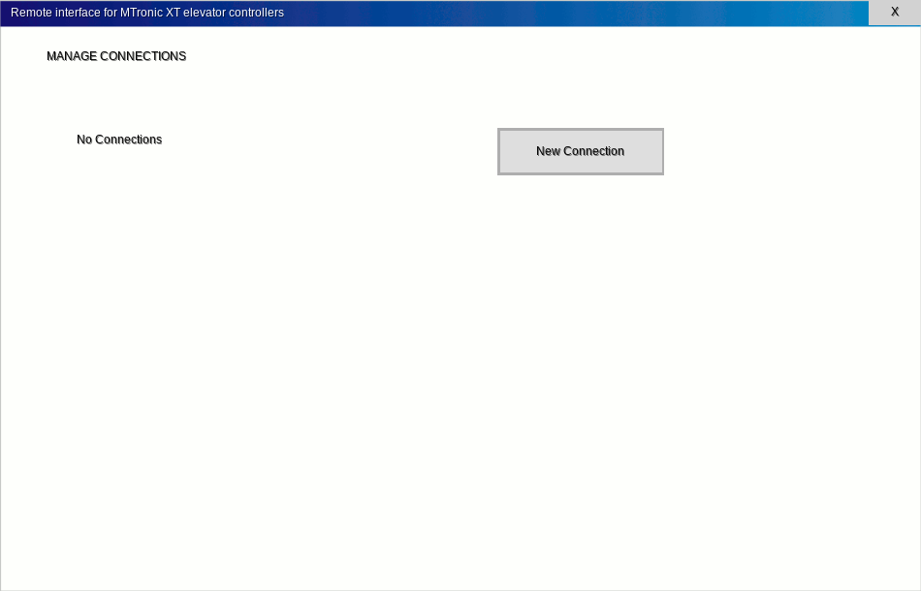
Later, after connections have been created, the window will look like this:
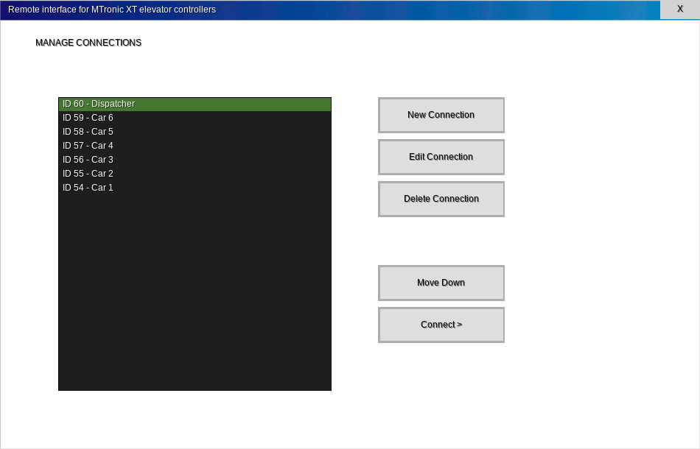
The following options are available:
New Connection - Creates a new connection and opens the connection editor window so connection settings can be entered.
Edit Connection - Opens the connection editor window to allow editing of the settings for the currently highlighted connection.
Delete Connection - Removes the highlighted connection.
Move Up - Moves the highlighted connection upwards in the list. Only available if the highlighted connection is not already at the top of the list.
Move Down - Moves the highlighted connection downwards in the list. Only available if the highlighted connection is not already at the bottom of the list.
Connect > - Connects to the selected controller or dispatcher.
Click New Connection to create a new connection. The connection editor will appear:
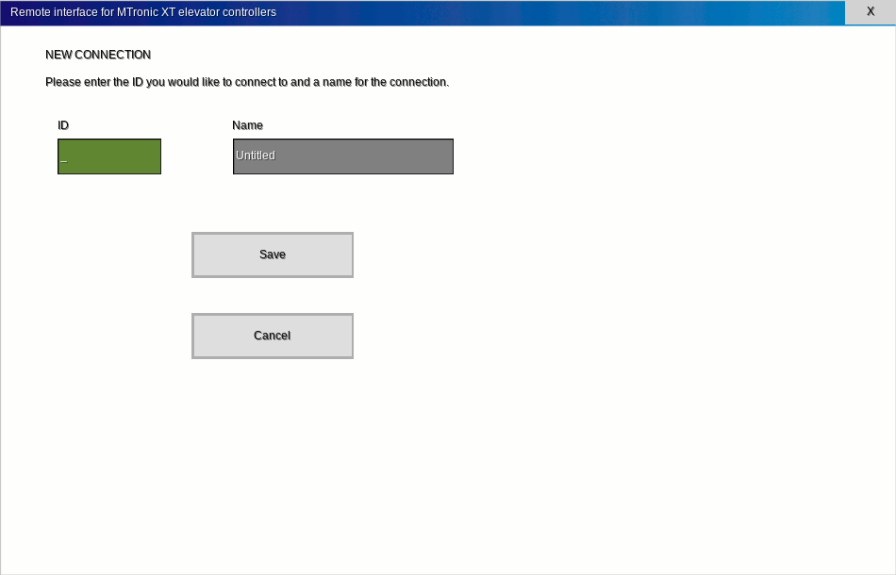
Enter the ID number of the controller or dispatcher (this can be obtained by pointing at the controller or dispatcher) into the ID field and a name into the Name field, then click Save. Any name can be used, as the name only serves as a reminder of which ID number corresponds to each controller or dispatcher in the list.
After clicking Save, the connection manager window will reappear. Once all desired connections have been added, select a connection and click Connect >.
If the selected connection is to a controller, the controller window will appear. See the Controller section.
If the selected connection is to a dispatcher, the dispatcher window will appear. See the Dispatcher section.

Controller
When mView is connected to a controller, the following screen will be displayed:
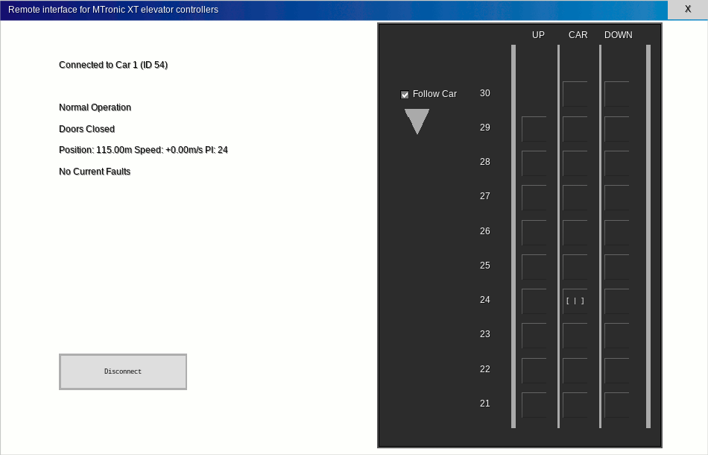
The status display and call status/registration sections function identically to those on the controller itself. See Car Status on page 28 for more information.
The Disconnect button is used to disconnect from this controller and return to the connection manager.

Dispatcher
When mView is connected to a dispatcher, the following screen will be displayed:
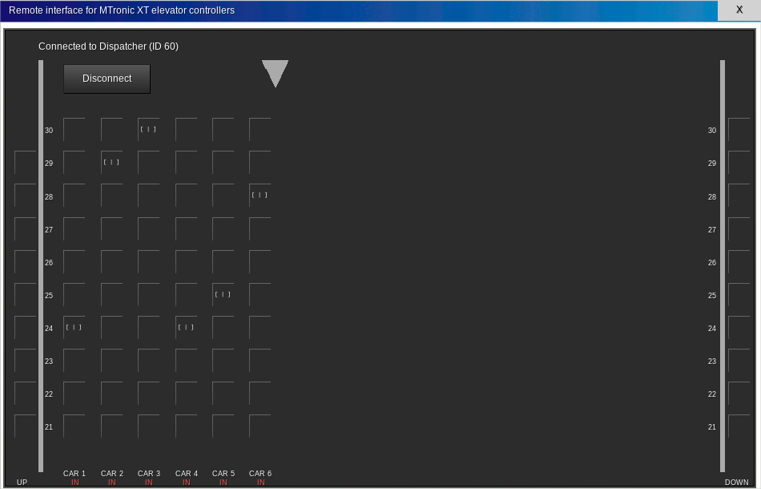
The items on this screen function identically to the screen on the dispatcher itself (see the Group Display section on page 36 for more information) except that the Menu button is not available.
The Disconnect button is used to disconnect from this dispatcher and return to the connection manager.

Mesecons Input/Output (“mesecons” mod)
If the “mesecons” mod is installed, input and output modules will become available that can be used to provide signals to mesecons devices depending on the state of a controller or dispatcher, as well as to send various requests to a controller or dispatcher upon receipt of a mesecons signal.
The Mesecons Input Module should be used when it is desired to have an elevator controller or dispatcher respond to a mesecons signal.
The Mesecons Output Module should be used when it is desired to have a mesecons signal indicate some aspect of the state of an elevator controller or dispatcher.
After placing either type of module, open its form (right-click by default). The following screen will appear:
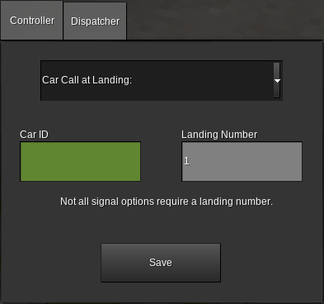
(input module shown, output module is similar)
Controller - Select this tab if this module will be connected to a controller.
Dispatcher - Select this tab if this module will be connected to a dispatcher.
Signal Name (drop-down near top of window) - Select which action should be performed upon receipt of a mesecons signal (for input modules) or in what case a mesecons signal should be generated (for output modules). See below for possible values.
Car ID or Dispatcher ID - Enter the ID number of the controller or dispatcher that this module will be used with.
Landing Number - If required by the selected signal option, enter the relevant landing number (not floor name).
Save - Saves your changes and exits the window.
The valid signal options are as follows:

Controller Input
Car Call at Landing: - When a mesecons signal is received, a car call will be established at the selected landing. This option requires a landing number.
Up Call (simplex car) at Landing: - When a mesecons signal is received, if the selected car is operating in simplex mode, an up hall call will be established at the selected landing. This option requires a landing number and has no effect if the selected car is in group operation mode.
Down Call (simplex car) at Landing: - When a mesecons signal is received, if the selected car is operating in simplex mode, a down hall call will be established at the selected landing. This option requires a landing number and has no effect if the selected car is in group operation mode.
Up Call (swing) at Landing: - When a mesecons signal is received, if the selected car is operating in group mode, a swing up call (up hall call specific to this car) will be established at the selected landing. This option requires a landing number and has no effect if the selected car is in simplex operation mode.
Down Call (swing) at Landing: - When a mesecons signal is received, if the selected car is operating in group mode, a swing down call (down hall call specific to this car) will be established at the selected landing. This option requires a landing number and has no effect if the selected car is in simplex operation mode.
Deactivate Fire Service Phase 1 - When a mesecons signal is received, fire service phase 1 on the selected car will be disabled. This option does not require a landing number.
Activate Fire Service (main landing) Phase 1 - When a mesecons signal is received, fire service phase 1 on the selected car will be enabled. The car will cancel all calls and recall to the landing specified by the Main Egress Floor parameter (see the Edit Parameters section on page 33). This option does not require a landing number.
Activate Fire Service (alternate landing) Phase 1 - When a mesecons signal is received, fire service phase 1 on the selected car will be enabled. The car will cancel all calls and recall to the landing specified by the Alternate Recall Floor parameter (see the Edit Parameters section on page 33). This option does not require a landing number.
Machine Room or Hoistway Smoke Detector - When a mesecons signal is received, fire service phase 1 on the selected car will be enabled. If the car is stopped at a floor, the doors will be opened. If the car is moving, all calls will be canceled and the car will stop at the next available floor in the current direction of travel and open its doors. The firefighters’ hat lamp in the car will flash until fire service is deactivated. This option does not require a landing number.

Controller Output
Normal Operation - A mesecons signal will be output when the selected car is in normal operation. This option does not require a landing number.
Fault - A mesecons signal will be output when the selected car is stopped due to any fault condition. This option does not require a landing number.
Emergency Stop - A mesecons signal will be output when the selected car is stopped due to the controller RUN/STOP switch being in the STOP position. This option does not require a landing number.
Inspection (Any) - A mesecons signal will be output when the selected car is operating in either car top inspection or machine room inspection mode. This option does not require a landing number.
Fire Service - A mesecons signal will be output when the selected car is operating in either fire service phase 1 or fire service phase 2. This option does not require a landing number.
Fire Service Phase 1 - A mesecons signal will be output when the selected car is operating in fire service phase 1. This option does not require a landing number.
Fire Service Phase 2 - A mesecons signal will be output when the selected car is operating in fire service phase 2. This includes both the ON and OFF positions of the in-car FIRE SVC keyswitch. This option does not require a landing number.
Independent Service - A mesecons signal will be output when the selected car is operating in independent service. This option does not require a landing number.
Doors Opening - A mesecons signal will be output when the doors of the selected car are opening, but not yet fully open. This option does not require a landing number.
Doors Open - A mesecons signal will be output when the doors of the selected car are fully open. This option does not require a landing number.
Doors Closing - A mesecons signal will be output when the doors of the selected car are closing, but not yet fully closed. This option does not require a landing number.
Doors Closed - A mesecons signal will be output when the doors of the selected car are fully closed. This option does not require a landing number.
Moving Up - A mesecons signal will be output when the selected car is moving upwards. This option does not require a landing number.
Moving Down - A mesecons signal will be output when the selected car is moving downwards. This option does not require a landing number.
Moving (Any Direction) - A mesecons signal will be output when the selected car is moving either upwards or downwards. This option does not require a landing number.
Collecting Up Calls - A mesecons signal will be output when the selected car is searching for up calls. This may not reflect the actual direction of travel. This option does not require a landing number.
Collecting Down Calls - A mesecons signal will be output when the selected car is searching for down calls. This may not reflect the actual direction of travel. This option does not require a landing number.
Car Light Switch - A mesecons signal will be output when the in-car CAR LIGHT switch in the selected car is in the ON position. This option does not require a landing number.
Car Fan Switch - A mesecons signal will be output when the in-car CAR FAN switch in the selected car is in the ON position. This option does not require a landing number.
Up Call Exists at Landing: - A mesecons signal will be output when an up hall exists for the selected car at the selected landing. This option requires a landing number.
Down Call Exists at Landing: - A mesecons signal will be output when a down hall call exists for the selected car at the selected landing. This option requires a landing number.
Car Call Exists at Landing: - A mesecons signal will be output when a car call exists for the selected car at the selected landing. This option requires a landing number.
Car at Landing: - A mesecons signal will be output when the selected car is at the selected landing. This option requires a landing number.
Moving to Landing: - A mesecons signal will be output when the selected car is moving to the selected landing. The destination may change if more calls are entered. This option requires a landing number.

Dispatcher Input
Up Call at Landing: - When a mesecons signal is received, an up hall call will be established at the selected landing for the selected dispatcher. This option requires a landing number.
Down Call at Landing: - When a mesecons signal is received, a down hall call will be established at the selected landing for the selected dispatcher. This option requires a landing number.
Deactivate Fire Service Phase 1 - When a mesecons signal is received, all cars connected to the selected dispatcher will exit fire service phase 1. This option does not require a landing number.
Activate Fire Service Phase 1 - When a mesecons signal is received, all cars connected to the selected dispatcher will enter fire service phase 1 and recall to the landing determined by each car’s Main Egress Floor setting (see the Edit Parameters section on page 33 for more information). This option does not require a landing number.

Dispatcher Output
Fire Service - A mesecons signal will be output when the group controlled by the selected dispatcher is in fire service, either as a result of a keyswitch connected to the dispatcher or due to a previous Activate Fire Service Phase 1 signal received by the same dispatcher. The signal will remain until either the keyswitch is rotated to RESET followed by OFF or a Deactivate Fire Service Phase 1 signal is received. This option does not require a landing number.
Up Call Exists at Landing: - A mesecons signal will be output when an up hall call exists for the selected dispatcher at the selected landing. This option requires a landing number.
Down Call Exists at Landing: - A mesecons signal will be output when a down hall call exists for the selected dispatcher at the selected landing. This option requires a landing number.

Digilines Input/Output (“digilines” mod)
If the “digilines” mod is installed, a digilines input/output module will become available that can be used to monitor and control a controller or dispatcher from a Luacontroller or other similar device.
After placing the module, open its form (right-click by default). The following screen will be displayed:
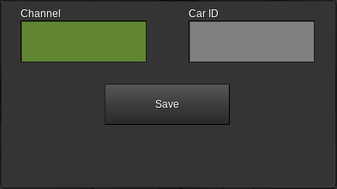
Channel - Enter the digilines channel name that will be used to communicate with this module.
Car ID - Enter the ID number of the controller or dispatcher that will be used with this module. This can be obtained by pointing at the controller or dispatcher.
Save - Saves your changes and closes the window.
To communicate with the module, send it a table containing a “command” field set to the name of the command you want to execute. If the command requires additional parameters, supply them in the same table.
The available commands are as follows:

CARCALL
If the module is connected to a controller, establishes a car call at the landing number specified by the floor parameter.

UPCALL
If the module is connected to a dispatcher or to a controller operating in simplex mode, establishes an up hall call at the landing number specified by the floor parameter. For establishing swing up calls (up hall calls specific to one car in a group) use the SWINGUPCALL command instead.

DOWNCALL
If the module is connected to a dispatcher or to a controller operating in simplex mode, establishes a down hall call at the landing number specified by the floor parameter. For establishing swing down calls (down hall calls specific to one car in a group) use the SWINGDOWNCALL command instead.

SWINGUPCALL
If the module is connected to a controller operating in group mode, establishes a swing up call (up hall call specific to one car in a group) at the landing number specified by the floor parameter. For simplex cars use the UPCALL command instead.

SWINGDOWNCALL
If the module is connected to a controller operating in group mode, establishes a swing down call (down hall call specific to one car in a group) at the landing number specified by the floor parameter. For simplex cars use the DOWNCALL command instead.

GET
Causes the module to reply on the same digilines channel with a table containing status information for the selected controller or dispatcher.
As a special case, sending a string message of “GET” will also trigger this command.
When connected to a controller, the returned table contains the following fields:
carstate - A string from the following list describing the current state of the car:
- normal - Normal Operation
- uninit - Uninitialized
- resync - Position Sync - Floor
- bfdemand - Position Sync - Terminal
- fault - Fault
- stop - Emergency Stop
- mrinspect - Machine Room Inspection
- carinspect - Car Top Inspection
- inspconflict - Inspection Conflict
- fs1 - Fire Service - Phase 1
- fs2 - Fire Service - Phase 2
- fs2hold - Fire Service - Phase 2 Hold
- indep - Independent Service
- capture - Captured
- test - Test Mode
See the Controller Messages section on page 57 for more information about these messages.
doorstate - A string from the following list describing the current state of the doors:
- closed - Doors are fully closed
- opening - Doors are opening but not yet fully open
- open - Doors are fully open
- closing - Doors are closing but not yet fully closed
- testtiming - Doors are closed but simulating an open/close cycle for test mode
carcalls - A table representing which landings currently have car calls established. The keys of the table represent landing numbers, and the value is set to true if a car call is present.
upcalls - A table representing which landings currently have up hall calls established. The format is the same as carcalls.
groupupcalls - A table representing which landings currently have up hall calls established from a dispatcher. The format is the same as carcalls. This field is only available in group operation mode.
swingupcalls - A table representing which landings currently have swing up calls (up hall calls specific to this car) established. The format is the same as carcalls. This field is only available in group operation mode.
downcalls - A table representing which landings currently have down hall calls established. The format is the same as carcalls.
groupdowncalls - A table representing which landings currently have down hall calls established from a dispatcher. The format is the same as carcalls. This field is only available in group operation mode.
swingdowncalls - A table representing which landings currently have swing down calls (down hall calls specific to this car) established. The format is the same as carcalls. This field is only available in group operation mode.
fireserviceled - A boolean value, true when fire service phase 1 is active, even if fire service phase 2 is also active.
direction - Either nil or a string value. A string value of up indicates that the controller is searching for up calls, a string value of down indicates that the controller is searching for down calls, and a nil value indicates that the controller is idle because no calls are present. This may not reflect the actual direction of travel.
switches - A table containing the following fields:
- stop - A boolean value, true when the controller RUN/STOP switch is in the STOP position.
- machineroominspection - A boolean value, true when the controller INSPECT/NORMAL switch is in the INSPECT position.
- cartopinspection - A boolean value, true when the car top INSPECT/RUN switch is in the INSPECT position.
- capture - A boolean value, true when the controller CAPTURE switch is in the on position.
- test - A boolean value, true when the controller TEST switch is in the on position.
- fireservice1 - A boolean value, true when the most recent fire service phase 1 switch position received was ON.
- fireservice2 - A string value, on when the in-car FIRE SVC switch is in the ON position, hold when the switch is in the HOLD position, and OFF when the switch is in the OFF position.
- independent - A boolean value, true when the in-car IND SVC switch is in the ON position.
- light - A boolean value, true when the in-car CAR LIGHT switch is in the ON position.
- fan - A boolean value, true when the in-car CAR FAN switch is in the ON position.
parameters - A table containing the following fields:
- contractspeed - A number value representing the contract speed setting of the car in meters per second.
- floorheights - A table representing the configured height of each landing in meters.
- floornames - A table containing the name assigned to each landing.
- doortimer - A number value representing the door dwell timer setting in seconds.
- groupmode - A string value, either simplex or group depending on the mode setting of the controller.
- mainlanding - A number value representing the Main Egress Landing setting (page 33).
- altrecalllanding - A number value representing the Alternate Recall Landing setting (page 33).
- nudgetimer - A number value representing the current setting of the nudging timer or 0 if nudging is disabled.
- carcallsecurity - A table containing the current security setting for each landing. A nil value indicates that security is disabled. A string value of auth indicates that security for this landing is set to allow authorized users only, while a string value of deny indicates that the car calls for this landing are locked.
drivestatus - A table representing the current state of the drive, containing the following fields (not all fields may be available on some drive types):
- apos - A number value indicating the current position of the car, measured in meters above the lowest landing.
- dpos - A number value indicating the current destination of the car, measured in meters above the lowest landing.
- vel - A number value indicating the current speed of the car, measured in meters per second. Positive values indicate upwards motion, while negative values indicate downwards motion.
- maxvel - A number value indicating the current maximum allowed speed of the car as set by the controller, in meters per second.
- state - A string value indicating the current state of the drive, from the following list:
  - uninit - Drive is not yet set up
  - stopped - Car is not moving
  - start - Car is preparing to move
  - running - Car is moving
  - fakerunning - Car has unloaded while moving and the rest of its motion is being simulated
- doorstate - A string value indicating the current state of the doors, from the following list:
  - open - Doors are open and may be closing
  - closed - Doors are closed and may be opening
- fault - A string value indicating any current fault that exists in the drive. An empty string indicates no fault. Possible values are as follows (see Controller Messages on page 57 for more information):
  - uninit - Drive Not Configured
  - metaload - Drive Metadata Load Failure
  - badorigin - Drive Origin Invalid
  - doorinterlock - Attempted to Move Doors With Car in Motion
  - outofbounds - Target Position Out of Bounds
- neareststop - A number value indicating the nearest valid position that the destination could be changed to, in the current direction of travel, considering the current position and speed. Measured in meters from the lowest floor level.
When connected to a dispatcher, the returned table contains the following fields:
fireserviceled - A boolean value, true if fire service phase 1 is currently active for the entire group.
upcalls - A table representing the landings at which up hall calls are currently established. Each up hall call is represented with a key containing the landing number and a value containing a table with the following fields:
- eta - A number value representing the estimated time in seconds until a car arrives to serve this call. Value is undefined if the call has not yet been assigned to a car.
- assignedcar - A number value or nil indicating which car in the group has been assigned to serve this call. Value may be nil if the call has not yet been assigned to a car.
downcalls - A table representing the landings at which down hall calls are currently established. The format is the same as the upcalls table.

Controller Messages

Message | Attempted to Move Doors With Car in Motion
Reason | Possible software issue.
Car Reaction | Car makes an emergency stop and all calls are canceled.
Troubleshooting | Contact manufacturer.

Message | Captured
Reason | Controller CAPTURE switch is in the on position and no further calls exist.
Car Reaction | Car remains at the last served floor with the doors closed. Hall calls are not accepted. Car calls are served normally.
Troubleshooting | Verify that the controller CAPTURE switch is in the off position.

Message | Car Top Inspection
Reason | INSPECT/RUN switch on the car top is in the INSPECT position.
Car Reaction | Car makes an emergency stop if running and cancels all calls. Once stopped, car can be moved at reduced speed in 1m increments using the car top UP and DN buttons.
Troubleshooting | Verify that the car top INSPECT/RUN switch is in the RUN position.

Message | Door Close Timeout
Reason | Door attempted to close, but did not reach the fully closed position within 10 seconds.
Car Reaction | All calls are canceled and the car is not allowed to run.
Troubleshooting | Remove and replace doors on the affected floor and try again.

Message | Door Open Timeout
Reason | Door attempted to open, but did not reach the fully open position within 10 seconds.
Car Reaction | All calls are canceled and the car is not allowed to run.
Troubleshooting | Remove and replace doors on the affected floor, push Reset Doors on the controller parameters page, and try again.

Message | Drive Metadata Load Failure
Reason | The drive attempted to load its metadata but was unable to load or parse it.
Car Reaction | All calls are canceled and the car is not allowed to run.
Troubleshooting | Remove and replace drive, hoist machine, and car.

Message | Drive Not Configured
Reason | The drive was unable to find its configuration information.
Car Reaction | All calls are canceled and the car is not allowed to run.
Troubleshooting | Punch the hoist machine. If this does not resolve the issue, remove and replace the car and hoist machine.

Message | Drive Origin Invalid
Reason | The drive was unable to parse its configuration information.
Car Reaction | All calls are canceled and the car is not allowed to run.
Troubleshooting | Punch the hoist machine. If this does not resolve the issue, remove and replace the car and hoist machine.

Message | Emergency Stop
Reason | Controller RUN/STOP switch is in the STOP position.
Car Reaction | Car makes an emergency stop if running and cancels all calls. Once stopped, car is not allowed to run.
Troubleshooting | Verify that the controller RUN/STOP switch is in the RUN position.

Message | Fault
Reason | Varies based on specific fault.
Car Reaction | Varies based on specific fault. In most cases, the car makes an emergency stop if running, cancels all calls, and is not allowed to run.
Troubleshooting | Click Fault History and follow instructions for the specific fault(s) displayed.

Message | Fire Service - Phase 1
Reason | Fire recall keyswitch was turned to the ON position.
Car Reaction | All calls are canceled and the car returns to the landing designated by the Main Landing parameter setting.
Troubleshooting | Turn the fire recall keyswitch to the RESET position, then OFF.

Message | Fire Service - Phase 2
Reason | In-car FIRE SVC keyswitch is in the ON position.
Car Reaction | All hall calls are canceled. Car responds to car calls, but doors do not operate automatically. Doors can be opened or closed using the door open and door close buttons. Call cancel button is operational.
Troubleshooting | Turn the in-car FIRE SVC keyswitch to the OFF position.

Message | Fire Service - Phase 2 Hold
Reason | In-car FIRE SVC switch is in the HOLD position.
Car Reaction | All calls are canceled. The car is not allowed to move and the door is not allowed to close.
Troubleshooting | Turn the in-car FIRE SVC keyswitch to the OFF position.

Message | Independent Service
Reason | In-car IND SVC switch is in the ON position.
Car Reaction | All hall calls are canceled. Car responds to car calls, but doors do not close automatically. Doors can be closed using the door close button. Call cancel button is operational.
Troubleshooting | Turn the in-car IND SVC switch to the OFF position.

Message | Inspection Conflict
Reason | Controller INSPECT/NORMAL and car top INSPECT/RUN switches are both in the INSPECT position at the same time.
Car Reaction | Car makes an emergency stop if running and cancels all calls. Car is not allowed to run.
Troubleshooting | Set the controller INSPECT/NORMAL switch to the NORMAL position or the car top INSPECT/RUN switch to the RUN position. Only one of these switches is allowed to be set to INSPECT at one time.

Message | Lost Communication With Drive
Reason | The controller was unable to communicate with the drive.
Car Reaction | All calls are canceled. The exact car motion behavior varies depending on the cause of the problem.
Troubleshooting | Remove and replace car, hoist motor, and drive.

Message | Machine Room Inspection
Reason | Controller INSPECT/NORMAL switch is in the INSPECT position.
Car Reaction | Car makes an emergency stop if running and cancels all calls. Car can be moved at reduced speed in 1m increments by using the controller UP and DOWN buttons.
Troubleshooting | Verify that the controller INSPECT/NORMAL switch is in the NORMAL position.

Message | Normal Operation
Reason | No faults are currently present in the controller memory and no special operation modes are active.
Car Reaction | None.
Troubleshooting | None.

Message | Position Sync - Floor
Reason | The car had previously stopped between floors due to an emergency stop or inspection operation and is now returning to the nearest floor.
Car Reaction | Car moves downward to the nearest floor.
Troubleshooting | Wait for the operation to complete.

Message | Position Sync - Terminal
Reason | The floor table was changed or the controller was reset. The car is now reestablishing its position by traveling to the lowest floor.
Car Reaction | Car moves downward to the lowest floor.
Troubleshooting | Wait for the operation to complete.

Message | Target Position Out of Bounds
Reason | The car attempted to move below the lowest floor or above the position of the hoist machine.
Car Reaction | All calls are canceled and the car is not allowed to run.
Troubleshooting | Verify that the floor table is correct and that the hoist machine is above the highest floor to be served. If the problem persists, remove and replace the car, drive, and hoist machine.

Message | Test Mode
Reason | The controller TEST switch is in the on position.
Car Reaction | All hall calls are canceled. Car responds to car calls, but doors do not open.
Troubleshooting | Verify that the controller TEST switch is in the off position.

Message | Uninitialized
Reason | Controller is missing setup information.
Car Reaction | All calls are canceled and the car is not allowed to run.
Troubleshooting | Replace controller.

