Nathaniel Jones

WSU CESI Lab

06/20/17

**Building Demand Characterization Study – Progress Report**

Purpose

The purpose of characterizing a building’s demand profiles is twofold. Firstly, we would like to be able to study the differences between real-life buildings and buildings generated by a simulation – EnergyPlus. The second purpose is to be able to find relationships between changes made by a user of EAGERS to a building under study and the shape of that building’s demand profile. The end goal with both these purposes is to be able to develop the building specification section of the EAGERS planning tool. We would like the changes made by the user to be reflected in the building demand profile, and we would also like the building demand profiles to closely resemble reality. In this sense, obtaining a more realistic demand profile for a building is a form of forecasting. The more accurate the estimation of future demand, the more the user can have faith in the decisions our program makes for the future.

Progress

Thus far, all buildings with total facility energy demand and total facility power demand data available have been downloaded from the NYSERDA DG Integrated Data System database. Out of approximately 500 buildings, around 150 were downloaded. Of those downloaded buildings, a set of 30 was selected as the set that is to be used in this study. These buildings were selected based on the “cleanliness” of their data (not a lot of missing data points or patterns that don’t make sense). A series of MATLAB functions that provide some information about the buildings’ data have been written. The results of running these functions on a few buildings from the NYSERDA database have been complied later on in this document. Workflow has also been put in place for study of simulated buildings as well. Although there may be some hiccups in applying the MATLAB functions written for the NYSERDA buildings to the EnergyPlus buildings, the process of making the necessary corrections should be a relatively quick one.

Metrics

The MATLAB functions that have been written thus far are for applying certain metrics to the real and simulated building data. The following table outlines a list of metrics that were brainstormed as metrics that could give information about the behavior of building demand profiles. Not necessarily all of these metrics will be used, but if time permits, it would be nice to use all of them. The metrics that have functions written for them so far are the turndown ratio, minimum 95% range, outlier difference, and demand histogram. It should be noted that unless real building data for heating and cooling demand is found, there is currently no way to implement the last two metrics: heating- and cooling-electric overlap.

|  |  |
| --- | --- |
| **Name** | **Mathematical Description** |
| Turndown Ratio | Max. value / min. value (usually describes one day) |
| Minimum 95% Range | The 95% of data points that result in lowest range (min-max) |
| Outlier Difference – (low, high) | Low: Absolute minimum minus min. 95% range minimum  High: Absolute maximum minus min. 95% range maximum |
| Demand Histogram (% of peak demand) | Number of data points within certain percentage values of the peak demand. |
| Cumulative Demand Histogram (% of peak demand) | Cumulative histogram of Demand Histogram. |
| Peak Magnitude Standard Deviation with Seasonal Bias Correction | Average one week to the left and right to get seasonally averaged demand. Then find standard deviation of daily peaks from the averaged demand. |
| Peak Magnitude Standard Deviation without Seasonal Bias Correction | Average all data points to get the total averaged demand. Then find the standard deviation of daily peaks from the averaged demand. |
| Peak Time (hrs) | Range of hours between which peak occurs. Peak defined as the hours within 5% of peak value determined by Min. 95% Range. |
| Trough Time (hrs) | Range of hours between which trough occurs. Trough defined as the hours within 5% of minimum value determined by Min. 95% Range. |
| Maximum Ramp Rate to Peak (%/hr) | Maximum slope of 3-point averaged (current, one behind, and one ahead) demand. |
| Transience (%/hr) | Mean absolute value of slope in demand. |
| Turbulence (%/hr2) | Mean absolute value of change in slope in demand. |
| Maximum Slope Difference (%/hr) | Maximum of the differences in slope from point to point. |
| Number Local Peaks | Number of points where the demand just ahead of and just after that point is lower. |
| Demand Range (kWh) | Range of demand values. |
| Average Demand Value (kWh) | Mean of all values in one day. |
| Annual Trend (kWh/hr) | Final minus initial value of seasonally averaged demand, divided by 8760 hours. |
| Time Unsteady (hrs) | Number of hours within which demand is changing by more than 10% of peak demand. |
| Noise | Standard deviation of data minus smoothed data (2- or 4-hr smoothing). |
| Measurement Noise | Average of % Peak Power Demand minus % Peak Energy Demand values. Comes from the fact that NYSERDA power demand values are given as the maximum value within one hour, whereas energy demand values are given as the average value within one hour. |
| Trend of Average Daily Value | Plot of average daily values for all days containing data. |
| Average Daily Value Standard Deviation | Standard deviation in the average value across all days with a complete set of data. |
| Average Daily Maximum Standard Deviation | Standard deviation of daily maximum value across all days with a complete set of data. |
| Average Daily Minimum Standard Deviation | Standard deviation of daily minimum value across all days with a complete set of data. |
| Heating-Electric Overlap | L2-norm (sum of square errors). Errors are abs(%electric - %heating). |
| Cooling-Electric Overlap | L2-norm (sum of square errors). Errors are abs(%electric - %cooling). |

Results

The results shown in the appendix of this document have been obtained for nine of the thirty buildings selected from among the entire set of NYSERDA database files. These nine were selected prior to any filtering of data, and as such were selected on the basis of the relative “niceness” of their data. In other words, the data for these nine buildings do not contain any egregious outliers that would noticeably skew the results of statistical analyses performed on them. The analyses performed on this subset of buildings so far includes a histogram displaying the frequency of demand values, a plot of the demand showing outliers based on the interquartile range, and lastly a set of box plots showing the distribution of each building’s daily turndown ratios.

It is difficult to make any conclusions about the behavior of real buildings versus simulated buildings at this point, since simulated buildings have not been tested yet, but there are a couple observations that can be gathered from these initial results. The first observation is that in most cases there seems to be a definitive seasonality in the demand data. Demand seems to hit a peak in the summers and a minimum in the winters. The second observation is that the turndown ratios of real buildings seem to skew more on the high side than the low side. Since the base demand for buildings generally doesn’t change as much as the peak demand for any set of given days, this observation suggests that it is safe to assume the peak demand will be higher at some point than the peak demand that was designed for. Both of these observations are to be expected of real buildings, so it will be important to look out for this same behavior in simulated buildings.

Next Steps

The obvious next steps in this study are to gather some data for simulated buildings and to finish writing the series of characterization metrics. Of especial importance are the metrics that reveal information about the noise in real building data. Therefore, the focus going forward will be on getting simulated building data and comparing measurements of noise between real and simulated data.

APPENDIX

**Demand Plots and Histograms**

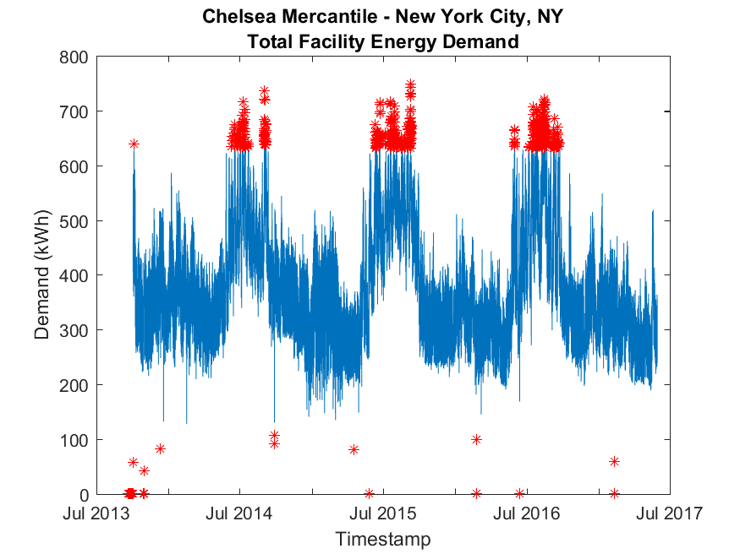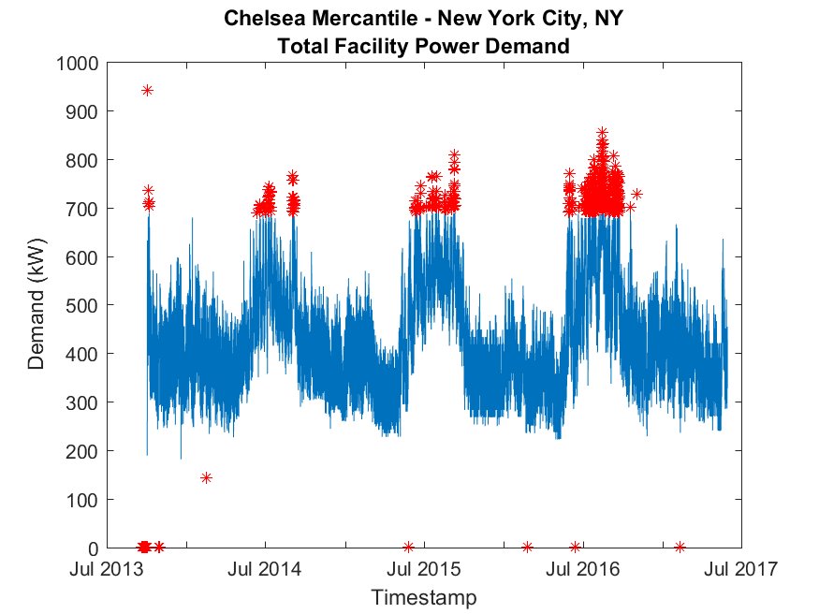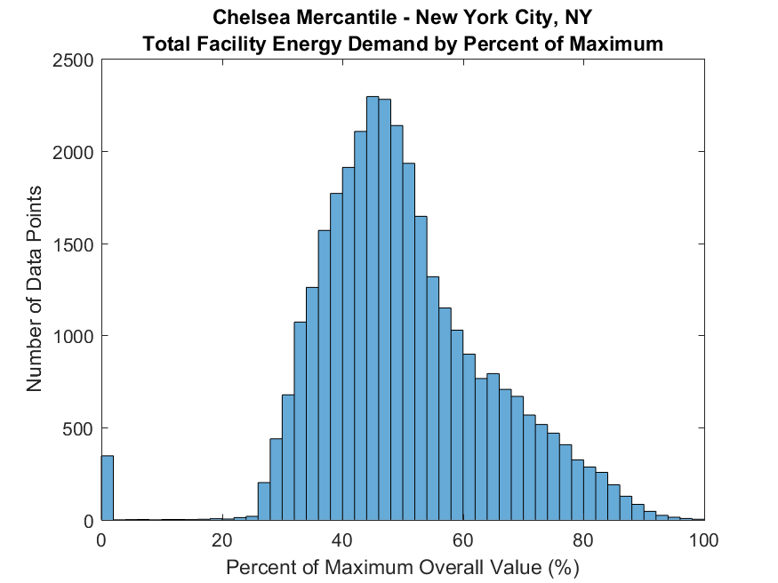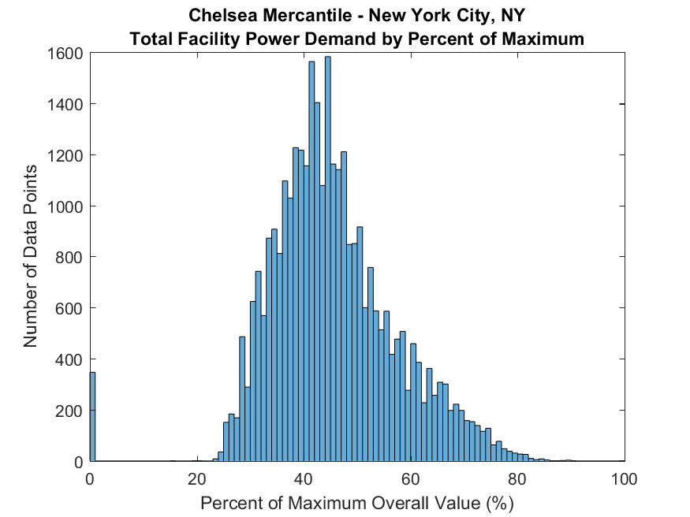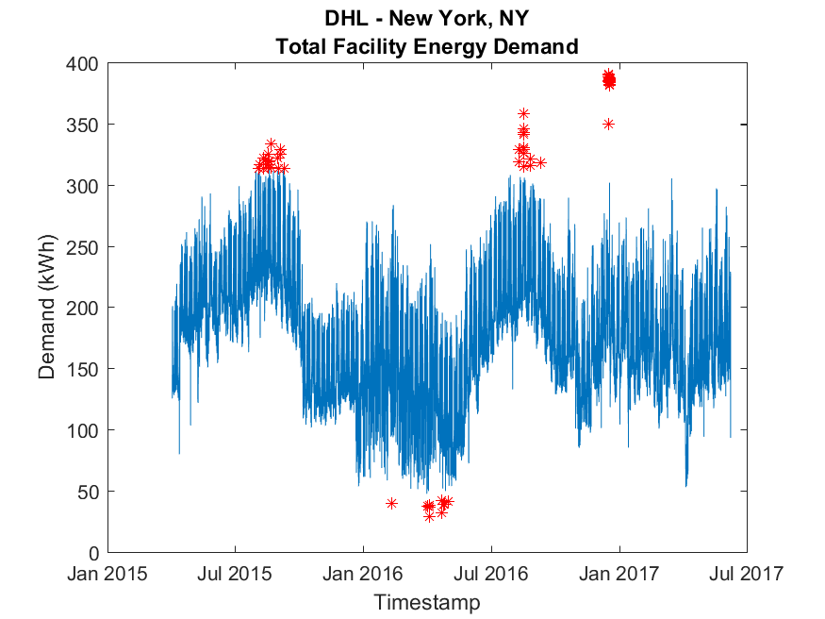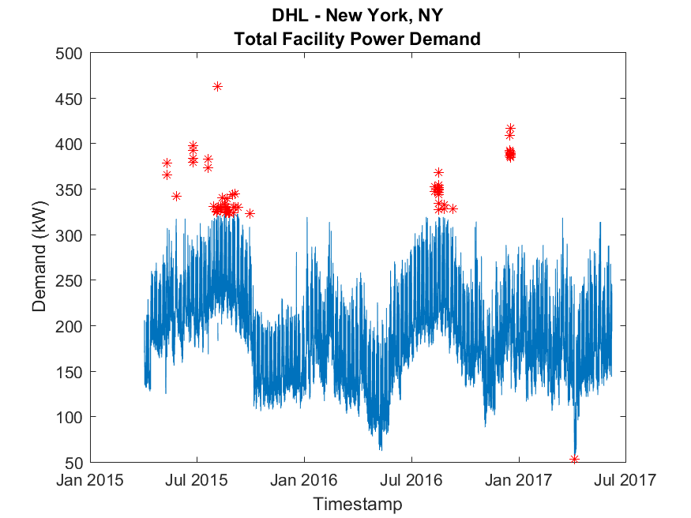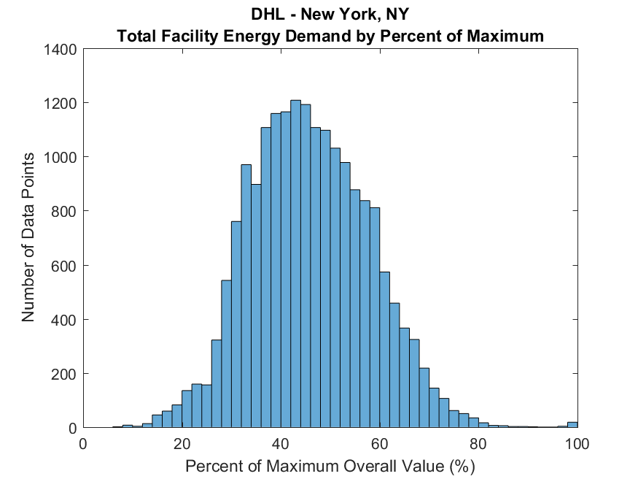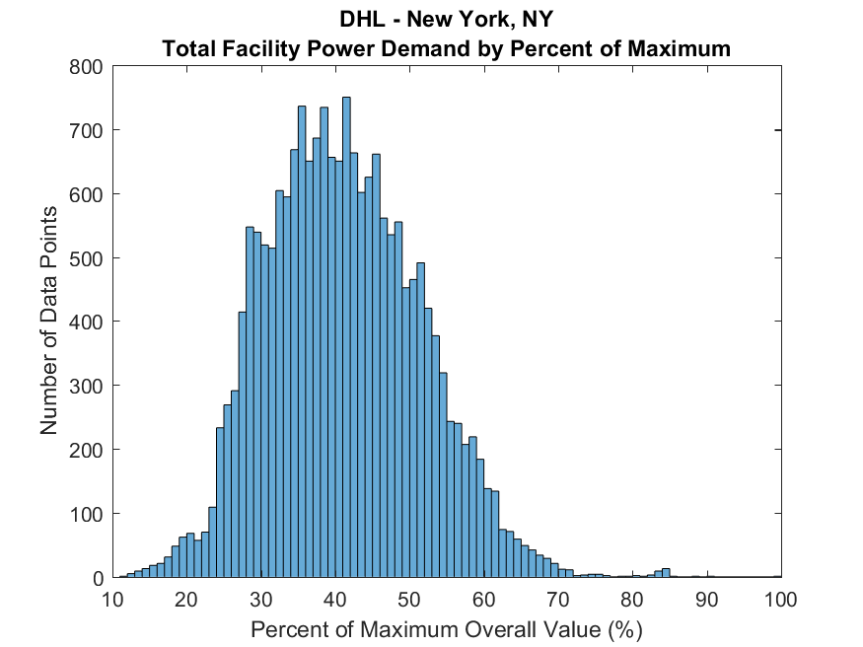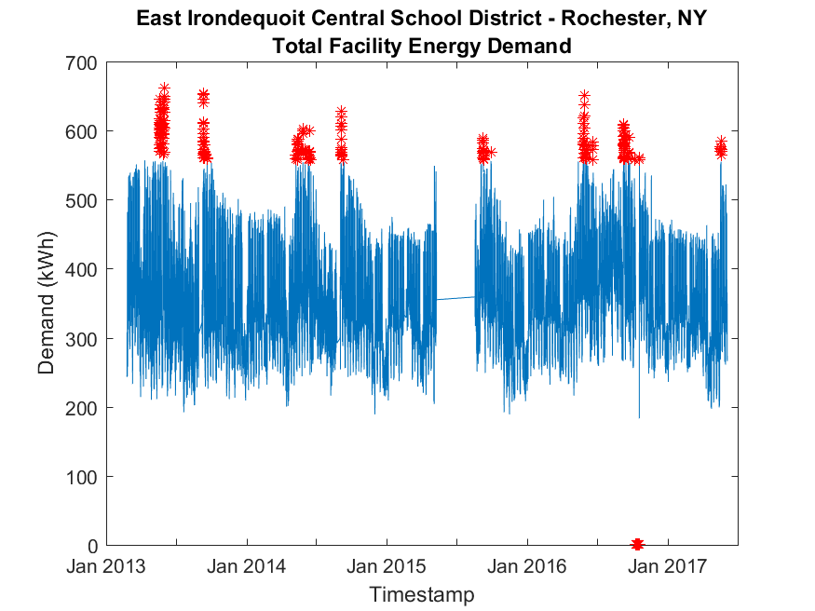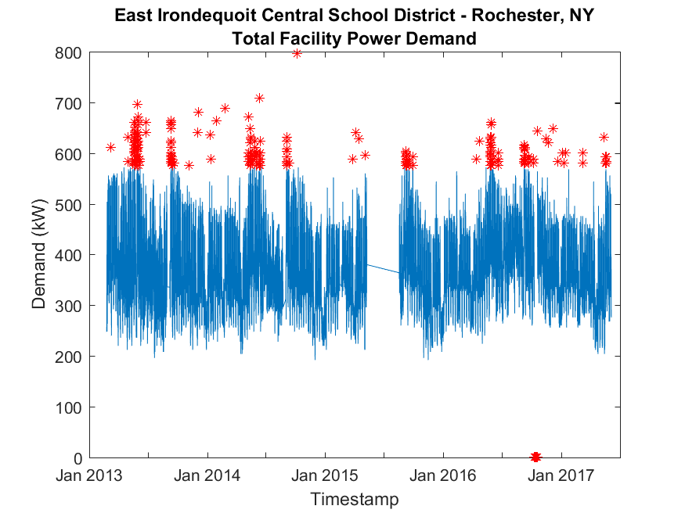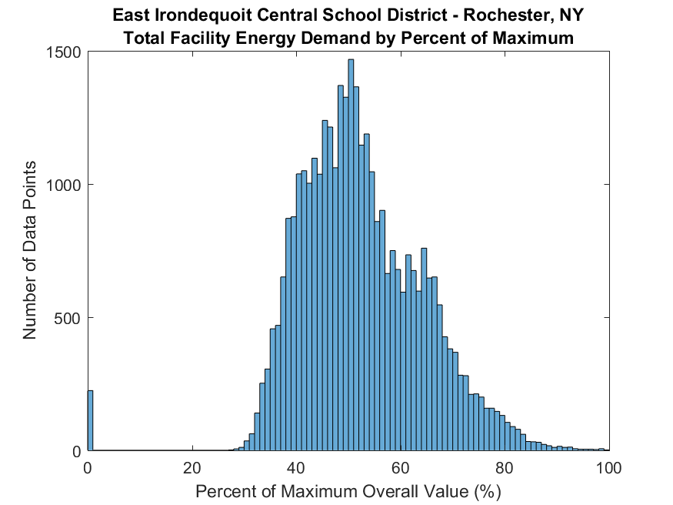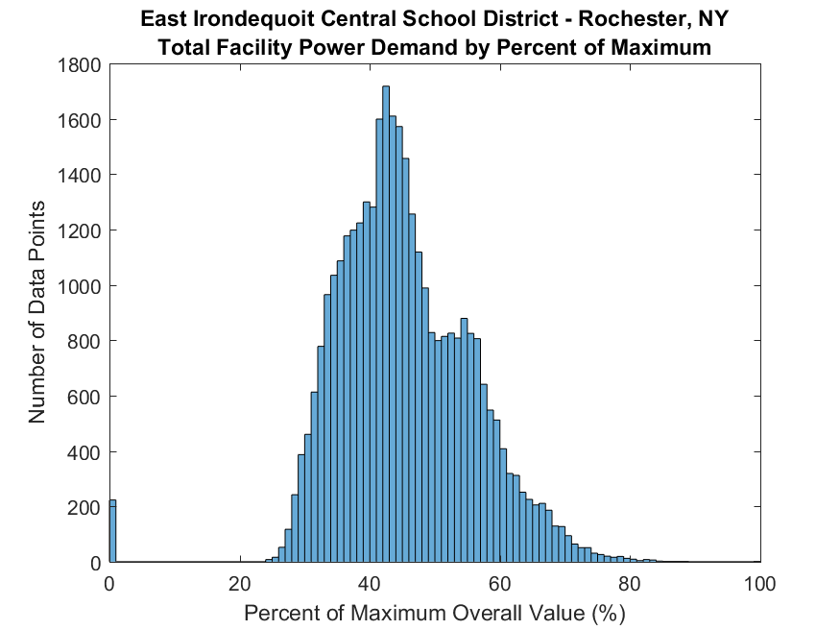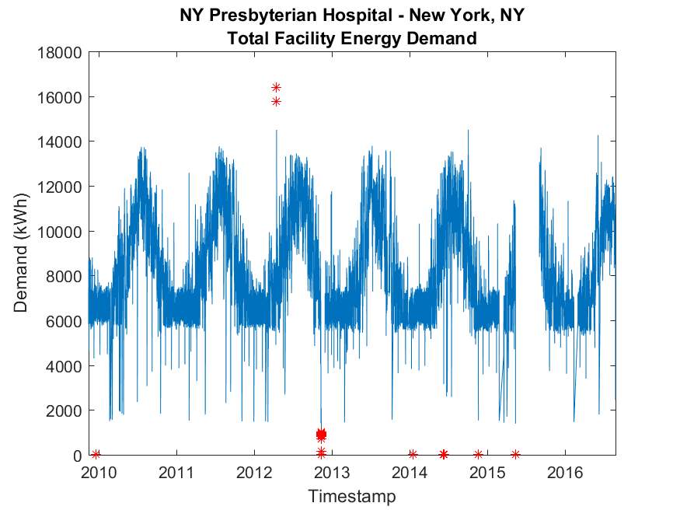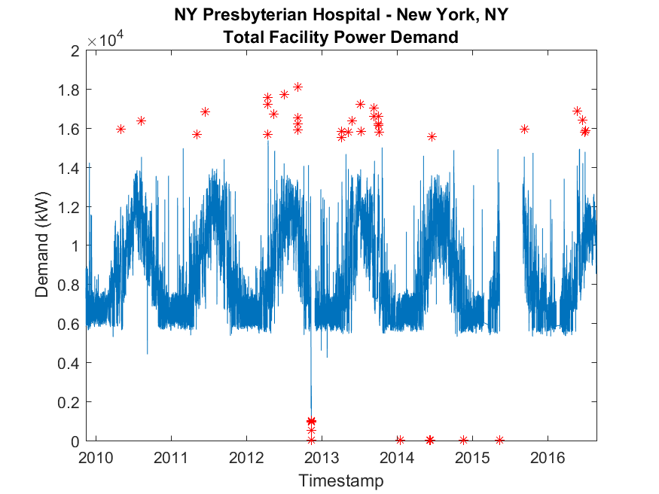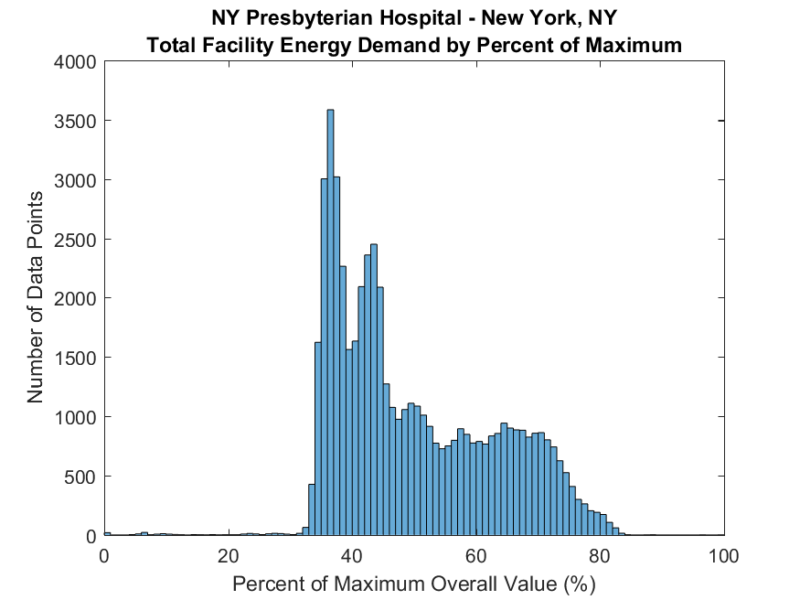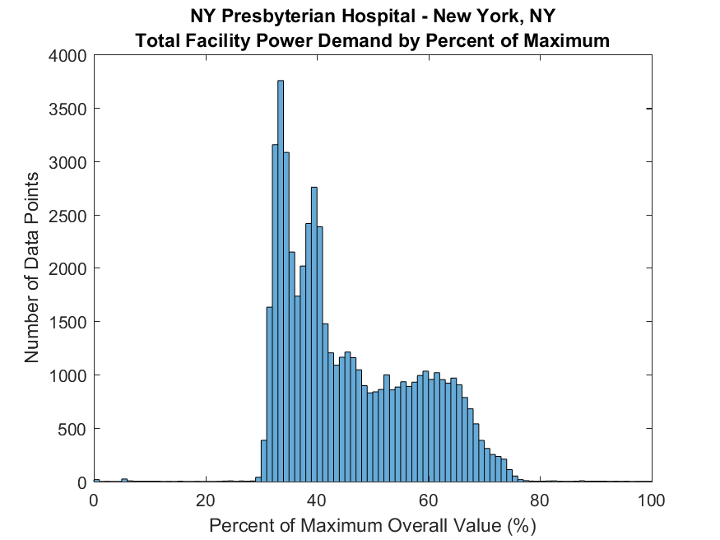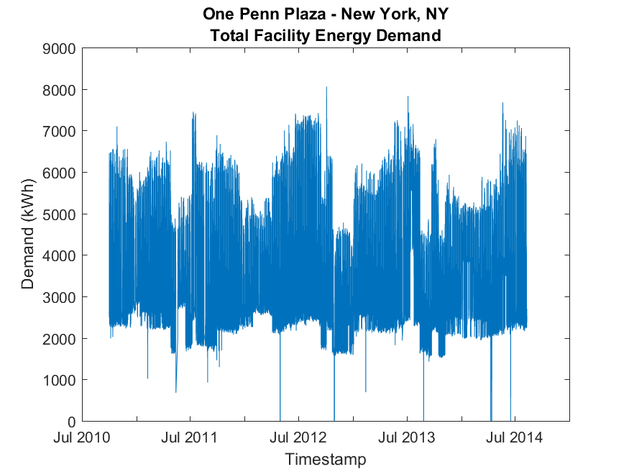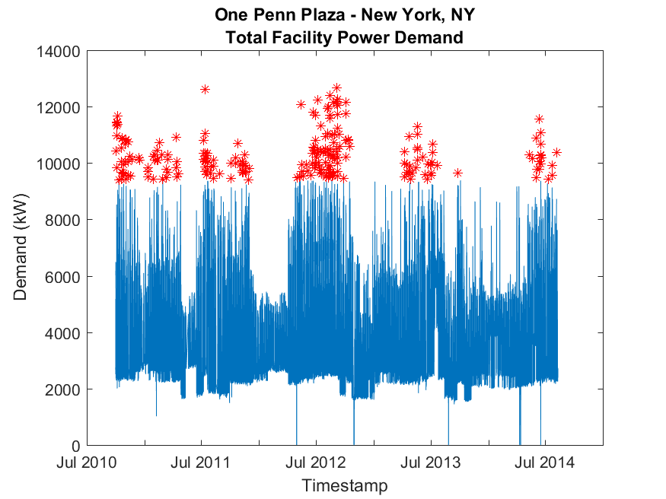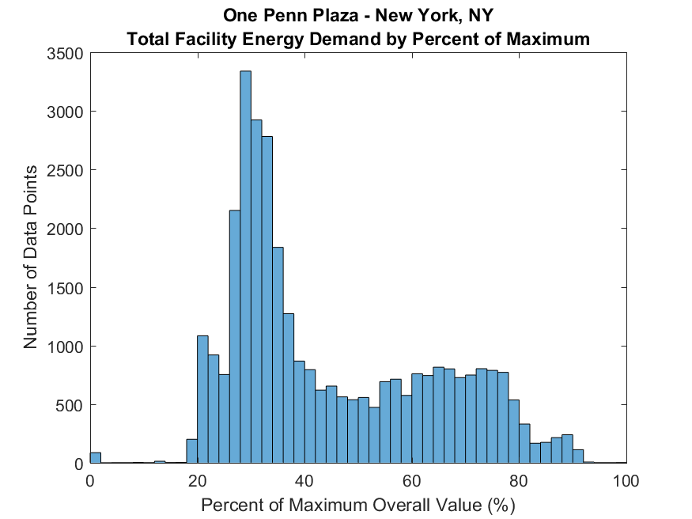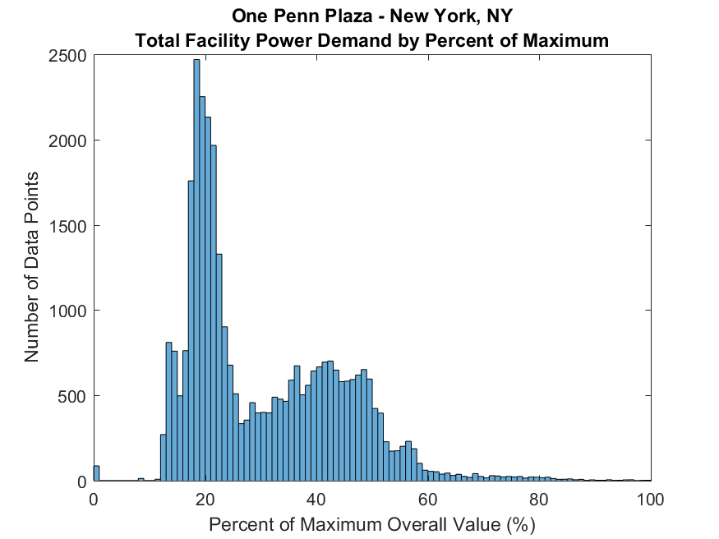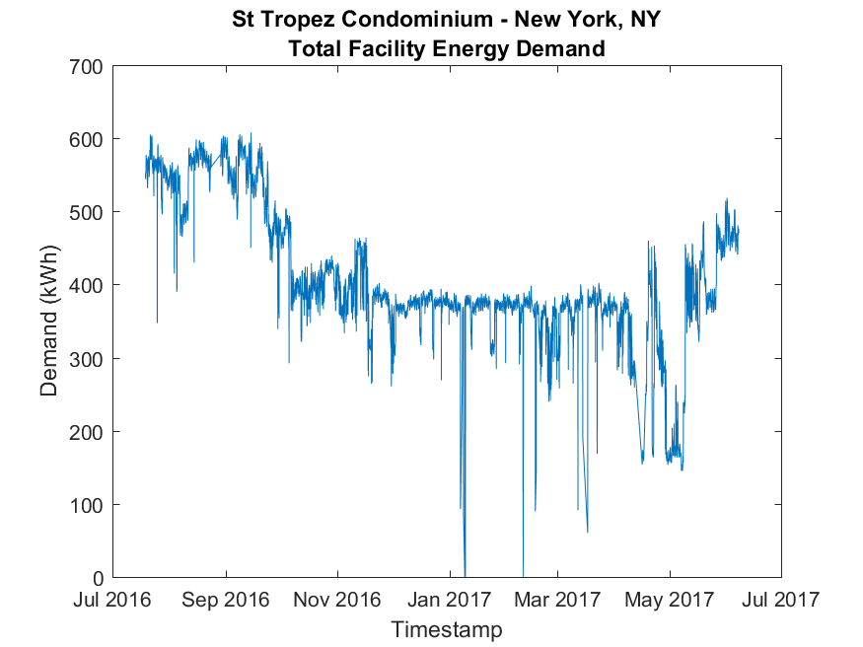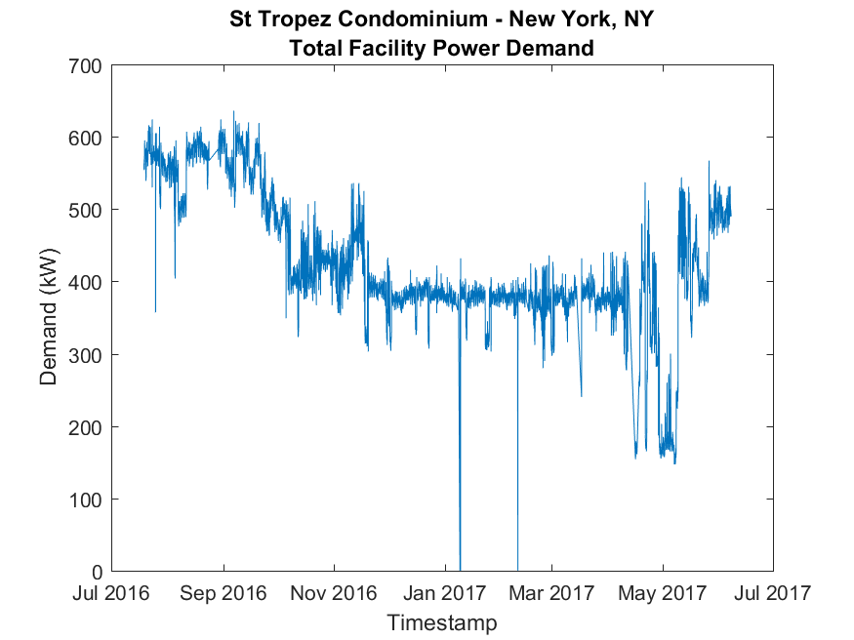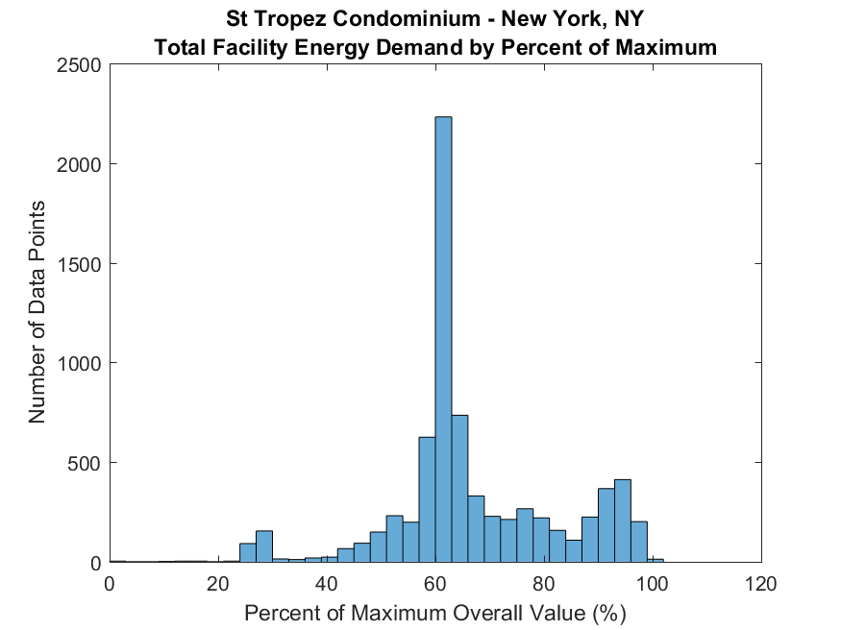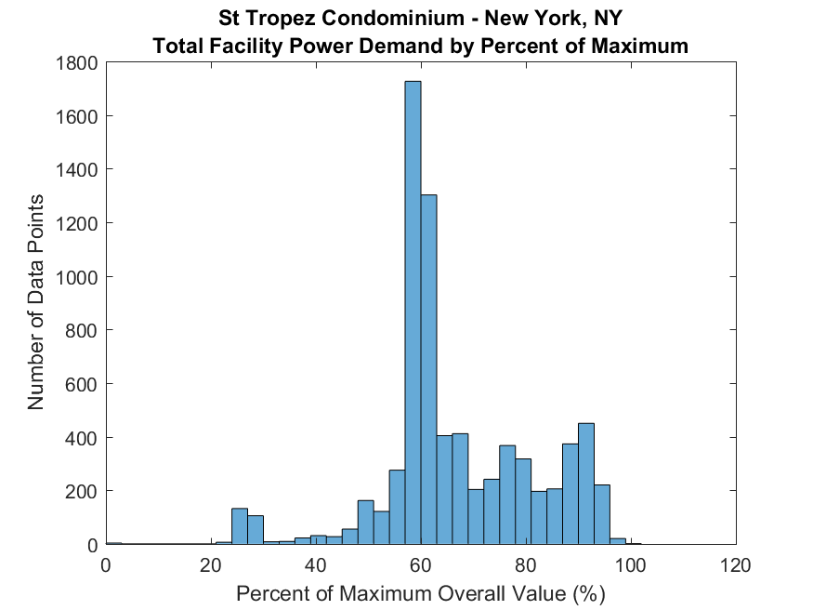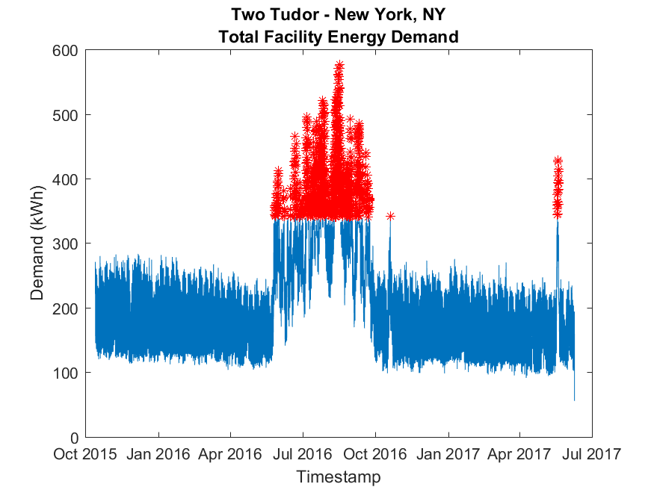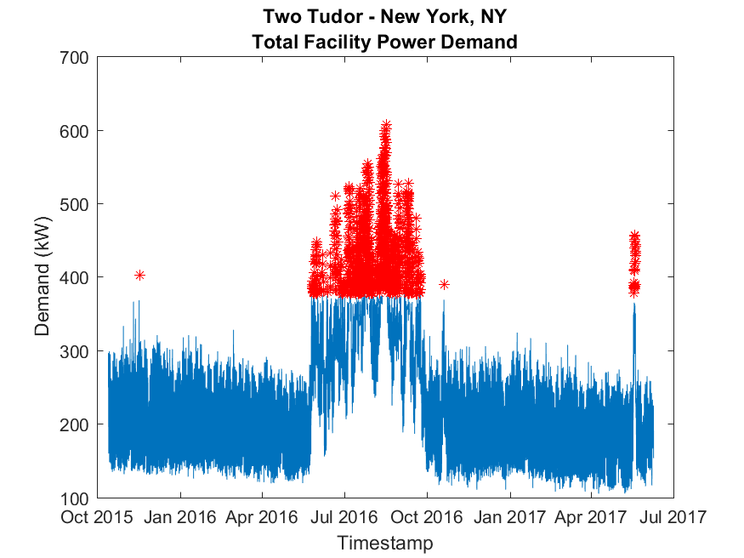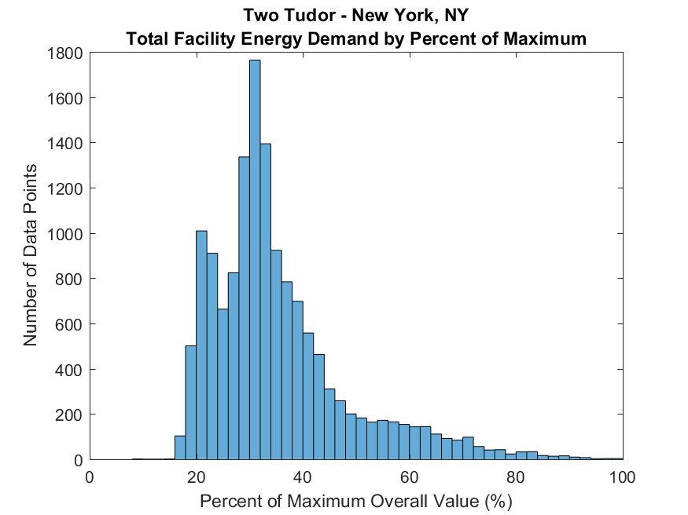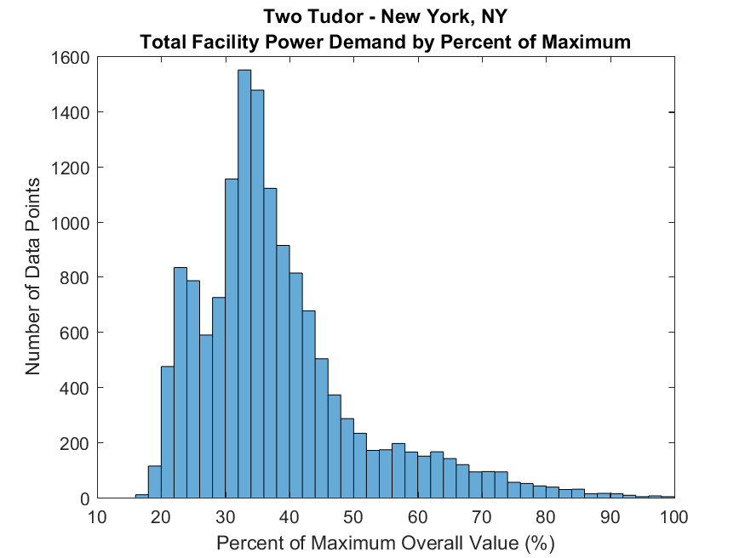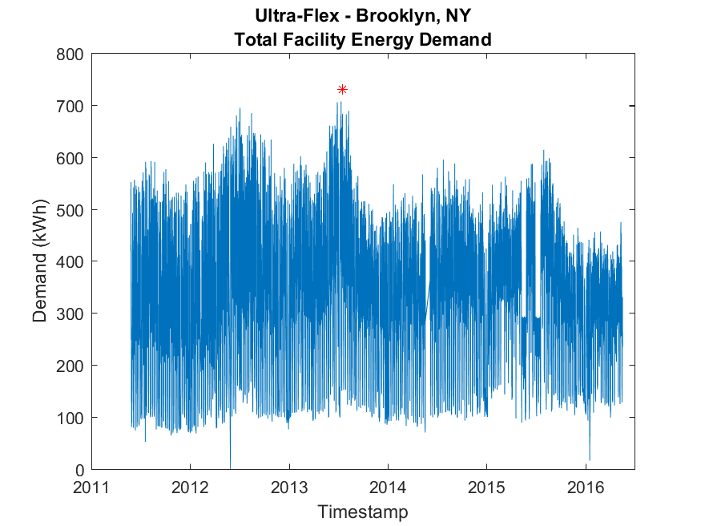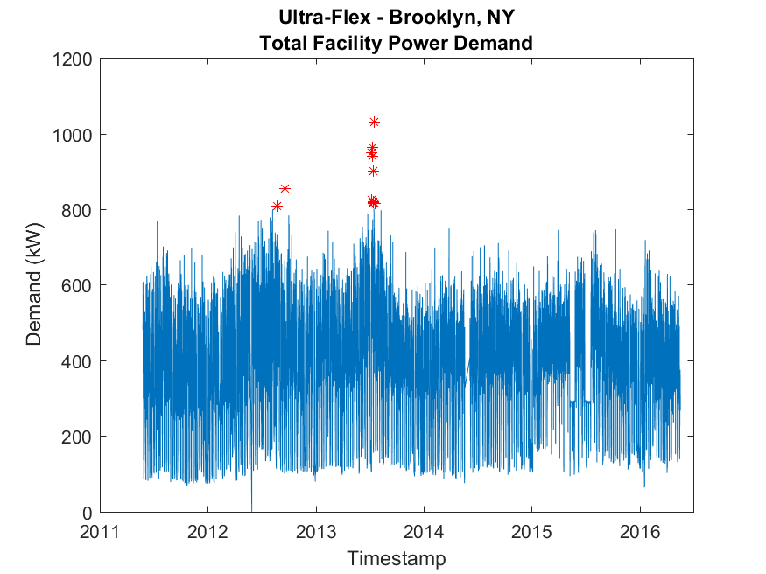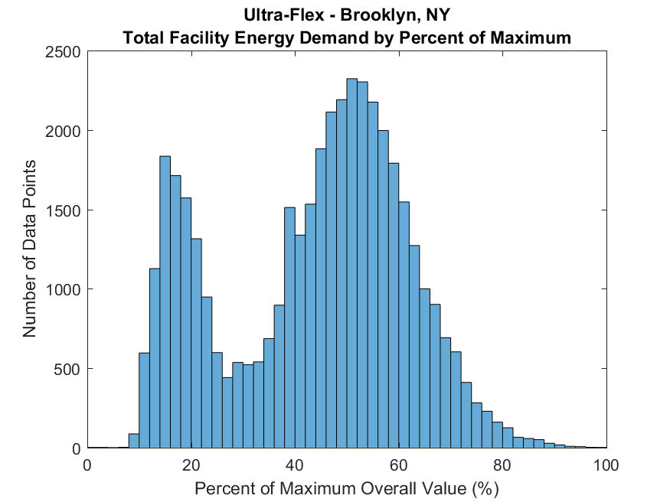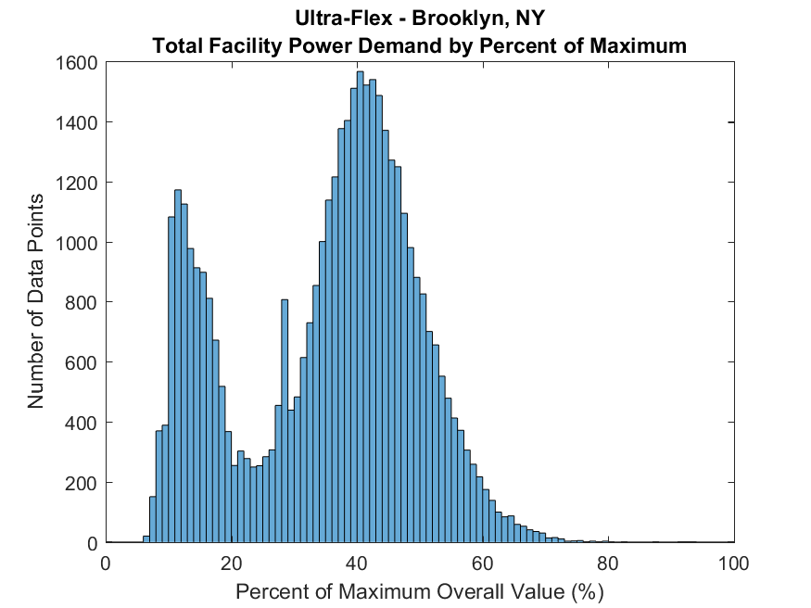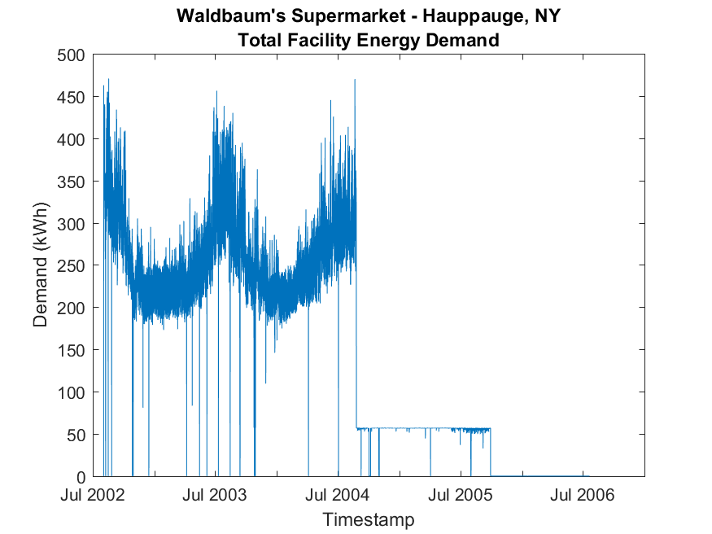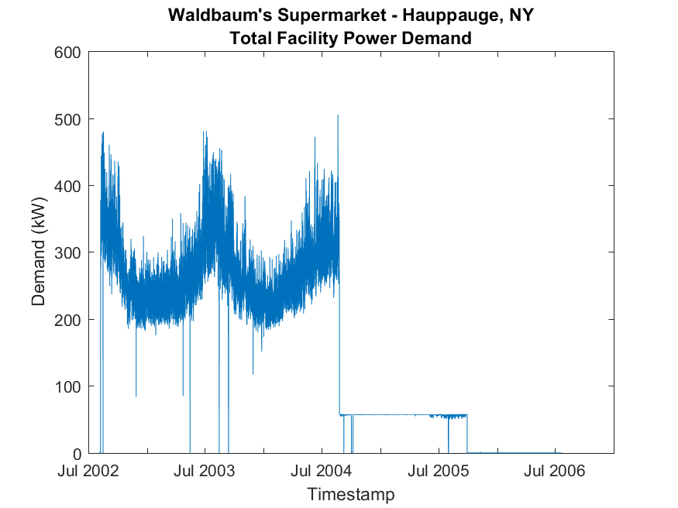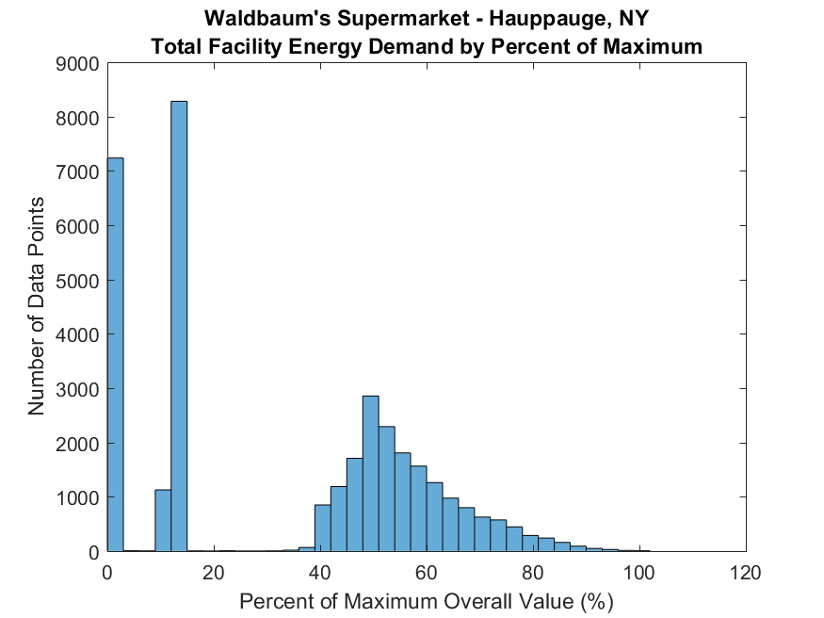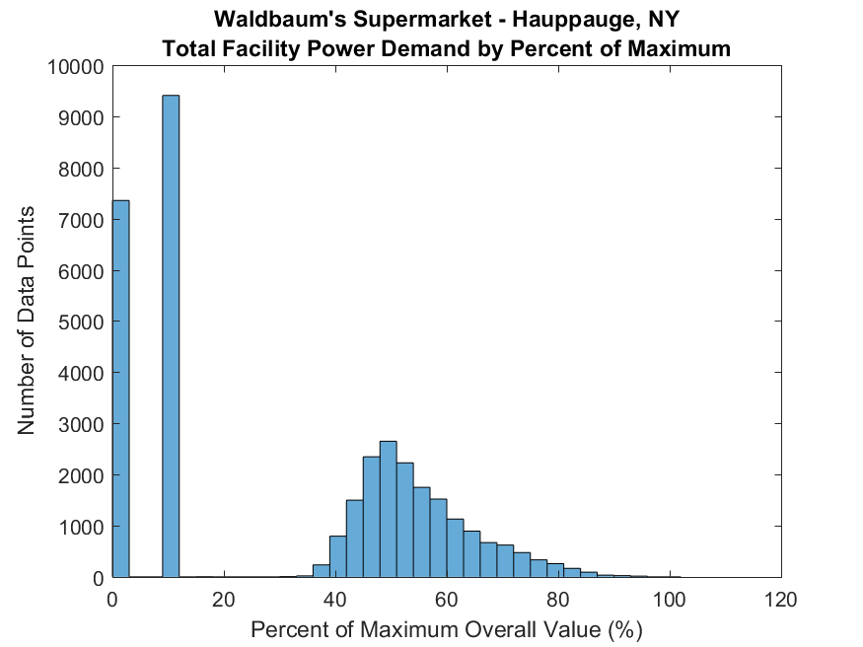

**Turndown Ratios**

