**Washington State University Progress Report**

**Progress Report on Energy Dispatch Controller**

**June 30, 2017**

**Summary:**

This report details three ongoing progress for WSU in a number of areas relevant to the successful construction of an optimal energy dispatch controller and system planning tool. The first section details the optimization method implemented in the GUI which includes slight modifications to the original proposal, reflecting improvements made during the course of this project. A summary of the ongoing joint optimization development details the trade-offs of certain assumptions. The second section provides a short recap of the work undertaken to generalize and scale the EnergyPlus fuel cell and micro-turbine modeling. The third section summarizes ongoing efforts in analyzing real building data and EnergyPlus simulated building data. This section also outlines efforts in developing linear and non-linear multi-zone building models for direct inclusion into the EDC code base. The final section outlines many of the currently functioning GUI features, and the efforts underway to complete additional GUI features for both the planning and control tools.

# Energy Dispatch Optimization (task 4.1 & 4.13)

Before proceeding with a discussion of the specific problem of energy dispatch optimization, and an outline of a feasible solution method, some clarification of terms may help.

**Optimization Problem:** Minimization of some cost function. Optimization problems are characterized as either mixed-integer or non-mixed-integer, by the shape of the cost function, i.e. linear, convex, non-linear, and by the types of constraints, i.e. equality constraints, linear constraints, or bound constraints.

**Solver:** The purpose of a solver is to convert a set of objectives and constraints into a standard optimization problem, i.e. minimize J(x) subject to Ax=b. Commercial & open-source solvers generally have a strict style guide and utilize multiple algorithms.

**Algorithm:** a numerical method used to solve an optimization problem. Different algorithms have strengths/weaknesses for different optimization problems. Example algorithms include Simplex, active set, interior point reflective…. These algorithms are generally fully defined mathematical formulations available open-source in several languages (C, C++, matlab, etc.)

**Model Predictive Control:** Formally a very specific formulation of an optimization problem which lends itself to certain algorithms. Informally it is a receding horizon optimization where the constraints represent a linear model of a system in discrete time. It typically uses quadratic weights penalizing a) the final error of the last step in the optimization, b) the error at each intermediate step, c) the control input (i.e. minimize the rocket fuel used change your orbit). MPC is specifically applicable when you want to control within bounds rather than to a specific point.

The crux of the project is an optimization of building equipment for energy and cost savings. The difficulty of the optimization problem is compounded by a host of factors:

1. Certain types of building equipment, such as chillers, fuel cells, and fans, have discrete modes, i.e. on/off or heating/cooling, resulting in a mixed-integer optimization problem.
2. The operating efficiency of certain equipment varies, resulting in a non-linear cost function.
3. Energy storage devices decouple supply and demand, and requires simultaneous optimization over a time horizon relevant to the energy storage system, thereby exponentially increasing the order of the mixed-integer problem.
4. Charging and discharging inefficiencies of energy storage devices introduce non-linearity.
5. Co-production of electricity and heat, and the use of electricity for cooling, combines multiple energy balance constraints into a single optimization.
6. Participation in ancillary service markets such as spinning reserves requires tracking of additional virtual states, and the valuing of extra capacity in the cost function.
7. Uncertainty in forecasting of weather, renewable energy generation, building use, and ancillary market prices dictates that a robust solution is preferred.
8. Variation in building design, equipment operation, building-equipment integration, energy market structures implies a requirement for an extremely generalized solution.

The disparate time scales involved suggest a multi-tiered or hierarchal optimization approach would be best suited. A high level optimization over a 24+ hour time horizon, for which certain assumptions become valid, can determine the boundary conditions for a short-term, <1hr, optimization of equipment and building HVAC set-points. Assumptions at the 24-hour time scale include:

1. A ‘smoother’ building energy use profile by aggregating variable or cyclic loads into 1-hr blocks of energy use.
2. Fast responding equipment can operate at any point within its allowable range.
3. Slow responding equipment can be approximated with a linear ramp rate, avoiding the complexity of a 1st or 2nd order response model.
4. Building temperature can achieve precisely the desired set-point, eliminating the need for a dynamic building model.

With these assumptions in mind a method referred to as complementary quadratic programming has been implemented to address the high-level scheduling portion of the optimization. A detailed explanation of the currently implemented approach is presented in the ‘Dispatch Scheduling’ portion of the help document provided with the EDC tool.

Any shorter-term optimization strategy would need to capture the dynamics of the equipment and building being optimized. Thus a modified model predictive control strategy would be best suited. NREL has developed a working model predictive control method that captures simple first order responses of the building and major equipment, i.e. fuel cell and chiller. The current formulation utilizes a solver ‘CVX’ to formulate a *linear non-mixed integer optimization problem*. Like model predictive control it uses constraints to represent a discrete-time model of a fuel cell, chiller, and building. The ‘model’ implemented through the constraints is the linear 1st order response of a chiller and a single-zone building with heat transfer to/from the ambient through a wall. Added to this linear MPC is a standard linear optimization of the electric dispatch including specifically 1 generator, 1 battery, and 1 load that is a function of the MPC part of the optimization (the HVAC fan).

The numerous adjustable parameters include: dispatch horizon, dispatch step, ambient temperature, incidental heating load (heat from occupants), incidental electric load (non-dispatchable loads), cost of electricity, cost of natural gas, price paid for ancillary service, equipment sizes and efficiencies, separate charging and discharging efficiencies, heat transfer coefficients for the wall, a ratio of fresh air entrained in the HVAC operation.

Like the high level scheduling optimization several valid assumptions can be made at the shorter time scale. Specifically:

1. Specific equipment, including the fuel cell and chiller are always ‘on’ and have constant efficiency for the short duration of the optimization. There are some trade-offs to the constant efficiency assumption which can under certain cases reduce the problem to a binary decision to ramp up to full power if the FC produces power cheaper than the grid, or ramp down if not. The constant efficiency assumption reduces the optimization of multiple fuel cells and chillers to a fixed sequence. Effectively they become a single large system whose cost function is estimated by a piecewise linear function. A quadratic implementation can regain the non-linear cost curves of individual systems.
2. The building is in either heating or cooling mode for the short duration of the optimization.
3. The building humidity is within tolerable levels, and no additional cooling is needed for de-humidification. Utilizing enthalpy curves for humidified air would result in a more complex non-linear optimization problem.
4. The state-of-charge at the end of the dispatch is a fixed value as determined by the higher level optimization.
5. There is no self-discharging of the battery. This avoids tracking additional virtual states, or implementing a binary variable. The self-dicharging can be determined from the higher level optimization and added as a virtual load during the shorter optimization.
6. A small margin between he building temperature and the tolerable comfort range provides sufficient buffer to participate in ancillary markets during the short time period of this optimization.
7. The initial condition of all equipment and states are known from the higher level optimization.

The list of solvers available to solve these types of optimization problems is extensive (<http://plato.asu.edu/sub/nlores.html>). In addition to Matlab, the primary commercial options would be Gurobi, Mosek, and CPLEX. All three have free academic licenses. Popular free solvers are available for use within Matlab or a Python environment. These include CVX (Matlab), Yalmip (Matlab), FORCES (Matlab/python), CVXopt (python), Opti Toolbox (Matlab), NEOS (web), SPM (Matlab, C). These solvers typically can be used for a host of different optimization problems. By avoiding the complexity of a mixed-integer problem the list of algorithms can be paired down to three: trust-region-reflective, active-set, and interior point.

For convex quadratic programming problems with both linear equality and linear inequality constraints the interior-point algorithms are vastly superior for larger problems. The interior-point methods can take advantage of the sparsity of the problem. Interior point methods have been generalized to work with quadratic constraints, conic problems, and linear semi-definite problems. These expansions could allow more complex, i.e. non-linear models within the MPC problem formulation. The task requirements of this project thus become:

1. Describe mathematically the ‘model’ or ‘models’ to be included in the optimization using linear, quadratic, or semi-definite constraints.
2. Describe mathematically the remaining optimization problem, i.e. the cost function and the energy balance equations.
3. Convert the described problem to a form a) that can be handled by a commercial or open-source solver, b) to a form directly implemented by an interior-point algorithm

Both the commercial and open-source solvers implement some variation of two different algorithms, SeDuMi and [SDPT3](https://github.com/sqlp/sdpt3). The majority of solvers (YALMIP, NEOS, MATLAB) convert your optimization problem into a format solvable by SDPT3. Commercial solvers use a robust method to convert a problem formulation into the format required by the solver. This conversion process can significantly exceed the computation time for interior-point methods. The conversion effort can become burdensome and redundant when implemented in a receding horizon control problem. When the structure of the problem doesn’t change, only specific values are being updated, the process can be accelerated by orders of magnitude if the problem conversion process can be avoided. To ensure success of the optimization algorithm some pre-conditioning is still necessary to normalize parameters and avoid redundant constraints.

# Fuel Cell and Microturbine Modeling (task 4.2 & 4.4)

# Building Energy Profile Analysis and Model Development (task 4.9)

Building energy profiles reveal a wealth of data about the typical and atypical building use. WSU is conducting a study of real building energy profiles with the objective of identifying characteristics describing the variability and unpredictability of building use. Comparing characteristics of real buildings and simulated building demands highlights the strengths and shortcomings of this projects selected simulation strategy. The second objective of characterizing these buildings is to ascertain the uncertainty and variability that a controller would need to cope with in a real-world situation. Incorporating these characteristics into the EAGERS planning tool will improve the accuracy and confidence in building energy assessments.

The NYSERDA DG Integrated Data System was utilized as a source of real-world building energy data. One-hundred and fifty of the approximately 500 buildings in the dataset included total facility energy demand and total facility power demand data. The energy demand data represents the hourly energy consumption, while the power demand data represents the peak hourly power use. The difference gives some indication of the intra-hourly variation in demand which must be tolerated by the hourly dispatch optimization. The appendix of this report includes a selected subset of nine buildings that had limited missing data points or other irregularities. Table 1 outlines a set of parameters WSU proposes to characterize and compare the dynamic energy use of the different buildings. Scripts compute these parameters for both real buildings and EnergyPlus simulated buildings. Due to data limitations, some metrics will not be possible for certain buildings.

Table Building energy use characteristic parameters

|  |  |
| --- | --- |
| Name | Description |
| Turndown Ratio | Max. value / min. value (usually describes one day) |
| Nominal Range | The smallest span which captures 95% of data points |
| Peak Outlier – (low, high) | Low: Absolute minimum minus min. 95% range minimum  High: Absolute maximum minus min. 95% range maximum |
| Demand Histogram | Distribution of instances of each demand range |
| Cumulative Demand Curve | % of time building demand is below threshold |
| Seasonal Demand Profile | Cumulative daily energy use |
| Smoothed Seasonal Demand | Smoothed approximation of typical daily average loads |
| Peak Deviation | Standard deviation of peak daily demand from the annual average. |
| Corrected Peak Deviation | Standard deviation of peak daily demand from the seasonally adjusted daily average. |
| Dip Deviation | Standard deviation of minimum daily demand from the annual average. |
| Corrected Dip Deviation | Standard deviation of minimum daily demand from the seasonally adjusted daily average. |
| Daily Deviation | Standard deviation of daily average from smoothed seasonal demand |
| On-Peak Duration (hrs) | Duration of operation ±5% from top of Nominal Range |
| Off-Peak Duration (hrs) | Duration of operation ±5% from top of Nominal Range |
| Maximum Ramp Rate (%/hr) | Maximum slope of locally averaged demand. |
| Transience (%/hr) | Mean absolute value of slope in demand. |
| Turbulence (%/hr2) | Mean absolute value of change in slope in demand. |
| Convexity (%/hr) | Maximum of the differences in slope from point to point. |
| Daily Surge Periods | Typical daily instances of a local demand spike exceeding 5%. |
| Daily Trough Periods | Typical daily instances of a local demand dip exceeding 5%. |
| Propensity of Dynamics | Frequency of hourly demand changes exceeding 10% |
| Data Standard Deviation | Standard deviation of data minus smoothed data (2- or 4-hr smoothing). |
| Sub-Hourly Variation | Average of % Peak Power Demand minus % Peak Energy Demand values. Comes from the inherent difference between power and energy demand values from the NYSERDA database, described in the “Results” section. |
| Coincidence of Heating and Electric Demand | L2-norm of normalized electric profile – normalized heating profile |
| Coincidence of Cooling and Electric Demand | L2-norm of normalized electric profile – normalized cooling profile |

An example of the NYSERDA data is shown in figure 1. The NY Presbyterian Hospital illustrates the seasonality common of most building types. The majority of the building operation occurs between 33% and 50% of peak demand.

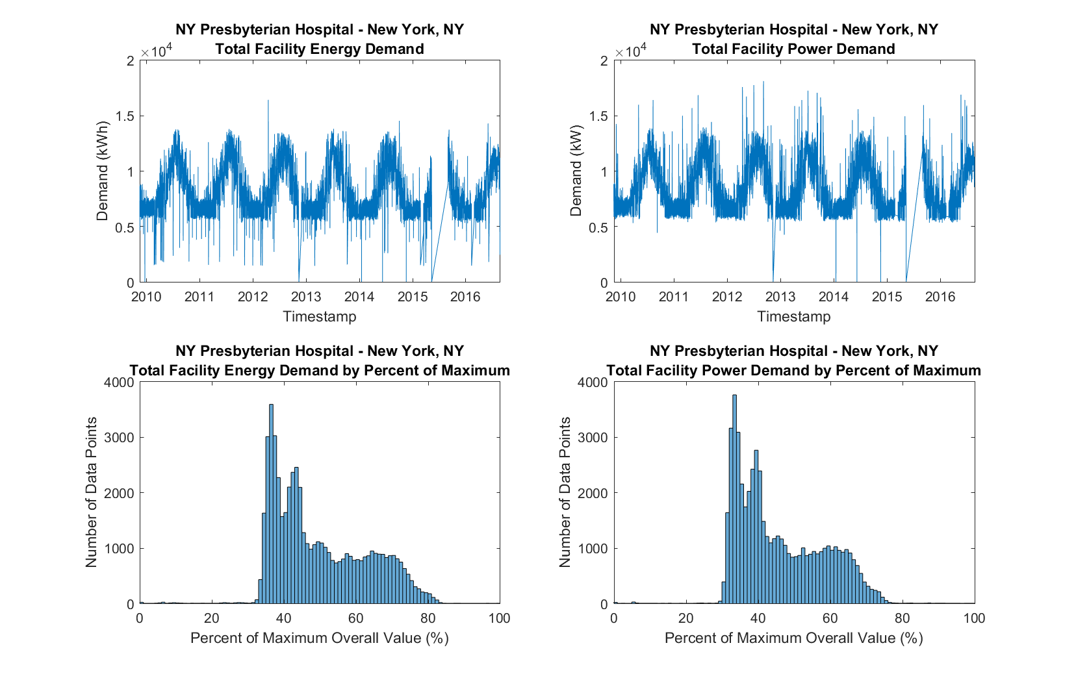

Figure 1 Electric demand data for NY Presbyterian Hospital

The average daily turndown ratio for NY Presbyterian Hospital is 1.25. This means that the daily peak demand is 125% of the daily minimum demand. The turndown ratio is less than 1.75 for 95% of the days in the dataset. This small turndown ratio results in the narrow band of operation seen in the total facility demand. This small turndown ratio implies a high daily baseload which is consistent with the expectations of a hospital. A summary of the nine buildings detailed in the appendix is shown in Figure 2. It is clear that other buildings, such as the One Penn Plaza office building, exhibit much higher turndown ratios. The Ultra-Flex building can be seen to swing from peak demand to 10% of peak demand in a single day.

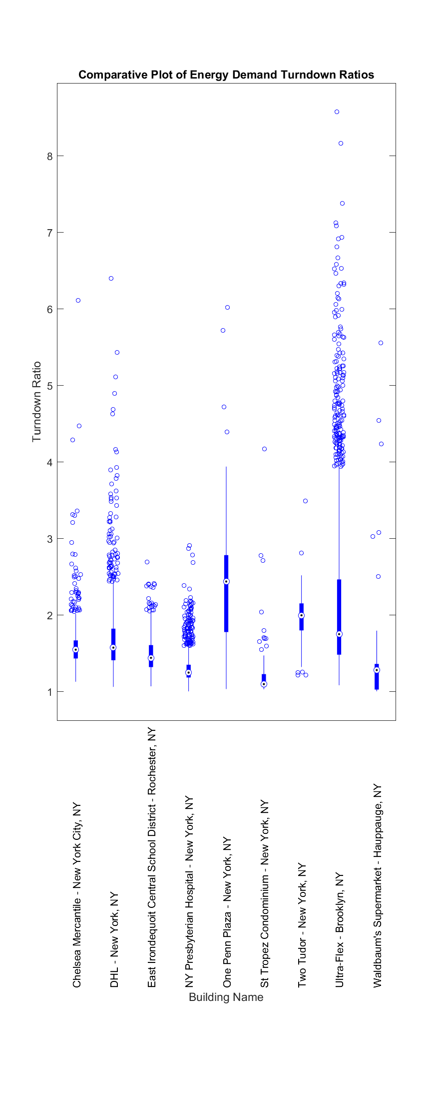 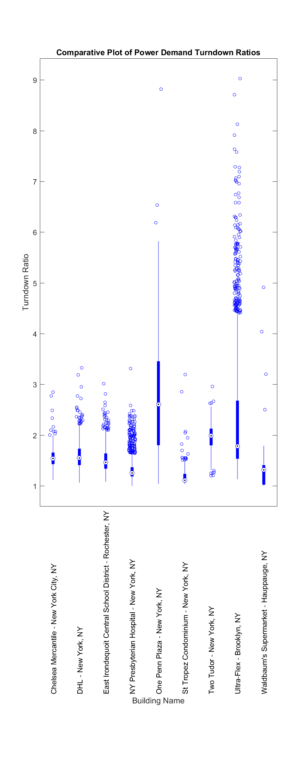

Figure 2 Turndown ratio of a) average hourly energy use, b) peak hourly power demand

The daily energy profiles differ considerably between the buildings, but most exhibit a mid-day or evening peak period. Figure 3 illustrates the typical daily energy profile for the Chelsea Mercantile Building. The minimum demand typically occurs in the early morning hours between 4 and 5 AM , and the peak demand occurs between 7 and 9 PM.

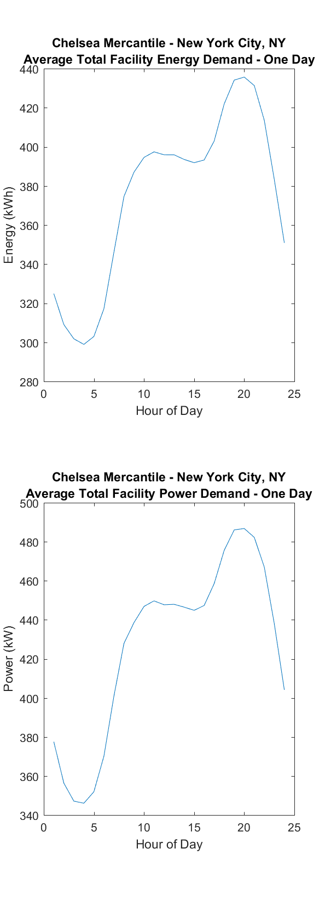

Figure 3 Typical daily profile for the Chelsea Mercantile Building a) hourly energy use, b) peak hourly power demand

Some preliminary conclusions about the behavior of real buildings versus simulated buildings at this point include:

1. Real buildings exhibit a strong seasonality in demand not captured by the default EnergyPlus building schedules. This seasonality may be exacerbated by the location of the building data set, New York.
2. There exists a large spread and significant skew in the turndown ratios of real buildings. This suggests that short periods of high demand may be inevitable. High discharge battery systems used as contingency generators can readily cope with this type of short-term spike.

# Energy Dispatch & Planning Tool Description

The figure below is a slightly modified version of Zhiwen’s presentation. When a user adds a system from the library, it appears in the GUI in this arrangement, connected to the relevant bus. Multiple components can be added in each category. Once visible in the system diagram on the GUI, each component category is a button. Clicking the button brings up options for that component. If multiple systems are present in the same component category, the user is presented with a list from which to select. The five buses, i.e. AC, DC, Heating, Hot Water, and Cooling, each represent a separate energy balance in the optimization at each time step. Items with optional heat recovery, i.e. mGT/ICE Engine, Fuel Cell, the red heat recovery arrows will appear as buttons that can enable or disable the heat recovery element.

Absorption

Chiller

Cold Thermal

Storage

Air Heater

Fuel Cell

Electrical

Storage

(Battery)

AC Bus

Wind

mGT/ICE Engine

Electric Utility

Solar PV

AC / DC Converter

Heating Demands (200C)

Hot Water Demands

Cooling

Controllable Refrigeration

DC Bus

High Temp Thermal

Storage

Hot Thermal

Storage

Electric

Chiller

Solar Thermal

Water Heater

# Appendix

**Demand Plots and Histograms**

