Common-Source and Cascode FET Amplifiers

Nathan Paternoster

4/7/14

Description

A common-source FET amplifier M1 is given with transistor parameters: Vtn = 2V, Kn = 1.2mA/V2, CGD = 0.8pF, CGS = 5pF, and external capacitors = 10uF. For part 1 we analyzed this amplifier to obtain its voltage gain AV = 4.92, and its high break frequency fH = 8.094MHz. During our DC analysis we also found ID to be 0.994mA $≈$ 1mA.

For the second part, a common-gate FET amplifier was added in series with the first to produce a cascade. Both transistors have the same parameters as before. This time our results were: AV = 4.914, fH = 12.06MHz, and ID = 0.994mA $≈$ 1mA.

Analysis

The cascode is composed of the original common-source FET amplifier connected to a common-gate amplifier. Because the common-gate amplifier adds no voltage gain to the circuit the overall midband voltage gain stayed the same between both configurations. The benefit of the cascode comes in the circuit’s frequency response. Because the second transistor is added, there is no direct coupling between the input and output. This removes the Miller effect and produces a higher bandwidth. We see this in the improved, higher high break frequency. The drain current ID also stays the same.

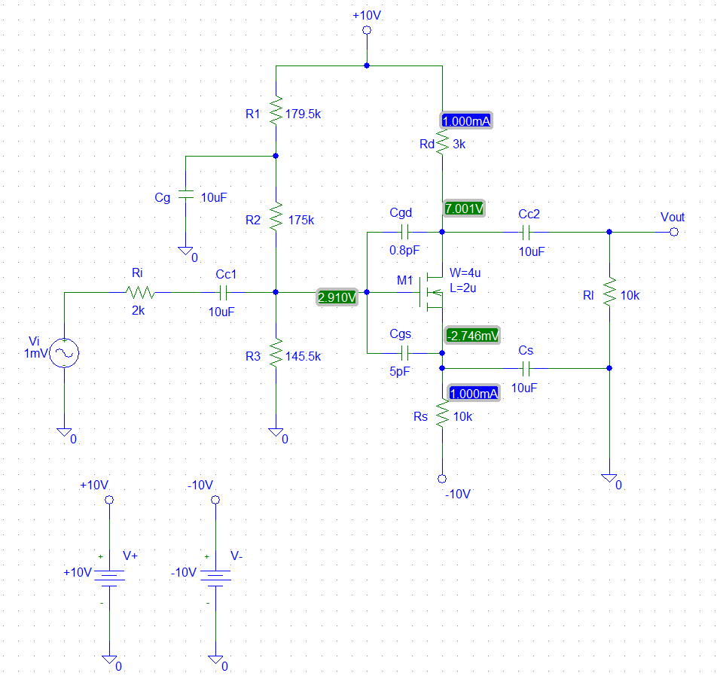

*Figure 1*: The common-source amplifier

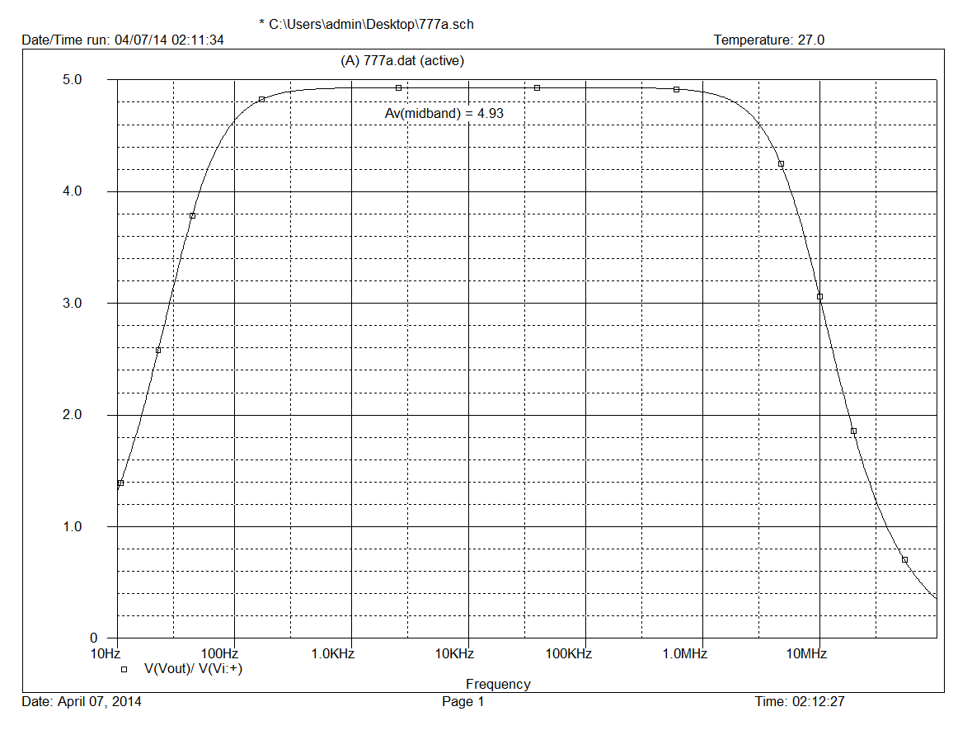*Figure 2*: The common-source amplifier midband voltage gain

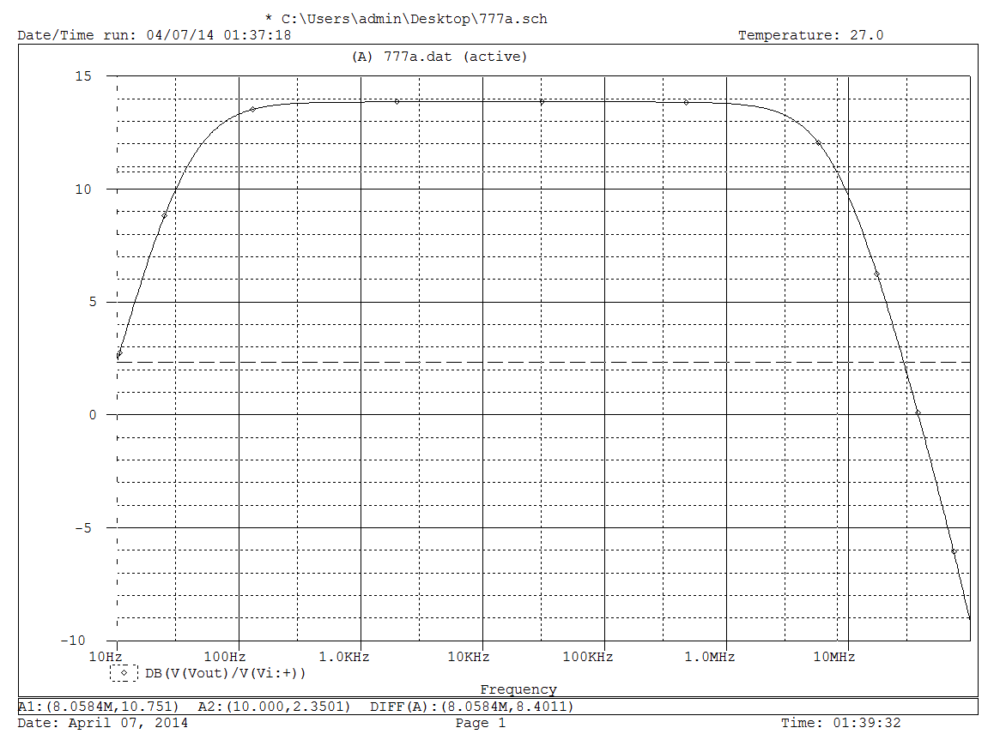

*Figure 3*: The common-source amplifier high break frequency

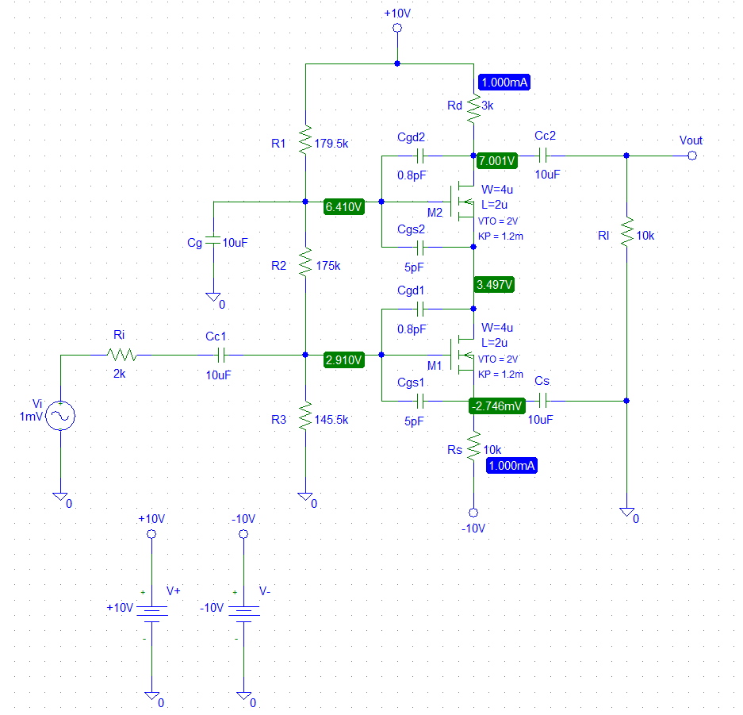

*Figure 4*: The FET cascode amplifier

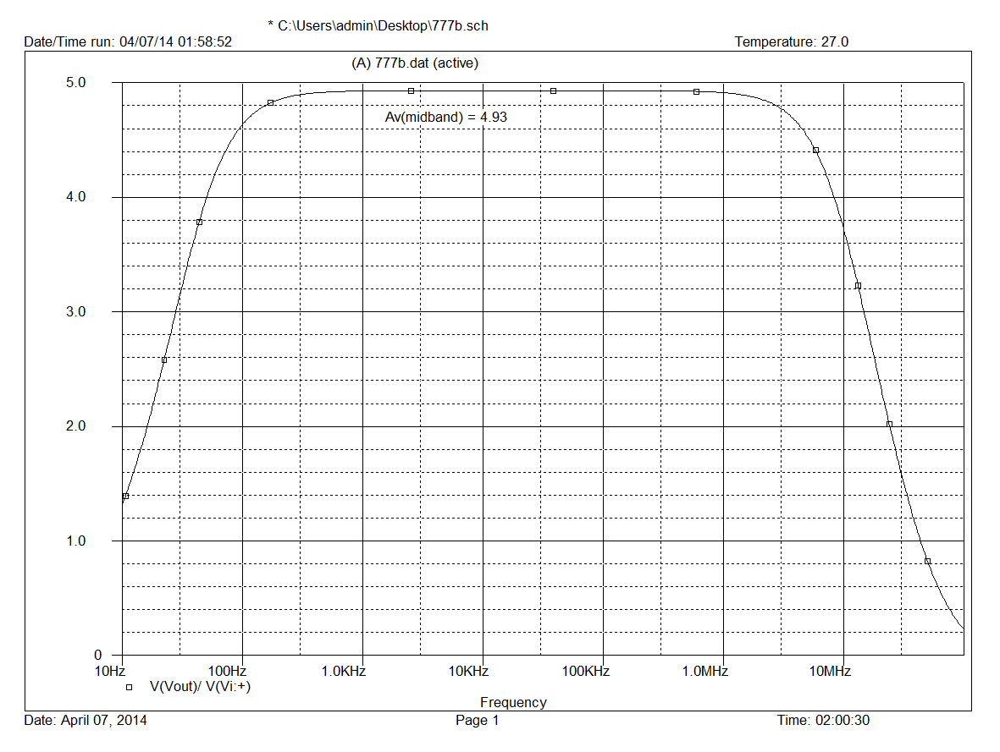

*Figure 5*: The cascode amplifier midband voltage gain

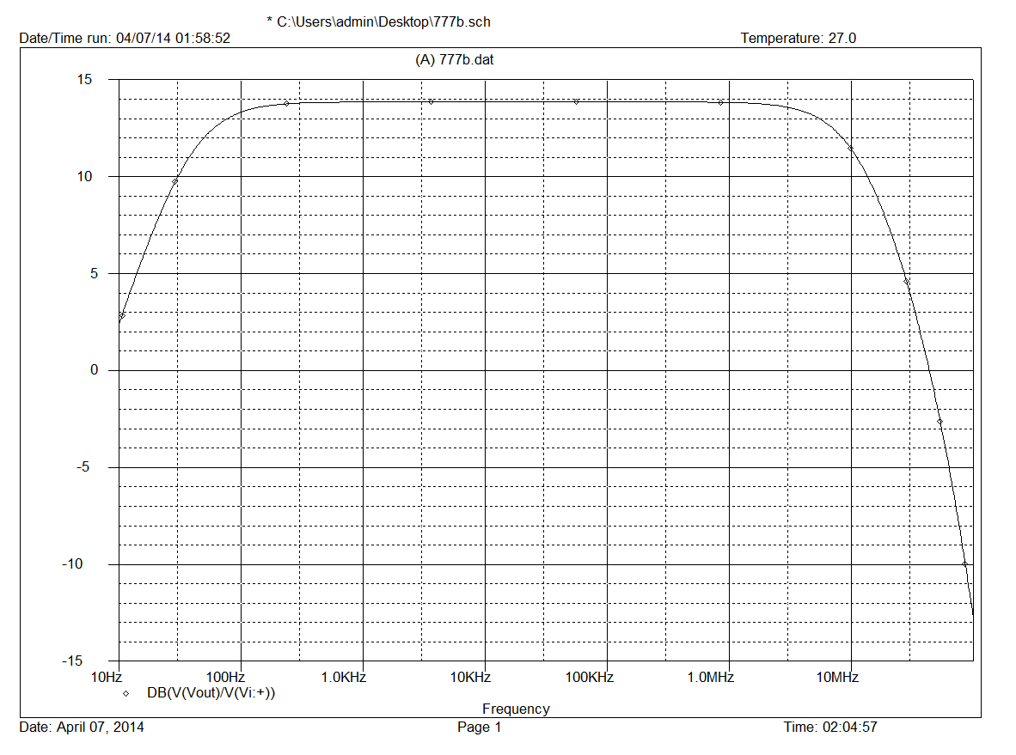

*Figure 6*: The cascode amplifier high break frequency