**ASSIGNMENT 5 - ROS URDF**

Nathan Ramos & Quinn Frady

**Description of the problem**

The goal of this assignment is to modify the URDF files we were given to match the chassis of our robot alongside its attached wheels. We will simulate the robot in RVIZ and Gazebo while controlling it with our keyboard and with our joystick.

**Tasks**

Our assignment has several tasks to complete. The first of which is to simply model our robot in RVIZ and Gazebo. Note that our robot was given to us with asymmetrical wheels and the .xacro file is built to model symmetrical wheels. The .urdf file allows us to individually place the wheels, so the .urdf file is the MOST accurate.

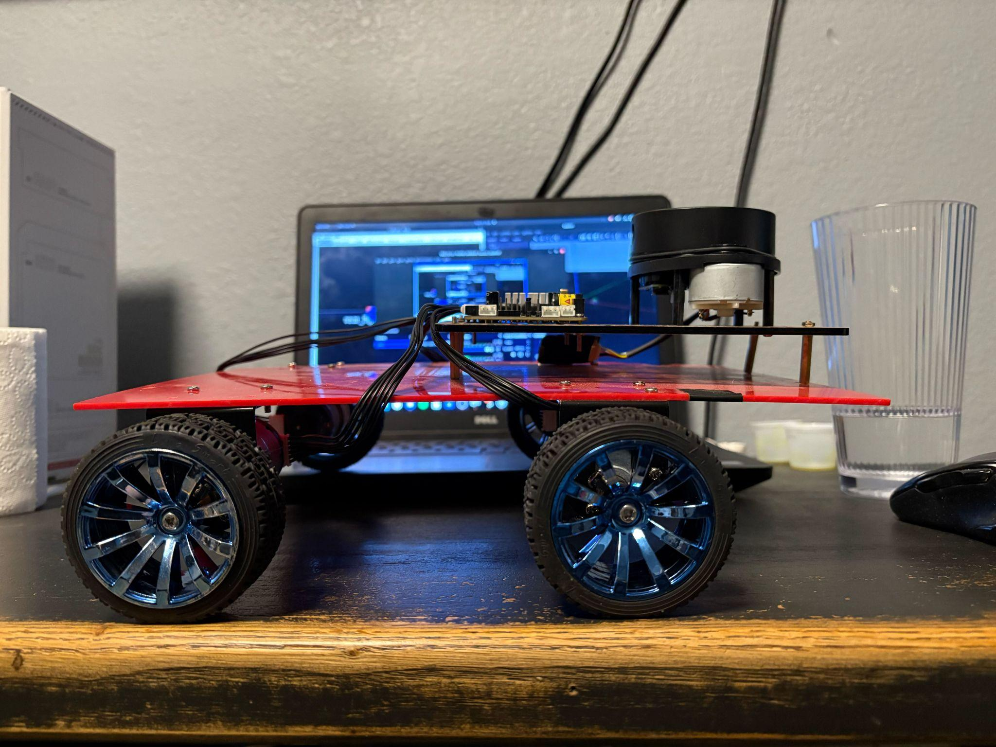

We built the launch file (Drive_robot) to automatically initialize the joy node, but the user must either use keyboard.launch or manually launch the keyboard node for driving the robot via keyboard commands. Overall, this was a fairly simple assignment to complete given that our nodes were given to us pre-built.

To execute this task you must run the following steps

1. Terminal 1
   1. Roscore
2. Terminal 2
   1. CD to DesignAssignments/da5
   2. Catkin_make
   3. To see the accurate simulation of what our robot LOOKs like, Roslaunch da5_1 mobile_robot.launch
   4. To drive our robot with symmetrical wheels, Roslaunch da5_1 drive_robot.launch
      1. The joystick is ready to run with this launch file
   5. To drive it with keyboard commands, Roslaunch da5_1 keyboard.launch OR rosrun teleop_twist_keyboard
3. View data in RVIZ

**Task Source Code Directory**

DesignAssignments/da5/src/da5_1/

**Task Video**

<https://youtu.be/JNFksxeNgoI>