MDR TB bedaquiline or amikacin costing study: Bayesian modelling

Nathan Green

07/12/2018

## Model

For the amikacin costs $c_{0}$ and bedaquiline costs $c_{1}$ the hierarchical model is

$$log(c_{i})∼t(μ_{c},σ_{c}^{2},4)$$

$$μ_{c}∼N(μ_{s},σ_{s}^{2})$$

Vague prior distributions:

$$μ_{s}∼N(0,0.000001)$$

$$log(σ_{s})∼U(−5,10)$$

$$μ_{c}∼N(0,0.000001)$$

$$log(σ_{c})∼U(−5,10)$$

## Results

We use a multi-level Bayesian model. Levels are at patient and centre. Times and frequencies for injectable treatment are used as baseline (c0).

Posterior distributions summary statistics are given below for each scenario.

* delta_c is the difference between the two scenarios i.e. c1 - c0.
* thresh is the exceedance threshold probability that bedaquiline is more costly than amikacin i.e. c1 - c0 > 0.
* m.cX.Y is the mean cost for intervention X at centre Y
* m.centreX is the overall mean cost for intervention X

## $rho0_obs  
## name mean sd median min max n  
## 1 m.centre1 26679.86 5964.198 26135.67 4498.391 76483.17 1840  
## 2 m.centre2 32734.42 2033.330 32707.75 19779.520 46493.63 1840  
## 3 m.c1.1 18071.32 2377.749 17914.57 11710.395 30395.51 1840  
## 4 m.c1.2 26064.51 1990.923 25971.62 19883.448 34150.39 1840  
## 5 m.c1.3 24163.57 2158.882 24081.14 17650.407 34911.38 1840  
## 6 m.c1.4 35087.32 2935.365 35075.89 26477.326 49212.04 1840  
## 7 m.c2.1 30265.37 2433.530 30560.87 22422.412 36288.15 1840  
## 8 m.c2.2 32096.79 1702.317 31958.59 26824.611 38753.22 1840  
## 9 m.c2.3 32505.45 1958.321 32349.58 26732.961 41885.82 1840  
## 10 m.c2.4 32643.27 1887.862 32514.05 27173.396 41177.56 1840  
##   
## $rho0.1_obs  
## name mean sd median min max n  
## 1 m.centre1 24778.32 5595.315 24295.48 1480.056 67826.58 1840  
## 2 m.centre2 29210.19 2202.733 29158.38 10425.841 75128.63 1840  
## 3 m.c1.1 17651.89 2325.029 17509.07 11236.432 27489.15 1840  
## 4 m.c1.2 25459.90 1905.430 25412.80 19728.905 33318.13 1840  
## 5 m.c1.3 23591.31 2078.179 23450.53 17796.951 33195.46 1840  
## 6 m.c1.4 34416.17 2929.571 34280.46 26623.886 46703.59 1840  
## 7 m.c2.1 29759.47 2110.746 30019.63 21705.008 36526.32 1840  
## 8 m.c2.2 31367.40 1556.589 31330.04 25905.945 38519.77 1840  
## 9 m.c2.3 31692.72 1744.972 31562.82 25944.617 39637.98 1840  
## 10 m.c2.4 31784.13 1665.092 31658.59 25801.831 38659.21 1840  
##   
## $rho0.33_obs  
## name mean sd median min max n  
## 1 m.centre1 24727.96 5322.036 24296.21 2924.687 83618.21 1840  
## 2 m.centre2 26535.57 1172.325 26477.02 21623.380 44849.58 1840  
## 3 m.c1.1 18146.19 2383.026 18009.70 10874.988 26834.71 1840  
## 4 m.c1.2 25955.36 2021.555 25865.23 19797.996 33705.79 1840  
## 5 m.c1.3 24185.05 2162.716 24086.17 17923.621 32283.87 1840  
## 6 m.c1.4 35096.99 2956.389 34859.33 27165.512 48751.60 1840  
## 7 m.c2.1 26791.54 1333.670 26932.01 21810.381 30698.45 1840  
## 8 m.c2.2 27776.56 1053.615 27686.09 24210.820 32141.89 1840  
## 9 m.c2.3 27857.88 1174.712 27730.09 22854.116 33037.64 1840  
## 10 m.c2.4 27981.50 1093.085 27895.46 24649.677 33986.70 1840  
##   
## $rho0_6mo_days  
## name mean sd median min max n  
## 1 m.centre1 25243.70 3335.829 25063.24 2646.611 57476.30 1840  
## 2 m.centre2 30289.09 2029.828 30200.48 16349.459 72971.42 1840  
## 3 m.c1.1 21646.61 1190.155 21576.47 18184.325 25864.93 1840  
## 4 m.c1.2 23621.72 1043.359 23622.63 20339.536 28119.43 1840  
## 5 m.c1.3 26959.63 1285.540 26847.96 23440.110 31642.23 1840  
## 6 m.c1.4 30698.49 1149.275 30654.29 27231.203 34925.00 1840  
## 7 m.c2.1 29432.24 2218.616 29745.92 21248.830 36928.31 1840  
## 8 m.c2.2 30935.04 1612.859 30912.91 24620.174 36915.03 1840  
## 9 m.c2.3 31375.95 1931.547 31241.70 25157.456 40207.79 1840  
## 10 m.c2.4 31378.42 1755.868 31237.14 25489.322 40765.26 1840  
##   
## $rho0.1_6mo_days  
## name mean sd median min max n  
## 1 m.centre1 26053.00 3550.682 25821.45 7681.585 78642.89 1840  
## 2 m.centre2 29366.71 1586.237 29339.59 13594.086 39993.38 1840  
## 3 m.c1.1 21704.52 1175.351 21646.66 17936.360 25692.45 1840  
## 4 m.c1.2 23698.66 1017.908 23670.50 20715.863 27139.78 1840  
## 5 m.c1.3 27005.48 1244.757 26937.03 23419.245 31913.12 1840  
## 6 m.c1.4 30816.86 1137.006 30738.64 27525.335 35450.34 1840  
## 7 m.c2.1 28389.72 1843.015 28624.65 21172.720 34130.22 1840  
## 8 m.c2.2 29535.65 1444.801 29486.32 24105.570 34831.94 1840  
## 9 m.c2.3 29799.02 1582.793 29731.37 24490.913 36255.37 1840  
## 10 m.c2.4 29913.17 1519.231 29786.47 25812.000 36944.04 1840  
##   
## $rho0.33_6mo_days  
## name mean sd median min max n  
## 1 m.centre1 25494.46 3684.127 25249.18 10138.02 85852.71 1840  
## 2 m.centre2 26494.88 1042.844 26477.70 20513.25 38061.12 1840  
## 3 m.c1.1 21683.79 1152.846 21609.80 17607.57 27381.98 1840  
## 4 m.c1.2 23639.00 1014.800 23607.71 20600.39 27685.44 1840  
## 5 m.c1.3 27041.81 1252.324 26999.11 22718.22 32621.74 1840  
## 6 m.c1.4 30775.68 1135.263 30711.53 26536.49 35265.13 1840  
## 7 m.c2.1 26111.17 1246.894 26222.44 20782.60 30577.56 1840  
## 8 m.c2.2 26900.84 1044.168 26851.47 23541.55 31192.50 1840  
## 9 m.c2.3 26905.33 1115.333 26860.39 23019.91 32337.30 1840  
## 10 m.c2.4 27012.03 1007.382 26951.23 24259.75 30616.64 1840  
##   
## $rho0_8mo_days  
## name mean sd median min max n  
## 1 m.centre1 32311.23 4785.766 31921.33 13016.44 96246.06 1840  
## 2 m.centre2 36644.70 1957.188 36599.51 21228.09 59162.66 1840  
## 3 m.c1.1 27310.61 1167.623 27255.12 24055.08 31961.77 1840  
## 4 m.c1.2 29258.18 1028.094 29232.69 26100.50 33285.29 1840  
## 5 m.c1.3 33676.09 1255.452 33649.35 29944.27 38712.63 1840  
## 6 m.c1.4 39158.87 1124.254 39164.20 35224.90 44204.12 1840  
## 7 m.c2.1 35486.76 2194.267 35758.24 26494.91 41506.66 1840  
## 8 m.c2.2 36969.63 1687.921 36869.00 31576.96 44440.67 1840  
## 9 m.c2.3 37294.99 1793.909 37115.75 31448.24 47626.93 1840  
## 10 m.c2.4 37333.84 1733.341 37224.54 31971.90 46219.28 1840  
##   
## $rho0.1_8mo_days  
## name mean sd median min max n  
## 1 m.centre1 34487.92 4402.5354 34224.82 17294.04 66891.43 1840  
## 2 m.centre2 37169.93 1729.7569 37136.72 21511.30 48341.44 1840  
## 3 m.c1.1 27346.99 1131.5708 27301.05 23768.32 32039.76 1840  
## 4 m.c1.2 29343.20 994.3732 29331.96 25728.52 33755.64 1840  
## 5 m.c1.3 33794.90 1280.3639 33782.53 29748.04 39258.70 1840  
## 6 m.c1.4 39324.06 1204.5398 39284.03 35351.85 43351.92 1840  
## 7 m.c2.1 34514.19 1883.8403 34699.00 27495.51 40831.82 1840  
## 8 m.c2.2 35716.80 1434.1070 35684.63 28751.33 43019.81 1840  
## 9 m.c2.3 35983.56 1616.2063 35883.63 30787.34 42946.41 1840  
## 10 m.c2.4 36033.64 1500.8562 35915.44 30549.70 41919.13 1840  
##   
## $rho0.33_8mo_days  
## name mean sd median min max n  
## 1 m.centre1 31834.73 4420.4126 31452.27 4070.611 98170.81 1840  
## 2 m.centre2 32687.85 1085.0286 32676.77 20100.141 37075.23 1840  
## 3 m.c1.1 27287.65 1145.0764 27236.13 23045.812 31508.40 1840  
## 4 m.c1.2 29312.47 995.5567 29293.92 26241.981 32960.66 1840  
## 5 m.c1.3 33731.25 1289.8594 33700.49 30200.103 38410.21 1840  
## 6 m.c1.4 39252.52 1111.9721 39239.04 35436.537 42987.45 1840  
## 7 m.c2.1 32229.54 1280.1174 32334.47 26324.363 35728.84 1840  
## 8 m.c2.2 33035.03 1018.7699 32982.37 29451.748 36989.57 1840  
## 9 m.c2.3 33046.69 1102.7529 32988.21 29290.352 38090.17 1840  
## 10 m.c2.4 33147.80 1015.1064 33071.10 29892.395 38726.95 1840

For example, if we scale the bedaquillin hospital length of stay by some 0 < $ρ$ < 1 and compare with the baseline then the posterior distributions of mean costs are given below. The red histogram is bedaquiline and the white for injectables.

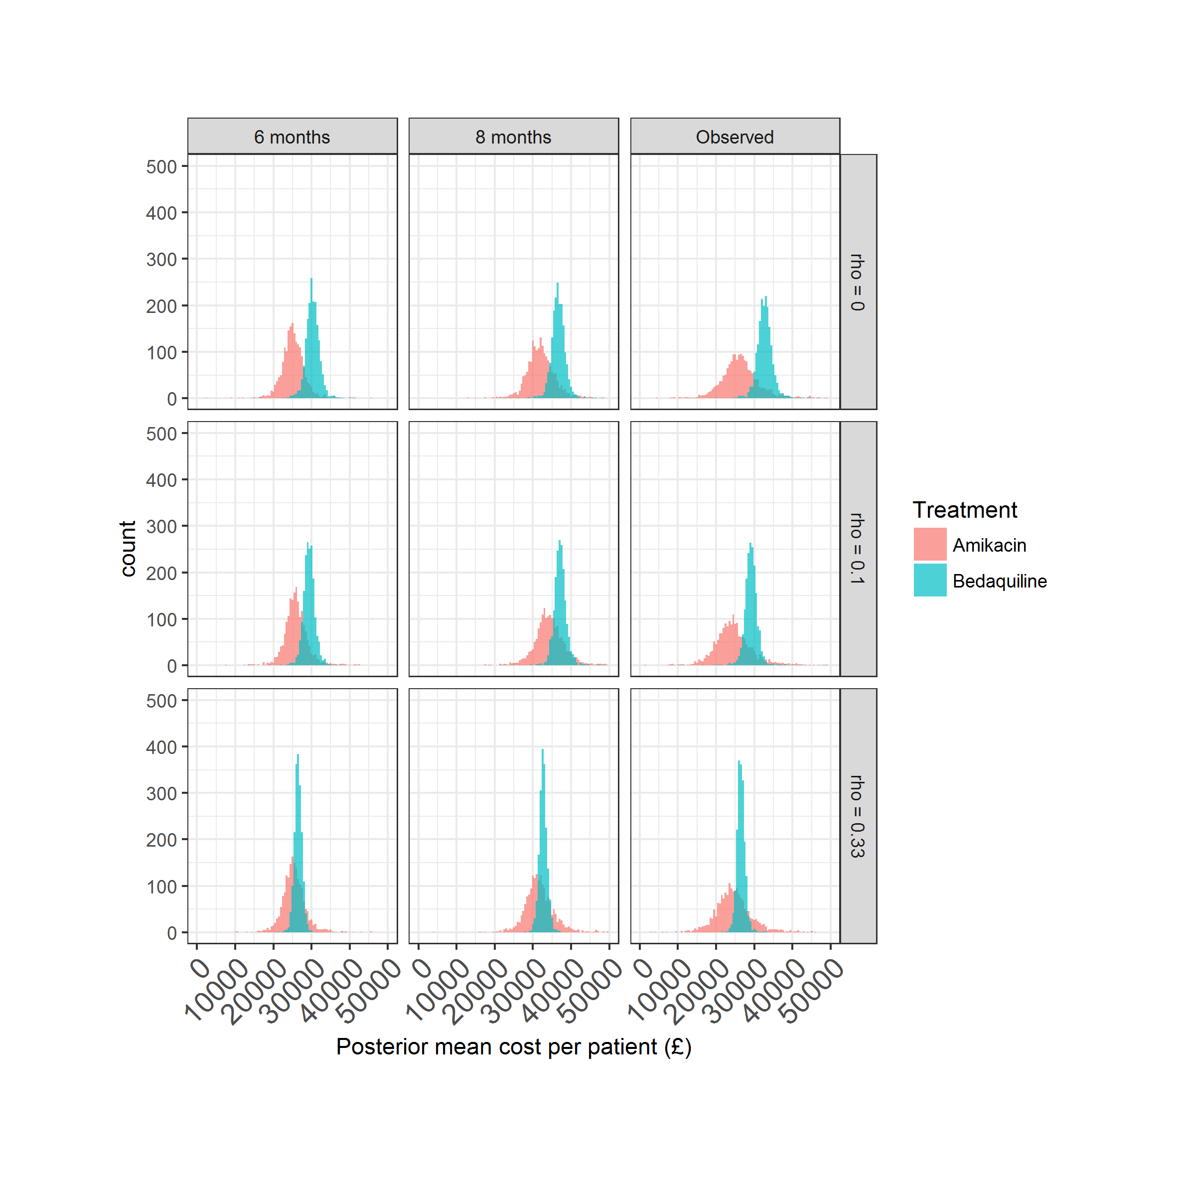

Mean costs posterior distributions with mean values substituted for missing costs.

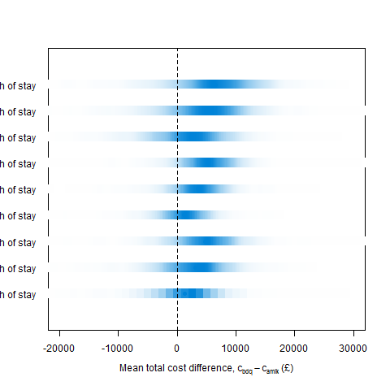

Difference in mean costs posterior distributions with mean values substituted for missing costs.

### Posterior predictive checking

To check the fit of the model we generate sample of individual-level costs from the posterior distribution and compare with the observed data.

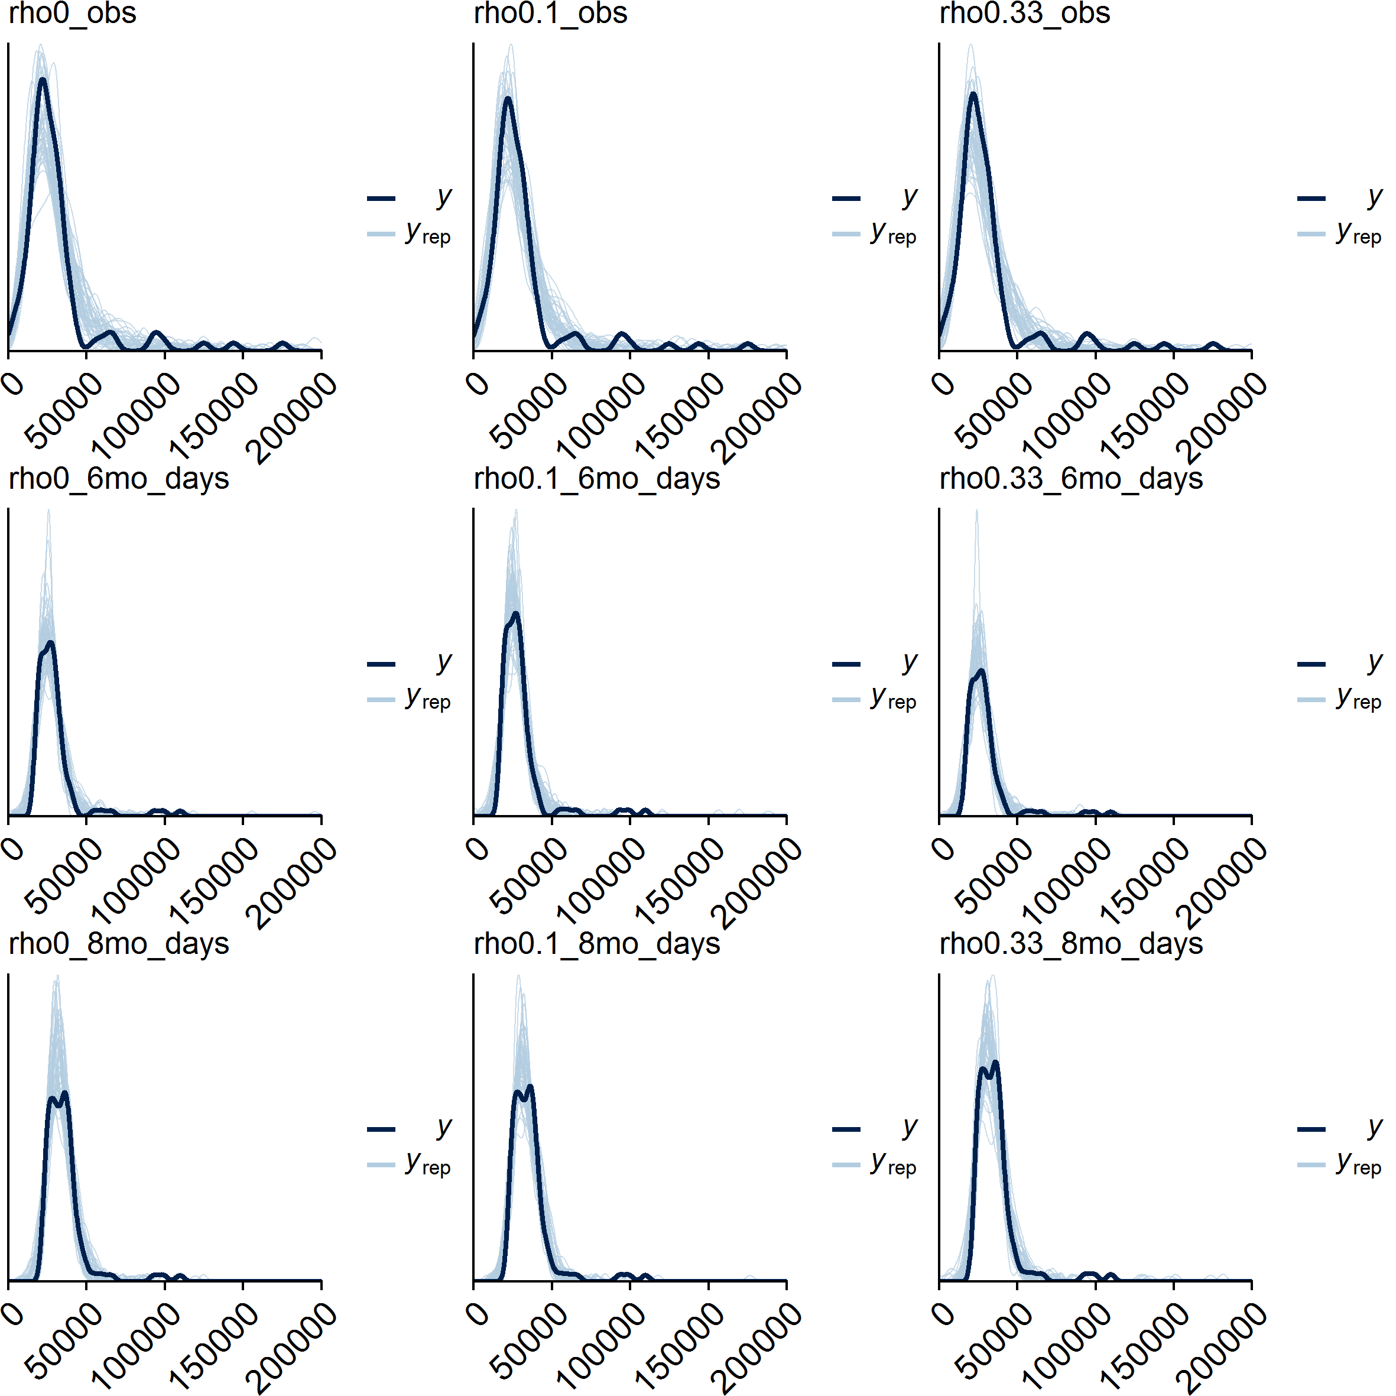

Posterior predictive checks for individual-level amikacin cost data.

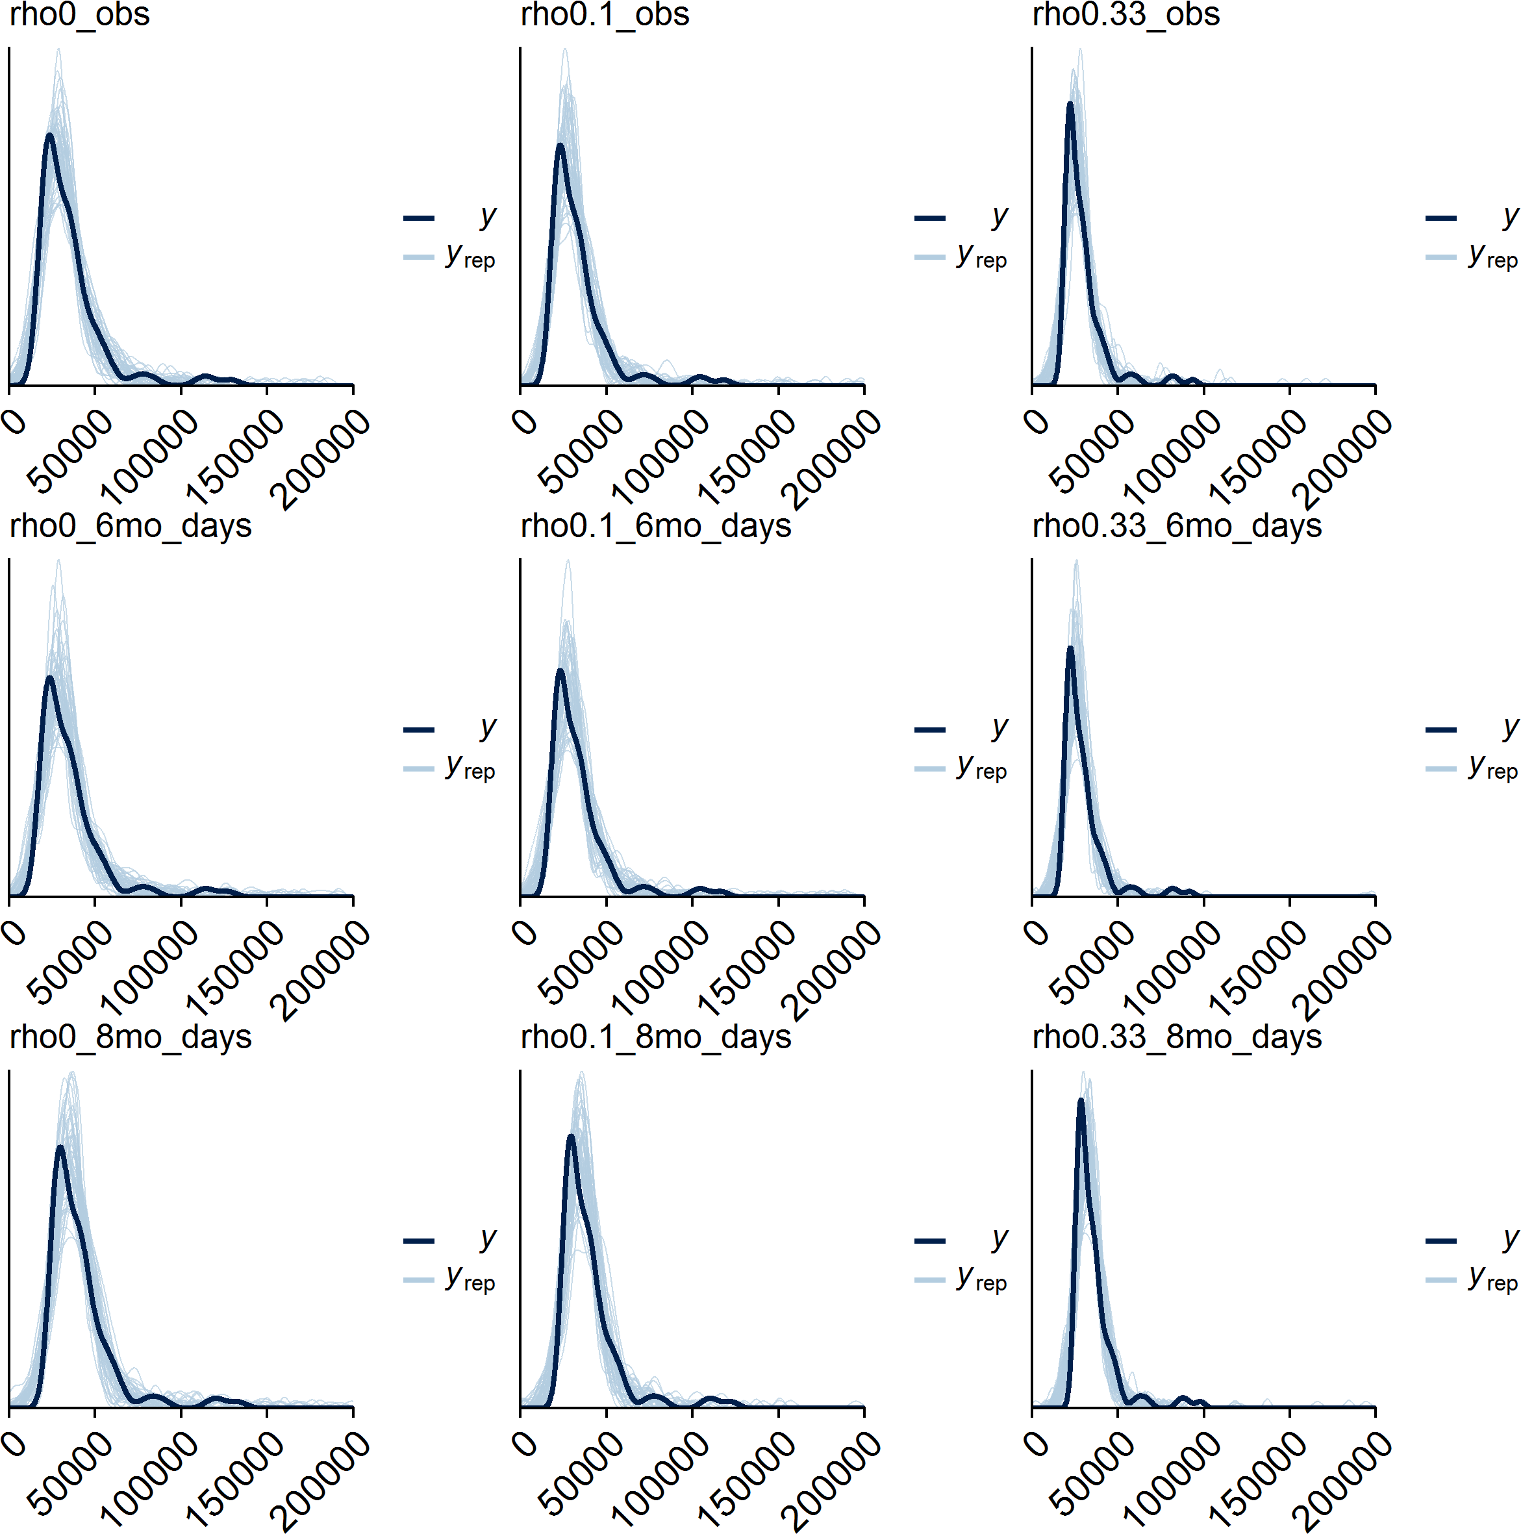

Posterior predictive checks for individual-level bedaquiline cost data.

### Cost sensitivity analysis

### Between centre costs

At the centre level, if we focus on the baseline scenario c_0 then the posterior mean distributions on cost for each centre are: