MDR TB bedaquiline or amikacin costing study: Generating patient-level cost data

Nathan Green

14/11/2018

This document gives some of the methods and data of the initial part of the analysis for circulation.

## Look-up costs

The cost have been obtained from 4 centres. They are not complete at time of writing. I have therefore crudely used the minimum, maximum and mean value across observed values in centres.

Also, hospital stay costs are scaled from 4% to 24% for different centre. Baseline values are fixed £2429 for stays under 20 days and £208 for each day thereafter.

The raw, and minimum, mean and maximum imputed cost matrices are:

|  |  |  |  |  |  |  |  |  |  |  |  |  |
| --- | --- | --- | --- | --- | --- | --- | --- | --- | --- | --- | --- | --- |
| centre_costid | centre_patientid | bed_under20d | bed_over20d | PICC | hick | OPAT | blood_amak | blood_liver | blood_renal | hear | ECG | scaling |
| 1 | 1 | 3016.089 | 258.2736 | 69 | 0 | 102 | 7.50 | 3.80 | 3.19 | 0.0 | 153 | 1.2417 |
| 2 | 4 | 2945.162 | 252.2000 | NA | NA | 148 | 7.50 | 2.65 | 1.62 | NA | 25 | 1.2125 |
| 3 | 2 | 2538.062 | 217.3392 | NA | NA | 100 | NA | NA | NA | 33.0 | 124 | 1.0449 |
| 4 | 3 | 2962.408 | 253.6768 | 200 | 200 | NA | 29.56 | 11.82 | 9.45 | 34.5 | 15 | 1.2196 |

Table 1: Original data

|  |  |  |  |  |  |  |  |  |  |  |  |  |
| --- | --- | --- | --- | --- | --- | --- | --- | --- | --- | --- | --- | --- |
| centre_costid | centre_patientid | bed_under20d | bed_over20d | PICC | hick | OPAT | blood_amak | blood_liver | blood_renal | hear | ECG | scaling |
| 1 | 1 | 3016.09 | 258.27 | 69 | 0 | 102 | 7.50 | 3.80 | 3.19 | 0.0 | 153 | 1.24 |
| 2 | 4 | 2945.16 | 252.20 | 69 | 0 | 148 | 7.50 | 2.65 | 1.62 | 0.0 | 25 | 1.21 |
| 3 | 2 | 2538.06 | 217.34 | 69 | 0 | 100 | 7.50 | 2.65 | 1.62 | 33.0 | 124 | 1.04 |
| 4 | 3 | 2962.41 | 253.68 | 200 | 200 | 100 | 29.56 | 11.82 | 9.45 | 34.5 | 15 | 1.22 |

Table 2: Fill with minimum values

|  |  |  |  |  |  |  |  |  |  |  |  |  |
| --- | --- | --- | --- | --- | --- | --- | --- | --- | --- | --- | --- | --- |
| centre_costid | centre_patientid | bed_under20d | bed_over20d | PICC | hick | OPAT | blood_amak | blood_liver | blood_renal | hear | ECG | scaling |
| 1 | 1 | 3016.09 | 258.27 | 69.0 | 0 | 102.00 | 7.50 | 3.80 | 3.19 | 0.0 | 153 | 1.24 |
| 2 | 4 | 2945.16 | 252.20 | 134.5 | 100 | 148.00 | 7.50 | 2.65 | 1.62 | 22.5 | 25 | 1.21 |
| 3 | 2 | 2538.06 | 217.34 | 134.5 | 100 | 100.00 | 14.85 | 6.09 | 4.75 | 33.0 | 124 | 1.04 |
| 4 | 3 | 2962.41 | 253.68 | 200.0 | 200 | 116.67 | 29.56 | 11.82 | 9.45 | 34.5 | 15 | 1.22 |

Table 3: Fill with mean values

|  |  |  |  |  |  |  |  |  |  |  |  |  |
| --- | --- | --- | --- | --- | --- | --- | --- | --- | --- | --- | --- | --- |
| centre_costid | centre_patientid | bed_under20d | bed_over20d | PICC | hick | OPAT | blood_amak | blood_liver | blood_renal | hear | ECG | scaling |
| 1 | 1 | 3016.09 | 258.27 | 69 | 0 | 102 | 7.50 | 3.80 | 3.19 | 0.0 | 153 | 1.24 |
| 2 | 4 | 2945.16 | 252.20 | 200 | 200 | 148 | 7.50 | 2.65 | 1.62 | 34.5 | 25 | 1.21 |
| 3 | 2 | 2538.06 | 217.34 | 200 | 200 | 100 | 29.56 | 11.82 | 9.45 | 33.0 | 124 | 1.04 |
| 4 | 3 | 2962.41 | 253.68 | 200 | 200 | 148 | 29.56 | 11.82 | 9.45 | 34.5 | 15 | 1.22 |

Table 4: Fill with maximum values

* bed_under20d is cost of hosptial stay fixed up to 19 days
* bed_over20d is the daily cost of hospital stay for every day over 19 days
* PICC is the cost of a PICC line
* hick is the cost of a Hickman line
* blood amik is the cost of a blood test
* blood liver is the cost of a blood test
* blood renal is the cost of a blood test
* hear is the cost of a hearing test
* ECG is the cost of an ECG
* scaling is the centre specific cost scaling

Note that the provided cost and patient data do not use the same ids (represented here by centre_costid and centre_patientid).

The total cost of bedaquiline treatment is £18000 for a duration of 24 weeks. The idealised duration of amikacin treatment is 24 or 32 weeks. Therefore, we scale the bedaquiline cost for an equivalent 32 weeks period of £24000 too.

## Scenarios

Cost are considered for 12 main scenarios. These can be grouped in to observed injection vs ideal injection scenarios, and observed injection vs tablets scenarios. For the comparison bedaquiline scenarios hospital length of stay is scaled by a predefined value to represent shorter symptom duration.

|  |  |  |
| --- | --- | --- |
| No. | Baseline | Comparison |
| 1a | Amikacin injection observed | Bedaquiline tablets 6 months; same hospital length of stay |
| 1b | Amikacin injection observed | Bedaquiline tablets 6 months; 90% hospital length of stay |
| 1c | Amikacin injection observed | Bedaquiline tablets 6 months; 66% hospital length of stay |
|  |  |  |
| 2a | Amikacin injection ideal 6 months | Bedaquiline tablets 6 months; same hospital length of stay |
| 2b | Amikacin injection ideal 6 months | Bedaquiline tablets 6 months; 90% hospital length of stay |
| 2c | Amikacin injection ideal 6 months | Bedaquiline tablets 6 months; 66% hospital length of stay |
|  |  |  |
| 3a | Amikacin injection ideal 8 months | Bedaquiline tablets 8 months; same hospital length of stay |
| 3b | Amikacin injection ideal 8 months | Bedaquiline tablets 8 months; 90% hospital length of stay |
| 3c | Amikacin injection ideal 8 months | Bedaquiline tablets 8 months; 66% hospital length of stay |

So, for each set of costs (minimum, mean, maximum) and each treatment scenario, in total there are 9 x 3 = 27 scenarios to consider.

### Patient-level cost calculation

The costs for each scenario consist of the following:

#### Observed and idealised injectable

* Time in hospital (from observed data)
* OPAT daily in discharge period (observed, up to 6 or 8 months)
* Number of lines (Hickman, PICC) in discharge period (observed, up to 6 or 8 months)
* Number of monthly hearing tests in discharge period (observed, up to 6 or 8 months)
* Number of weekly blood tests (observed, up to 6 or 8 months)

#### Bedaquiline

* Time in hospital from observed data (possible scaled downwards)
* Monthly ECG and blood tests (renal, LFT) in discharge period (up to 6 or 8 months)
* Total fixed cost of treatment (up to 6 or 8 months)

### Estimated number of events

For the idealised scenarios we need to estimate how many Hickman and PICC lines would occur for each individual in the fixed period. We do this by estimating a pooled weekly rate for each from the total sample. We then calculate each according to their duration on treatment after hospital discharge.

### Patient time to event equations

Initial hospital length of stay

$$t_{adm}=d_{hosp_end}−d_{IV_start}$$

Out-patient (OP) duration

$$t_{OP}=\left\{\begin{matrix}d_{IV_end}−d_{hosp_end} for observed scenarios \\ t_{Tx}−t_{adm} for non-observed scenarios\end{matrix}\right.$$

where

$$t_{Tx}=24,32$$

Total hospital length of stay including readmissions

$$t_{adm}^{inj}=t_{adm}+t_{readm}$$

Total hospital length of stay for bedaquiline

$$t_{adm}^{bdq}=ρt_{adm}+t_{readm}, 0≤ρ≤1$$

Total out-patient duration for amikacin

$$t_{OP}^{inj}=max\left\{t_{OP}−t_{readm},0\right\}$$

Total out-patient duration for bedaquiline

$$t_{OP}^{bdq}=max\left\{t_{OP}−t_{readm}+(1−ρ)t_{adm},0\right\}$$

Estimated number of Hickman and PICC lines

$${\hat{n}}_{hick}=t_{OP}^{inj}\frac{∑n_{hick}}{∑t_{OP}^{inj}}, {\hat{n}}_{PICC}=t_{OP}^{inj}\frac{∑n_{PICC}}{∑t_{OP}^{inj}}$$

### Total cost equations

* Bedaquiline tablets
$$c_{bdq}^{i}=\left[c_{bed<20}+max\left\{t_{adm}^{bdq}−19,0\right\}c_{bed≮20}\right]+\left\lfloor \frac{t_{OP}^{bdq}}{7}\right\rfloor \left(c_{ECG}+c_{renal}+c_{liver}\right)+c_{bdq}$$

* Observed injectible amikacin
$$c_{amik}^{i}=\left[c_{bed<20}+max\left\{t_{adm}^{inj}−19,0\right\}c_{bed≮20}\right]+c_{hick}n_{hick}^{i}+c_{PICC}n_{PICC}^{i}+c_{OP}t_{OP}^{i}+c_{hear}n_{hear}^{i}$$

* Ideal injectible amikacin

$$c_{amik,ideal}^{i}=\left[c_{bed<20}+max\left\{t_{adm}^{inj}−19,0\right\}c_{bed≮20}\right]+c_{hick}{\hat{n}}_{hick}^{i}+c_{PICC}{\hat{n}}_{PICC}^{i}+c_{OPAT}{\hat{t}}_{OP}^{i}+c_{hear}{\hat{n}}_{hear}^{i}$$

## Results

### Patient-level data

Each patient’s cost is calculated using the costs for their particular site. Their times to events and counts are available (obs). The analysis data thus consist of the original recorded data, the derived counts and times and the total cost per patient.

##   
## Attaching package: 'kableExtra'

## The following object is masked from 'package:dplyr':  
##   
## group_rows

Observed treatment

6 months treatment

Mean costs

No change

No change

10% reduction

33% reduction

PICC line

134.50

0.99

0.93

0.93

0.93

Hickman line

100.00

0.09

0.09

0.09

0.09

Hearing test

22.50

4.04

3.95

3.95

3.95

Renal test

4.75

4.42

4.42

4.65

5.08

Liver test

6.09

4.42

4.42

4.65

5.08

ECG

79.25

4.42

4.42

4.65

5.08

Fixed admission < 20 days

2865.43

0.31

0.31

0.31

0.36

Admission >= 20 days per day

245.37

55.93

55.93

48.49

31.40

Bedaquiline total

18000.00

NA

NA

NA

NA

0

1

2

3

4

5

6

7

8

9

10

11

12

13

12

16

13

11

8

9

5

1

6

5

3

1

4

1

## Group.1 x  
## 1 1 6.066667  
## 2 2 2.444444  
## 3 3 5.608696  
## 4 4 3.266667

## Group.1 x  
## 1 1 91  
## 2 2 66  
## 3 3 129  
## 4 4 98

Table 5: Number of hearing tests

0

1

2

3

22

58

9

6

## Group.1 x  
## 1 1 1.0666667  
## 2 2 0.7407407  
## 3 3 0.8260870  
## 4 4 1.3000000

## Group.1 x  
## 1 1 16  
## 2 2 20  
## 3 3 19  
## 4 4 39

Table 6: Number of picc lines

0

1

2

87

7

1

## Group.1 x  
## 1 1 0.00000000  
## 2 2 0.03703704  
## 3 3 0.13043478  
## 4 4 0.16666667

## Group.1 x  
## 1 1 0  
## 2 2 1  
## 3 3 3  
## 4 4 5

Table 7: Number of Hickman lines

## Group.1 x  
## 1 1 83.46667  
## 2 2 108.33333  
## 3 3 53.04348  
## 4 4 167.10000

## Group.1 x  
## 1 1 1252  
## 2 2 2925  
## 3 3 1220  
## 4 4 5013

Table 8: Number of OPAT_days_inj

## Group.1 x  
## 1 1 5.333333  
## 2 2 4.444444  
## 3 3 4.130435  
## 4 4 4.166667

## Group.1 x  
## 1 1 80  
## 2 2 120  
## 3 3 95  
## 4 4 125

Table 9: Number of visits for ECG, liver and renal tests

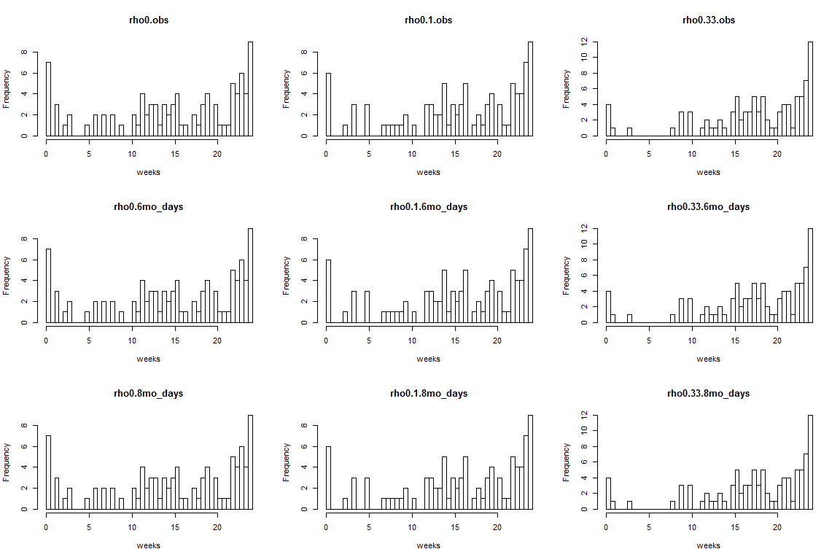

Out-patient weeks for bdq

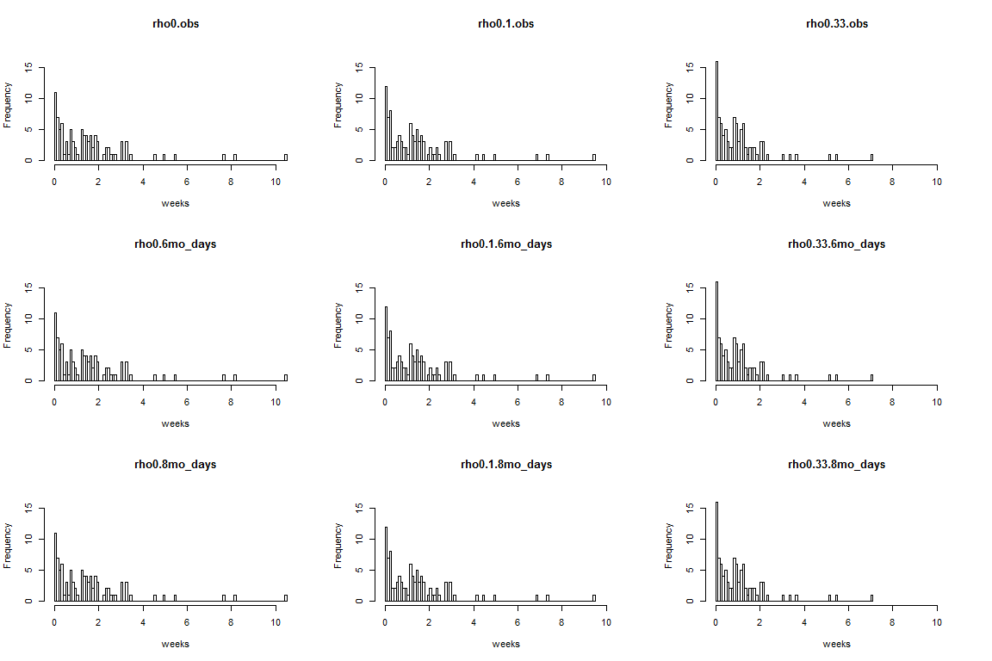

Total admission weeks for bdq

Below we give the individual total costs for each scenario (unit cost table and length of stay) histograms for amikacin (red) vs bedaquiline (blue).

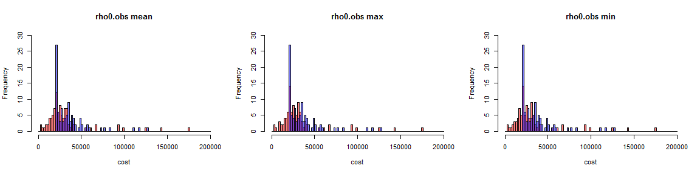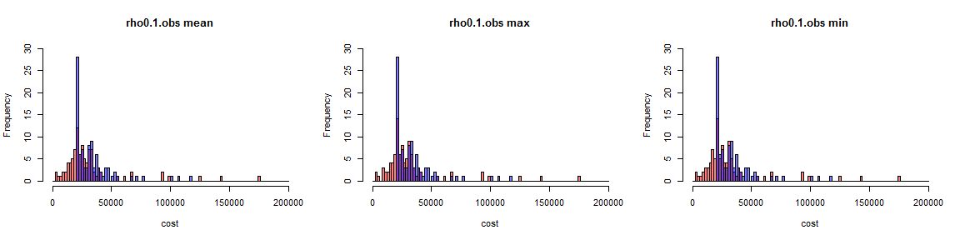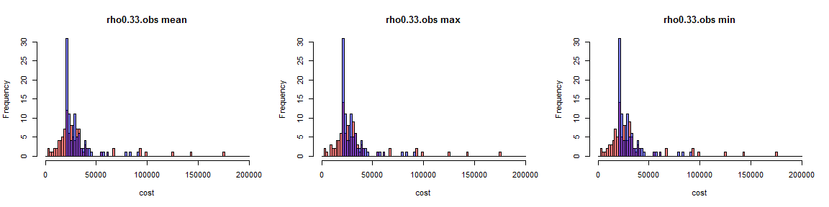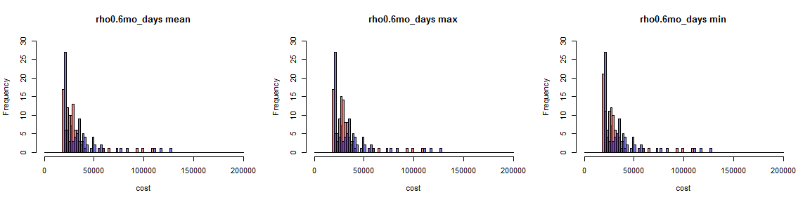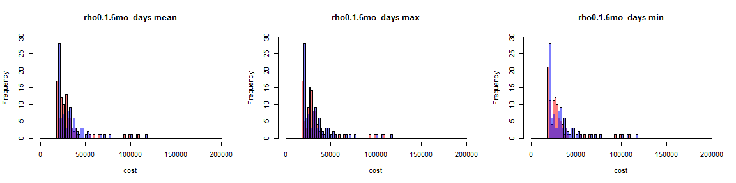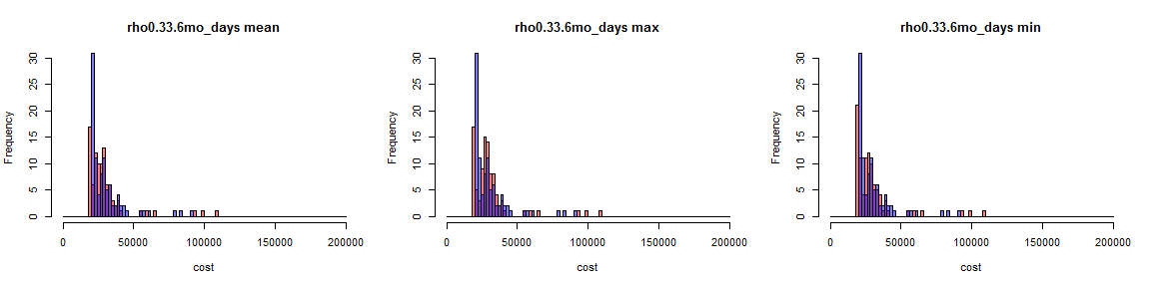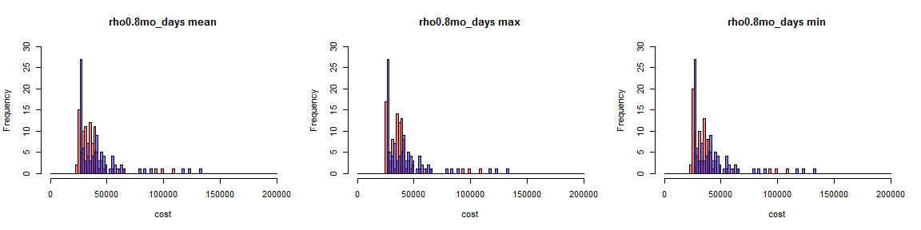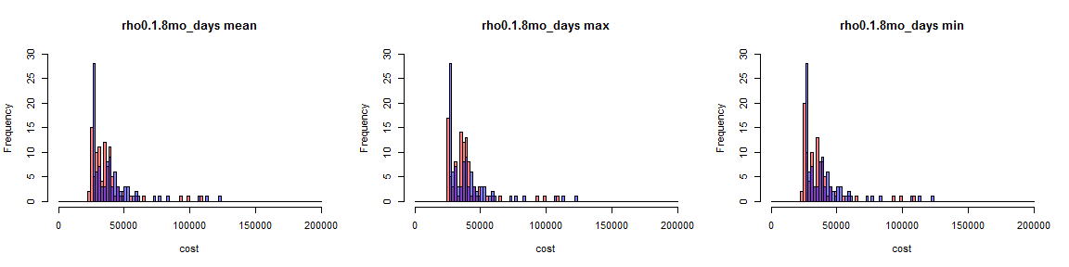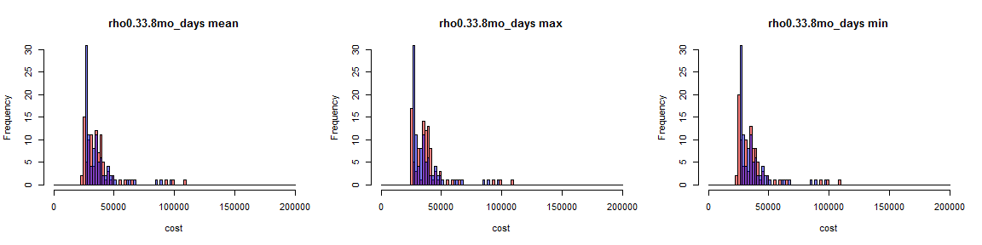

For each scenario the summary costs are given below.