IDEA: Main Chapter of HTA Report Cost-Effectiveness Comparison

Nathan Green

4 February 2016

# source("../../../analysis scripts/IDEA/alt-YAML_Binomial_dectrees/indiv-dectree-sampling.R")

library(IDEAdectree)  
library(BCEA)  
library(ggplot2)  
  
# load("C:/Users/ngreen1/Dropbox/TB/IDEA/R/packages/IDEAdectree/data/TBdata_clinical_cleaned.RData")  
load("../data/TBdata_clinical_cleaned.RData")  
load("../data/COSTdistns_allerror.RData")  
load("../data/senspec_env.RData")  
load("../data/drug_dose-cost.RData")  
  
## sensitivities and specificities from IDEA lab data  
attach(senspec.env)  
  
dat <- list()  
  
yearindays <- 365  
WTP <- c(20000, 30000)/yearindays

##TODO##  
## doesnt work at the moment...!!  
  
  
dat1 <- IDEAdectree.simple(data=data, name.ruleout = "TSPOT",  
 SPEC = TSPOT.noIndet.spec.mean, SENS = TSPOT.noIndet.sens.mean,   
 SPECvar = TSPOT.noIndet.spec.var, SENSvar = TSPOT.noIndet.sens.var, wholecohortstats = TRUE)  
dat2 <- IDEAdectree.simple(data=data, name.ruleout = "TSPOT",  
 SPEC = TSPOT.HIV.noIndet.spec.mean, SENS = TSPOT.HIV.noIndet.sens.mean,   
 SPECvar = TSPOT.HIV.noIndet.spec.var, SENSvar = TSPOT.HIV.noIndet.sens.var, wholecohortstats = TRUE)  
dat3 <- IDEAdectree.simple(data=data, name.ruleout = "TSPOT",  
 SPEC = TSPOT.HIVneg.noIndet.spec.mean, SENS = TSPOT.HIVneg.noIndet.sens.mean,   
 SPECvar = TSPOT.HIVneg.noIndet.spec.var, SENSvar = TSPOT.HIVneg.noIndet.sens.var, wholecohortstats = TRUE)  
  
dat$e <- cbind(dat1$e, dat2$e[,2], dat3$e[,2])  
dat$c <- cbind(dat1$c, dat2$c[,2], dat3$c[,2])  
  
intlabels <- c("Current",  
 "Enhanced TSPOT: All, no Indets", "Enhanced TSPOT: HIV positive, no Indets", "Enhanced TSPOT: HIV negative, no Indets")  
  
my.plot.bcea(dat1, dat2, dat3, wtp=WTP, intlabels = intlabels, wtpNEG = "Y")  
my.plot.bcea(dat1, dat2, dat3, wtp=WTP*yearindays, intlabels = c("All","HIV positive","HIV negative"), wtpNEG = "Y", SCALEcosts=FALSE, SCALEdays=FALSE, labelLong=FALSE, TITLE="(a)", N=769)  
  
my.plot.bcea(dat1, dat2, dat3, wtp=WTP, intlabels = intlabels, contour=TRUE, wtpNEG = "Y")  
my.plot.bcea(dat1, dat2, dat3, wtp=WTP*yearindays, intlabels = c("All","HIV positive","HIV negative"), contour=TRUE, wtpNEG = "Y", SCALEcosts=FALSE, SCALEdays=FALSE, labelLong=FALSE, TITLE="(a)", N=769)  
  
my.plot.bcea(dat1, dat2, dat3, wtp=WTP, intlabels = intlabels, contour=TRUE, LEVELS=0.5, wtpNEG = "Y")  
my.plot.bcea(dat1, dat2, dat3, wtp=WTP*yearindays, intlabels = c("All","HIV positive","HIV negative"), contour=TRUE, LEVELS=0.5, wtpNEG = "Y", SCALEcosts=FALSE, SCALEdays=FALSE, labelLong=FALSE, TITLE="(a)", N=769)  
  
my.plot.ceac(dat1, dat2, dat3, intlabels = intlabels)

dat1 <- IDEAdectree.simple(data=data, name.ruleout = "TSPOT",  
 SPEC = TSPOT.noIndet.spec.mean, SENS = TSPOT.noIndet.sens.mean,   
 SPECvar = TSPOT.noIndet.spec.var, SENSvar = TSPOT.noIndet.sens.var)

## Loading required package: triangle

## Loading required package: assertive

dat2 <- IDEAdectree.simple(data=data, name.ruleout = "TSPOT",  
 SPEC = TSPOT.HIV.noIndet.spec.mean, SENS = TSPOT.HIV.noIndet.sens.mean,   
 SPECvar = TSPOT.HIV.noIndet.spec.var, SENSvar = TSPOT.HIV.noIndet.sens.var)  
dat3 <- IDEAdectree.simple(data=data, name.ruleout = "TSPOT",  
 SPEC = TSPOT.HIVneg.noIndet.spec.mean, SENS = TSPOT.HIVneg.noIndet.sens.mean,   
 SPECvar = TSPOT.HIVneg.noIndet.spec.var, SENSvar = TSPOT.HIVneg.noIndet.sens.var)  
  
dat$e <- cbind(dat1$e, dat2$e[,2], dat3$e[,2])  
dat$c <- cbind(dat1$c, dat2$c[,2], dat3$c[,2])  
  
intlabels <- c("Current",  
 "Enhanced TSPOT: All, no Indets", "Enhanced TSPOT: HIV positive, no Indets", "Enhanced TSPOT: HIV negative, no Indets")  
  
# m <- bcea(e=dat$e, c=-dat$c, ref=1, interventions = intlabels)  
# contour2(m, wtp=WTP, graph = "ggplot2", ICER.size=2, pos=c(0.1,0.9))+#, xlim=c(-5,5), ylim=c(-200,200)) +  
# ggtitle("") #+ geom_abline(intercept = 0, slope = WTP)  
  
my.plot.bcea(dat1, dat2, dat3, wtp=WTP, intlabels = intlabels, wtpNEG = "Y")

## Loading required package: MASS

## Loading required package: car

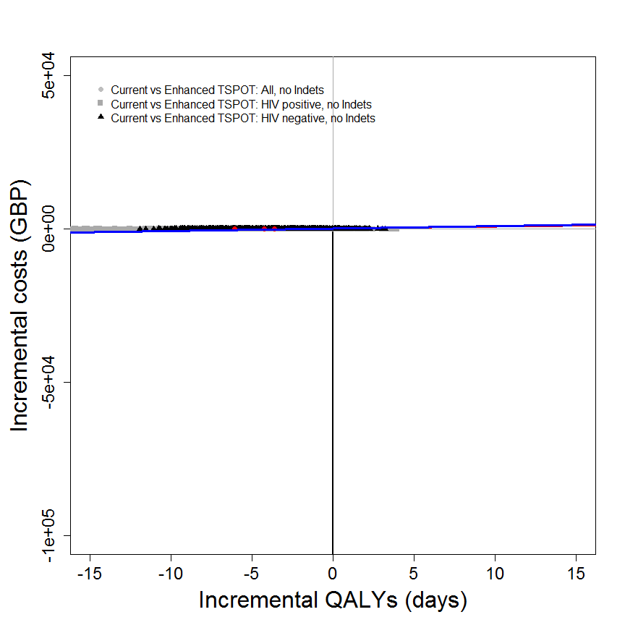

## [[1]]  
## NULL  
##   
## [[2]]  
## NULL

my.plot.bcea(dat1, dat2, dat3, wtp=WTP*yearindays, intlabels = c("All","HIV positive","HIV negative"), wtpNEG = "Y", SCALEcosts=FALSE, SCALEdays=FALSE, labelLong=FALSE, TITLE="(a)", N=769)

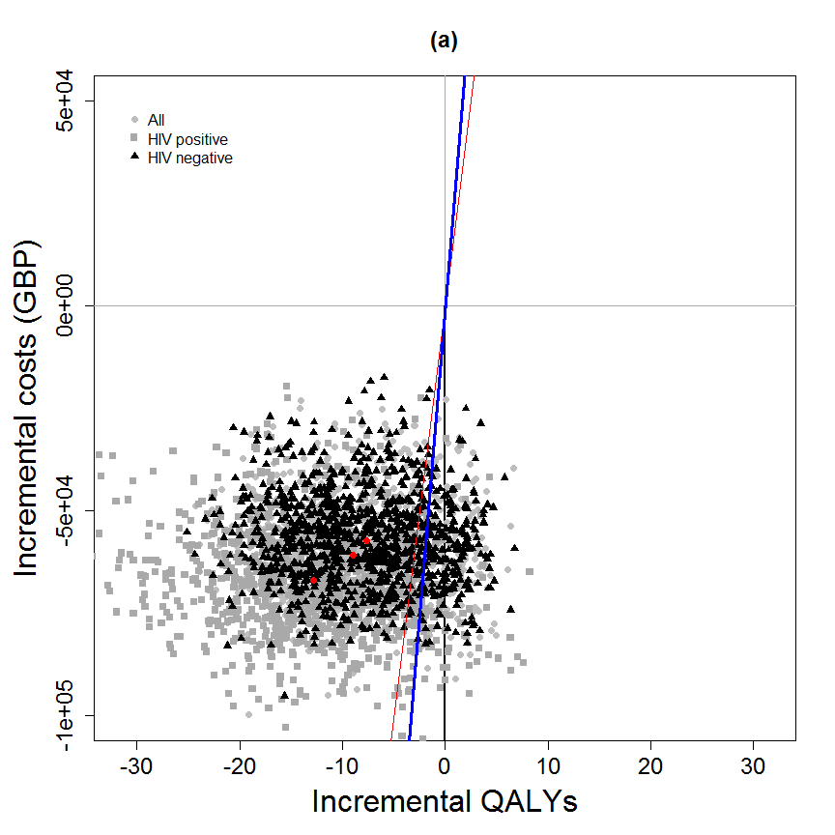

## [[1]]  
## NULL  
##   
## [[2]]  
## NULL

my.plot.bcea(dat1, dat2, dat3, wtp=WTP, intlabels = intlabels, contour=TRUE, wtpNEG = "Y")

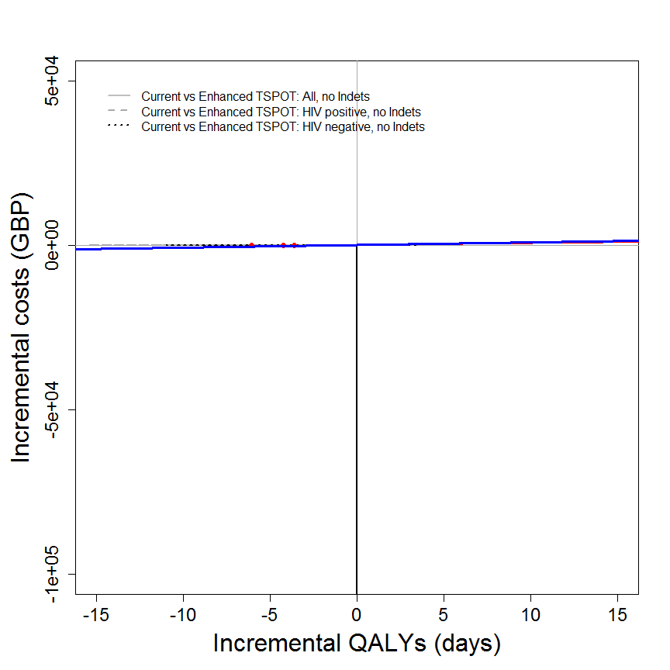

## [[1]]  
## NULL  
##   
## [[2]]  
## NULL

my.plot.bcea(dat1, dat2, dat3, wtp=WTP*yearindays, intlabels = c("All","HIV positive","HIV negative"), contour=TRUE, wtpNEG = "Y", SCALEcosts=FALSE, SCALEdays=FALSE, labelLong=FALSE, TITLE="(a)", N=769)

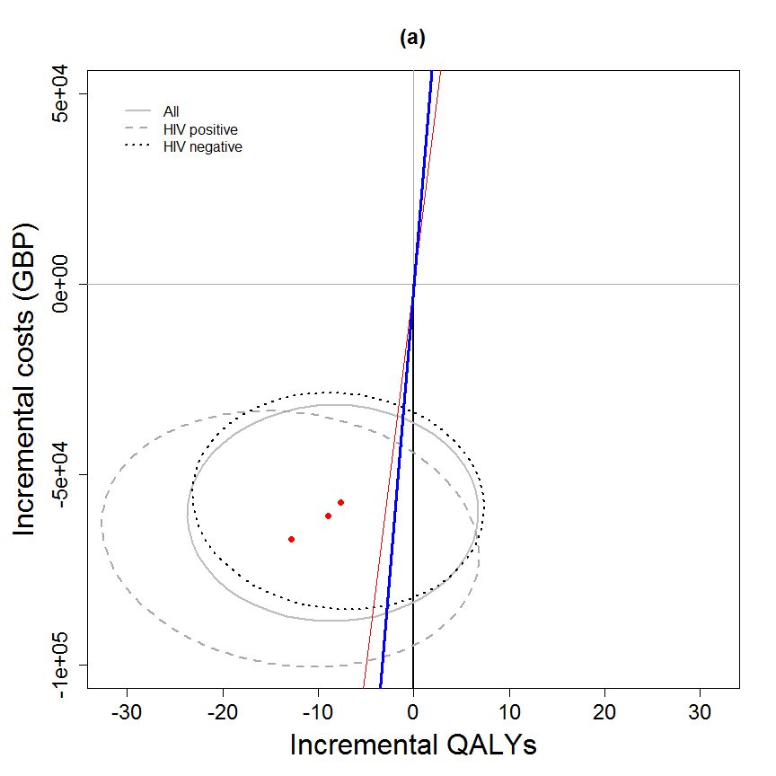

## [[1]]  
## NULL  
##   
## [[2]]  
## NULL

my.plot.bcea(dat1, dat2, dat3, wtp=WTP, intlabels = intlabels, contour=TRUE, LEVELS=0.5, wtpNEG = "Y")

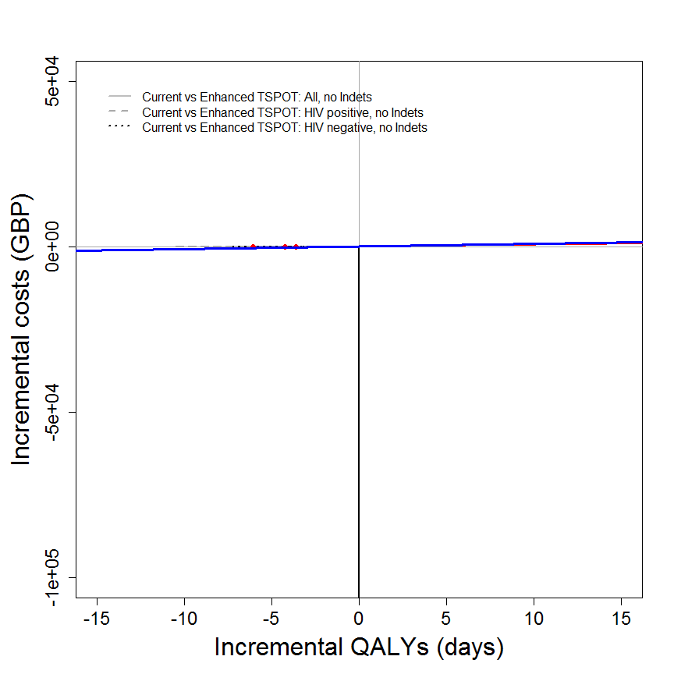

## [[1]]  
## NULL  
##   
## [[2]]  
## NULL

my.plot.bcea(dat1, dat2, dat3, wtp=WTP*yearindays, intlabels = c("All","HIV positive","HIV negative"), contour=TRUE, LEVELS=0.5, wtpNEG = "Y", SCALEcosts=FALSE, SCALEdays=FALSE, labelLong=FALSE, TITLE="(a)", N=769)

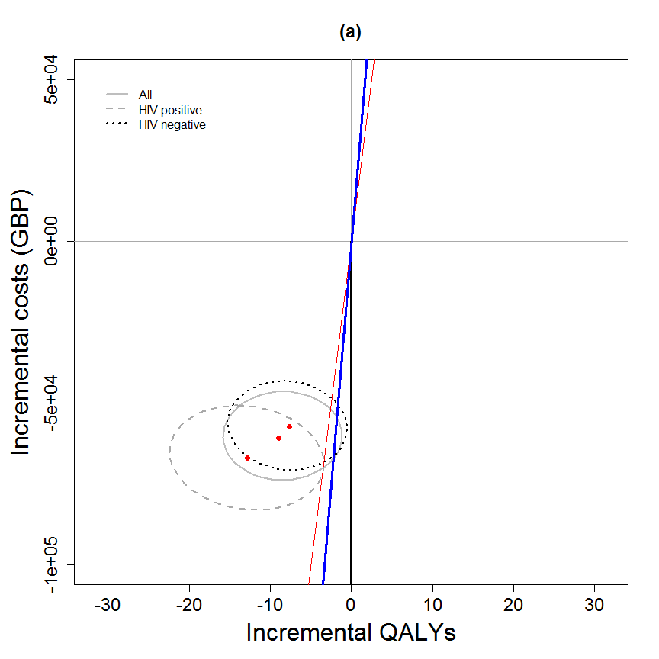

## [[1]]  
## NULL  
##   
## [[2]]  
## NULL

my.plot.ceac(dat1, dat2, dat3, intlabels = c("All","HIV positive","HIV negative"), labelLong=FALSE, TITLE="(a)")

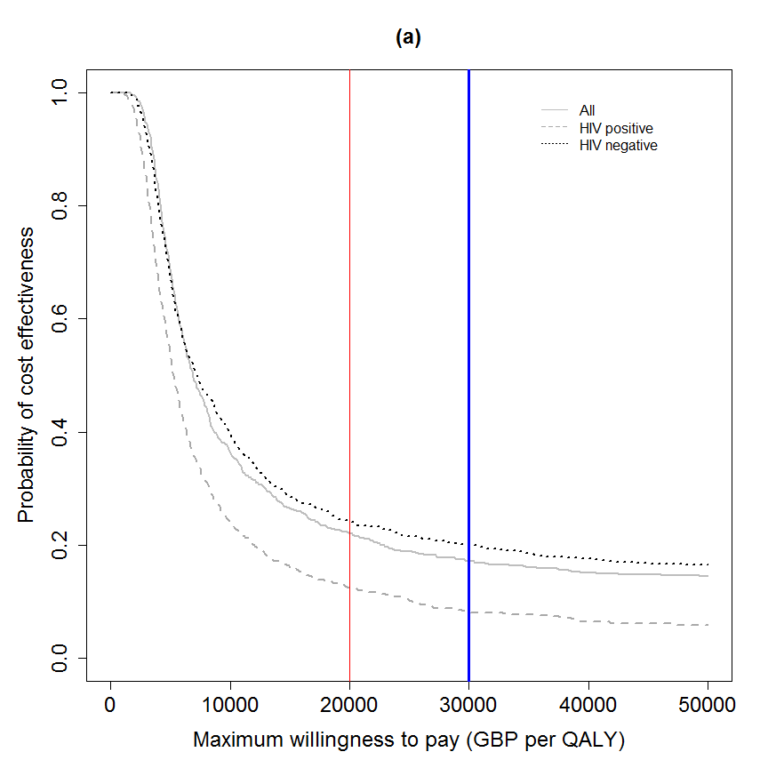

## [[1]]  
## NULL  
##   
## [[2]]  
## NULL

my.plot.ceac(dat1, dat2, dat3, intlabels = c("All","HIV positive","HIV negative"), labelLong=FALSE, TITLE="(a)", SCALEcosts=FALSE, SCALEdays=FALSE, N=769)



## [[1]]  
## NULL  
##   
## [[2]]  
## NULL

my.plot.ceac(dat1, dat2, dat3, intlabels = c("All","HIV positive","HIV negative"), labelLong=FALSE, TITLE="(a)", SCALEcosts=FALSE, SCALEdays=FALSE, N=769, CI=TRUE)

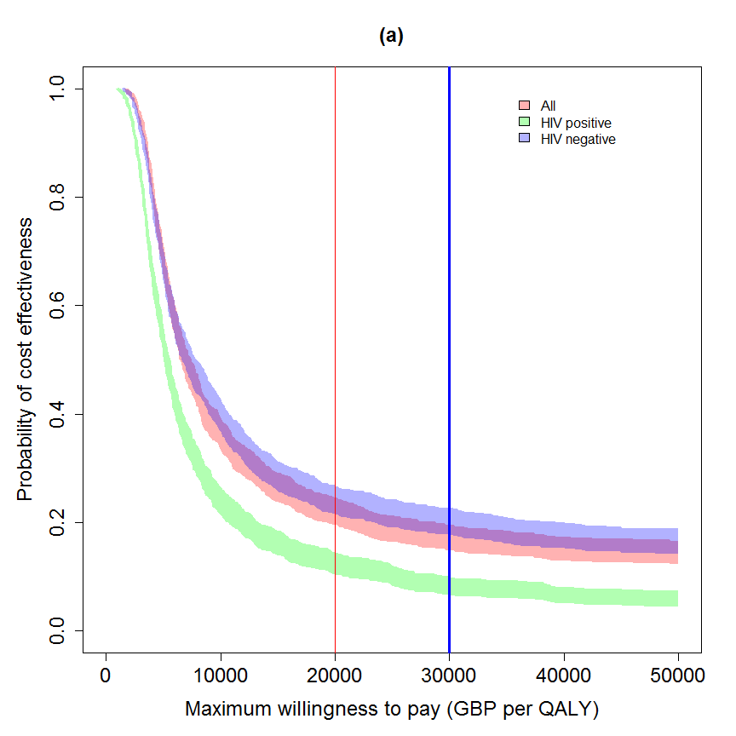

## [[1]]  
## NULL  
##   
## [[2]]  
## NULL

## in years (not days)  
# m <- bcea(e=dat$e/365, c=-dat$c, ref=1, interventions = intlabels)  
# contour2(m, wtp=20000, graph = "ggplot2", ICER.size=2, pos=c(0.1,0.9))  
#   
# ceac.plot(m)

dat1 <- IDEAdectree.simple(data=data, name.ruleout = "TSPOT",  
 SPEC = TSPOT.Indet.spec.mean, SENS = TSPOT.Indet.sens.mean,   
 SPECvar = TSPOT.Indet.spec.var, SENSvar = TSPOT.Indet.sens.var)  
dat2 <- IDEAdectree.simple(data=data, name.ruleout = "TSPOT",  
 SPEC = TSPOT.HIV.Indet.spec.mean, SENS = TSPOT.HIV.Indet.sens.mean,   
 SPECvar = TSPOT.HIV.Indet.spec.var, SENSvar = TSPOT.HIV.Indet.sens.var)  
dat3 <- IDEAdectree.simple(data=data, name.ruleout = "TSPOT",  
 SPEC = TSPOT.HIVneg.Indet.spec.mean, SENS = TSPOT.HIVneg.Indet.sens.mean,   
 SPECvar = TSPOT.HIVneg.Indet.spec.var, SENSvar = TSPOT.HIVneg.Indet.sens.var)  
  
dat$e <- cbind(dat1$e, dat2$e[,2], dat3$e[,2])  
dat$c <- cbind(dat1$c, dat2$c[,2], dat3$c[,2])  
  
intlabels <- c("Current", "Enhanced TSPOT: All, with Indets", "Enhanced TSPOT: HIV positive, with Indets", "Enhanced TSPOT: HIV negative, with Indets")  
  
# m <- bcea(e=dat$e, c=-dat$c, ref=1, interventions = intlabels)  
# contour2(m, wtp=WTP, graph = "ggplot2", ICER.size=2, pos=c(0.1,0.9))+#, xlim=c(-5,5), ylim=c(-200,200)) +  
# ggtitle("") #+ geom_abline(intercept = 0, slope = WTP)  
  
my.plot.bcea(dat1, dat2, dat3, wtp=WTP, intlabels = intlabels, wtpNEG = "Y")

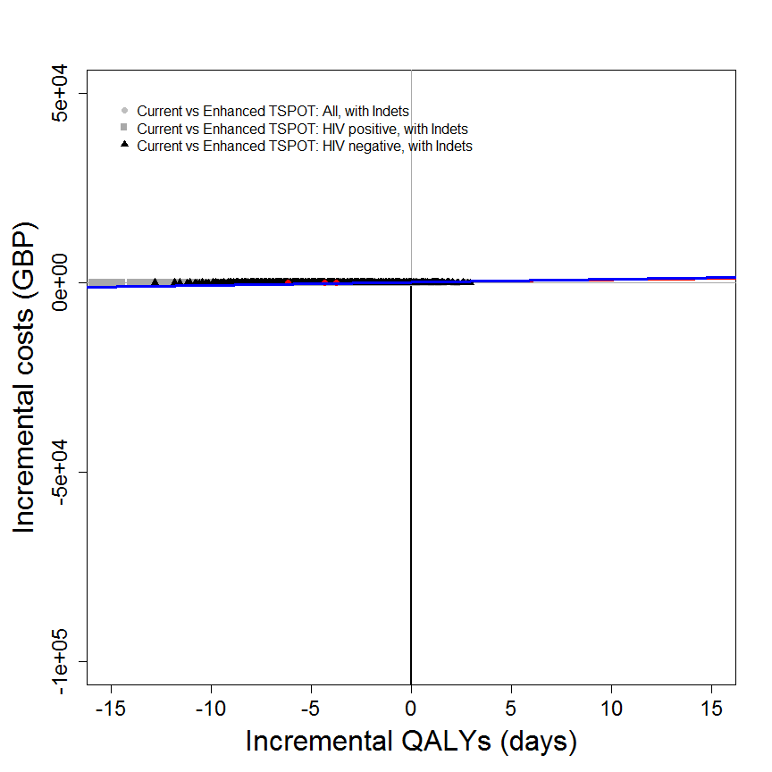

## [[1]]  
## NULL  
##   
## [[2]]  
## NULL

my.plot.bcea(dat1, dat2, dat3, wtp=WTP*yearindays, intlabels = c("All","HIV positive","HIV negative"), wtpNEG = "Y", SCALEcosts=FALSE, SCALEdays=FALSE, labelLong=FALSE, TITLE="(b)", N=769)

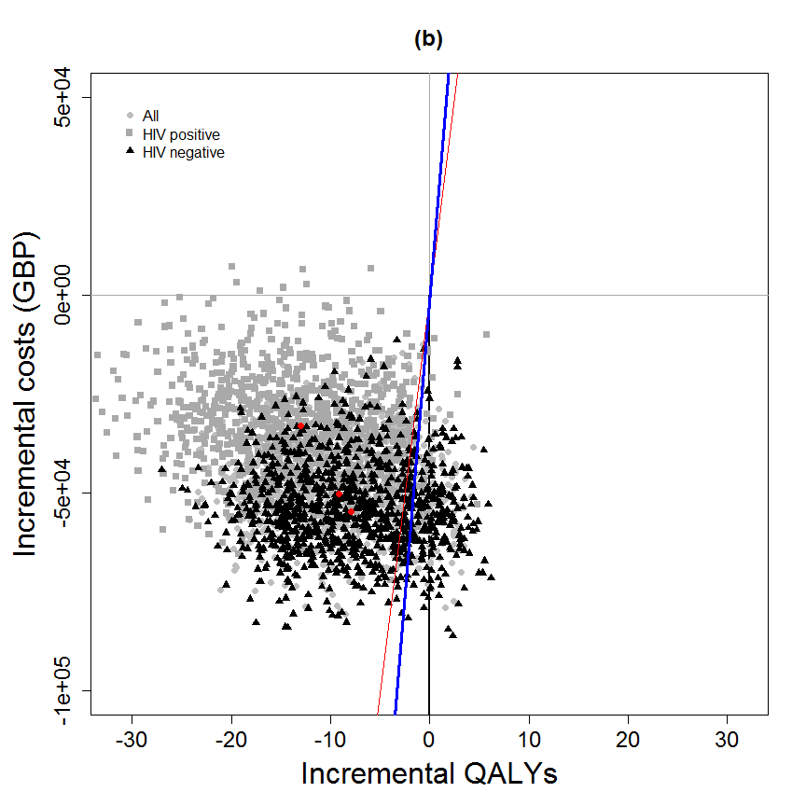

## [[1]]  
## NULL  
##   
## [[2]]  
## NULL

my.plot.bcea(dat1, dat2, dat3, wtp=WTP, intlabels = intlabels, contour=TRUE, wtpNEG = "Y")

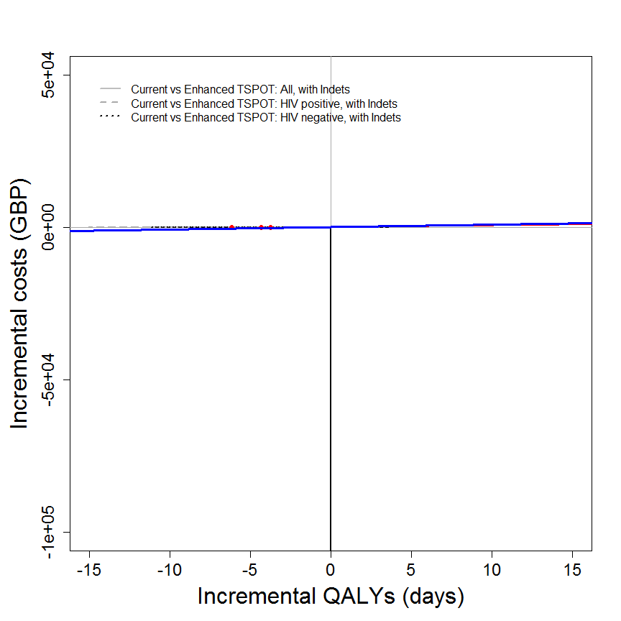

## [[1]]  
## NULL  
##   
## [[2]]  
## NULL

my.plot.bcea(dat1, dat2, dat3, wtp=WTP*yearindays, intlabels = c("All","HIV positive","HIV negative"), contour=TRUE, wtpNEG = "Y", SCALEcosts=FALSE, SCALEdays=FALSE, labelLong=FALSE, TITLE="(b)", N=769)

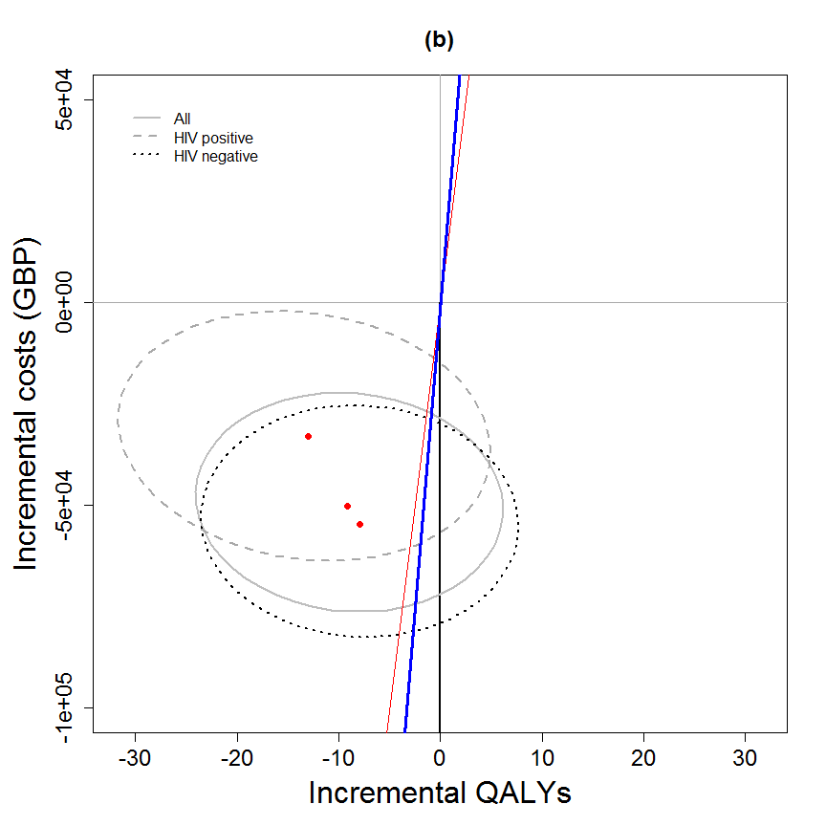

## [[1]]  
## NULL  
##   
## [[2]]  
## NULL

my.plot.bcea(dat1, dat2, dat3, wtp=WTP, intlabels = intlabels, contour=TRUE, LEVELS=0.5, wtpNEG = "Y")

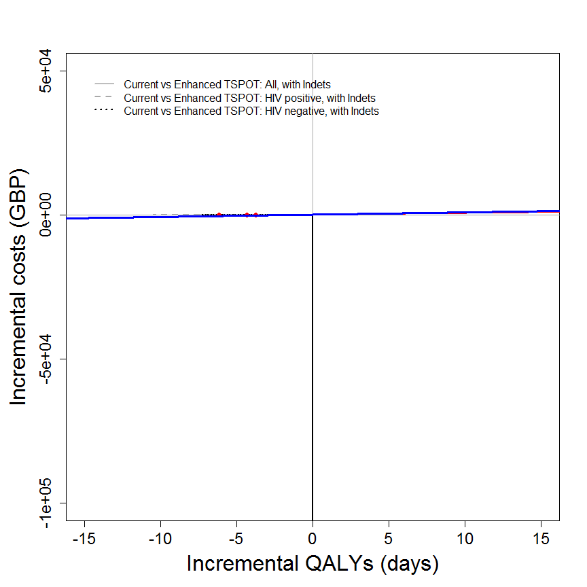

## [[1]]  
## NULL  
##   
## [[2]]  
## NULL

my.plot.bcea(dat1, dat2, dat3, wtp=WTP*yearindays, intlabels = c("All","HIV positive","HIV negative"), contour=TRUE, LEVELS=0.5, wtpNEG = "Y", SCALEcosts=FALSE, SCALEdays=FALSE, labelLong=FALSE, TITLE="(b)", N=769)

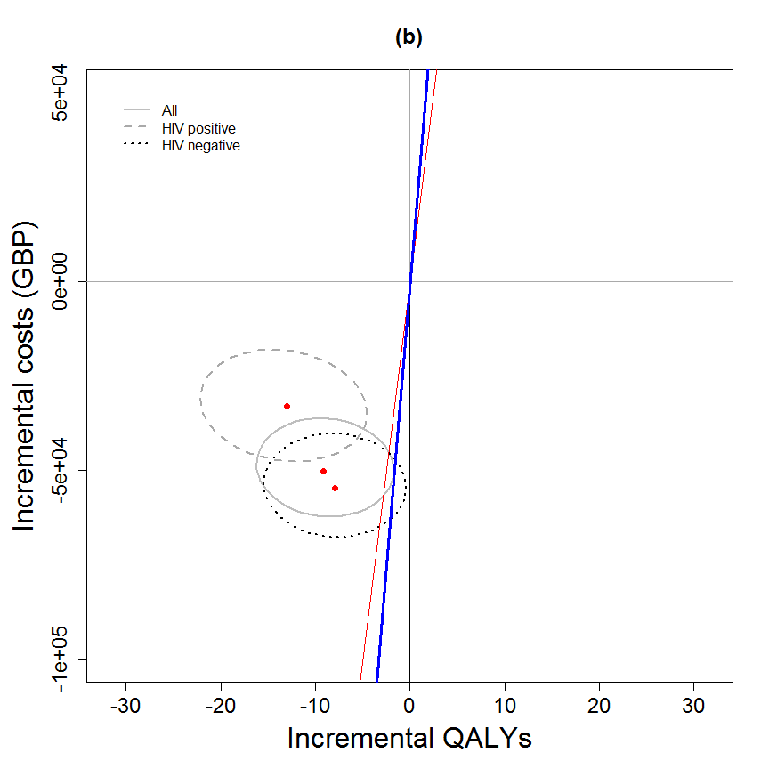

## [[1]]  
## NULL  
##   
## [[2]]  
## NULL

my.plot.ceac(dat1, dat2, dat3, intlabels = c("All","HIV positive","HIV negative"), labelLong=FALSE, TITLE="(b)")

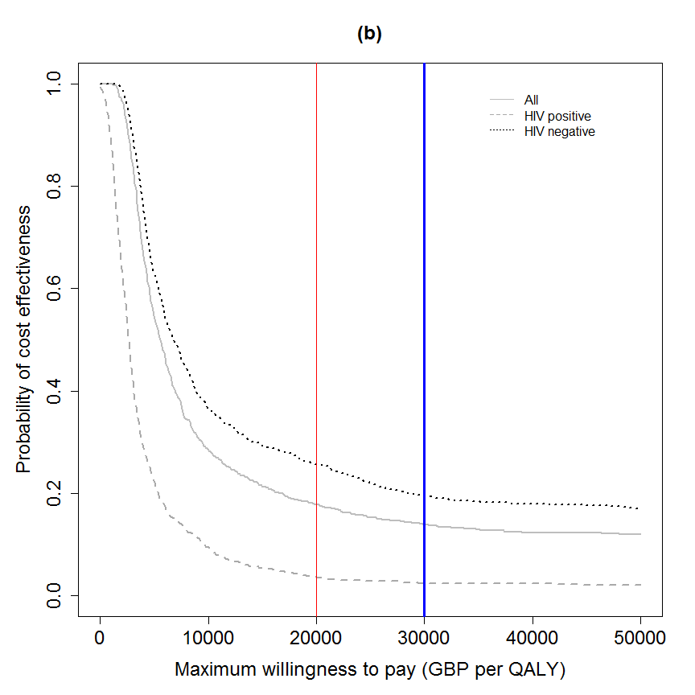

## [[1]]  
## NULL  
##   
## [[2]]  
## NULL

my.plot.ceac(dat1, dat2, dat3, intlabels = c("All","HIV positive","HIV negative"), labelLong=FALSE, TITLE="(b)", SCALEcosts=FALSE, SCALEdays=FALSE, N=769)



## [[1]]  
## NULL  
##   
## [[2]]  
## NULL

my.plot.ceac(dat1, dat2, dat3, intlabels = c("All","HIV positive","HIV negative"), labelLong=FALSE, TITLE="(b)", SCALEcosts=FALSE, SCALEdays=FALSE, N=769, CI=TRUE)

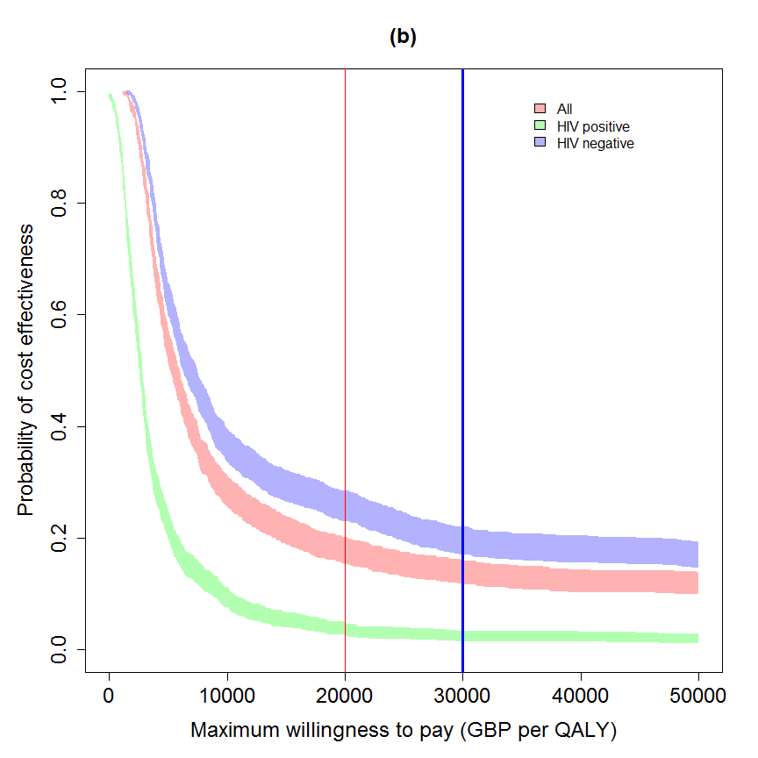

## [[1]]  
## NULL  
##   
## [[2]]  
## NULL

## in years (not days)  
# m <- bcea(e=dat$e/365, c=-dat$c, ref=1, interventions = intlabels)  
# contour2(m, wtp=20000, graph = "ggplot2", ICER.size=2, pos=c(0.1,0.9))  
#   
# ceac.plot(m)

dat1 <- IDEAdectree.simple(data=data, name.ruleout = "QFN",  
 SPEC = QFN.noIndet.spec.mean, SENS = QFN.noIndet.sens.mean,   
 SPECvar = QFN.noIndet.spec.var, SENSvar = QFN.noIndet.sens.var)  
dat2 <- IDEAdectree.simple(data=data, name.ruleout = "QFN",  
 SPEC = QFN.HIV.noIndet.spec.mean, SENS = QFN.HIV.noIndet.sens.mean,   
 SPECvar = QFN.HIV.noIndet.spec.var, SENSvar = QFN.HIV.noIndet.sens.var)  
dat3 <- IDEAdectree.simple(data=data, name.ruleout = "QFN",  
 SPEC = QFN.HIVneg.noIndet.spec.mean, SENS = QFN.HIVneg.noIndet.sens.mean,   
 SPECvar = QFN.HIVneg.noIndet.spec.var, SENSvar = QFN.HIVneg.noIndet.sens.var)  
  
dat$e <- cbind(dat1$e, dat2$e[,2], dat3$e[,2])  
dat$c <- cbind(dat1$c, dat2$c[,2], dat3$c[,2])  
  
intlabels <- c("Current",  
 "Enhanced QFN: All, no Indets", "Enhanced QFN: HIV positive, no Indets", "Enhanced QFN: HIV negative, no Indets")  
  
# m <- bcea(e=dat$e, c=-dat$c, ref=1, interventions = intlabels)  
# contour2(m, wtp=WTP, graph = "ggplot2", ICER.size=2, pos=c(0.1,0.9))+#, xlim=c(-5,5), ylim=c(-200,200)) +  
# ggtitle("") #+ geom_abline(intercept = 0, slope = WTP)  
  
my.plot.bcea(dat1, dat2, dat3, wtp=WTP, intlabels = intlabels, wtpNEG = "Y")

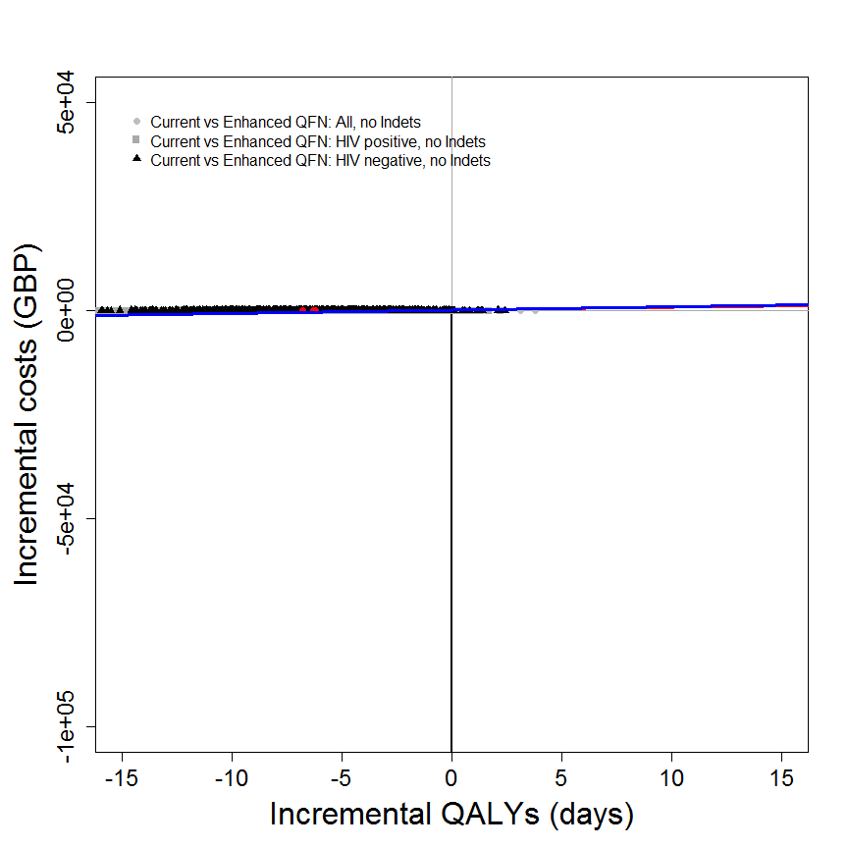

## [[1]]  
## NULL  
##   
## [[2]]  
## NULL

my.plot.bcea(dat1, dat2, dat3, wtp=WTP*yearindays, intlabels = c("All","HIV positive","HIV negative"), wtpNEG = "Y", SCALEcosts=FALSE, SCALEdays=FALSE, labelLong=FALSE, TITLE="(c)", N=769)

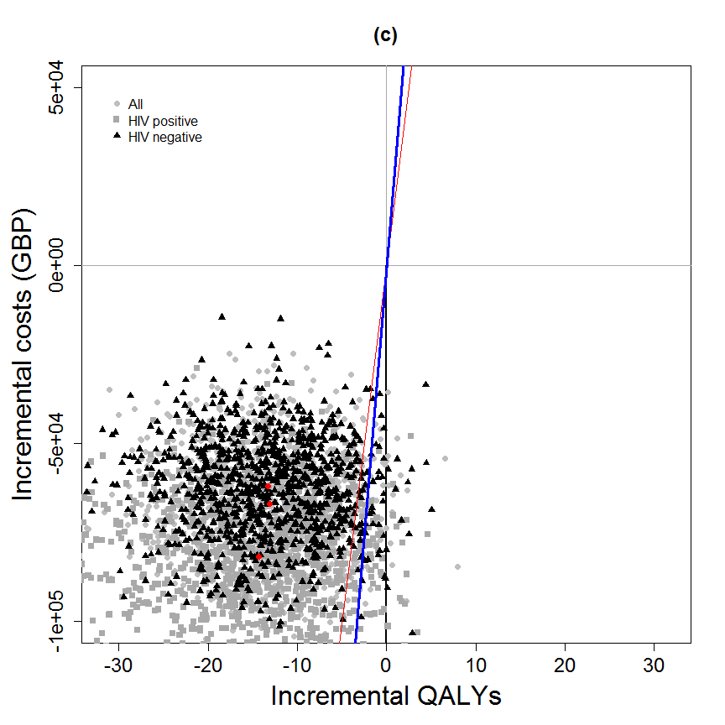

## [[1]]  
## NULL  
##   
## [[2]]  
## NULL

my.plot.bcea(dat1, dat2, dat3, wtp=WTP, intlabels = intlabels, contour=TRUE, wtpNEG = "Y")

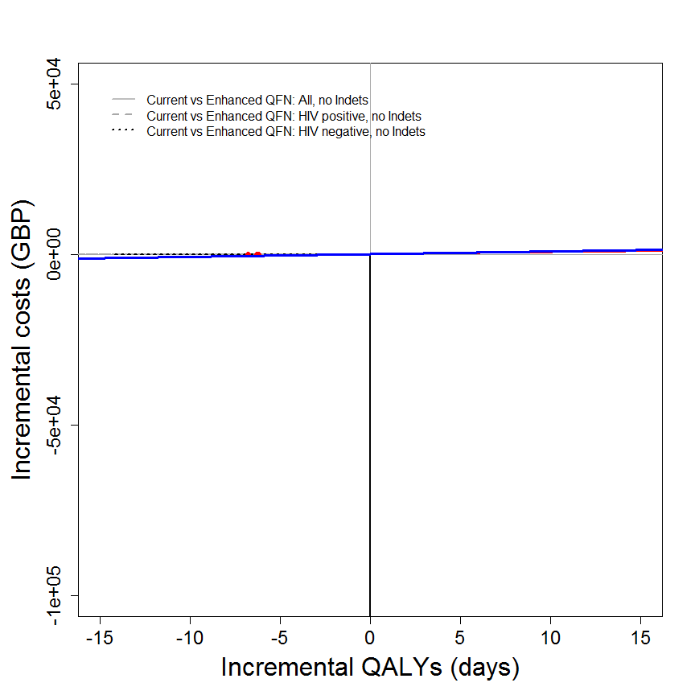

## [[1]]  
## NULL  
##   
## [[2]]  
## NULL

my.plot.bcea(dat1, dat2, dat3, wtp=WTP*yearindays, intlabels = c("All","HIV positive","HIV negative"), contour=TRUE, wtpNEG = "Y", SCALEcosts=FALSE, SCALEdays=FALSE, labelLong=FALSE, TITLE="(c)", N=769)

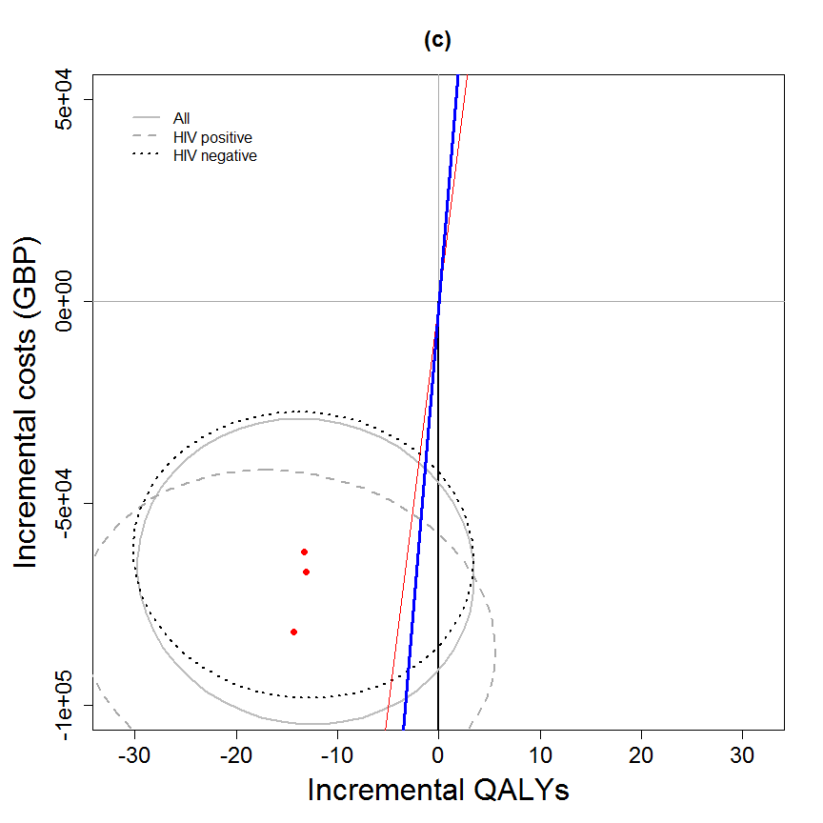

## [[1]]  
## NULL  
##   
## [[2]]  
## NULL

my.plot.bcea(dat1, dat2, dat3, wtp=WTP, intlabels = intlabels, contour=TRUE, LEVELS=0.5, wtpNEG = "Y")

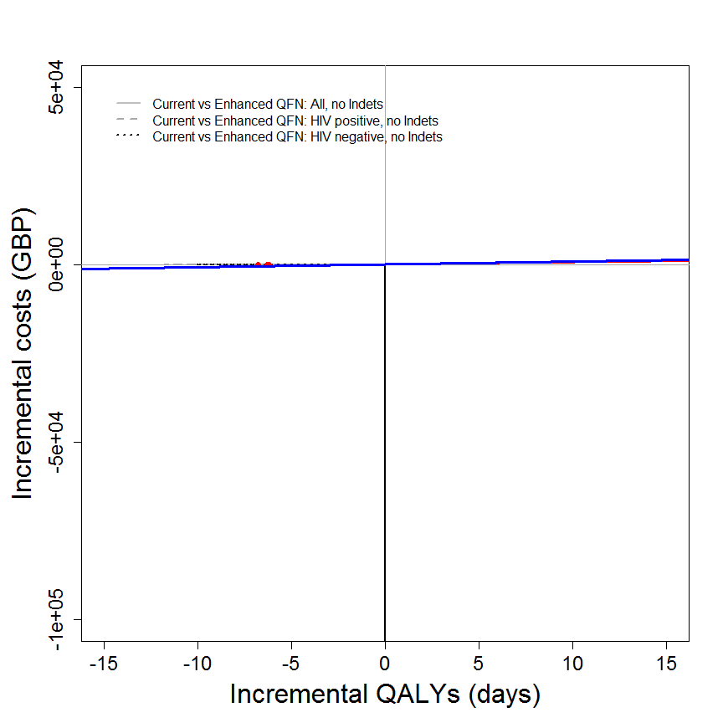

## [[1]]  
## NULL  
##   
## [[2]]  
## NULL

my.plot.bcea(dat1, dat2, dat3, wtp=WTP*yearindays, intlabels = c("All","HIV positive","HIV negative"), contour=TRUE, LEVELS=0.5, wtpNEG = "Y", SCALEcosts=FALSE, SCALEdays=FALSE, labelLong=FALSE, TITLE="(c)", N=769)

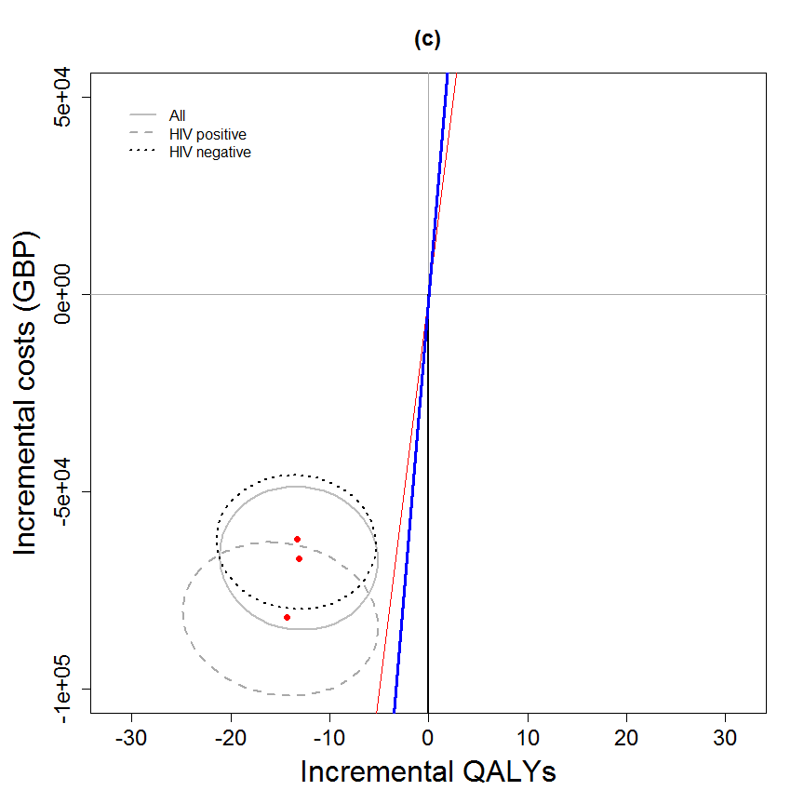

## [[1]]  
## NULL  
##   
## [[2]]  
## NULL

my.plot.ceac(dat1, dat2, dat3, intlabels = c("All","HIV positive","HIV negative"), labelLong=FALSE, TITLE="(c)")

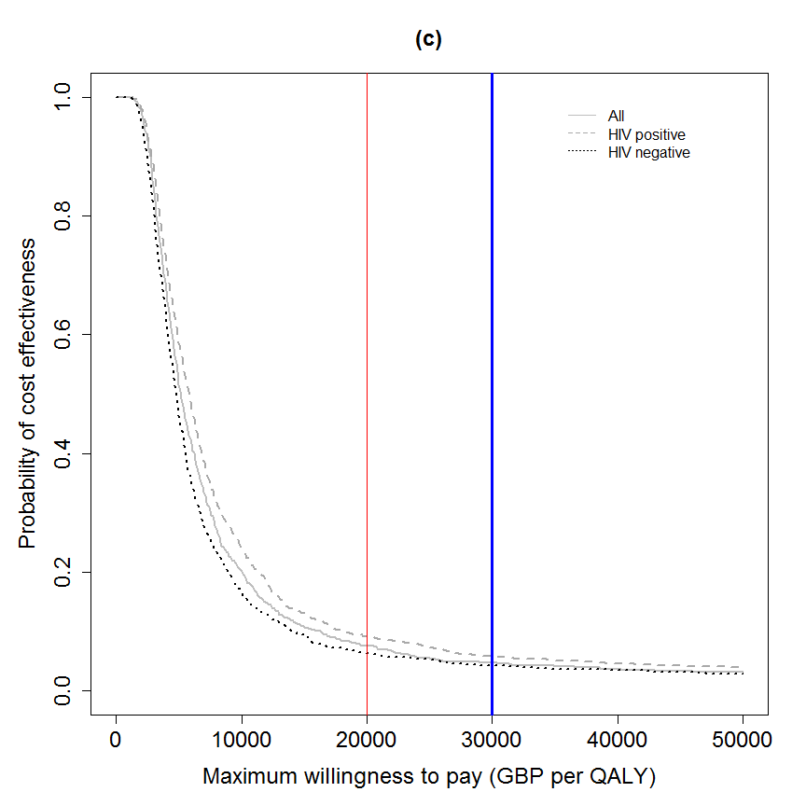

## [[1]]  
## NULL  
##   
## [[2]]  
## NULL

my.plot.ceac(dat1, dat2, dat3, intlabels = c("All","HIV positive","HIV negative"), labelLong=FALSE, TITLE="(c)", SCALEcosts=FALSE, SCALEdays=FALSE, N=769)



## [[1]]  
## NULL  
##   
## [[2]]  
## NULL

my.plot.ceac(dat1, dat2, dat3, intlabels = c("All","HIV positive","HIV negative"), labelLong=FALSE, TITLE="(c)", SCALEcosts=FALSE, SCALEdays=FALSE, N=769, CI=TRUE)

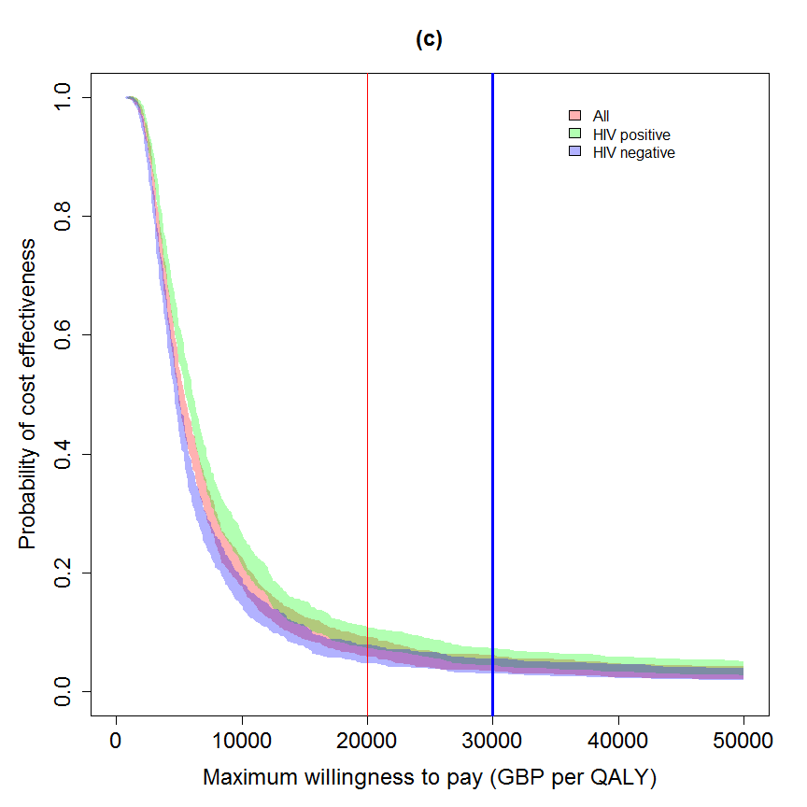

## [[1]]  
## NULL  
##   
## [[2]]  
## NULL

## in years (not days)  
# m <- bcea(e=dat$e/365, c=-dat$c, ref=1, interventions = intlabels)  
# contour2(m, wtp=20000, graph = "ggplot2", ICER.size=2, pos=c(0.1,0.9))  
#   
# ceac.plot(m)

dat1 <- IDEAdectree.simple(data=data, name.ruleout = "QFN",  
 SPEC = QFN.Indet.spec.mean, SENS = QFN.Indet.sens.mean,   
 SPECvar = QFN.Indet.spec.var, SENSvar = QFN.Indet.sens.var)  
dat2 <- IDEAdectree.simple(data=data, name.ruleout = "QFN",  
 SPEC = QFN.HIV.Indet.spec.mean, SENS = QFN.HIV.Indet.sens.mean,   
 SPECvar = QFN.HIV.Indet.spec.var, SENSvar = QFN.HIV.Indet.sens.var)  
dat3 <- IDEAdectree.simple(data=data, name.ruleout = "QFN",  
 SPEC = QFN.HIVneg.Indet.spec.mean, SENS = QFN.HIVneg.Indet.sens.mean,   
 SPECvar = QFN.HIVneg.Indet.spec.var, SENSvar = QFN.HIVneg.Indet.sens.var)  
  
dat$e <- cbind(dat1$e, dat2$e[,2], dat3$e[,2])  
dat$c <- cbind(dat1$c, dat2$c[,2], dat3$c[,2])  
  
intlabels <- c("Current", "Enhanced QFN: All, with Indets", "Enhanced QFN: HIV positive, with Indets", "Enhanced QFN: HIV negative, with Indets")  
  
# m <- bcea(e=dat$e, c=-dat$c, ref=1, interventions = intlabels)  
# contour2(m, wtp=WTP, graph = "ggplot2", ICER.size=2, pos=c(0.1,0.9))+#, xlim=c(-5,5), ylim=c(-200,200)) +  
# ggtitle("") #+ geom_abline(intercept = 0, slope = WTP)  
  
my.plot.bcea(dat1, dat2, dat3, wtp=WTP, intlabels = intlabels, wtpNEG = "Y")

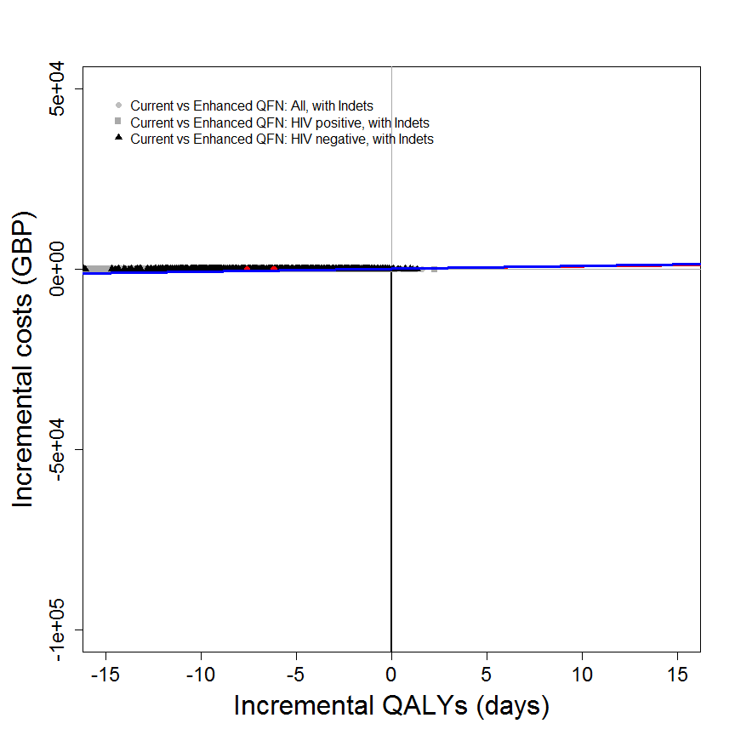

## [[1]]  
## NULL  
##   
## [[2]]  
## NULL

my.plot.bcea(dat1, dat2, dat3, wtp=WTP*yearindays, intlabels = c("All","HIV positive","HIV negative"), wtpNEG = "Y", SCALEcosts=FALSE, SCALEdays=FALSE, labelLong=FALSE, TITLE="(d)", N=769)

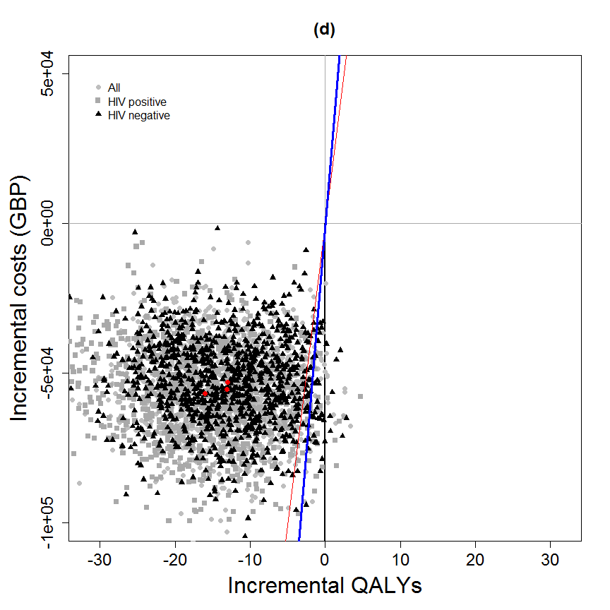

## [[1]]  
## NULL  
##   
## [[2]]  
## NULL

my.plot.bcea(dat1, dat2, dat3, wtp=WTP, intlabels = intlabels, contour=TRUE, wtpNEG = "Y")

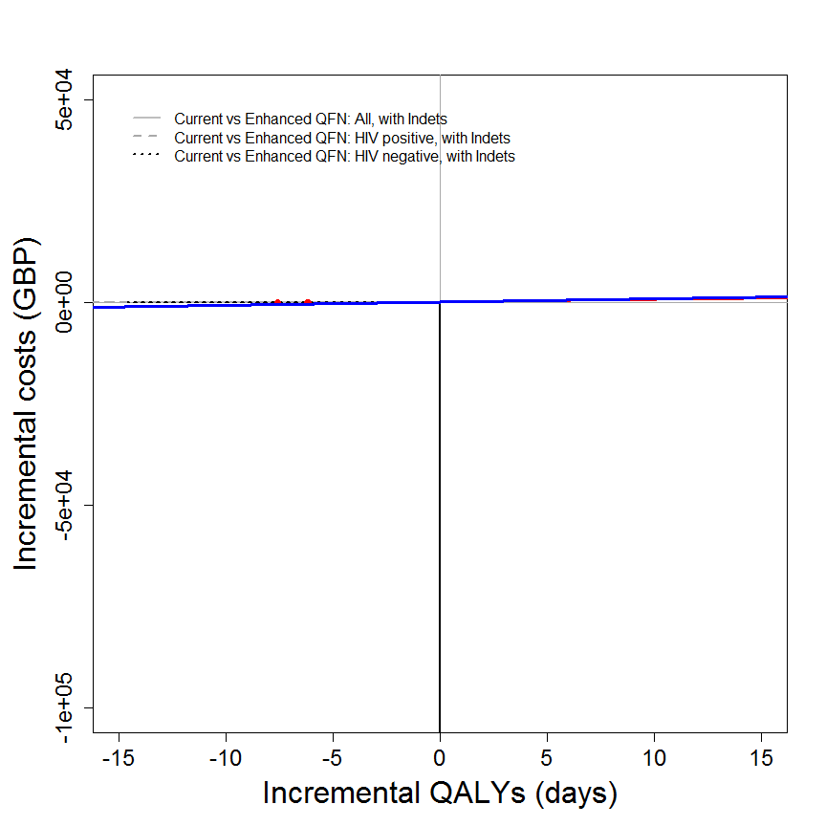

## [[1]]  
## NULL  
##   
## [[2]]  
## NULL

my.plot.bcea(dat1, dat2, dat3, wtp=WTP*yearindays, intlabels = c("All","HIV positive","HIV negative"), contour=TRUE, wtpNEG = "Y", SCALEcosts=FALSE, SCALEdays=FALSE, labelLong=FALSE, TITLE="(d)", N=769)

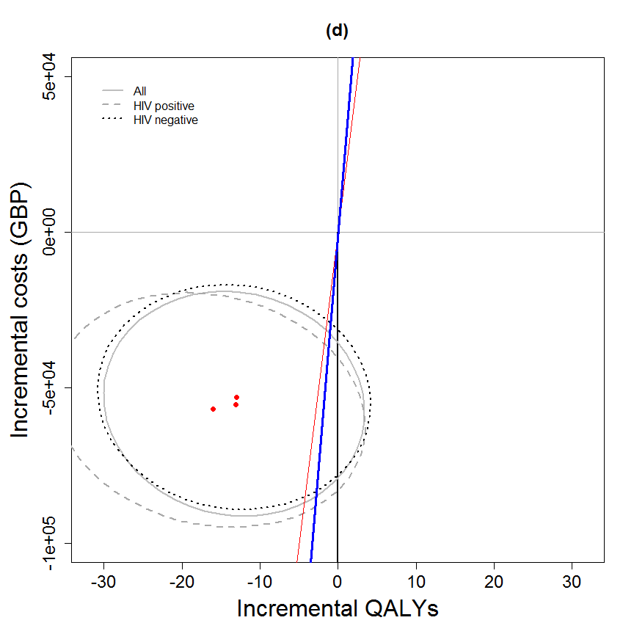

## [[1]]  
## NULL  
##   
## [[2]]  
## NULL

my.plot.bcea(dat1, dat2, dat3, wtp=WTP, intlabels = intlabels, contour=TRUE, LEVELS=0.5, wtpNEG = "Y")

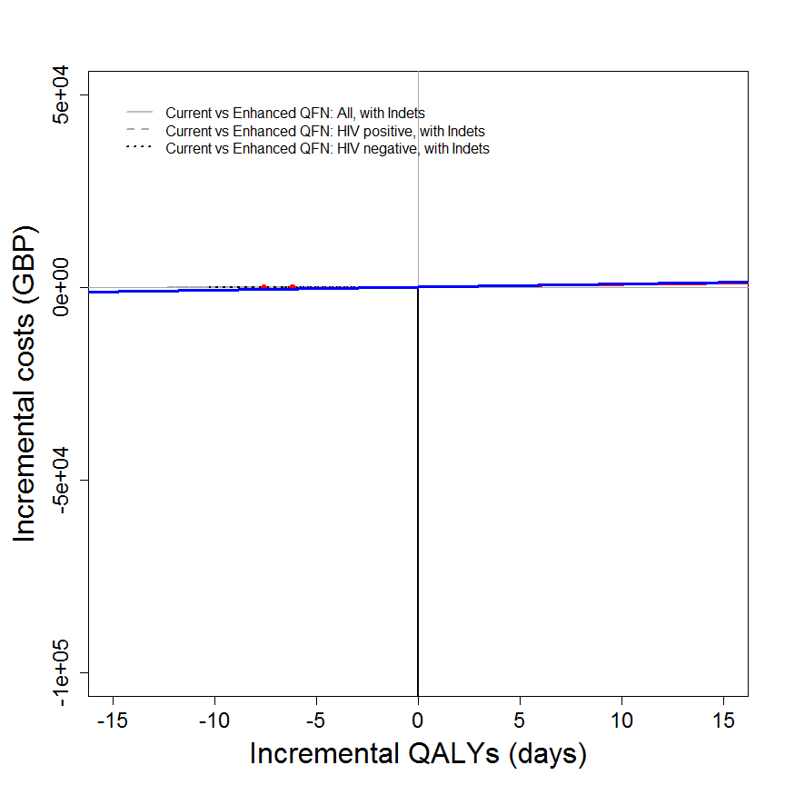

## [[1]]  
## NULL  
##   
## [[2]]  
## NULL

my.plot.bcea(dat1, dat2, dat3, wtp=WTP*yearindays, intlabels = c("All","HIV positive","HIV negative"), contour=TRUE, LEVELS=0.5, wtpNEG = "Y", SCALEcosts=FALSE, SCALEdays=FALSE, labelLong=FALSE, TITLE="(d)", N=769)

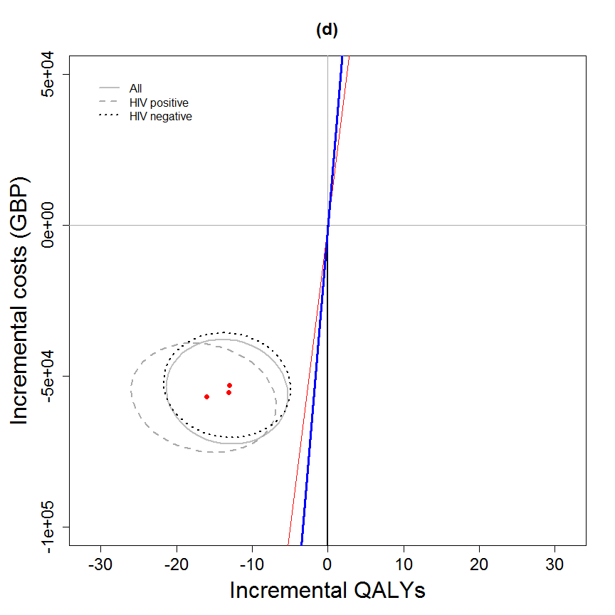

## [[1]]  
## NULL  
##   
## [[2]]  
## NULL

my.plot.ceac(dat1, dat2, dat3, intlabels = c("All","HIV positive","HIV negative"), labelLong=FALSE, TITLE="(d)")

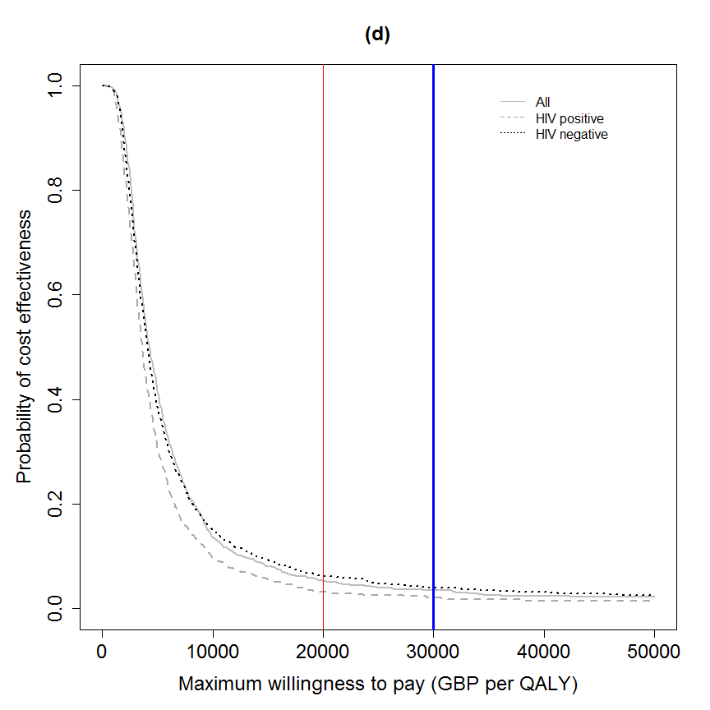

## [[1]]  
## NULL  
##   
## [[2]]  
## NULL

my.plot.ceac(dat1, dat2, dat3, intlabels = c("All","HIV positive","HIV negative"), labelLong=FALSE, TITLE="(d)", SCALEcosts=FALSE, SCALEdays=FALSE, N=769)



## [[1]]  
## NULL  
##   
## [[2]]  
## NULL

my.plot.ceac(dat1, dat2, dat3, intlabels = c("All","HIV positive","HIV negative"), labelLong=FALSE, TITLE="(d)", SCALEcosts=FALSE, SCALEdays=FALSE, N=769, CI=TRUE)

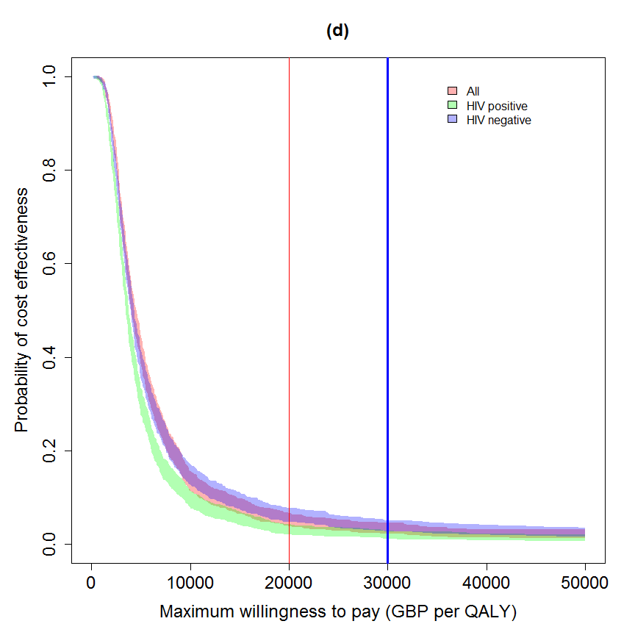

## [[1]]  
## NULL  
##   
## [[2]]  
## NULL

## in years (not days)  
# m <- bcea(e=dat$e/365, c=-dat$c, ref=1, interventions = intlabels)  
# contour2(m, wtp=20000, graph = "ggplot2", ICER.size=2, pos=c(0.1,0.9))  
#   
# ceac.plot(m)

detach(senspec.env)