IDEA study: TST and QFN cost-effectiveness comparison: Indeterminates included

Nathan Green

29 January 2016

# http://stackoverflow.com/questions/20060518/in-rstudio-rmarkdown-how-to-setwd  
opts_chunk$set(root.dir = '/tmp')

source("../../../analysis scripts/IDEA/alt-YAML_Binomial_dectrees/indiv-dectree-sampling.R")

library(IDEAdectree)  
library(BCEA)

## Warning: package 'BCEA' was built under R version 3.2.2

library(ggplot2)

## Warning: package 'ggplot2' was built under R version 3.2.3

# load("C:/Users/ngreen1/Dropbox/TB/IDEA/R/packages/IDEAdectree/data/TBdata_clinical_cleaned.RData")  
load("../data/TBdata_clinical_cleaned.RData")  
load("../data/COSTdistns_allerror.RData")  
load("../data/senspec_env.RData")  
  
## sensitivities and specificities from IDEA lab data  
attach(senspec.env)  
  
dat <- list()  
  
yearindays <- 365  
WTP <- 20000/yearindays  
  
IDEAdectree.simple.TSPOT <- function(...){IDEAdectree.simple(SPEC = TSPOT.Indet.spec.mean, SENS = TSPOT.Indet.sens.mean,   
 SPECvar = TSPOT.Indet.spec.var, SENSvar = TSPOT.Indet.sens.var,  
 ...)}  
IDEAdectree.simple.QFN <- function(...){IDEAdectree.simple(SPEC = QFN.Indet.spec.mean, SENS = QFN.Indet.sens.mean,   
 SPECvar = QFN.Indet.spec.var, SENSvar = QFN.Indet.sens.var,  
 ...)}

## prevalence  
  
dat1 <- IDEAdectree.simple.TSPOT(data=data, name.ruleout = "TSPOT", prev = 0.1)

## Loading required package: assertive

## Warning: package 'assertive' was built under R version 3.2.3

dat2 <- IDEAdectree.simple.TSPOT(data=data, name.ruleout = "TSPOT", prev = 0.5)  
dat3 <- IDEAdectree.simple.QFN(data=data, name.ruleout = "QFN", prev = 0.1)  
dat4 <- IDEAdectree.simple.QFN(data=data, name.ruleout = "QFN", prev = 0.5)  
dat$e <- cbind(dat1$e, dat2$e[,2], dat3$e[,2], dat4$e[,2])  
dat$c <- cbind(dat1$c, dat2$c[,2], dat3$c[,2], dat4$c[,2])  
  
intlabels <- c("Current",  
 "Enhanced TSPOT: Prevalence=0.1", "Enhanced TSPOT: Prevalence=0.5",  
 "Enhanced QFN: Prevalence=0.1", "Enhanced QFN: Prevalence=0.5")  
  
m <- bcea(e=dat$e, c=-dat$c, ref=1, interventions = intlabels)  
contour2(m, wtp=WTP, graph = "ggplot2", ICER.size=2, pos=c(0.1,0.9))+#, xlim=c(-5,5), ylim=c(-200,200)) +  
 ggtitle("") #+ geom_abline(intercept = 0, slope = WTP)

## Loading required namespace: MASS

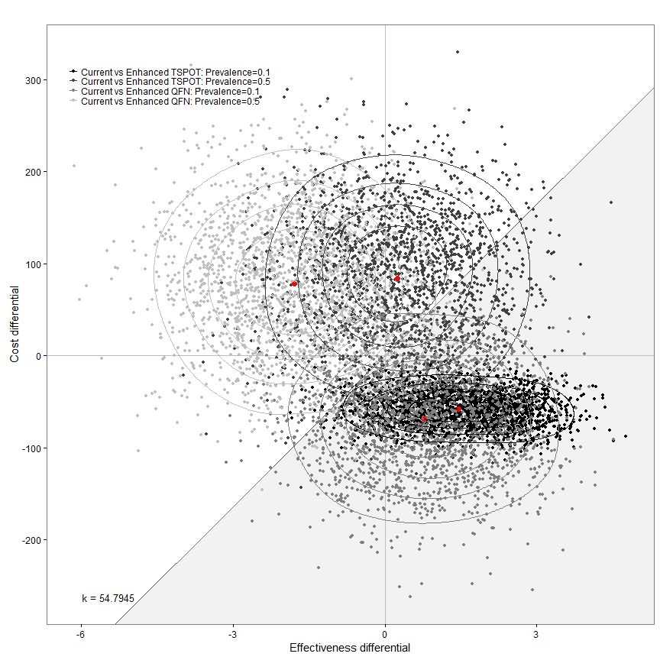

my.plot.bcea(dat1, dat2, dat3, dat4, WTP, intlabels, YLIM=c(-200,200))

## Loading required package: MASS

## Warning: package 'MASS' was built under R version 3.2.2

## Loading required package: car

## Warning: package 'car' was built under R version 3.2.3

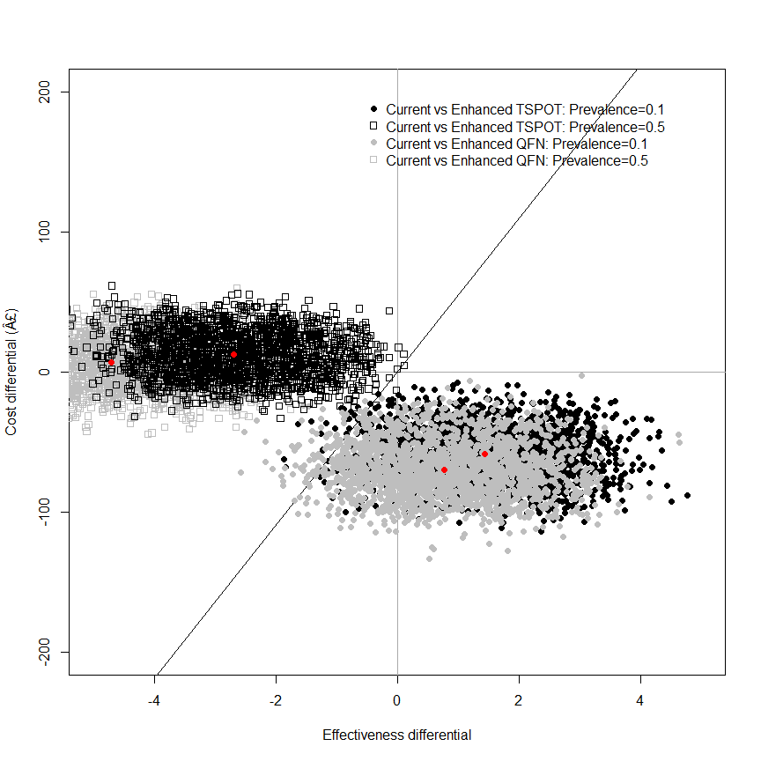

my.plot.bcea(dat1, dat2, dat3, dat4, WTP, intlabels, contour=TRUE, YLIM=c(-200,200))

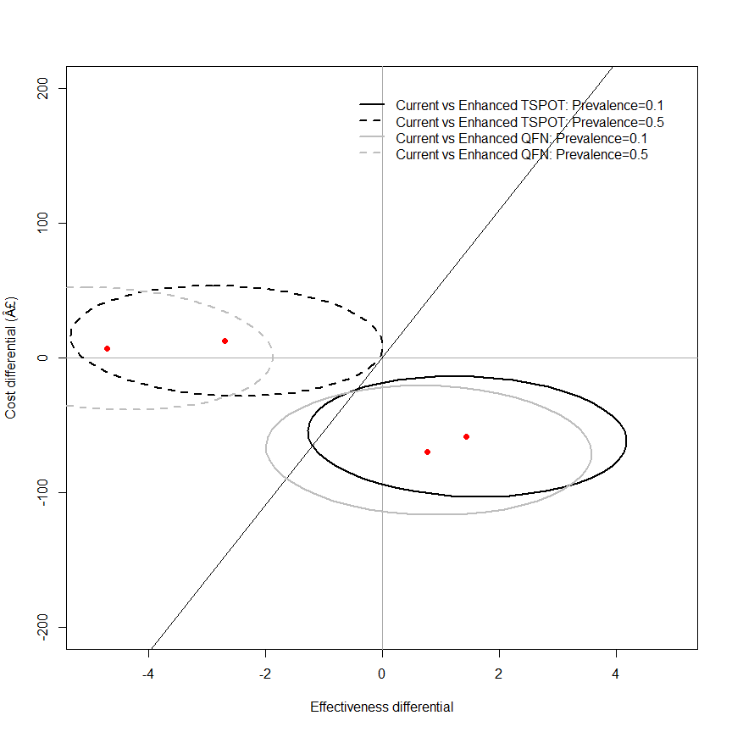

my.plot.bcea(dat1, dat2, dat3, dat4, WTP, intlabels, contour=TRUE, LEVELS=0.5, YLIM=c(-200,200))

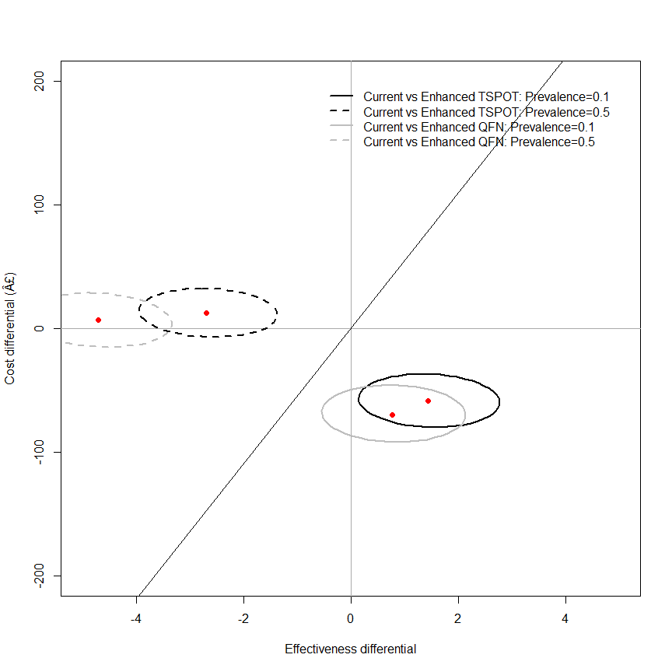

my.plot.ceac(dat1, dat2, dat3, dat4, intlabels)

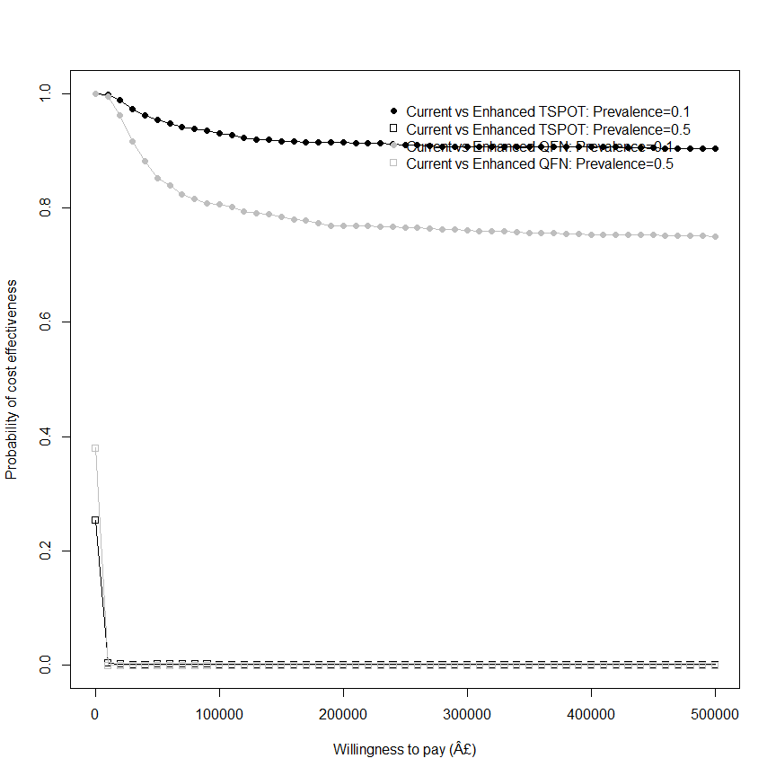

## in years (not days)  
m <- bcea(e=dat$e/365, c=-dat$c, ref=1, interventions = intlabels)  
contour2(m, wtp=20000, graph = "ggplot2", ICER.size=2, pos=c(0.1,0.9))

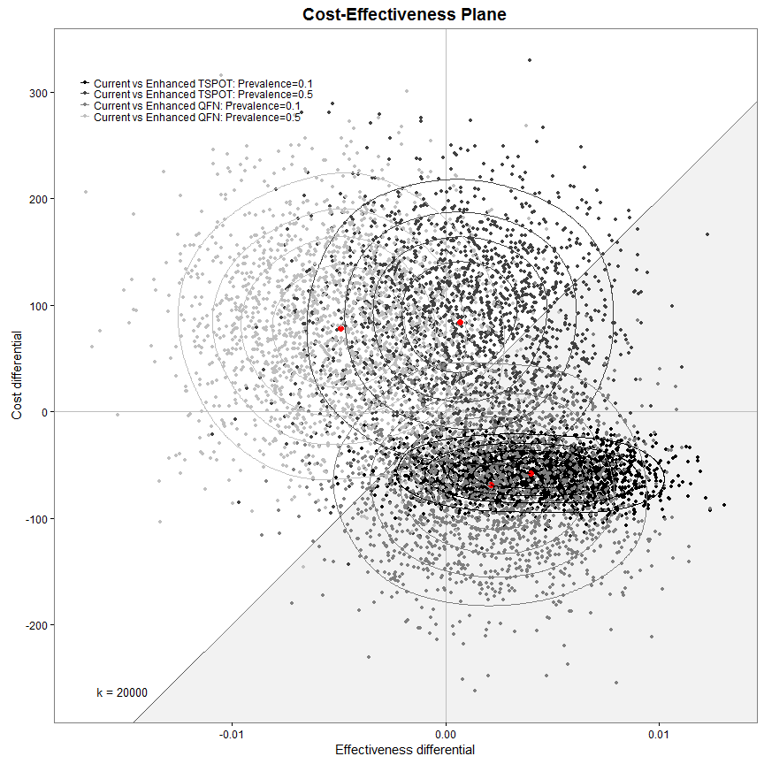

ceac.plot(m)

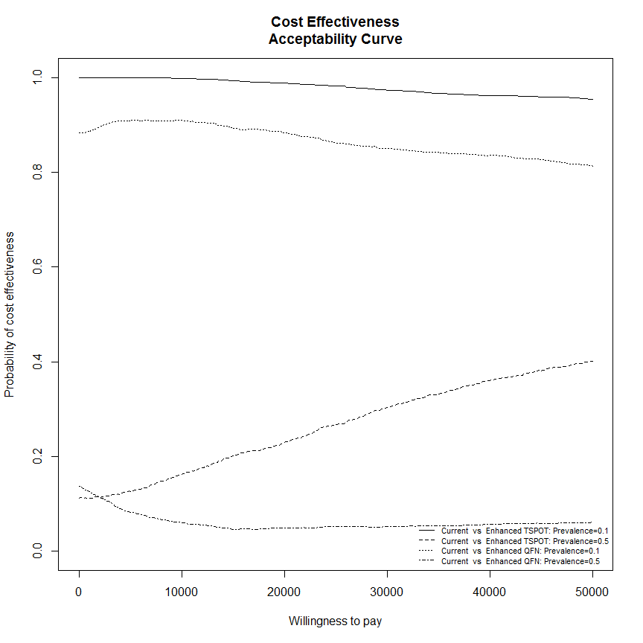

sink(file="../../../output_data/IDEA-BCEA-logfile.txt", append = TRUE)  
summary(m)  
sink()

## rule-out test cost  
  
dat1 <- IDEAdectree.simple.TSPOT(data=data, c.ruleout = 1)  
dat2 <- IDEAdectree.simple.TSPOT(data=data, c.ruleout = 200)  
dat3 <- IDEAdectree.simple.QFN(data=data, c.ruleout = 1)  
dat4 <- IDEAdectree.simple.QFN(data=data, c.ruleout = 200)  
dat$e <- cbind(dat1$e, dat2$e[,2], dat3$e[,2], dat4$e[,2])  
dat$c <- cbind(dat1$c, dat2$c[,2], dat3$c[,2], dat4$c[,2])  
  
intlabels <- c("Current",  
 "Enhanced TSPOT: Rule-out test=£1", "Enhanced TSPOT: Rule-out test=£200",  
 "Enhanced QFN: Rule-out test=£1", "Enhanced QFN: Rule-out test=£200")  
  
m <- bcea(e=dat$e, c=-dat$c, ref=1, interventions = intlabels)  
contour2(m, wtp=WTP, graph = "ggplot2", ICER.size=2, pos=c(0.1,0.9))#, xlim=c(-10,10), ylim=c(-200,200)) + ggtitle("")

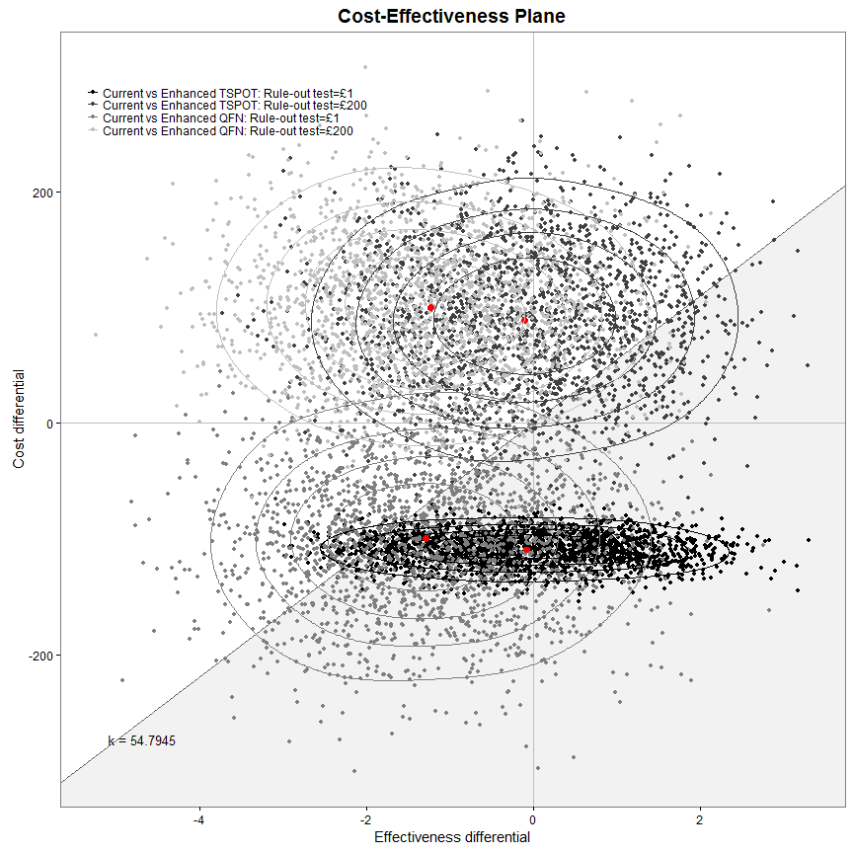

my.plot.bcea(dat1, dat2, dat3, dat4, WTP, intlabels, YLIM=c(-200,200))

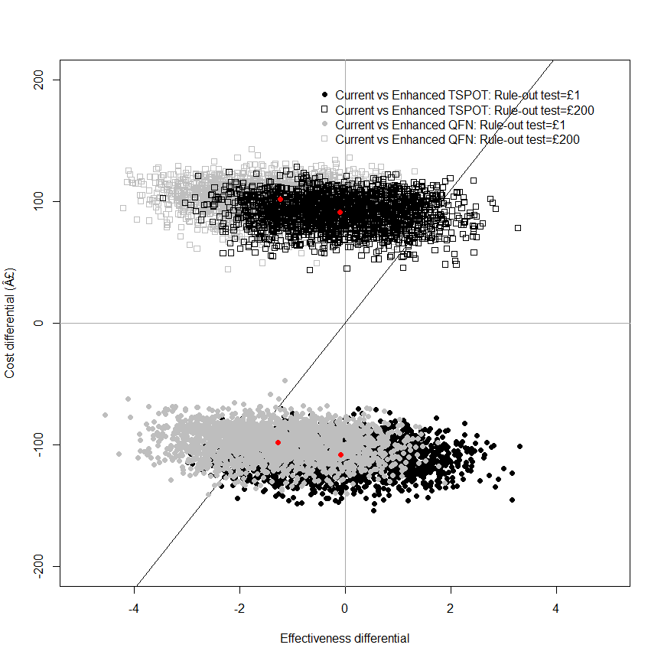

my.plot.bcea(dat1, dat2, dat3, dat4, WTP, intlabels, contour=TRUE, YLIM=c(-200,200))

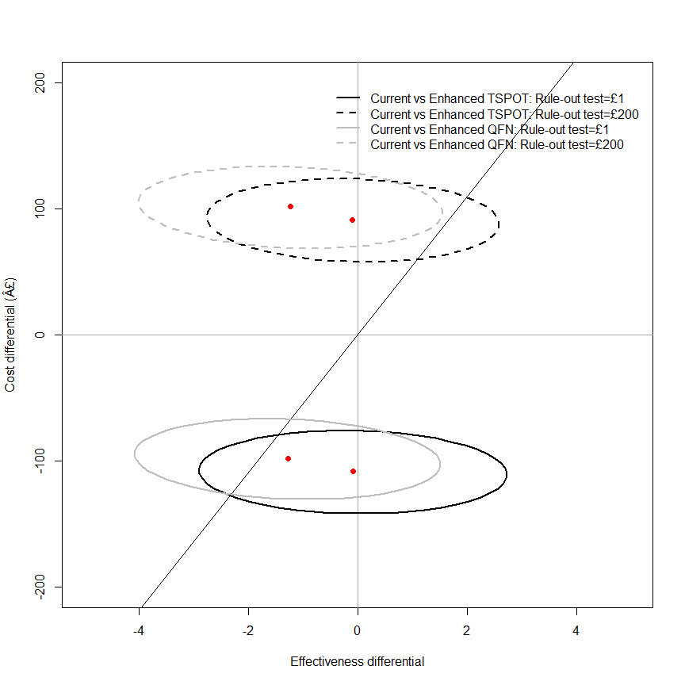

my.plot.bcea(dat1, dat2, dat3, dat4, WTP, intlabels, contour=TRUE, LEVELS=0.5, YLIM=c(-200,200))

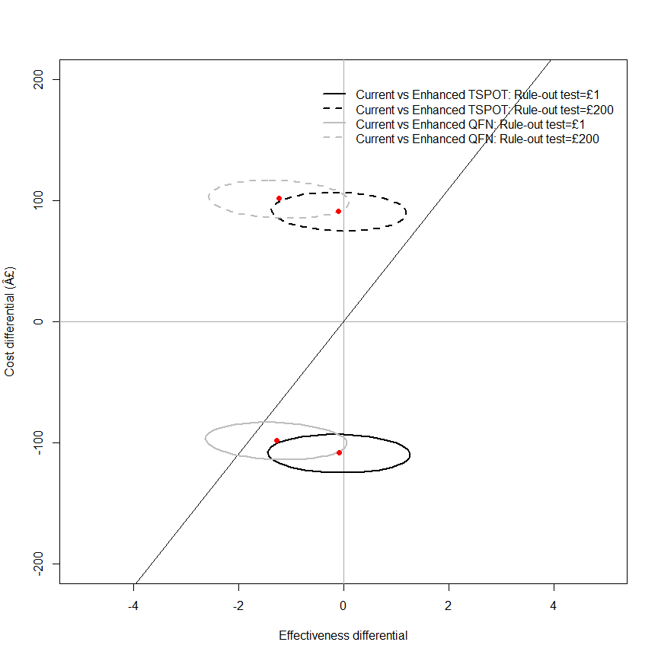

my.plot.ceac(dat1, dat2, dat3, dat4, intlabels)

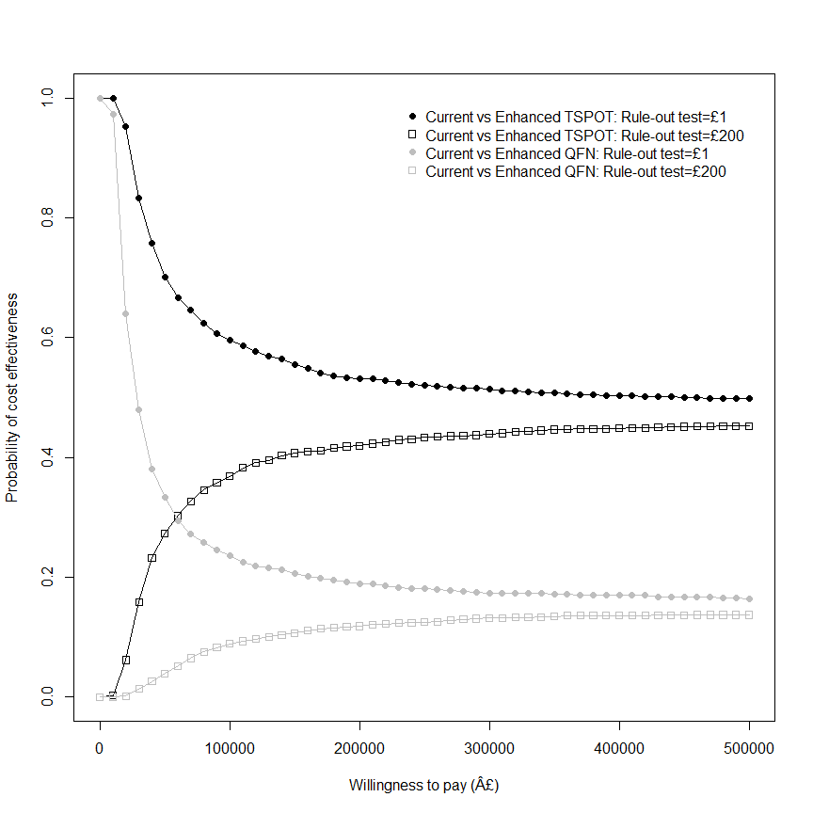

## in years (not days)  
m <- bcea(e=dat$e/365, c=-dat$c, ref=1, interventions = intlabels)  
contour2(m, wtp=20000, graph = "ggplot2", ICER.size=2, pos=c(0.1,0.9))

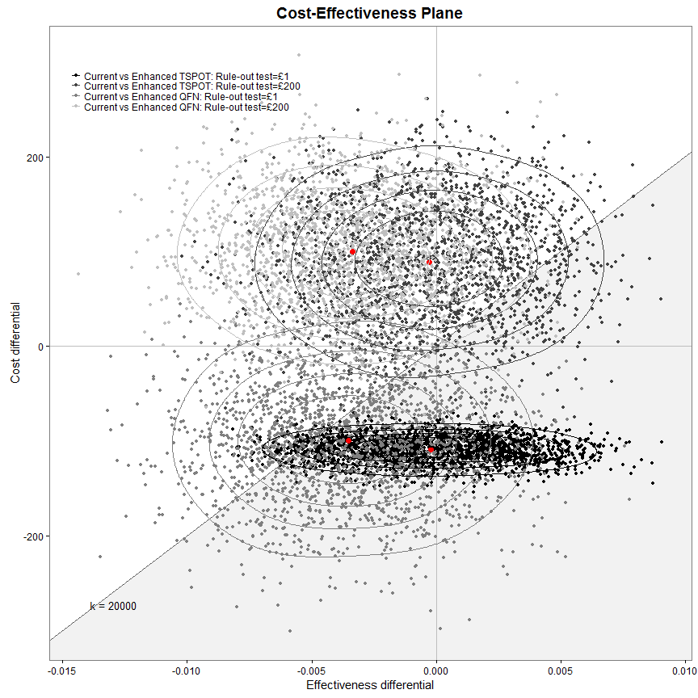

ceac.plot(m)

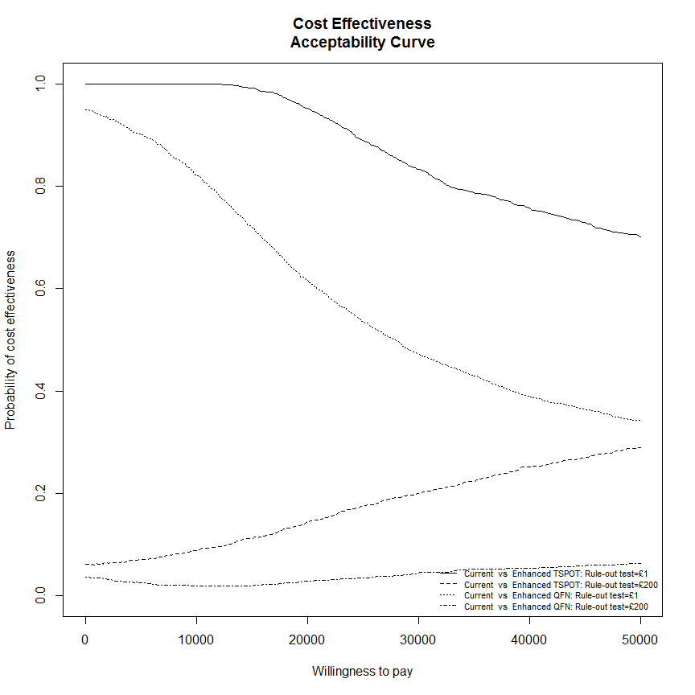

sink(file="../../../output_data/IDEA-BCEA-logfile.txt", append = TRUE)  
summary(m)  
sink()

## False negative follow-up time  
  
dat1 <- IDEAdectree.simple.TSPOT(data=data, name.ruleout = "TSPOT", FNtime = 7)  
dat2 <- IDEAdectree.simple.TSPOT(data=data, name.ruleout = "TSPOT", FNtime = 100)  
dat3 <- IDEAdectree.simple.QFN(data=data, name.ruleout = "QFN", FNtime = 7)  
dat4 <- IDEAdectree.simple.QFN(data=data, name.ruleout = "QFN", FNtime = 100)  
dat$e <- cbind(dat1$e, dat2$e[,2], dat3$e[,2], dat4$e[,2])  
dat$c <- cbind(dat1$c, dat2$c[,2], dat3$c[,2], dat4$c[,2])  
  
intlabels <- c("Current","Enhanced TSPOT: Follow-up=7 days","Enhanced TSPOT: Follow-up=100 days",  
 "Enhanced QFN: Follow-up=7 days","Enhanced QFN: Follow-up=100 days")  
m <- bcea(e=dat$e, c=-dat$c, ref=1, interventions = intlabels)  
contour2(m, wtp=WTP, graph = "ggplot2", ICER.size=2, pos=c(0.1,0.9))+#, xlim=c(-10,10), ylim=c(-200,200)) +  
 ggtitle("")

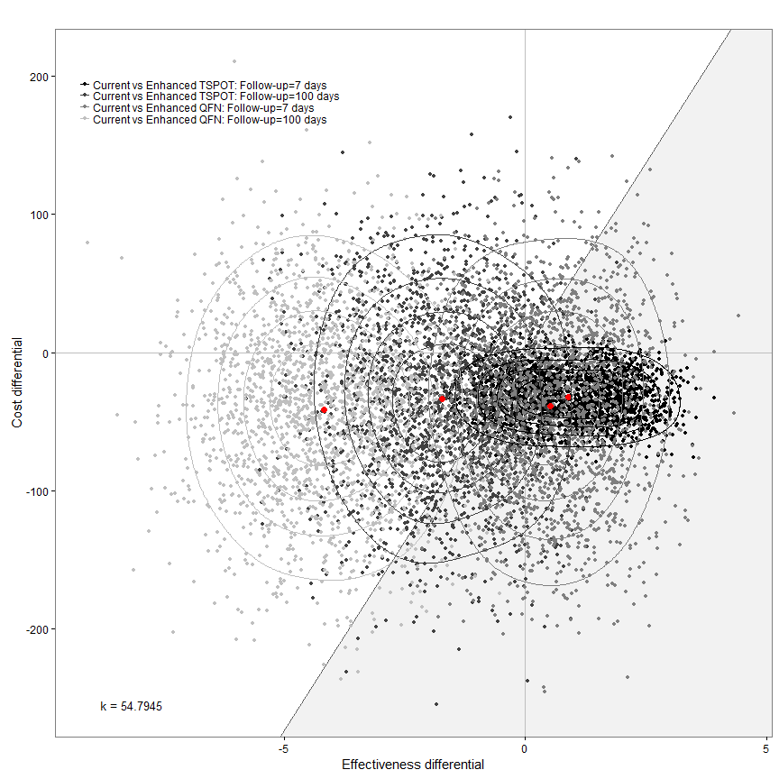

my.plot.bcea(dat1, dat2, dat3, dat4, WTP, intlabels, YLIM=c(-200,200))

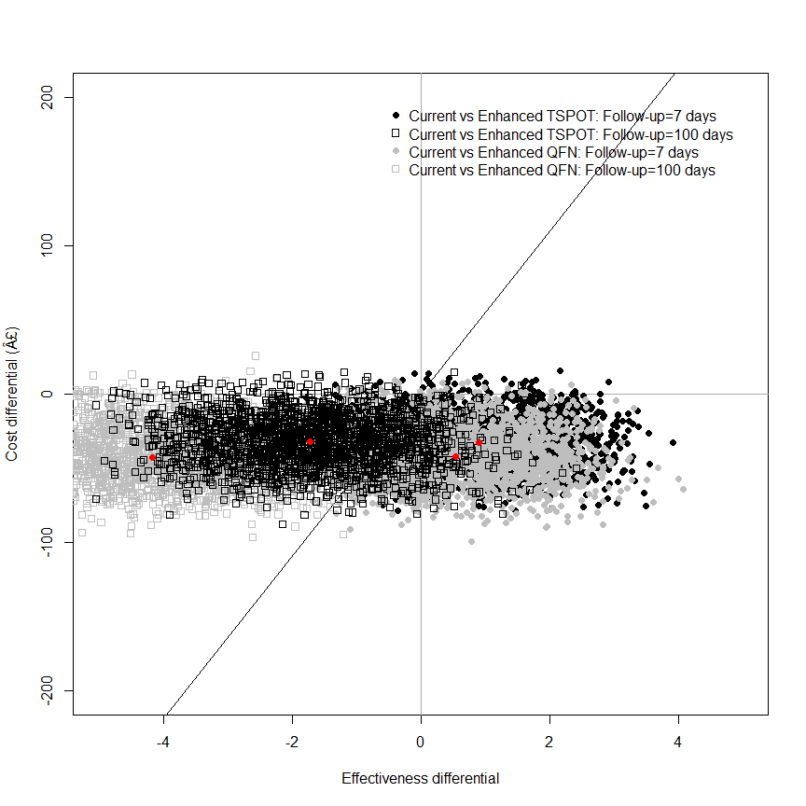

my.plot.bcea(dat1, dat2, dat3, dat4, WTP, intlabels, contour=TRUE, YLIM=c(-200,200))

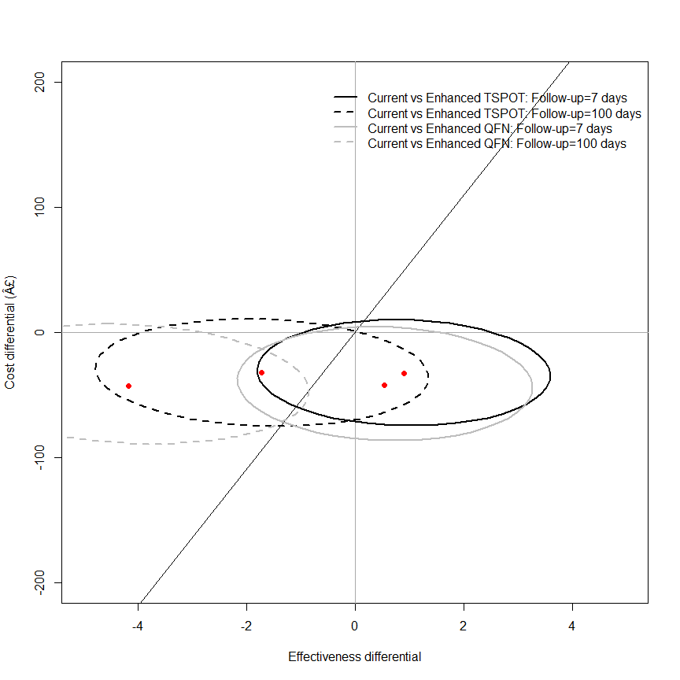

my.plot.bcea(dat1, dat2, dat3, dat4, WTP, intlabels, contour=TRUE, LEVELS=0.5, YLIM=c(-200,200))

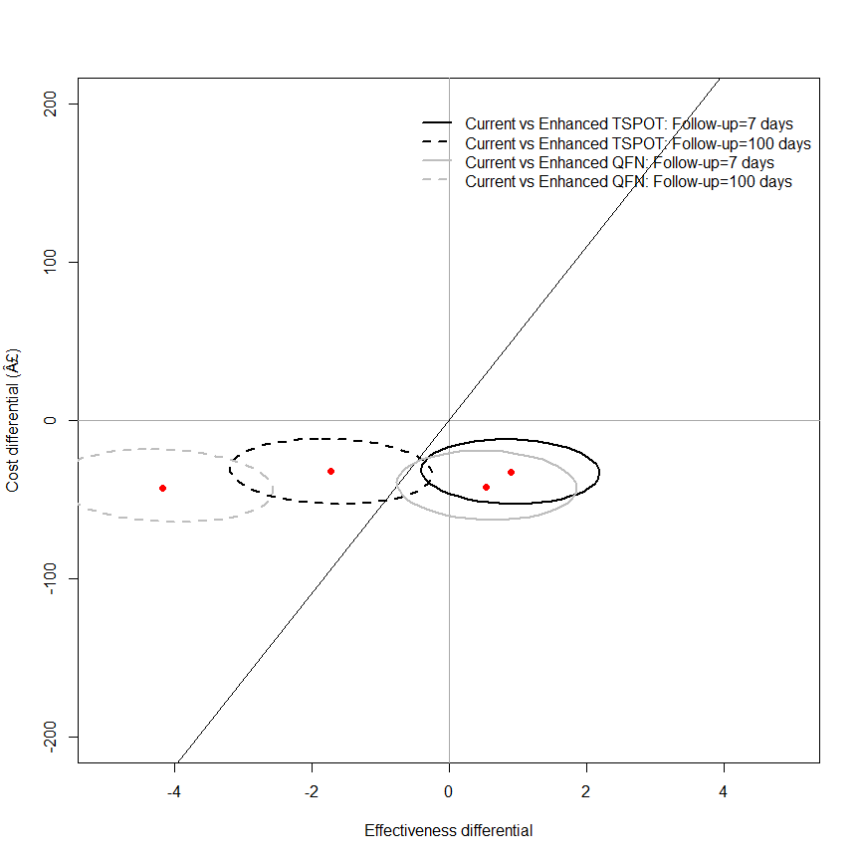

my.plot.ceac(dat1, dat2, dat3, dat4, intlabels)

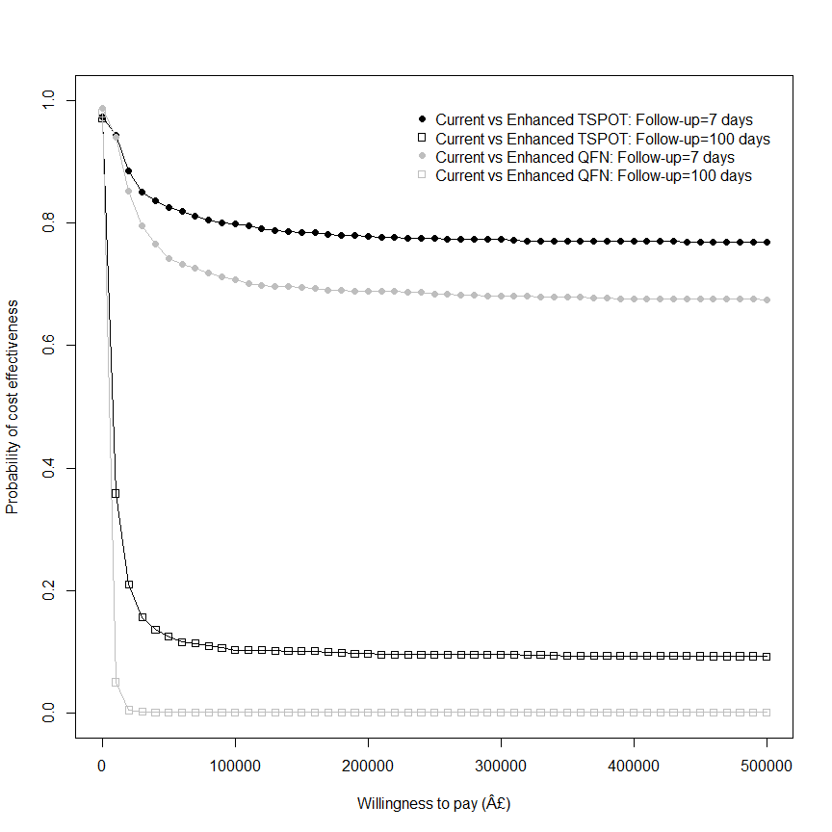

## in years (not days)  
m <- bcea(e=dat$e/365, c=-dat$c, ref=1, interventions = intlabels)  
contour2(m, wtp=20000, graph = "ggplot2", ICER.size=2, pos=c(0.1,0.9))

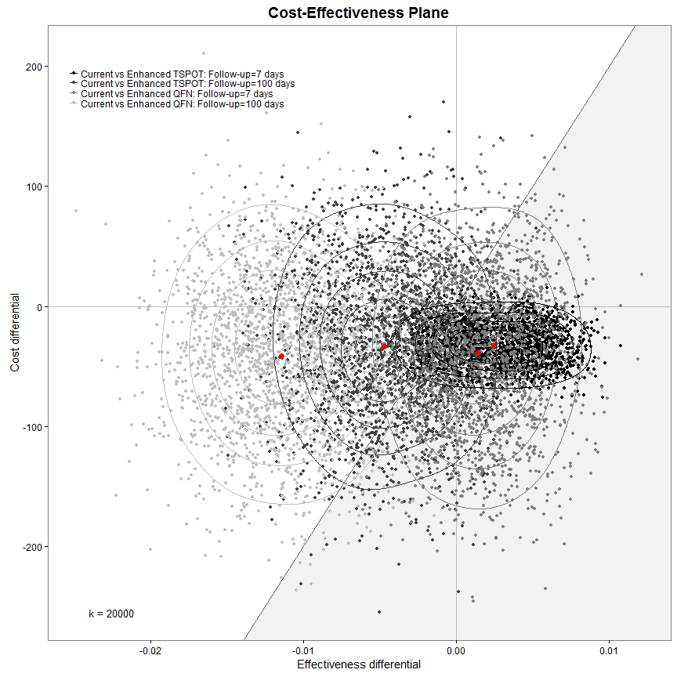

ceac.plot(m, pos=c(0,0))

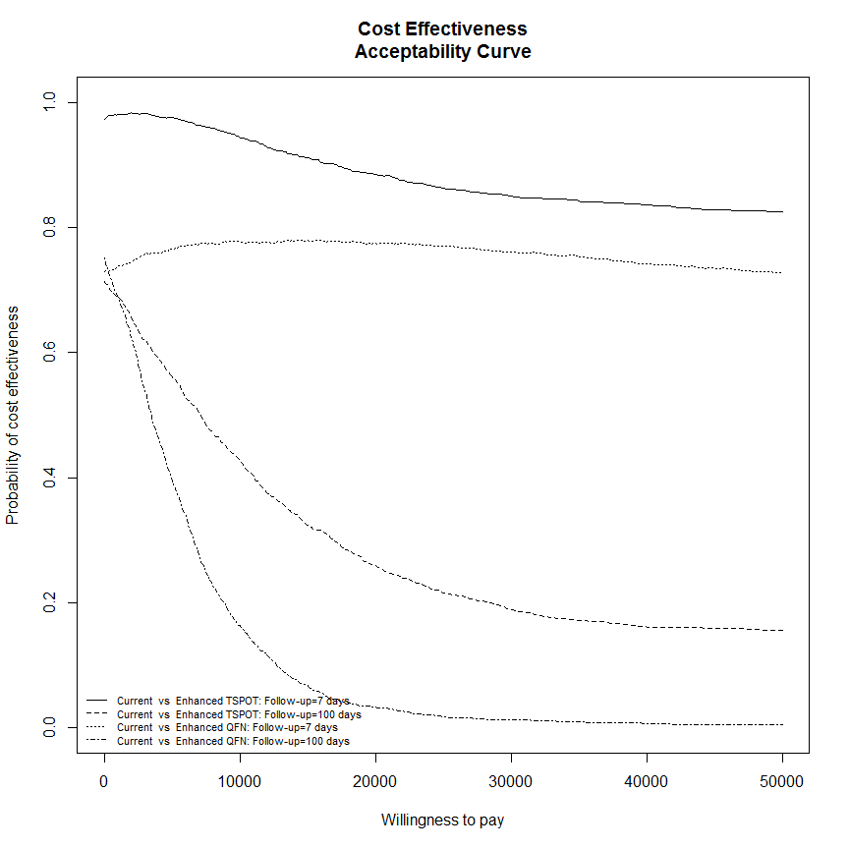

sink(file="../../../output_data/IDEA-BCEA-logfile.txt", append = TRUE)  
summary(m)  
sink()

## clinical judgement cut-off values  
  
dat1 <- IDEAdectree.simple.TSPOT(data=data, name.ruleout = "TSPOT", cutoff = 0.7)  
dat2 <- IDEAdectree.simple.TSPOT(data=data, name.ruleout = "TSPOT", cutoff = 0.3)  
dat3 <- IDEAdectree.simple.QFN(data=data, name.ruleout = "QFN", cutoff = 0.7)  
dat4 <- IDEAdectree.simple.QFN(data=data, name.ruleout = "QFN", cutoff = 0.3)  
dat$e <- cbind(dat1$e, dat2$e[,2], dat3$e[,2], dat4$e[,2])  
dat$c <- cbind(dat1$c, dat2$c[,2], dat3$c[,2], dat4$c[,2])  
  
intlabels <- c("Current","Enhanced TSPOT: Threshold=0.7","Enhanced TSPOT: Threshold=0.3",  
 "Enhanced QFN: Threshold=0.7","Enhanced QFN: Threshold=0.3")  
m <- bcea(e=dat$e, c=-dat$c, ref=1, interventions = intlabels)  
contour2(m, wtp=WTP, graph = "ggplot2", ICER.size=2, pos=c(0.1,0.9))+#, xlim=c(-10,10), ylim=c(-200,200)) +  
 ggtitle("")

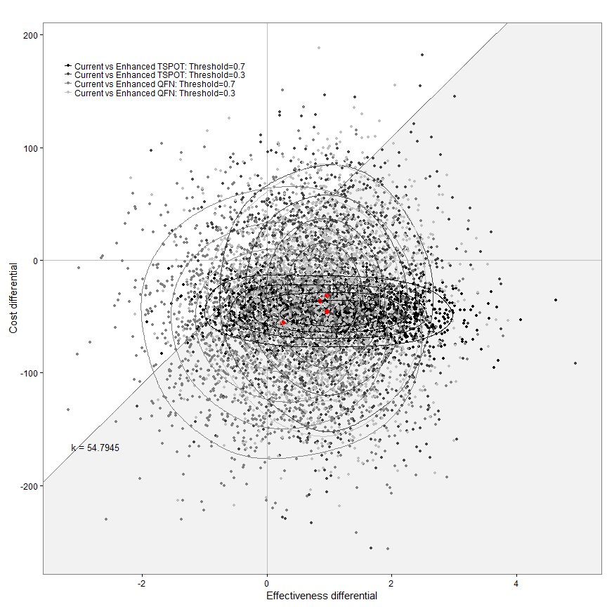

my.plot.bcea(dat1, dat2, dat3, dat4, WTP, intlabels, YLIM=c(-200,200))

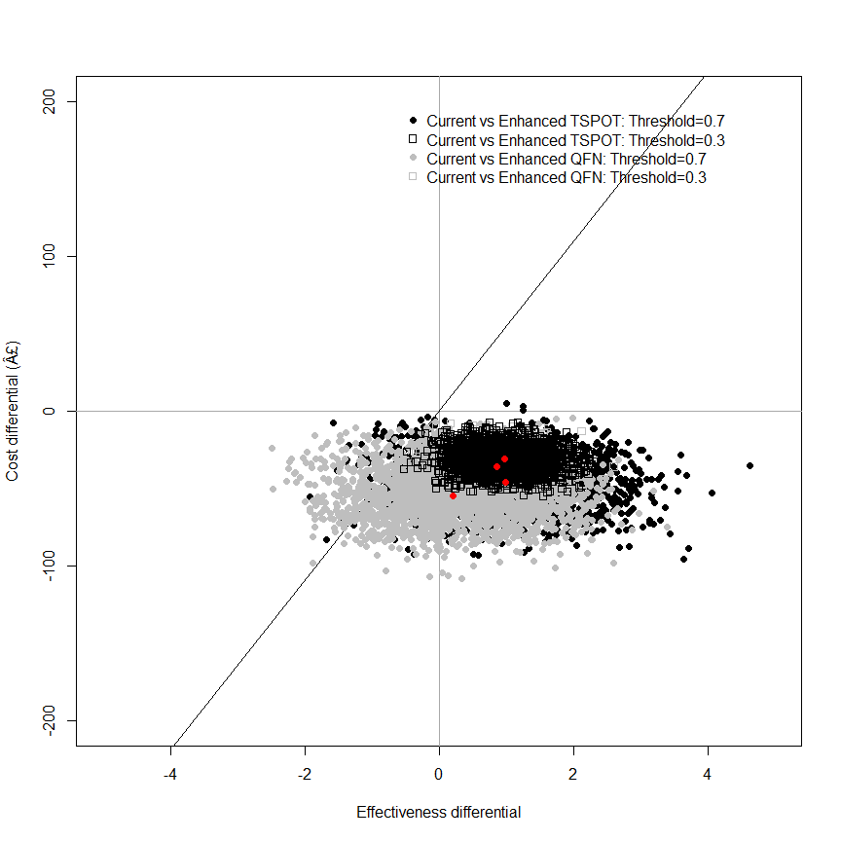

my.plot.bcea(dat1, dat2, dat3, dat4, WTP, intlabels, contour=TRUE, YLIM=c(-200,200))

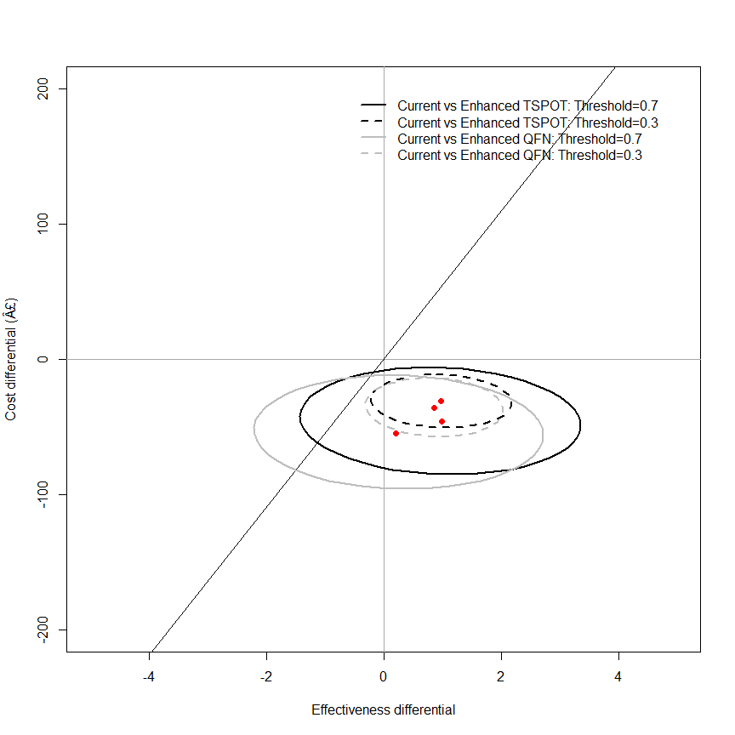

my.plot.bcea(dat1, dat2, dat3, dat4, WTP, intlabels, contour=TRUE, LEVELS=0.5, YLIM=c(-200,200))

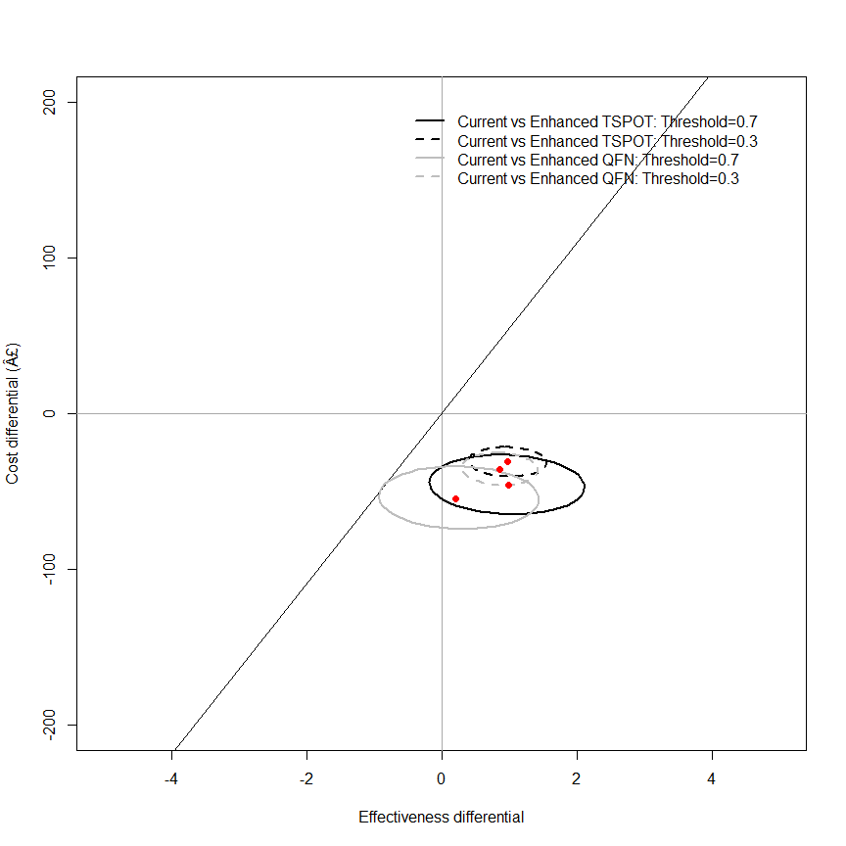

my.plot.ceac(dat1, dat2, dat3, dat4, intlabels)

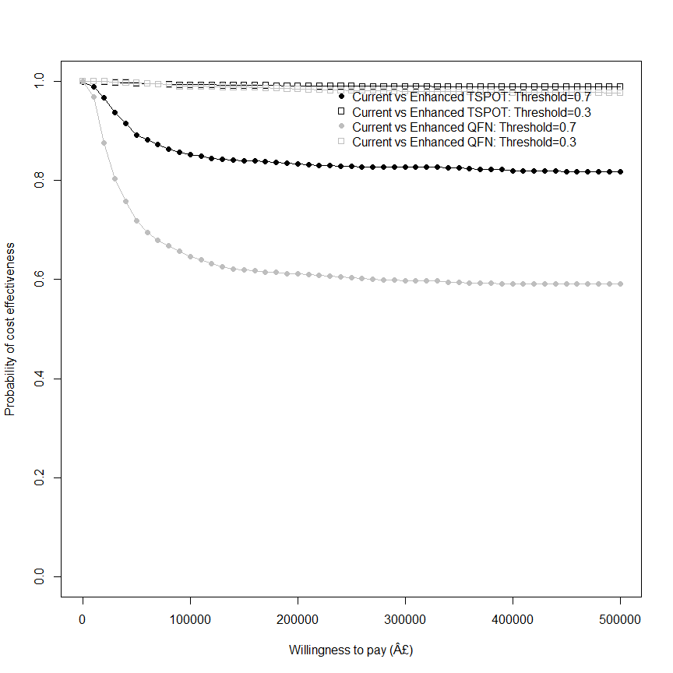

## in years (not days)  
m <- bcea(e=dat$e/365, c=-dat$c, ref=1, interventions = intlabels)  
contour2(m, wtp=20000, graph = "ggplot2", ICER.size=2, pos=c(0.1,0.9))

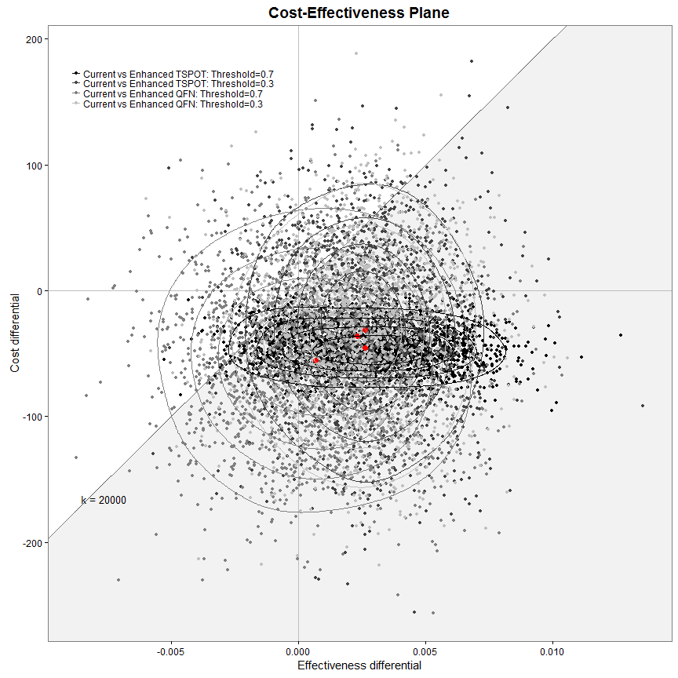

ceac.plot(m, pos=c(0,0))

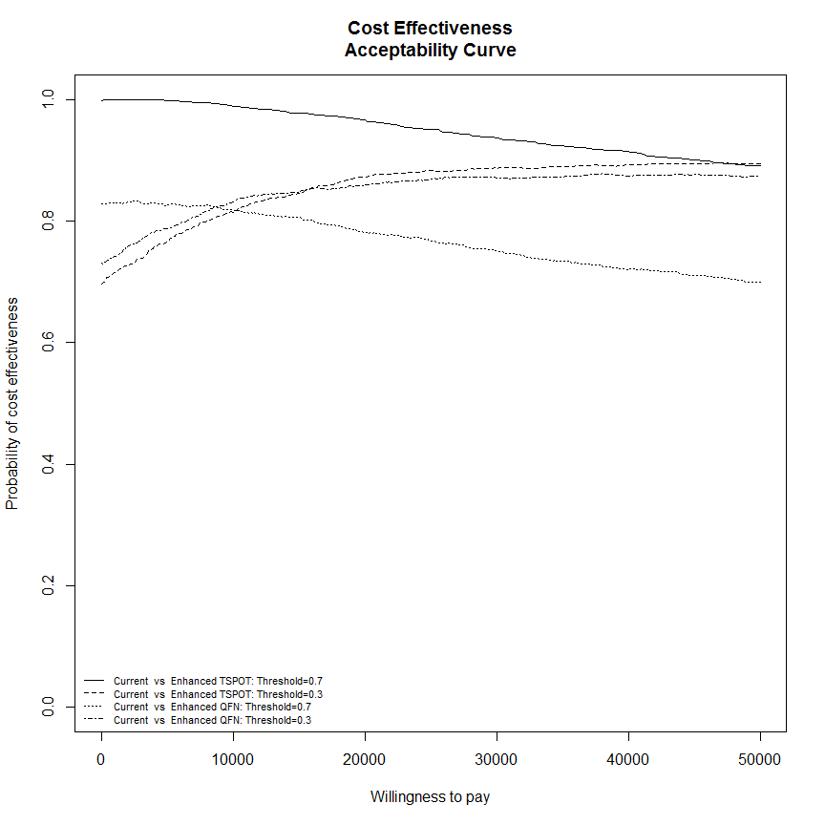

sink(file="../../../output_data/IDEA-BCEA-logfile.txt", append = TRUE)  
summary(m)  
sink()

## Ethnic group  
#   
# dat1 <- IDEAdectree.simple.1cutoff(data=data[data$Ethnclass=="Indian Sub-continent",])  
# dat2 <- IDEAdectree.simple.1cutoff(data=data[data$Ethnclass=="Black",])  
# dat2 <- IDEAdectree.simple.1cutoff(data=data[data$Ethnclass=="White",])  
# dat$e <- cbind(dat1$e, dat2$e[,2], dat3$e[,2])  
# dat$c <- cbind(dat1$c, dat2$c[,2], dat3$c[,2])  
#   
# intlabels <- c("Current","Enhanced: Indian Sub-continent","Enhanced: Black","Enhanced: White")  
# m <- bcea(e=dat$e, c=-dat$c, ref=1, interventions = intlabels)  
# contour2(m, wtp=WTP, graph = "ggplot2", ICER.size=2, pos=c(0.1,0.9), xlim=c(-5,20), ylim=c(-400,100)) + ggtitle("")  
#   
# sink(file="../../../output_data/IDEA-BCEA-logfile.txt", append = TRUE)  
# summary(m)  
# sink()

## cob incidence  
#   
# dat1 <- IDEAdectree.simple.1cutoff(data=data[data$WHOcut%in%c("[40,100)", "[100,150)", "[150,200)", "[200,400)", "[400,1e+04)"),])  
# dat2 <- IDEAdectree.simple.1cutoff(data=data[data$WHOcut%in%c("[100,150)", "[150,200)", "[200,400)", "[400,1e+04)"),])  
# dat2 <- IDEAdectree.simple.1cutoff(data=data[data$WHOcut%in%c("[150,200)", "[200,400)", "[400,1e+04)"),])  
# dat$e <- cbind(dat1$e, dat2$e[,2], dat3$e[,2])  
# dat$c <- cbind(dat1$c, dat2$c[,2], dat3$c[,2])  
#   
# intlabels <- c("Current","Enhanced: >40/100000","Enhanced: >100/100000","Enhanced: >150/100000")  
# m <- bcea(e=dat$e, c=-dat$c, ref=1, interventions = intlabels)  
# contour2(m, wtp=WTP, graph = "ggplot2", ICER.size=2, pos=c(0.1,0.9), xlim=c(-5,20), ylim=c(-400,100)) + ggtitle("")  
#   
# sink(file="../../../output_data/IDEA-BCEA-logfile.txt", append = TRUE)  
# summary(m)  
# sink()

detach(senspec.env)