Natsal-data-plots.R

ngreen1

Thu May 05 16:30:44 2016

load("./mrp/data/cleaned-regn-input-mrpNatsal.RData")  
  
Natsal0 <- Natsal  
  
rsample <- sample(x=1:nrow(Natsal), prob=Natsal$total_wt, replace=TRUE)  
Natsal <- Natsal[rsample,]  
  
  
attach(Natsal)  
  
# http://stats.stackexchange.com/questions/94026/how-can-i-improve-the-predictive-power-of-this-logistic-regression-model  
  
names(Natsal)

## [1] "sin2" "id" "total_wt"   
## [4] "psu" "strata" "stratagrp"   
## [7] "stratagrp2" "stratagrp3" "rsex"   
## [10] "drink" "drinkoft" "manyalc2"   
## [13] "drinknum" "smokenow" "exsmoke"   
## [16] "bothmapa2" "ynotboth2" "notused"   
## [19] "fsterils" "msterils" "conpill"   
## [22] "condom" "femidom" "emcypill"   
## [25] "emcyiud" "coil" "mirena"   
## [28] "cap" "injectns" "gels"   
## [31] "rhythm" "withdraw" "implants"   
## [34] "otherfp" "conpatch" "ynotused"   
## [37] "yfsteril" "ymsteril" "yconpill"   
## [40] "ycondom" "yfemidom" "yemcypill"   
## [43] "yemcyiud" "ycoil" "ymirena"   
## [46] "ycap" "yinjectn" "ygels"   
## [49] "yrhythm" "ywithdrw" "yimplant"   
## [52] "yothrfp" "yconptch" "dblcon2"   
## [55] "usnotused" "usfsteril" "usmsteril"   
## [58] "usconpill" "uscondom" "usfemidom"   
## [61] "usemcypill" "usemcyiud" "uscoil"   
## [64] "usmirena" "uscap" "usinjectn"   
## [67] "usgels" "usrhythm" "uswithdrw"   
## [70] "usimplant" "usother" "usconptch"   
## [73] "sex4wks" "cond4wk" "yrcond"   
## [76] "nonocon" "het5yrs" "het1yr"   
## [79] "het3mnt" "sam1yr" "sam3mnt"   
## [82] "overlp5y" "lbyear" "lbyear2"   
## [85] "lbyear3" "lbyear4" "lbyear5"   
## [88] "lbyear6" "lbyear7" "lbyear8"   
## [91] "lbyear9" "lbyear10" "lbyear11"   
## [94] "lbyear12" "lbyear13" "lbyear14"   
## [97] "lbyear15" "lbyear16" "lbyear17"   
## [100] "lbyear18" "lbyear19" "lbyear20"   
## [103] "stdclin" "chlamydia" "gonorrh"   
## [106] "warts" "syphilis" "trich"   
## [109] "herpes" "plicecrab" "hepatitis"   
## [112] "nsungu" "epididy" "dkstd"   
## [115] "nostd" "whnchlam" "chtstwh1"   
## [118] "chtstwy1" "chtrtlgr" "chlmtest"   
## [121] "chltstwh" "chltstwy" "chlofref"   
## [124] "drcan12m" "income" "ethnic"   
## [127] "sexid" "dage" "rdob"   
## [130] "afsex" "afsexall" "emergncy"   
## [133] "yemergncy" "sex4wks1" "sex4wks2"   
## [136] "hetnonew" "totnewyr" "nocondom"   
## [139] "rnssecgp_6" "rnssecgp_4" "ethnicgrp"   
## [142] "cttestly" "sex.age" "ethnic2"   
## [145] "increasingdrinker" "student" "age"   
## [148] "sex" "gor_l" "gor"   
## [151] "age.scaled" "total_wt.int"

#x11()  
par(mfrow=c(2,1))  
tab <- table(cttestly, ethnicgrp)  
barplot(tab, legend=levels((cttestly)), ylim=c(0,2000), beside=TRUE)  
x <- barplot(prop.table(tab,2)*100, xaxt="n")#, legend=levels((cttestly)))

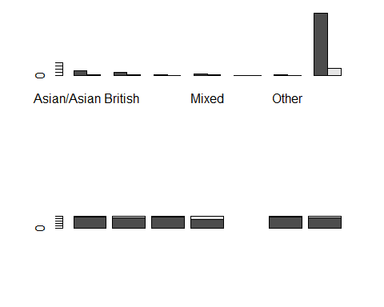

# labs <- paste(colnames(tab), "")  
# text(cex=1, x=x-.5, y=-50.5, labs, xpd=TRUE, srt=45)  
  
#x11()  
tab <- table(cttestly, smokenow)  
barplot(tab, legend=levels((cttestly)), beside=TRUE)  
barplot(prop.table(tab,2)*100)#, legend=levels((cttestly)))

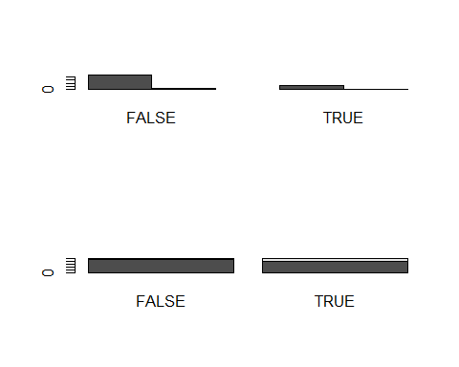

#x11()  
tab <- table(cttestly, dage)  
barplot(tab, legend=levels((cttestly)), beside=TRUE)  
barplot(prop.table(tab,2)*100)#, legend=levels((cttestly)))

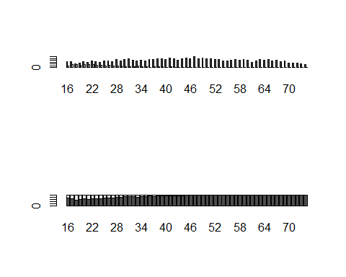

#x11()  
tab <- table(cttestly, rsex)  
barplot(tab, legend=levels((cttestly)), beside=TRUE)  
barplot(prop.table(tab,2)*100)#, legend=levels((cttestly)))

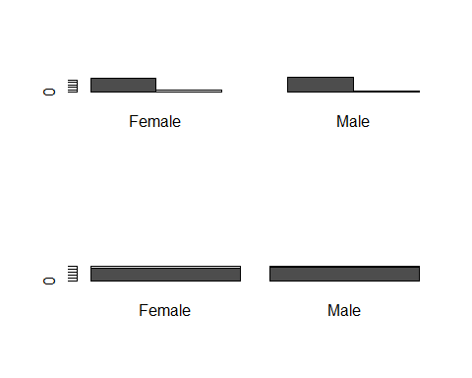

#x11()  
tab <- table(cttestly, drinkoft)  
barplot(tab, legend=levels((cttestly)), beside=TRUE)  
barplot(prop.table(tab,2)*100)#, legend=levels((cttestly)))

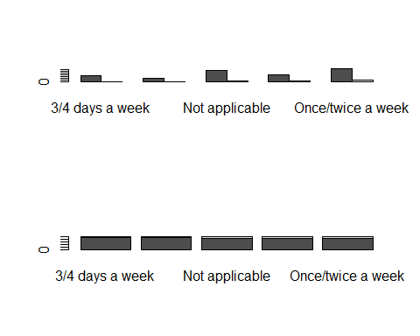

#x11()  
tab <- table(cttestly, drinknum)  
barplot(tab, legend=levels((cttestly)), beside=TRUE)  
barplot(prop.table(tab,2)*100)#, legend=levels((cttestly)))

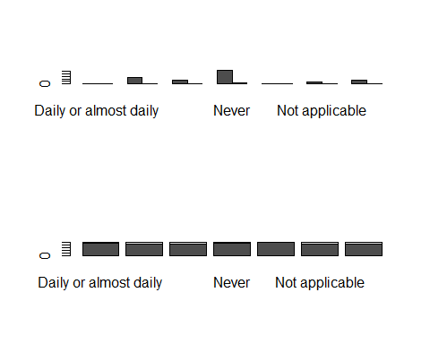

#x11()  
tab <- table(cttestly, manyalc2)  
barplot(tab, legend=levels((cttestly)), beside=TRUE)  
barplot(prop.table(tab,2)*100)#, legend=levels((cttestly)))

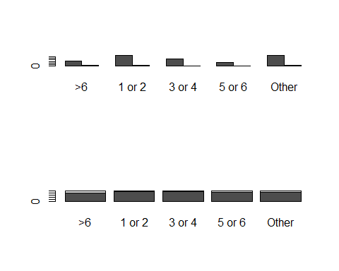

plot(table(drinkoft, manyalc2))  
  
#x11()  
tab <- table(cttestly, increasingdrinker)  
barplot(tab, legend=levels((cttestly)), beside=TRUE)

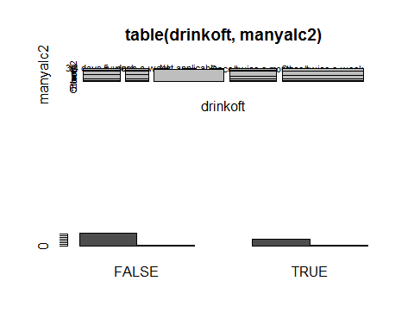

barplot(prop.table(tab,2)*100)#, legend=levels((cttestly)))  
  
#x11()  
tab <- table(cttestly, rnssecgp_4)  
barplot(tab, legend=levels((cttestly)), beside=TRUE)

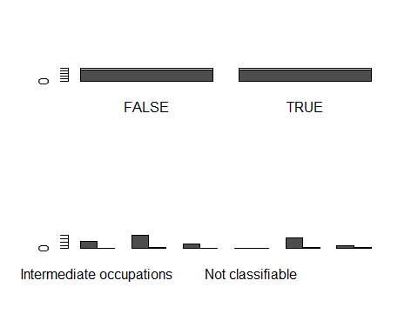

barplot(prop.table(tab,2)*100)#, legend=levels((cttestly)))  
  
#x11()  
tab <- table(cttestly, student)  
barplot(tab, legend=levels((cttestly)), beside=TRUE)

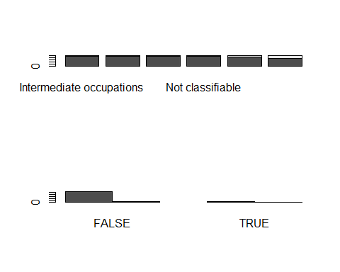

barplot(prop.table(tab,2)*100)#, legend=levels((cttestly)))  
  
  
#x11()  
tab <- table(cttestly, gor)  
barplot(tab, legend=levels((cttestly)), beside=TRUE)

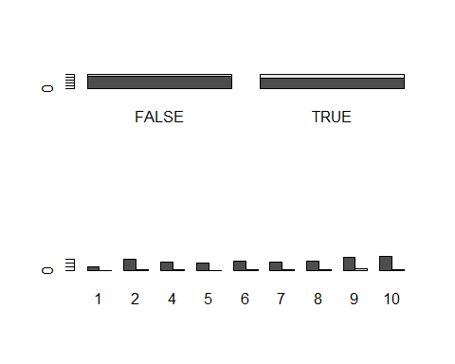

barplot(prop.table(tab,2)*100)#, legend=levels((cttestly)))

