library(lme4)

## Loading required package: Matrix

library(car)  
library(arm)

## Loading required package: MASS

##   
## arm (Version 1.8-6, built: 2015-7-7)

## Working directory is C:/Users/Nathan/Dropbox/small-area & chlamydia/R_code/scripts/mrp

##   
## Attaching package: 'arm'

## The following object is masked from 'package:car':  
##   
## logit

library(pander)  
library(knitr)  
library(stargazer)

##   
## Please cite as:

## Hlavac, Marek (2015). stargazer: Well-Formatted Regression and Summary Statistics Tables.

## R package version 5.2. http://CRAN.R-project.org/package=stargazer

library(xtable)

##   
## Attaching package: 'xtable'

## The following object is masked from 'package:arm':  
##   
## display

library(lattice)  
library(plyr)  
  
library(STIecoPredict)  
  
# load("C:/Users/ngreen1/Dropbox/small-area & chlamydia/R_code/scripts/mrp/data/cleaned-regn-input-mrpNatsal.RData")  
load("./data/cleaned-regn-input-mrpNatsal.RData")

## older ages sparsely sampled  
Natsal <- subset(Natsal, age>15 & age<45)

calcTotalProbs <- function(formula, data=sim_prop_la, extracols = c("LAname","la_code","region_code","region_name","gor")){  
  
 stopifnot(is.formula(formula))  
  
 colnames <- names(data)  
 TERMS <- attr(terms(formula),"term.labels")  
 p.TERMS <- paste("p.", TERMS, sep="")  
 p.TERMS <- unique(gsub("(p.age)|(p.sex)", "p.agesex", p.TERMS))  
  
 stopifnot(all(p.TERMS%in%colnames))  
  
 newcolnames <- c(TERMS, p.TERMS, extracols)  
 dropl <- !colnames%in%newcolnames  
 p.todrop <- dropl & grepl("^p\\.", names(data))  
 factors.todrop <- gsub("p.", "", colnames[p.todrop])  
  
 singlelevels <- apply(data[ ,factors.todrop, drop=FALSE], 2, function(x) unique(x)[1]) #because repetition  
  
 if(length(factors.todrop)>0){  
 for (i in 1:length(factors.todrop)){  
 data <- data[data[,factors.todrop[i]]==singlelevels[i], ]  
 }}  
  
 data$totalprob <- apply(data[ ,p.TERMS, drop=FALSE], 1, prod)  
 # stopifnot(aggregate(totalprob, probs_levels_array$LAname, sum))  
  
 return(data[ ,c(newcolnames, "totalprob")])  
}

What are range do we want to regress over? The surveillance data is only for <24 years olds in most cases so theres probably no point in using all ages.

# http://stats.stackexchange.com/questions/31569/questions-about-how-random-effects-are-specified-in-lmer  
  
fit0 <- glmer(formula = cttestly ~ 1+(1|age),  
 data = Natsal, family = binomial(link="logit"), weights = total_wt)

## Warning: non-integer #successes in a binomial glm!

## a null model  
fit12 <- fit0  
summary(fit12)

## Generalized linear mixed model fit by maximum likelihood (Laplace  
## Approximation) [glmerMod]  
## Family: binomial ( logit )  
## Formula: cttestly ~ 1 + (1 | age)  
## Data: Natsal  
## Weights: total_wt  
##   
## AIC BIC logLik deviance df.resid   
## 4704.3 4718.4 -2350.2 4700.3 8542   
##   
## Scaled residuals:   
## Min 1Q Median 3Q Max   
## -1.3696 -0.4500 -0.3238 -0.2031 7.2803   
##   
## Random effects:  
## Groups Name Variance Std.Dev.  
## age (Intercept) 0.7829 0.8848   
## Number of obs: 8544, groups: age, 29  
##   
## Fixed effects:  
## Estimate Std. Error z value Pr(>|z|)   
## (Intercept) -1.7728 0.1692 -10.48 <2e-16 ***  
## ---  
## Signif. codes: 0 '***' 0.001 '**' 0.01 '*' 0.05 '.' 0.1 ' ' 1

fit13 <- update(fit0, .~. + sex)

## Warning: non-integer #successes in a binomial glm!

summary(fit13)

## Generalized linear mixed model fit by maximum likelihood (Laplace  
## Approximation) [glmerMod]  
## Family: binomial ( logit )  
## Formula: cttestly ~ (1 | age) + sex  
## Data: Natsal  
## Weights: total_wt  
##   
## AIC BIC logLik deviance df.resid   
## 4636.3 4657.5 -2315.2 4630.3 8541   
##   
## Scaled residuals:   
## Min 1Q Median 3Q Max   
## -1.5901 -0.4407 -0.3269 -0.2051 8.3210   
##   
## Random effects:  
## Groups Name Variance Std.Dev.  
## age (Intercept) 0.8298 0.911   
## Number of obs: 8544, groups: age, 29  
##   
## Fixed effects:  
## Estimate Std. Error z value Pr(>|z|)   
## (Intercept) -2.09981 0.17918 -11.719 <2e-16 ***  
## sexWomen 0.63173 0.07579 8.335 <2e-16 ***  
## ---  
## Signif. codes: 0 '***' 0.001 '**' 0.01 '*' 0.05 '.' 0.1 ' ' 1  
##   
## Correlation of Fixed Effects:  
## (Intr)  
## sexWomen -0.240

fit14 <- update(fit13, .~. - (1|age) + (sex|age))

## Warning: non-integer #successes in a binomial glm!

summary(fit14)

## Generalized linear mixed model fit by maximum likelihood (Laplace  
## Approximation) [glmerMod]  
## Family: binomial ( logit )  
## Formula: cttestly ~ sex + (sex | age)  
## Data: Natsal  
## Weights: total_wt  
##   
## AIC BIC logLik deviance df.resid   
## 4637.6 4672.9 -2313.8 4627.6 8539   
##   
## Scaled residuals:   
## Min 1Q Median 3Q Max   
## -1.5292 -0.4450 -0.3270 -0.2037 8.8038   
##   
## Random effects:  
## Groups Name Variance Std.Dev. Corr   
## age (Intercept) 0.98864 0.9943   
## sexWomen 0.01918 0.1385 -1.00  
## Number of obs: 8544, groups: age, 29  
##   
## Fixed effects:  
## Estimate Std. Error z value Pr(>|z|)   
## (Intercept) -2.1427 0.1961 -10.924 < 2e-16 ***  
## sexWomen 0.6912 0.0884 7.819 5.33e-15 ***  
## ---  
## Signif. codes: 0 '***' 0.001 '**' 0.01 '*' 0.05 '.' 0.1 ' ' 1  
##   
## Correlation of Fixed Effects:  
## (Intr)  
## sexWomen -0.527

fit15 <- update(fit13, .~. + ethnic2)

## Warning: non-integer #successes in a binomial glm!

summary(fit15)

## Generalized linear mixed model fit by maximum likelihood (Laplace  
## Approximation) [glmerMod]  
## Family: binomial ( logit )  
## Formula: cttestly ~ (1 | age) + sex + ethnic2  
## Data: Natsal  
## Weights: total_wt  
##   
## AIC BIC logLik deviance df.resid   
## 4565.5 4621.9 -2274.7 4549.5 8536   
##   
## Scaled residuals:   
## Min 1Q Median 3Q Max   
## -1.7324 -0.4406 -0.3228 -0.1798 8.2499   
##   
## Random effects:  
## Groups Name Variance Std.Dev.  
## age (Intercept) 0.8548 0.9246   
## Number of obs: 8544, groups: age, 29  
##   
## Fixed effects:  
## Estimate Std. Error z value Pr(>|z|)   
## (Intercept) -2.01196 0.18218 -11.044 < 2e-16 ***  
## sexWomen 0.64221 0.07652 8.393 < 2e-16 ***  
## ethnic2ASIAN/ASIAN BRITISH -1.27065 0.18060 -7.036 1.98e-12 ***  
## ethnic2BLACK/BLACK BRITISH -0.03250 0.17329 -0.188 0.8512   
## ethnic2CHINESE -2.02076 0.78769 -2.565 0.0103 *   
## ethnic2MIXED 0.22444 0.20645 1.087 0.2770   
## ethnic2OTHER -0.67310 0.40509 -1.662 0.0966 .   
## ---  
## Signif. codes: 0 '***' 0.001 '**' 0.01 '*' 0.05 '.' 0.1 ' ' 1  
##   
## Correlation of Fixed Effects:  
## (Intr) sexWmn e2ASIB e2BLAB e2CHIN e2MIXE  
## sexWomen -0.236   
## e2ASIAN/ASB -0.040 -0.021   
## e2BLACK/BLB -0.047 -0.023 0.053   
## eth2CHINESE -0.006 -0.017 0.012 0.012   
## ethnc2MIXED -0.038 -0.009 0.050 0.048 0.011   
## ethnc2OTHER -0.019 -0.005 0.024 0.025 0.005 0.022

fit16 <- update(fit15, .~. + smokenow+increasingdrinker)

## Warning: non-integer #successes in a binomial glm!

summary(fit16)

## Generalized linear mixed model fit by maximum likelihood (Laplace  
## Approximation) [glmerMod]  
## Family: binomial ( logit )  
## Formula:   
## cttestly ~ (1 | age) + sex + ethnic2 + smokenow + increasingdrinker  
## Data: Natsal  
## Weights: total_wt  
##   
## AIC BIC logLik deviance df.resid   
## 4526.2 4596.7 -2253.1 4506.2 8534   
##   
## Scaled residuals:   
## Min 1Q Median 3Q Max   
## -1.9628 -0.4388 -0.3161 -0.1734 9.0180   
##   
## Random effects:  
## Groups Name Variance Std.Dev.  
## age (Intercept) 0.8652 0.9302   
## Number of obs: 8544, groups: age, 29  
##   
## Fixed effects:  
## Estimate Std. Error z value Pr(>|z|)   
## (Intercept) -2.30515 0.19094 -12.073 < 2e-16 ***  
## sexWomen 0.72029 0.07899 9.118 < 2e-16 ***  
## ethnic2ASIAN/ASIAN BRITISH -1.12336 0.18376 -6.113 9.76e-10 ***  
## ethnic2BLACK/BLACK BRITISH 0.10883 0.17640 0.617 0.53728   
## ethnic2CHINESE -1.84491 0.78773 -2.342 0.01918 *   
## ethnic2MIXED 0.23953 0.20815 1.151 0.24984   
## ethnic2OTHER -0.57186 0.40571 -1.410 0.15868   
## smokenowTRUE 0.47909 0.08226 5.824 5.73e-09 ***  
## increasingdrinkerTRUE 0.23588 0.08314 2.837 0.00455 **   
## ---  
## Signif. codes: 0 '***' 0.001 '**' 0.01 '*' 0.05 '.' 0.1 ' ' 1  
##   
## Correlation of Fixed Effects:  
## (Intr) sexWmn e2ASIB e2BLAB e2CHIN e2MIXE e2OTHE smTRUE  
## sexWomen -0.282   
## e2ASIAN/ASB -0.084 0.022   
## e2BLACK/BLB -0.086 0.010 0.078   
## eth2CHINESE -0.017 -0.006 0.019 0.018   
## ethnc2MIXED -0.047 0.001 0.058 0.054 0.013   
## ethnc2OTHER -0.034 0.011 0.033 0.033 0.008 0.025   
## smokenwTRUE -0.156 0.070 0.046 0.068 0.019 -0.019 0.010   
## incrsngTRUE -0.223 0.211 0.161 0.132 0.032 0.060 0.058 -0.064

fit17 <- update(fit14, .~. + ethnic2+smokenow+increasingdrinker)

## Warning: non-integer #successes in a binomial glm!

## Warning in checkConv(attr(opt, "derivs"), opt$par, ctrl = control  
## $checkConv, : Model failed to converge with max|grad| = 0.00727316 (tol =  
## 0.001, component 1)

summary(fit17)

## Generalized linear mixed model fit by maximum likelihood (Laplace  
## Approximation) [glmerMod]  
## Family: binomial ( logit )  
## Formula:   
## cttestly ~ sex + (sex | age) + ethnic2 + smokenow + increasingdrinker  
## Data: Natsal  
## Weights: total_wt  
##   
## AIC BIC logLik deviance df.resid   
## 4528.1 4612.8 -2252.1 4504.1 8532   
##   
## Scaled residuals:   
## Min 1Q Median 3Q Max   
## -1.9040 -0.4430 -0.3167 -0.1712 9.4791   
##   
## Random effects:  
## Groups Name Variance Std.Dev. Corr   
## age (Intercept) 1.00783 1.004   
## sexWomen 0.01488 0.122 -1.00  
## Number of obs: 8544, groups: age, 29  
##   
## Fixed effects:  
## Estimate Std. Error z value Pr(>|z|)   
## (Intercept) -2.34393 0.20558 -11.402 < 2e-16 ***  
## sexWomen 0.77218 0.09026 8.555 < 2e-16 ***  
## ethnic2ASIAN/ASIAN BRITISH -1.11730 0.18357 -6.086 1.15e-09 ***  
## ethnic2BLACK/BLACK BRITISH 0.11367 0.17616 0.645 0.51875   
## ethnic2CHINESE -1.83089 0.78671 -2.327 0.01995 *   
## ethnic2MIXED 0.24357 0.20766 1.173 0.24083   
## ethnic2OTHER -0.56436 0.40527 -1.393 0.16375   
## smokenowTRUE 0.47843 0.08222 5.819 5.92e-09 ***  
## increasingdrinkerTRUE 0.23684 0.08309 2.850 0.00437 **   
## ---  
## Signif. codes: 0 '***' 0.001 '**' 0.01 '*' 0.05 '.' 0.1 ' ' 1  
##   
## Correlation of Fixed Effects:  
## (Intr) sexWmn e2ASIB e2BLAB e2CHIN e2MIXE e2OTHE smTRUE  
## sexWomen -0.517   
## e2ASIAN/ASB -0.081 0.029   
## e2BLACK/BLB -0.082 0.015 0.078   
## eth2CHINESE -0.017 -0.001 0.019 0.018   
## ethnc2MIXED -0.046 0.006 0.058 0.055 0.013   
## ethnc2OTHER -0.033 0.014 0.034 0.033 0.008 0.025   
## smokenwTRUE -0.143 0.057 0.046 0.067 0.019 -0.019 0.010   
## incrsngTRUE -0.208 0.186 0.161 0.132 0.032 0.060 0.057 -0.065  
## convergence code: 0  
## Model failed to converge with max|grad| = 0.00727316 (tol = 0.001, component 1)

pander(anova(fit12, fit13, fit14, fit15, fit16, fit17))

Data: Natsal

|  |  |  |  |  |  |  |  |  |
| --- | --- | --- | --- | --- | --- | --- | --- | --- |
|  | Df | AIC | BIC | logLik | deviance | Chisq | Chi Df | Pr(>Chisq) |
| **fit12** | 2 | 4704 | 4718 | -2350 | 4700 | NA | NA | NA |
| **fit13** | 3 | 4636 | 4657 | -2315 | 4630 | 69.99 | 1 | 5.972e-17 |
| **fit14** | 5 | 4638 | 4673 | -2314 | 4628 | 2.698 | 2 | 0.2595 |
| **fit15** | 8 | 4565 | 4622 | -2275 | 4549 | 78.14 | 3 | 7.707e-17 |
| **fit16** | 10 | 4526 | 4597 | -2253 | 4506 | 43.32 | 2 | 3.925e-10 |
| **fit17** | 12 | 4528 | 4613 | -2252 | 4504 | 2.03 | 2 | 0.3625 |

## a null model  
fit21 <- glmer(formula = cttestly ~ 1+(1|gor),  
 data = Natsal, family = binomial(link="logit"), weights = total_wt)

## Warning: non-integer #successes in a binomial glm!

summary(fit21)

## Generalized linear mixed model fit by maximum likelihood (Laplace  
## Approximation) [glmerMod]  
## Family: binomial ( logit )  
## Formula: cttestly ~ 1 + (1 | gor)  
## Data: Natsal  
## Weights: total_wt  
##   
## AIC BIC logLik deviance df.resid   
## 5179.2 5193.3 -2587.6 5175.2 8542   
##   
## Scaled residuals:   
## Min 1Q Median 3Q Max   
## -1.1399 -0.4252 -0.3228 -0.2364 4.4928   
##   
## Random effects:  
## Groups Name Variance Std.Dev.  
## gor (Intercept) 0 0   
## Number of obs: 8544, groups: gor, 9  
##   
## Fixed effects:  
## Estimate Std. Error z value Pr(>|z|)   
## (Intercept) -1.66123 0.03557 -46.71 <2e-16 ***  
## ---  
## Signif. codes: 0 '***' 0.001 '**' 0.01 '*' 0.05 '.' 0.1 ' ' 1

fit22 <- update(fit21, .~. + sex+(1|age))

## Warning: non-integer #successes in a binomial glm!

summary(fit22)

## Generalized linear mixed model fit by maximum likelihood (Laplace  
## Approximation) [glmerMod]  
## Family: binomial ( logit )  
## Formula: cttestly ~ (1 | gor) + sex + (1 | age)  
## Data: Natsal  
## Weights: total_wt  
##   
## AIC BIC logLik deviance df.resid   
## 4638.3 4666.5 -2315.2 4630.3 8540   
##   
## Scaled residuals:   
## Min 1Q Median 3Q Max   
## -1.5901 -0.4407 -0.3269 -0.2051 8.3210   
##   
## Random effects:  
## Groups Name Variance Std.Dev.  
## age (Intercept) 8.298e-01 0.910956  
## gor (Intercept) 1.441e-10 0.000012  
## Number of obs: 8544, groups: age, 29; gor, 9  
##   
## Fixed effects:  
## Estimate Std. Error z value Pr(>|z|)   
## (Intercept) -2.09981 0.17918 -11.719 <2e-16 ***  
## sexWomen 0.63173 0.07579 8.335 <2e-16 ***  
## ---  
## Signif. codes: 0 '***' 0.001 '**' 0.01 '*' 0.05 '.' 0.1 ' ' 1  
##   
## Correlation of Fixed Effects:  
## (Intr)  
## sexWomen -0.240

fit23 <- update(fit22, .~. + ethnic2+student)

## Warning: non-integer #successes in a binomial glm!

summary(fit23)

## Generalized linear mixed model fit by maximum likelihood (Laplace  
## Approximation) [glmerMod]  
## Family: binomial ( logit )  
## Formula: cttestly ~ (1 | gor) + sex + (1 | age) + ethnic2 + student  
## Data: Natsal  
## Weights: total_wt  
##   
## AIC BIC logLik deviance df.resid   
## 4568.8 4639.3 -2274.4 4548.8 8534   
##   
## Scaled residuals:   
## Min 1Q Median 3Q Max   
## -1.6806 -0.4396 -0.3240 -0.1813 8.3237   
##   
## Random effects:  
## Groups Name Variance Std.Dev.  
## age (Intercept) 0.888903 0.9428   
## gor (Intercept) 0.001764 0.0420   
## Number of obs: 8544, groups: age, 29; gor, 9  
##   
## Fixed effects:  
## Estimate Std. Error z value Pr(>|z|)   
## (Intercept) -2.00020 0.18671 -10.713 < 2e-16 ***  
## sexWomen 0.64218 0.07658 8.386 < 2e-16 ***  
## ethnic2ASIAN/ASIAN BRITISH -1.26782 0.18479 -6.861 6.85e-12 ***  
## ethnic2BLACK/BLACK BRITISH -0.03366 0.18533 -0.182 0.8559   
## ethnic2CHINESE -1.99428 0.78842 -2.529 0.0114 *   
## ethnic2MIXED 0.22176 0.20907 1.061 0.2888   
## ethnic2OTHER -0.66286 0.40839 -1.623 0.1046   
## studentTRUE -0.09783 0.12163 -0.804 0.4212   
## ---  
## Signif. codes: 0 '***' 0.001 '**' 0.01 '*' 0.05 '.' 0.1 ' ' 1  
##   
## Correlation of Fixed Effects:  
## (Intr) sexWmn e2ASIB e2BLAB e2CHIN e2MIXE e2OTHE  
## sexWomen -0.228   
## e2ASIAN/ASB -0.026 -0.014   
## e2BLACK/BLB -0.023 -0.010 0.124   
## eth2CHINESE 0.000 -0.014 0.026 0.033   
## ethnc2MIXED -0.030 -0.004 0.080 0.099 0.020   
## ethnc2OTHER -0.009 -0.001 0.049 0.066 0.014 0.040   
## studentTRUE -0.086 -0.013 -0.082 -0.107 -0.056 -0.035 -0.066

fit24 <- update(fit23, .~. + smokenow+increasingdrinker)

## Warning: non-integer #successes in a binomial glm!

## Warning in checkConv(attr(opt, "derivs"), opt$par, ctrl = control  
## $checkConv, : Model failed to converge with max|grad| = 0.00576332 (tol =  
## 0.001, component 1)

summary(fit24)

## Generalized linear mixed model fit by maximum likelihood (Laplace  
## Approximation) [glmerMod]  
## Family: binomial ( logit )  
## Formula: cttestly ~ (1 | gor) + sex + (1 | age) + ethnic2 + student +   
## smokenow + increasingdrinker  
## Data: Natsal  
## Weights: total_wt  
##   
## AIC BIC logLik deviance df.resid   
## 4529.9 4614.6 -2253.0 4505.9 8532   
##   
## Scaled residuals:   
## Min 1Q Median 3Q Max   
## -1.9228 -0.4395 -0.3160 -0.1733 9.1838   
##   
## Random effects:  
## Groups Name Variance Std.Dev.  
## age (Intercept) 0.881515 0.93889   
## gor (Intercept) 0.002646 0.05144   
## Number of obs: 8544, groups: age, 29; gor, 9  
##   
## Fixed effects:  
## Estimate Std. Error z value Pr(>|z|)   
## (Intercept) -2.30115 0.19410 -11.856 < 2e-16 ***  
## sexWomen 0.71982 0.07903 9.108 < 2e-16 ***  
## ethnic2ASIAN/ASIAN BRITISH -1.13131 0.18768 -6.028 1.66e-09 ***  
## ethnic2BLACK/BLACK BRITISH 0.09232 0.18682 0.494 0.62117   
## ethnic2CHINESE -1.84313 0.78916 -2.336 0.01951 *   
## ethnic2MIXED 0.23100 0.21040 1.098 0.27225   
## ethnic2OTHER -0.57889 0.40896 -1.416 0.15692   
## studentTRUE -0.04062 0.12277 -0.331 0.74076   
## smokenowTRUE 0.47652 0.08273 5.760 8.40e-09 ***  
## increasingdrinkerTRUE 0.23811 0.08332 2.858 0.00427 **   
## ---  
## Signif. codes: 0 '***' 0.001 '**' 0.01 '*' 0.05 '.' 0.1 ' ' 1  
##   
## Correlation of Fixed Effects:  
## (Intr) sexWmn e2ASIB e2BLAB e2CHIN e2MIXE e2OTHE stTRUE smTRUE  
## sexWomen -0.275   
## e2ASIAN/ASB -0.068 0.027   
## e2BLACK/BLB -0.060 0.018 0.138   
## eth2CHINESE -0.010 -0.004 0.031 0.037   
## ethnc2MIXED -0.037 0.005 0.085 0.099 0.021   
## ethnc2OTHER -0.024 0.014 0.057 0.069 0.016 0.042   
## studentTRUE -0.089 -0.018 -0.088 -0.107 -0.056 -0.044 -0.068   
## smokenwTRUE -0.162 0.068 0.033 0.049 0.013 -0.025 0.001 0.103   
## incrsngTRUE -0.216 0.211 0.159 0.125 0.034 0.059 0.059 -0.051 -0.069  
## convergence code: 0  
## Model failed to converge with max|grad| = 0.00576332 (tol = 0.001, component 1)

fit25 <- update(fit24, .~. - sex - student + sex*student)

## Warning: non-integer #successes in a binomial glm!

## Warning in checkConv(attr(opt, "derivs"), opt$par, ctrl = control  
## $checkConv, : Model failed to converge with max|grad| = 0.00569904 (tol =  
## 0.001, component 1)

summary(fit25)

## Generalized linear mixed model fit by maximum likelihood (Laplace  
## Approximation) [glmerMod]  
## Family: binomial ( logit )  
## Formula:   
## cttestly ~ (1 | gor) + (1 | age) + ethnic2 + smokenow + increasingdrinker +   
## sex + student + sex:student  
## Data: Natsal  
## Weights: total_wt  
##   
## AIC BIC logLik deviance df.resid   
## 4530.6 4622.3 -2252.3 4504.6 8531   
##   
## Scaled residuals:   
## Min 1Q Median 3Q Max   
## -1.8449 -0.4405 -0.3162 -0.1726 9.3367   
##   
## Random effects:  
## Groups Name Variance Std.Dev.  
## age (Intercept) 0.888829 0.94278   
## gor (Intercept) 0.002643 0.05141   
## Number of obs: 8544, groups: age, 29; gor, 9  
##   
## Fixed effects:  
## Estimate Std. Error z value Pr(>|z|)   
## (Intercept) -2.32673 0.19617 -11.861 < 2e-16 ***  
## ethnic2ASIAN/ASIAN BRITISH -1.13369 0.18761 -6.043 1.52e-09 ***  
## ethnic2BLACK/BLACK BRITISH 0.09107 0.18666 0.488 0.62561   
## ethnic2CHINESE -1.82644 0.78788 -2.318 0.02044 *   
## ethnic2MIXED 0.22871 0.21024 1.088 0.27666   
## ethnic2OTHER -0.57912 0.40845 -1.418 0.15624   
## smokenowTRUE 0.47791 0.08275 5.775 7.69e-09 ***  
## increasingdrinkerTRUE 0.24001 0.08333 2.880 0.00398 **   
## sexWomen 0.76502 0.08870 8.625 < 2e-16 ***  
## studentTRUE 0.06266 0.15228 0.411 0.68074   
## sexWomen:studentTRUE -0.21390 0.18938 -1.129 0.25869   
## ---  
## Signif. codes: 0 '***' 0.001 '**' 0.01 '*' 0.05 '.' 0.1 ' ' 1  
##   
## Correlation of Fixed Effects:  
## (Intr) e2ASIB e2BLAB e2CHIN e2MIXE e2OTHE smTRUE inTRUE sexWmn  
## e2ASIAN/ASB -0.066   
## e2BLACK/BLB -0.059 0.138   
## eth2CHINESE -0.012 0.031 0.036   
## ethnc2MIXED -0.036 0.086 0.099 0.021   
## ethnc2OTHER -0.023 0.056 0.069 0.015 0.042   
## smokenwTRUE -0.161 0.033 0.048 0.012 -0.026 0.001   
## incrsngTRUE -0.216 0.159 0.124 0.034 0.059 0.059 -0.069   
## sexWomen -0.297 0.020 0.013 0.004 -0.001 0.013 0.066 0.197   
## studentTRUE -0.142 -0.077 -0.090 -0.035 -0.043 -0.055 0.091 -0.028 0.263  
## sxWmn:sTRUE 0.115 0.010 0.005 -0.016 0.012 -0.001 -0.012 -0.021 -0.452  
## stTRUE  
## e2ASIAN/ASB   
## e2BLACK/BLB   
## eth2CHINESE   
## ethnc2MIXED   
## ethnc2OTHER   
## smokenwTRUE   
## incrsngTRUE   
## sexWomen   
## studentTRUE   
## sxWmn:sTRUE -0.593  
## convergence code: 0  
## Model failed to converge with max|grad| = 0.00569904 (tol = 0.001, component 1)

## random slopes  
fit26 <- update(fit25, .~. - (1|age) + (student|age))

## Warning: non-integer #successes in a binomial glm!

## Warning in checkConv(attr(opt, "derivs"), opt$par, ctrl = control  
## $checkConv, : Model failed to converge with max|grad| = 0.0764602 (tol =  
## 0.001, component 1)

summary(fit26)

## Generalized linear mixed model fit by maximum likelihood (Laplace  
## Approximation) [glmerMod]  
## Family: binomial ( logit )  
## Formula: cttestly ~ (1 | gor) + ethnic2 + smokenow + increasingdrinker +   
## sex + student + (student | age) + sex:student  
## Data: Natsal  
## Weights: total_wt  
##   
## AIC BIC logLik deviance df.resid   
## 4523.1 4628.9 -2246.5 4493.1 8529   
##   
## Scaled residuals:   
## Min 1Q Median 3Q Max   
## -1.6434 -0.4428 -0.3174 -0.1736 9.3647   
##   
## Random effects:  
## Groups Name Variance Std.Dev. Corr   
## age (Intercept) 0.9950061 0.99750   
## studentTRUE 0.3527867 0.59396 -1.00  
## gor (Intercept) 0.0001661 0.01289   
## Number of obs: 8544, groups: age, 29; gor, 9  
##   
## Fixed effects:  
## Estimate Std. Error z value Pr(>|z|)   
## (Intercept) -2.32592 0.20491 -11.351 < 2e-16 ***  
## ethnic2ASIAN/ASIAN BRITISH -1.11124 0.18616 -5.969 2.38e-09 ***  
## ethnic2BLACK/BLACK BRITISH 0.08187 0.18261 0.448 0.65393   
## ethnic2CHINESE -1.80060 0.78606 -2.291 0.02198 *   
## ethnic2MIXED 0.22503 0.20934 1.075 0.28238   
## ethnic2OTHER -0.58356 0.40312 -1.448 0.14773   
## smokenowTRUE 0.46408 0.08305 5.588 2.30e-08 ***  
## increasingdrinkerTRUE 0.25484 0.08325 3.061 0.00220 **   
## sexWomen 0.78160 0.08929 8.754 < 2e-16 ***  
## studentTRUE 0.70664 0.24136 2.928 0.00341 **   
## sexWomen:studentTRUE -0.25794 0.18709 -1.379 0.16800   
## ---  
## Signif. codes: 0 '***' 0.001 '**' 0.01 '*' 0.05 '.' 0.1 ' ' 1  
##   
## Correlation of Fixed Effects:  
## (Intr) e2ASIB e2BLAB e2CHIN e2MIXE e2OTHE smTRUE inTRUE sexWmn  
## e2ASIAN/ASB -0.065   
## e2BLACK/BLB -0.060 0.118   
## eth2CHINESE -0.012 0.026 0.032   
## ethnc2MIXED -0.034 0.076 0.086 0.018   
## ethnc2OTHER -0.023 0.049 0.061 0.013 0.037   
## smokenwTRUE -0.155 0.033 0.052 0.012 -0.028 0.003   
## incrsngTRUE -0.203 0.159 0.127 0.033 0.057 0.058 -0.073   
## sexWomen -0.285 0.019 0.011 0.003 -0.004 0.011 0.061 0.198   
## studentTRUE -0.504 -0.025 -0.088 -0.015 -0.040 -0.052 0.018 0.014 0.204  
## sxWmn:sTRUE 0.113 0.015 0.007 -0.014 0.018 0.009 -0.008 -0.021 -0.462  
## stTRUE  
## e2ASIAN/ASB   
## e2BLACK/BLB   
## eth2CHINESE   
## ethnc2MIXED   
## ethnc2OTHER   
## smokenwTRUE   
## incrsngTRUE   
## sexWomen   
## studentTRUE   
## sxWmn:sTRUE -0.419  
## convergence code: 0  
## Model failed to converge with max|grad| = 0.0764602 (tol = 0.001, component 1)

fit261 <- update(fit25, .~. - (1|age) + (ethnic2|age))

## Warning: non-integer #successes in a binomial glm!

## Warning in (function (fn, par, lower = rep.int(-Inf, n), upper =  
## rep.int(Inf, : failure to converge in 10000 evaluations

## Warning in checkConv(attr(opt, "derivs"), opt$par, ctrl = control  
## $checkConv, : Model failed to converge with max|grad| = 0.124901 (tol =  
## 0.001, component 1)

summary(fit261)

## Generalized linear mixed model fit by maximum likelihood (Laplace  
## Approximation) [glmerMod]  
## Family: binomial ( logit )  
## Formula: cttestly ~ (1 | gor) + ethnic2 + smokenow + increasingdrinker +   
## sex + student + (ethnic2 | age) + sex:student  
## Data: Natsal  
## Weights: total_wt  
##   
## AIC BIC logLik deviance df.resid   
## 4559.0 4791.8 -2246.5 4493.0 8511   
##   
## Scaled residuals:   
## Min 1Q Median 3Q Max   
## -1.7866 -0.4382 -0.3109 -0.1736 7.1008   
##   
## Random effects:  
## Groups Name Variance Std.Dev. Corr   
## age (Intercept) 0.95388 0.97667   
## ethnic2ASIAN/ASIAN BRITISH 0.30449 0.55181 -0.54   
## ethnic2BLACK/BLACK BRITISH 0.31153 0.55815 -0.82 0.93   
## ethnic2CHINESE 0.23776 0.48760 -0.90 0.84 0.98  
## ethnic2MIXED 0.04712 0.21708 -0.89 0.10 0.46  
## ethnic2OTHER 0.72743 0.85289 -0.15 -0.75 -0.45  
## gor (Intercept) 0.00368 0.06066   
##   
##   
##   
##   
##   
## 0.61   
## -0.28 0.58  
##   
## Number of obs: 8544, groups: age, 29; gor, 9  
##   
## Fixed effects:  
## Estimate Std. Error z value Pr(>|z|)   
## (Intercept) -2.35626 0.20284 -11.616 < 2e-16 ***  
## ethnic2ASIAN/ASIAN BRITISH -1.06465 0.24768 -4.298 1.72e-05 ***  
## ethnic2BLACK/BLACK BRITISH 0.20666 0.21536 0.960 0.33725   
## ethnic2CHINESE -1.57620 0.85449 -1.845 0.06509 .   
## ethnic2MIXED 0.32977 0.24895 1.325 0.18529   
## ethnic2OTHER -0.79231 0.66344 -1.194 0.23238   
## smokenowTRUE 0.48782 0.08366 5.831 5.51e-09 ***  
## increasingdrinkerTRUE 0.23821 0.08421 2.829 0.00468 **   
## sexWomen 0.77287 0.08945 8.640 < 2e-16 ***  
## studentTRUE 0.09676 0.15399 0.628 0.52978   
## sexWomen:studentTRUE -0.20397 0.19153 -1.065 0.28689   
## ---  
## Signif. codes: 0 '***' 0.001 '**' 0.01 '*' 0.05 '.' 0.1 ' ' 1  
##   
## Correlation of Fixed Effects:  
## (Intr) e2ASIB e2BLAB e2CHIN e2MIXE e2OTHE smTRUE inTRUE sexWmn  
## e2ASIAN/ASB -0.266   
## e2BLACK/BLB -0.414 0.278   
## eth2CHINESE -0.103 0.055 0.077   
## ethnc2MIXED -0.164 0.058 0.113 0.027   
## ethnc2OTHER -0.053 -0.015 -0.001 0.000 0.037   
## smokenwTRUE -0.160 0.033 0.045 0.008 -0.024 -0.001   
## incrsngTRUE -0.210 0.118 0.108 0.033 0.046 0.049 -0.071   
## sexWomen -0.292 0.025 0.022 0.004 0.006 0.007 0.067 0.196   
## studentTRUE -0.142 -0.021 -0.056 -0.011 -0.047 -0.024 0.097 -0.030 0.264  
## sxWmn:sTRUE 0.113 -0.004 -0.009 -0.004 0.012 -0.016 -0.014 -0.021 -0.451  
## stTRUE  
## e2ASIAN/ASB   
## e2BLACK/BLB   
## eth2CHINESE   
## ethnc2MIXED   
## ethnc2OTHER   
## smokenwTRUE   
## incrsngTRUE   
## sexWomen   
## studentTRUE   
## sxWmn:sTRUE -0.594  
## convergence code: 0  
## Model failed to converge with max|grad| = 0.124901 (tol = 0.001, component 1)  
## failure to converge in 10000 evaluations

## a saturated model  
fit27 <- fit26 <- update(fit25, .~. - (1|age) + (student:ethnic2|age))

## Warning: non-integer #successes in a binomial glm!

## Warning in commonArgs(par, fn, control, environment()): maxfun < 10 *  
## length(par)^2 is not recommended.

## Warning in optwrap(optimizer, devfun, start, rho$lower, control =  
## control, : convergence code 1 from bobyqa: bobyqa -- maximum number of  
## function evaluations exceeded

## Warning in (function (fn, par, lower = rep.int(-Inf, n), upper =  
## rep.int(Inf, : failure to converge in 10000 evaluations

## Warning in checkConv(attr(opt, "derivs"), opt$par, ctrl = control  
## $checkConv, : unable to evaluate scaled gradient

## Warning in checkConv(attr(opt, "derivs"), opt$par, ctrl = control  
## $checkConv, : Model failed to converge: degenerate Hessian with 2 negative  
## eigenvalues

summary(fit27)

## Generalized linear mixed model fit by maximum likelihood (Laplace  
## Approximation) [glmerMod]  
## Family: binomial ( logit )  
## Formula: cttestly ~ (1 | gor) + ethnic2 + smokenow + increasingdrinker +   
## sex + student + (student:ethnic2 | age) + sex:student  
## Data: Natsal  
## Weights: total_wt  
##   
## AIC BIC logLik deviance df.resid   
## 4681.6 5408.1 -2237.8 4475.6 8441   
##   
## Scaled residuals:   
## Min 1Q Median 3Q Max   
## -2.1588 -0.4347 -0.3107 -0.1722 7.1946   
##   
## Random effects:  
## Groups Name Variance Std.Dev. Corr   
## age (Intercept) 0.474679 0.68897   
## studentFALSE:ethnic2WHITE 0.194791 0.44135 0.64  
## studentTRUE:ethnic2WHITE 0.028055 0.16750 -0.59  
## studentFALSE:ethnic2ASIAN/ASIAN BRITISH 0.222791 0.47201 0.17  
## studentTRUE:ethnic2ASIAN/ASIAN BRITISH 0.968036 0.98389 -0.70  
## studentFALSE:ethnic2BLACK/BLACK BRITISH 0.348498 0.59034 -0.21  
## studentTRUE:ethnic2BLACK/BLACK BRITISH 0.595353 0.77159 -0.61  
## studentFALSE:ethnic2CHINESE 0.154870 0.39353 -0.50  
## studentTRUE:ethnic2CHINESE 1.773760 1.33183 -0.45  
## studentFALSE:ethnic2MIXED 0.107862 0.32842 -0.20  
## studentTRUE:ethnic2MIXED 0.547719 0.74008 0.40  
## studentFALSE:ethnic2OTHER 0.965346 0.98252 0.43  
## studentTRUE:ethnic2OTHER 2.652857 1.62876 -0.40  
## gor (Intercept) 0.002711 0.05207   
##   
##   
##   
## -0.16   
## 0.54 0.31   
## -0.07 0.45 0.48   
## 0.53 0.17 0.64 0.79   
## -0.71 0.68 0.09 0.30 -0.28   
## -0.19 0.82 0.61 0.61 0.27 0.78   
## 0.27 0.12 0.38 0.87 0.94 -0.21 0.20   
## 0.61 0.23 0.52 0.69 0.96 -0.37 0.18 0.89   
## 0.05 -0.19 -0.66 -0.86 -0.67 -0.32 -0.61 -0.68 -0.45   
## 0.09 -0.26 -0.67 -0.86 -0.63 -0.40 -0.67 -0.64 -0.42 1.00   
## 0.02 -0.10 -0.51 0.24 0.33 -0.45 -0.44 0.53 0.47 0.18 0.22  
##   
## Number of obs: 8544, groups: age, 29; gor, 9  
##   
## Fixed effects:  
## Estimate Std. Error z value Pr(>|z|)   
## (Intercept) -2.33632 0.21596 -10.818 < 2e-16 ***  
## ethnic2ASIAN/ASIAN BRITISH -1.00781 0.27194 -3.706 0.000211 ***  
## ethnic2BLACK/BLACK BRITISH 0.12839 0.23598 0.544 0.586400   
## ethnic2CHINESE -1.62733 1.10539 -1.472 0.140974   
## ethnic2MIXED 0.21739 0.26027 0.835 0.403571   
## ethnic2OTHER -0.95489 0.80327 -1.189 0.234535   
## smokenowTRUE 0.47804 0.08446 5.660 1.51e-08 ***  
## increasingdrinkerTRUE 0.24424 0.08471 2.883 0.003937 **   
## sexWomen 0.78572 0.09028 8.703 < 2e-16 ***  
## studentTRUE 0.51485 0.27045 1.904 0.056956 .   
## sexWomen:studentTRUE -0.20480 0.19397 -1.056 0.291048   
## ---  
## Signif. codes: 0 '***' 0.001 '**' 0.01 '*' 0.05 '.' 0.1 ' ' 1  
##   
## Correlation of Fixed Effects:  
## (Intr) e2ASIB e2BLAB e2CHIN e2MIXE e2OTHE smTRUE inTRUE sexWmn  
## e2ASIAN/ASB -0.271   
## e2BLACK/BLB -0.289 0.179   
## eth2CHINESE -0.120 0.023 0.071   
## ethnc2MIXED -0.227 0.069 0.153 0.029   
## ethnc2OTHER -0.002 -0.150 0.003 0.031 0.029   
## smokenwTRUE -0.155 0.047 0.042 0.008 -0.017 -0.012   
## incrsngTRUE -0.199 0.110 0.095 0.016 0.037 0.025 -0.073   
## sexWomen -0.275 0.032 0.002 -0.008 -0.003 -0.014 0.064 0.200   
## studentTRUE -0.388 0.070 0.035 0.010 0.041 -0.040 0.025 0.020 0.183  
## sxWmn:sTRUE 0.105 -0.009 -0.001 0.014 0.021 0.008 -0.013 -0.026 -0.452  
## stTRUE  
## e2ASIAN/ASB   
## e2BLACK/BLB   
## eth2CHINESE   
## ethnc2MIXED   
## ethnc2OTHER   
## smokenwTRUE   
## incrsngTRUE   
## sexWomen   
## studentTRUE   
## sxWmn:sTRUE -0.428  
## convergence code: 0  
## unable to evaluate scaled gradient  
## Model failed to converge: degenerate Hessian with 2 negative eigenvalues  
## failure to converge in 10000 evaluations

pander(anova(fit21, fit22, fit23, fit24, fit25, fit26, fit261, fit27))

Data: Natsal

|  |  |  |  |  |  |  |  |  |
| --- | --- | --- | --- | --- | --- | --- | --- | --- |
|  | Df | AIC | BIC | logLik | deviance | Chisq | Chi Df | Pr(>Chisq) |
| **fit21** | 2 | 5179 | 5193 | -2588 | 5175 | NA | NA | NA |
| **fit22** | 4 | 4638 | 4667 | -2315 | 4630 | 544.8 | 2 | 4.919e-119 |
| **fit23** | 10 | 4569 | 4639 | -2274 | 4549 | 81.55 | 6 | 1.708e-15 |
| **fit24** | 12 | 4530 | 4615 | -2253 | 4506 | 42.86 | 2 | 4.93e-10 |
| **fit25** | 13 | 4531 | 4622 | -2252 | 4505 | 1.273 | 1 | 0.2593 |
| **fit261** | 33 | 4559 | 4792 | -2247 | 4493 | 11.61 | 20 | 0.9288 |
| **fit26** | 103 | 4682 | 5408 | -2238 | 4476 | 17.39 | 70 | 1 |
| **fit27** | 103 | 4682 | 5408 | -2238 | 4476 | 0 | 0 | 1 |

pander(anova(fit12, fit13, fit14, fit15, fit16, fit17, fit21, fit22, fit23, fit24, fit25, fit26, fit261, fit27))

Data: Natsal

|  |  |  |  |  |  |  |  |  |
| --- | --- | --- | --- | --- | --- | --- | --- | --- |
|  | Df | AIC | BIC | logLik | deviance | Chisq | Chi Df | Pr(>Chisq) |
| **fit12** | 2 | 4704 | 4718 | -2350 | 4700 | NA | NA | NA |
| **fit21** | 2 | 5179 | 5193 | -2588 | 5175 | 0 | 0 | 1 |
| **fit13** | 3 | 4636 | 4657 | -2315 | 4630 | 544.8 | 1 | 1.678e-120 |
| **fit22** | 4 | 4638 | 4667 | -2315 | 4630 | 0 | 1 | 1 |
| **fit14** | 5 | 4638 | 4673 | -2314 | 4628 | 2.698 | 1 | 0.1005 |
| **fit15** | 8 | 4565 | 4622 | -2275 | 4549 | 78.14 | 3 | 7.707e-17 |
| **fit16** | 10 | 4526 | 4597 | -2253 | 4506 | 43.32 | 2 | 3.925e-10 |
| **fit23** | 10 | 4569 | 4639 | -2274 | 4549 | 0 | 0 | 1 |
| **fit17** | 12 | 4528 | 4613 | -2252 | 4504 | 44.63 | 2 | 2.035e-10 |
| **fit24** | 12 | 4530 | 4615 | -2253 | 4506 | 0 | 0 | 1 |
| **fit25** | 13 | 4531 | 4622 | -2252 | 4505 | 1.273 | 1 | 0.2593 |
| **fit261** | 33 | 4559 | 4792 | -2247 | 4493 | 11.61 | 20 | 0.9288 |
| **fit26** | 103 | 4682 | 5408 | -2238 | 4476 | 17.39 | 70 | 1 |
| **fit27** | 103 | 4682 | 5408 | -2238 | 4476 | 0 | 0 | 1 |

fit <- glmer(formula = cttestly ~ 1+smokenow+ (1|sex:age)+(1|ethnic2)+(1|gor),  
 data = Natsal, family = binomial(link="logit"), weights = total_wt.int)  
fit

## Generalized linear mixed model fit by maximum likelihood (Laplace  
## Approximation) [glmerMod]  
## Family: binomial ( logit )  
## Formula: cttestly ~ 1 + smokenow + (1 | sex:age) + (1 | ethnic2) + (1 |   
## gor)  
## Data: Natsal  
## Weights: total_wt.int  
## AIC BIC logLik deviance df.resid   
## 5634878 5634914 -2817434 5634868 8539   
## Random effects:  
## Groups Name Std.Dev.  
## sex:age (Intercept) 1.0845   
## gor (Intercept) 0.1197   
## ethnic2 (Intercept) 0.7180   
## Number of obs: 8544, groups: sex:age, 58; gor, 9; ethnic2, 6  
## Fixed Effects:  
## (Intercept) smokenowTRUE   
## -2.5073 0.5334

# save(fit, file="C:/Users/nathan.green/Dropbox/small-area & chlamydia/R_code/scripts/mrp/data/fit.RData")  
  
# step() doesn't work for random effects models

# display(fit)  
  
ranef(fit)

## $`sex:age`  
## (Intercept)  
## Men:16 0.50213811  
## Men:17 1.32138602  
## Men:18 1.26897911  
## Men:19 1.11383879  
## Men:20 0.98799218  
## Men:21 1.05570226  
## Men:22 0.71049242  
## Men:23 0.82805392  
## Men:24 0.16651452  
## Men:25 0.29593459  
## Men:26 0.33681149  
## Men:27 0.17215297  
## Men:28 -0.23686584  
## Men:29 -0.09384687  
## Men:30 -0.92437398  
## Men:31 -0.54921028  
## Men:32 -1.19340463  
## Men:33 -0.25713846  
## Men:34 -0.85340329  
## Men:35 -0.48667138  
## Men:36 -1.32233576  
## Men:37 -1.02878806  
## Men:38 -2.01889336  
## Men:39 -2.52401757  
## Men:40 -1.62262839  
## Men:41 -2.09192666  
## Men:42 -1.10996025  
## Men:43 -1.41610772  
## Men:44 -1.87914326  
## Women:16 0.81397486  
## Women:17 1.33740009  
## Women:18 1.76365564  
## Women:19 1.73081415  
## Women:20 1.82381797  
## Women:21 1.69087739  
## Women:22 1.42639104  
## Women:23 1.21515285  
## Women:24 1.38821357  
## Women:25 0.76709084  
## Women:26 0.96966337  
## Women:27 0.79424736  
## Women:28 0.60558424  
## Women:29 0.53087116  
## Women:30 0.29948974  
## Women:31 0.15052937  
## Women:32 -0.34497854  
## Women:33 0.21528407  
## Women:34 -0.15412637  
## Women:35 -0.40999250  
## Women:36 -0.75268238  
## Women:37 -0.51551816  
## Women:38 -0.21039688  
## Women:39 -0.24405502  
## Women:40 -1.10655711  
## Women:41 -0.21717456  
## Women:42 -0.78786309  
## Women:43 -0.95280104  
## Women:44 -0.97705080  
##   
## $gor  
## (Intercept)  
## 1 -0.122361584  
## 2 -0.004505743  
## 4 -0.030313032  
## 5 -0.130919082  
## 6 -0.040293765  
## 7 -0.018963621  
## 8 0.212938633  
## 9 0.179808756  
## 10 -0.045376647  
##   
## $ethnic2  
## (Intercept)  
## WHITE 0.59862603  
## ASIAN/ASIAN BRITISH -0.69175981  
## BLACK/BLACK BRITISH 0.56991449  
## CHINESE -1.16737744  
## MIXED 0.68026083  
## OTHER 0.01083641

se.ranef(fit)

## $`sex:age`  
## (Intercept)  
## Men:16 0.1285246  
## Men:17 0.1284675  
## Men:18 0.1284539  
## Men:19 0.1284649  
## Men:20 0.1284506  
## Men:21 0.1284401  
## Men:22 0.1284959  
## Men:23 0.1284886  
## Men:24 0.1285803  
## Men:25 0.1284979  
## Men:26 0.1285301  
## Men:27 0.1285446  
## Men:28 0.1285916  
## Men:29 0.1286561  
## Men:30 0.1288660  
## Men:31 0.1286520  
## Men:32 0.1290492  
## Men:33 0.1286456  
## Men:34 0.1289220  
## Men:35 0.1287591  
## Men:36 0.1291150  
## Men:37 0.1289530  
## Men:38 0.1297588  
## Men:39 0.1305939  
## Men:40 0.1292178  
## Men:41 0.1296404  
## Men:42 0.1288515  
## Men:43 0.1291367  
## Men:44 0.1299293  
## Women:16 0.1285158  
## Women:17 0.1284548  
## Women:18 0.1284454  
## Women:19 0.1284715  
## Women:20 0.1284476  
## Women:21 0.1284764  
## Women:22 0.1284374  
## Women:23 0.1284506  
## Women:24 0.1284524  
## Women:25 0.1284958  
## Women:26 0.1284829  
## Women:27 0.1284819  
## Women:28 0.1284829  
## Women:29 0.1284807  
## Women:30 0.1285266  
## Women:31 0.1285436  
## Women:32 0.1286690  
## Women:33 0.1285805  
## Women:34 0.1286290  
## Women:35 0.1286708  
## Women:36 0.1288649  
## Women:37 0.1286752  
## Women:38 0.1286556  
## Women:39 0.1286066  
## Women:40 0.1289775  
## Women:41 0.1286078  
## Women:42 0.1286862  
## Women:43 0.1288599  
## Women:44 0.1287878  
##   
## $gor  
## (Intercept)  
## 1 0.03985713  
## 2 0.03970888  
## 4 0.03973719  
## 5 0.03976733  
## 6 0.03973650  
## 7 0.03974438  
## 8 0.03972157  
## 9 0.03969532  
## 10 0.03969877  
##   
## $ethnic2  
## (Intercept)  
## WHITE 0.1320416  
## ASIAN/ASIAN BRITISH 0.1321392  
## BLACK/BLACK BRITISH 0.1321258  
## CHINESE 0.1336279  
## MIXED 0.1321492  
## OTHER 0.1324920

## prediction plot  
model1 <- glmer(cttestly~1+(1|age), binomial, data=Natsal)  
xv <- seq(0,45,1)  
y <- predict(model1, type="response")  
plot(Natsal$age, Natsal$cttestly)  
points(Natsal$age, y, col="red")

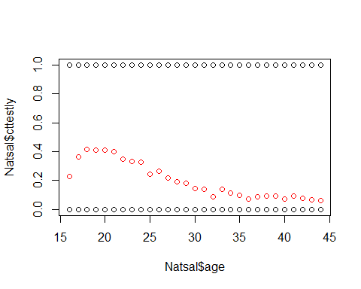

## random effects plots  
lattice::dotplot(ranef(fit, condVar=TRUE))

## $`sex:age`

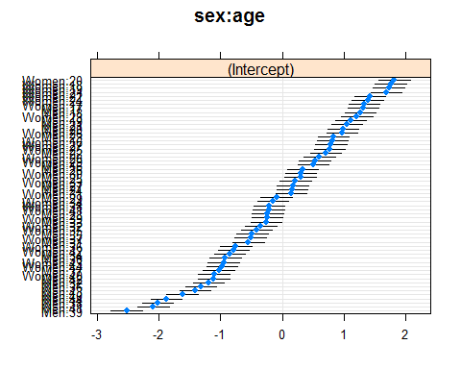

##   
## $gor

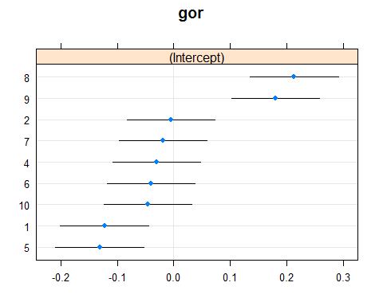

##   
## $ethnic2

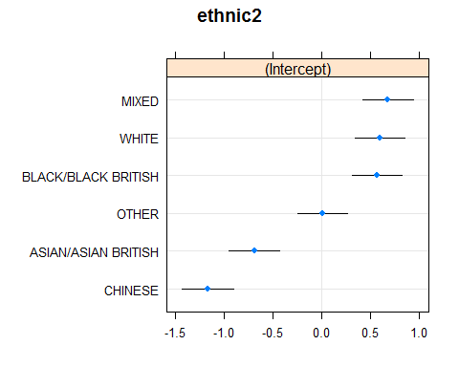

qqmath(fit)

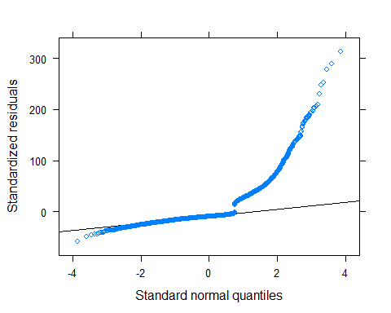

# http://stackoverflow.com/questions/23478792/warning-messages-when-trying-to-run-glmer-in-r  
  
aa <- allFit(fit)  
is.OK <- sapply(aa,is,"merMod")  
## extract just the successful ones  
aa.OK <- aa[is.OK]  
  
lapply(aa.OK,function(x) x@optinfo$conv$lme4$messages) #messages

# Append predictions to joint distribution dataset

formula <- paste(fit@call$formula, collapse = "")  
  
## convert formula to fixed effect model with same variables  
TERMS <- attr(terms(fit@call$formula),"term.labels")  
TERMS <- unlist(strsplit(TERMS, split=" \\| "))  
TERMS <- unlist(strsplit(TERMS, split=":"))  
TERMS <- gsub(" ", "", TERMS, fixed = TRUE)  
TERMS <- TERMS[TERMS!="1" & TERMS!="gor"]  
  
fixeff.formula <- as.formula(paste("cttestly~",paste(TERMS, collapse = "+"),sep=""))  
  
## census data  
# test.calcTotalProbs(sim_prop_la)  
sim_prop_la <- calcTotalProbs(formula=fixeff.formula, data=sim_prop_la, extracols = c("LAname","gor"))  
  
  
pred <- invlogit(fixef(fit)["(Intercept)"] +  
 # (fixef(fit)["sexWomen"]*(sim_prop_la$sex=="Women")) +  
 # (fixef(fit)["studentTRUE"]*sim_prop_la$student) +  
   
 # if(grep("+ethnic2", formula)==1){}  
 # (fixef(fit)["studentTRUE:sexWomen"]*(sim_prop_la$sex=="Women" & sim_prop_la$student)) +  
 # (fixef(fit)["ethnic2ASIAN/ASIAN BRITISH"]*(sim_prop_la$ethnic2=="ASIAN/ASIAN BRITISH")) +  
 # (fixef(fit)["ethnic2BLACK/BLACK BRITISH"]*(sim_prop_la$ethnic2=="BLACK/BLACK BRITISH")) +  
 # (fixef(fit)["ethnic2CHINESE"]*(sim_prop_la$ethnic2=="CHINESE")) +  
 # (fixef(fit)["ethnic2MIXED"]*(sim_prop_la$ethnic2=="MIXED")) +  
 # (fixef(fit)["ethnic2OTHER"]*(sim_prop_la$ethnic2=="OTHER")) +  
 # (fixef(fit)["ethnic2NOT ANSWERED"]*(sim_prop_la$ethnic2=="NOT ANSWERED")) +  
   
 (fixef(fit)["smokenowTRUE"]*sim_prop_la$smokenow) +  
   
 # if(grep("+increasingdrinker", formula)==1){}   
 # (fixef(fit)["increasingdrinkerTRUE"]*sim_prop_la$increasingdrinker)+  
   
 # if(grep("\\(student|age\\)", formula)==1){}  
 # (ranef(fit)$age[as.character(sim_prop_la$age),2]*sim_prop_la$student) +  
   
 # if(grep("\\(1|ethnic2\\)", formula)==1){}  
 ranef(fit)$ethnic2[as.character(sim_prop_la$ethnic2),1] +  
   
 # if(grep("\\(1|sex:age\\)", formula)==1){}  
 ranef(fit)$'sex:age'[paste(sim_prop_la$sex, sim_prop_la$age,sep=":"), 1] +  
   
 # if(grep("\\(increasingdrinker|ethnic2\\)", formula)==1){}  
 # ranef(fit)$ethnic2[as.character(sim_prop_la$ethnic2),"(Intercept)"] +  
 # ranef(fit)$ethnic2[as.character(sim_prop_la$ethnic2),2]*sim_prop_la$increasingdrinker +  
   
 # if(grep("\\(ethnic2|age\\)", formula)==1){}  
 # (ranef(fit)$age[as.character(sim_prop_la$age), "(Intercept)"]) +  
 # (ranef(fit)$age[as.character(sim_prop_la$age), "ethnic2ASIAN/ASIAN BRITISH"]*(sim_prop_la$ethnic2=="ASIAN/ASIAN BRITISH")) +  
 # (ranef(fit)$age[as.character(sim_prop_la$age), "ethnic2BLACK/BLACK BRITISH"]*(sim_prop_la$ethnic2=="BLACK/BLACK BRITISH")) +  
 # (ranef(fit)$age[as.character(sim_prop_la$age), "ethnic2CHINESE"]*(sim_prop_la$ethnic2=="CHINESE")) +  
 # (ranef(fit)$age[as.character(sim_prop_la$age), "ethnic2MIXED"]*(sim_prop_la$ethnic2=="MIXED")) +  
 # (ranef(fit)$age[as.character(sim_prop_la$age), "ethnic2OTHER"]*(sim_prop_la$ethnic2=="OTHER")) +  
 # (ranef(fit)$age[as.character(sim_prop_la$age), "ethnic2NOT ANSWERED"]*(sim_prop_la$ethnic2=="NOT ANSWERED")) +  
  
 # if(grep("\\(1|age\\)", formula)==1){}  
 # ranef(fit)$age[as.character(sim_prop_la$age),1] +  
   
 # if(grep("\\(sex|age\\)", formula)==1){}  
 # ranef(fit)$age[as.character(sim_prop_la$age),"(Intercept)"] +  
 # ranef(fit)$age[as.character(sim_prop_la$age),2]*(sim_prop_la$sex=="Women") +  
   
 # if(grep("\\(1|age.scaled\\)", formula)==1){}  
 # ranef(fit)$age.scaled[as.character(sim_prop_la$age.scaled),1] +  
   
 # if(grep("\\(1|gor\\)", formula)==1){}  
 ranef(fit)$gor[as.character(sim_prop_la$gor),1]  
 )  
  
predweighted <- pred * sim_prop_la$totalprob  
LApred <- tapply(predweighted, sim_prop_la$LAname, sum)

The LA specific post-stratified estimates are then

(out <- data.frame(LApred=LApred[order(LApred)]))

## LApred  
## SLOUGH 0.2509621  
## LEICESTER 0.2580646  
## NEWHAM 0.2605053  
## REDBRIDGE 0.2697894  
## HARROW 0.2791209  
## BRADFORD 0.2791852  
## BIRMINGHAM 0.2844523  
## TOWER HAMLETS 0.2846884  
## OADBY AND WIGSTON 0.2849147  
## HOUNSLOW 0.2886517  
## BRENT 0.2898580  
## BLACKBURN WITH DARWEN 0.2900311  
## EALING 0.2985889  
## COVENTRY 0.2994294  
## DERBY 0.3039231  
## CHARNWOOD 0.3048534  
## SANDWELL 0.3056993  
## OLDHAM 0.3069048  
## SOUTH BUCKS 0.3071952  
## NOTTINGHAM 0.3081484  
## BLABY 0.3082689  
## BROXTOWE 0.3082823  
## WOKING 0.3085116  
## WINDSOR AND MAIDENHEAD 0.3091347  
## WOLVERHAMPTON 0.3096499  
## HARBOROUGH 0.3100285  
## RUTLAND 0.3102975  
## SOUTH NORTHAMPTONSHIRE 0.3105732  
## PENDLE 0.3106263  
## KIRKLEES 0.3120191  
## WYCOMBE 0.3135953  
## RICHMONDSHIRE 0.3147752  
## NEWCASTLE UPON TYNE 0.3152713  
## RUSHCLIFFE 0.3156464  
## SOUTH DERBYSHIRE 0.3159503  
## MIDDLESBROUGH 0.3164336  
## BASSETLAW 0.3164948  
## CRAWLEY 0.3166327  
## GEDLING 0.3172303  
## MELTON 0.3173555  
## DAVENTRY 0.3174481  
## SURREY HEATH 0.3182961  
## SOUTH HOLLAND 0.3183851  
## HINCKLEY AND BOSWORTH 0.3184772  
## NORTHAMPTON 0.3186361  
## STOCKTON-ON-TEES 0.3187761  
## WALSALL 0.3189183  
## DERBYSHIRE DALES 0.3191253  
## LUTON 0.3191351  
## EPSOM AND EWELL 0.3197297  
## RUSHMOOR 0.3208048  
## WALTHAM FOREST 0.3208062  
## WOKINGHAM 0.3213507  
## ROCHDALE 0.3213713  
## EAST NORTHAMPTONSHIRE 0.3215400  
## BOLTON 0.3216294  
## AYLESBURY VALE 0.3216917  
## CHILTERN 0.3216942  
## WELLINGBOROUGH 0.3217618  
## SOUTH KESTEVEN 0.3222571  
## SOLIHULL 0.3223436  
## HILLINGDON 0.3232732  
## SUNDERLAND 0.3232897  
## MILTON KEYNES 0.3238307  
## NORTH KESTEVEN 0.3238418  
## NORTHUMBERLAND 0.3240324  
## MANCHESTER 0.3244012  
## RUGBY 0.3244359  
## GRAVESHAM 0.3245241  
## READING 0.3246395  
## VALE OF WHITE HORSE 0.3246500  
## HIGH PEAK 0.3247017  
## NORTH EAST DERBYSHIRE 0.3251786  
## HART 0.3252701  
## CRAVEN 0.3252931  
## KETTERING 0.3253227  
## RUNNYMEDE 0.3253825  
## WEST LINDSEY 0.3254601  
## EREWASH 0.3258566  
## MOLE VALLEY 0.3259862  
## REIGATE AND BANSTEAD 0.3260832  
## NORTH WEST LEICESTERSHIRE 0.3267036  
## GATESHEAD 0.3268326  
## GUILDFORD 0.3270716  
## SOUTH TYNESIDE 0.3272015  
## WARWICK 0.3277746  
## SOUTH OXFORDSHIRE 0.3278703  
## CHESTERFIELD 0.3283068  
## AMBER VALLEY 0.3283357  
## HYNDBURN 0.3284352  
## DARTFORD 0.3285451  
## TANDRIDGE 0.3285481  
## CALDERDALE 0.3287778  
## NEWARK AND SHERWOOD 0.3290020  
## KENSINGTON AND CHELSEA 0.3290138  
## BRACKNELL FOREST 0.3297757  
## ELMBRIDGE 0.3300593  
## EAST STAFFORDSHIRE 0.3305000  
## HARROGATE 0.3306173  
## EASTLEIGH 0.3307999  
## NORTH TYNESIDE 0.3308982  
## MERTON 0.3309825  
## SHEFFIELD 0.3310957  
## WEST OXFORDSHIRE 0.3314507  
## SHEPWAY 0.3316397  
## TRAFFORD 0.3316477  
## EAST LINDSEY 0.3318251  
## HORSHAM 0.3319546  
## SPELTHORNE 0.3320688  
## TONBRIDGE AND MALLING 0.3320735  
## DUDLEY 0.3322118  
## TEST VALLEY 0.3323555  
## CHERWELL 0.3324177  
## PORTSMOUTH 0.3325876  
## BURNLEY 0.3329222  
## MAIDSTONE 0.3330074  
## DARLINGTON 0.3332081  
## ROTHER 0.3333506  
## BARNET 0.3333756  
## ASHFORD 0.3334272  
## BROMSGROVE 0.3337655  
## REDCAR AND CLEVELAND 0.3339482  
## SHROPSHIRE 0.3340656  
## MALVERN HILLS 0.3340745  
## SOUTH STAFFORDSHIRE 0.3341118  
## CAMDEN 0.3343261  
## OXFORD 0.3345509  
## BOSTON 0.3346243  
## PRESTON 0.3346629  
## BURY 0.3347088  
## LICHFIELD 0.3349718  
## WYRE FOREST 0.3349740  
## EAST HAMPSHIRE 0.3350805  
## ARUN 0.3352013  
## STAFFORD 0.3354200  
## TEWKESBURY 0.3355983  
## NEWCASTLE-UNDER-LYME 0.3356792  
## WAVERLEY 0.3356921  
## HARTLEPOOL 0.3360517  
## ADUR 0.3360801  
## COUNTY DURHAM 0.3360888  
## HAMBLETON 0.3361594  
## TUNBRIDGE WELLS 0.3362814  
## WEST BERKSHIRE 0.3364502  
## CORBY 0.3365218  
## BOLSOVER 0.3366448  
## SOUTHAMPTON 0.3367055  
## NORTH WARWICKSHIRE 0.3371488  
## STOKE-ON-TRENT 0.3371714  
## FAREHAM 0.3372263  
## BASINGSTOKE AND DEANE 0.3373213  
## SEVENOAKS 0.3379959  
## NEW FOREST 0.3386634  
## WEST DORSET 0.3387878  
## NUNEATON AND BEDWORTH 0.3388320  
## SWINDON 0.3391382  
## EAST DORSET 0.3393150  
## WEST DEVON 0.3394593  
## WORTHING 0.3398875  
## MEDWAY 0.3399249  
## WYCHAVON 0.3400962  
## TAUNTON DEANE 0.3401493  
## WILTSHIRE 0.3404003  
## STRATFORD-ON-AVON 0.3404509  
## LEWES 0.3405259  
## FYLDE 0.3406963  
## RIBBLE VALLEY 0.3408316  
## WARRINGTON 0.3411028  
## ASHFIELD 0.3412548  
## BRIGHTON AND HOVE 0.3414298  
## MANSFIELD 0.3414635  
## SOUTH LAKELAND 0.3416452  
## NORTH DORSET 0.3417819  
## EDEN 0.3418736  
## COTSWOLD 0.3419683  
## WEALDEN 0.3420694  
## MID SUSSEX 0.3421502  
## BATH AND NORTH EAST SOMERSET 0.3424748  
## SOUTH GLOUCESTERSHIRE 0.3425098  
## SELBY 0.3425315  
## REDDITCH 0.3427135  
## GOSPORT 0.3427769  
## CHRISTCHURCH 0.3427792  
## ROTHERHAM 0.3428244  
## PURBECK 0.3429430  
## POOLE 0.3430330  
## EXETER 0.3434859  
## ISLE OF WIGHT 0.3435492  
## STOCKPORT 0.3436363  
## YORK 0.3436628  
## TELFORD AND WREKIN 0.3438520  
## NORTH SOMERSET 0.3439968  
## WINCHESTER 0.3443292  
## CHORLEY 0.3446511  
## SWALE 0.3446719  
## EAST DEVON 0.3447088  
## MENDIP 0.3451280  
## STAFFORDSHIRE MOORLANDS 0.3453261  
## LEEDS 0.3453819  
## CROYDON 0.3453923  
## SOUTH HAMS 0.3456727  
## CHESHIRE EAST 0.3458659  
## ROSSENDALE 0.3462329  
## EAST RIDING OF YORKSHIRE 0.3463665  
## THANET 0.3463690  
## TAMESIDE 0.3464111  
## CANNOCK CHASE 0.3474805  
## TAMWORTH 0.3474960  
## HAVANT 0.3475753  
## CHICHESTER 0.3476097  
## NORTH LINCOLNSHIRE 0.3476985  
## HAMMERSMITH AND FULHAM 0.3480153  
## WEST SOMERSET 0.3481580  
## SOUTH RIBBLE 0.3482957  
## EASTBOURNE 0.3483442  
## WAKEFIELD 0.3484531  
## NORTH DEVON 0.3486936  
## MID DEVON 0.3487624  
## SEDGEMOOR 0.3488243  
## TORRIDGE 0.3493651  
## WATFORD 0.3494153  
## BOURNEMOUTH 0.3497387  
## SCARBOROUGH 0.3498322  
## GREENWICH 0.3499397  
## WYRE 0.3500272  
## CHELTENHAM 0.3504008  
## TEIGNBRIDGE 0.3509780  
## KINGSTON UPON THAMES 0.3510539  
## SALFORD 0.3511609  
## RYEDALE 0.3512118  
## LIVERPOOL 0.3515032  
## SEFTON 0.3515326  
## STROUD 0.3518200  
## TORBAY 0.3521458  
## SOUTH SOMERSET 0.3523021  
## SOUTHWARK 0.3525169  
## GLOUCESTER 0.3526013  
## FOREST OF DEAN 0.3527766  
## CANTERBURY 0.3529329  
## BARKING AND DAGENHAM 0.3532281  
## DOVER 0.3533550  
## WEYMOUTH AND PORTLAND 0.3543683  
## DONCASTER 0.3543754  
## WORCESTER 0.3545425  
## KINGSTON UPON HULL, CITY OF 0.3547943  
## HASTINGS 0.3549844  
## WANDSWORTH 0.3556678  
## NORTH EAST LINCOLNSHIRE 0.3557198  
## ST. HELENS 0.3561155  
## WIRRAL 0.3563823  
## HARINGEY 0.3564073  
## CORNWALL 0.3567426  
## LINCOLN 0.3573928  
## PLYMOUTH 0.3576768  
## BARNSLEY 0.3577416  
## CHESHIRE WEST AND CHESTER 0.3579243  
## WIGAN 0.3585708  
## ALLERDALE 0.3588344  
## ISLINGTON 0.3603684  
## COPELAND 0.3610156  
## ENFIELD 0.3612604  
## BARROW-IN-FURNESS 0.3613026  
## HALTON 0.3617968  
## HACKNEY 0.3633355  
## BLACKPOOL 0.3634335  
## LAMBETH 0.3641152  
## CAMBRIDGE 0.3643169  
## LANCASTER 0.3649776  
## BEDFORD 0.3656849  
## SUTTON 0.3667190  
## LEWISHAM 0.3669148  
## CARLISLE 0.3680912  
## KNOWSLEY 0.3707579  
## PETERBOROUGH 0.3731170  
## RICHMOND UPON THAMES 0.3742176  
## WELWYN HATFIELD 0.3760714  
## WEST LANCASHIRE 0.3773348  
## BEXLEY 0.3777977  
## ST ALBANS 0.3796434  
## NORTH HERTFORDSHIRE 0.3811138  
## BROMLEY 0.3812342  
## HERTSMERE 0.3845387  
## BRENTWOOD 0.3851532  
## THREE RIVERS 0.3859537  
## EPPING FOREST 0.3862359  
## CENTRAL BEDFORDSHIRE 0.3866775  
## UTTLESFORD 0.3867389  
## HAVERING 0.3872116  
## EAST CAMBRIDGESHIRE 0.3874328  
## DACORUM 0.3877109  
## EAST HERTFORDSHIRE 0.3879185  
## SUFFOLK COASTAL 0.3890423  
## BABERGH 0.3898290  
## SOUTH CAMBRIDGESHIRE 0.3908462  
## NORTH NORFOLK 0.3921942  
## FOREST HEATH 0.3927067  
## COLCHESTER 0.3937291  
## BASILDON 0.3938321  
## ROCHFORD 0.3960301  
## CHELMSFORD 0.3960324  
## MID SUFFOLK 0.3962114  
## THURROCK 0.3971751  
## BRECKLAND 0.3972978  
## HUNTINGDONSHIRE 0.3976008  
## BROADLAND 0.3978220  
## ST EDMUNDSBURY 0.3983659  
## MALDON 0.3983903  
## KING'S LYNN AND WEST NORFOLK 0.3984057  
## SOUTHEND-ON-SEA 0.3988969  
## HARLOW 0.3990215  
## SOUTH NORFOLK 0.4001112  
## CASTLE POINT 0.4001995  
## BRAINTREE 0.4002037  
## IPSWICH 0.4011139  
## STEVENAGE 0.4015599  
## BROXBOURNE 0.4025270  
## WAVENEY 0.4059742  
## TENDRING 0.4060676  
## NORWICH 0.4065427  
## GREAT YARMOUTH 0.4082915  
## FENLAND 0.4099431

## Re-adjust for conditioning of ages between 16-24

popCensus <- read.csv("..\\..\\packages\\STIecoPredict\\raw-data\\popCensus.csv")  
out$LAname <- rownames(out)  
out <- merge(out, popCensus[popCensus$Sex=="All", c("LAname","prob.25.and.over")])  
out$LApred.adj <- out$LApred*(1-out$prob.25.and.over)  
out[order(out$LApred.adj),]

## LAname LApred prob.25.and.over LApred.adj  
## 75 DERBYSHIRE DALES 0.3191253 0.8962546 0.03310779  
## 210 ROTHER 0.3333506 0.8997499 0.03341844  
## 239 SOUTH NORTHAMPTONSHIRE 0.3105732 0.8909857 0.03385694  
## 82 EAST DORSET 0.3393150 0.9000095 0.03392827  
## 59 CHRISTCHURCH 0.3427792 0.8999479 0.03429578  
## 92 ELMBRIDGE 0.3300593 0.8960633 0.03430528  
## 237 SOUTH LAKELAND 0.3416452 0.8994953 0.03433695  
## 115 HARBOROUGH 0.3100285 0.8882290 0.03465220  
## 67 CRAVEN 0.3252931 0.8933732 0.03468496  
## 57 CHILTERN 0.3216942 0.8918552 0.03478955  
## 81 EAST DEVON 0.3447088 0.8989661 0.03482728  
## 166 MOLE VALLEY 0.3259862 0.8927853 0.03495052  
## 230 SOUTH BUCKS 0.3071952 0.8859246 0.03504341  
## 85 EAST LINDSEY 0.3318251 0.8929196 0.03553195  
## 311 WOKING 0.3085116 0.8847383 0.03555958  
## 102 FYLDE 0.3406963 0.8952742 0.03567968  
## 258 STRATFORD-ON-AVON 0.3404509 0.8946343 0.03587186  
## 299 WEST DEVON 0.3394593 0.8939577 0.03599704  
## 300 WEST DORSET 0.3387878 0.8936985 0.03601364  
## 235 SOUTH HOLLAND 0.3183851 0.8868501 0.03602525  
## 167 NEW FOREST 0.3386634 0.8936169 0.03602807  
## 234 SOUTH HAMS 0.3456727 0.8954600 0.03613662  
## 309 WINDSOR AND MAIDENHEAD 0.3091347 0.8826057 0.03629065  
## 177 NORTH KESTEVEN 0.3238418 0.8877227 0.03636009  
## 4 ARUN 0.3352013 0.8906978 0.03663823  
## 129 HORSHAM 0.3319546 0.8888702 0.03689006  
## 240 SOUTH OXFORDSHIRE 0.3278703 0.8873161 0.03694570  
## 91 EDEN 0.3418736 0.8918046 0.03698915  
## 236 SOUTH KESTEVEN 0.3222571 0.8850529 0.03704251  
## 304 WEST SOMERSET 0.3481580 0.8935464 0.03706266  
## 128 HINCKLEY AND BOSWORTH 0.3184772 0.8835733 0.03707925  
## 295 WEALDEN 0.3420694 0.8915985 0.03708083  
## 120 HART 0.3252701 0.8859537 0.03709586  
## 316 WYCHAVON 0.3400962 0.8905801 0.03721330  
## 154 MALVERN HILLS 0.3340745 0.8884585 0.03726317  
## 158 MELTON 0.3173555 0.8815627 0.03758674  
## 118 HARROGATE 0.3306173 0.8856366 0.03781053  
## 302 WEST LINDSEY 0.3254601 0.8836929 0.03785334  
## 262 SURREY HEATH 0.3182961 0.8810713 0.03785455  
## 198 PURBECK 0.3429430 0.8895907 0.03786408  
## 274 TEWKESBURY 0.3355983 0.8871404 0.03787551  
## 64 COTSWOLD 0.3419683 0.8886864 0.03806572  
## 185 NORTHUMBERLAND 0.3240324 0.8823361 0.03812691  
## 1 ADUR 0.3360801 0.8865339 0.03813368  
## 180 NORTH SOMERSET 0.3439968 0.8889726 0.03819307  
## 174 NORTH EAST DERBYSHIRE 0.3251786 0.8823444 0.03825908  
## 203 REIGATE AND BANSTEAD 0.3260832 0.8826552 0.03826415  
## 73 DAVENTRY 0.3174481 0.8792816 0.03832182  
## 217 RYEDALE 0.3512118 0.8907176 0.03838127  
## 270 TEIGNBRIDGE 0.3509780 0.8904934 0.03843442  
## 280 TORRIDGE 0.3493651 0.8897433 0.03851985  
## 146 LEWES 0.3405259 0.8867311 0.03857100  
## 228 SLOUGH 0.2509621 0.8462844 0.03857679  
## 113 HAMBLETON 0.3361594 0.8850741 0.03863343  
## 268 TANDRIDGE 0.3285481 0.8819970 0.03876968  
## 312 WOKINGHAM 0.3213507 0.8791399 0.03883848  
## 183 NORTH WEST LEICESTERSHIRE 0.3267036 0.8810809 0.03885131  
## 285 VALE OF WHITE HORSE 0.3246500 0.8801639 0.03890479  
## 303 WEST OXFORDSHIRE 0.3314507 0.8825956 0.03891375  
## 20 BLABY 0.3082689 0.8736998 0.03893443  
## 294 WAVERLEY 0.3356921 0.8838712 0.03898351  
## 104 GEDLING 0.3172303 0.8769558 0.03903335  
## 163 MID SUSSEX 0.3421502 0.8857434 0.03909291  
## 224 SEVENOAKS 0.3379959 0.8843114 0.03910228  
## 179 NORTH NORFOLK 0.3921942 0.9002879 0.03910650  
## 86 EAST NORTHAMPTONSHIRE 0.3215400 0.8782770 0.03913882  
## 3 AMBER VALLEY 0.3283357 0.8803760 0.03927682  
## 319 WYRE FOREST 0.3349740 0.8825717 0.03933541  
## 253 STAFFORDSHIRE MOORLANDS 0.3453261 0.8860750 0.03934127  
## 134 ISLE OF WIGHT 0.3435492 0.8854216 0.03936331  
## 232 SOUTH DERBYSHIRE 0.3159503 0.8753656 0.03937829  
## 315 WORTHING 0.3398875 0.8839609 0.03944025  
## 273 TEST VALLEY 0.3323555 0.8812146 0.03947897  
## 36 BROMSGROVE 0.3337655 0.8810744 0.03969328  
## 83 EAST HAMPSHIRE 0.3350805 0.8814070 0.03973822  
## 87 EAST RIDING OF YORKSHIRE 0.3463665 0.8850873 0.03980191  
## 204 RIBBLE VALLEY 0.3408316 0.8828837 0.03991695  
## 214 RUSHCLIFFE 0.3156464 0.8735298 0.03991986  
## 161 MID DEVON 0.3487624 0.8855222 0.03992556  
## 15 BASSETLAW 0.3164948 0.8737244 0.03996557  
## 181 NORTH TYNESIDE 0.3308982 0.8790948 0.04000731  
## 7 AYLESBURY VALE 0.3216917 0.8756342 0.04000745  
## 296 WELLINGBOROUGH 0.3217618 0.8754888 0.04006294  
## 248 SPELTHORNE 0.3320688 0.8793300 0.04007075  
## 148 LICHFIELD 0.3349718 0.8802991 0.04009644  
## 212 RUGBY 0.3244359 0.8756212 0.04035294  
## 38 BROXTOWE 0.3082823 0.8687018 0.04047692  
## 216 RUTLAND 0.3102975 0.8694717 0.04050261  
## 182 NORTH WARWICKSHIRE 0.3371488 0.8798018 0.04052470  
## 137 KETTERING 0.3253227 0.8753492 0.04055172  
## 205 RICHMOND UPON THAMES 0.3742176 0.8916109 0.04056111  
## 98 FAREHAM 0.3372263 0.8796784 0.04057562  
## 259 STROUD 0.3518200 0.8843048 0.04070389  
## 298 WEST BERKSHIRE 0.3364502 0.8787674 0.04078874  
## 136 KENSINGTON AND CHELSEA 0.3290138 0.8759189 0.04082440  
## 168 NEWARK AND SHERWOOD 0.3290020 0.8758900 0.04083243  
## 119 HARROW 0.2791209 0.8531974 0.04097566  
## 279 TORBAY 0.3521458 0.8834477 0.04104340  
## 283 TUNBRIDGE WELLS 0.3362814 0.8779227 0.04105233  
## 14 BASINGSTOKE AND DEANE 0.3373213 0.8780189 0.04114682  
## 282 TRAFFORD 0.3316477 0.8757649 0.04120230  
## 53 CHESHIRE EAST 0.3458659 0.8808637 0.04120519  
## 318 WYRE 0.3500272 0.8821007 0.04126797  
## 2 ALLERDALE 0.3588344 0.8848481 0.04132046  
## 200 REDBRIDGE 0.2697894 0.8466443 0.04137373  
## 172 NORTH DEVON 0.3486936 0.8809998 0.04149462  
## 52 CHERWELL 0.3324177 0.8743189 0.04177862  
## 227 SHROPSHIRE 0.3340656 0.8748315 0.04181448  
## 56 CHICHESTER 0.3476097 0.8795935 0.04185445  
## 95 EPSOM AND EWELL 0.3197297 0.8688940 0.04191847  
## 260 SUFFOLK COASTAL 0.3890423 0.8921397 0.04196221  
## 55 CHESTERFIELD 0.3283068 0.8719785 0.04203032  
## 243 SOUTH STAFFORDSHIRE 0.3341118 0.8741630 0.04204361  
## 126 HIGH PEAK 0.3247017 0.8699608 0.04222396  
## 229 SOLIHULL 0.3223436 0.8688482 0.04227592  
## 278 TONBRIDGE AND MALLING 0.3320735 0.8724810 0.04234568  
## 34 BROADLAND 0.3978220 0.8934467 0.04238926  
## 223 SELBY 0.3425315 0.8762457 0.04238975  
## 173 NORTH DORSET 0.3417819 0.8758670 0.04242642  
## 195 POOLE 0.3430330 0.8762317 0.04245661  
## 152 MAIDSTONE 0.3330074 0.8723421 0.04251102  
## 160 MERTON 0.3309825 0.8711825 0.04263633  
## 255 STOCKPORT 0.3436363 0.8759257 0.04263643  
## 242 SOUTH SOMERSET 0.3523021 0.8788539 0.04268002  
## 165 MILTON KEYNES 0.3238307 0.8678326 0.04279984  
## 307 WILTSHIRE 0.3404003 0.8742227 0.04281463  
## 41 CALDERDALE 0.3287778 0.8697180 0.04283383  
## 58 CHORLEY 0.3446511 0.8756798 0.04284711  
## 226 SHEPWAY 0.3316397 0.8706287 0.04290467  
## 90 EASTLEIGH 0.3307999 0.8699474 0.04302139  
## 249 ST ALBANS 0.3796434 0.8865720 0.04306219  
## 25 BOSTON 0.3346243 0.8713092 0.04306306  
## 8 BABERGH 0.3898290 0.8892385 0.04317803  
## 23 BOLSOVER 0.3366448 0.8715590 0.04323897  
## 130 HOUNSLOW 0.2886517 0.8501907 0.04324271  
## 63 CORNWALL 0.3567426 0.8787630 0.04325039  
## 103 GATESHEAD 0.3268326 0.8674385 0.04332541  
## 79 EALING 0.2985889 0.8545769 0.04342173  
## 96 EREWASH 0.3258566 0.8666746 0.04344495  
## 71 DARLINGTON 0.3332081 0.8693839 0.04352235  
## 238 SOUTH NORFOLK 0.4001112 0.8910998 0.04357219  
## 317 WYCOMBE 0.3135953 0.8608640 0.04363240  
## 221 SEDGEMOOR 0.3488243 0.8745129 0.04377296  
## 6 ASHFORD 0.3334272 0.8684523 0.04386158  
## 77 DOVER 0.3533550 0.8757742 0.04389580  
## 192 PENDLE 0.3106263 0.8584664 0.04396405  
## 80 EAST CAMBRIDGESHIRE 0.3874328 0.8864717 0.04398457  
## 27 BRACKNELL FOREST 0.3297757 0.8665968 0.04399312  
## 220 SCARBOROUGH 0.3498322 0.8739305 0.04410315  
## 159 MENDIP 0.3451280 0.8721001 0.04414184  
## 68 CRAWLEY 0.3166327 0.8605779 0.04414560  
## 61 COPELAND 0.3610156 0.8776722 0.04416224  
## 176 NORTH HERTFORDSHIRE 0.3811138 0.8840977 0.04417195  
## 153 MALDON 0.3983903 0.8891032 0.04418020  
## 78 DUDLEY 0.3322118 0.8664673 0.04436115  
## 28 BRADFORD 0.2791852 0.8409656 0.04440005  
## 252 STAFFORD 0.3354200 0.8673522 0.04449273  
## 162 MID SUFFOLK 0.3962114 0.8873991 0.04461377  
## 88 EAST STAFFORDSHIRE 0.3305000 0.8649982 0.04461809  
## 269 TAUNTON DEANE 0.3401493 0.8682928 0.04480009  
## 178 NORTH LINCOLNSHIRE 0.3476985 0.8710922 0.04482105  
## 40 BURY 0.3347088 0.8660763 0.04482544  
## 241 SOUTH RIBBLE 0.3482957 0.8710115 0.04492614  
## 101 FOREST OF DEAN 0.3527766 0.8725919 0.04494661  
## 123 HAVANT 0.3475753 0.8701205 0.04514289  
## 21 BLACKBURN WITH DARWEN 0.2900311 0.8440003 0.04524477  
## 222 SEFTON 0.3515326 0.8708548 0.04539876  
## 5 ASHFIELD 0.3412548 0.8669362 0.04540864  
## 244 SOUTH TYNESIDE 0.3272015 0.8610556 0.04546280  
## 275 THANET 0.3463690 0.8686116 0.04550887  
## 31 BRENT 0.2898580 0.8427662 0.04557547  
## 231 SOUTH CAMBRIDGESHIRE 0.3908462 0.8832264 0.04564053  
## 201 REDCAR AND CLEVELAND 0.3339482 0.8629415 0.04577044  
## 188 NUNEATON AND BEDWORTH 0.3388320 0.8647624 0.04582284  
## 265 SWINDON 0.3391382 0.8647585 0.04586555  
## 272 TENDRING 0.4060676 0.8869908 0.04588939  
## 284 UTTLESFORD 0.3867389 0.8813230 0.04589700  
## 290 WARRINGTON 0.3411028 0.8654000 0.04591242  
## 305 WEYMOUTH AND PORTLAND 0.3543683 0.8700696 0.04604321  
## 209 ROSSENDALE 0.3462329 0.8669793 0.04605616  
## 72 DARTFORD 0.3285451 0.8597528 0.04607753  
## 106 GOSPORT 0.3427769 0.8651396 0.04622703  
## 32 BRENTWOOD 0.3851532 0.8798137 0.04629014  
## 35 BROMLEY 0.3812342 0.8785680 0.04629402  
## 310 WIRRAL 0.3563823 0.8700835 0.04629996  
## 84 EAST HERTFORDSHIRE 0.3879185 0.8805782 0.04632594  
## 190 OLDHAM 0.3069048 0.8484677 0.04650600  
## 211 ROTHERHAM 0.3428244 0.8642954 0.04652286  
## 286 WAKEFIELD 0.3484531 0.8664131 0.04654877  
## 202 REDDITCH 0.3427135 0.8639589 0.04662314  
## 264 SWALE 0.3446719 0.8645372 0.04669023  
## 219 SANDWELL 0.3056993 0.8471027 0.04674060  
## 132 HYNDBURN 0.3284352 0.8570024 0.04696543  
## 156 MANSFIELD 0.3414635 0.8623958 0.04698679  
## 289 WANDSWORTH 0.3556678 0.8677248 0.04704604  
## 276 THREE RIVERS 0.3859537 0.8780704 0.04705917  
## 54 CHESHIRE WEST AND CHESTER 0.3579243 0.8684547 0.04708326  
## 140 KIRKLEES 0.3120191 0.8490703 0.04709294  
## 208 ROCHFORD 0.3960301 0.8809158 0.04716094  
## 89 EASTBOURNE 0.3483442 0.8645923 0.04716850  
## 287 WALSALL 0.3189183 0.8518180 0.04725796  
## 24 BOLTON 0.3216294 0.8527468 0.04736096  
## 11 BARNSLEY 0.3577416 0.8676083 0.04736203  
## 189 OADBY AND WIGSTON 0.2849147 0.8336245 0.04740281  
## 263 SUTTON 0.3667190 0.8707002 0.04741669  
## 10 BARNET 0.3333756 0.8577256 0.04743081  
## 233 SOUTH GLOUCESTERSHIRE 0.3425098 0.8613117 0.04750210  
## 94 EPPING FOREST 0.3862359 0.8768238 0.04757506  
## 44 CANNOCK CHASE 0.3474805 0.8628443 0.04765891  
## 256 STOCKTON-ON-TEES 0.3187761 0.8503913 0.04769169  
## 39 BURNLEY 0.3329222 0.8566259 0.04773242  
## 107 GRAVESHAM 0.3245241 0.8527741 0.04777836  
## 251 ST. HELENS 0.3561155 0.8654061 0.04793099  
## 292 WATFORD 0.3494153 0.8623436 0.04809925  
## 12 BARROW-IN-FURNESS 0.3613026 0.8667160 0.04815587  
## 293 WAVENEY 0.4059742 0.8810934 0.04827299  
## 22 BLACKPOOL 0.3634335 0.8670340 0.04832431  
## 62 CORBY 0.3365218 0.8563028 0.04835724  
## 48 CENTRAL BEDFORDSHIRE 0.3866775 0.8748302 0.04840037  
## 306 WIGAN 0.3585708 0.8648269 0.04846912  
## 267 TAMWORTH 0.3474960 0.8603804 0.04851726  
## 261 SUNDERLAND 0.3232897 0.8496793 0.04859713  
## 313 WOLVERHAMPTON 0.3096499 0.8424520 0.04878471  
## 30 BRECKLAND 0.3972978 0.8771522 0.04880717  
## 266 TAMESIDE 0.3464111 0.8587557 0.04892859  
## 207 ROCHDALE 0.3213713 0.8473843 0.04904629  
## 215 RUSHMOOR 0.3208048 0.8463676 0.04928601  
## 46 CARLISLE 0.3680912 0.8660744 0.04929682  
## 184 NORTHAMPTON 0.3186361 0.8451874 0.04932889  
## 70 DACORUM 0.3877109 0.8727572 0.04933342  
## 65 COUNTY DURHAM 0.3360888 0.8529363 0.04942645  
## 121 HARTLEPOOL 0.3360517 0.8521313 0.04969154  
## 47 CASTLE POINT 0.4001995 0.8755298 0.04981292  
## 76 DONCASTER 0.3543754 0.8588864 0.05000721  
## 29 BRAINTREE 0.4002037 0.8748582 0.05008222  
## 122 HASTINGS 0.3549844 0.8581945 0.05033872  
## 246 SOUTHEND-ON-SEA 0.3988969 0.8728213 0.05073120  
## 99 FENLAND 0.4099431 0.8755383 0.05102220  
## 131 HUNTINGDONSHIRE 0.3976008 0.8714101 0.05112743  
## 250 ST EDMUNDSBURY 0.3983659 0.8713210 0.05126134  
## 69 CROYDON 0.3453923 0.8513902 0.05132867  
## 308 WINCHESTER 0.3443292 0.8507412 0.05139415  
## 125 HERTSMERE 0.3845387 0.8661840 0.05145741  
## 175 NORTH EAST LINCOLNSHIRE 0.3557198 0.8547810 0.05165727  
## 74 DERBY 0.3039231 0.8298431 0.05171462  
## 288 WALTHAM FOREST 0.3208062 0.8385820 0.05178389  
## 112 HALTON 0.3617968 0.8562473 0.05200926  
## 17 BEDFORD 0.3656849 0.8576956 0.05203857  
## 271 TELFORD AND WREKIN 0.3438520 0.8482105 0.05219311  
## 50 CHELMSFORD 0.3960324 0.8679299 0.05230404  
## 291 WARWICK 0.3277746 0.8401943 0.05238025  
## 116 HARINGEY 0.3564073 0.8514266 0.05295263  
## 206 RICHMONDSHIRE 0.3147752 0.8317720 0.05295400  
## 13 BASILDON 0.3938321 0.8650196 0.05315961  
## 105 GLOUCESTER 0.3526013 0.8485200 0.05341206  
## 171 NEWHAM 0.2605053 0.7945819 0.05351251  
## 114 HAMMERSMITH AND FULHAM 0.3480153 0.8453190 0.05383135  
## 257 STOKE-ON-TRENT 0.3371714 0.8390217 0.05427727  
## 169 NEWCASTLE-UNDER-LYME 0.3356792 0.8378123 0.05444302  
## 110 GUILDFORD 0.3270716 0.8335006 0.05445722  
## 117 HARLOW 0.3990215 0.8634359 0.05449203  
## 124 HAVERING 0.3872116 0.8589430 0.05461891  
## 19 BIRMINGHAM 0.2844523 0.8075361 0.05474680  
## 108 GREAT YARMOUTH 0.4082915 0.8658775 0.05476107  
## 145 LEICESTER 0.2580646 0.7856309 0.05532107  
## 142 LAMBETH 0.3641152 0.8477447 0.05543849  
## 37 BROXBOURNE 0.4025270 0.8621376 0.05549334  
## 193 PETERBOROUGH 0.3731170 0.8509222 0.05562347  
## 157 MEDWAY 0.3399249 0.8355715 0.05589334  
## 18 BEXLEY 0.3777977 0.8519284 0.05594113  
## 127 HILLINGDON 0.3232732 0.8269007 0.05595838  
## 151 LUTON 0.3191351 0.8245390 0.05599577  
## 51 CHELTENHAM 0.3504008 0.8396696 0.05617990  
## 301 WEST LANCASHIRE 0.3773348 0.8504608 0.05642635  
## 277 THURROCK 0.3971751 0.8578363 0.05646390  
## 100 FOREST HEATH 0.3927067 0.8560307 0.05653769  
## 213 RUNNYMEDE 0.3253825 0.8261444 0.05656959  
## 93 ENFIELD 0.3612604 0.8433423 0.05659421  
## 147 LEWISHAM 0.3669148 0.8454347 0.05671228  
## 141 KNOWSLEY 0.3707579 0.8470122 0.05672145  
## 314 WORCESTER 0.3545425 0.8394465 0.05692303  
## 164 MIDDLESBROUGH 0.3164336 0.8193716 0.05715689  
## 109 GREENWICH 0.3499397 0.8347685 0.05782106  
## 139 KINGSTON UPON THAMES 0.3510539 0.8338085 0.05834220  
## 199 READING 0.3246395 0.8190186 0.05875370  
## 43 CAMDEN 0.3343261 0.8237655 0.05891979  
## 218 SALFORD 0.3511609 0.8319631 0.05900798  
## 9 BARKING AND DAGENHAM 0.3532281 0.8321089 0.05930386  
## 254 STEVENAGE 0.4015599 0.8515688 0.05960401  
## 281 TOWER HAMLETS 0.2846884 0.7902409 0.05971598  
## 66 COVENTRY 0.2994294 0.8004494 0.05975132  
## 49 CHARNWOOD 0.3048534 0.8033914 0.05993680  
## 247 SOUTHWARK 0.3525169 0.8298092 0.05999516  
## 111 HACKNEY 0.3633355 0.8341900 0.06024468  
## 26 BOURNEMOUTH 0.3497387 0.8274236 0.06035664  
## 135 ISLINGTON 0.3603684 0.8302481 0.06117321  
## 133 IPSWICH 0.4011139 0.8450408 0.06215630  
## 16 BATH AND NORTH EAST SOMERSET 0.3424748 0.8142162 0.06362629  
## 33 BRIGHTON AND HOVE 0.3414298 0.8098846 0.06491109  
## 144 LEEDS 0.3453819 0.8113852 0.06514416  
## 138 KINGSTON UPON HULL, CITY OF 0.3547943 0.8155835 0.06542991  
## 60 COLCHESTER 0.3937291 0.8330870 0.06571849  
## 320 YORK 0.3436628 0.8087265 0.06573358  
## 194 PLYMOUTH 0.3576768 0.8146921 0.06628034  
## 225 SHEFFIELD 0.3310957 0.7958780 0.06758391  
## 197 PRESTON 0.3346629 0.7978170 0.06766315  
## 150 LIVERPOOL 0.3515032 0.7945585 0.07221334  
## 196 PORTSMOUTH 0.3325876 0.7822320 0.07242693  
## 143 LANCASTER 0.3649776 0.8014817 0.07245471  
## 170 NEWCASTLE UPON TYNE 0.3152713 0.7610754 0.07532605  
## 297 WELWYN HATFIELD 0.3760714 0.7965010 0.07653015  
## 245 SOUTHAMPTON 0.3367055 0.7709503 0.07712228  
## 45 CANTERBURY 0.3529329 0.7795524 0.07780320  
## 97 EXETER 0.3434859 0.7733329 0.07785694  
## 155 MANCHESTER 0.3244012 0.7542648 0.07971681  
## 149 LINCOLN 0.3573928 0.7708403 0.08190004  
## 187 NOTTINGHAM 0.3081484 0.7341226 0.08192969  
## 186 NORWICH 0.4065427 0.7931411 0.08409697  
## 191 OXFORD 0.3345509 0.7312606 0.08990700  
## 42 CAMBRIDGE 0.3643169 0.7430736 0.09360264

gor.names <- c("North East", #1  
 "North West", #2  
 "notused", #3  
 "Yorkshire and The Humber", #4  
 "East Midlands", #5  
 "West Midlands", #6  
 "South West", #7  
 "East", #8  
 "London", #9  
 "South East", #10  
 "Wales", #11  
 "Scotland") #12  
  
pred.logit <- (fixef(fit)["smokenowTRUE"]*sim_prop_la$smokenow) +  
 ranef(fit)$ethnic2[as.character(sim_prop_la$ethnic2),1] +  
 ranef(fit)$'sex:age'[paste(sim_prop_la$sex, sim_prop_la$age,sep=":"), 1]  
  
pred.logit.Natsal <- (fixef(fit)["smokenowTRUE"]*Natsal$smokenow) +  
 ranef(fit)$ethnic2[as.character(Natsal$ethnic2),1] +  
 ranef(fit)$'sex:age'[paste(Natsal$sex, Natsal$age,sep=":"), 1]  
  
# par(mfrow=c(2,1))  
  
for (i in c(1,2,4,5,6,7,8,9,10)){  
 plot(pred.logit[sim_prop_la$gor==i][order(pred[sim_prop_la$gor==i])], sort(pred[sim_prop_la$gor==i]), type="l", ylab="", xlab="")  
 points(pred.logit.Natsal[Natsal$gor==i], Natsal$cttestly[Natsal$gor==i]*0.6+runif(sum(Natsal$gor==i))/100, col=rgb(0.1,0.1,0.1,0.5))  
 # hist(pred.logit.Natsal[Natsal$gor==i & Natsal$cttestly==0], breaks=20, col=rgb(0.1,0.1,0.1,0.5), main="", prob=T, xlim=c(-1,3),ylim=c(0,0.5), xlab="")  
 # hist(pred.logit.Natsal[Natsal$gor==i & Natsal$cttestly==1], breaks=10, col=rgb(0.8,0.8,0.8,0.5), add=T, prob=T)  
 plot(density(pred.logit.Natsal[Natsal$gor==i & Natsal$cttestly==0], prob=T, breaks=30), col="black", type="l", main=gor.names[i], xlim=c(-1,3),ylim=c(0,0.7), xlab="")  
 lines(density(pred.logit.Natsal[Natsal$gor==i & Natsal$cttestly==1], breaks=10), col="darkgrey")  
}

## Warning in density.default(pred.logit.Natsal[Natsal$gor == i & Natsal  
## $cttestly == : non-matched further arguments are disregarded

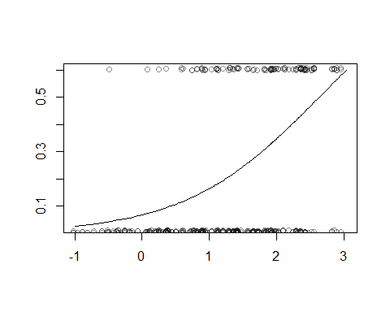

## Warning in density.default(pred.logit.Natsal[Natsal$gor == i & Natsal  
## $cttestly == : non-matched further arguments are disregarded

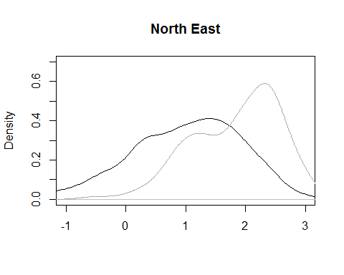

## Warning in density.default(pred.logit.Natsal[Natsal$gor == i & Natsal  
## $cttestly == : non-matched further arguments are disregarded

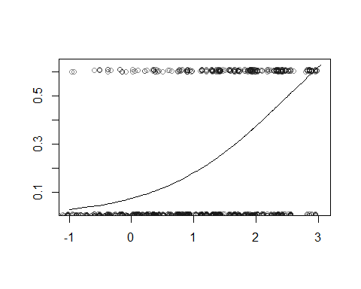

## Warning in density.default(pred.logit.Natsal[Natsal$gor == i & Natsal  
## $cttestly == : non-matched further arguments are disregarded

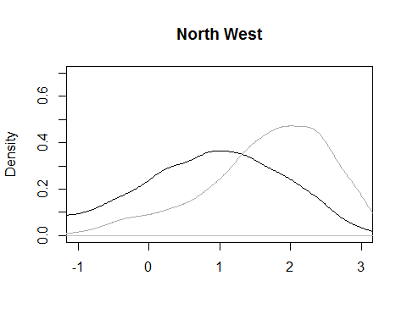

## Warning in density.default(pred.logit.Natsal[Natsal$gor == i & Natsal  
## $cttestly == : non-matched further arguments are disregarded

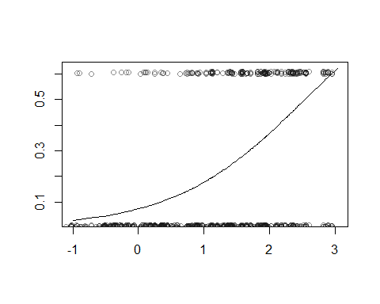

## Warning in density.default(pred.logit.Natsal[Natsal$gor == i & Natsal  
## $cttestly == : non-matched further arguments are disregarded

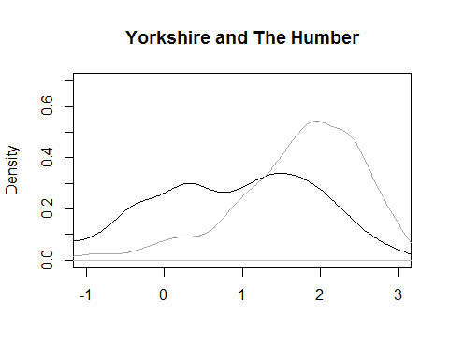

## Warning in density.default(pred.logit.Natsal[Natsal$gor == i & Natsal  
## $cttestly == : non-matched further arguments are disregarded

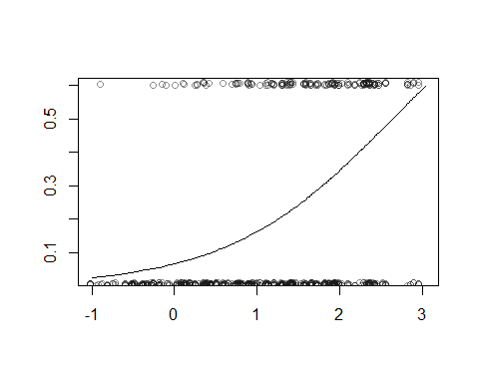

## Warning in density.default(pred.logit.Natsal[Natsal$gor == i & Natsal  
## $cttestly == : non-matched further arguments are disregarded

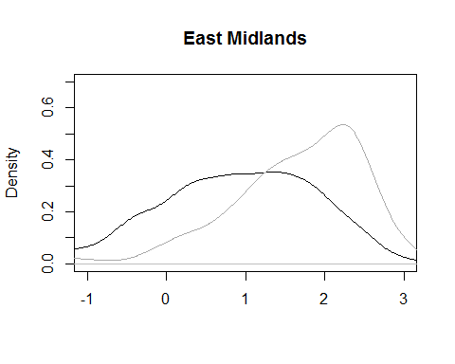

## Warning in density.default(pred.logit.Natsal[Natsal$gor == i & Natsal  
## $cttestly == : non-matched further arguments are disregarded

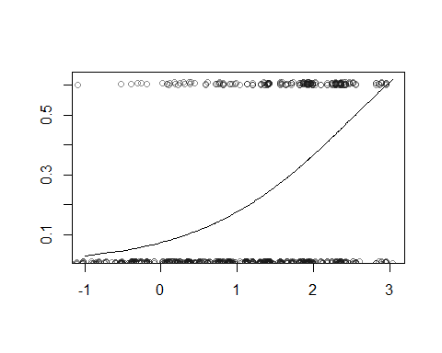

## Warning in density.default(pred.logit.Natsal[Natsal$gor == i & Natsal  
## $cttestly == : non-matched further arguments are disregarded

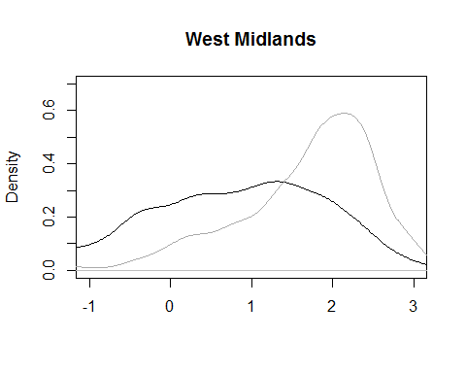

## Warning in density.default(pred.logit.Natsal[Natsal$gor == i & Natsal  
## $cttestly == : non-matched further arguments are disregarded

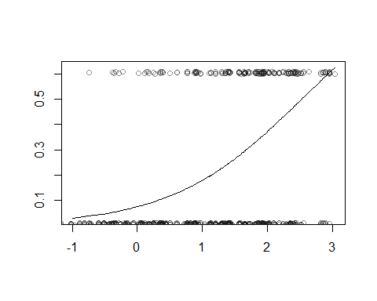

## Warning in density.default(pred.logit.Natsal[Natsal$gor == i & Natsal  
## $cttestly == : non-matched further arguments are disregarded

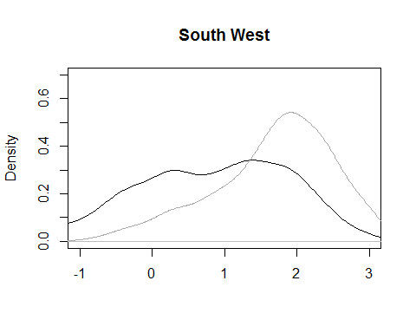

## Warning in density.default(pred.logit.Natsal[Natsal$gor == i & Natsal  
## $cttestly == : non-matched further arguments are disregarded

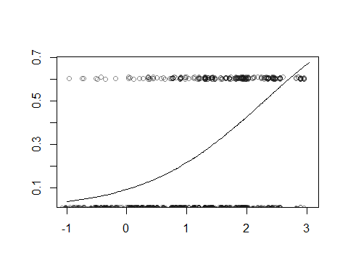

## Warning in density.default(pred.logit.Natsal[Natsal$gor == i & Natsal  
## $cttestly == : non-matched further arguments are disregarded

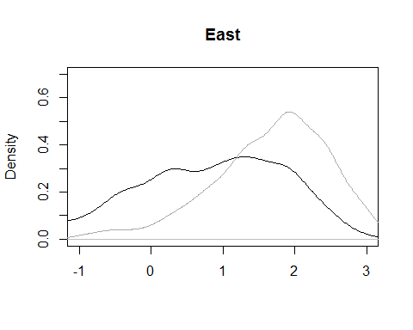

## Warning in density.default(pred.logit.Natsal[Natsal$gor == i & Natsal  
## $cttestly == : non-matched further arguments are disregarded

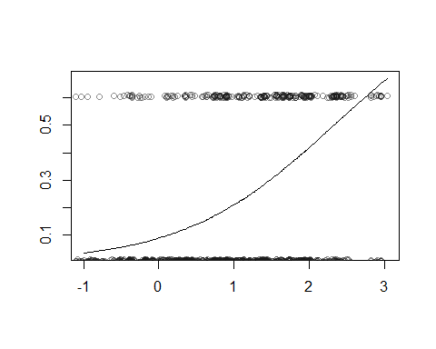

## Warning in density.default(pred.logit.Natsal[Natsal$gor == i & Natsal  
## $cttestly == : non-matched further arguments are disregarded

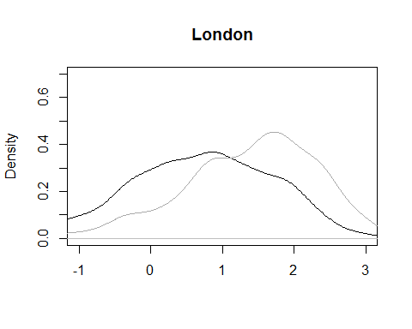

## Warning in density.default(pred.logit.Natsal[Natsal$gor == i & Natsal  
## $cttestly == : non-matched further arguments are disregarded

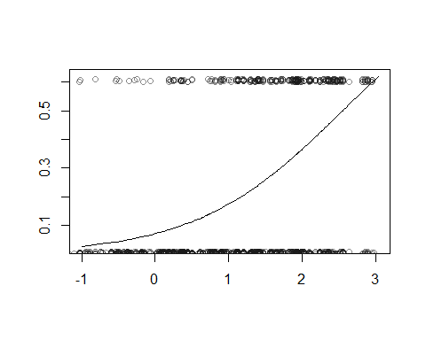

## Warning in density.default(pred.logit.Natsal[Natsal$gor == i & Natsal  
## $cttestly == : non-matched further arguments are disregarded

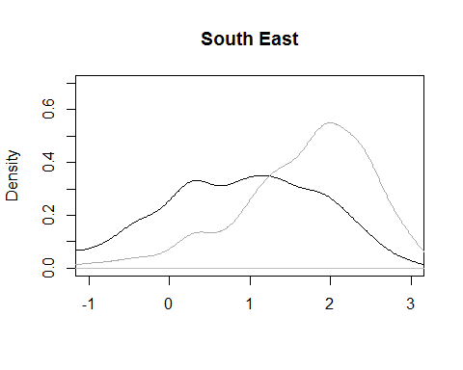

pred.logit <- (fixef(fit)["smokenowTRUE"]*sim_prop_la$smokenow) +  
 ranef(fit)$gor[as.character(sim_prop_la$gor),1] +  
 ranef(fit)$'sex:age'[paste(sim_prop_la$sex, sim_prop_la$age,sep=":"), 1]  
  
pred.logit.Natsal <- (fixef(fit)["smokenowTRUE"]*Natsal$smokenow) +  
 ranef(fit)$gor[as.character(Natsal$gor),1] +  
 ranef(fit)$'sex:age'[paste(Natsal$sex, Natsal$age,sep=":"), 1]  
  
# par(mfrow=c(2,1))  
  
for (i in levels(sim_prop_la$ethnic2)[1:6]){  
 plot(pred.logit[sim_prop_la$ethnic2==i][order(pred[sim_prop_la$ethnic2==i])], sort(pred[sim_prop_la$ethnic2==i]), type="l", ylab="", xlab="", ylim=c(0,0.65))  
 points(pred.logit.Natsal[Natsal$ethnic2==i], Natsal$cttestly[Natsal$ethnic2==i]*0.6+runif(sum(Natsal$ethnic2==i))/100, col=rgb(0.1,0.1,0.1,0.5))  
 # hist(pred.logit.Natsal[Natsal$ethnic2==i & Natsal$cttestly==0], breaks=20, col=rgb(0.1,0.1,0.1,0.5), main="", prob=T, xlim=c(-1,3),ylim=c(0,0.5), xlab="")  
 # hist(pred.logit.Natsal[Natsal$ethnic2==i & Natsal$cttestly==1], breaks=10, col=rgb(0.8,0.8,0.8,0.5), add=T, prob=T)  
 plot(density(pred.logit.Natsal[Natsal$ethnic2==i & Natsal$cttestly==0]), col="black", type="l", main=i, xlim=c(0,2.5),ylim=c(0,0.7), xlab="")  
 lines(density(pred.logit.Natsal[Natsal$ethnic2==i & Natsal$cttestly==1]), col="darkgrey")  
}

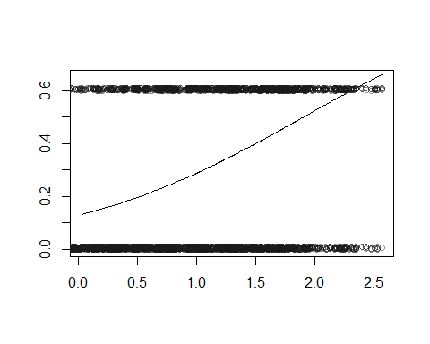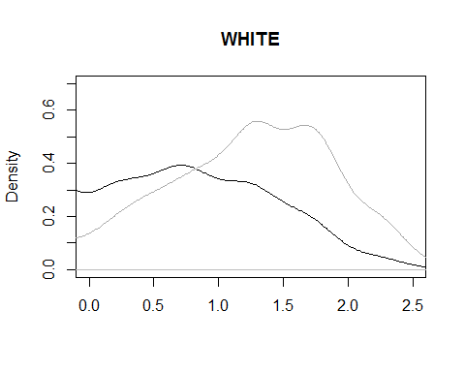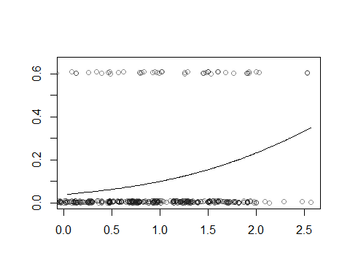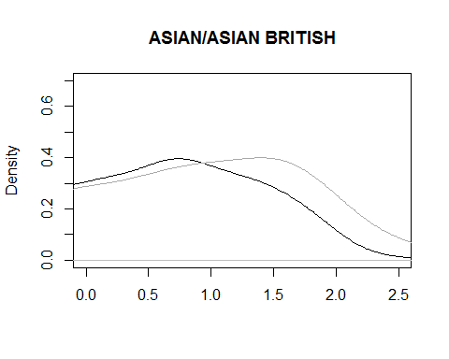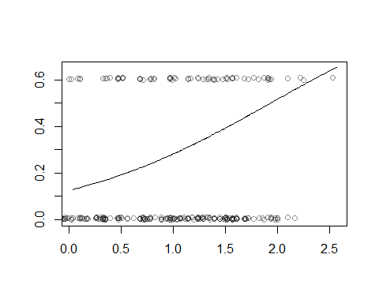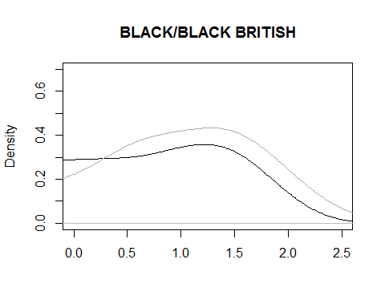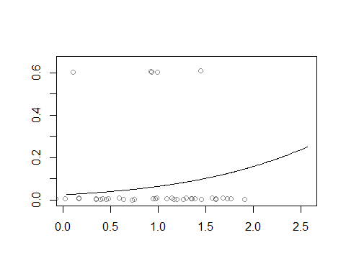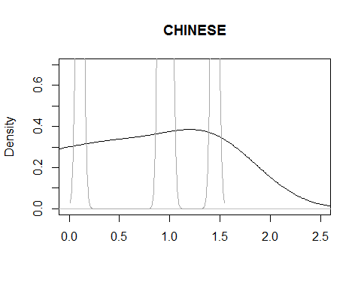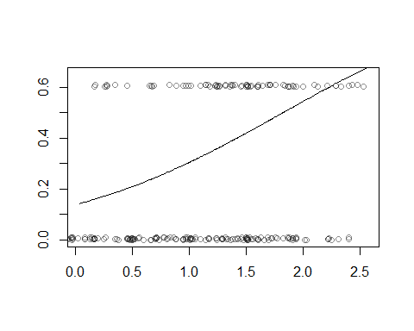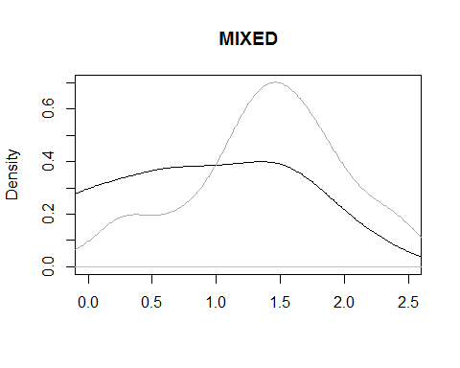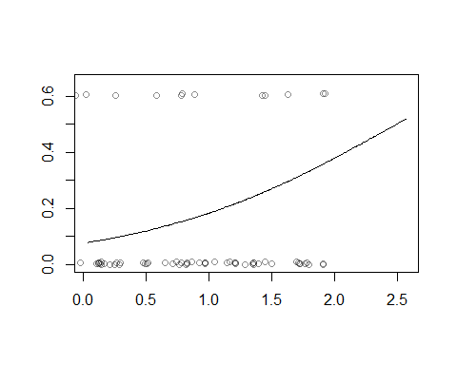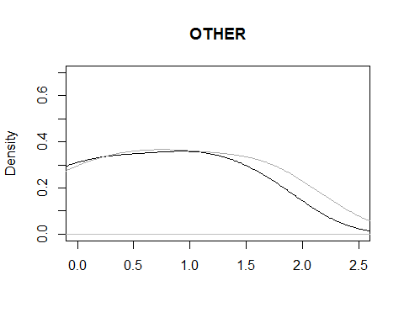

# Simpler models

## complete pooling

fit <- lm(formula = cttestly ~ 1,  
 data = Natsal, family = binomial(link="logit"))

# No pooling: separate estimate within each Region

fitsep <- list()  
for (i in unique(Natsal$gor)){  
 fitsep[[i]] <- update(fit, data=Natsal[Natsal$gor==i])  
  
 # fitsep[[i]] <- glmer(formula = cttestly ~ (1|sex)+(1|age)+(1|ethnic2)+smokenow+increasingdrinker+(1|gor),  
 # data = Natsal[Natsal$gor==1], family = binomial(link="logit"))  
}

pred <- invlogit(fixef(fit)["(Intercept)"] +  
 (fixef(fit)["sexWomen"]*(LApop$sex=="Women")) +  
 ranef(fit)$age[as.character(LApop$age),1]  
 )  
  
predweighted <- pred * LApop$pop.adj  
LApred <- tapply(predweighted, LApop$Name, sum)

The LA specific post-stratified estimates are then

as.data.frame(LApred[order(LApred)])