Museums and Galleries

**The Queensland Art Gallery | Gallery of Modern Art (QAGOMA)**

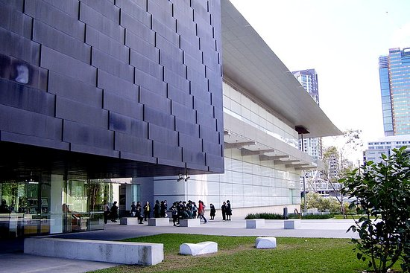

Open daily 10.00am – 5.00pm

Address: Stanley Pl, South Brisbane QLD 4101, Australia

Contact Number: +61 7 3840 7303

Website: <https://www.qagoma.qld.gov.au>

The Queensland Art Gallery | Gallery of Modern Art (QAGOMA) is a single institution located across two adjacent river-side buildings in the Cultural Precinct at Brisbane's South Bank. Our vision is to be the leading institution for the contemporary art of Australia, Asia and the Pacific.

QAGOMA holds a [Collection](https://www.qagoma.qld.gov.au/learn/collection) of over 17,000 works of historical, modern and contemporary art, and stages a dynamic program of Australian and international [exhibitions](https://www.qagoma.qld.gov.au/whats-on/exhibitions). We are home to the [Children's Art Centre](https://www.qagoma.qld.gov.au/learn/kids/home) which collaborates on interactive artworks with leading artists from around the world, and the [Australian Cinémathèque](https://www.qagoma.qld.gov.au/whats-on/cinema), the only dedicated cinema facility in an Australian art museum.

QAGOMA operates its own [retail outlets](http://www.australianartbooks.com.au/) and [cafes and restaurants](https://www.qagoma.qld.gov.au/visit/eat-and-drink), proceeds from which support the Gallery.

**Museum of Brisbane**

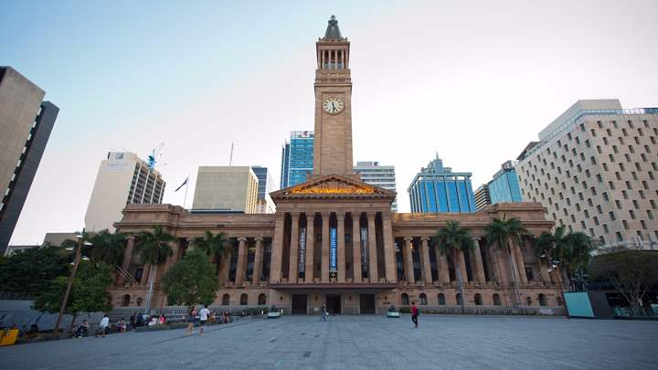

Opening Hours: Open 7 days a week, 10am – 5pm, and 10am – 7pm Fridays

Address: Level 3, City Hall | King George Square, Brisbane, Queensland 4001, Australia

Contact Number: +61 7 3999 0800

Website: <http://www.museumofbrisbane.com.au>

Free Entry

Located in City Hall, the Museum is part of the living history of the city, examining how Brisbane and its people change over time and how our individual and collective stories reveal our character and create our identity.

We are also the keeper of City Hall’s rich heritage, and visitors can experience a bird’s eye view of Brisbane from the top of the iconic Clock Tower on one of our popular tours, as well as learn the stories behind City Hall during an insider’s tour of the 90-year-old building.

Museum of Brisbane is an avid supporter of the city’s artists, designers, and artisans. We are dedicated to transforming their artistic vision into a stunning reality through our exhibitions and artist-in-residence programs. The work of Brisbane’s artists, designers and chefs can also be found at MoB Shop which stocks a bespoke range of jewelry, fashion accessories, homewares, design objects, books, artworks and gourmet food products.

Museum of Brisbane opened in October 2003, replacing the Brisbane City Gallery, on the ground floor of City Hall.

In 2010, when City Hall closed for restoration, the Museum temporarily relocated to Ann Street.

It re-opened after a significant refurbishment to City Hall in April 2013.

Reopening in 2013 in a purpose-built gallery on Level 3, Museum of Brisbane is the jewel in the crown of the revitalised City Hall, offering views of two of the building’s most beautiful features – the clock tower and copper dome.

**Queensland Museum**

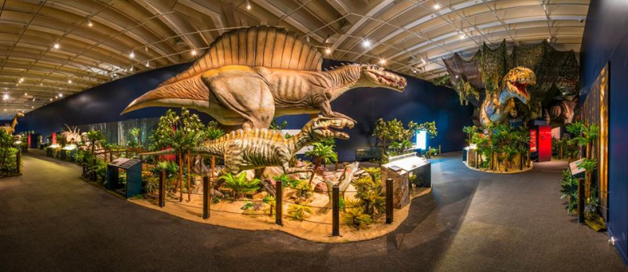

Open daily from 9.30am - 5.00pm.

Address: Grey St & Melbourne St, South Brisbane QLD 4101, Australia

Contact Number: +61 7 3840 7555

Website: <http://www.qm.qld.gov.au>

General admission is free.

Queensland Museum is a museum of natural history, cultural heritage, science and human achievement that tells the changing story of Queensland.

The Museum houses permanent and changing exhibitions and also provides in-depth education experiences, innovative public programs, early childhood activities and entertaining holiday activities. We aim to connect visitors to Queensland, its people and Queensland’s place in the world - past, present and future, through exhibitions, displays and public programs.

Behind the scenes, the Museum is home to millions of objects, specimens and artefacts that tell the changing story of Queensland.

A popular destination for South East Queenslanders as well as visitors from around Australia and overseas, the Museum has welcomed over 10 million visitors since it was established at its current site at South Bank over 20 years ago.

Part of Brisbane's Cultural Precinct, Queensland Museum is within walking distance of the Queensland Art Gallery, Gallery of Modern Art, Queensland Performing Arts Centre and the State Library of Queensland. The Cultural Precinct sits alongside South Bank, a vibrant mix of parkland, recreational and commercial space on the Brisbane River across from the Central Business District.

**Queensland Maritime Museum**

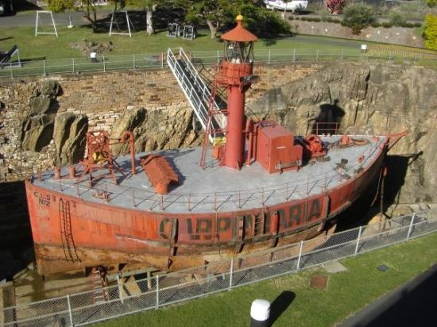

Open daily 9.30am to 4.30pm.

Address: Southbank | (near the Goodwill Bridge), Brisbane, Queensland 4101, Australia

Contact Number: +61 7 3844 5361

Website: <https://maritimemuseum.com.au>

Entry Fee:

Adult $16

Child $7

Family $38 (includes 2 adults and up to 3 children under 15)

Pensioners, Senior and Students with card $14

The Queensland Maritime Museum was founded in 1971 and is run by a self-funded voluntary Association. It is situated on the banks of the Brisbane River at the southern end of South Bank Parklands. The Museum contains extensive collections of historical maritime artifacts, books, documents and photographs. The collection is displayed to the public in the galleries and grounds of the Museum under the broad headings of Navigation, Lighthouses, Ship Models, Marine Engines, Vessels, and the Dry Dock.

**Sir Thomas Brisbane Planetarium**

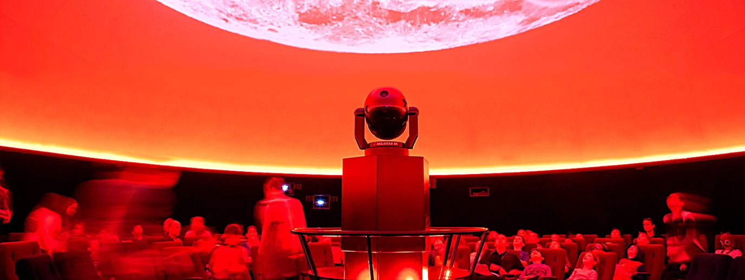

Open Tuesday-Friday from 10am to 4pm; Saturday from 11am-8:15pm; Sunday 11am-4pm

Address: Mount Coot Tha Rd, Toowong QLD 4066, Australia

Contact Number: +61 7 3403 2578

Website: <https://www.brisbane.qld.gov.au/facilities-recreation/arts-culture/planetarium/visiting-planetarium>

Entry Fee:

* adults: $15.80
* children (3-14 years): $9.60
* concession card holders: $13

Authorised Companion: free.

The Sir Thomas Brisbane Planetarium was established in 1978 by Brisbane City Council. Located within Brisbane's Mt Coot-tha Botanic Gardens, the Planetarium is home of the Cosmic Skydome, a 12.5-metre-diameter projection dome.

Enjoy a show in the Cosmic Skydome, take a tour of Brisbane's current night sky with one of our astronomers or visit the Planetarium's Display Zone to take an astronomical journey from the present day Solar System to the time of the Big Bang.

**Old Government House**

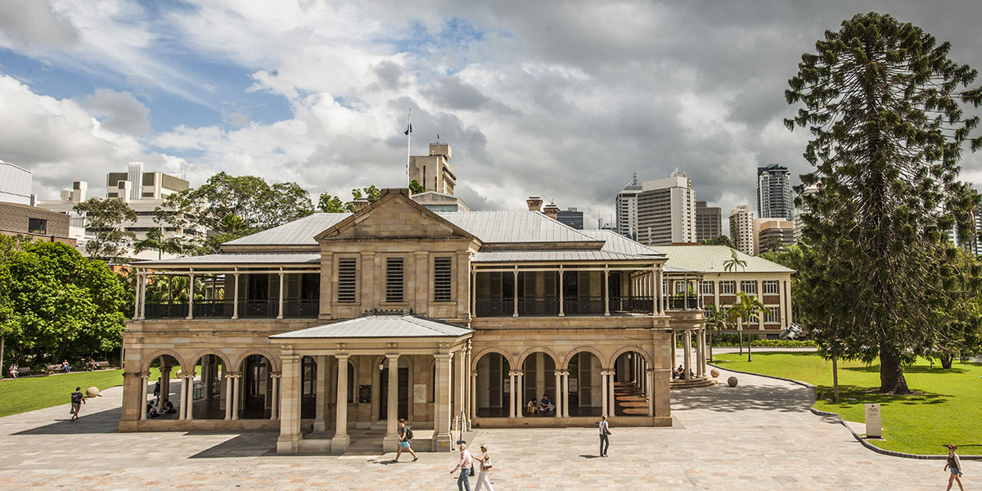

Open Tuesday-Friday, Sunday from 10am to 4pm

Address: 2 George Street Brisbane QLD 4001Australia

Contact Number: (+61 7) 3138 8005

Website: <http://www.ogh.qut.edu.au/visiting/>

Email: [ogh.enquiries@qut.edu.au](mailto:ogh.enquiries@qut.edu.au)

Entry Fee: General Admission is Free

Old Government House was the hub of colonial life in the early days of Brisbane. Constructed between 1860 and 1862, shortly after Queensland achieved separation from New South Wales, the House was Queensland's first public building. A rare surviving example of the domestic work of Queensland's first Colonial Architect Charles Tiffin, the House was both a private residence and official state office for Governor Bowen, the colony's first governor, and continued to be the home of Queensland's governors until 1910.

Old Government House successively became the University of Queensland's inaugural building (1910-1972) and the headquarters of the National Trust of Queensland (1972-2002). As one of Queensland's most significant historical buildings, it was the first building in the state to be heritage listed in 1978. In 2002, the Queensland University of Technology accepted custodial responsibility for the House and undertook a lengthy restoration project. This included the delivery of an interpretative multimedia centre to highlight the cultural and historical significance of each part of this landmark colonial building.

Old Government House was reopened to the public in June 2009 as an historic house museum, a gallery housing the works of renowned Australian artist William Robinson and an elegant venue available to hire for private functions. Located centrally in Brisbane adjacent to the City Botanic Gardens, the House stands with renewed grandeur within the Gardens Point Campus of QUT.

**Queensland Performing Arts Centre**

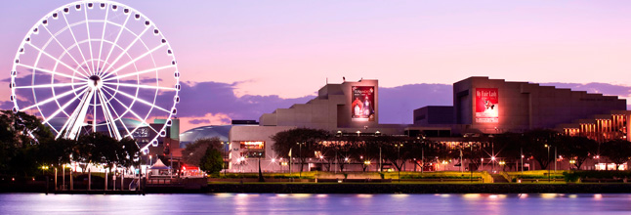

Address: Grey St & Melbourne St, South Brisbane QLD 4101, Australia

Contact Number: **136 246**

Website: https://www.qpac.com.au

Email: qpac.reception@qpac.com.au

Queensland Performing Arts Centre (QPAC) is one of Australia's leading centres for live performance. Welcoming over 1.3 million visitors to more than 1,200 performances each year, we embrace the best in live performance – the world renowned alongside the emerging, local and new – and connect to the stories and ideas at the heart of each production. Through the warmth and expertise of our staff, we have become a trusted curator, presenter and host; a place to come together to relax, reflect, share stories and celebrate.

QPAC is located in the vibrant cultural and educational precinct at South Bank that encompasses the Cultural Precinct (QPAC, Queensland Art Gallery | Gallery of Modern Art, Queensland Museum and State Library of Queensland) as well as Griffith University, Queensland University of Technology, Opera Queensland, Queensland Symphony Orchestra, Queensland Theatre, Merivale Street Studio, The Australian Broadcasting Corporation and Brisbane Convention and Exhibition Centre. This precinct is unique in Australia in size and character.

At the heart of QPAC's activities is the aim to cultivate excellence in cultural thinking, planning and delivery and help build the success of art in Queensland. QPAC strives to be a place that is readily accessible, filled with people learning, exploring and having fun.

Malls

**Queen Street Mall**

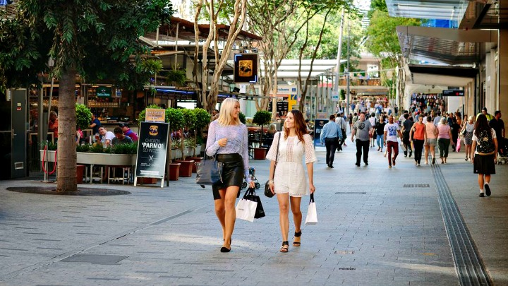

Open Monday-Sunday (times are dependent on individual stores)

Address: Queen Street mall, Queen St, Brisbane City QLD 4000, Australia

Contact Number: +61 7 3006 6290

Website: http://www.visitbrisbane.com.au/the-city/things-to-do/shopping/queen-street-mall?sc_lang=en-au

Email: [qsm@brisbanemarketing.com.au](mailto:qsm@brisbanemarketing.com.au)

The Queen Street Mall is a vibrant shopping and lifestyle precinct that lies at the heart of Brisbane City and is Australia's most popular pedestrian mall, playing host to more than 26 million visitors a year.

The mall offers an unrivalled mix of local, national and international labels and flagship stores. More than 700 retailers have made their homes here – many enjoy mall and street frontage, others are tucked away inside world-class centres and heritage-listed arcades. Must-visits include the sparkling high-end [QueensPlaza](http://www.visitbrisbane.com.au/the-city/things-to-do/shopping/queensplaza), [Wintergarden](http://www.visitbrisbane.com.au/the-city/things-to-do/shopping/wintergarden) with its diverse range of retailers, the magnificent and historically significant [Brisbane Arcade](http://www.visitbrisbane.com.au/the-city/things-to-do/shopping/brisbane-arcade) and [Tattersall's Arcade](http://www.visitbrisbane.com.au/the-city/things-to-do/shopping/tattersall-s-arcade), the convenient [MacArthur Central](http://www.visitbrisbane.com.au/brisbane/things-to-do/shopping/macarthur-central) and the ever-popular [The Myer Centre](http://www.visitbrisbane.com.au/the-city/things-to-do/shopping/the-myer-centre).

The Queen Street Mall is not merely the state's shopping hotspot, it is also Brisbane's heart – the place you head with friends and family if it's fun and entertainment you seek. More than 1,000 events take place throughout the mall each year, buskers take over the streets on a daily basis and The City Sounds fills the air with music on Friday nights and weekends. In addition, there is an [Event Cinema](http://www.visitbrisbane.com.au/the-city/things-to-do/arts-and-entertainment/cinemas/event-cinemas-brisbane-city-myer-centre), countless eateries, a [farmers market](http://www.visitbrisbane.com.au/the-city/whats-on/eat-and-drink/jan-power-s-city-farmers-market), beauty salons, the [Treasury Casino and Hotel](http://www.visitbrisbane.com.au/the-city/accommodation/hotels-and-resorts/treasury-casino-and-hotel), a [Hilton Hotel](http://www.visitbrisbane.com.au/the-city/accommodation/hotels-and-resorts/hilton-brisbane) and [NEXT Hotel](http://www.visitbrisbane.com.au/the-city/accommodation/hotels-and-resorts/next-hotel) that all take pride of place on the mall. And [parklands](http://www.visitbrisbane.com.au/the-city/quick-guides/nature-in-the-city), [museums](http://www.visitbrisbane.com.au/the-city/quick-guides/arts-and-entertainment-in-the-city), galleries, cafes, [day spas](http://www.visitbrisbane.com.au/things-to-do/health-and-beauty/pampering-day-in-the-city), [restaurants](http://www.visitbrisbane.com.au/the-city/quick-guides/eat-and-drink-in-the-city) and [bars](http://www.visitbrisbane.com.au/the-city/quick-guides/bars-in-the-city) are all within walking distance from the mall.

The Queen Street Mall truly is Queensland’s premier shopping and entertainment destination.

**James Street Precinct**

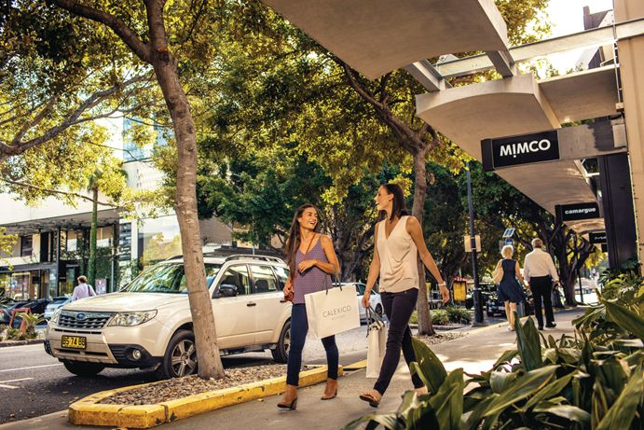

Open Monday-Sunday (times are dependent on individual stores)

Address: James St, Fortitude Valley, QLD 4006 Australia

Contact Number: +61 7 3850 0111

Website: <http://www.jamesst.com.au>

Email: [info@jamesst.com.au](mailto:info@jamesst.com.au)

James Street is a two minute stroll from the heart of Fortitude Valley and is without a doubt the place to be seen. Locals gather here to enjoy a crisp glass of white, a classic cocktail or a delicious bite to eat at the chic bars and cafes that line the street.

For day time pleasures, the James Street Market is a hot spot with its range fresh fruit, vegetables and meat, while movie buffs can get their fix at Palace Centro Cinemas.

James Street also houses an array of fashion and homeware retailers that has earned it a reputation as one of Brisbane's most stylish strips. Must-shops include Kisses, Little Kisses, Sass & Bide, Scanlan and Theodore, Mimco, Swedish Style, D.I.Q, Magnolia Interiors, Novo, Little Joe, and The Standard.

**DFO**

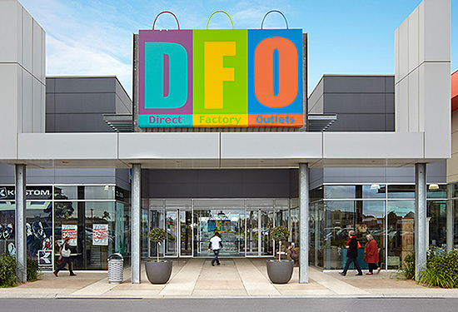

Open Monday-Sunday 10am-6pm

Address: 18th Avenue, Skygate, Brisbane Airport QLD 4008

Contact Number: 07 3305 9250

Website: <https://www.dfo.com.au/brisbane/>

Email: [DFOBrisbane.Reception@vicinity.com.au](mailto:DFOBrisbane.Reception@vicinity.com.au)

Next to Brisbane Airport, this retail super hub offers shoppers more than 120 leading Australian and international brands at up to 70 per cent lower prices - all under one roof.

With so many brands to choose from, you are sure to find what you're looking for, including fashion, shoes, handbags, luggage, homewares, manchester and jewellery.

**Westfield Carindale Shopping Centre**

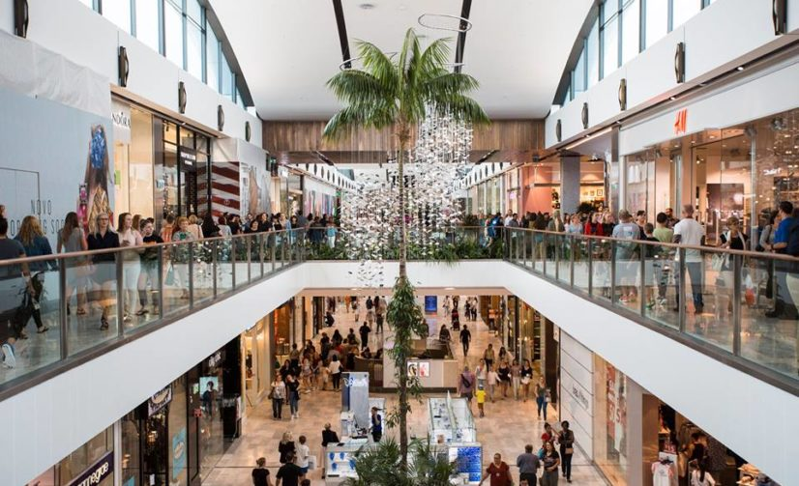

Find the closest Westfield Shopping Centre to you using this link: <https://www.westfield.com.au>

Website: <https://www.westfield.com.au>

Email: info@westfield.com

Chermside Address: [Cnr Gympie & Hamilton Rds Chermside/Brisbane QLD 4032](https://www.westfield.com.au/chermside/centre-info/map)

**Chermside phone numbers:** [3117 5300](tel:(07)%203117%205300)

Carindale Address:

One of many Westfield Centres in Brisbane

Zoos

Restaurants