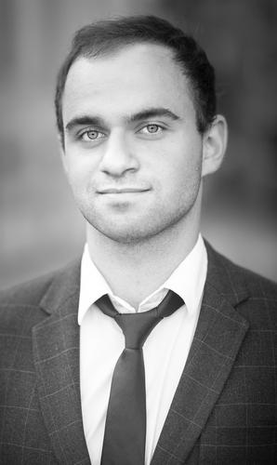**Sibirli A. Emin**

Objective:Junior lawyer

 Address: Russia, Moscow, st. Leninskie gori, 1

 +7 (962) 992 69 22

 emin.sibirli@gmail.com

Age: 24

**EDUCATION**

|  |  |
| --- | --- |
| 2013 – 2018  **Skills developed** | **Lomonosov Moscow State University (MSU)**  Faculty of Law. Bachelor of Civil Law (BCL)    Independent project works have developed my analytical thought, accuracy and ability to organize and manage projects. |

Research papers:

|  |  |
| --- | --- |
| ***2013***  ***2014***  ***2015***  ***2017***  ***2018*** *(diploma work)* | The bodies of local self – government as the cornerstone of civil society.  Invalidity of transactions in Russian Civil law.  The constitutional basis for Land rights.  Legal aspects of Blockchain Technology.  The emergence of rights to land contracts and other land transactions |

**EXPERIENCE**

|  |  |
| --- | --- |
| Jan 2016 – Aug 2016  Sep 2016 – Dec 2016  July 2017 – Aug 2017    June 2018 – Aug 2018  (labor contract)    **Duties included** | **Corona LLC, Russia**  Junior Associate    **Novosibirsk Economic Bar Association (NECA)**  Legal Assistant  **Ingosstrakh Insurance Company**  Summer Legal Trainee    **Liniya Prava Law Firm**  Junior Lawyer   * drafts and editing of legal documents (contracts, legal opinions, power of attorney, legal opinions) * pre-trial dispute settlement (claim work, negotiations) * assistance to senior lawyers in court proceedings * legal due diligence for M&A practice * analysis of judicial practice, law reforms * interaction with the notaries, state authorities |
| **CASES** |  |

* Risk analysis of supply agreement for a major manufacturer of carbonated beverages.
* Negotiations on the terms of lease of commercial premise for the chain of liquor stores.
* Editing the frame contract for the supply of goods to a leading retail company.
* Drafting an agreement on termination of the obligation by replacement of performance for 500.000 rubles.
* Drafting a claim to the subcontractor for violation of terms of performance and quality of construction works for 2.5М rubles.

|  |  |
| --- | --- |
| **Areas of interest**  **Computer skills**  **Languages**  **Personality** | Corporate (M&A, JV), Real Estate, Private Equity, IP  MS Office, My arbiter, Garant, Consultant +, Dropbox, Adobe  Russian (native), English (upper - intermediate), French (A1)  - Confident, proactive, responsible, result oriented  - Able to work equally as a team member and independently  - Focused on personal growth and professional development |
|  |  |

**REFERENCES**

|  |  |
| --- | --- |
| **Academic**  **Employer** | **Alyona N. Kucher**,  Associate Professor of the Civil Law Department of Lomonosov Moscow State University (MSU); Partner of Debevoise & Plimpton (Moscow office)  *Email: ankucher@debevoise.com*  **Novikova V. Svetlana,**  Chairman of the Novosibirsk Economic Bar Association (NECA)  *Email: snvikva@gmail.com* |