11 Wavelength Shifting Fiber 11-2
11.1 Introduction 11-2
11.2 Technical Design Criteria 11-2
11.3 The NOνA Wavelength Shifting Fiber 11-2
11.3.1 Overview 11-2
11.3.2 NOvA fiber diameter 11-3
11.3.3 Fiber Survival in Liquid Scintillator 11-3
11.4 Dye Concentration in NOνA Fiber 11-4
11.4.1 Studies of Kuraray Fibers (Batch1) 11-6
11.4.2 Studies of Kuraray Fiber (Batch 2) 11-7
11.4.3 Studies with APDs 11-9
11.4.4 Summary of Observed Fluctuations 11-9
11.5 Measurement Methods for NOνA Fiber Technical Criteria 11-9
11.5.1 Quality Assurance Instruments developed for Fiber Tests 11-9
11.5.2 Fiber Transportation and QA Testing Plan 11-11
11.6 Changes in the Fiber design since the CDR 11-12
11.7 Work Remaining to Complete the Fiber Design 11-12
11.8 Chapter 11 References 11-12

Wavelength Shifting Fiber

Introduction
Plastic wavelength shifting (WLS) fibers provide an efficient method for collecting light generated in the long liquid scintillator filled cells of the detector. The violet light (~425nm) emitted by the scintillator is absorbed by a fluorescent dye in the WLS fiber. The blue-green (450 – 650 nm) light emitted by the dye is partially trapped within the fiber by total internal reflection. Once trapped much of the short wavelength light (< 520 nm) is attenuated while traveling through a full length of WLS fiber, however, the longer wavelengths are only weakly attenuated. This light coupled with the high quantum efficiency of avalanche photodiodes at long wavelengths yields a strong signal for minimum ionizing particles traversing anywhere along the length of a cell. To instrument the 15 kT NOνA detector, 13,000 kilometers of fiber are required.

Technical Design Criteria
NOvA scientific performance requirements (see Chapter 4) can be met with a mean signal of at least 20 photoelectrons for minimum ionizing particles through the far end of the 15.5 m long NOνA cell. The combined effects of the Scintillator, PVC cell walls, and the Wavelength Shifting Fiber determine the amount of light reaching the APD (See Chapter 5). For the WLS fiber this translates into two technical design criteria:
- Capture fraction for the scintillation light, and
- An effective attenuation length for light transmitted through ~16 meters of fiber.

A large fiber diameter will maximize the capture fraction, however, the diameter is limited by the need to fit a loop of fiber safely into the cell cross section. A high concentration of K27 fluorescent dye in the fiber will improve the capture fraction but worsen the attenuation length for short wavelength light. Required therefore, is an experimental optimization dependent on the details of the cell shape, wall reflectivity, the number and diameter of the fibers, and the photodetector quantum efficiency (see chapter 6).
The WLS fiber also must survive emersion in liquid scintillator for the 20-year lifetime of the experiment.

The NOνA Wavelength Shifting Fiber

Overview
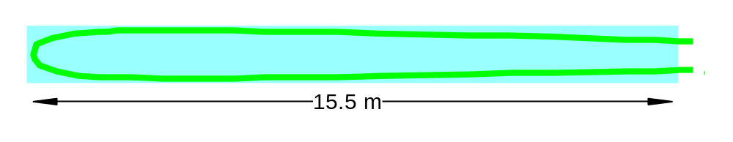
To maximize light collection and transmission at a reasonable cost and to satisfy the experiment’s mechanical constraints, NOνA will use loop of a 0.7 mm diameter fiber inside of each PVC extrusion cell. The looped fiber design, as shown in Figure 11.1, effectively provides two fibers with a no cost 95% reflective mirror about 16 meters from the photodetector. From the far end of each cell, where light collection is most important the looped fiber can yield more light by nearly a factor of four when compared to a single fiber with a nonreflecting end. Because two fibers in the same cell will partially shadow each other, the overall improvement factor is only ~3.7.

Fig. 11.1: A single NOνA cell with a looped WLS fiber, shown in green
Suitable multi-clad WLS fiber is available from Kuraray [1], the same vendor (Kuraray) and type of fiber (multiclad) used for optical readout of most large area scintillation counters. The fiber core material is polystyrene (refractive index n=1.59) followed by an acrylic inner cladding (n=1.49) and a fluorinated-polymer outer cladding (n=1.42). The second cladding increases the acceptance angle for total internal reflection, improves the transmission of the fiber, and provides protection for the inner layer of cladding and the fiber core. The thickness of each cladding layer is 3% of the fiber diameter reducing the diameter of the core to 88% of the outer diameter. Variations in the WLS fiber diameter or cladding thickness are carefully controlled by Kuraray to minimize attenuation variations and to maintain compatibility with precision connectors.
The absorption spectrum of the commonly chosen K27 fluorescent dye is well matched to the emission spectrum of liquid scintillators. A typical concentration of the K27 fluorescent dye is 200 parts per million (ppm), however, the NOvA fibers are atypical. The fibers are unusually long and thin. Also, the avalanche photodiodes used in the readout have high quantum efficiency at long wavelengths. These characteristics of the readout are sufficiently different from previous applications that a thorough survey of the available dye concentrations was performed. This is discussed in section 11.4 of this chapter.

NOvA fiber diameter
The NOvA baseline fiber has an outer diameter of 0.70 mm, the smallest fiber diameter that is practical to handle during module construction. We use the most flexible fiber (called S-type) to facilitate the U-bend at the far end of a cell and the right angle bend toward the APD. Data provided by Kuraray indicates that S-type fiber of 1mm diameter will suffer core damage with a bend diameter smaller than 40 mm, or 40 times the fiber diameter. Kuraray conservatively recommends a bend diameter of 100 times the fiber diameter. The smallest U-bend diameter, 60 mm or 85 times the fiber diameter, occurs in the thicker walled vertical modules, but Kuraray has indicated [2] that this bend should be safe for the fiber core. Although Non-S fiber exhibits much longer attenuation lengths, for this fiber Kuraray recommends a bend diameter greater than 200 times the fiber diameter, which rules out Non-S fiber.

Fiber Survival in Liquid Scintillator
The WLS must survive in liquid scintillator for the length of the experiment. Kuraray has verified [2] that the two claddings are insoluble in pseudocumene and therefore provide a double barrier against scintillator penetration to the sensitive fiber core. Previous aging tests on single clad fibers [3,4] and double clad fibers [4-7] have shown that WLS fiber are unaffected by room temperature scintillator for at least 10 years, and for an equivalent of >15 years in accelerated aging tests in heated scintillator. To provide another measure of safety, an increase in the thickness of the inner acrylic layer has been suggested [8]. We are investigating this option with Kuraray, however, they have no experience with this product. Consequently, they require an R&D period to engineer the pre-form and search for hidden problems.
Since the NOvA fiber will have a U-bend of 60 mm diameter in the scintillator, the continuity of the cladding layers protecting the fiber core from the liquid scintillator in this condition was tested. A 0.8 mm fiber coiled 10 times at a diameter of 60 mm, was immersed in a liquid scintillator containing 50% pseudocumene at a temperature of 42 C for 14 days with no measurable degradation in light transmission [9]. Another series of tests on a larger sample of fiber with various diameters, curvatures of 3 and 6 cm, and at a range of temperatures is being performed. In results representing 2 months of exposure, all of the S-type fibers are still active. Aging tests will continue throughout the project. Another study [10] immersed the fiber end directly into scintillator samples and periodically measured the length of fiber core that had dissolved. Below a concentration of 25% pseudocumene, no loss of core material could be seen over a period of 120 days. Also, fiber ends with exposed cores that had been sitting in vials containing 16% pseudocumene scintillator for 10 years showed a typical 0.5 mm of dissolved core. For comparison, NOvA uses scintillator with a 4% concentration with the core of the fiber protected by two layers of cladding.

Dye Concentration in NOνA Fiber
With the major characteristics of the WLS fiber determined by other considerations, only the dye concentration remained as an adjustable parameter. For concentrations < 1000 ppm the dye does not significantly affect the cost of the fiber.
Fiber optimization involves finding the dye concentration that achieves the largest APD signal for scintillation light generated at the far end of a cell. Due to an imperfect cell reflectivity (~ 93%) it is important that the scintillation light be absorbed by a fiber after a small number of reflections. For example, increasing the dye concentration from 150 to 300 ppm in the fiber core reduces the absorption length from 0.4 mm to 0.2 mm for scintillation light. For light intercepting the core of the 0.7 mm diameter fiber, this increase in dye concentration yields an average absorption probability that increases from 68% to 88%. In a simple model of a looped 0.7 mm diameter fiber in a 93% reflective cell, this increased dye concentration results in a scintillation light capture efficiency that increases by 25%, from 0.24 to 0.30. However, a stronger attenuation caused by the increased dye concentration might reduce the amount of light reaching the photodetector.
Due to the overlap of the absorption spectrum and the emission spectrum of the dye [1], as shown in Figure 11.2, the light emitted below 500 nm is severely attenuated. The intensity at wavelengths < 490 nm, including the first emission peak of the K27 dye at 475 nm, has been completely absorbed after passing through less than 0.5 m of fiber. The result is a spectrum shifting toward longer wavelengths after passing through typical lengths of fiber, as shown in Figure 11.3. The intensity at number of fixed wavelengths > 520 nm, shown in Fig. 11.4, are adequately parameterized by single exponentials. The integrated intensity, a sum of exponentials, cannot be described by such a simple function.

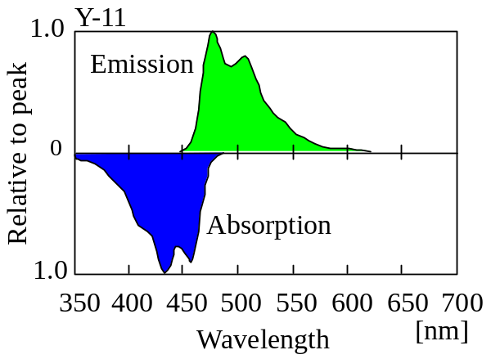

Fig. 11.2 Absorption and emission spectra of the K27 dye (Kuraray Y11 fiber) dissolved in styrene monomer.

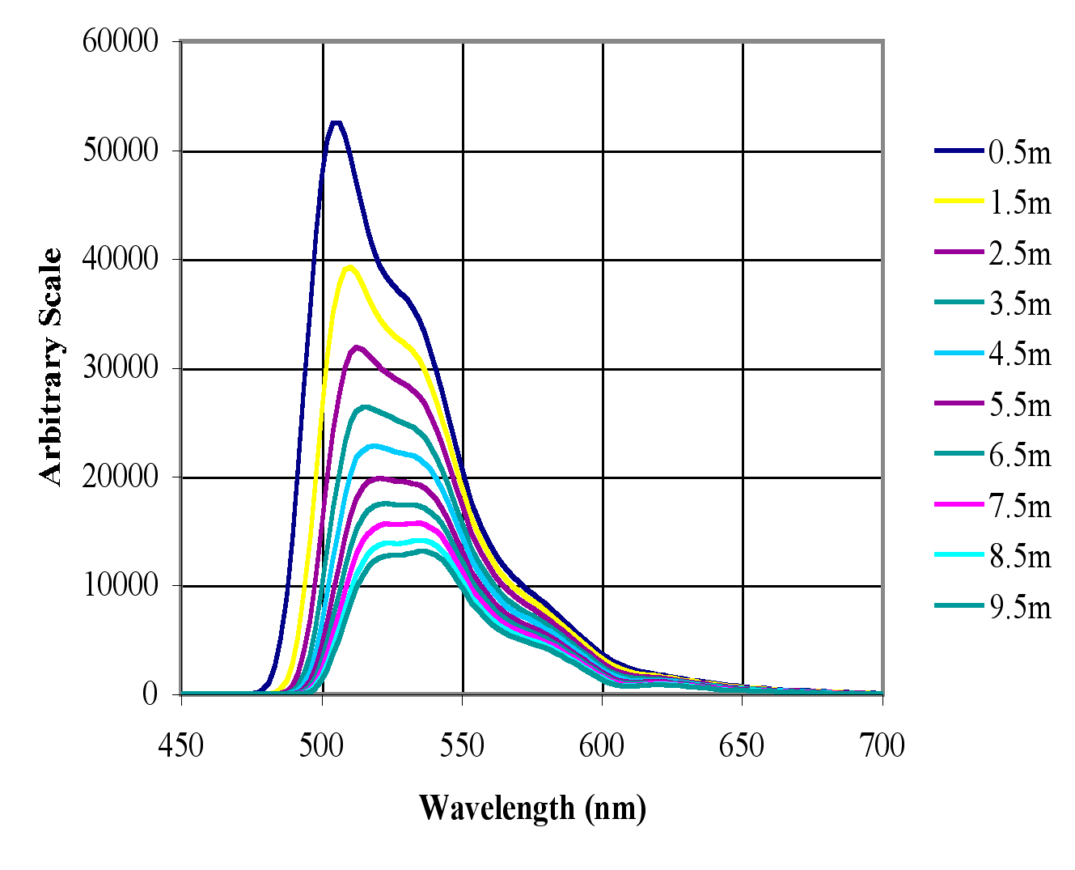

Fig. 11.3: Spectrum of light exiting a 0.7 mm WLS fiber doped with 150 ppm of the K27 dye stimulated at distances from 0.5 to 9.5 meters.
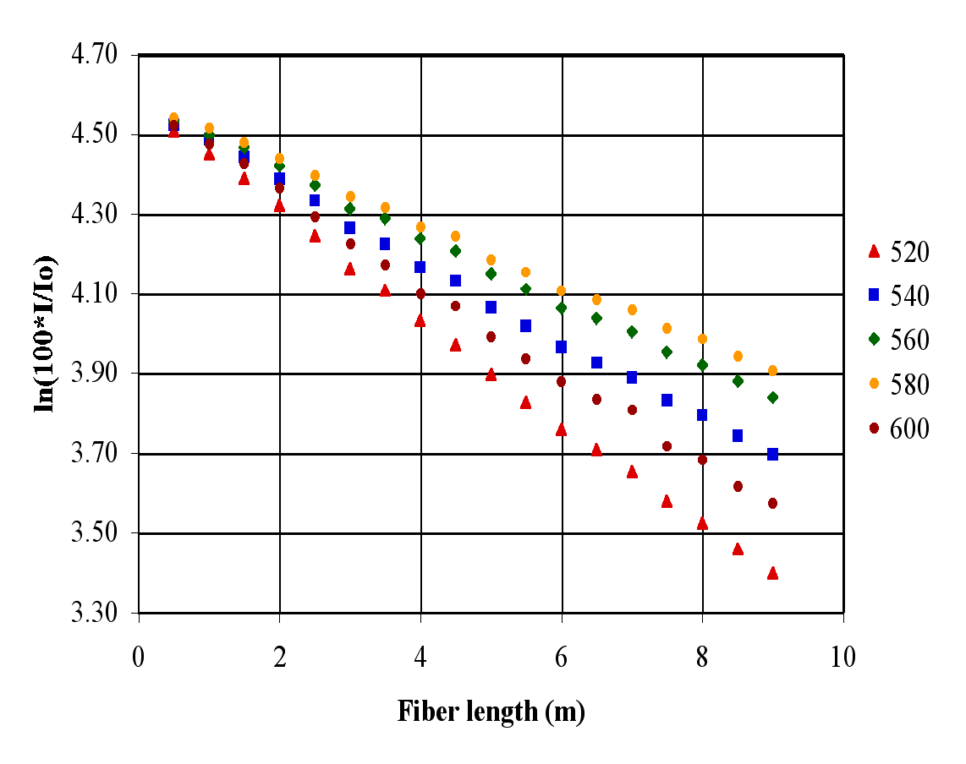

Fig. 11.4: log(Intensity) vs. distance at fixed wavelengths for light exiting a 0.7 mm WLS fiber doped with 150 ppm of the K27 dye stimulated at distances from 0.5 to 9.5 m.

With a typical dye concentration the attenuation of light at long wavelengths (> 550 nm) is determined primarily by the optical properties of the polystyrene core rather than by the dye. An increased dye concentration, therefore, does not lead to a comparable increase in the absorption of the longer wavelength light.

Studies of Kuraray Fibers (Batch1)
In our initial study we obtained fibers in 3 diameters (0.6, 0.7 and 0.8 mm) and 3 dye concentrations (150, 250 and 300 ppm) and a few other samples. We obtained attenuation length vs. wavelength data for each of these fibers. At 580 nm, the attenuation length can exceed 18 m, as shown in Fig. 11.5; only slightly shorter than the ~22 m attenuation length that Kuraray quotes for S–type fiber with an un-doped polystyrene core at this wavelength. The sharp drop in the attenuation length to ~7 m at 610 nm is due to an absorption resonance observed in all fibers with a polystyrene core.

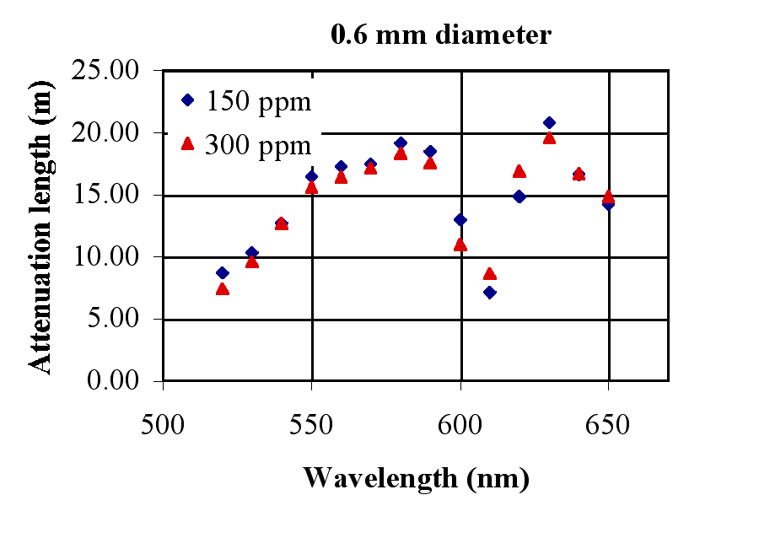
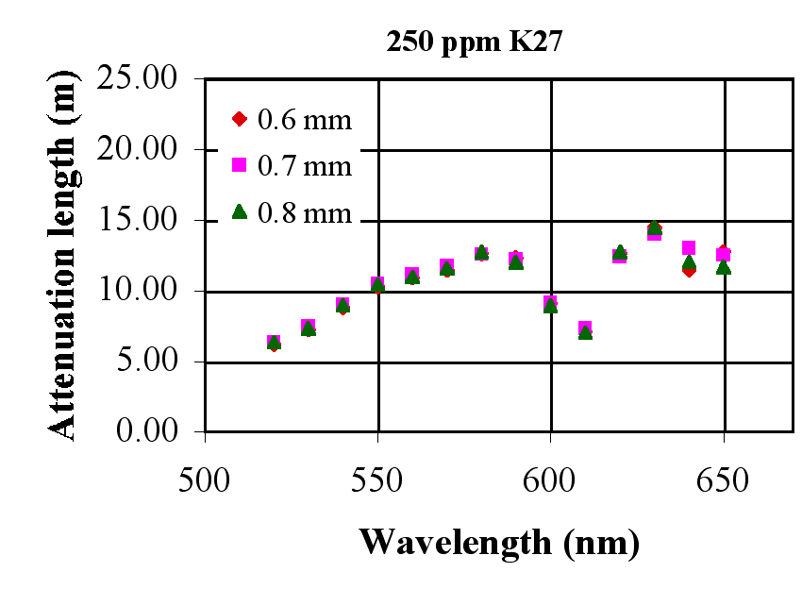

Fig. 11.5 Attenuation lengths derived from fits to the light intensity exiting a fiber illuminated at distances between 4 and 9 m: 0.6 mm diameter fibers with K27 dye concentrations of 150 and 300 ppm (left), and various diameters for a dye concentration of 250 ppm (right).

If determined primarily by the dye concentration, the attenuation length would be inversely proportional to the dye concentration and a reduction of 50% would have been expected for an increase of a factor of two in dye concentration. However, a doubling of the dye concentration from 150 to 300 ppm has reduced the attenuation length only slightly, ~5%, uniformly across the wavelength range. An upward fluctuation in the properties of the particular 300 ppm fiber samples could explain this measurement. Also, we have measured at 580 nm attenuation lengths approaching 20 m in fibers with diameters between 0.6 and 0.8 mm with no discernable diameter dependence. Therefore, the core-cladding interface in fibers with diameters in this range can be of sufficient quality that attenuation due internal reflections does not compete with the core polystyrene attenuation.
It was surprising to find, as shown in the second plot in Figure 11.5, that all fibers with a dye concentration of 250 ppm had an attenuation length of about 12 m at 580 nm. For light traveling from the far end of the NOvA cell, 36% less light is seen at this wavelength than with the two other dye concentrations. All fiber diameters with the same dye concentration were produced sequentially from the same pre-form. This suggests a problem with the 250 ppm pre-form, but a further investigation lead away from that conclusion.
We obtained Kuraray’s spectrographic Quality Control (QC) measurements [2] for two samples of each fiber diameter and dye concentration in the production of this R&D fiber. These measurements exhibit the short attenuation lengths for the 250 ppm dye concentration we had observed. Also, their data shows two fiber samples with a 0.6 mm diameter fiber and a 150 ppm dye concentration that had attenuation lengths at 580 nm that differed by 20% from an average of 17.5 m. Kuraray reported that they could not find any anomalies in their pre-form production or in the drawing parameters that would explain any of the variations seen in attenuation length. Independently, we had the K27 content in the fibers analyzed [10] by liquid chromatography at Indiana University and found that the dye concentrations were consistent with the quoted values, with no indications of impurities.
Under the assumption that the attenuation length is diameter independent (consistent with our observations in the range 0.6 – 0.8 mm), the six measurements by Kuraray of attenuation at each dye concentration could be used to determine their variation. If attenuation length variations are induced in the drawing process, they should depend only on wavelength. Therefore, we determined the average attenuation length and the fractional variation at the seven wavelengths in the range 520 – 580 nm that Kuraray provided, as shown in Fig. 11.6. The averages at each wavelength are not independent but show a general trend of increasing attenuation length and fractional variation as the wavelength increases.
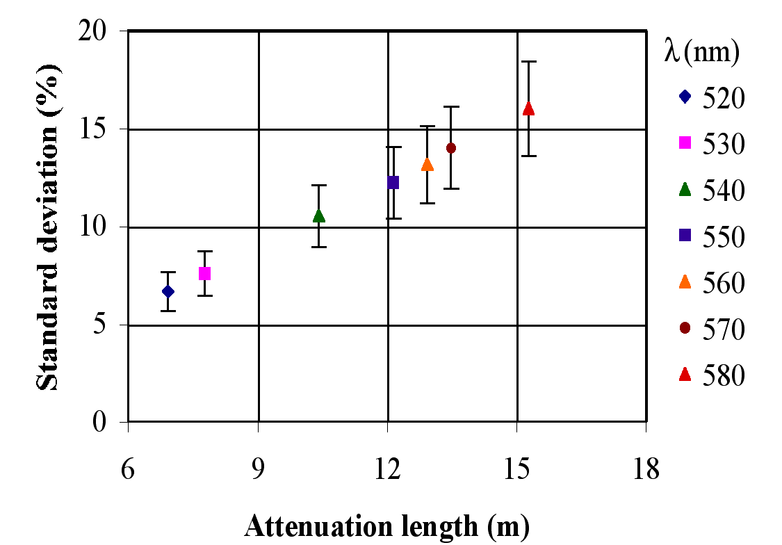

Fig. 11.6: Variation (%) in the attenuation length as determined from Kuraray QC data for six fiber samples with each dye concentration.

The experience of the MINOS collaboration [11] is that their batch-to-batch variations in attenuation were about 8% at an average detected wavelength that we estimate to be about 530 nm. At this wavelength the current samples show a similar variation (Fig 11.6). The light from the far end of the NOvA cell detected by the APD will have an average wavelength of about 550 nm, so that 12 m attenuation length with a variation of about 12% can be expected, and variations of 15-20% from the average would be fairly common at 580 nm.
As discussed in Chapter 6, variations in the fiber will impact the overall NOvA light output. In this chapter we show that the technical design criterion of 16% variation (std. dev.) set in Ch 6 is satisfied by a 12 % variation (std. dev.) in attenuation length for the fiber. The long attenuation length of the 150 and 300 ppm doped fibers above are likely examples.

Studies of Kuraray Fiber (Batch 2)
In additional samples of 0.7 mm diameter fiber ordered from Kuraray the attenuation length variations are similar to those seen in the first batch. It appears that Kuraray has not been able to improve the control the variations in the attenuation length at long wavelengths. Therefore, we will assume that the variations in the production fiber will be about the same as those seen here.
To perform the fiber optimization, we constructed a test cell with an approximate NOvA cross section (4 cm x 6 cm), assembled from sections of white PVC produced in an early extrusion test and placed it in a dark box, as shown in Fig. 11.7. This simulation does not entirely reproduce the environment of the fibers in the NOvA liquid scintillator filled cells. However, given the broad maximum in the light yield vs. dye concentration that can be expected, these tests incorporate all the important features of light collection and transmission in the NOvA cell.

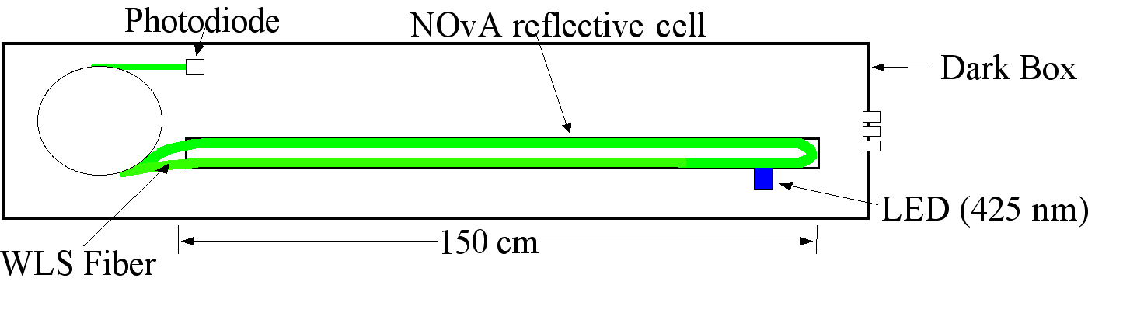

Fig. 11.7: Station to test WLS fibers in a simulated NOνA cell illuminated by an LED.

A blue LED with an emission spectrum similar to that of liquid scintillator illuminated the cell, and a photodiode with the same quantum efficiency characteristics as an APD measured the light amplitude. The LED was located 15 cm from the end of the cell and its light collimated to a spot on the cell wall to insure a diffuse illumination of the cell. Five small spools, each holding a WLS fiber loop 16 m long, were prepared in each of the six dye concentrations. The free ends of the fiber loop were glued into a plastic ferrule and polished. The polished ends were lead to the photodiode while the U-bend in the loop was guided around a semi-circular section of clear plastic at the end of the cell. The loop legs were held near the walls by clips.
The maximum photodiode current in the simulator was seen with the fiber with a dye concentration of 300 ppm. Four of the six fibers had a light yield that ranged from 5 to 15% lower than the maximum, as shown in Fig. 11.8. However, the fiber with a dye concentration 500 ppm yielded <50% of the maximum light output. This is another example of light yield variations that are not associated with dye concentration.
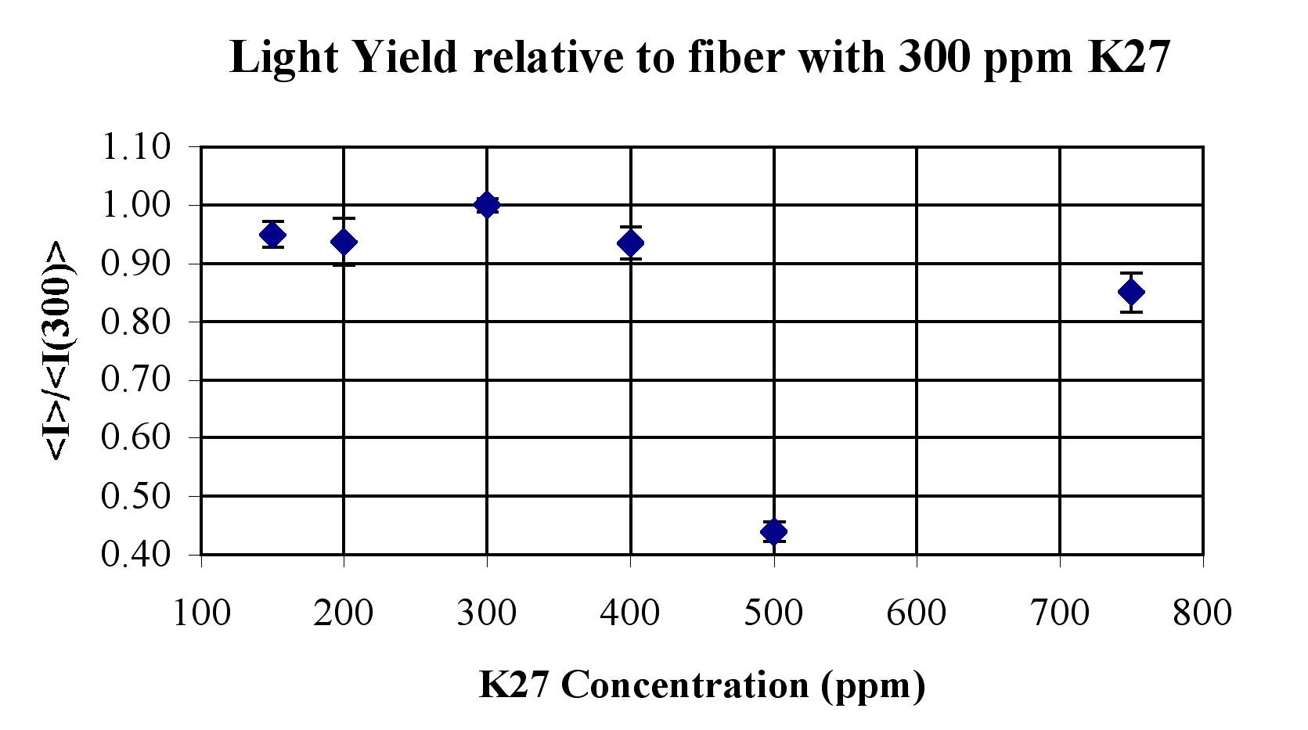

Fig 11.8: Using the NOvA test cell described in the text, the average photodiode current for five full-length fiber loops in each dye concentration relative to the fiber with a dye concentration of 300 ppm giving the maximum light yield.
In both batches of fiber the 300 ppm dye concentration yielded the highest photodiode current and this is the reasonable choice for the experiment. However, we must assume that the variations we have seen in the light output of the fibers will continue to be found in the delivered fiber. Therefore, the average photoelectron yield must be sufficiently high to allow for reasonable fluctuations in the fiber quality.

Studies with APDs
Fibers from Batch 1 were tested with cosmic ray muons in scintillator-filled cells with fibers readout by an APD, as discussed in Section 6.3. These results show that the light yield for the 250 ppm doped fiber was lower than would be expected compared to the 150 and 300 ppm doped fibers, consistent with the scanning and cell simulator measurements discussed above. Therefore, the QA procedure, measuring the attenuation length vs. wavelength of the supplied fiber, discussed in the next section, is a good predictor of the light yield.

Summary of Observed Fluctuations
The light from the far end of the fiber loop must travel an average distance d = 16m, to reach the APD. Our measurements indicate that this light has an average attenuation length L ~ 12m. Therefore, of the light generated at the far end of the loop, about 26% (exp[–16/12]) reaches the APD. As discussed in this chapter, there are variations in the attenuation length of σ_{A} = 12%. These variations result in a variation of the light reaching the APD, σ = (d/L) σ_{A} = 16%, which meets the requirement for light output of the fiber as specified in Chapter 6.

Measurement Methods for NOνA Fiber Technical Criteria

Quality Assurance Instruments developed for Fiber Tests
In the Quality Assurance (QA) process the diameter, attenuation length vs. wavelength, and normalized light yield will be measured over a fiber length of up to 30 m at the beginning of every spool, each spool containing ~3200 m of fiber. The measurements will not require that fiber be cut from the spool, so that the tested fiber can be rewound onto the spool for later use in module production. In the attenuation length measurements made to date, samples that yielded significantly lower values than previous measurements or there were indications that the fiber had been damaged in handling, were eliminated. While the selected trials correlated well with the light yield measurements made in a simulated NOvA cell and with Kuraray Quality Control measurements, by constructing new equipment as planned, the handling of fiber will be minimized, the reliability of the attenuation length measurements will be improved, and light yield normalization will be maintained over the full production.
The attenuation length vs. wavelength measurements are made with an excellent and inexpensive digital spectrometer obtained from Ocean Optics Corporation. The entrance slit is 0.25 mm wide which allows for quick measurements, however, the light cone exiting a fiber has a large half angle (45°), and the intensity is not uniform over the fiber cross section. To keep the light levels high, the fiber cannot be located far from the slit to approximate a point source. Effects seen in the initial measurements indicate that a better mounting scheme will be needed to insure that the fiber has a repeatable position and is axially aligned.
To make a light yield measurement the preparation of the fiber face must be carefully executed and it is essential to avoid contamination of the fiber face or the spectrometer optics with dust or fiber polishing detritus; most fibers carry a static charge causing them to attract small dust particles and cladding flakes. Before polishing, fast curing glue is used to secure the fiber into a hard plastic and close fitting ferrule. A machine for diamond polishing of fibers, designed for this purpose by Fermilab engineer Carl Lindenmeyer is used to face-off the fiber and ferrule. This single-fiber polishing machine has been used in preparing fibers for a number of experiments, including CDF and ATLAS. The hard surface of the ferrule will insure an accurate positioning of the fiber at the spectrometer entrance.
There are two common techniques for measurement of fiber light yields and attenuation lengths: a string of LED light sources lit sequentially at fixed distances along the fiber, as employed by the MINOS collaboration, or a single LED light source (or a radioactive source and scintillator) translated to known locations over the fiber, as employed by the CDF and ATLAS collaborations. The two techniques have a common set of trade-offs.
Multiple light source systems have no moving parts and produce results quickly, however, the individual sources must be checked often to avoid drifts in the normalization and relative calibration. Scanning on the other hand, takes time and requires maintenance of an electro-mechanical device, however, the relative normalization along the fiber is constant, with the single light source monitored by a photodiode and requiring only periodic recalibration. Both systems require the development of an automated procedure to prepare a length of fiber for measurement with the minimum amount of handling. Over the 4 years of absolute light yield and attenuation length measurements, the calibration ease of a single light source scanning system, we feel outweighs the slower speed and scanner maintenance requirements.
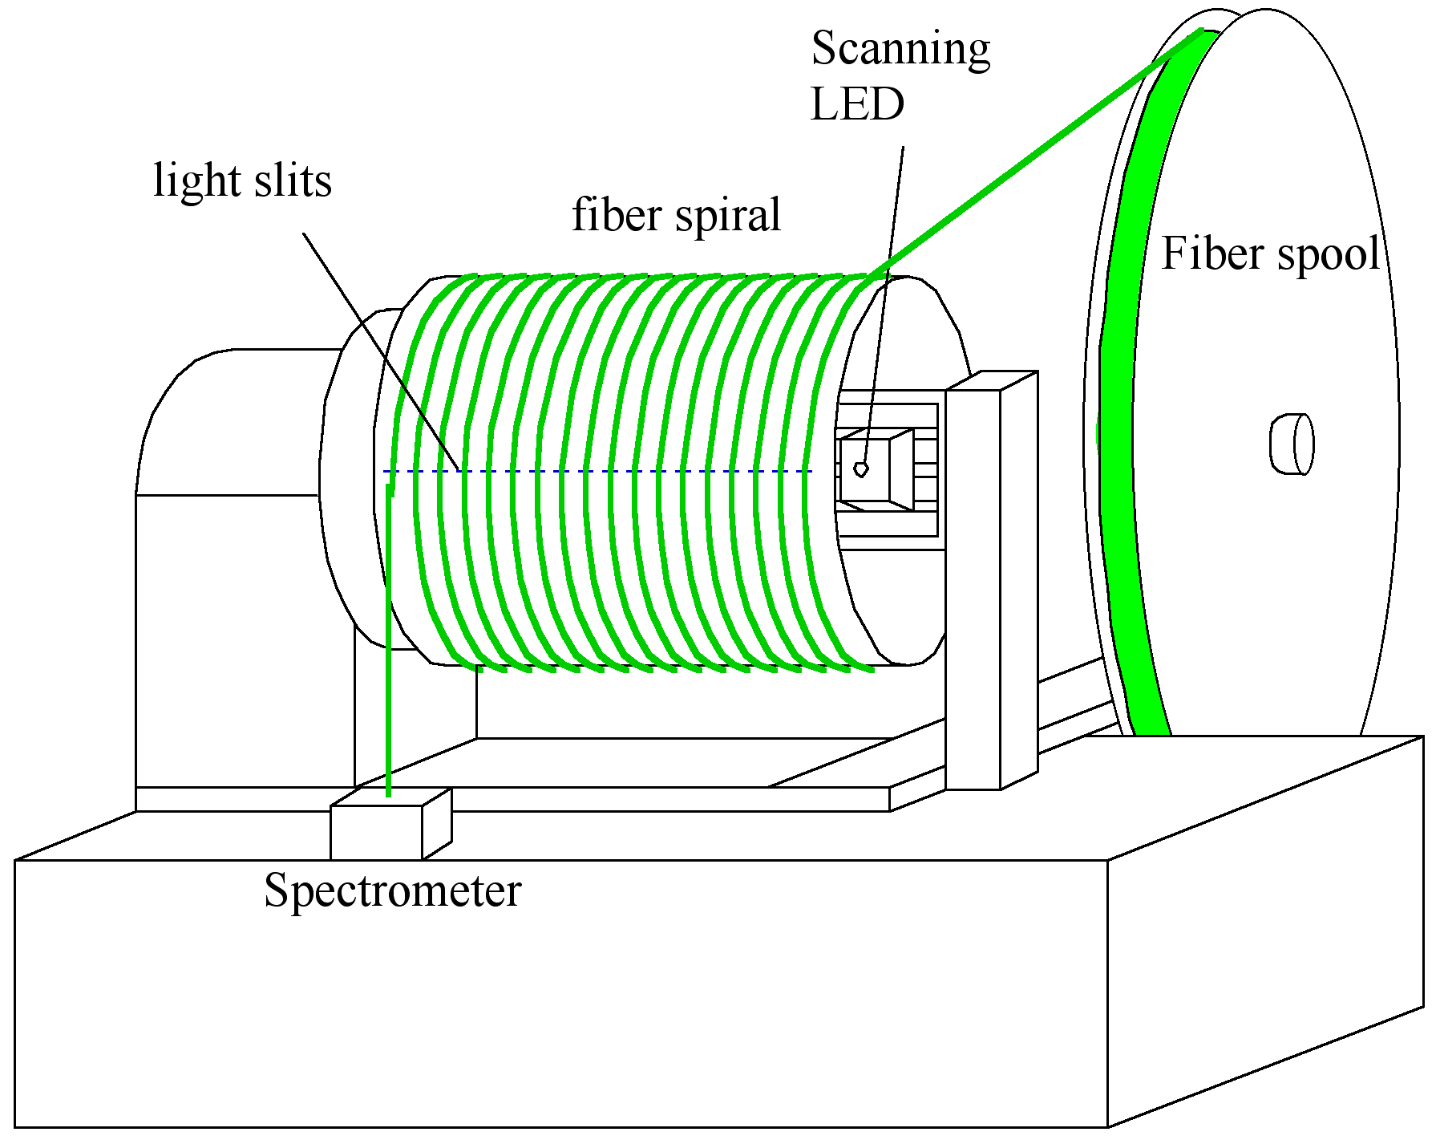

Fig. 11.9. Drawing of the fiber scanning machine to be used in the Quality Assurance procedures. Spectrometer is mounted on the drum and uses slip ring electrical connections.

The mechanics of the scanner, shown in Fig. 11.9, enables unrolling of ~30 m of fiber from a spool at a constant but low tension onto a 15.9 cm radius drum and into a helical groove on its surface locating the fiber over the illumination holes. The fiber is feed into the groove using a modified lathe that has the appropriate gearing for very coarse screw threads (2 threads per inch). The fiber spool is mounted on a stage that moves 1.27 cm along the drum axis for each rotation of the drum. Torque motors maintain a safe tension on the fiber spool at all times. Before winding, the polished end of the fiber is inserted and clamped into the spectrometer. Once the 30 m long spiral has been completely wound, the drum is locked in place. At this point the measurement room is darkened and a blue LED light source is stepped down the inside of the drum, illuminating one hole in the drum and one fiber location at a time. The light pattern will be adjusted to minimize the sensitivity to the exact positioning of the LED. If necessary, the spectrometer gate can be adjusted to maximize the statistical significance at each point. Scanning, readout of the spectrometer, and database entry are performed by a single PC.
The light intensity will be monitored by two independent photodiodes mounted on the LED scanning head. In addition, a few spools containing fiber standards will be maintained and used occasionally to cross check the normalization. The LED power-supply has two options for control: maintain a constant LED current, or adjust the LED current to maintain a constant photodiode signal. As we gain experience with the LED and photodiodes we will choose the control function that is most reliable.
Kuraray provides a series of fiber tests, however, we intend to make an equivalent scanning machine available to them. We expect that they will then test for out-of-specification fiber before shipment.

Fiber Transportation and QA Testing Plan
The testing of fiber in our R&D to optimize the dye concentration has provided the data necessary to choose the Quality Assurance procedures and provided data on the variations in the attenuation length at long wavelengths, the critical parameter in maintaining an optimum signal from the fibers. The contract with Kuraray for the production fiber will contain acceptance criteria balancing their production realities and the requirements of the experiment. These criteria will be based on Kuraray’s Quality Control data and NOvA Quality Assurance data taken during the R&D period.
The WLS Fiber QA plan has all fiber delivered to the High Energy Physics Laboratory at Michigan State University’s Biological and Physical Science (BPS) Building. The laboratory has a high bay area, 60’ x 20’, equipped with a crane, and a roll up door allowing ground level truck entry. Adjacent to the high bay area are 3 secure laboratories, each 15’ x 20’, and a chemical, paint and plastics processing room with an exhaust hood. The laboratory is large enough to accommodate areas for the following tasks in the QA process:

1) receive the monthly shipments of fiber spools in crates,
2) unpack the spools from the crates, check fiber diameter and prepare end for QA testing,
3) perform the QA measurements on each spool of fiber and analyze the data,
4) repackage fiber spools in the crates,
5) prepare crates for transportation to a subbasement storage location, and
6) transmit QA data to a central database.
7) Four times per year, ship fiber crates to the module factory, once it is in operation.

Approximately 120 spools, each carrying about 3200 m of 0.7 mm diameter fiber, will be delivered to MSU monthly for ~3.5 years during the NOνA construction project. The long procurement from a single vendor will require that nearly all the fiber is received and QA tested before the module factories are ready to begin full production. The fiber is supplied in sturdy pine crates, 2 m long, 1 m wide and 0.67 m high, containing 16 spools of fiber, and weighing about 150 kg. In three years of production, 253 crates will need storage. Stacking 3 crates one on top of the other, the storage area needed will peak at ~1,500 sq. ft. in the 31st month of production when shipment of fiber to the module factories begins. A storage space has been secured in the subbasement of the BPS building that is temperature controlled and has full fire protection via sprinklers. Though water will not hurt the fibers, the spools are cardboard. Storing the crates well off the floor and covering them with a waterproof material should prevent any damage to the spools. A single fiber of ~16 m will be cut from one spool of each delivery and stored in a separate box nearby the other crates. It will be periodically tested to monitor the light yield of the fiber while in storage.
The QA team consists of the Level 2 and Level 3 Managers to supervise a Senior Technician and a Student Technician. The team must perform the tasks 1 – 7 noted above. The monthly tasks 1,2,5 and 6, should occupy two people for about one week (5 days). Tasks 3 and 4 involve the daily operation of testing 8 spools of fiber including the analysis of the data and entries into the local database. We are reasonably certain that the testing of a spool, including a preliminary data check and local database entries can be made in less than one hour, including 15 minutes of contingency, e.g., dealing with out-of-specification fiber or spurious test data. A total of 3 weeks (15 days) or less is needed to process the 120 spools, with holiday and vacation breaks made up by management personnel or by employing additional Student Technician labor.
On a spool found to have substandard fiber, the Quality Assurance testing will be repeated after removing ~100 m of fiber from the spool. Also, the previous spool of fiber in the production sequence can have its fiber transferred to an empty spool to access the fiber produced immediately before the substandard fiber. In this way the region of substandard fiber at the beginning and end of a spool will be bracketed. Spools with indications that substandard fiber continues beyond the tested point at the beginning or end of a spool will be segregated and perhaps returned to Kuraray for credit and analysis.

Changes in the Fiber design since the CDR
At the time of the Conceptual Design Report, the proposed fiber diameter was 0.8 mm with a K27 dye concentration of 200 ppm, a concentration typical of the previous fiber applications. In testing we have found that the requirement of a mean number of 20 photoelectrons for minimum ionizing particles through the far end of a NOvA cell could be met with a fiber of 0.7 mm diameter at a considerable cost savings. Furthermore, the smaller diameter provides a greater safety margin between the curvature of the fiber at the bottom of the loop, and the point at which the fiber is damaged. Difficulties in handling fibers with a diameter smaller than 0.7 mm prevent any additional cost savings. However, we have found during R&D that improvements in the photoelectron yield can be obtained by optimizing the dye concentration at values of ~300 ppm.

Work Remaining to Complete the Fiber Design
The QA procedures will be given a good workout with about 75 km of fiber required for the Integration Prototype Near Detector (IPND). This IPND effort will provide a step towards the QA required for 13,000 km of fiber expected during a 3.5year period of NOνA fiber production. The IPND fiber represents about 3 days of module production for the Far Detector.
Long term fiber survival tests will continue throughout the project.

Chapter 11 References
[1] Kuraray Scintillation Materials, Kuraray Co., Ltd., Methacrylic Resin Division, contact psf@kurary.co.jp. The Kuraray fiber catalog can be found in docdb note # 2665
[2] O. Shinji, Chief Scientist at Kuraray, private communication
[3] K. G. Young et al., Radiat. Phys. Chem. 41 215 (1993)
[4] D. Koolbeck and K. Ruddick, a re-analysis of the ref [2] data, NOvA docdb note # 389, August 2005.
[5] P. Border et al., Nucl. Instrtum. Methods A463, page 194 (2001).
[6] L. Benussi et al., Nucl. Instrtum. Methods A488, page 503 (2001)
[7] D. Cronin-Hennesy, NOνA docdb note # 139, December 2005.
[8] A. Bross and A. Pla-Dalmau, private communication.
[9] Stuart Mufson and Mark Messier, private communication.
[10] Matt Strait, NovA docdb note # 2014.
[11] Jon Karty, private communication
[12] Leon Mualem, NOvA docdb note # 24, August 2005.

