SOFTWARE DESIGN DOCUMENT
Cloud-Native Distributed Load-Testing Platform
Containers • Workers • Autoscaling • Metrics
Prepared as a high-level engineering design for a scalable system that simulates user traffic, measures performance, and produces reports for web applications and APIs.

Document type | Software Architecture and System Design
System name | Distributed Load-Testing Platform
Primary goal | Simulate concurrent users and measure application performance under load
Core concepts | Load tests, containers, workers, autoscaling, and metrics

Document Contents
- 1. Executive Summary
- 2. System Definition
- 3. Goals and Scope
- 4. Core Requirements
- 5. Architecture Overview
- 6. Component Design
- 7. Load Test Lifecycle
- 8. Worker Execution Model
- 9. Container and Autoscaling Design
- 10. Metrics and Reporting Design
- 11. Data Design
- 12. API Design
- 13. Deployment Topology
- 14. Security, Safety and Abuse Prevention
- 15. MVP Roadmap and Future Enhancements
- 16. Recommended Technology Stack
This document describes the design of a cloud-native distributed load-testing platform based on the initial whiteboard requirements: load tests, containers, workers, autoscaling, and metrics.

1. Executive Summary
The proposed system is a cloud-native distributed load-testing platform. It allows engineers to define a performance test, automatically launch multiple containerized workers, generate traffic against an authorized target application, collect real-time metrics, and produce a final performance report.
Instead of running a test from one machine, the platform distributes the traffic across many worker containers. This makes the system scalable, fault tolerant, and suitable for testing modern web applications, APIs, microservices, and e-commerce platforms before major traffic events.
Item | Design decision
Primary users | Software engineers, QA engineers, DevOps engineers, site reliability teams
Main output | Live performance dashboard and final load-test report
Scaling strategy | Calculate required workers from virtual-user demand, then autoscale based on runtime metrics
Core infrastructure | Docker containers, Kubernetes, queue service, PostgreSQL, Prometheus, Grafana
Key safety rule | Users should only test applications they own or are explicitly authorized to test

2. System Definition
A distributed load-testing system is a software platform that uses many coordinated worker processes to simulate large numbers of users accessing a target application at the same time. The system measures how the target behaves under pressure by tracking throughput, latency, errors, resource usage, and stability.
In this design, each worker runs inside a container. A controller service manages the lifecycle of each test, while an autoscaling layer increases or reduces worker capacity according to the test size and live infrastructure signals.

3. Goals and Scope

3.1 Goals
- Allow users to create load tests for websites, APIs and backend services.
- Support high concurrency by distributing traffic generation across worker containers.
- Autoscale worker capacity based on configured virtual users and live resource usage.
- Collect real-time metrics such as requests per second, latency percentiles and error rate.
- Generate clear final reports that identify performance limits and likely bottlenecks.
- Prevent misuse through authentication, authorization, rate limiting and target verification.

3.2 Out of Scope for the First Release
- Global multi-region load generation.
- Browser-based real-user simulation with full JavaScript rendering.
- Complex scenario recording from browser sessions.
- AI-based automatic bottleneck detection beyond basic report recommendations.

4. Core Requirements
Requirement | Description
Load Tests | Users can define target URL, method, headers, body, virtual users, duration, ramp-up and stop conditions.
Containers | Traffic-generation workers run in isolated containers so they can be started, stopped and scaled independently.
Workers | Each worker receives a portion of the test load and reports status and metrics to the platform.
Autoscaling | The system increases or decreases the number of workers based on desired load and runtime conditions.
Metrics | The platform records throughput, response time, latency percentiles, success/failure counts and resource usage.
Reports | Each test run ends with a summarized report for engineers and stakeholders.

5. Architecture Overview
The architecture separates control, execution and observation. The controller API receives test definitions and manages orchestration. Worker containers generate traffic. The metrics stack collects measurements. The database stores configurations, run history and report summaries.
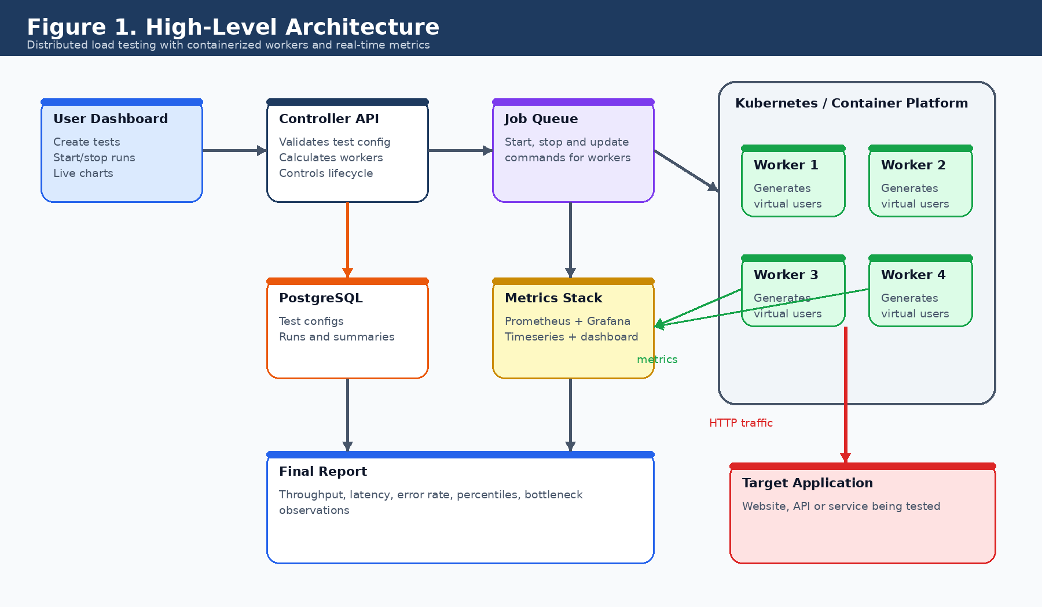
Figure 1. High-Level Architecture of the distributed load-testing platform.

6. Component Design
Component | Responsibility
Frontend Dashboard | React-based interface for creating tests, starting/stopping runs, viewing charts and downloading reports.
Controller API | Backend service that validates test configuration, stores tests, calculates required workers and coordinates the run lifecycle.
Scheduler / Orchestrator | Translates test demand into worker replicas and Kubernetes jobs or deployments.
Queue Service | Decouples controller and workers. It carries commands such as start test, stop test and update load profile.
Worker Containers | Stateless load generators that simulate virtual users and send traffic to the target application.
Metrics Stack | Prometheus scrapes or receives metrics, while Grafana or the custom dashboard visualizes them.
Database | PostgreSQL stores users, tests, test runs, workers and summarized metrics.
Report Generator | Produces a final report with success rate, failures, latency percentiles and bottleneck observations.

7. Load Test Lifecycle
A load test begins when a user creates a configuration and starts a run. The platform validates the target, calculates the required capacity, launches workers, streams metrics, and finally generates a report when the test completes.
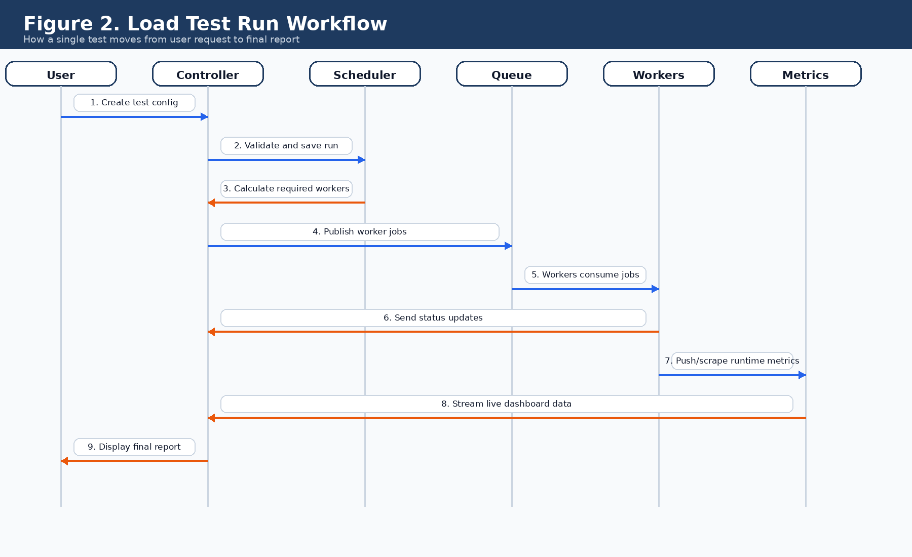
Figure 2. Load test run workflow from test creation to final report.
- The user defines the test through the dashboard.
- The controller validates the target URL, method, headers, duration and virtual-user limits.
- The scheduler calculates the required number of workers based on worker capacity.
- The queue distributes execution commands to worker containers.
- Workers generate traffic and emit metrics while the test is running.
- The metrics stack streams live results to the dashboard.
- The report generator summarizes the run after completion.

8. Worker Execution Model
Workers are stateless load-generation programs. A worker does not own the test definition permanently; it receives a job, executes its assigned portion of the test, sends metrics, and exits or waits for another job. This model supports horizontal scaling and fast recovery.
Area | Design
Input | Target URL, HTTP method, headers, body, duration, ramp-up profile, virtual users assigned to worker.
Execution | Spawn virtual-user routines or event loops, send requests, track responses, respect stop conditions.
Output | Request counts, success/failure counts, status codes, timeouts, latency percentiles and resource usage.
Failure handling | If a worker fails, the controller can mark it unhealthy and replace it with another worker pod.
Example worker job payload:
{
"runId": "run_123",
"target": "https://example.com/api/login",
"method": "POST",
"virtualUsers": 500,
"durationSeconds": 900,
"rampUpSeconds": 120,
"headers": { "Content-Type": "application/json" },
"body": { "username": "test", "password": "test" }
}

9. Container and Autoscaling Design
The platform should scale in two complementary ways. First, it should scale from the requested load. Second, it should scale from live operational signals such as CPU, memory, queue lag and worker health.
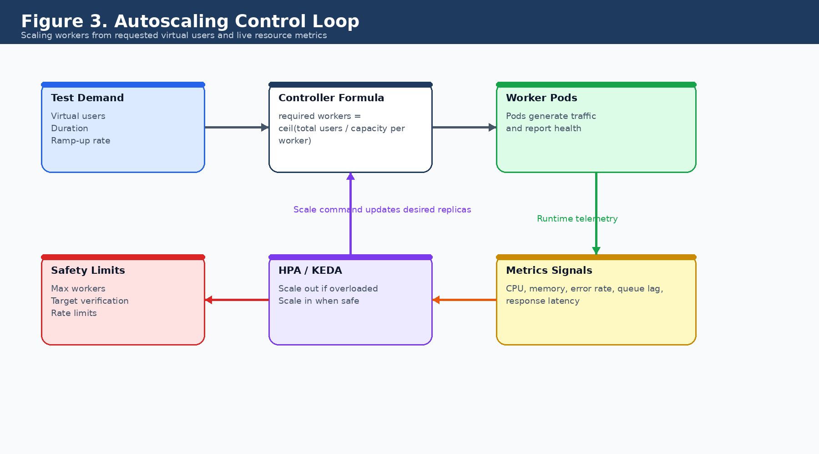
Figure 3. Autoscaling control loop for worker containers.

9.1 Test-Based Scaling
The controller estimates how many workers are needed before the test starts. For example, if one worker can safely simulate 500 virtual users and the user requests 10,000 users, the controller should start 20 workers.
Required workers = ceiling(total virtual users / safe capacity per worker)

9.2 Resource-Based Scaling
During the run, Kubernetes Horizontal Pod Autoscaler or KEDA can add more pods if workers become overloaded or if queue lag increases. Scaling in should be conservative so the system does not interrupt a running test.
Signal | Scaling behavior
CPU usage | Scale out when average worker CPU remains above 70% for a configured window.
Memory usage | Scale out when workers approach memory limits or garbage collection pressure becomes high.
Queue lag | Scale out when job messages or metric batches are waiting too long.
Error rate | Do not automatically increase traffic if the target is already failing heavily; protect the target and stop if configured.
Max workers | Enforce per-user and system-wide limits to avoid abuse and infrastructure overload.

10. Metrics and Reporting Design
Metrics are central to this platform. The system must measure both the target application's behavior and the health of the load-testing infrastructure. Metrics should be available live during the test and summarized after completion.
Metric group | Examples
Throughput | Requests per second, total requests, successful requests, failed requests.
Latency | Average, minimum, maximum, p50, p90, p95 and p99 response times.
Reliability | Error rate, timeout rate, HTTP status code distribution.
Worker health | CPU, memory, active virtual users, dropped requests, worker restarts.
Test progress | Elapsed time, remaining time, current stage, current virtual users.
Report summary | Maximum stable users, failure point, bottleneck observations and recommended next steps.
Suggested metric names:
- loadtest_requests_total
- loadtest_failed_requests_total
- loadtest_request_duration_ms_bucket
- loadtest_active_virtual_users
- loadtest_worker_cpu_usage_percent
- loadtest_worker_memory_usage_bytes
- loadtest_errors_by_status_code

11. Data Design
PostgreSQL should store durable system data, while Prometheus or a time-series database stores high-volume runtime metrics. The relational database should keep test definitions, user ownership, run summaries and report metadata.
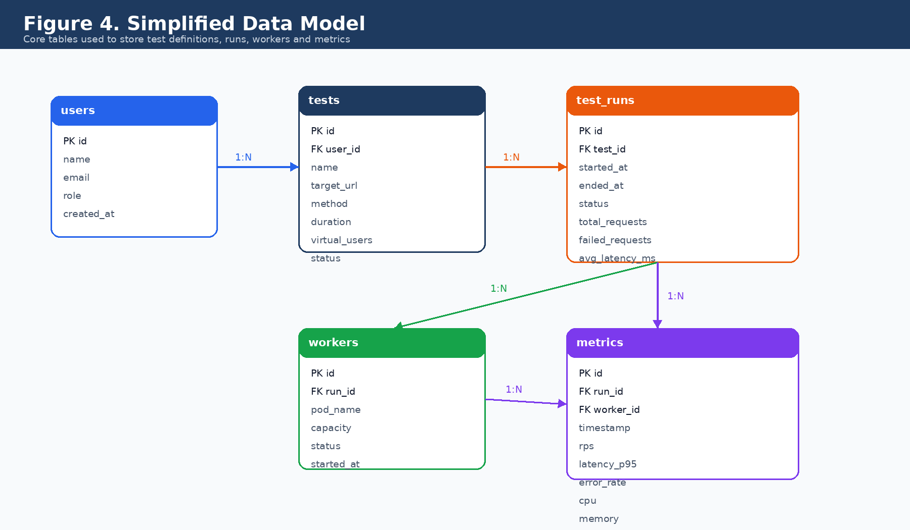
Figure 4. Simplified relational data model.
Table | Purpose
users | Stores platform users and roles.
tests | Stores reusable test definitions and target settings.
test_runs | Stores each execution of a test with start/end time and final status.
workers | Stores worker participation and health for a run.
metrics | Stores summarized metric snapshots when long-term SQL storage is required.

12. API Design
The API should be simple and lifecycle oriented. A user creates a test, starts a run, monitors metrics, stops the run if necessary, and retrieves the final report.
Endpoint | Purpose
POST /tests | Create a reusable load-test definition.
GET /tests | List tests owned by the authenticated user or team.
GET /tests/{id} | Retrieve one test definition.
POST /tests/{id}/runs | Start a new run for the selected test.
POST /runs/{id}/stop | Stop a running test.
GET /runs/{id}/metrics | Return live or summarized metrics for dashboard charts.
GET /runs/{id}/report | Download or view the final test report.

13. Deployment Topology
A production deployment should place the controller, queue, workers, metrics stack and persistent storage inside a Kubernetes cluster. The target application remains external unless the organization is testing an internal service.
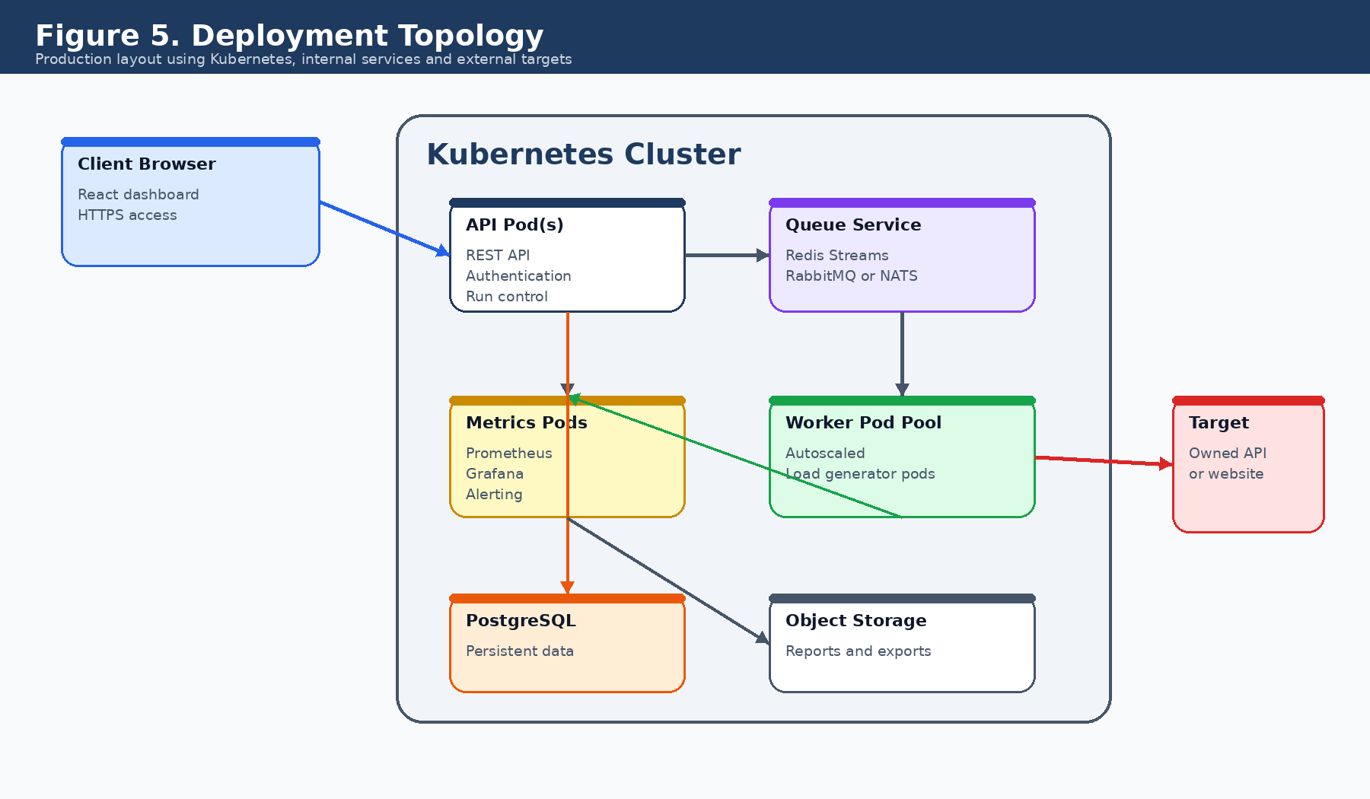
Figure 5. Suggested production deployment topology.
Deployment element | Design note
Ingress | Terminates HTTPS and routes dashboard/API traffic.
API pods | Run multiple replicas behind a service for availability.
Worker pods | Autoscaled pool that can expand during large tests.
Queue | Internal service for job distribution and worker coordination.
Database | Persistent PostgreSQL instance with backups.
Metrics | Prometheus, Grafana and alerting rules.
Storage | Stores exported reports and historical artifacts.

14. Security, Safety and Abuse Prevention
A load-testing platform can be misused if it is allowed to send high traffic to arbitrary targets. The system should therefore include strong safety controls from the first release.
Control | Purpose
Authentication | Require users to sign in before creating or running tests.
Authorization | Ensure users can only view and run tests belonging to their account or team.
Target verification | Require DNS, HTTP file or token-based verification before large tests can run.
Rate limits | Limit maximum virtual users, duration and total requests per account tier.
Audit logs | Store who started a test, target, duration, load level and stop reason.
Emergency stop | Allow administrators and automated policies to stop abusive or dangerous tests immediately.
Network controls | Restrict outbound traffic to verified targets and block private or sensitive IP ranges by default.

15. MVP Roadmap and Future Enhancements

15.1 MVP Release
- Create and save basic HTTP load-test definitions.
- Start and stop tests manually from the dashboard.
- Run workers in Docker or Kubernetes with a fixed capacity model.
- Collect basic metrics: requests, failures, average latency and p95 latency.
- Show live charts and generate a simple final report.
- Add authentication, target verification and account-level limits.

15.2 Future Enhancements
- Multi-region load generation for geographic performance testing.
- Scenario builder for multi-step user journeys such as login, search and checkout.
- CI/CD integration so tests can run after deployments.
- Advanced reports with automatic bottleneck suggestions.
- Team workspaces, role-based permissions and shared dashboards.
- Scheduled tests and performance regression alerts.

16. Recommended Technology Stack
Layer | Recommended option
Frontend | React, TypeScript, Tailwind CSS, charting library for live metrics.
Backend API | Go, Node.js/NestJS or Python/FastAPI.
Workers | Go for high concurrency, or k6-based workers for fast load-testing capability.
Database | PostgreSQL for durable application data.
Queue | Redis Streams, RabbitMQ, NATS or Kafka depending on scale.
Containers | Docker images for worker and backend services.
Orchestration | Kubernetes for scheduling and managing containerized workloads.
Autoscaling | Kubernetes HPA and KEDA using CPU, memory, queue and custom metrics.
Metrics | Prometheus for collection and Grafana or custom dashboard for visualization.
Storage | Object storage for generated reports and exports.

Conclusion
This design turns the whiteboard idea into a complete engineering architecture. The system is separated into a control plane, a worker execution plane and an observation plane. That separation makes the platform scalable, measurable, maintainable and safer to operate.
The best first implementation is an MVP that focuses on creating tests, launching worker containers, collecting essential metrics and producing a clear report. Kubernetes autoscaling, advanced dashboards and multi-region execution can then be added as the platform matures.

