Inheritance
Inheritance is a feature many people want but have a difficult time implementing. There are numerous ways of implementing this functionality. All of which have pros and cons. There are two basic ways to create an object database. The first is the put all fields in a single table from the entire object hierarchy. This may duplicate data across parent child tables but makes saving and loading simpler. The second way is to split the data logically based on the object hierarchy of your model. The properties of parent objects are stored in parent table fields and the child properties are stored in child table fields. This makes inserts, deletes, referential integrity, etc more difficult but in a generated framework there is no reason to care. The NHydrate generator opts for the latter. Different tables hold logical objects and are tied together with API.
Let us take a simple example of an Entity and a Customer. Let us say that Customer derives from Entity and both have a primary key of UserId. Now in code you would create an Entity class, then a Customer class that derives from it. In code, when you instantiate a Customer you actually have an Entity as well. You can of course cast the Customer as an Entity and use the properties and methods of the base class. This is completely possible to model and generate with NHydrate. You simply define your parent table in the model and define a relationship from Entity to Customer. In the generated code, there is an Entity class and collection; as well as a Customer class and collection.
The code works as expected but how is it saved? In the database, there is also an Entity and Customer table. There is also a one-to-one relationship from Entity and Customer. This relationship dictates that a Customer row cannot exist without a parent Entity row. This is just like your code. You cannot instantiate a derived class without also having its base class. You can cast to the base, so you essentially have a base class in memory as well. They are of course the same object but I am making a point. A Customer cannot exist without is Entity base. This relationship also defines the rule that all Customers are Entities but not all Entities are Customers.
Now in the database there must exists one row in Customer table for a Customer object, but also one row in the Entity table since the base properties are there. It is not possible to have a row in the Customer table without a corresponding row in the Entity table. This is all completely transparent to you the developer. In code you only need create a Customer object and save. The back end API knows how to split the data across tables. When you load a Customer, the API knows how to load the data from different tables into your objects. In fact, you need not be aware of any of these details or even that the objects are derived in the first place. You can use them like any other object in the framework. That is the beauty of generated code. Then entire complexity of inheritance hierarchies is hidden from you. You do not care how tables are implemented in the database or how each relates to the others. The database truly becomes a data repository that stores stuff for you. The details of the load and save are not anymore so important.
Let us expand this example to have multiple derived tables. Not only do we have a Customer derived from Entity, but we also have Employee as well. They are both Entity objects but play different roles in our system. Now when you create a Customer and save it, there is one row inserted into the Customer table of course and one row inserted into the Entity table. There are two database rows created for each Customer. Now when you create an Employee object, there are also two database rows created: one in Employee table and one in Entity. This may look odd to traditional relational database programmers. After adding one Customer and one Employee, the Entity table has two rows in it. This is completely logical when you think about what we are doing. We are splitting data across tables to facilitate object inheritance. This is not functionality that a relational database handles implicitly. We have turned our relational database into a sort of object database.
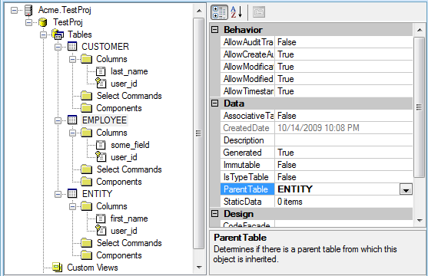
All of the relationships of the table and all base tables can be used as if the child object contained all of them. For example, if Entity has a relation to an EmailAddress table to hold multiple email address for an Entity, each Customer and Employee would also have this relationship. In fact, there is no way to know in code which layer has the relationship. It is only important that Customer and Employee have an EmailAddressList hanging off of them so the developer can walk the relationship and pull the needed data.
This functionality can be taken to any depth you desire. An object can be derived from another that is derived from another, and so on. A relationship is visible from all layers in any object above the level at which the relationship is defined. This also facilitates LINQ queries. In the example above you could select based on the following query.
CustomerCollection customerCollection =
CustomerCollection.RunSelect(x=>
x.EmailAddressList.Email == "q@q.com");

Notice that you cannot tell that EmailAddressList is actually related to Entity. Since Customer is a derived class of Entity, it too has the LINQ capabilities and properties of its parent object. This allows you to perform quite powerful ad hoc, strongly-typed queries across whole hierarchies of objects. In fact, if all tables in a database are related in some way through a relationship (no islands), you can query any set of objects based on the existence of other objects with LINQ. Keep in mind that all queries are strongly-typed and compile-time checked. You do not need to deploy an application to discover a logic error. If you have an error, your application will not even compile.
Inheritance is a powerful tool that has been a long time coming. The intricacies and problems associated with it are not easily solvable, which is why most applications avoid it all together. The NHydrate framework provides an easy to use interface to define and use inheritance hierarchies in code, with little understanding of the database particulars relating to persistence of such a framework.

